Study Skills for Electronics

Dafydd Peckham
Student No: 2521754

L4 – Study Skills
ACDA4021
Electrical & Electronic Engineering Degree Apprenticeship

Section 1: Personal Presentation
As a part of the module, a presentation on the student’s background was delivered. The presentation outlines background and interests of the student. The presentation describes hobbies such as working on cars and the place of work at SERB pharmaceuticals.
Image 1
This image outlines where the student works and what the job entails.
Image 2
The image illustrates what the student participates in their free time, such as working on cars.
Image 3
This image presents the pets that they live with.
Image 4
The following image outlines where the student was born and where they have lived in their life.

When the student was producing the PowerPoint, delivery of different skills was required to give success. Many of those key points are listed and reason for them below:
Communication skills- This skill would’ve been required for not creating the presentation skills, but to deliver a clear and effective presentation to peers in the classroom, keeping engagement up with interesting points, but to also deliver in a formal clear way.
Digital skills- Digital skills came into play when creating the PowerPoint, without the use of digital skills the PowerPoint, the student would have struggled with remembering facts that the PowerPoint could have given with images, but also using digital skills to create the presentation keeps the audience engaged.
Presenting information with limited wording- A key point whilst the presentation was being delivered, was the need to relay information on the student’s life with limited wording. The use of images and key wording gave tremendous help, whilst the student also learning a script to deliver the presentation in a calm, formal confident way.
Improvements after the student received feedback from peers, included not using enough wording in the presentation, meaning that the presentation could have used more wording to help the flow of the presentation and minimise pausing to remember what each image meant to the student’s life.
Another piece of feedback included looking at the presentation t many times and not the audience, this gave off a less confident delivery of presentation and could have been mistaken as the student not remembering or writing a script that would’ve helped the delivery in a more organised and clearer way.

Section 2: Personal research on required skill sets
Higher education identifies higher demands academically, as well as more complex skills required than level 3 and below work. To support with this, successful skill sets such as improved workflow, time management and the ability to reduce overdue assignments. A range of online sources support these ideas that are expected for students to have in higher education
“Time Management: You should be able to manage multiple tasks or projects at once to ensure they are all completed on time.” [1]. This supports the skills required students to maximise work life, academic life and personal life. The quote states that being able to “cope with less time and a larger workload is through managing your time more effectively” [1], these highlights prioritising the urgent workload “Finishing an essay that is due this week” [1] and not the not urgent workload “Re-organising revision notes into alphabetical or subject order” [1]. Without successful time management students are more likely to submit work late, miss deadlines, increase stress and not achieve the grades that were set out.
“Communication: You should be able to effectively communicate your thoughts and feelings to peers, both verbally and in writing” [1]. This highlights that students are required to take part in activities such as written assignments, presentations and group discussion. “From day one of first year, you will be conversing with senior academics which you may find intimidating” [1], this quote perfectly outlines the necessity for effective communication in higher education. This shows that communication skills are needed for academic success, but also for helping with confidence when talking to peers and attending communication led projects in higher education.
Many skills required for higher education were found to be transferable skills to a job location. According to Indeed [2] this demonstrates the importance of skills that are also needed for better job opportunities therefore giving a higher success rate at the job. “In the workplace, the ability to communicate clearly and succinctly is a key factor in completing work” [2] this highlights that employers are actively looking for applicants with a strong skill set in communication, brought on from higher education. “Time management is one of the most important qualities for employees in any profession” [2]. This supports the view of time management having been noted as one of the most important skills wanted by employers, mainly in roles where employees would need to manage many responsibilities. From this, students who achieve these skills in higher education are more likely to be successful in work and adapt to workplace demands.
Section 3: Self-evaluation and action planning
Self-evaluation formatted in an exercise found to be a strong way for students to discover strengths and weaknesses. A self-evaluation in the format of a quiz was completed through [3] [4]. The student after doing two personality tests had the same results of INTP (Introverted, Intuitive, Thinking, Perceiving). The results showed that a more analytical thinking, focusing on abstract ideas and independent work. Strengths [5] for the student following this are identified as critical analysis, innovative thinking and problem-solving. Following this [5] the evaluation for the student highlighted that areas for development included, task completion, collaborating effectively in groups and time management. These points using [3] [4] informed potential career paths in technical, analytical and research-based roles.
Short Term goals
The student aimed to achieve improved organisation on a day-to-day basis, to complete all coursework on time and to better practical electronical skills with routine practice.
Long-Term goals
The student has planned to complete a HND/Beng qualification, whilst gaining site specific experience and to further secure employment in engineering and electronics.
S.M.A.R.T Action Plans
A digital calendar was made to plan tasks and track deadlines. [Image 5]
Weekly revision lessons were scheduled to help learning. [Image 6]
Projects were completed to show practical skills.
Regular breaks were scheduled to increase focus and reduce stress

Section 4: Application
- Looking after your data
The student after class discussion found that the 3-2-1 backup strategy was the best way to maintain at least three copies of all important data. Two copies of data were stored at physical location such as an external or personal hard drive; however external hard driver is still vulnerable to physical damage or theft. One other method was to store a folder on the university network. One copy was then stored on an off-site cloud-based storage system, e.g. iCloud. This strategy gave protection against any hardware failure that could have accrued, any accidental deletion and/or file corruption. Online sources backed up the student’s way of saving data as it quoted “The 3-2-1 Rule is designed to create multiple layers of protection for your digital files” [6]. In the student’s case, ransomware incident occurred. After the student had backed up their data to an offsite cloud storage the files were recovered and work continued. However cloud storage relies on internet access, which may delay recovery in unavailable again.
- Time management and self-organisation

During the module, it was observed that improving organisation and productivity by also reducing stress came from implementing personal planning methods. “Make a list of things you must do. Arrange them in order of importance and try to focus on the most urgent first. Some people find creating a timetable useful so they can plan when they can spend time on each task” [7]. This quote highlighted the importance of how personal planning important and less important tasks had improved the student’s workflow and concentration when tasks were planned. Screenshots of an electronic calendar of task being allocated times and dates were shown. The student found this method of planning extremely useful when knowing what engineering-based work was completed and when the work was due. Source [8] backed this method with the following quote “Optimizing your calendar means making the most of your working hours. Effective time management allows you to create a micro plan for the day ahead and focus on high-priority tasks”. From this, it was understood that the student using an electronic diary planner was a very effective way of time management and self-management (see image 5 for calendar). However digital calendars require consistent updating, otherwise tasks may be missed.

For evidence of the e-portfolio and Professional Development Plan (PDP) screenshots were provided and attached (image 7). The structure of the PDP was separated into 4 sections keeping focus on development sections, this included time management, financial awareness, communication and self-management. All 4 sections followed the SMART framework guideline. This was chosen to ensure goals were defined and realistic. The layout allowed progress to be monitored which supported the reflection on a personal, academic and professional level. Goals many require regular review and adjustments as some circumstances may have changed.

Section 5: Conclusion & Evaluation:
This report has given the use and development of study skills needed for success in higher education and professional jobs within electronic engineering. Areas covered included, presentation skills, personal research into academic and employment skills, self-evaluation and action planning and the application of data management and time management strategies.
The presentation task highlighted the need of clear communication, structured format, and delivery. Feedback gave areas for improvement, especially in maintaining engagement from peers. Research into skills confirmed that time management and communication are needed for both academic success and success in employment.
Self-evaluation gave insight to personal strengths and weaknesses, enabling realistic academic, personal and professional goals using SMART framework. The use of a PDP and calendar demonstrated the self-organisation, workload management and reduced stress. In addition, the 3-2-1 backup strategy proved to be a solution for protecting data, especially when recovering from a ransomware incident.
Further development could have focused on improving group communication skills, presentation delivery techniques and exploring more productivity and date security logs. Reflection and regular revies of goals will support academic progression and development throughout the degree.

Section 6: Referencing
[1] “What Are the 6 Essential Skills for University Students?” Available:
What Are The 6 Essential Skills for University Students?
Accessed: Jan. 2026.
[2] Indeed Editorial Team, “8 sought-after skills employers look for,” Indeed UK. Available: https://uk.indeed.com
Accessed: Jan. 2026.
[3] Live Lingua, “I am a Visual-INTP learner | Language Learning Style Quiz,” Live Lingua. Available: https://www.livelingua.com
Accessed: Jan. 2026.
[4] 16Personalities, “Free Personality Test,” 16Personalities. Available: https://www.16personalities.com
Accessed: Jan. 2026.
[5] “Personality,” Available: Personality
Accessed: Jan. 2026.
[6] Permanent.org, “3-2-1 Backup Rule: Keeping Your Digital Files Safe for the Long Haul,” Permanent.org. Available: https://www.permanent.org
Accessed: Jan. 2026.
[7] Mind, “Self-care, managing stress and building resilience,” Mind UK. Available: https://www.mind.org.uk
Accessed: Jan. 2026.
Section 7: Appendices
Image 1
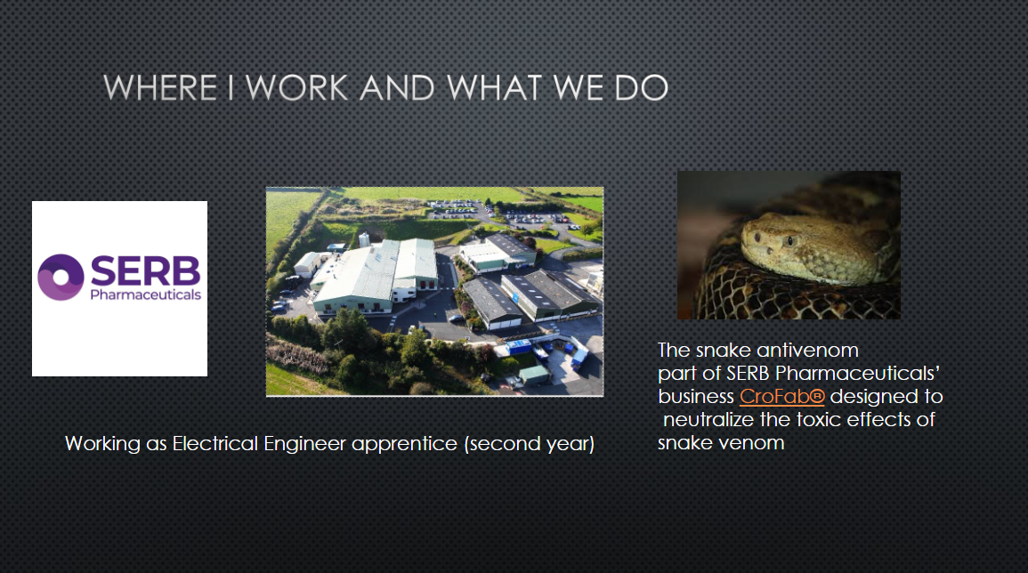
Image 2
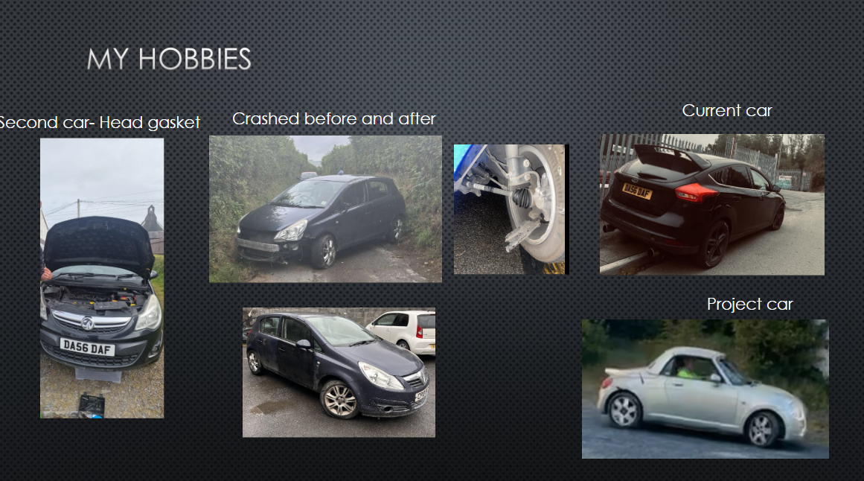
Image 3
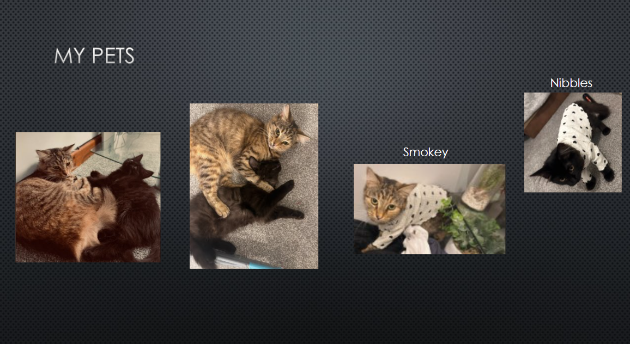
Image 4
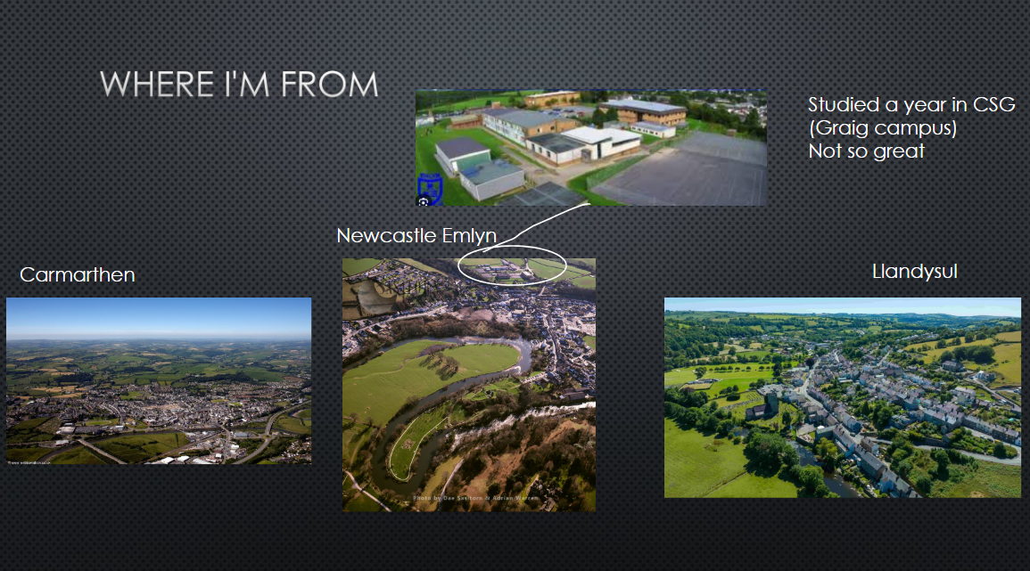
Image 5 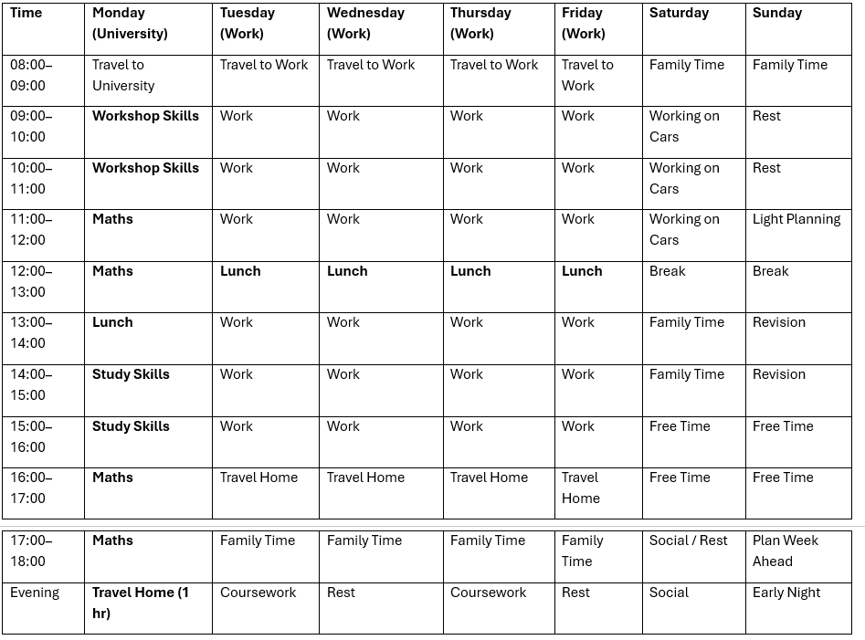
Image 6
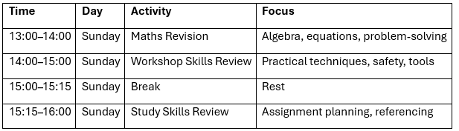
Image 7


