BA Computer Games Design & Animation

Changemakers: Creativity and Value Creation
ACCA5033

Assignment 2: Iteration and Development

Morgan Jones
Student No. 2210512



Content

Task E:
Iterative Development
-Initial design
-Photobash Iterations
-Colour scheme Iterations
-Block out Iterations

Task F:
Orthographic Views
-Reference images for texturing

Task G:
Final Design
Final Design: Rendered
Side by side: Block out & Final design
Colour Variations

Task H:
Evaluation
Feedback
Gantt Chart

Iterative Development
Initial Design
Metasoma Brood
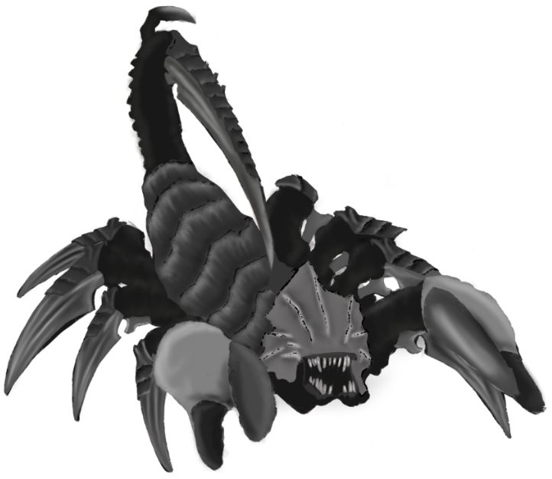
As mentioned in part one of the assignment I am looking to make a creature character for the Tyranid faction in the popular tabletop game Warhammer 40,000 by Games Workshop. I’ve decided to go with my “Metasoma Brood” design which is a Tyranid that draws inspiration from a Scorpion.

One of the unique aspect of Warhammer miniatures, is that each miniature comes with different iterations of weapons, heads etc to help personalise the model. Keeping this in mind for iterations of my design, I’ll be looking to create different iterations of the tail, head and arms. This way I can keep the identity of the scorpion design but have different iterations that might suit other people’s tastes of design.

Another element that effect most Warhammer factions, is that each faction has it’s own set of colour schemes, meaning that the model can have multiple colour schemes applied to it. However as a base scheme I will probably use the classic Purple and White, Leviathan colour scheme.

Photobash Iterations

Head Iteration Ideas
Tyrant Head [1] | Hierodule Head | Venomthrope Head [2]
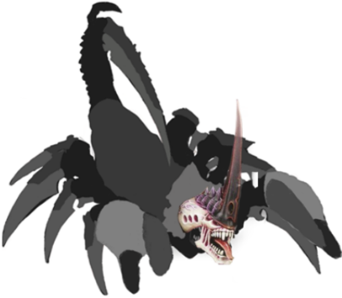 | 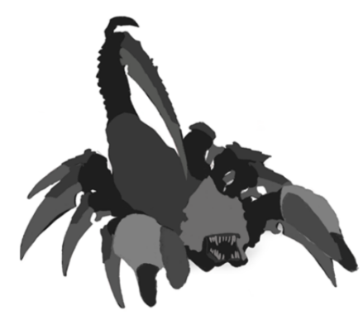 | 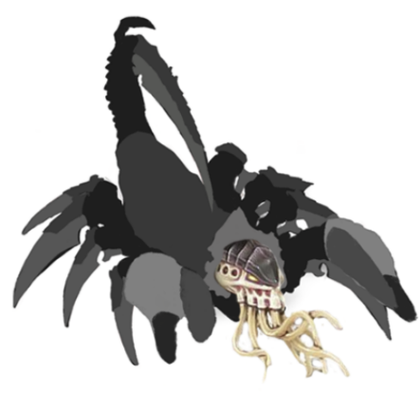
Frontal Limb Iteration Ideas
Cannon Limbs [3] | Crushing Claw Limbs | Scythe Limbs [4]
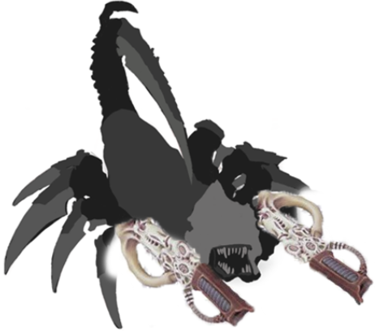 |  | 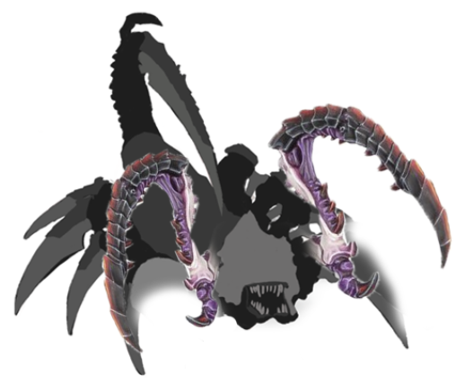
Tail Iteration Ideas
Cannon Tail [5] | Scorpion Tail | Tentacle Tail [6]
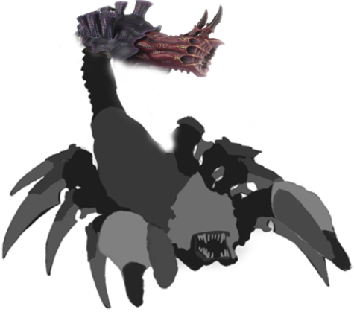 | 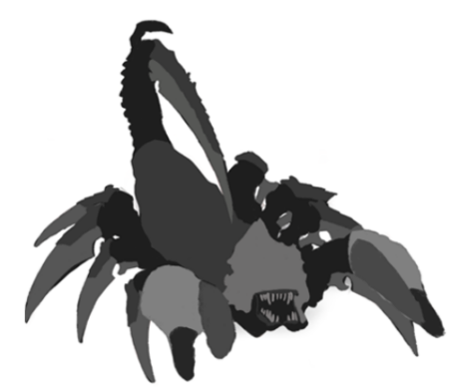 | 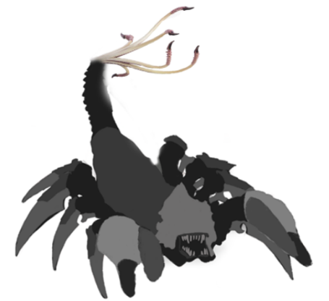
I created some rough photobash concepts to explore different limb designs for my final character. By using multiple resources, I was able to avoid getting stuck on one approach and instead, find inspiration for various iterations of my design. This approach helped me come up with different variations of limbs that I could use for my character.[7].

Colour Scheme Iterations
Colour Scheme Iteration Possibilities
Leviathan [8] | Kraken [9] | Jormungandr [10]
Primary: White  Secondary: Purple | Primary: White  Secondary: Red | Primary: Black  Secondary: Yellow
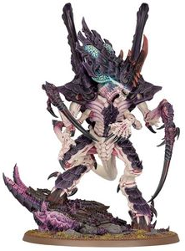 | 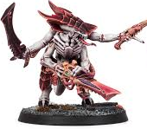 | 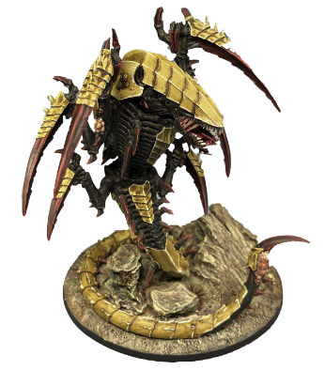
Behemoth [11] | Ouroboris [12] | Tiamet [13]
Primary: Red  Secondary: Blue | Primary: Blue  Secondary: Black | Primary: White  Secondary: Blue
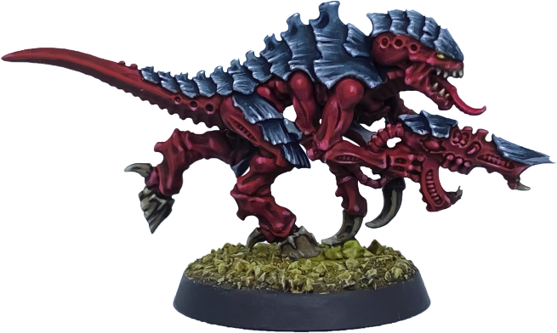 | 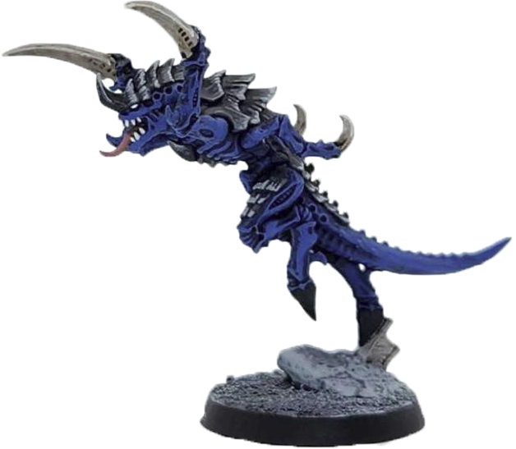 | 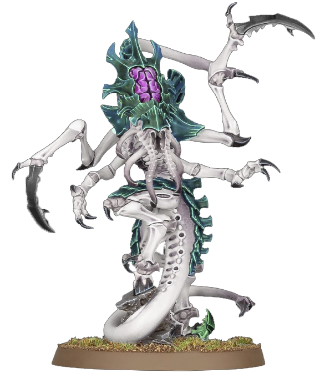
Colossus [14] | Typhon [15] | Dagon [16]
Primary: Brown  Secondary: Black | Primary: Black  Secondary: White | Primary: Black  Secondary: Red
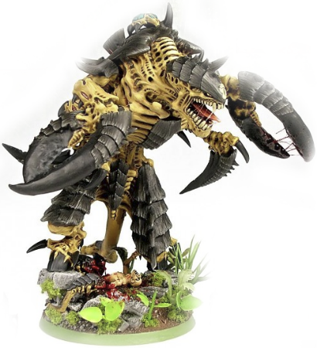 | 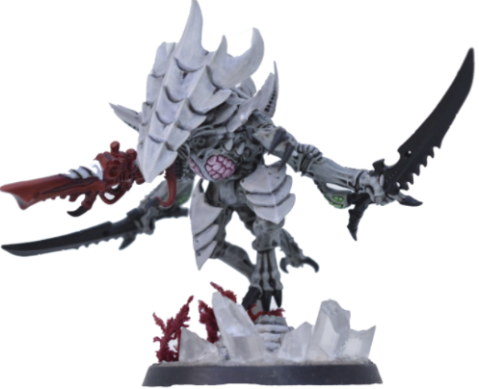 | 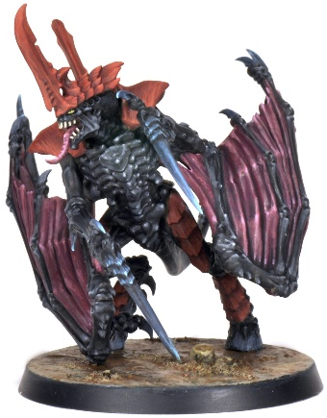
As previously stated, Warhammer 40,000 factions have sub-armies, each with their own unique colour scheme. Having different colour shcemes is important for variety but also different colours can be used for capturing attention and conveying emotion[17].

Head Iteration Ideas
Tyrant Head | Hierodule Head | Venomthrope Head
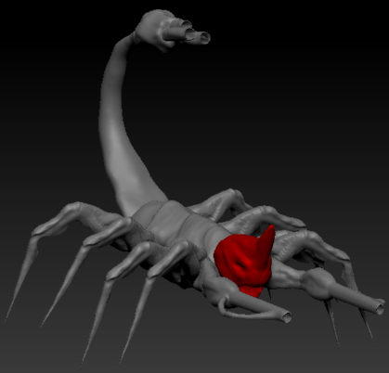 | 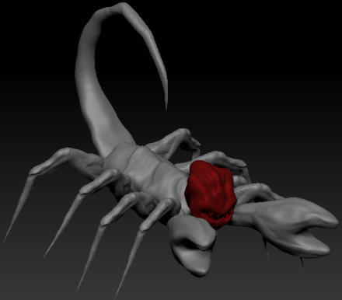 | 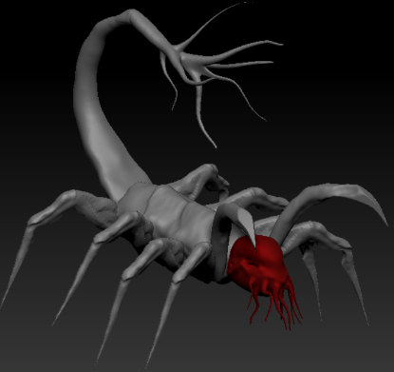
Frontal Limb Iteration Ideas
Cannon Limbs | Crushing Claw Limbs | Scythe Limbs
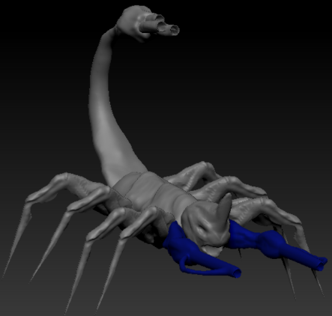 | 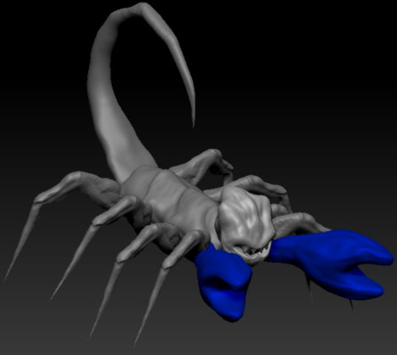 | 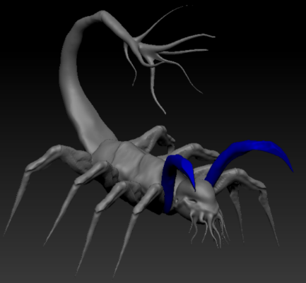
Tail Iteration Ideas
Cannon Tail | Scorpion Tail | Tentacle Tail
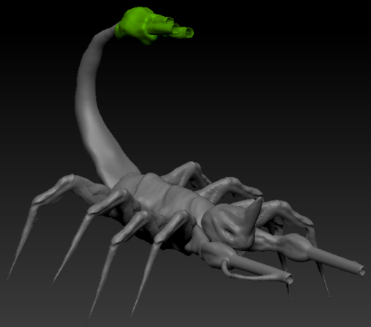 | 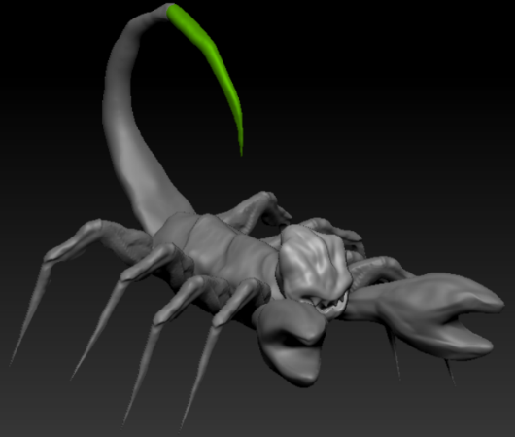 | 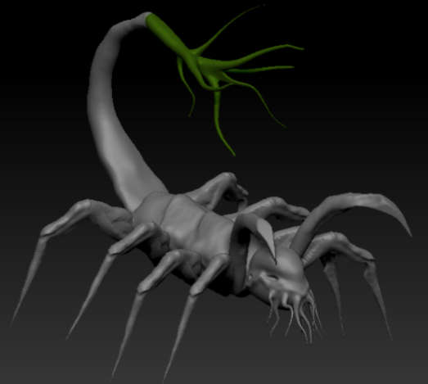
Rough block out iterrations based on the photobashed Tyranid limbs. As previosuly mentioned, Warhammer miniatures allow a variations of weapons and limbs for there characters, so in theory all of these iterations have a possibility of being used.
Block out Iterations

Orthographic Views
Front View
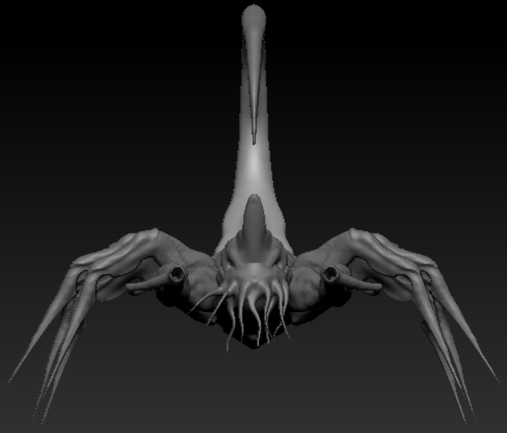

Side View
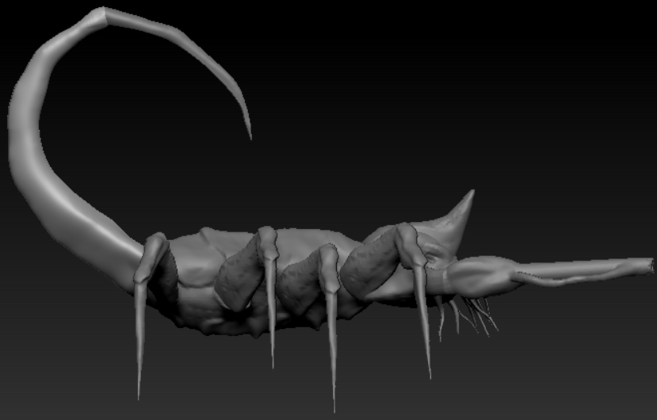

Rear View
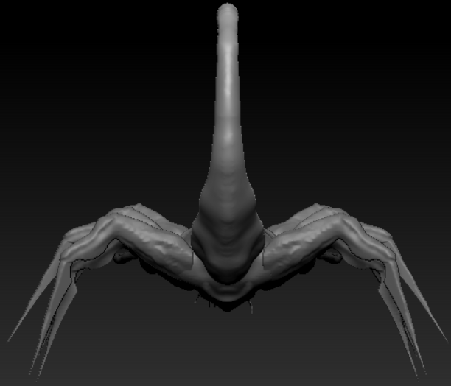

Top View
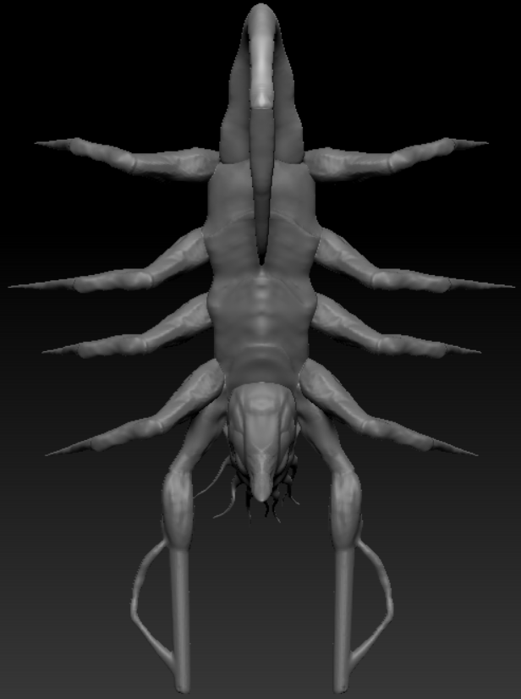
Reference images for texturing
Deathleaper – Tentacles [4] | 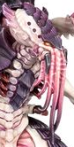
Mawloc – Tail [18] | 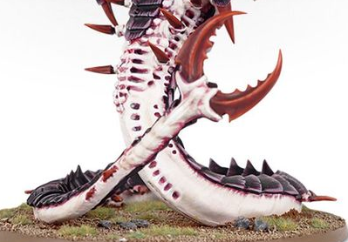
Psychophage – Carapace [19] | 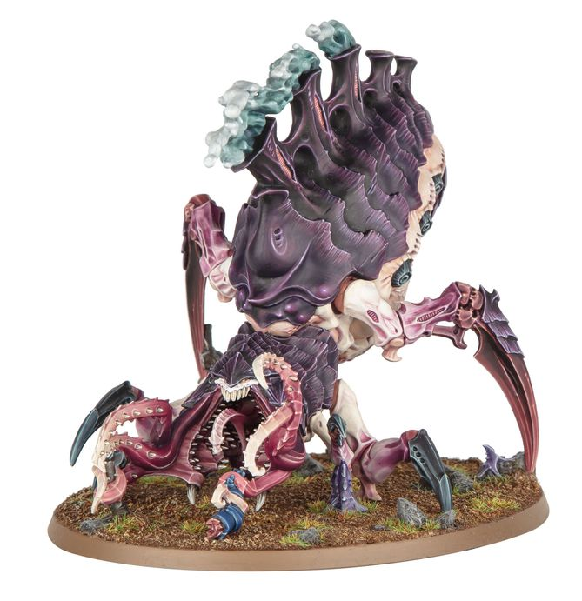
Psychophage – Scything talon [19]
Tyranid Prime – Skin [20] | 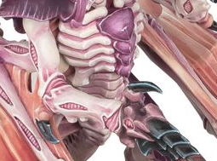

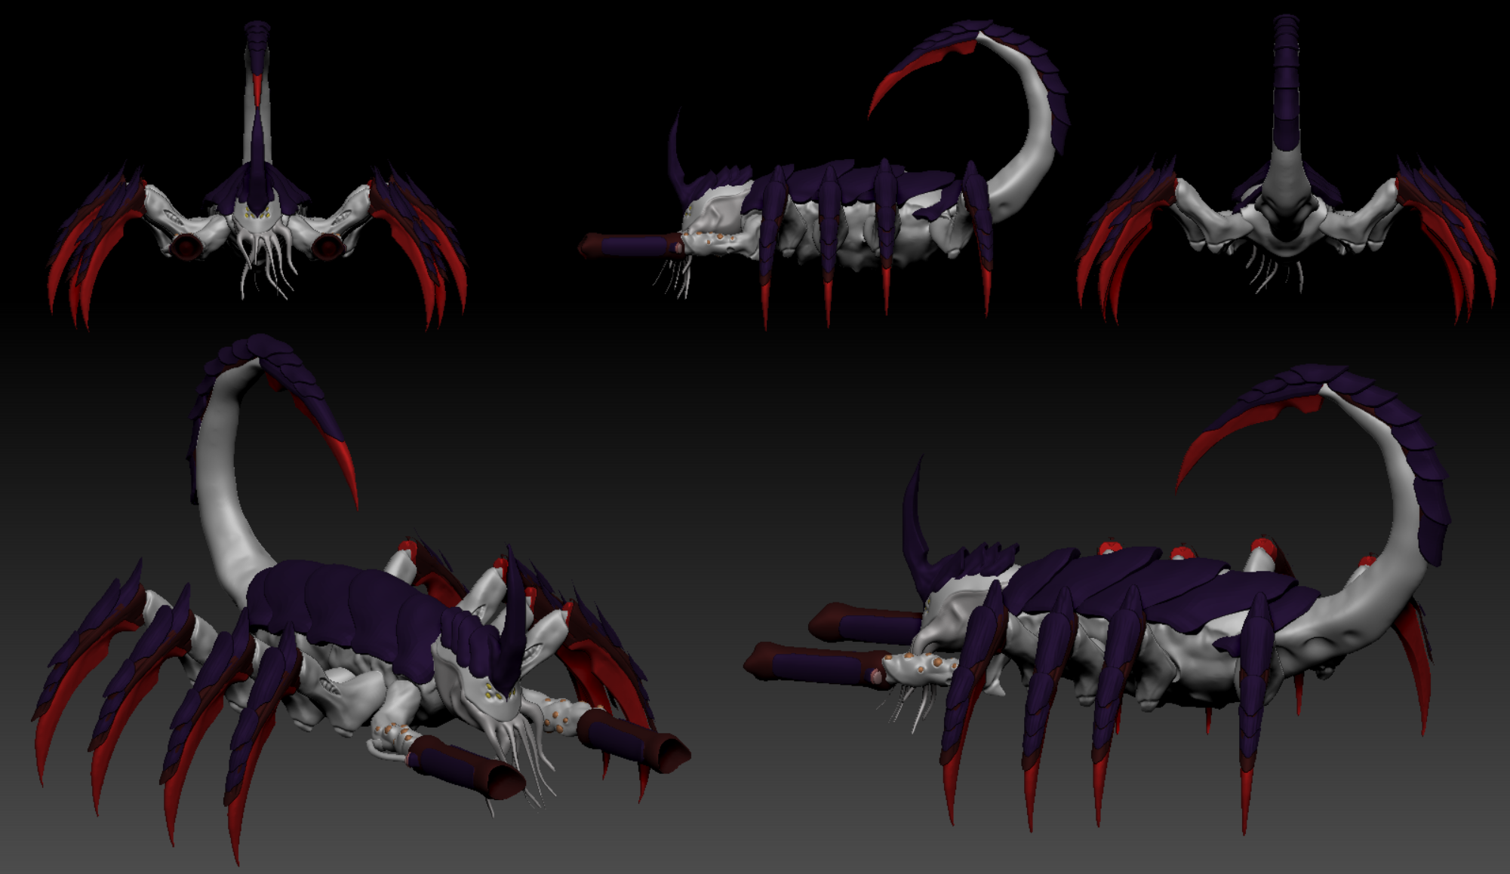
Final Design

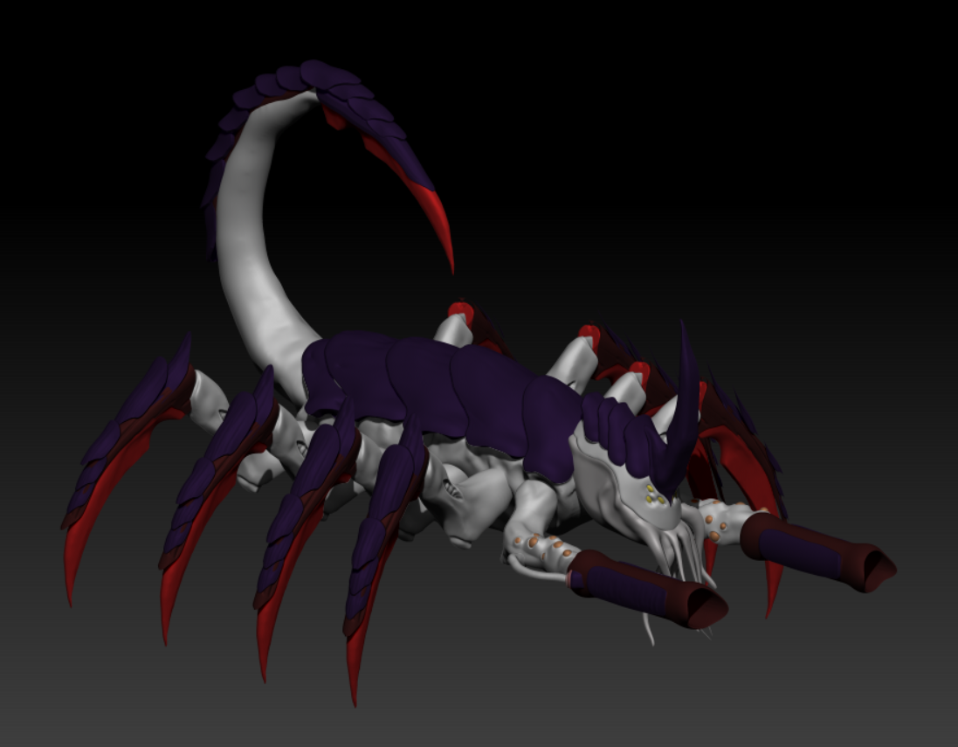
Final Design: Rendered

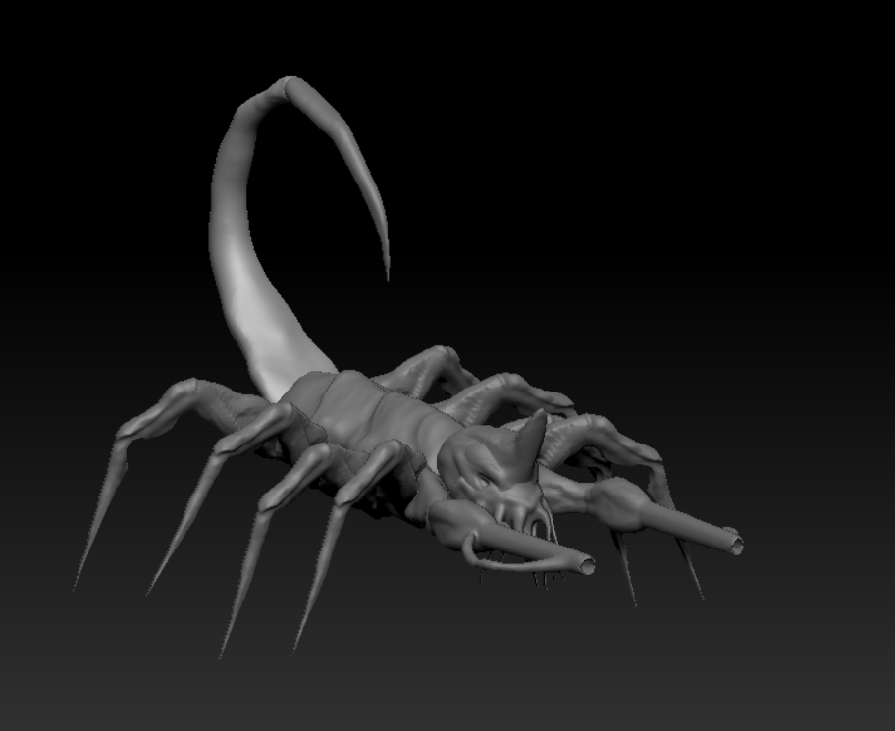
Side by Side: Block out & Final Design

Colour Variations
Hive Fleet: Leviathan  Primary: White  Secondary: Purple  Weapons: Red | 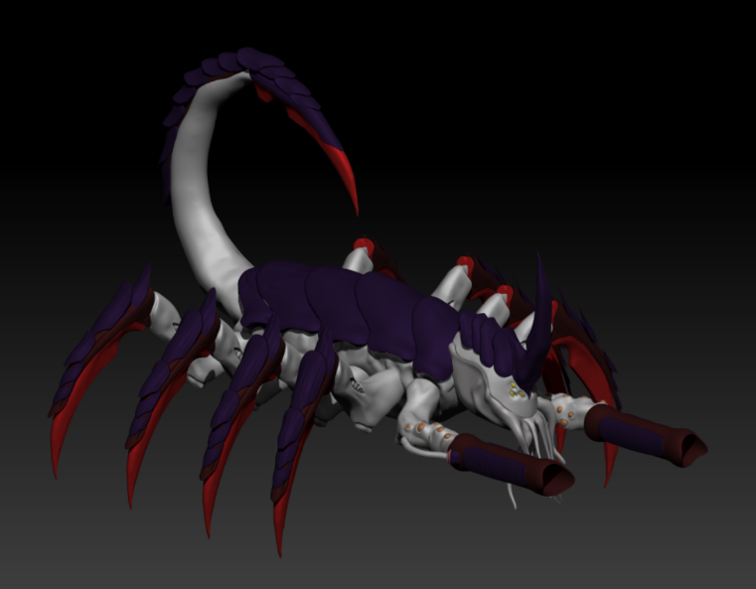
Hive Fleet: Jormungandr  Primary: Black  Secondary: Yellow  Weapons: Red | 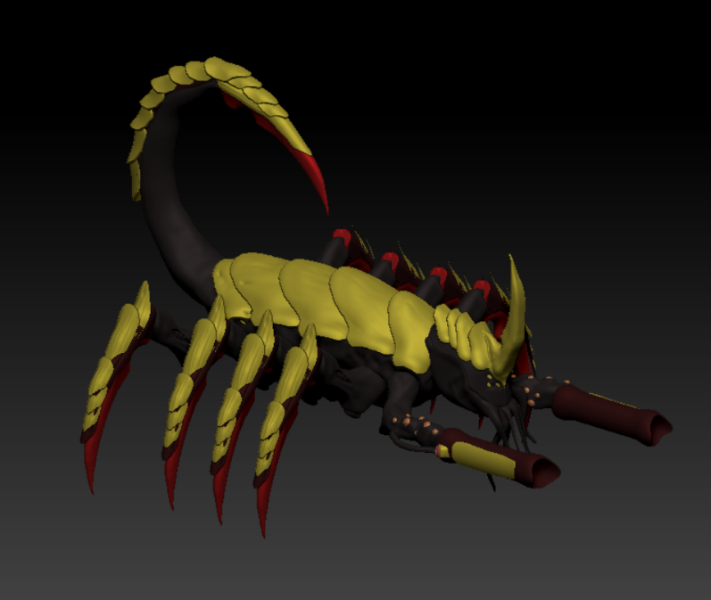
Hive Fleet: Behemoth  Primary: Red  Secondary: Blue  Weapons: Black | 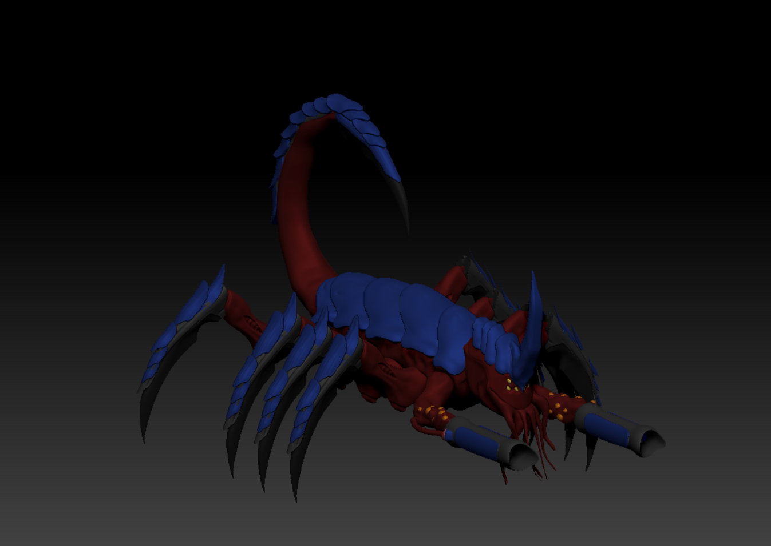

Evaluation

The two main inspirations that heavily influenced my design choices were creating a new character for the Tyranid faction in Warhammer 40,000 and basing the shape of the character on a scorpion. While creating the character, I didn't face any major challenges, but I had to keep two factors in mind. These factors were:
How can I create a unique character without straying too far from the source material?
"How can I ensure a consistent and appealing shape language without visual repetition?"
I utilised various techniques to keep my character design within the parameters of the Tyranid faction. For instance, I repurposed limbs and weapons from existing Tyranid characters while following the design process provided by Warhammer miniature designer, Jes. This process involved basing the character design on an insect, crustacean, dinosaur, etc. while also incorporating the Tyranid narrative: “We’re going to eat you, we look a bit different because we’ve bread things more that we believe might eat you more efficiently”. [21]
In terms of the character's shape language, it is evident that the character's scything claws on the tail and legs are the main focal points, similar to a scorpion. The scythes alone give the impression that this character is dangerous. To avoid repetition, I substituted the scorpion claws with cannons. This alteration not only breaks up the character but also maintains the shape of the scorpion.
By paying attention to the “Designing the new tyranids -Warhammer 40,0000” video [22], I always kept in mind the key design elements of Tyranids[23]:
-6 or more limbs, with one pair atrophied or mutated into a weapon.
-Sets of carapace plates on the forehead, number of plates depends on the size of the character.
-All Tyranid weapons look like they’re made/grown from their own biological material.
In terms of the character's shape language, it is evident that the character's scything claws on the tail and legs are the main focal points. The scythes alone give the impression that this character is dangerous. To avoid repetition, I substituted the scorpion claws with cannons. This alteration not only breaks up the character but also maintains the shape of the scorpion.
Although the primary objective of my blockout was to define the character's size and shape language, I realize that in the future, I need to spend more time on this phase to enhance the character's shape as it’ll help with the more intricate parts of the model later on. For instance, in my block out, the legs of the character were too thin, and I had to remodel them from ground up, which isn’t efficient.
It is important to note that while going through the head options for my character, I accidentally merged the "Tyrant Head" and "Venomthrope Head" iterations into a single asset. However, this turned out to be advantageous, as I believe the resulting head design is unique and fits well with my character's overall design.

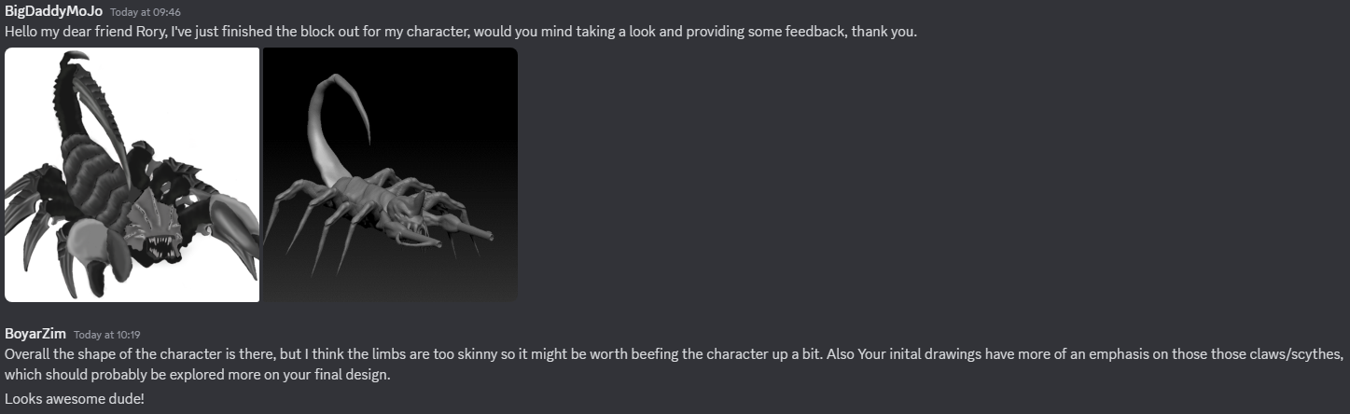
Feedback

Although I already knew that I had to make the model larger, I emphasized the scythes on the tail and legs based on this feedback.

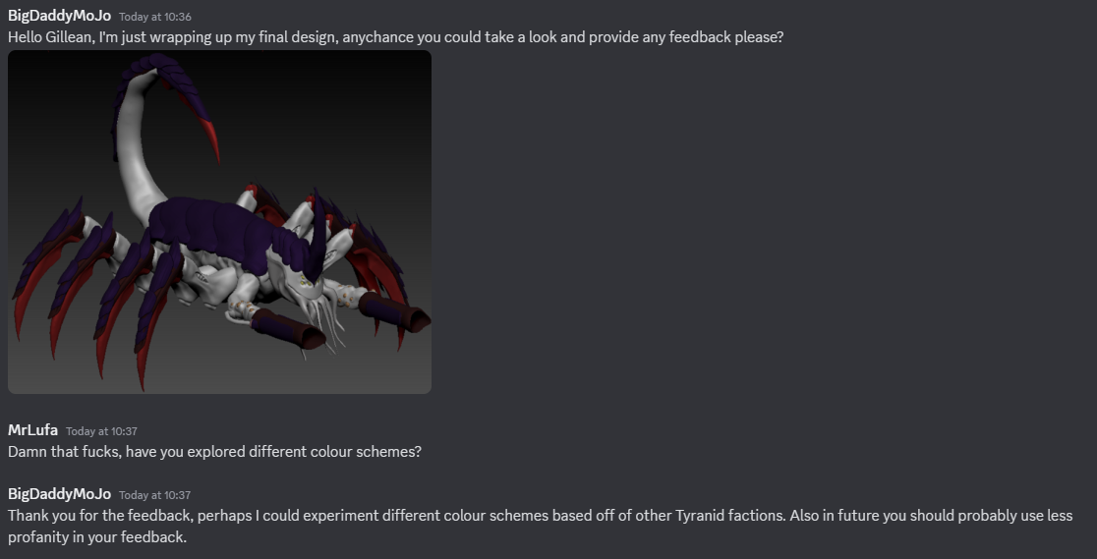
Due to this feedback, I experimented with different Tyranid color schemes that I felt best suited my character.

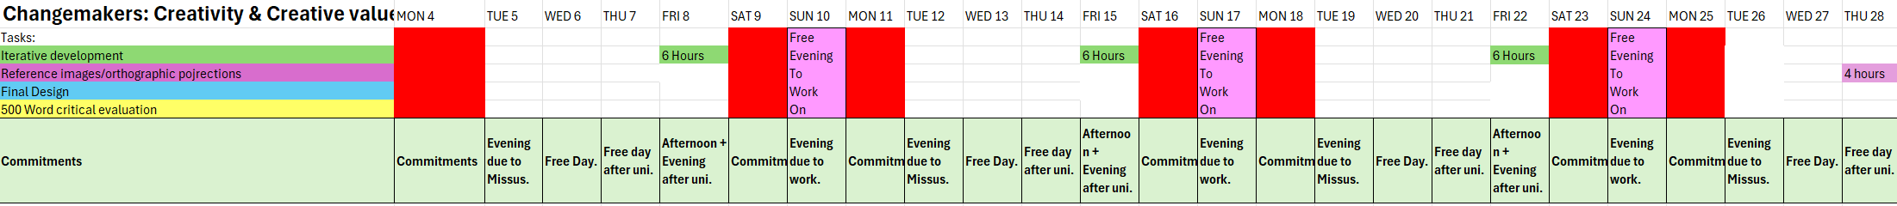
Gantt Chart

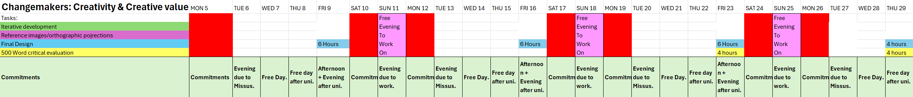

References

[1] Warhammer.com. (2022). Tyranids – Hive Tyrant. Image: “ 99120106060_HiveTyrantLead”. Available at: https://www.warhammer.com/en-GB/shop/tyranids-hive-tyrant-no-wings-2022?queryID=7633b4fe7c80a7612aa96666d80c3751
[2] Warhammer.com. (No date). Tyranids – Venomthropes. Image: “99120106057_VenomthropesLead”. Available at: https://www.warhammer.com/en-GB/shop/Venomthropes
[3] Warhammer.com. (No date). Tyranids – Tyranid Harpy. Image: “99120106024_Harpies01”. Available at: https://www.warhammer.com/en-GB/shop/Tyranid-Harpy?queryID=e760a5795d76511a2ea7ed8ca87c0c48
[4] Warhammer.com. (2023). Tyranids – Lictor. Image: “99120106069_Lictor1”. Available at: https://www.warhammer.com/en-GB/shop/tyranids-lictor-2023?queryID=0298eb84ab7195697db24642914711ed
[5] Warhammer.com. (No date). Tyranids – Exocrine. Image: “99120106056_ExocreneLead”. Available at: https://www.warhammer.com/en-GB/shop/Exocrine
[6] Warhammer.com. (No date). Tyranids – Toxicrene. Image: “99120106033_Toxicrene01”. Available at: https://www.warhammer.com/en-GB/shop/Toxicrene
[7] WPEngine.com. (2023). How to be inspired without copying someone’s work. Subheading: “Use multiple resources”, paragraph 1. Available at: https://wpengine.co.uk/resources/how-to-be-inspired-without-copying/#:~:text=Use%20multiple%20resources,to%20one%20or%20two%20sources.
[8] Warhammer.com. (2023). Tyranids – Norn Emissary. Image: “99120106064_NornEmissary1”. Available at: https://www.warhammer.com/en-GB/shop/tyranids-norn-emissary-2023?queryID=ca3bc483ca606c9b4726bc98113a2058
[9] Stahly. (2023). Showcase- Hive fleet kraken tyrranid warrior leader. Image: “Tyranids_Hivefleet_Kraken_Tyranid_Warrior_Leader_01.jpg”. Available at: https://taleofpainters.com/2024/01/showcase-hive-fleet-kraken-tyranid-warrior-leader/
[10] Get_R0wdy. (2023). Hive fleet Jormungandr – Trygon. Image: “hive-fleet-jormungandr-trygon-v0-d4fniw3tqmza1”. Available at: https://www.reddit.com/r/Tyranids/comments/13gms9h/hive_fleet_jormungandr_trygon/
[11] Pintureando. (2023). New Leviathan box Termagant – Hive fleet Behemoth. Image: “new-leviathan-box-termagant-hive-fleet-behemoth-v0-hmt9w45zwy5b1”. Available at: https://www.reddit.com/r/Warhammer40k/comments/149ac2w/new_leviathan_box_termagant_hive_fleet_behemoth/
[12] Jones, R. (2023). How to paint Hive fleet Ouroboris – TheChirurgeon’s method. Image: “TheChirurgeon_Ouroboris_Tyranids-1024x704”. Available at: https://www.goonhammer.com/how-to-paint-hive-fleet-ouroboris-thechirurgeons-method/

[13] miniaturemachinations. (2023). Instagram – Hive fleet Tiamet Neurolictor photoshop mock-up!. Image: “Miniature Machinations _ Hive Fleet Tiamet Neurolictor Photoshop Mock-up! I was asked to mock-up some color swaps for anyone looking to buy and paint up these new… _ Instagram”. Available at: https://www.instagram.com/miniaturemachinations/p/Cu5bheeO5kR/
[14] Martinez, P. (2016). Making bad 40k characters good. Image: “HiveFleetColossus-OldOneEyea.jpg_2-300x300”. Available at: https://www.belloflostsouls.net/2016/05/making-bad-40k-characters-good.html
[15] Cottel, C. (No date). Pinterest – Emperor. Image: “pin-720505640376011406”. Available at: https://www.pinterest.co.uk/pin/720505640376011406/
[16] Charlie, B. (2023). Fury of the storm: 40K co-op developer diary #1. Image: “2099AB2D-0128-4A73-94A0-883C8A3AF4DC-1024x934”. Available at: https://www.goonhammer.com/fury-of-the-swarm-40k-co-op-developer-diary-1/
[17] Glasgowcreative.co.uk. (2021). Why colour scheme is so important when branding your business. Subheading “Colour association”, paragraph 1. Available at: https://www.glasgowcreative.co.uk/blog/why-colour-scheme-is-important-branding-business/
[18] Warhammer.com. (No date). Tyranids – Mawloc. Image: “99120106019_MawlocNEW01”. Available at: https://www.warhammer.com/en-GB/shop/Tyranid-Mawloc?queryID=b0c9a167d9d9a993104339ab3357cb85
[19] Warhammer.com (2023). Tyranids – Psychophage. Image: “99120106074_Psychophage1”. Available at: https://www.warhammer.com/en-GB/shop/tyranids-psychophage-2023
[20] Warhammer.com. (2023). Tyranids – Tyranid Prime. Image: “99120106075_Prime1”. Available at: https://www.warhammer.com/en-GB/shop/tyranids-prime-2023?queryID=91a3d8fc999966299d17f2598448e77d
[21] Youtube.com. (2023). Warhammer – Designing the new tyranids – Warhammer 40,000. Time stamp:01:32 – 01:53. Available at: https://www.youtube.com/watch?v=TRT3Hl88goU
[22] Youtube.com. (2023). Warhammer – Designing the new tyranids – Warhammer 40,000. Full Video “Designing the new tyranids – Warhammer 40,00”. Available at: https://www.youtube.com/watch?v=TRT3Hl88goU
[23] Youtube.com. (2023). Warhammer – Designing the new tyranids – Warhammer 40,000. Time stamp:00:33 – 01:02. Available at: https://www.youtube.com/watch?v=TRT3Hl88goU

Bibliography
Books
Warhammer Design Studio. Warhammer 40,000 – Codex: Tyranids. 9th edition. Nottingham: Games Workshop 2022.
Warhammer Design Studio. Warhammer 40,000 – Codex: Tyranids. 10th edition. Nottingham: Games Workshop 2023.
Bishop, R. Boo, R. Cruz, M, R. Gadea, L. Fundamentals of character design: How to create engaging characters for illustration, animation & visual development. Worcester: 3DTotal Publihsing 2022.
Websites
Games Workshop. (No date). Warhammer.com. Available at: https://www.warhammer.com/en-GB/home
Games Workshop LTD. (2023). Starting a Tyranids Army in Warhammer 40,000 – Everything You Need To Know From Painting to Lore. Available at: https://www.warhammer-community.com/2023/09/08/starting-a-tyranids-army-in-warhammer-40000-everything-you-need-to-know-from-painting-to-lore/
Masterclass.com. (2021). How to design a character: 6 tips for designing characters. Available at: https://www.masterclass.com/articles/how-to-design-a-character
Levanier, J. (2021). How to design a character: the ultimate guide to character design. Available at: https://99designs.com/blog/art-illustration/character-design/
Images
Warhammer.com. (2022). Tyranids – Hive Tyrant. Image: “ 99120106060_HiveTyrantLead”. Available at: https://www.warhammer.com/en-GB/shop/tyranids-hive-tyrant-no-wings-2022?queryID=7633b4fe7c80a7612aa96666d80c3751
Warhammer.com. (No date). Tyranids – Venomthropes. Image: “99120106057_VenomthropesLead”. Available at: https://www.warhammer.com/en-GB/shop/Venomthropes
Warhammer.com. (No date). Tyranids – Tyranid Harpy. Image: “99120106024_Harpies01”. Available at: https://www.warhammer.com/en-GB/shop/Tyranid-Harpy?queryID=e760a5795d76511a2ea7ed8ca87c0c48
Warhammer.com. (2023). Tyranids – Lictor. Image: “99120106069_Lictor1”. Available at: https://www.warhammer.com/en-GB/shop/tyranids-lictor-2023?queryID=0298eb84ab7195697db24642914711ed
Warhammer.com. (No date). Tyranids – Exocrine. Image: “99120106056_ExocreneLead”. Available at: https://www.warhammer.com/en-GB/shop/Exocrine
Warhammer.com. (No date). Tyranids – Toxicrene. Image: “99120106033_Toxicrene01”. Available at: https://www.warhammer.com/en-GB/shop/Toxicrene
Warhammer.com. (2023). Tyranids – Norn Emissary. Image: “99120106064_NornEmissary1”. Available at: https://www.warhammer.com/en-GB/shop/tyranids-norn-emissary-2023?queryID=ca3bc483ca606c9b4726bc98113a2058
Stahly. (2023). Showcase- Hive fleet kraken tyrranid warrior leader. Image: “Tyranids_Hivefleet_Kraken_Tyranid_Warrior_Leader_01.jpg”. Available at: https://taleofpainters.com/2024/01/showcase-hive-fleet-kraken-tyranid-warrior-leader/
Get_R0wdy. (2023). Hive fleet Jormungandr – Trygon. Image: “hive-fleet-jormungandr-trygon-v0-d4fniw3tqmza1”. Available at: https://www.reddit.com/r/Tyranids/comments/13gms9h/hive_fleet_jormungandr_trygon/
Pintureando. (2023). New Leviathan box Termagant – Hive fleet Behemoth. Image: “new-leviathan-box-termagant-hive-fleet-behemoth-v0-hmt9w45zwy5b1”. Available at: https://www.reddit.com/r/Warhammer40k/comments/149ac2w/new_leviathan_box_termagant_hive_fleet_behemoth/
Jones, R. (2023). How to paint Hive fleet Ouroboris – TheChirurgeon’s method. Image: “TheChirurgeon_Ouroboris_Tyranids-1024x704”. Available at: https://www.goonhammer.com/how-to-paint-hive-fleet-ouroboris-thechirurgeons-method/
miniaturemachinations. (2023). Instagram – Hive fleet Tiamet Neurolictor photoshop mock-up!. Image: “Miniature Machinations _ Hive Fleet Tiamet Neurolictor Photoshop Mock-up! I was asked to mock-up some color swaps for anyone looking to buy and paint up these new… _ Instagram”. Available at: https://www.instagram.com/miniaturemachinations/p/Cu5bheeO5kR/
Martinez, P. (2016). Making bad 40k characters good. Image: “HiveFleetColossus-OldOneEyea.jpg_2-300x300”. Available at: https://www.belloflostsouls.net/2016/05/making-bad-40k-characters-good.html
Cottel, C. (No date). Pinterest – Emperor. Image: “pin-720505640376011406”. Available at: https://www.pinterest.co.uk/pin/720505640376011406/
Charlie, B. (2023). Fury of the storm: 40K co-op developer diary #1. Image: “2099AB2D-0128-4A73-94A0-883C8A3AF4DC-1024x934”. Available at: https://www.goonhammer.com/fury-of-the-swarm-40k-co-op-developer-diary-1/
Warhammer.com. (No date). Tyranids – Mawloc. Image: “99120106019_MawlocNEW01”. Available at: https://www.warhammer.com/en-GB/shop/Tyranid-Mawloc?queryID=b0c9a167d9d9a993104339ab3357cb85
Warhammer.com (2023). Tyranids – Psychophage. Image: “99120106074_Psychophage1”. Available at: https://www.warhammer.com/en-GB/shop/tyranids-psychophage-2023
Warhammer.com. (2023). Tyranids – Tyranid Prime. Image: “99120106075_Prime1”. Available at: https://www.warhammer.com/en-GB/shop/tyranids-prime-2023?queryID=91a3d8fc999966299d17f2598448e77d

Videos
Youtube.com. (2023). Warhammer – Designing the new tyranids – Warhammer 40,000. Available at: https://www.youtube.com/watch?v=TRT3Hl88goU
Filmscomicexplained. (2024). The Tyranids (Bio-mechnical world eaters) Warhammer 40k lore. Available at: https://www.youtube.com/watch?v=c0v72no_QY0

