Theo Tiencken

Theo TIENCKEN, 2534156, Computer architecture and operating systems, computer Networking and Cybersecurity

Table of contents

Table of contents 1
Introduction 2
Key functions Of A General Purpose operating System 2
Process management 2
Memory management. 2
Error handling 3
User Interface 4
File management 5
Use of Windows OS CLI Commands 5
File and Directory Management 5
Process management 7
Network Testing and monitoring 8
Use of Linux CLI Commands 10
Process Management 10
File and Directory Management 11
Network Testing and monitoring 12
Use of Windows OS Scripts 13
Use of Linux OS Scripts 15
Conclusion 16
References 17
Appendix 1 18
Appendix 2 Photos of Online course engagement 20

Introduction

In this report I will document and explain my understanding of a general purpose operating system and its key functions. I will also provide several screenshots of where the different functions can be found. Also, I will be showcasing my use of Linux and windows Command Line Interfaces (CLI) as well as bash and batch scripts.

Key functions Of A General Purpose operating System

The key functions of a General Purpose Operating system (OS) are Process Management, Device Management, Memory Management , File management and Security[1] . Other key areas of an OS include User Interfaces , networking and Error handling [2].
Process management is when the OS controls the execution of programs and allocates system resources to tasks that the OS has created and terminated. The Operating system ensures that resources are shared equally between all tasks.[3] Specialized programs order and switch between different processes. There are a few tools at your disposal to monitor process management. The below photo shows Task manager a tool which monitors different processes currently running.
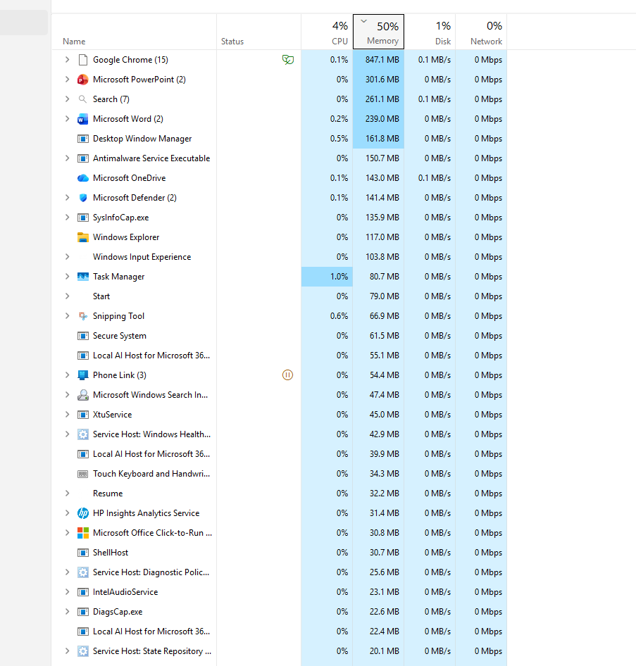
Figure 1 [A list of currently running tasks in Task manager]

Memory management. The OS controls how much memory a single process has access to since a CPU has many processes open simultaneously each competing for the same resources[2]. The OS allocates then de-allocates memory upon process start up and process termination [4]. Resourse Monitor is a tool that you can use to check memory management. Below are two photos from recourse monitor showing memory. 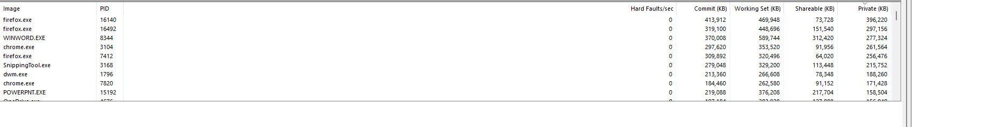
Figure 2 [ shows memory allocation in terxt form in resource manager]

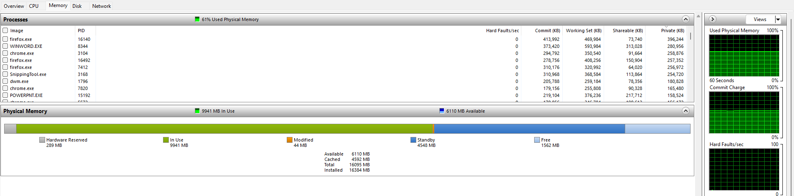
Figure 3 [ Shows a more in depth view of memory management ]

Error handling. The O.S handles errors by constantly scanning Hardware and software for processes that are behaving strangely or are unable to be completed due to a fault[1]. The OS will also scan for Interrupt requests that demand the processors attention, drawing awareness to issues[5]. You can use the Event viewer tool to monitor as a user for faults that the OS has detected.
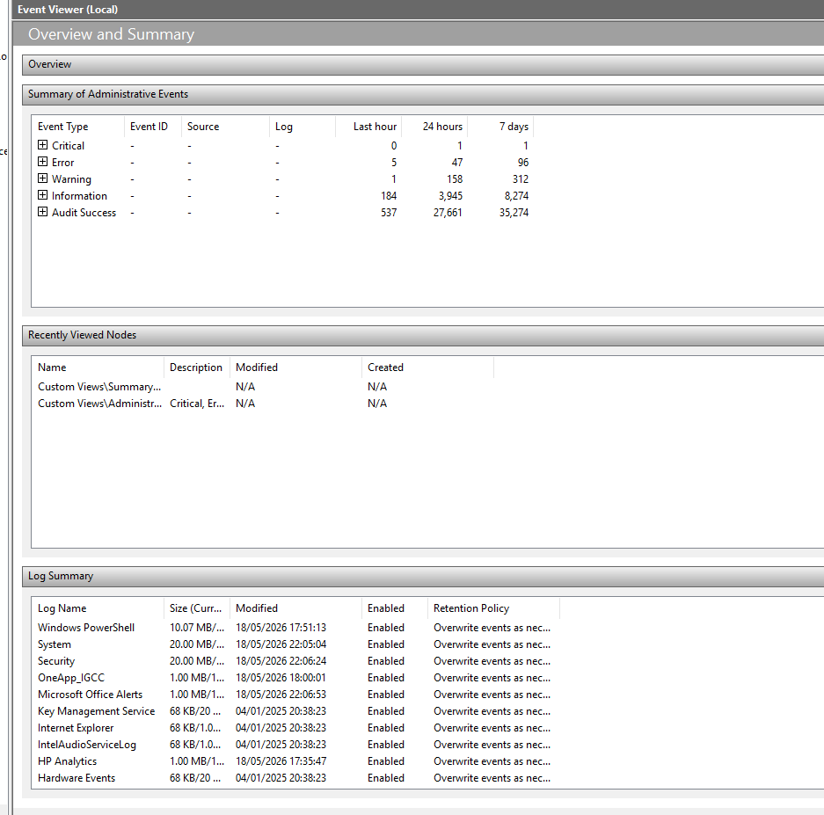
Figure 4 [shows a list of events in event viewer]

User Interface.
Perhaps the one most people are familiar with as the OS operates either the command line interface (CLI) or a graphic user interface (GUI)[6][2] these act as the middleman between the user and the hardware of the computer. The OS interprets the actions of a user e.g. a mouse movement, typing of a keyboard or auditory input then translates it into something the hardware can interpret[3]. A user can use either a CLI or a GUI to interface with the OS. Below are two photos one a CLI and the other a GUI.
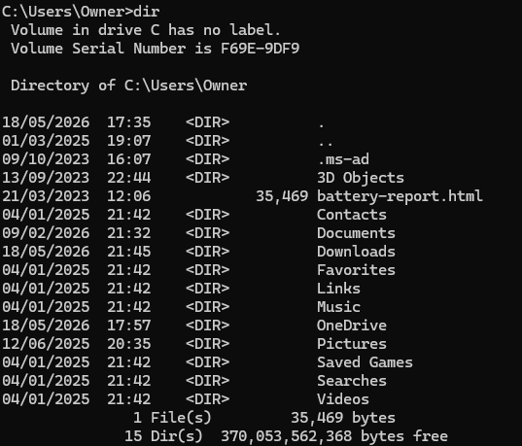
Figure 5 [ Shows the CLI command prompt (Microsoft )]
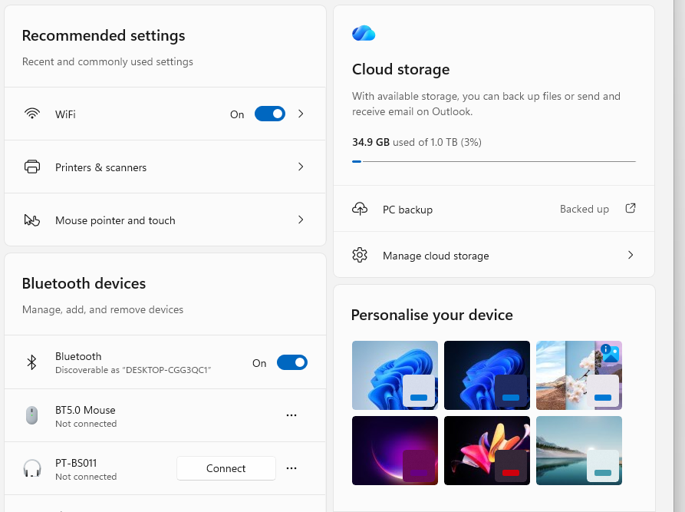

Fig 6[ shows windows settings a GUI]
File management
Finally, another function the OS does is file management[6]. The OS manages files that are frequently accessed and sorts them into directories[3] . The OS organizes files into a logical structure and assigns metadata to them[3][3. 1. 3] . The base directory is known as the root directory which can then be divided into further directories with user input. 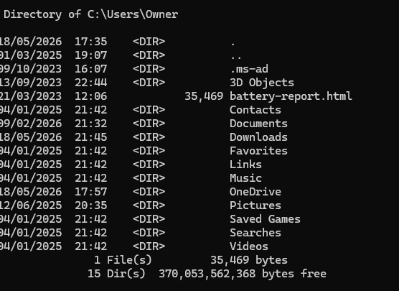
Fig 5 [ shows the organization of files using the dir command]

Use of Windows OS CLI Commands

File and Directory Management

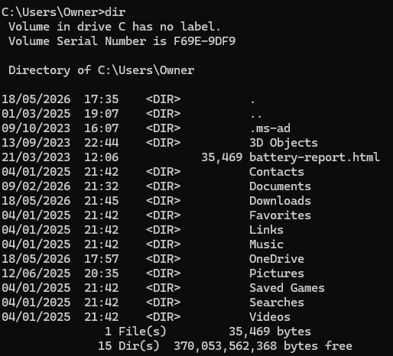
Using the Dir command I have been able to retrieve a list of all current directories in the computer[7]. This has given me a clear list of all available directories in the computer so that a user can manage files by moving them between different directories.
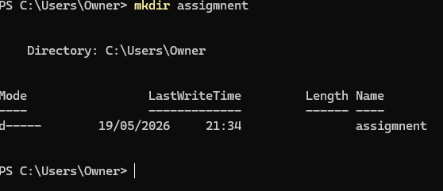
Using the mkdir command I have created a directory called assignment which I can use to put my files in related to the assignment[8]. The mkdir command is used to further divide directories ensuring your files are easy to navigate to by using a tree structure called paths to follow down to retrieve files[8].

Process management

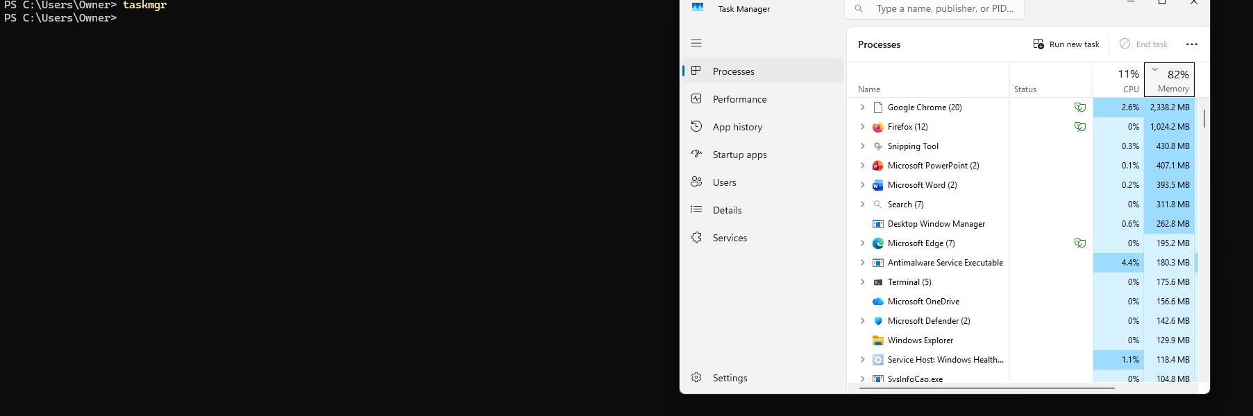
Using the taskmgr command I was able to open task manager. Windows task manager is used to see what processes are currently being run and how many systems recources its using[9].
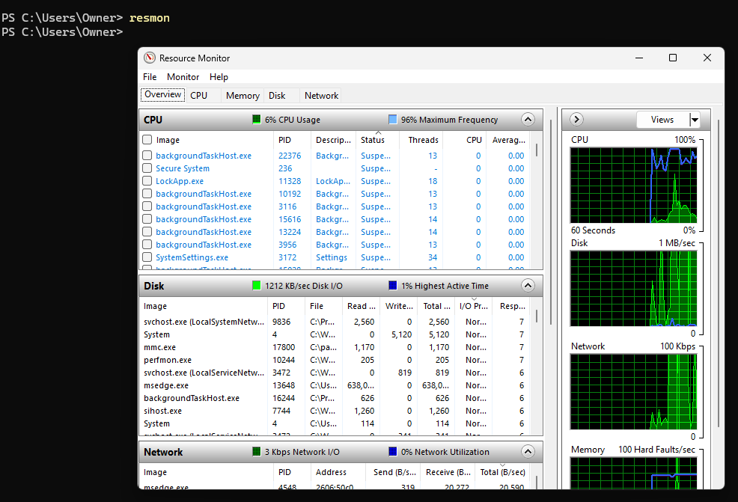
Using the resmon command I was able to get recourse monitor which is another tool to see how different recourses are being used. Recourse Monitor is used to check the CPU, HDDS and network recourses.[10].

Network Testing and monitoring
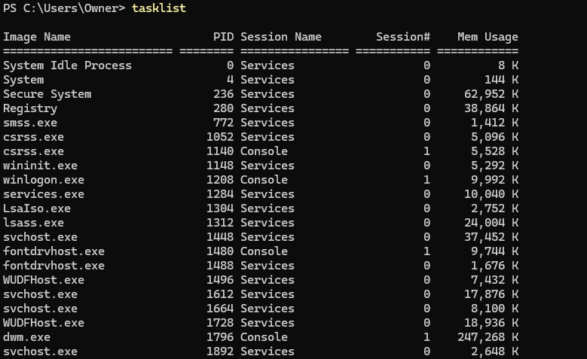
Using the tasklist command I was able to get a list of the currently running processes and their ids. This is used to check for any strange behaving processes[11].
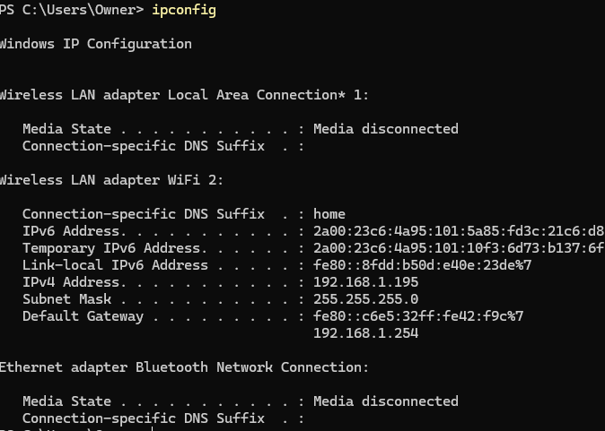
Using the Ipconfig command you can clearly see the the address of the machine which is used by routers for the purposes of identification on the internet.
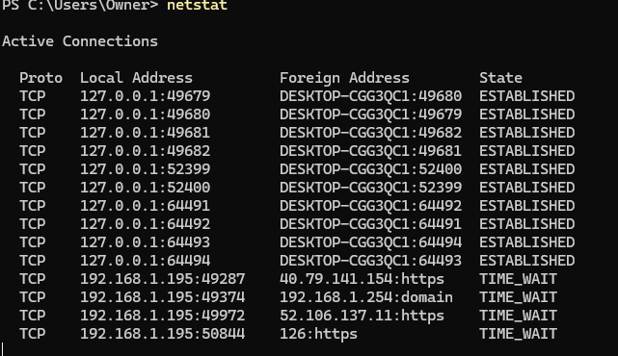
Using the netstat command which tells you which ports are listening.
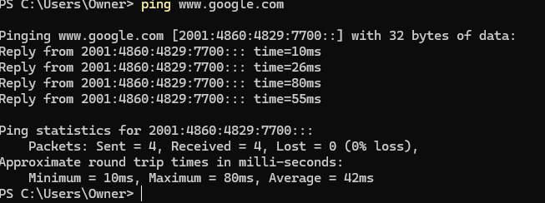
Using the Ping command I was able to get a response time between the computer and a specific website in this case google to establish if there was any delay between the device and the website[10]

Use of Linux CLI Commands

Process Management
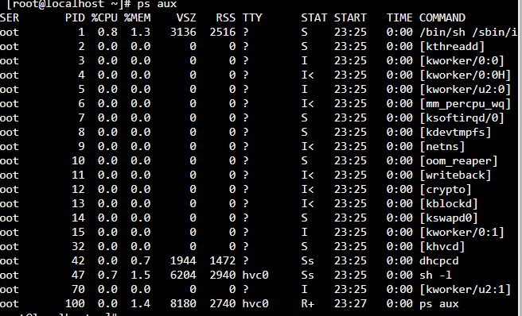
Using the ps aux command I was able to retrieve a list of currently running processes in Linux along with their ids[12]. This can be used to look for any faulty processes or ones that are not behaving correctly.
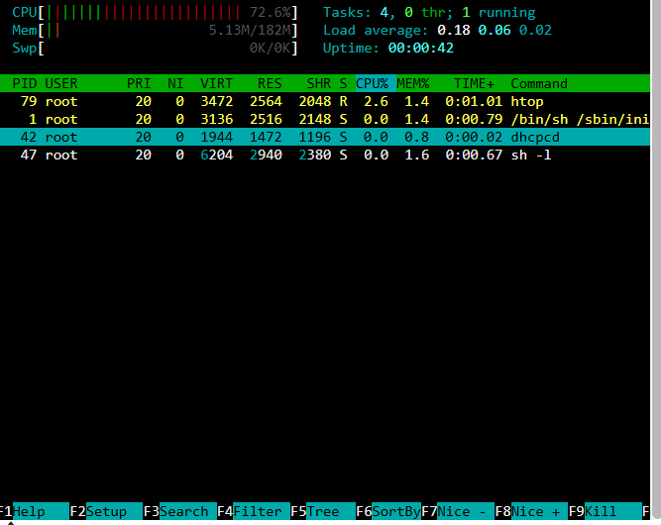
Using the htop command. This displays a more visual representation of the processes and show cpu load as well as memory usage. This is much more intuitive [13][14].

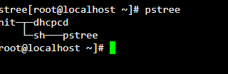
The command pstree [12] was used this shows how processes are running in a logical tree like structure[13]. This can help to further distinguish how processes are being managed by categorizing them based on how much they are using

File and Directory Management

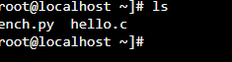
The ls command was used[13] this command gives a list for all current files in a directory. This is useful since it shows you an easy to understand list of all working files.
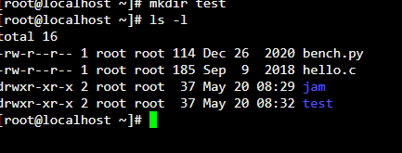
Using the mkdir [13] command I was able to create a directory as you can see the test directory shows after the ls-l command in a list of all directories currently available.
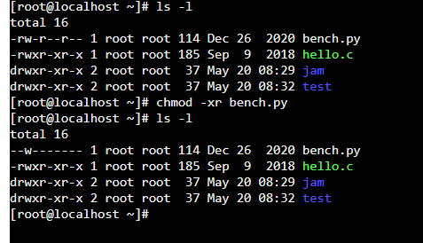
Using chmod -xr I was able to change the read/write permissions of the file bench.py [15]
In the top part it has all permissions enabled but after using chmod -xr it only has write permissions. This can be used to enable or disable certain users from making changes to files[13][13. 13. 15].

Network Testing and monitoring
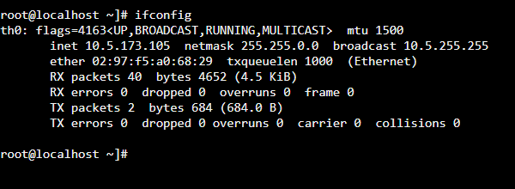
Ifconfig allows you to check the ip address of the device as well as other information which you may need to look at for troubleshooting purposes to see if there are any issues or it is not behaving as expected[13].
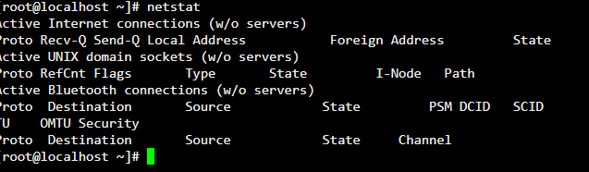
The netstat command was used to show a list of currently running network connections and interface statistics such as Bluetooth connections in relationship to the device[15].
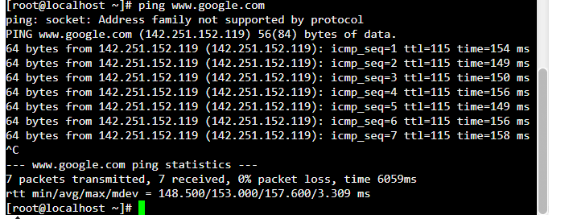
The Ping command was used to ping ww.google.com. Ping allows the user to receive packet information in regards to how long it takes to communicate to it as well as any data loss[14].

Use of Windows OS Scripts

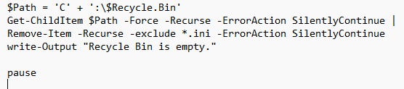
The above photo shows a script for emptying the recycle bin of a computer. The variables which is a string preceded by a $ e.g. $Recycle.Bin is the variable recycle bin[16]. Variables are used to assign a value to something[17]. Get -Childitem is being used to retrieve everything in the recycle.bin. Then the write-output is used to see that the recycle bin is empty.
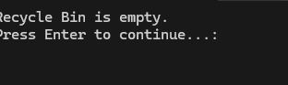
Here is the output from the above code showing that the recycle bin is empty and that it has succeeded in the task.

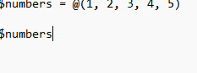
The above code is a simple array[18] . An Array is a group of variables[17] that are similar . In this array the variables are numbers which the @ symbol is stating that the numbers inside the bracket are an array.
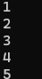
Here is the output of the code as here we can see that the numbers have been listed and they have been outputted into the CLI
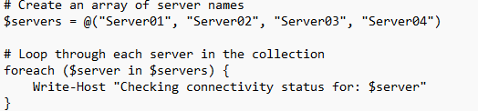
The above code shows an array being created with the variables for servers[17. 17. 18].
The next part demonstrates a Loop. The Foreach loop will for every server in the array it will check for connectivity in the server. This will be used for troubleshooting purposes if the servers are not connected because there is a problem[19].
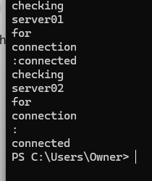
Here is the output for the code. Where the server status has scome back as connected,
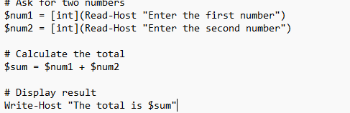
This shows a user prompt where the code is asking the end user to provide two numbers which will then be added together. The end result will then be displayed [20]
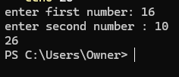
The above screenshot shows the output of the code with the user putting in both numbers then the output of the added sums.

Use of Linux OS Scripts
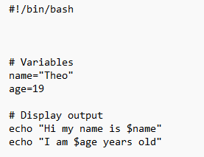
This Bash script file shows the creation of variables [21]which are used to assign meaning to a piece of data in a script as well as also be changed aswell. Then the output is displayed.
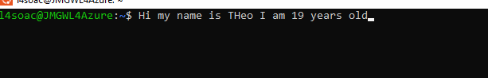
This shows the output of the code here we can see it has echoed out the text and also the variables aswell
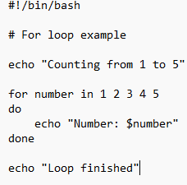
This piece of code shows a forloop. The loop allows you to automate repetitive or to repeat lines of code in the above example the loop is listing the numbers from 1 to 5 then when the loop is finished it echoes out loop finished to show it has finished the loop.[22].

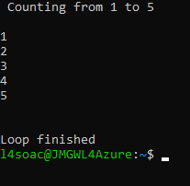
Here is the output for the above code. Here we can see the echoed commands and that the loop has terminated.
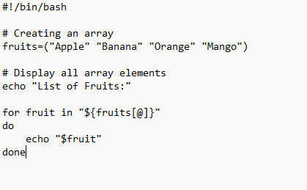
This code shows an arrays are used to group variables together or to list them. In this code the array has a range of fruits as the variable[23]. This helps to keep code clutter free and provide an easy way to access variables in code.

Conclusion

In conclusion an operating system is an essential part of a computer responsible for many tasks that without it would make the computer inoperable. [3] Operating systems key main functions are too interface with the user through a GUI[1] or a CLI. This makes sure that Hardware components can talk to the user in an understandable manner.
Operating systems also are responsible for managing files through directories and sub directories [8], managing memory through applications such as perfmon and managing current programs through task manager.[3] [2] . Operating systems also prevent errors by ensuring CPU resources are shared equally between all processes that are active and ensuring no process takes resources from the others.
Windows Powershell and os scripting language allow you to easily monitor your device through the CLI and check for any errors that might exist[2. 2. 10]. Powershell commands allow for novice coders to have unparalleled ability to engage with there devices on a deeper level by utilising near English code.[11]

While Linux Ubuntu may be more powerful than windows Powershell and allow for more customization in how you apply code [14. 14. 15. 13. 14. 15] being a Windows user I found it harder to learn since it was much different to what I am used to.
Functionally they are both very similar sharing many key syntax areas and similar code layouts I found windows powershell to be the better one.

References
References
[1] GeeksforGeeks. "Functions of Operating System." Accessed: May 18 2026. [Online]. Available: https://www.geeksforgeeks.org/operating-systems/functions-of-operating-system/
[2] Lenovo. "Operating System: What is an Operating System and How Does it Work? | Lenovo UK." Lenovo. Accessed: May 18 2026. [Online]. Available: https://www.lenovo.com/gb/en/glossary/operating-system/
[3] BBC. "Operating systems." BBC. Accessed: 18/05/26[Online]. Available: https://www.bbc.co.uk/bitesize/guides/zkrr97h/revision/10
[4] C. A. R. dos Santos and R. Matias, "Failure patterns in operating systems: An exploratory and observational study," Journal of Systems and Software. vol. 137, pp.512–530, -03-01 2018, doi: 10.1016/j.jss.2017.03.058. Accessed: May 18, 2026. Available at: https://www.sciencedirect.com/science/article/pii/S0164121217300675.
[5] S. S. Smalley Ian. "What is an Operating System? | IBM." Accessed: May 18 2026. [Online]. Available: https://www.ibm.com/think/topics/operating-systems
[6] GeeksforGeeks. "Basics of Batch Scripting." GeeksforGeeks.org. Accessed: May 19 2026. [Online]. Available: https://www.geeksforgeeks.org/linux-unix/basics-of-batch-scripting/
[7] S. Henry-Stocker, "Creating a directory tree with a single command: The mkdir command can create not just a directory but also a complex directory structure if you ask in the right way," 2023,
[8] "Keep Windows Task Manager Running But Hidden," 2011,
[9] Vukasinovic Mladen, "Fig 6. Command tasklist show process ID, sessions for each running process." researchgate.net, Accessed: May 19, 20262026. [Online]. Available: https://www.researchgate.net/figure/Command-tasklist-show-process-ID-sessions-for-each-running-process_fig5_373829346
[10] "Linux Process Management Command Cheat Sheet." Accessed: May 19 2026. [Online]. Available: https://www.geeksforgeeks.org/linux-unix/linux-process-management-command-cheat-sheet/
[11] E. Siever and E. Siever,Linux : in a nutshell, 6th Ed. Beijing ;: O'Reilly, 2009.
[12] "PowerShell | Variables." Accessed: May 20 2026. [Online]. Available: https://www.codecademy.com/resources/docs/powershell/variables
[13] Lenovo. "Array: Learn Why You Should Use Arrays in Your Programs | Lenovo UK." lenovo.com. Accessed: May 20 2026. [Online]. Available: https://www.lenovo.com/gb/en/glossary/array/
[14] b. d. foy. "Perl foreach loops." Accessed: May 20 2026. [Online]. Available: https://www.perl.com/article/perl-foreach-loops/
[15] S. Rajack."How to Prompt for Input in PowerShell?" SharePoint Diary. (-10-082021). Accessed: May 20, 20262026, [Blog]. Available at: https://www.sharepointdiary.com/2021/10/prompt-for-input-in-powershell.html
[16] "Bash Variables." Accessed: May 20 2026. [Online]. Available: https://www.w3schools.com/bash/bash_variables.php
[17] D. Panovski. "Bash For Loop: Syntax and Examples." Accessed: May 20 2026. [Online]. Available: https://linuxize.com/post/bash-for-loop/
[18] "Bash Arrays." Accessed: May 20 2026. [Online]. Available: https://www.w3schools.com/bash/bash_arrays.php

Appendix 1
Lecture answears
O.S lecture activity log

Q1} What is an operating system?
An operating system is core software that runs on a computer/device that then manages all the devices software and hardware recourses. The O.S acts as the intermediary between hardware, apps and the user presenting it in an easy to understand manner.

Q2} What does an operating system do?
An operating system controls and manages all of a computers/devices essential functions. It controls hardware, runs apps, organises files and manages how much recourses like processing power and memory to an app. This keeps the device running smoothly.

Q3} What is the Linux O.S?
The Linux operating system is a free and open source `operating system which is known for its customizability, security and stability. Linux is used in many things such as small chips found in cars to phones and servers. Linux is often used as a backbone for many other operating systems such as android. It is also a competitor and alternative to Windows and Mac O.S.

9th feb

Q1) list of common OS functions
. Memory management
.file management
. Device management
. user interface
. security and access control
.resource allocation
. Error handling and logging of system errors

Appendix 2 Photos of Online course engagement



