ECEW7015
Responding to poverty and disadvantage in education

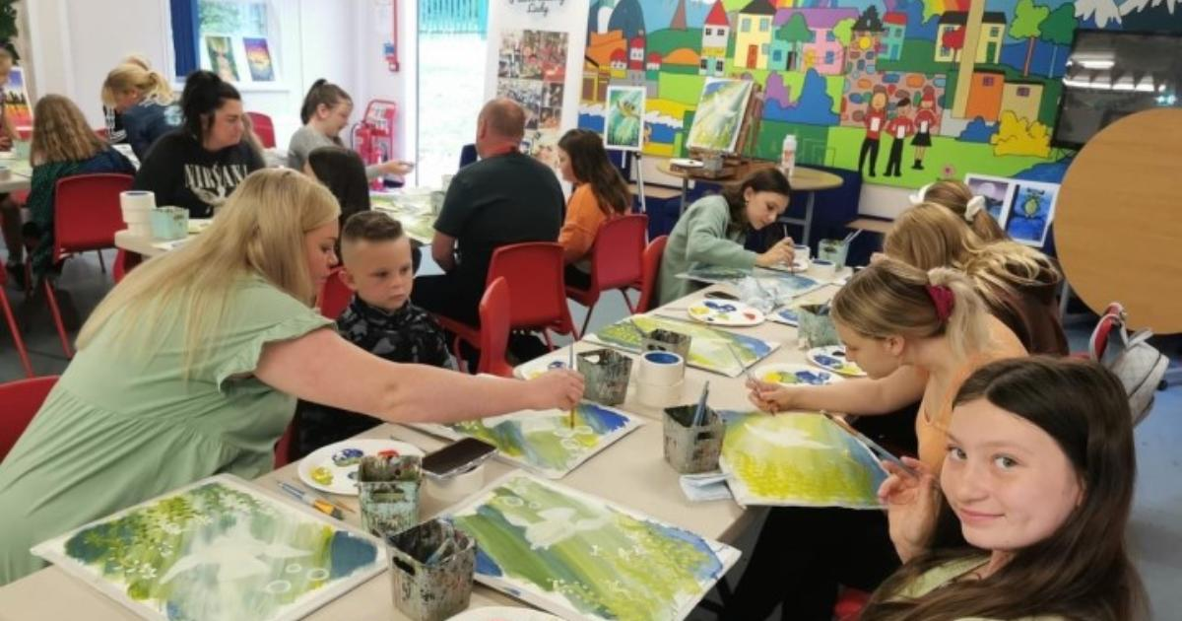

Introduction

This module aims to develop your understanding of poverty and disadvantage, and how it impacts on learning and development. It looks at some of the ‘radical’ changes to educational policy in Wales whilst enabling you to critically reflect on your own experiences and perceptions of poverty and disadvantage. It enables you to critically reflect on the ways in which your educational settings measure learning and development and whether this supports the ongoing issues related to poverty and disadvantage. We encourage you to think creatively about how to support learners in your educational setting, whilst thinking about a whole systems approach.
This booklet is personal and individual to you. Due to the nature of the module, it is possible that it will bring up some strong personal emotions for some, as well as a reflection on practice. Please contact your university wellbeing services or email your module tutor.

Setting the scene:

This section reflects on some important readings and provides context before our main introductory session. This section will also help you think about your educational settings and give you some foundational ideas for your assignment.
There have been several changes in the past few years in relation to how educational settings can respond to poverty and disadvantage. Here are some important points to consider before moving in to your asynchronous learning on Pebble Pad
Children’s Rights

Under the UNCRC, children and young people have the following basic human rights:

The Right to life, survival and development (article 6)

The Right to access adequate, nutritious food, clean water, and the best possible healthcare9 (article 24)

The Right to an adequate standard of living (article 27)

Activity 1
Here are some quotes from the Children’s Commissioner for Wales (2019) report: A Charter for Change: Protecting Welsh Children from the impact of poverty (20 min activity)

“We only had one uniform to last the week, so I couldn’t get messy” (Child/ Young Person, South Wales).

“Sometimes, when I was younger, I used to sit in the bath when I was on my period because I had no pads. I’d miss school and my brother would bring my homework home for me and there I’d be just sitting in the bath

“I never get to go on any school trips as mum can’t afford it”

“It’s not just about money, it’s every way that young people have to live, like having no clothes like proper winter coats. It’s all the layers of poverty that mean that young people can be compared. Like ‘keeping up with the Joneses’.” (Youth Worker, North Wales)

“Schools are far too expensive for people who can barely afford food”

“I am one of 5, it would cost my mam £1000 a year to buy us uniforms. I’m not talking about fancy stuff: Tesco shoes, Tesco trousers.... In our school, we had to have trousers with school logo on them and they cost £60 so my mam would buy Tesco and sew a badge on and we’d get sent home for that.” (Child/ Young Person, South Wales).

Reflect: In what way does your educational setting’s attitudes, beliefs, actions and policies support or hinder learners who are living in disadvantage and poverty?

Reflect: What would learners say about their experiences in your educational setting?

Activity 2:

Understanding Welsh Policy

There have been some important changes to policy in Wales recently. Here are some of the most recent ones that would be useful to know about. Other policies are hyperlinked in these documents and may also be useful Please write any notes that may be useful to you.

Child Poverty Strategy for Wales 2024 | GOV.WALES
Community Focused Schools | GOV.WALES

Radical and sustained action?

Radical and sustained action is needed to create a truly equitable education system for all
Jeremy Miles (Welsh Government, 2022)

Please watch this video which highlights of the Bevan Foundation webinar and the statement by Jeremy Miles on tackling poverty and the call for radical action (1 hour but 12:44 onwards is useful).
(hyperlink picture please Richard?) https://www.bevanfoundation.org/events/wales-after-covid-education/

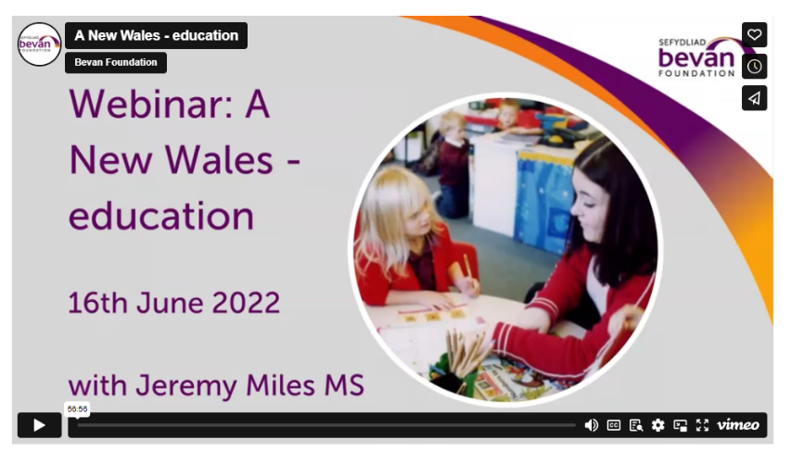

Reflect: What does radical action mean to you? Is this different to your colleagues?
What radical action do you think you can take?

Reflect: What are the main issues that you can highlight for you in practice?

Core Strand 1: Contested definitions of inequality, inequity and diversity.

Learning Outcome 1: Demonstrate a critical understanding of poverty and disadvantage on learners.

Activity 1 (5 min)

Reflect: Which students, if any, are disadvantaged or ‘at risk’ in terms of poverty and disadvantage in your setting?

Opinion: What are the external or internal factors which contribute to learners being
‘at risk’? Examples: Asylum seekers, refugee children, children whose parents are not in work, children with learning difficulties, mental health difficulties, children who speak minority languages, suffer poverty at home, lack of access to technology etc. etc.

‘There need be no difference in performance- none whatsoever- between pupils from disadvantaged backgrounds and those from wealthier homes’ –
Michael Gove, Secretary of State for Education, 2012

Reflect: To what extent do you agree with this statement?

Activity 2: (15 mins)
At present, disadvantaged children in English high schools are more than 18 months of learning behind their more advantaged peers by the time they finish their GCSEs, whilst primary school pupils are more than 9 months behind their non-disadvantaged peers (Hutchinson et al., 2020). The same sources indicate that at the present rate of change, it will take over 500 years for the disadvantage gap to be eliminated at secondary level.

Reflect: Is it reasonable to use this metric- the achievement gap- to talk about child poverty and disadvantage? What might be the problems with this?

The current educational policy response to the achievement gap is the Pupil Premium Grant – PPG. The PPG is a monetary grant delivered to schools and designed to improve educational attainment for disadvantaged pupils. Each child in receipt of Free School Meals (FSM) brings with them the PPG which equates to £1.345 per year for a primary school pupil, and £995 for a secondary school child. The school chooses how this money is spend, must account for the spend and demonstrate the impact of it. Research demonstrates that the money is mostly used to support small in class teaching interventions, extra teaching, teachers, and support staff, wellbeing interventions, pre and post school extra-curricular activities, breakfast clubs, trips out, and extra material resources such as books and equipment (Morris & Dobson, 2020).

Reflect: What interventions are in place in your school or educational setting?

Opinion: To what extent is it the school’s (or teachers’) role to respond to poverty and disadvantage?

Core Strand 2: Educational and theoretical positions of poverty

Learning Outcome 2: Critically examine ways of measuring learning and development with learners who are impacted by poverty and disadvantage

Sub strand 1: Examining ways of measuring learning and development with learners impacted by poverty and disadvantage

Activity 1 (1 hour)

Read three sources of information from the reading list options below:

A scoping study relating Australian secondary schooling, educational disadvantage and assessment for learning
Classroom-Based STEM Assessment: Contemporary Issues and Perspectives
How Trajectories of Disadvantage Help Explain School Attainment
Creating inclusive educational spaces: assessing assessment in a post-pandemic world
Navigating datascapes: mapping testing practices within and across national and global contexts
Progress made by high-attaining children from disadvantaged backgrounds
Effective approaches to assessment that improve teaching and learning

In the text box below write about how you think learning and development are measured for learners impacted by poverty and disadvantage: Write a critical reflection in your learning log of your updated thinking from Activity 1 about how you think and feel about the ways of measuring learning and development of learners who are impacted by poverty and disadvantage.

Activity 2 (30 mins)

Watch the video about Personalised Assessments as an assessment method

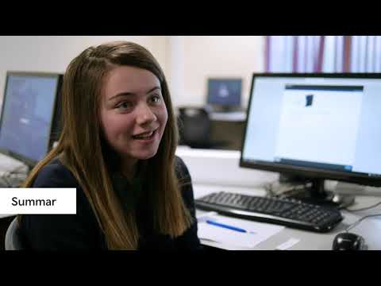

Consider Personalised Assessments as a way of measuring the learning and development of learners impacted by poverty and disadvantage:

- In a socio-cultural context (their physical, social, cultural, economic, and historical circumstances)
- In an educational context

Sub strand 2: Analysing theories of poverty and disadvantage.
Analyse theories of poverty and disadvantage to identify the advantages and drawbacks of methods used to identify learners impacted by poverty and disadvantage.

Activity 1 (30 min)

Consider the ways that ways that learners impacted by poverty and disadvantage are identified in an educational context:

- In a school, college or university
- In a classroom

Watch the video below situated within an international context, in which Kandice explains the significance of school location in shaping outcomes for learners.



Consider how structural inequalities, including those associated with gender, race or ethnicity, disability and nationality or migration status could have connections to economic disadvantage.

Activity 2

Read the article below about education as a way of escaping poverty in preparation for National Saturday 1: (20min)

Philosophical Reflections on Child Poverty and Education

Create a two-minute representation for peers in breakout rooms (spoken, written, visual or multimodal) for National Saturday 1 of an ideal educational setting that does not exclude learners, drawing upon insights gained from studying Core Strand 2. (30 min)

Core Strand 3: Whole Systems Approaches - how to plan for positive change

Learning Outcome 3 critically explore the whole systems approach and how this affects practice.

Sub strand 1: Understanding a Whole Systems Approach to education.

Activity 1:
The head of PISA at OECD, Andreas Schleicher (2018) published a book, World Class: How to Build a 21st- Century School System. Schleicher states his main conclusion: Over the past decade, there has been virtually no improvement in the learning outcomes of students in the Western world, even though expenditure on schooling rose by almost 20% during this period. (p. 13)

Reflect: Why do you think this is the case?

A Welsh perspective

It is now essential that we integrate all [of these] policy developments into a whole system approach, supported by an implementation strategy that will enable us to achieve sustained momentum to the end goal – of creating the excellent and equitable education and lifelong learning system that is our ambition for Wales. As Michael Fullan argues ‘moral purpose accompanied by powerful pedagogy is unstoppable’.

Jeremy Miles' Speech 2022: Bevan Foundation: High standards and aspirations for all

Activity 2:

Poverty and disadvantage are complex, messy, and unpredictable issues within society. They require people who system thinkers; those who can deal with the details of everyday life and learning, as well as seeing problems for learners as interwoven in systems that are sometimes not in the control of educators.

Reflect: The Welsh Government is calling for a whole systems approach to tackling poverty and disadvantage which has impacted on policy about the future of all schools (15 mins)
- What do you think is the difference between whole systems and whole school approaches?
- What does this mean for your practice?

- What barriers can you think of?

Activity 3:

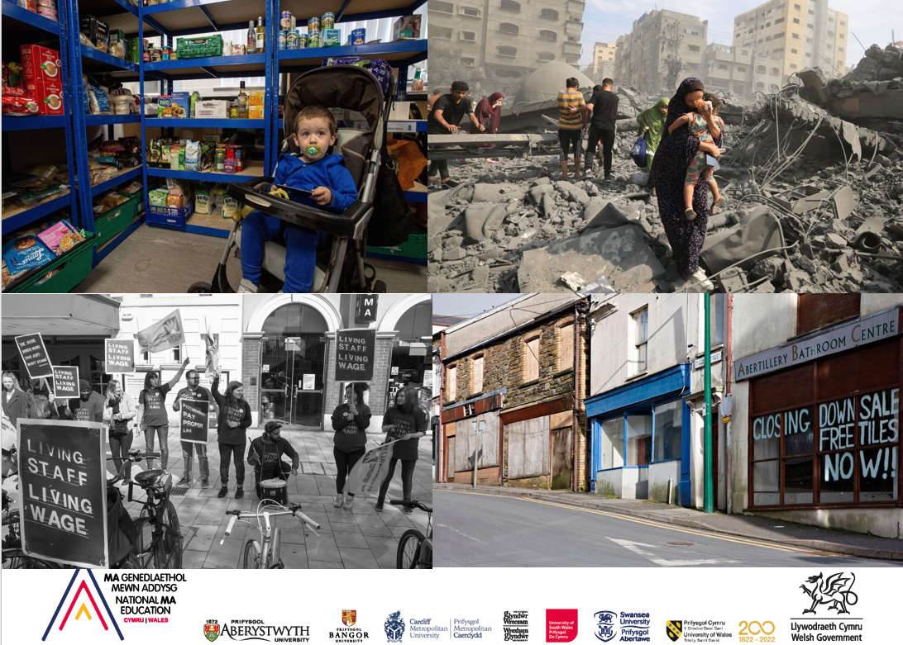

Reflect: Look at the pictures above. Choose one. Consider sections of systems such as health, education, history, culture, economy, politics that impact on your learners and how this could impact on education systems in your areas of work. Draw a diagram to help think about the challenges, issues, possible solutions. This will help with your assignment.
Consider: As times and issues change, how does the whole system change?
We will reflect more on these pictures in groups in National Saturday 2

Sub strand 2: In the learning environment: A Community Focussed Schools approach

Read the Welsh Government want all schools in Wales to be Community Focussed Schools. This requires:

  - building a strong partnership with families
  - responding to the needs of their community
  - collaborating effectively with other services

This is relational work.
Reflect: How do you feel about this? Do you think you and others have the values, knowledge, skills, and attitudes to be part of this approach?
Reflect: What do you think are the barriers to this in practice?

Sub strand 3: In the learning environment: A Community Focussed Schools approach

Read the Welsh Government want all schools in Wales to be Community Focussed Schools. It states that this requires:

  - building a strong partnership with families
  - responding to the needs of their community
  - collaborating effectively with other services

Community Focussed Schools require whole systems approaches This is relational work (connecting and building trusted relationships)

Activity 1 (20 min)
Consider these questions. Write down your answers. Use these to find further academic literature to support your thinking. This will help you to think critically about the whole systems approach as well as issues for your plan of action.

Reflect: How do you feel about every school becoming a Community Focussed School? Do you think you have values, knowledge, skills and attitudes to be part of this approach?

Reflect: What do you think are the barriers to this in practice to the 2 main points above?

Activity 2 (2 hours)

Read: Tredway and Milletello (2019) ‘The Imagineer’s of Community School Leadership’ in Ferrara, J. and Jacobson, R. (2019) (Ed.) People and Places Transforming Education and Communities, London: Rowman & Littlefield
Utilising the table below adapted from Tredway and Militello’s chapter note down answers to the prompts in the right-hand column.
What do they mean for you and your practice?

What is the Intent of these actions / approaches / policies and strategies?

How do you go about implementing them and how do they Impact?

Select two or three criteria or solutions which are new to you. Or you have considered in a different way. Research them further and bring them to the National Saturday session for discussion.

Community Schools Criteria | Community Learning Exchange Axions | How the criteria and axioms are often manifested in community schools | What does this mean for you?
Engaging students and adults in their learning.  Emphasizing high quality teaching, not high stakes testing. | Learning and Leadership are a dynamic social process. | Emphasis on high quality teaching, not on high stakes testing  Engaging, culturally relevant and challenging curricula  Positive disciplinary practices, i.e. restorative justice, focus on self-regulation and cultivating respectful discipline systems, collective responsibility for healthy climate and culture  Supporting practices to reduce suspensions and address chronic absenteeism and eliminating harsh punishment, including data systems that track progress. | What is your understanding of what high stakes testing?  In what way is your curriculum engaging, culturally relevant and challenging?  Give an example of where you practise positive discipline.  How do you use data to track progress, where is this done from a positive perspective?
Using culturally responsive curricula, discipline practices, pedagogy and processes. | Conversations are critical and central curricula and pedagogical processes. | Community family meetings reflect the cultural practices of the community.  Student Voice in decision making.  Parent / family learning opportunities that respond to parent / family decisions about what they need to know or do.  Inclusion of parents and community members in teaching and learning practices in the classroom setting.  Social Emotional Learning SEL curriculum is in instituted and steward of and effectiveness evidence is one criteria of school success. | Where and how do you embrace your community?  How do you respond to student voices?  What parent / family learning opportunities does your school offer?  What involvement do parents and community members in influencing classroom practice?  What does Social Emotional Learning look like in your setting? Does is feature as a measurement of success?
Implementing wraparound support and opportunities for students and adults | The people closest to the issues are best situated to discover answers to local concerns. | Processes and practices that ensure the voices and ideas of parents and community members become infused in the design and work of the school.  Asset and equity-based inventories.  Wraparound support that are and opportunities that are co-designed and co- decided and managed with input from constituents.  Community School coordinator who was trusting relationships with students, parents and community.  Linked Day: Overlap and communication between school day teachers and after school staff.  Developing teacher and counsellor pipelines for adults who work in aftercare program. | How do voices of parents and community contribute to the design and work of the school?  What inventories are measure / captured within your setting?  Who contributes to decisions around wrap around support and opportunities?  What do you do to facilitate trusted relationships?  How is communication between school day teachers and after school staff ensured?  How does your setting enable information is shared between after care programs and teachers?
Ensuring shared and inclusive leadership. | Crossing Boundaries enriches development and the educational process. | Inclusive school leadership including a community school coordinator.  Authentic parent and community engagement.  Crosswalk between day school and after school.  Purposefully fostering community-based leadership  Intentional intergenerational leadership by honouring the often marginalised of youth and elders. | What authentic parent and community engagement do you offer?  What are the transitions between your school day and after school offer?
Using the wisdom of People and Power of Place as Guideposts for change. | Hopes and change are built on assets and dreams of locals and their communities. | Dynamic and equitable partnerships with organizations students, parents, families and caregivers, in which all voices are honoured.  Collaborating with community members to learn the context and history of the place through community, historical and cultural mappings fully engaging with community assets and community gripes (those who carry the history and knowledge). | What opportunities do you have to collaborate with community members to learn the context and history of the place through your community?

Having undertaken this task identify 3 – 5 improvements / changes which could be made to enhance your workplace.

What questions are you now asking of yourself and your workplace?

Core Strand 4: Plan, implement and evaluate a change in practice. ​

Learning Outcome 4: Critically examine how to plan, implement and evaluate a change in practice that will benefit learners who are impacted by poverty and disadvantage in educational settings.
Sub stand 1: Planning and Implementing. Ideas from practice:

Activity 1: (20 mins)
Consider where your change in practice would be situated on the diagram below and how would it effect or link to other systems. We will discuss this in National Saturday 1:
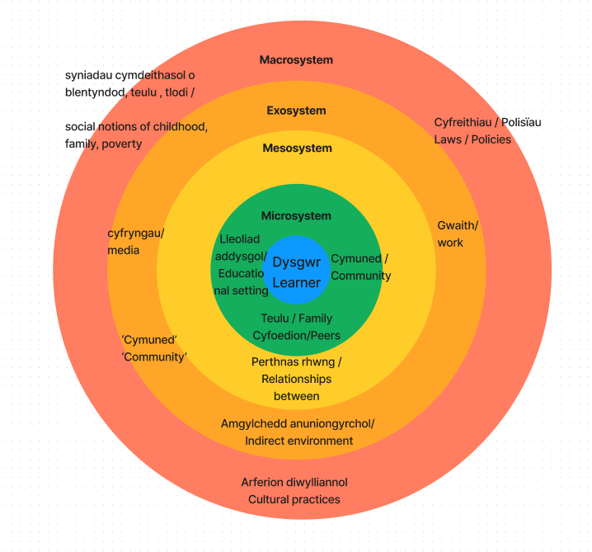

(adapted from Bronfenbrenner, 1979)

(adapted from Bronfenbrenner, 1979)
Activity 2 (1 hour)
Read: Scanlan, M. and Johnson, L (2021) ‘Inclusion the social frontier: Family and community engagement’. In: Theoharis, G. Scanlan, M. (eds) Leadership for Increasingly Diverse Schools, Taylor & Francis Group, 2020. pp 227-290
Reflect: How can you be a border spanner, boundary crosser and advocate for learners when responding to poverty and disadvantage?

Sub strand 2: Evaluating changes in practice.
Wales is currently thinking of ways to create system change for poverty and disadvantage through policies and practice for our learners. Evaluating interventions will be the next step. There is no set way to evaluate interventions at present. Be part of the solution!
We will talk more about this on our National Saturday 2. Remember use the Ask the Experts sessions to help

Activity 1: (30 min) Evaluating your change in practice.
- Waving a magic wand: What could be the meaningful measures to evaluate responses to poverty and disadvantage in my educational setting?

- What would it look like? How would it feel?

- What can we do in reality?

- What should we do?

- What are the barriers?

- What are the steps to get there?

- Think back to Jeremy Miles’ speech on taking ‘radical action’. How do we become educators who enable and perform ‘radical action’?

Think about children’s rights, children’s voice, working with families, needs of the community, collaborating with other services. Think about what measurements you would use to evaluate the changes in practice

Activity 2 (1 hour)
Read the Scottish Government’s ideas around evaluating systems-change initiatives. Although these are prompts for policy evaluation, this may highlight ways to about the questions you could ask to evaluate your changes in an education setting.
Annex B: Evaluating the effectiveness of system-change initiatives - Child poverty - monitoring and evaluation: policy evaluation framework - gov.scot (www.gov.scot)

Further useful information: (Richard should this be in its own drop down on the top?)

What schools are doing already:
Please watch the British Council’s (2022) webinar on Community Focussed School in Wales (1 hour). This showcases some excellent practice across Wales. This may offer insight into what can be done in practice to respond to poverty in your settings. However, please remember that you could focus on other ideas to respond to poverty and disadvantage that may be related.
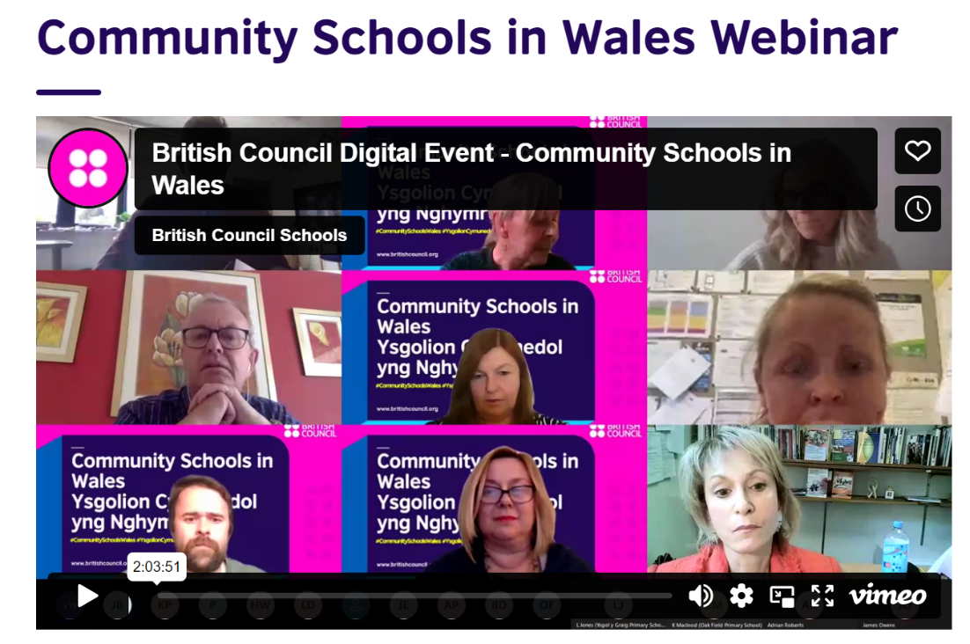

https://wales.britishcouncil.org/en/community-school-wales-webinar

Systems Leadership:

Read Systems Leaders and Systems Leadership by Prof Alma Harris. say is important for system leadership?
https://nael.cymru/wp-content/uploads/2021/04/System-Leaders-and-System-Leadership.pdf

System leadership is a practice not a role that supports and mobilizes change.
Reflect:
Is everyone a systems leader?
Are you a disruptor? How?

