Primary Source Analysis

Source: Saxton’s Map of Wales. Created by Cartographer and Surveyor, Christopher Saxton (1542/4 – 1610/11) in 1580, although never published. This map was purchased by the National Library of Wales in 1986.
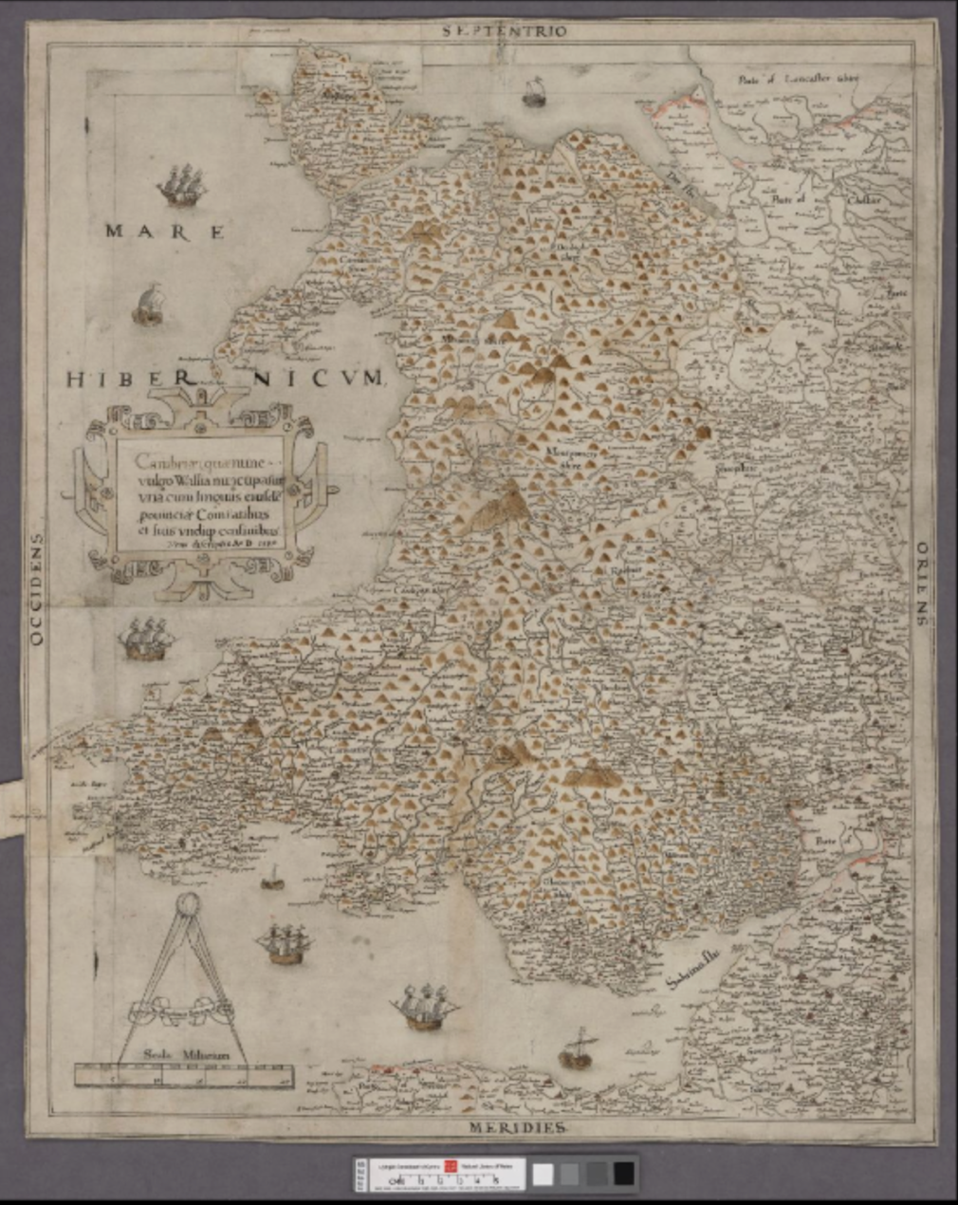
The primary source chosen for this assignment is a map of Wales, commonly known as Saxton’s Proof Map of Wales, and was created in 1580 by Christopher Saxton (1542/4 – 1610/11). Saxton was a cartographer and surveyor, from Dunningley, near Wakefield Yorkshire, who was apprenticed by John Rudd, Vicar of Dewsbury, in c.1570. Saxton later gained favour with Queen Elizabeth I after creating the first national atlas, for which he received patronage and assistance from Thomas Seckford, the Master of the Queen’s requests, who financed his grand cartographic projects. Although the map was never published it is plausible that the map was commissioned by Queen Elizabeth 1st as noted by David Fletcher:
In 1575, the Queen required that Saxton be given assistance in wherever he went on his county survey. Alongside this, in the following year, an open letter was written to Justices of the Peace and Mayors of Wales, asking that he be assisted in the principality, and he was also given a ‘pass’ by the Privy Council so that people with knowledge of the land would assist him in his cartography. In 1577, the Queen issued him with letters patent giving Saxton the sole right to publish his own maps for the next 10 years – an important safeguard against plagiarism.
This, plus the fact that much of the information in this map was also used in Saxton’s wall map of England and Wales (1597) all points to Queen Elizabeth I commissioning the map, with the most likely reason being so she could familiarise herself with the lands she rules over.

The timing of Queen Elizabeth commissioning this map is highly significant into understanding the way we may interpret the source. The map was most likely commissioned in the 1570s and later created in 1580, which is highly significant as the 1570s and 1580s was a particularly turbulent time for Queen Elizabeth I. In 1568, Mary, Queen of Scots became Queen Elizabeth I prisoner after fleeing Scotland due to being accused of her late husband’s murder and being forced to abdicate the Scottish throne in favour of her one-year-old son James VI. Due to Mary being a catholic, and Elizabeth a protestant and daughter of Anne Boleyn, many deemed Queen Elizabeth as illegitimate and that Mary, Queen of Scots should be the rightful Queen. As a result, Mary subsequently became the focus of rebellion and a good excuse for Catholic Europe to engage in war and gain control of England. In 1569, there was a major catholic uprising in the North, with the goal of freeing Mary and marrying her to Thomas Howard, Duke of Norfolk. However, this was defeated and over 750 people involved were executed. The Pope initially believed that the revolt was successful so decided to excommunicate Elizabeth and branded her a heretic. Due to her excommunication, this opened Elizabeth up to further rebellions as English Catholics were forced to choose between their faith, or being a loyal servant to their Queen, and catholic Europe was practically being encouraged to invade by the Pope or to have no allegiance with her at all. Later in 1571, the Ridolfi Plot was uncovered which not only showed Mary and the Duke of Norfolk’s attempts at plotting against Elizabeth for her freedom, but also highlighted Spain’s involved via the Spanish Ambassador acting upon the orders of King Philip II of Spain. As a result, this clearly highlighted to Queen Elizabeth that an attack on England and Wales was imminent, so her gaining a detailed map of England and Wales was necessary so she could effectively plan how she would defend the country.

Elizabeth’s fear and preparation for a potential invasion, provides a clear explanation for a lot of the features on the map. The most notable features for this are the extremely detailed coastline of Wales. Compared to the Cambriae Typus map of Wales, by Humphrey Llwyd (posthumously published in 1573), the map has an extremely detailed coastline, with little to no inaccuracies. The accurate coastline would have been of the highest importance to Queen Elizabeth 1st as an attack on her territories would of most certainly came in the form of a sea invasion, so therefore she would have been familiar with the coastline and plan her defence effectively. Similarly, all towns and cities with castles have also been marked clearly on the map, by a tiny image of what appears to be a castle. These include, Carmarthen, Pembroke, Lampeter (Llanbeder), Swansea (Swanfey), Aberystwyth, and Bangor. Again, this would be extremely important landmarks to feature on this map, as they provide the bases for troops to be stationed in the event of an invasion. It is important to note how most of these castles have been built on the southern coast of Wales but also the England/Wales border. This was most likely done to defend Wales’ southern border from invasion from foreign countries and the castles on the England/Wales border was most likely built in during the reign of Edward 1st after he conquered Wales in 13th Century.

Another interesting feature, from the coastline is that two islands off the coast of Aberystwyth have not been featured on this map but had been on maps prior, particularly the Gough Map, (published in mid 13th century). Discover Ceredigion states on their website:
According to the legend, Cantre’r Gwaelod was a rich and fertile ‘lowland hundred’ and sixteen cities governed by Gwyddo Garanhir, whose palace, Caer Wyddno, was reputedly near Aberystwyth. The land stretched across Cardigan Bay and lay below sea level, protected by sea walls. The guardian of the sea defences was Seithennyn, a friend of the king, charged with the all-important role of shutting the sea gates every night. One night, Seithennyn, who liked his drink, was at a feast in the king’s palace, and forgot to shut the sea gates. It was a stormy night and the high spring tides broke through, quickly flooding Cantre’r Gwaelod, and forcing its people to flee to the hills.
This tale was first recorded in the Black Book of Carmarthen, but because of a lack of contributing evidence, it was deemed as a Welsh myth, and subsequently not true at all. However, in 2022, while examining the Gough Map, in the Bodleian Library at Oxford University, Professor Simon K Haslett (Swansea University) and Professor David Willis (Jesus College, Oxford University) uncovered two islands, one off the coast of Aberystwyth, and another further north towards Barmouth. Due to the clear markings of these islands, plus its link to the account, previously mentioned, in the Black Book of Carmarthen, indicates that this story does have an element of truth to it, and these islands did genuinely exist. However, one key mystery is what actually happened to these islands. We know that it is extremely likely that they were eventually submerged, and by the time Saxton’s map was created in 1580 there is no trace of the islands whatsoever, but what caused it? In Professor Haslett and Willis thesis, they state:
Historical erosion proposed for the ‘lost’ islands of Cardigan Bay are entirely plausible within the context of other coasts where unconsolidated Pleistocene deposits (rocks and minerals left behind by Glaciers during the Pleistocene epoch) are exposed in coastal cliffs and occur within a high-energy wave environment. Moreover, the geological and geomorphical similarity between Cardigan Bay and other areas along the northwest European coast, such as the Celtic coasts of Brittany and Cornwall, along with similar geomythological evidence, might suggest marine and fluvial dissection and erosion of ‘lost’ landscapes underlain by unconsolidated Pleistocene deposits provides a credible model to further investigate coastal evolution in these regions.
These findings, by Professor Haslett and Willis, therefore, signifies how the people of Cantre’r Gwaelod are the most likely the first British refugees of climate change all the way in 15th century as records from the publication of the Prima Europe tabula in 1486, and later in 16th century with Saxton’s map of Wales, signifies that at this point, these islands ceased to exist.
These findings are highly significant for a historian because it helps aid in historical and archaeological discoveries, that without them, would have most certainly remained a mystery.

Alongside the detailed coastline and plotting of castles, all rivers in Wales have been plotted, although left unnamed, alongside with important seas and waterways that lead to key ports. The 3 seas/waterways mentioned is Mare Hibernicum, Dee Flu and Sabrina Flu, which now is commonly known as the Irish Sea, Dee Estuary, and the mouth of the River Severn. The Dee Estuary and the mouth of the River Severn are of particular importance as they contained two key historic dockyard towns, which are Chester and Bristol. These ports and waterways are particularly important to note on the map, as these would be key areas to defend as they provided trade with other countries in Europe, particularly Protestant countries, such as the Netherlands, Scandinavian Countries, and a number of German territories within the Holy Roman Empire.
Similarly, Welsh, and bordering English counties have also been labelled. They are Pembrokeshire, Carmarthenshire, Cardiganshire, Brecknockshire, Glamorganshire, Monmouthshire, Radnorshire, Montgomeryshire, Merionethshire, Denbighshire, Flintshire, Caernarvonshire, and Anglesey. They also feature the English counties of Devonshire, Somersetshire, Gloucestershire, Herefordshire, Worcestershire, Shropshire, Staffordshire, Cheshire, and Lancashire.
An important thing to note about this, is that Saxton uses the anglicised versions of the Welsh counties but also uses the Welsh names for towns within Wales. The Laws in Wales Acts of 1535 and 1542, enacted by King Henry VIII brought Wales under the power of the English monarchy rather than the Pope. Due to this change in administrative control, it was also deemed that Wales would be split into seven counties (1535), which was later extended to twelve mentioned above, apart from Monmouthshire which was left out thus meaning that a notion arose that it was now detached from Wales. Saxton therefore specifically mentions the anglicised version of these counties to highlight that these counties were now under English control, and most notably the control of Queen Elizabeth I. Although in spite of this, it is important to highlight the vast majority town names remain in Welsh, most notably Llanbeder, which they could have instead chosen to use the anglicised version of Lampeter. As a result, historians can interpret this to be a discreet symbol of Welsh patriotism, as although Wales was under English administrative control (as represented via the counties), the people who lives in Wales will always be Welsh and are proud of their Welsh heritage so refuse to submit to their ‘invaders’ and keep their town names in Welsh.

Another important element featured on the map is the compass points. On the borders of the map, it features the following Latin words: Septentrio, Oriens, Meridies, and Occidens. This is translated to, North, East, South and West. A compass point on a map was of key importance if the map was to be used for navigation purposes rather than decorative purposes. This therefore signifies that Elizabeth most likely intended to use this map for defences purposes, against either rebellion or attack from catholic Europe.

In conclusion, Saxton’s Proof Map of Wales, is an extremely valuable source for historians to gain a better understanding of Wales’ history, whether that is politically through its most probable purpose of being an instrumental planning tool for Queen Elizabeth I in the event of an invasion from Catholic Europe, or a rebellion gathered together by her prisoner Mary, Queen of Scots, or a representation of English dominance over Wales due to the use of anglicised county names. It also could be used as a symbol of Welshness or Welsh resistance to the English as in spite of the administrative regions still being anglicised, the individuals towns remain with Welsh names. The source is also valuable for aiding in the piecing together of the Welsh landscape and helping to create a better understanding of Welsh literature and aiding in the myth busting of towns from Welsh folklore.
Bibliography

BBC News, Wales – Map may show evidence of Wales’ Atlantis off Ceredigion [online]. Available
https://www.bbc.co.uk/news/uk-wales-62605682

BBC Wales History – The 1536 Act of Union [online]. Available
https://www.bbc.co.uk/wales/history/sites/themes/periods/tudors_04.shtml

BBC Wales History – The 1543 Act of Union [online]. Available
https://www.bbc.co.uk/wales/history/sites/themes/periods/tudors_05.shtml

Discover Ceredigion, Lost Lands – Cantre’r Gwaelod and the Celtic Otherworld [online]. Available
https://www.discoverceredigion.wales/heritage-and-culture-to-explore/ceredigion-legends/lost-lands-cantrer-gwaelod-and-the-celtic-otherworld/

National Library of Wales, Cambriae Typus [online]. Available
https://www.library.wales/discover-learn/digital-exhibitions/maps/maps-of-wales/cambriae-typus

National Library of Wales, Prima Europe Tabula [online]. Available
https://www.library.wales/discover-learn/digital-exhibitions/maps/maps-of-wales/prima-europe-tabula

National Library of Wales, Saxton’s Proof Map of Wales [online]. Available
https://www.library.wales/discover-learn/digital-exhibitions/maps/maps-of-wales/saxtons-proof-map-of-wales

Oxford Dictionary of National Biography, Saxton, Christopher [online]. Available
https://www.oxforddnb.com/display/10.1093/ref:odnb/9780198614128.001.0001/odnb-9780198614128-e-24760

S.K Haslett and D. Willis, ‘The ‘lost’ islands of Cardigan Bay, Wales UK: insights into post-glacial evolution of some Celtic coasts of northwest Europe’, Journal from Atlantic Geoscience (2022), pp.143. [online] Available
https://journals.lib.unb.ca/index.php/ag/article/view/32596/1882528188

(All available as of 20/01/25)

The National Library of Wales, Saxton’s Proof Map of Wales [online]. Available https://www.library.wales/discover-learn/digital-exhibitions/maps/maps-of-wales/saxtons-proof-map-of-wales
The National Library of Wales, Saxton’s Proof Map of Wales [online]. Available https://www.library.wales/discover-learn/digital-exhibitions/maps/maps-of-wales/saxtons-proof-map-of-wales
Oxford Dictionary of National Biography, Saxton, Christopher [online]. Available https://www.oxforddnb.com/display/10.1093/ref:odnb/9780198614128.001.0001/odnb-9780198614128-e-24760
ibid
The National Library of Wales, Saxton’s Proof Map of Wales [online]. Available https://www.library.wales/discover-learn/digital-exhibitions/maps/maps-of-wales/saxtons-proof-map-of-wales
National Library of Wales, Cambriae Typus [online]. Available https://www.library.wales/discover-learn/digital-exhibitions/maps/maps-of-wales/cambriae-typus
Discover Ceredigion, Lost Lands – Cantre’r Gwaelod and the Celtic Otherworld [online]. Available https://www.discoverceredigion.wales/heritage-and-culture-to-explore/ceredigion-legends/lost-lands-cantrer-gwaelod-and-the-celtic-otherworld/
BBC News, Wales – Map may show evidence of Wales’ Atlantis off Ceredigion [online]. Available https://www.bbc.co.uk/news/uk-wales-62605682
S.K Haslett and D. Willis, ‘The ‘lost’ islands of Cardigan Bay, Wales UK: insights into post-glacial evolution of some Celtic coasts of northwest Europe’, Journal from Atlantic Geoscience (2022), pp.143. [online] Available https://journals.lib.unb.ca/index.php/ag/article/view/32596/1882528188
National Library of Wales, Prima Europe Tabula [online]. Available https://www.library.wales/discover-learn/digital-exhibitions/maps/maps-of-wales/prima-europe-tabula
BBC Wales History – The 1536 Act of Union [online]. Available https://www.bbc.co.uk/wales/history/sites/themes/periods/tudors_04.shtml
BBC Wales History – The 1543 Act of Union [online]. Available https://www.bbc.co.uk/wales/history/sites/themes/periods/tudors_05.shtml

