Student Name: Rebecca Travers
Student Number: 2128316
Module Number: BMSW4005_BIRM
Module Title: Professional Career Development
Lecturer: Ade Adegbite
Reflective Report

Table of Contents
Introduction 2
PDP 3
Swot 5
Learning Styles. 5
Mumford and Honey. 6
Fleming 1987 ‘VARK’ 7
Gibbs reflective cycle 8
Description 9
Feelings 9
Evaluation 10
Analysis 10
Conclusion 10
Action Plan 11
Appendix 11
Appendix 1 12
Appendix 2 12
References 13

Introduction
The purpose of this report is to reflect on techniques learnt within the professional career development module. I will then use them to assess my skill sets using analytical tools such as a PDP (personal development plan) and SWOT (strengths, opportunities, weaknesses, and threats). “SWOT analysis is one of many tools that can be used in an organization’s strategic planning process” (Phadermrod, Crowder and Wills, 2019). Part 2 of the report will use the Gibbs reflective cycle to evaluate the skills learnt in the professional career development module. Based on research conducted by Sekarwinahyu, M. et al. 2019 the Gibbs reflective cycle is a framework commonly used by students within reflective writing assignments. The purpose of reflective writing and using the Gibbs reflective cycle is to determine what worked well, and areas for improvement with a SMART goal in place should the same situation arise in the future.

PDP
A personal development plan has been formulated below to outline future objectives. Personal development plans are helpful due to the goal being specific and measurable. ‘PDP aims to facilitate competence development by articulating the performance management process and the development dialogue, forcing employees to focus on their development activities’ Lejeune, Beausaert, and Raemdonck (2021, pg. 1092).
Objective | Time | Activities | Success Criteria | Resources
Short term
To progress onto Level 5/6 Business Studies. | May 2023 | Complete outstanding assignments to at least a pass. | Be accepted to level 5. | Alarm Clock Laptop  Library Access  Notebook  Pens
To achieve higher than a merit in level 5/6. | May 2025 | Complete assignments on time. | Merit or above. | Alarm Clock Laptop  Library Access  Notebook  Pens
Long term
Gain managerial experience within an established company. | May 2026 | Confidence building within interview techniques.  Studying Levels 5/6/7 leadership and management. | Manage a company. | Careers advisor  Interview simulator.
Open a mobile catering business. | May 2030 | Continue onto master's degree in business leadership and management.  Secure funding.  Obtain Van, logo and register as a business. | Registered business. | Business plan  Vehicle  Funding

Swot
SWOT is a commonly used framework which was credited to Albert Humphrey, who tested the approach in the 1960s/1970s. SWOT examines 4 areas, Strengths, weaknesses, opportunities, and threats. By looking into these 4 areas strategic planning can start to stengthen any weaknesses and threats can be mitigated. Based on feedback from the open-book assessment and the mock interview I have formulated a swot analysis to help identify areas of improvement.
STRENGTHS  - Stick to deadlines.  - Assignment organisation  - Note-taking in lectures | WEAKNESS  - Confidence  - Keeping eye contact  - Remembering key information under pressure.
OPPORTUNITY  - Progression onto further levels of education.  - Managerial roles within a company. | THREAT  - Illness  - Home commitments

Learning Styles.

Mumford and Honey.
Honey and Mumford’s (1986) learning styles are commonly used to help identify the four learning techniques. Knowing your learning style helps with self-improvement. In research by Newton and Salvi (2020, pg1), ‘95.4% of trainee’s (pre-service) teachers agreed that matching instruction to Learning Styles is effective.’ Another benefit of knowing your learning style is understanding how you may come across to others. According to Honey and Mumford, Activists learn through involvement in short-term tasks. Reflectors take time to listen and think; they thoroughly review the job before making an informed decision. Theorists learn by taking on new situations by linking them to theory. Pragmatists learn by linking information and real-life situations. It is suggested that a range of learning styles are utilised to be an effective learner. Knowing what learning style you are strongest in allows room for improvement in weaker scoring styles. Below are my results of the learning styles quiz, along with how this has improved my learning.
Figure 1
Results interpreted by learning styles quiz (Appendix 1)
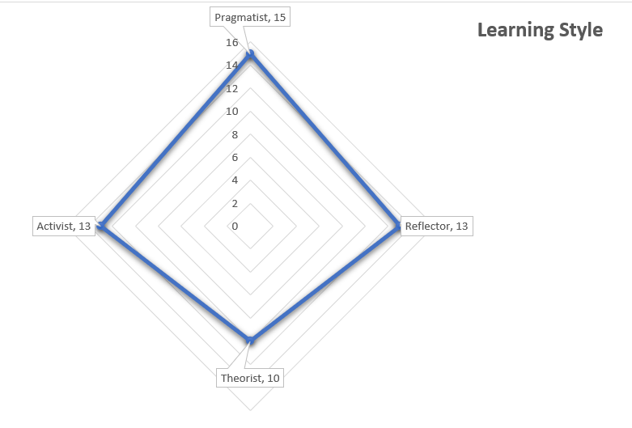
Figure 1 shows the results obtained from the Mumford and Honey learning styles questionnaire (Appendix 1). From doing this, I identified myself as a Pragmatistic learner.
A definition of a pragmatistic learner from the Cambridge Dictionary is ‘Someone who deals with problems in a sensible way that suits the conditions that really exist, rather than following fixed theories, ideas, or rules’. A strength of this learning style is that pragmatists are down-to-earth and tend to be enthusiastic about putting innovative ideas into practice. However, an area for improvement for somebody with this learning style could be to spend more time listening to others and to take time when decision-making so all rules and procedures are followed.
Knowing your learning styles in terms of career development is essential to keep progressing. With this knowledge, I have identified areas for improvement within my work. I have tried to listen to other people’s input without rushing decisions, especially in group work situations. In previous assignments, I have struggled with remembering things to include within the given task. To improve this issue, I have taken the extra time when studying the assignment brief to ensure that all requirements are met, referring to it throughout writing my assignments. I have highlighted the criteria that need to be met, ticking section by section, so nothing is overlooked. Another learning style to consider is VARK – introduced by Fleming in 1987.

Fleming 1987 ‘VARK’
According to Sanan Malo (2021, pg 106), the ‘VARK model for learning styles as one of the most popular models for learning styles has been introduced by Fleming in 1987 to help the students and others to learn more about their individual learning preferences.’ Fleming outlines learners fitting into four categories; visually, by remembering pictures, diagrams, and colours; auditorial, by remembering spoken words; reading and writing are learners that work from making lists reading textbooks and note taking and kinaesthetic learners that learn by doing. I completed the Fleming learning style quiz, and the results are as follows.
Figure 2
Figure 2 shows results interpreted from appendix 2.
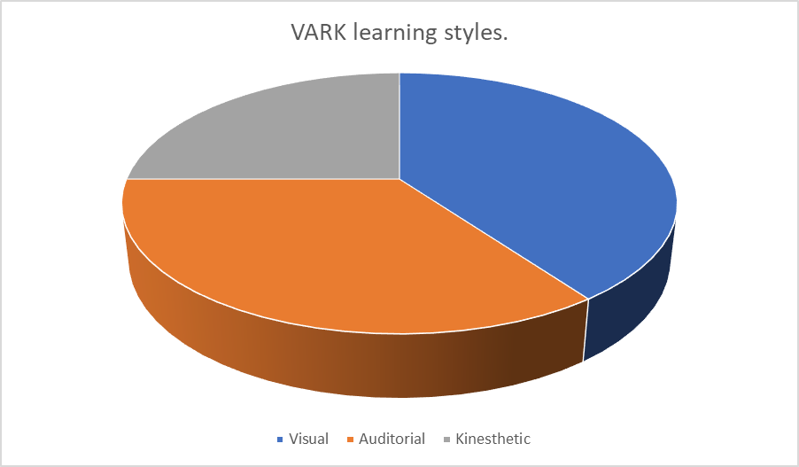

The results of Flemings's learning styles determined that my learning style was visual. Implementing some techniques useful for visual learners has been helpful, especially in assignment writing. I tried using visual props, such as watching videos, to clarify information I did not understand. I also found it helpful to colour-code information when researching and linking with other literature using the same colour highlighter for referencing supporting points in other literature. According to Sahabuddin et al. ( pg 5, 2018) “visual learning style, namely: likes neatness and skills, if speaking tends to be faster, like to make a mature planning for the long term, very thorough down to the details.
Assignment writing then became more organised than previously. Charts, graphs, and pictures are the things that stand out in my memory over the information I read. Therefore, I have tried to implement more charts and graphs within my work to express my findings. A suggestion from the learning styles quiz was for a visual learner to sit at the front of the class. I implemented that suggestion and spent the term at the front table. Sitting at the front improved my engagement with lectures, resulting in my understanding thoroughly, unlike in previous modules when I sat at the back of the room and lost concentration. I also wrote notes in different coloured pens. By doing this, I seemed to remember more, and if I could not remember, the notes helped me reflect.

Gibbs reflective cycle

The Gibbs reflective cycle is a learning cycle that highlights the importance of thoughts and feelings by reflecting on events to create an action plan of improvement. Markkanen, et al. (2020) used the Gibbs’ reflective cycle for teachers to evaluate things that went well and challenges within a day's work. Using the Gibbs reflective cycle, they noted improvements in self-control and in skills preparing for challenges that may arise in the future. According to Gibbs (1988, pg9) this is how to break down how we reflect within critical thinking:

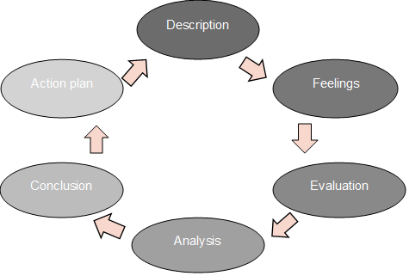

Description
Over the last 10 weeks several career development tools have been presented. In the first 2 weeks, we focused on the importance of personal development plans and improving self-awareness. I completed different learning style quizzes and looked for things I could do to benefit my learning style. In week 3 we considered our employment opportunities. The next week consisted of an open book assessment. In the next 3 weeks we studied the recruitment process, CV writing and mock interviews. In the last 3 weeks we focused on career development, employment legislations and alternative routes after graduation.

Feelings
I found lectures remarkably interesting and highly motivating. The specific techniques taught were relevant and necessary, because of this I felt better engagement with tasks, thus improving my knowledge reflected in the results of the mock interview and open book assessment. By integrating tools developed from the learning styles quizzes in week 2 and formulating a personal development plan in week 1 I found myself feeling more organised and relaxed than previous modules. Before the open book assessment, I felt nervous however, during the task the nerves subsided. The mock interview was an area that caused me anxiety on the lead up.

Evaluation
The open book assessment went well in my opinion. Scoring 70% shows there are still areas for improvement with my main feedback being “try to support your work with academic evidence in future tasks”. In the mock interview I scored 11/15 which is equivalent to 73.3%. Feedback shows my main weaknesses were answering behavioural questions without the use of STAR. CV writing and interviews are areas I have had limited experience in, the lectures were useful in gaining insight on the best ways to present ourselves in writing and in person.

Analysis
In the open book assessment, I used techniques developed in week 2 to help organise my thoughts. As I only had 2 hours to complete 500 words based on a chosen question, it was helpful for me to use highlighters and web diagrams to plan through what to include in my response. The CV builder was a helpful tool giving scores on how effective your CV could be. My final score on the CV builder was 96%. Another useful tool was the interview simulator. This helped with preparing for the interview. As a group we looked at all options for after we graduate. Options included further study, job opportunities and gap years for anybody seeking a break. We studied employment legislation the rights of employees and employers, and the recruitment process was also considered.

Conclusion
To conclude on the last 10 weeks, I believe I have learnt some important skills to develop a career in which I can prosper. I believe the scoring in which I received for the open book assessment and the mock interview demonstrate the effectiveness of knowing your learning style and using theoretical frameworks such as PDP and SWOT to focus on specific areas of improvement. To improve further continuous reviews of PDP and SWOT should be exercised. Self-confidence is an area in which I need to develop. This was identified in the feedback from the mock interview. I was overwhelmed due to lack of experience, and this resulted in lack of eye contact and not exercising the STAR – (Situation: What was happening? Task: What needed to be done? Action: What did you do? Result: What was the impact?) method of answering questions.

Action Plan
If I had to do the same work again there would be a few changes I would make to improve on the results I got. According to Ikin Syamsudin Adeani, Bunga Febriani and Syafryadin Syafryadin (pg 140, 2020) “Gibbs reflecting could cause awareness of the students regarding their skills.” Using this to go forward, I would look for supporting literature to support my points in the open book assessment. The second thing I would do differently is to try to be more confident. This is an area that needs specific attention, in the mock interview I felt the pressure, and this affected my ability to answer questions confidently. To improve this area more experience is needed in answering questions using the STAR approach, which can be gained on the interview simulator.

Appendix

Appendix 1
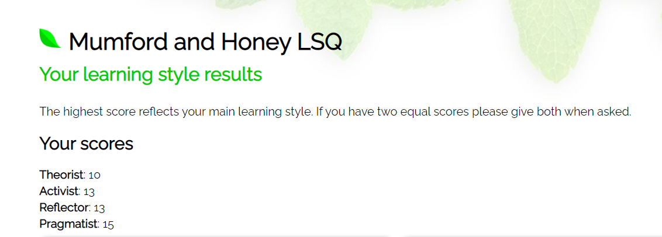

Appendix 2
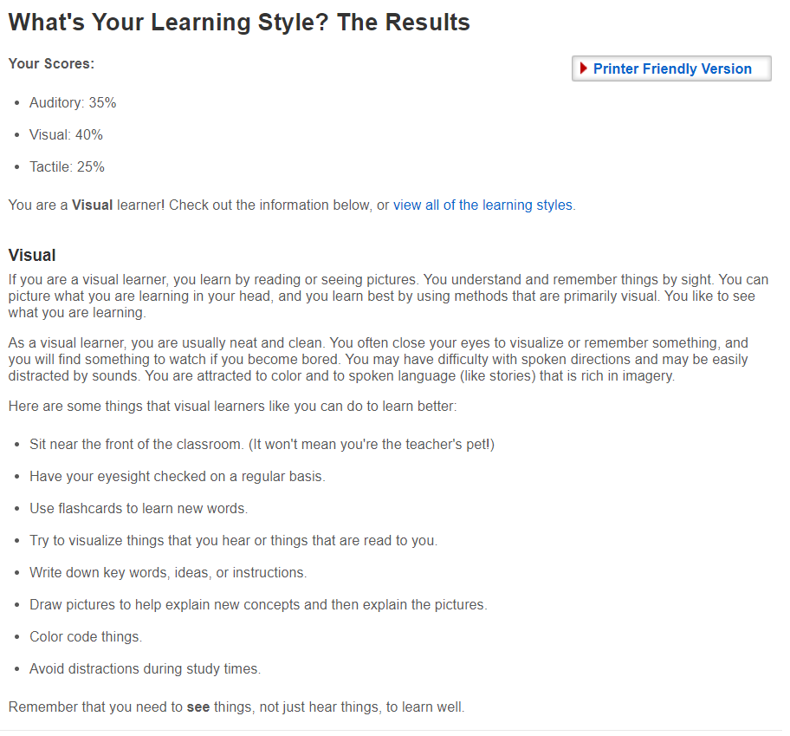

References
Gibbs, G. (1998) Learning By Doing : A guide to teaching and learning methods, Oxford: Further Education Unit, Oxford Polytechnic

Ikin Syamsudin Adeani, Bunga Febriani and Syafryadin Syafryadin (2020) ‘USING GIBBS REFLECTIVE CYCLE IN MAKING REFLECTIONS OF LITERARY ANALYSIS’, Indonesian EFL journal (Online), 6(2), pp. 139–148. Available at: https://doi.org/10.25134/ieflj.v6i2.3382.

Lejeune, C., Beausaert, S. and Raemdonck, I. (2021) ‘The impact on employees’ job performance of exercising self-directed learning within personal development plan practice’, International journal of human resource management, 32(5), pp. 1086–1112. Available at: https://doi.org/10.1080/09585192.2018.1510848.

Markkanen, P. et al. (2020) ‘A reflective cycle: Understanding challenging situations in a school setting’, Educational research (Windsor), 62(1), pp. 46–62. Available at: https://doi.org/10.1080/00131881.2020.1711790.

Newton P. M and Salvi A (2020) ‘How Common Is Belief in the Learning Styles Neuromyth, and Does It Matter? A Pragmatic Systematic Review’, Frontiers in Education (Lausanne), 5. Available at: https://doi.org/10.3389/feduc.2020.602451.

Perry, M. (2017) ‘Personal Professional Development Plans’, Canadian journal of medical laboratory science, 79(1), p. 8–.

Phadermrod, B., Crowder, R.M. and Wills, G.B. (2019) ‘Importance-Performance Analysis based SWOT analysis’, international journal of information management, 44, pp. 194–203. Available at: https://doi.org/10.1016/j.ijinfomgt.2016.03.009.

Pragmatist (no date) Cambridge Dictionary. Available at: https://dictionary.cambridge.org/dictionary/english/pragmatist (Accessed: March 23, 2023).

Sahabuddin, R. et al. (2018) ‘EFFECT OF VISUAL LEARNING STYLE AND SCHOOL CLIMATE ON STUDENTS’ ACHIEVEMENT OF LEARNING ENTREPRENEURSHIP AT SMKN 1 PALANGGA’, Journal of entrepreneurship education, 21(3), pp. 1–13.

Sanan Sh. Malo (2021) ‘Investigating Kurdish EFL Students’ Learning Styles at University Level’, مجلة جامعة كويه للعلوم الانسانية والاجتماعية, 4(1), pp. 104–109. Available at: https://doi.org/10.14500/kujhss.v4n1y2021.pp104-109.

Sekarwinahyu, M. et al. (2019) ‘Development of problem-based learning for online tutorial program in plant development using Gibbs’ reflective cycle and e-portfolio to enhance reflective thinking skills’, Journal of physics. (“Reflection on Oral Medication Administration - Eddusaver”) Conference series. Bristol: IOP Publishing, 1157(2), p. 22099–. doi: 10.1088/1742-6596/1157/2/022099.

