An investigation into the effect of Blast Furnace Cast House Emissions on Atmospheric Particulate (PM₁₀) Concentrations in Port Talbot

Georgina Brooks (P148174)
University of Wales Trinity Saint David
April 2018



Mount Pleasant, Swansea, SA1 6ED, Wales UK
Tel: (01792) 481000 Fax: (01792) 475037
www.uwtsd.ac.uk

Mount Pleasant, Abertawe, SA1 6ED, Cymru DU
Ffôn: (01792) 481000 Fax: (01792) 475037
www.uwtsd.ac.uk

Copyright

The copyright of this dissertation rests with the University of Wales Trinity Saint David. No information derived from this dissertation shall be published without the prior consent of the University.

Signed: ………………………………………………
Date: …………………………………………………

Mount Pleasant, Swansea, SA1 6ED, Wales UK
Tel: (01792) 481000 Fax: (01792) 475037
www.uwtsd.ac.uk

Mount Pleasant, Abertawe, SA1 6ED, Cymru DU
Ffôn: (01792) 481000 Fax: (01792) 475037
www.uwtsd.ac.uk

Author’s Declaration

I declare that the work in this dissertation was carried out in accordance with the regulations of the University of Wales Trinity Saint David. The work is original except where indicated by special references in the text and no part of the dissertation has been submitted for any other degree.
Any views expressed in the dissertation are those of the author and in no way represent those of the University of Wales Trinity Saint David.
The dissertation has not been presented to any other University for examination either in the United Kingdom or overseas.
I hereby give permission for my work, if accepted, to be available for photocopying and inter-library loan, and for the title and summary to be made available to outside organisations.

Signed: ………………………………………………
Date: …………………………………………………

Acknowledgements

The author would like to thank many people for their help and support during the development and writing of this dissertation.
Firstly, a huge thank you to Professor Chris House for his help in developing the research proposal and providing a great deal of support and advice throughout the writing process.
Secondly, a big thank you to the author’s colleagues at Tata Steel Strip Products UK, particularly Claire Grainger, Michael Launder and Andrew Townsend, for their help, advice and builds. Thank you also to Tata Steel Strip Products UK for funding the last three year’s study.
Finally, a very special thank you to the author’s partner Morgan Thorpe, wonderful parents Joanna Brooks, Gary Brooks, Maureen Thorpe and Michael Thorpe for their endless encouragement, support and love, without which this dissertation would not have been possible.

Abstract

Steelworks particulate emissions are known to create public concern. The residents of Port Talbot are identified as experiencing possibly the worst air pollution in the UK with a large area of Port Talbot designated an Air Quality Management Area for PM₁₀ (particulate matter less than ten microns in diameter). The research aim was to investigate the effect of Blast Furnace Cast House particulate emissions upon Port Talbot air quality by establishing the effect of these emissions upon PM₁₀ concentrations at various monitoring stations. This was supplemented by an investigation of PM₁₀ decay with distance from source and identification of the PM₁₀ trajectory path across Port Talbot. Meteorological parameter (wind direction, wind speed, relative humidity, rainfall and temperature) influence upon PM₁₀ concentrations was assessed and a decision tool developed for assigning a severity level for each Cast House emission considering risk of public exposure to elevated PM₁₀ concentrations. Time and date logged Cast House emission data was gathered (2013 to 2016) allowing a timeline of emissions to be created for plotting against meteorological and PM₁₀ data. A range of statistical techniques (linear regression, correlation coefficient and polynomial regression) were used to analyse the strength of relationships between the variables and pollution roses to identify the PM₁₀ trajectory. The AURN (Automatic Urban Rural Network) monitor was found to be most impacted by Cast House emissions - potentially contributing 0.66µg/m³ (at 200˚) and 0.47µg/m³ (at 210˚) to the background concentration. The Theodore Road monitor was found to be the least impacted. The highest PM₁₀ concentrations were found to impact the AURN from the south-south-west to south-west before travelling north to north-eastwards to impact the Theodore Road monitor, potentially deflected by the hills to the east of the town. Very weak statistical correlations were observed between each meteorological parameter and PM₁₀ making it clear that multiple meteorological variables, essential for understanding PM₁₀ dispersion and transportation, are not measured at the AURN. The worst case conditions for each meteorological parameter were established, in terms of contributing to elevated PM₁₀ concentrations at times of Cast House emissions. The statistical analysis was used to order the significance of meteorological parameters in the decision tool. This research contributes to the global debate on the effect of Blast Furnace particulate emissions upon nearby residential areas. The demonstrated effect of Cast House emissions upon PM₁₀ concentrations in Port Talbot justifies further detailed study into Blast Furnace operations globally and contributes to the conversation concerning the need for continuously improving pollution abatement technology, consistent tapping performance and the allocation of resources for further research to reduce emissions as far as possible across the world. The research methodology may be utilised for other installations where date and time data is available for process emissions. Suggestions for further work include incorporating missing meteorological variables into the analysis and investigation of emission mass and additional sources of PM₁₀, both within and outside the Steelworks boundary.

Table of Contents

Copyright i
Author’s Declaration ii
Acknowledgements iii
Abstract iv
Table of Contents v
List of Figures viii
List of Tables xi
List of Abbreviations xiii
1. Introduction 1
1.1 Establishing the Field 1
1.2 Previous Work in the Field 1
1.3 Rationale 2
1.4 Research Aim and Objectives 3
1.5 Contribution to Literature 4
2. Port Talbot AQMA and Cast House Emissions 5
2.1 Port Talbot AQMA and AURN 5
2.2 Iron Making at Port Talbot and the Blast Furnace Process 6
2.3 Integrated Steelworks and Blast Furnace Emission Contribution 7
2.4 Blast Furnace Cast House Emissions 7
3. Literature Review 9
3.1 Effect of Cast House Emissions 9
3.1.1 Quantifying Fugitive Emissions 10
3.1.2 Quantifying Cast House Fugitive Emissions 11
3.2 Distance from Source and PM₁₀ Trajectory Path 14
3.2.1 Distance from Source 14
3.2.2 Port Talbot Typography 14
3.3 Effect of Weather Conditions 16
3.3.1 Effect of Specific Weather Conditions 16
3.3.2 Missing Meteorological Variables 18
3.4 Decision Tool Development 19
3.4.1 Decision Tools in Air Quality Management 19
3.4.2 Pitfalls of Decision Tools 19
4. Methodological Review 20
4.1 Introduction 20
4.2 Effect of Cast House Emissions 22
4.3 Distance from Source and PM₁₀ Trajectory Path 24
4.4 Influence of Weather Conditions 25
4.4.1 Statistical Analysis 25
4.4.2 Atmospheric Stability 27
4.5 Decision Tool Development 28
5. Results and Discussion 29
5.1 Effect of Cast House Emissions upon Port Talbot Air Quality 29
5.1.1 AURN (Margam Fire Station) 29
5.1.2 Little Warren 31
5.1.3 Docks Monitor 32
5.1.4 Talbot Road 33
5.1.5 Theodore Road 35
5.1.6 Prince Street 36
5.1.7 Twll-yn-y-Wal Park 37
5.1.8 Dyffryn School 39
5.2 Influence of distance from source and Port Talbot PM₁₀ Trajectory 40
5.3 Influence of weather conditions upon PM₁₀ concentrations in Port Talbot 46
5.3.1 Influence of Wind Direction 47
5.3.2 Influence of Wind Speed 49
5.3.3 Influence of Temperature 51
5.3.4 Influence of Relative Humidity 53
5.3.5 Influence of Rainfall 55
5.3.6 Summary and Discussion - Statistical Analysis 57
5.3.6.1 Linear Regression 57
5.3.6.2 Correlation 57
5.3.6.3 Non-Linear Relationship Analysis 60
5.3.6.4 Polynomial Relationships - Discussion 66
5.3.6.5 Influence of Atmospheric Stability 66
5.4 Decision Tool Development 68
5.4.1 Introduction 68
5.4.2 Low to Very High Severity Weather Conditions 70
5.4.3 Creation of the Decision Tool 74
6. Evaluation and Conclusions 76
6.1 Assumptions 76
6.2 Limitations and Recommendations for Further Work 77
6.2.1 Purpose of the Decision Tool 77
6.2.2 Data Points 78
6.2.3 Missing Variables and Transboundary Pollution 79
6.2.4 Monitoring Location Weather Data 79
6.2.5 Investigation of Emission Mass 80
6.2.6 PM₁₀ Behaviour and Additional Sources 81
6.3 Conclusions 83
7. References 85
8. Bibliography 93

List of Figures

Figure Number | Figure Title | Page Number
Figure 1 | The Port Talbot AQMA | 6
Figure 2 | Analysis of Topographic Effect on Wind Flow across Port Talbot (AQEG 2011) | 15
Figure 3 | Analysis of Topographic Effect on Wind Flow across Port Talbot (AQEG 2011) – with area of interest highlighted | 15
Figure 4 | Locations of Port Talbot Air Quality Monitoring Network Monitors | 20
Figure 5 | Wind Sectors from which the Little Warren, Talbot Road, AURN and Twll-yn-y-Wal Park Monitors are impacted with PM₁₀ particles from the direction of the Blast Furnaces | 22
Figure 6 | Wind Sectors from which the Docks, Theodore Road, Prince Street and Dyffryn School Monitors are impacted with PM₁₀ particles from the direction of the Blast Furnaces | 23
Figure 7 | AURN and Theodore Road Monitor locations and the Wind Sector from which both monitors are impacted from the Blast Furnaces (190˚ to 200˚) | 24
Figure 8 | Location of Tata Steel Port Talbot in relation to the St. Athan Weather Station | 27
Figure 9 | AURN (Margam Fire Station) Monitor average PM₁₀ v Wind Direction | 30
Figure 10 | Little Warren Monitor average PM₁₀ v Wind Direction | 31
Figure 11 | Docks Monitor average PM₁₀ v Wind Direction | 33
Figure 12 | Talbot Road Monitor average PM₁₀ v Wind Direction | 34
Figure 13 | Theodore Road Monitor average PM₁₀ v Wind Direction | 35
Figure 14 | Prince Street Monitor average PM₁₀ v Wind Direction | 37
Figure 15 | Twll-yn-y-Wal Park Monitor average PM₁₀ v Wind Direction | 38
Figure 16 | Dyffryn School Monitor average PM₁₀ v Wind Direction | 39
Figure 17 | PM₁₀ Pollution Roses for the AURN and Theodore Road Monitors | 41
Figure 18 | AURN and Theodore Road Monitor Pollution Roses (full dataset) on Port Talbot Map | 42
Figure 19 | AURN and Theodore Road Monitor Pollution Roses with Trajectory Line (full dataset) | 42
Figure 20 | AURN and Theodore Road Monitor Pollution Roses (data collected at times of Cast House emissions) | 43
Figure 21 | Comparison of the AURN and Theodore Road Monitor Pollution Roses with 12th April 2016 data included and removed | 44
Figure 22 | Full Dataset Time Plot for the AURN Monitor (Daily Averages) | 46
Figure 23 | Average PM₁₀ Concentration v Wind Direction | 47
Figure 24 | Scatter Figure with Linear Regression Trend Line (PM₁₀ vs Wind Direction) | 48
Figure 25 | Summary Output of Linear Regression Analysis (PM₁₀ vs Wind Direction) | 48
Figure 26 | Average PM₁₀ Concentration v Wind Speed | 49
Figure 27 | Scatter Figure with Linear Regression Trend Line (PM₁₀ vs Wind Speed) | 50
Figure 28 | Summary Output of Linear Regression Analysis (PM₁₀ vs Wind Speed) | 50
Figure 29 | Average PM₁₀ Concentration v Temperature | 51
Figure 30 | Scatter Figure with Linear Regression Trend Line (PM₁₀ vs Temperature) | 52
Figure 31 | Summary Output of Linear Regression Analysis (PM₁₀ vs Temperature) | 52
Figure 32 | Average PM₁₀ Concentration v Relative Humidity | 53
Figure 33 | Scatter Figure with Linear Regression Trend Line (PM₁₀ vs Relative Humidity) | 54
Figure 34 | Summary Output of Linear Regression Analysis (PM₁₀ vs Relative Humidity) | 54
Figure 35 | Average PM₁₀ Concentration v Rainfall | 55
Figure 36 | Scatter Figure with Linear Regression Trend Line (PM₁₀ vs Rainfall) | 56
Figure 37 | Summary Output of Linear Regression Analysis (PM₁₀ vs Rainfall) | 56
Figure 38 | Correlation Matrix (AURN Full Dataset) | 58
Figure 39 | Correlation Matrix (Data collected at times of Cast House Emissions) | 59
Figure 40 | PM₁₀ and Wind Direction Polynomial Trend Lines - Quadratic (independent variables - x and x²), Cubic (independent variables - x and x³) and Higher Order Relationships (independent variables x and x⁴, x⁵ or x⁶) | 61
Figure 41 | PM₁₀ and Relative Humidity Polynomial Trend Lines | 62
Figure 42 | PM₁₀ and Rainfall Polynomial Trend Lines | 63
Figure 43 | PM₁₀ and Wind Speed Polynomial Trend Lines | 64
Figure 44 | PM₁₀ and Temperature Polynomial Trend Lines | 65
Figure 45 | AURN Monitor Radar Chart | 71
Figure 46 | Low to Very High Severity Conditions (Wind Direction) | 72
Figure 47 | Low to Very High Severity Conditions (Relative Humidity) | 72
Figure 48 | Low to Very High Severity Conditions (Rainfall) | 73
Figure 49 | Low to Very High Severity Conditions (Wind Speed) | 73
Figure 50 | Low to Very High Severity Conditions (Temperature) | 74
Figure 51 | Decision Tool Flow Chart | 75

List of Tables

Table Number | Table Title | Page Number
Table 1 | Research Objectives | 3
Table 2 | The Daily Mean Air Quality Objective | 5
Table 3 | Factors affecting whether Cast House Emissions are Generated | 8
Table 4 | Missing Weather Condition Definitions | 18
Table 5 | Wind Sectors impacting the Port Talbot Monitors from the direction of the Blast Furnaces | 22
Table 6 | Pasquill’s Stability Classes | 27
Table 7 | Decision Tool ‘Low’, ‘Medium’, ‘High’ and ‘Very High’ PM₁₀ Bands | 28
Table 8 | Comparison of PM₁₀ Concentrations for the AURN Monitor | 30
Table 9 | Comparison of PM₁₀ Concentrations for the Little Warren Monitor | 31
Table 10 | Comparison of PM₁₀ Concentrations for the Docks Monitor | 32
Table 11 | Comparison of PM₁₀ Concentrations for the Talbot Road Monitor | 34
Table 12 | Comparison of PM₁₀ Concentrations for the Theodore Road Monitor | 35
Table 13 | Comparison of PM₁₀ Concentrations for the Prince Street Monitor | 36
Table 14 | Comparison of PM₁₀ Concentrations for the Twll-yn-y-Wal Park Monitor | 37
Table 15 | Comparison of PM₁₀ Concentrations for the Dyffryn School Monitor | 39
Table 16 | Concentrations of PM₁₀ and Weather Conditions at times of Cast House Emissions – AURN and Theodore Road Monitors | 45
Table 17 | Linear Regression Analysis Results | 57
Table 18 | Correlation Coefficient Analysis Results | 58
Table 19 | Polynomial Regression Analysis Results | 60
Table 20 | Atmospheric Stability Analysis | 67
Table 21 | Mean, Minimum and Maximum PM₁₀ Concentrations for Low, Medium and High Severity Cast House Emissions | 68
Table 22 | Mean, Minimum and Maximum PM₁₀ Concentrations for Low, Medium and High Severity Cast House Emissions (200-210˚ Wind Band) | 69
Table 23 | Weather Conditions Contributing to Low, Medium, High and Very High PM₁₀ Concentrations at the AURN Monitor | 70
Table 24 | Assumptions | 76
Table 25 | Recommendation 1 | 77
Table 26 | Recommendation 2 | 78
Table 27 | Recommendation 3 | 79
Table 28 | Recommendation 4 | 79
Table 29 | Recommendation 5 | 79
Table 30 | Recommendation 6 | 80
Table 31 | Recommendation 7 | 80
Table 32 | Recommendation 8 | 81
Table 33 | Recommendation 9 | 82

List of Abbreviations

AQAP - Air Quality Action Plan
AQEG – Air Quality Expert Group
AQMA - Air Quality Management Area
AURN - Automatic Urban Rural Network
BF – Blast Furnace
BFs – Blast Furnaces
BF4 – Blast Furnace No.4
BF5 – Blast Furnace No.5
BOS – Basic Oxygen Steelmaking
CFD – Computational Fluid Dynamics
DEFRA – Department of Environment, Food and Rural Affairs
EIF – Environmental Incident Form
LAQM - Local Air Quality Management
LIDAR - Light Detection and Ranging Technology
NETCEN – National Environmental Technology Centre
NPTCBC - Neath Port Talbot County Borough Council
NRW – Natural Resources Wales
PM₁ ₋ Particles with measured diameters of less than one micron (1µm)
PM_{2.5 -} Particles with measured diameters of less than two and a half (2.5µm)
PM₁₀ ₋ Particles with measured diameters of less than ten microns (10µm)
TSP – Total Suspended Particulate

Introduction

1.1 Establishing the Field

Air pollution is described as the introduction of particulates, toxic and hazardous substances or biological organisms into the atmosphere, with around 50-70% of air pollution known to arise from industrial processes (DISA India 2013). Particulate emissions from Steelworks are known to create public concern (Guinot et al. 2016) and Port Talbot residents are identified as potentially experiencing the UK’s worst air pollution (AQEG 2011).

A large area of Port Talbot is located within an Air Quality Management Area (AQMA) for PM₁₀ (Hayes 2013). PM₁₀ is defined as inhalable dust particles with a diameter measuring less than ten microns (10µm) (Schwartz et al. 1996). The AQMA was designated on 1st July 2000, following Neath Port Talbot County Borough Council (NPTCBC) recognising the possibility of exceeding the daily mean air quality objective (Hayes et al. 2013; Hodges and Horne 2005). The objective is to ensure the twenty-four hour average PM₁₀ concentration does not exceed 50µg/m³ over thirty-five times per calendar year (Welsh Government 2012).

Long before the AQMA was designated, the health implications of PM₁₀ inhalation were widely known; including respiratory conditions, cardiovascular disease, birth defects and premature births, premature death and lung cancer (Pope 1989; Pope 1996; Pope at al. 1992; Seaton et al. 1995; Sharma and Patil 2016). Consequently, residential area particulate pollution is an area of extensive study – particularly in relation to industrial emissions (Suzdalev et al 1993). A NPTCBC source apportionment study highlighted the Steelworks as a key source of high PM₁₀ concentrations in Port Talbot (NPTCBC 2002).

1.2 Previous Work in the Field

Extensive literature has been published on particulate characterisation in the vicinity of integrated Steelworks globally (Hleis et al. 2013; Mohiuddin et al. 2014; Dai et al. 2015; Hleis et al. 2016). Many studies have concerned Port Talbot’s particulate concentrations and chemical composition of dust deposits (Passant et al., 2002; Moreno et al., 2004; Dall'Osto et al., 2008). In addition, research has sought to establish the impact of specific processing units (i.e. Blast Furnaces or Sinter Plant for example) elsewhere in the world (Pope 1989; Pope 1996; Hutchison et al. 2005; Mazzei and Prati 2009; Sajjadi at al. 2012) and more specifically, the processing units within Port Talbot’s Steelworks upon PM₁₀ concentrations in the town (Moreno et al. 2004; Hayes and Chatterton 2009; Hansard at al. 2012; Hleis et al. 2013; Taiwo 2014). However, there has been very little study of the effect of particular emission types (e.g. Blast Furnace Cast House emissions) and no studies have used date and time logged emission data to assess the emission impact upon the nearby monitoring network. Hodges and Horne (2005) found a possible association between the reduction in particulates emitted from a Port Talbot Cast House (Blast Furnace No.5) with installation of fume extraction and the reduction in PM₁₀ concentrations measured in the residential area during 2003 (year after installation). However, the reduction was not sustained in 2004.

1.3 Rationale

There is little published research into the effect of particulate emissions from individual Steelworks processes upon PM₁₀ concentrations in nearby residential areas (May 1977). However, a few internal studies have been conducted at the Port Talbot Steelworks concerning this subject area (Hodges 2005; Hodges and Horne 2005; Hodges et al. 2006). Hodges and Horne (2005) suggest further research is required concerning Port Talbot Steelworks emissions and breaches of the daily mean PM₁₀ objective. They also add, research is required to assess impacts of ‘short term emission incidents’. Blast Furnace (BF) Cast House emissions are considered to be such an emission incident and this research addresses this further work suggestion. In addition, Hodges (2005) advocates that resources for improving Port Talbot air quality require focussing upon reducing fugitive rather than point source emissions. Cast House emissions are one example of many fugitive emissions which may emanate from integrated Steelworks.

Research shows no two BF Cast Houses are identical, owing to differences in operational parameters, dimensions and proportions and, as a result, the amount of fume generated during casting (May 1977). For example, Boscolo and Padoano (2011) researched a BF in Italy, finding the Cast House generated on average 107.4t of total suspended particulate (TSP), which was reduced by 87.6t (based on an annual iron yield of 387000t) following fume extraction installation. However, there is no guarantee that BF4 or BF5’s particulate mass emission would be of the same order of magnitude as found by Boscolo and Padoano. Therefore, an individual study of Port Talbot Cast House emissions is necessary owing to these many potential differences. It should also be noted that this research is concerned with PM₁₀ rather than TSP owing to the AQMA for PM₁₀ in Port Talbot. Whilst the findings of the research presented here may not mirror findings of similar research on other BFs around the world (were such studies to occur), this research is important. A demonstrable effect of Cast House emissions upon PM₁₀ concentrations in Port Talbot justifies further detailed study into BF operations globally and contributes to global conversations concerning the requirement for continuously improving pollution abatement technology.

A literature review has revealed no research into the effect of specific weather conditions upon PM₁₀ concentration build-up and dispersion associated with Port Talbot BF Cast House emissions. Owing to the fact that each Cast House is different (May 1977) and Port Talbot has interesting typographical features (Hayes and Chatterton 2009; AQEG 2011) affecting the transportation and dispersion of PM₁₀, this research is justified, novel and contributes to global literature on the subject.

Globally, governments and organisations have aimed to minimise public exposure to PM₁₀ with implementation of legislative measures and guidelines (Barmpadimos et al. 2011), such as those currently in place in the Port Talbot AQMA. However, iron and steel production continues to increase with production rocketing from 800Mt in 2000 to 1.6Bt in 2014 (The Economist 2016). Therefore, improving BF pollution abatement and casting technology and operation to reduce emissions is vital in safeguarding global public health (Basu et al. 1996) as currently one tenth of deaths are attributed to poor air quality (World Bank 2016).

1.4 Research Aim and Objectives

The broad aim of this research was to investigate incidents of particulate (PM₁₀) emissions from the BF4 and BF5 Cast Houses and the effect of this particular type of emission upon Port Talbot air quality.

More specifically, this research comprises of the following objectives:
Table 1: Research Objectives

Objective 1 | To establish the effect of Blast Furnace Cast House emissions upon measured PM₁₀ concentrations recorded by the Port Talbot monitoring network.
Objective 2 | To identify the extent to which the concentration of PM₁₀ produced in a Cast House emission may decrease with distance and the trajectory of PM₁₀ across Port Talbot.
Objective 3 | To assess the influence of weather conditions upon measured PM₁₀ concentrations at the Automatic Urban Rural Network (AURN) monitor to allow the worst possible conditions for each meteorological factor to be ascertained in terms of contributing to elevated PM₁₀ concentrations at times of Cast House emissions.
Objective 4 | To develop a decision tool to aid those initiating an Environmental Incident Form (EIF) for a Cast House emission in assigning a severity level for the emission (i.e. low, medium, high or very high), with consideration to the analysis undertaken to fulfil Objective 3. This will allow for the consideration of risk of public exposure to elevated PM₁₀ concentrations and risk of breach of the daily mean PM₁₀ objective, rather than simply using the severity level to denote whether the emission is small, medium or large.

1.5 Contribution to Literature

This research contributes to global debate on the effect of BF particulate emissions upon nearby residential areas and adds weight to the justification argument concerning the need for continuous improvement and investment in casting technology and consistent tapping performance to reduce emissions globally. The research findings may be contextualised outside the steel industry to other sectors (e.g. quarrying) in which particulates are emitted. In addition, the methodology developed may be used to assess the effect of other industrial processes, where date and time process emission data is available, to identify the effect upon PM₁₀ concentrations. Further, this methodology can be utilised to assess road vehicle impact upon pollutant concentrations as many UK cities are part of the Automatic Urban Rural Network (AURN) of monitors - with data readily available for download (DEFRA 2017). The decision tool developed to aid Tata Steel personnel in assigning Cast House emission severity levels may be extrapolated for use in other BF operations around the world and contextualised for other Steelworks emission sources and other industries.

2. Port Talbot AQMA and Cast House Emissions

2.1 Port Talbot AQMA and AURN

Key sources impacting Port Talbot’s air quality include transport systems, construction industries and notably the Tata Steel operated Steelworks, all of which have a complex relationship with the area’s weather and topography (Hayes and Chatterton 2009; AQEG 2011). NPTCBC cite PM₁₀ concentrations as the first of four key environmental issues impacting the area, amongst traffic emissions, legacy industrial nickel and nuisance dust (NPTCBC 2013). NPTCBC is required to monitor atmospheric pollutants associated with UK air quality objectives, with the Local Air Quality Management (LAQM) regime laid down by the Environment Act 1995 (Part IV). If an objective is not met, an Air Quality Management Area (AQMA) requires designated and an Air Quality Action Plan (AQAP) is developed to restore compliance (NPTCBC 2013).

Table 2: The Daily Mean Air Quality Objective

Air Quality Objective | The objective of relevance in Port Talbot is not to exceed a PM₁₀ concentration of 50μg/m³ (daily mean) in excess of thirty-five times in any calendar year as per Directive 2008/50/EC and the subsequent transposition in the Air Quality Standards (Wales) Regulations 2010 (Welsh Government 2012). This objective has not been exceeded in Port Talbot since 2007, however, continued improvement is recognised as imperative in safeguarding public health (NPTCBC 2017).

The AQMA contains an AURN monitor for air quality legislation compliance monitoring and reporting. The AURN measures hourly a wide range of pollutants (including PM₁₀) and a suite of meteorological data, which is publically available via internet and electronic platforms (DEFRA 2017). The Port Talbot AQMA for PM₁₀ is presented in Figure 1.

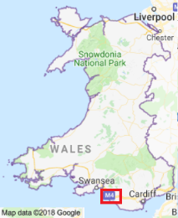
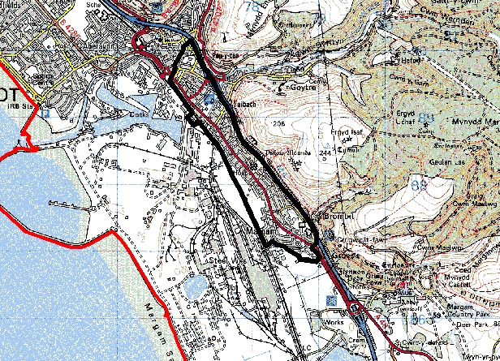

AQMA
Scale 2cm: 1km


Source: DEFRA (2002) © Crown copyright. All rights reserved. DEFRA. Licence No. GD272361 2002
Figure 1 – The Port Talbot Air Quality Management Area (AQMA)

2.2 Iron Making at Port Talbot and the Blast Furnace Process

Iron making in Port Talbot commenced in the 13th century, however, a Steelworks as we recognise it today has existed since 1902 (Tata Steel 2011). The Steelworks, which operates as part of Tata Steel Strip Products UK, is integrated in nature, consisting of Coke Making, Sintering, Iron Making, Steel Making, Continuous Casting and Rolling installations (Hleis 2013). Particulate matter emissions can be generated at various stages of iron and steel production (Masaitis 1998).
Iron making at Port Talbot takes place via the BF process (Taiwo et al. 2014), the principle method worldwide (Proctor et al. 2000). Raw materials are charged into the top of the BF and heated air blasted into the BF via the tuyere system. Over ~eight hours, the raw materials are converted into molten iron and slag via a series of chemical reactions. The molten iron and slag is tapped through the taphole in the hearth of the BF which is plugged with refractory clay. A taphole drill creates an opening and releases the flow of molten iron. Following tapping, the taphole is resealed with clay (Ricketts 2005). Large particulate emissions can be generated during this process with the majority captured via fume extraction systems installed on the Cast House (Basu, Sharma and Dhillon 1996). However, emissions can escape to atmosphere under certain conditions.

2.3 Integrated Steelworks and Blast Furnace Emission Contribution

Integrated Steelworks are known to emit PM₁₀ (Summat et al. 2006), likely at each production stage and potentially containing metals and metal oxides in varying concentrations (IFC 2007). Metallic particulate inhalation has been associated with cancer, pulmonary and cardiovascular system inflammation and organ damage, with research showing these effects being possible at a low atmospheric concentration (Geiger and Cooper 2010). Following global concern, many studies have sought to characterise particulate components of deposits sampled in the vicinity of integrated Steelworks (Hleis et al. 2013; Mohiuddin et al. 2014; Dai et al. 2015; Hleis et al. 2016). Studies have also been undertaken in Port Talbot, identifying the Steelworks as emitting a range of heavy metals (Passant et al., 2002; Moreno et al., 2004; Dall'Osto et al., 2008; Hleis et al. 2013). These studies support Hutchison et al. (2005) who found higher metal concentrations in particulate matter in samples taken downwind rather than upwind of the Redcar Steelworks (Northern England). These species were concentrated in the coarse fraction of the sample, suggesting the source(s) is fugitive in nature and a likely contributor to daily mean breaches. The findings of Hutchison et al. (2005) is supported by Hodges (2006) who found increased insoluble metal concentrations in particulate samples taken downwind of the Port Talbot BF area compared to upwind.
Research has sought to establish impacts of specific processing units (i.e. BFs or Sinter Plant for example) elsewhere in the world (Pope 1989; Pope 1996; Hutchison et al. 2005; Mazzei and Prati 2009; Sajjadi et al. 2012) and also in Port Talbot (Moreno et al. 2004; Hodges 2005; Hodges and Horne 2005; Hayes and Chatterton 2009; Hansard et al. 2012; Hleis et al. 2013; Taiwo et al. 2014) upon PM₁₀ concentrations in nearby residential areas. Hleis et al. (2013) cite BFs as a notable source of PM₁₀ which contribute to particulate concentrations in nearby towns and this has been found to be the case in Port Talbot (Moreno et al. 2004; Hodges and Horne 20005; Hayes and Chatterton 2009). Further, Taiwo et al. (2014) found 45% of PM₁₀ mass recorded at a local monitor was attributed to the Port Talbot Steelworks, with the largest proportion of the 45% originating from the BFs. Mazzei and Prati (2009) also found a 25-30% contribution to PM₁₀ concentrations from a BF in a nearby Italian town. The above studies provide justification for detailed investigation into Port Talbot BF emissions

2.4 Blast Furnace Cast House Emissions

BF particulate emissions can take different forms, most notably Cast House emissions (Douchanov 2002) which include graphite and iron oxide particles (IFC 2007). Emissions are predominantly generated in the initial and final stages – drilling and plugging the tap hole respectively (Boscolo and Padoano 2011) and arise when molten iron contacts the taphole and atmosphere. Factors affecting emission generation (May 1977) are presented in Table 3.

Table 3 – Factors affecting whether Cast House emissions are generated (May 1977)

Turbulence | The more turbulent the molten iron, the larger the emission is likely to be. A smoother and more controlled cast results in less fume to atmosphere.
Taphole Diameter | Too large a diameter results in a less controlled cast
Clay Quality | Quality clay is less likely to become eroded by molten slag and more likely to maintain an optimum taphole diameter
Taphole Angle | The taphole angle should be ideally 6-20˚ from horizontal. This creates a lower trajectory for the iron flow, allowing for closer fitting fume capture hoods in the trough area

Literature Review

3.1 Effect of Cast House Emissions

There is limited literature on the subject of the effect of Cast House emissions upon ambient air quality surrounding a Steelworks. Despite this, it has long been recognised across the world that there exists a need to prevent and mitigate Cast House emissions (May 1977). For example, in 1971, the Maryland State Bureau of Air Quality Control reached consensus that Cast House emissions from a Steelworks in the State made a substantial contribution to the elevated particulate concentrations observed (State of Maryland Bureau of Air Quality Control 1971 [cited in May 1977]). The research presented here is novel as no published research was found to use date and time stamped Cast House emission data to establish the impact of emissions upon PM₁₀ concentrations in a nearby town, let alone in Port Talbot. The studies discussed in this chapter are those most relevant to the subject area of this research.

In 2005, internal research conducted by Tata Steel, then Corus, (Hodges and Horne 2005) assessed the impact BF5 Cast House fume extraction installation (January 2003) had upon local PM₁₀ concentrations. Firstly, it is notable that the NETCEN monitor (located at the old Groeswen Hospital location) was particularly impacted with PM₁₀ from the direction of the BFs. The NETCEN site was located in fairly close proximity to the current locations of the AURN, Prince Street and Twll-yn-y-Wal Park monitors (shown in Figure 4). Hodges and Horne (2005) found an association between reduced particulate emissions from BF5 with the fume extraction installation and reduced PM₁₀ concentrations at the NETCEN in 2003. However, the reduction in PM₁₀ concentrations was not sustained in the following year. This finding is supported AQEG (2011) who suggest PM₁₀ concentrations were not noticeably reduced by the fume extraction installation. However, this should have been confirmed statistically by Hodges and Horne and the study improved substantially the analysis was continued for a longer period to understand why the reduction was not sustained. It is possible that either 2003 or 2004 were unusual years, potentially due to the existing meteorological factors. The influence of meteorological factors is discussed further in Section 3.3.

Boscolo and Padoano (2011) estimated PM₁₀ generated from multiple processes at a Steelworks in Servola, Italy (BF iron casting included) and the impact of retrofitting dust abatement to reduce emissions. Following installation of a Cast House fume extraction hood, Boscolo and Padoano (2011) report a PM₁₀ emission reduction of 23%. It should be acknowledged that every Cast House is different (May 1977), however, assuming the fume extraction installed on BF5 removed PM₁₀ of a similar order of magnitude to Boscolo and Padoano’s BF, it is reasonable to expect the overall trend of ambient PM₁₀ concentrations to decrease in the following years. Especially as the BF5 Cast House was identified by many sources (Welsh Environment Agency, NPTCBC and Corus) as an area in need of substantial improvement prior to fume extraction installation and a significant contributor to PM₁₀ concentrations at the NETCEN site (Tate et al. 2003). Therefore, Hodges and Horne (2005) can be criticised for the short study period of their research post fume extraction installation which could have impacted the reliability and validity of the results obtained. Hodges and Horne (2005) do suggest, however, further research is required to assess the impact of the ‘short term emission incident’, of which Cast House emissions are an example. This research presented here addresses this suggestion.

Further internal Tata Steel research (Hodges 2005) investigated an extensive list of particulate emission sources at the Steelworks and their impact upon PM₁₀ concentrations in Port Talbot. This allowed the contribution of each source (fugitive and point sources) to background PM₁₀ concentrations to be established. Hodges (2005) found fugitive sources (e.g. Cast House Emissions) had greater offsite impact, therefore, improvement activities should be focussed upon fugitive emission reduction. Hodges (2005) found Cast House emissions from BF4 and BF5 contributed 0.024µg/m³ and 0.012µg/m³ respectively (0.036µg/m³ combined) to background PM₁₀ concentrations at the NETCEN site. Hodges (2005) states the modelling was undertaken using best estimates for process emissions but acknowledges that significant uncertainties exist, especially for the fugitive sources studied. However, it is not outlined what these uncertainties are and their expected impact upon the results and conclusions. In addition to these pre-existing uncertainties, care should be taken when relying upon Hodges’ estimates today as much has changed since the 2005 modelling took place. BF4 has since been rebuilt with improved dust capture technology. Furthermore, the BF raw material mix has likely changed with a move towards increased granulated coal injection for cost efficiency (Bennett and Fukushima 2003). It must also be noted that the analysis was conducted using a single year’s meteorological data (2000). It is questionable why this should be the case, especially as it was likely not the most recent year of data available. One year’s data is not sufficient, especially considering the differences between 2003 and 2004 as found by Hodges and Horne (2005) which were potentially due to weather factors. Therefore, once again, care must be taken when relying upon the results and conclusions of this research. The research proposed here will analyse four years meteorological data to fulfil the research aim and objectives.

3.1.1 Quantifying Fugitive Emissions

Fugitive emissions are emissions which do not pass through a chimney, vent, stack or equivalent and include liquid vapour, gases and solid particulate matter (US EPA 1999). As they are unconfined in nature, fugitive emissions are notoriously difficult to capture and quantifiably measure (Mueller et al. 2013). Mueller et al.’s (2013) study concerned fugitive emissions generated during material movement (fly ash) rather than Cast House fugitive emissions which are of concern here. Generally, material movement emissions are estimated using emission factors derived from sampling. By comparison, Mueller et al. utilised advanced hourly particulate monitoring combined with collected meteorological parameter data (including atmospheric stability - discussed in Section 3.3.2) for input into a dispersion model. This allowed the researchers to quantify PM₁₀ and PM_{2.5} mass generated per volume of ash produced. The researchers also carefully considered the effects of other fugitive sources (e.g. road dust) in the vicinity of the fly ash process and took measures to remove their effects. The two sources of emission – fly ash and road dust – were difficult to separate due to their similar chemical signatures. Consequently, a CCTV information and statistical relationship coupled approach was derived but it was acknowledged that was not an ideal method as it led to uncertainties in the emission factors. However, it allow for isolation of emissions likely attributable to the fly ash process. It is possible that this approach led to overestimation of emissions, however, this is preferable to underestimating the threat of exposure for persons in the vicinity of the process. This issue requires serious consideration were this methodology to be applied to reviewing calculations for the contribution of Cast House emissions Port Talbot background concentrations (such as those derived by Hodges 2005). For example, there are many processes operating in the vicinity of the BFs which could contribute fugitive emissions and which would be very difficult to isolate from the fugitive emission being studied. This point is highlighted in Chapter 6 – Evaluation and Conclusions.

Despite the issues encountered, Mueller et al.’s study is successful in contributing to knowledge on a subject with very little pre-existing knowledge. In addition, the study can be praised for its meticulous consideration of meteorological factors. This level of consideration was not mirrored in the research of Boscolo and Padoano (2011). Towards the end of their research paper, Boscolo and Padoano (2011) make passing comments concerning potential effects of special and seasonal weather conditions at certain times of the year. It is possible that the lack of consideration of weather conditions confounded the study, as perceived air quality improvements may not have resulted entirely from retrofitted dust abatement but partly due to favourable weather conditions. For example, Hutchison et al. (2005) advocate wind direction was a key factor in explaining the results of their research into the effect of BF refurbishment on local air quality (northerly before refurbishment and south-westerly during and post refurbishment). Therefore, if meteorological factors are not fully examined, unsound conclusions may be drawn. This oversight is a substantial flaw in Boscolo and Padoano research and correcting this flaw should at least have been made as a suggestion for further work. They do, however, suggest that the PM₁₀ concentration data relied upon in the study be considered in greater depth. It is important to note that Boscolo and Padoano’s research work does specifically relate to Cast House emission estimation, therefore, its value cannot be underestimated due to the lack of research on the subject.

3.1.2 Quantifying Cast House Fugitive Emissions

A review of the literature reveals that technology is not currently available, and certainly not installed on BFs globally, to quantify particulate mass released in Cast House emissions. Researchers are generally forced to rely upon developing emission factors derived from sampling, time lapse photography and production data, and it is clear that this method has not changed significantly in the last forty years. For example, May’s research in 1977 utilised a similar methodology to that of Hodges and Horne (2005) and Boscolo and Padoano (2011) and an almost identical approach to Mueller et al. (2013).

Boscolo and Padoano estimated the TSP emanating from their BF of study amounted to 380t per annum, with approximately 270t per annum generated as fugitive emissions. Therefore, this figure is substantially contributed to by Cast House emissions (Douchanov 2002). In addition, the researchers estimated TSP emissions attributable to Cast House emissions, using a method similar to that of Mueller et al. (2013). This study considered other emission sources and developed emission factors for each of those sources (Pig Iron Casting Machine, Coking Plant and materials storage and handling). Therefore, the issue of isolating emissions, as occurred during Mueller et al.’s study, is not as serious an issue here as each source is considered in detail. Boscolo and Padoano have clearly selected the most significant sources of fugitive emissions in the area but there are other sources, such as the likely nearby sintering process which is a significant source of fugitive emission (Taiwo et al. 2014) but not considered. Therefore, it is suggested if updated emission factors were to be developed for the Port Talbot Cast Houses, this should not be done in isolation. All other significant sources of emission in the vicinity of the plant should be considered in parallel. Before installation of retrofitted dust abatement, the minimum, average and maximum Cast House fugitive emission was estimated as 66.1t, 107.4t and 247.9t respectively (based on annual yield of 387000t cast iron). It should be noted that these estimates refer to TSP rather than PM₁₀. Following installation, the emission factors were updated and the TSP emissions from the process were estimated to be reduced by 87.6t per annum.

The other aforementioned areas of the plant (Pig Iron Casting Machine, Coking Plant and materials storage and handling) also had improved equipment retrofitted and an attempt is made to consider the impact of all improvements combined upon PM₁₀ concentrations in the town. However, no attempt is made to consider the impact of each improvement individually. The conclusions drawn regarding offsite ambient air quality impact are decidedly lacking with statements made as to a general downwards trend (particularly in 2008 and 2009) in PM₁₀ concentrations and the number of breaches post retrofitting equipment. As discussed previously, no consideration is afforded to meteorological factors which could have impacted the results. However, the researchers do concede that the favourable trend of emission reduction in 2009 could have been partly attributable to a 40 day BF down period during quarter two, although the reduction was sustained in quarter one. Similarly to Hodges and Horne (2005), the study period post retrofitting is too short to conclude a sustained reduction in PM₁₀ concentrations. However, Hodges and Horne were able to conclude the contribution of Cast House emissions from BF5 to ambient PM₁₀ concentrations via a dispersion model, whereas Boscolo and Padoano were only able to make general observations of trends.

Technological advances aimed at measuring fugitive emission particulate loading have occurred in recent years, although the literature has not provided examples of this technology being utilised in a Steelworks environment, let alone deployed on a BF Cast House. For example light scattering technology devices have been developed which are capable of providing real time fugitive emission concentration measurements, but not the total particulate mass of the emission (Matta 2011). In addition, LIDAR (light detection and ranging) technology has been utilised to measure fugitive emission PM₁₀ concentration from arable farming operations (Holmen et al. 1998) and also from unpaved roads and a blower fan (Fitz et al. (2003). However, Chambers (2004) reports that LIDAR technology requires development in order to be utilised as a means of extracting mass particulate emission data from the measurements. Emission factors, meteorological data and production data are still required to ascertain the mass emission.

In recent years, optical remote sensing technology has developed which allows for real-time measurement of fugitive emission mass particulates when coupled with an anemometer. However, an algorithm for particulate matter light extinction profiles along the cross-section of the plume, emission factors and meteorological data are still required to quantify particulate mass (Du et al. 2011). Therefore, there is no technology or sampling device in existence which can, by a simple method, measure the entire mass of particulate matter, specifically PM₁₀, released in a Cast House emission, let alone a device that could withstand the harsh environment of the BF Cast House.

3.2 Distance from Source and PM₁₀ Trajectory Path

3.2.1 Distance from Source

It is widely agreed that fugitive PM₁₀ is deposited a short distance from its source following atmospheric suspension. By contrast, finer fractions (PM₁ and PM_{2.5}) are capable of transportation over very long distances – possibly thousands of kilometres (WHO 2006). This view is supported by Chow et al. (1999) whose Las Vegas PM₁₀ source apportionment study concluded the zone most impacted by PM₁₀ was within 1km of the fugitive source. Therefore, it is likely PM₁₀ emissions from the Steelworks are deposited in the Port Talbot residential areas, especially considering the typography and prevailing wind of the area (as described below) and the fact that an AQMA was deemed necessary in this location (NPTCBC 2013). As PM₁₀ particles are heavier than the smaller fraction particles, they do not remain suspended in the atmosphere for as long – approximately minutes up to a couple of hours. In comparison, the smallest particles can remain suspended in the atmosphere for many weeks (Ohmsen 2001; East Devon District Council 2015; Dylos Corporation 2018) This has been taking into consideration when developing the methodology described in Chapter 4. No literature could be found to dispute the above findings. A literature review concerning the effect of weather conditions upon PM₁₀ build-up and dispersion is discussed in Section 3.3.

3.2.2 Port Talbot Typography

Typographical conditions of the study area must always be considered (Sharan et al. 1996). It has been recognised that Port Talbot’s typography to the east (i.e. the hills) can at times alter the wind field with the wind direction recorded at monitoring stations not reflecting the general movement of PM₁₀ from the Steelworks direction (AQEG 2011). This is presented visually in Figure 2 which presents wind flow at 5m/s through Port Talbot as affected by the area topography using FLOWSTAR software (provided by David Carruthers - AQEG member, published in AQEG 2011). In addition, Figure 3 shows the same map (with the area of interest highlighted) which shows the wind direction alter from south-westerly to northerly, potentially deflected by the hills. This analysis only presents the trajectory of wind flow at 5m/s, therefore, it is not clear what the impact would be at very high or very low wind speeds. AQEG’s work does, however, make it very clear that PM₁₀ unlikely travels in straight lines across Port Talbot and this is without accounting for the effect of various obstacles and heat sources in the area as acknowledged by Hayes and Chatterton (2009). The literature review did not provide any research to dispute the conclusions of AQEG (2011) or Hayes and Chatterton (2009) discussed here.

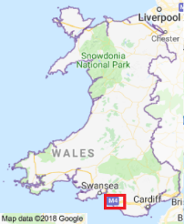

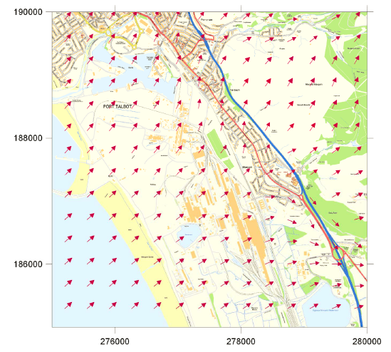
Scale 2.5cm: 1km
Figure 2 – Analysis of topographic effect on wind flow across Port Talbot - provided by David Carruthers (AQEG member) published in (AQEG 2011).

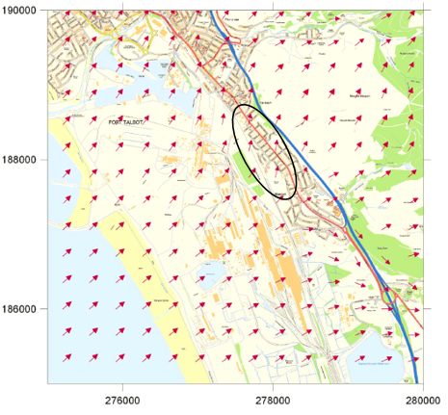
Scale 2.5cm: 1km
Figure 3 – Analysis of topographic effect on wind flow across Port Talbot published in (AQEG 2011) – with area of interest highlighted.

3.3 Effect of Weather Conditions

PM₁₀ dispersion and transport from source to neighbouring areas and subsequent removal is heavily dependent upon meteorological conditions in the area (Dayan and Miller 1989; Goel and Trivedy 1998; Sharan et al. 1996). This view is supported by Hayes et al. (2013) who explain that in order for air quality data analysis to be meaningful, weather conditions must be fully considered during data interrogation. Therefore, it is essential that meteorological data gathered from within the vicinity of the fugitive emission source of study (BF Cast Houses) is used when determining the effect upon PM₁₀ concentrations (Hayes and Chatterton 2009). Data for the following AURN measured weather conditions (wind direction, wind speed, temperature, humidity and rainfall) is compared with PM₁₀ emissions associated with Cast House operations in Chapter 5 – Results and Discussion. These factors are acknowledged by Jayamurugan et al. (2013) as governing pollutant concentrations in ambient air.

3.3.1 Effect of Specific Weather Conditions

Studies have found atmospheric PM₁₀ to be influenced by wind direction, and this is also the case in Port Talbot. AQEG (2011) report that PM₁₀ concentrations are generally higher when monitors are impacted from the direction of the Steelworks. As previously discussed, studies show particulate concentrations to be increased in samples taken downwind of a Steelworks compared to upwind (Hutchison et al. 2005; Hodges et al. 2006). A review of the literature reveals a lack of published results of the statistical significance of the relationship between wind direction and PM₁₀. However, were such results available for locations around the world, the significance found elsewhere would not necessarily be applicable to Port Talbot owing to differences in industrial landscape, typography and meteorological factors.

In the wider industrial sector, research advocates for the joint influence of wind direction and speed (Ayanlade and Oyegbade 2016). Hayes and Chatterton (2009) suggest this is also the case in Port Talbot. Their study found key Steelworks PM₁₀ sources were not in the immediate vicinity of the AURN with wind speed playing a key role. Therefore, suggesting re-suspended dust from stockyards or grounded stack plumes as key sources. However, the subsequent work of Taiwo et al. (2014) contests this, concluding the BF process as the main source. This suggests that key sources can be within close proximity to the monitor depending on current wind speed. In addition, these studies were conducted many years apart, in which time improvements have been made to stockyard fugitive dust management.
The literature generally agrees that particulate concentrations build-up in the atmosphere during low wind speed conditions. For example, Filonchyk et al. (2016) observed negative correlations of varying significance (depending on the Chinese city of study) between particulate concentrations and wind speed (the lower the wind speed the higher the particulate concentration). Czernecki et al. (2017) supports this, also finding a negative relationship, albeit rather weak, between average daily wind speed and PM₁₀. This study could have been improved by utilising hourly rather than daily average wind speed data as it allows for more precise and reliable analysis to be undertaken (Suh and Choi 2017).

Despite these findings, high PM₁₀ concentrations associated with Cast House emissions may not be realised at the Port Talbot monitors during very low wind speeds. This is supported by Ohmsen (2001) who considered thermal effect upon plume buoyancy at a Lead Smelting Plant BF. Ohmsen found BF fugitive emission dispersion is controlled by thermal effects and wind mobilisation. At very low wind speeds, Cast House emissions become buoyant due to thermal effects. However, at higher speeds (exceeding 2m/s) emissions remain closer to ground level and impact local monitors. Studies have also considered high wind speed effect, which are found to transport pollutants into the area from afar (Giri et al. 2008). AQEG (2005) also offer support, finding similar occurrences in the UK, with gales contributing elevated particulates due to sea spray transportation (AQEG 2005).
Substantial literature exists on the combined effect of PM₁₀ concentrations and ambient temperature upon mortality and respiratory health (Ren et al. 2006; Wu and Zhang 2009; Li et al. 2012; Wu et al. 2014). However, there is far less research into the statistical relationship between the variables and no research was found concerning the worst case temperature range for atmospheric PM₁₀ build up. Therefore, the research presented here is novel in that regard. Li et al. (2015) found negative correlations of fair significance between particulate concentrations and temperature over a summer in Shijiazhuang. This is supported by Czernecki et al. (2016) who made a similar finding in Poznan, Poland. However, Filonchyk et al.’s (2016) findings contrast with these studies as either weak/very weak positive linear relationships were found in some Chinese cities and no obvious relationships were found in others. These studies were not carried out in the same location, therefore, it is unlikely that the same results would be obtained owing to geographical and meteorological differences. The season in which the study takes place is also significant, with seasonal effects observed by Tai et al. (2010).
The subject literature agrees that rainfall and high relative humidity removes atmospheric pollutant particles (Seinfeld and Spyros, 1998; Hayes and Chatterton 2009) with studies observing a ‘washing effect’ evidenced by the negative correlation found i.e. the higher the rainfall/humidity level, the lower the PM₁₀ (Shaheen et al. 2005; Giri et al. 2008). In Giri et al.’s study of the Kathmandu Valley, the negative correlation observed between rainfall and PM₁₀ was not significant, yet the negative correlation between humidity and PM₁₀ was the most significant of all meteorological variables studied. This study is very important in the context of this research as it explores the worst case humidity range for elevated PM₁₀, which was found to be 40-60%. Between this range, particles gather mass, meaning they remain at ground level rather than becoming airborne. The worst case meteorological conditions for contributing to elevated PM₁₀ is a research area which is severely lacking in published literature.
The statistical relationship between rainfall and PM₁₀ was also researched by Yoo et al. (2014) who found statistically significant negative correlation and therefore, a stronger relationship than observed by Giri et al. (2008). This was once again attributed to a washing effect, supporting Giri et al. (2008) and Shaheen et al. (2005). Yoo et al. (2014) found PM₁₀ to be suppressed most effectively of all pollutants studied (PM₁₀, CO, NO₂, SO₂ and O₃).

In contrast to Giri et al.’s (2008) findings, Filonchyk et al. (2016) found a weak positive correlation between relative humidity and PM₁₀ in one area of China and no relationship in the remaining study areas. The lack of consensus does not make either study less valid and is likely due to the differing study locations and, therefore, differences in climates and weather systems. The work of Csavina et al. (2014) offers an explanation as to why weak relationships were observed in the previous studies. Csavina et al. (2014) advocate for the combined influence of factors (relative humidity and wind speed in this case) in determining PM₁₀ concentrations, as individually no relationship was observed. This is validated by Pasquill (1961) who reports on the existence of many interdependencies in meteorological processes. Therefore, it is unlikely that consideration of just two variables at once will reveal significant relationships. The consideration of multiple and interdependent variables is outside this research scope but is suggested for further work in Chapter 6 – Evaluation and Conclusions.
This literature review has revealed no research concerning weather condition effects upon PM₁₀ concentrations associated with Cast House emissions. Considering that each Cast House is different (May 1977) and Port Talbot’s interesting typographical features (Hayes and Chatterton 2009; AQEG 2011) affecting PM₁₀ transportation and dispersion, this research is justified, novel and contributes to the global subject literature.

3.3.2 Missing Meteorological Variables

The US Bureau of Land Management (1994) identifies three key variables known to affect pollutant dispersion - transport wind speed, mixing height and atmospheric stability as defined in Table 4. These factors are not measured in Port Talbot.
Table 4 – Missing Weather Condition Definitions (US Bureau of Land Management 1994)

Transport Wind Speed | Measure of the atmosphere’s ability to horizontally move the pollutant of interest away from its source
Mixing Height | Vertical distance the air is able to mix through
Atmospheric Stability | The air’s tendency to vertically mix through the atmosphere

Zoras et al. (2006) concur that atmospheric stability is an extremely important variable, particularly in areas with complicated typography, such as Port Talbot (AQEG 2011). Barmpadimos et al. (2011) add wind gusts to the list of significant variables, owing to the information provided on atmospheric stability and mixing which mean wind speed cannot provide. This research could be vastly improved if these missing variables were added to the suite of analysis undertaken by the Port Talbot monitoring network. This would allow their impact upon Cast House emission transportation and dispersion to be assessed to inform the literature. The literature review revealed no research considering the impact of these variables upon Port Talbot PM₁₀ behaviour and certainly not in relation to Cast House emissions. Recommendations concerning this issue are outlined in Chapter 6 – Evaluation and Conclusions.

3.4 Decision Tool Development

3.4.1 Decision Tools in Air Quality Management

Decision tools can have many applications, for example, Ghenai and Lin (2006) suggest dispersion modelling outputs should be fed into decision tools. Here, a tool was used to determine required levels of decontamination prior to decommissioning activities. Decision tools can also be a useful component of air quality management with tools being used in varied applications. For example, Pantazaras et al. (2018) developed a tool for a University Facility Manager to balance energy consumption and indoor air quality by establishing relationships between many factors - CO₂ set point, occupancy, cooling load and ventilation rate. Additional applications include aiding city planners in balancing pedestrian wind comfort and air quality (Fan et al. 2017) and developing tools for urban area air pollution reduction (Frumau 2015). There is no evidence in the literature, however, of a tool being used to assess emission severity from industrial plants, let alone Cast Houses. Therefore, this application is novel and contributes to knowledge in this field.

3.4.2 Pitfalls of Decision Tools

It is acknowledged that decision tools tend to focus upon the problem faced rather than paying attention to solutions (Liu et al. 2006). Therefore, the author deems it important that the decision tool developed in this research is utilised by Tata Steel and other interested parties to work towards a solution. As discussed further in Chapter 6 – Evaluation and Conclusions, it is suggested the tool is utilised to justify environmental process improvements and to inform the local air quality notification system (airAware).
There is a risk of introducing subjectivity into decision tools. When navigating a decision tool, the answers arrived at should be based on fact rather than individual perceptions which vary significantly with experience. Subjectivity introduces bias, inaccuracy and uncertainty, making it unlikely that two users would achieve the same results under exactly the same conditions (Redmill 2002). It is also important that tools are simple and easy to understand (Harding 2003) to ensure that they are used and incorporated into daily management.

Methodological Review

4.1 Introduction

This chapter outlines the chosen and most appropriate method for answering the research aim and objectives stated in Chapter 1 - Introduction. Publically available AURN PM₁₀ and meteorological data and PM₁₀ data from additional local monitors was collected from the Welsh Air Quality Forum and NPTCBC Pollution Monitoring websites. Currently, meteorological data is only available for the AURN monitor. Site specific Little Warren wind data is available however due to its coastal location. Due to this limitation, it has been necessary to extrapolate AURN meteorological data to other monitor locations. For example, in Chapter 5 Part 3, AURN wind date was used to create pollution roses for the Theodore Road monitor. This is not ideal, with Noon (2000) advocating that local geography can influence meteorological factors, especially wind speed. Wind speeds recorded at one monitor are not necessarily the same at another monitor within close proximity due to local funnelling or wind obstructing features. Overton (2009) supports the view that site specific data is preferable, adding that a monitor’s recorded data is specific to the location in which it is recorded, meaning the data only offers information of variations and changes in that location. This issue is discussed further in Chapter 6 – Evaluation and Conclusions.


With the exception of the Prince Street monitor (operated by Natural Resources Wales [NRW]), the monitoring network is operated and maintained by NPTCBC (NPTCBC 2018). The monitor locations are presented in Figure 4.
Scale 2.5cm: 500m

Microsoft product screen shot reprinted with permission from Microsoft Corporation. © 2017 Microsoft
Figure 4 – Locations of Port Talbot air quality monitoring network monitors

The period 1st January 2013 to 31st December 2016 was selected for study in order to fulfil the research aim and objectives. Studies considered in the literature review (Hutchison 2005; Mazzei and Prati 2009; Filonchyk et al. 2016; Czernecki et al. 2017) collected their own data over a relatively short time period i.e. months rather than years. Therefore, they were constrained by the time allowed by their sampling campaign with the risk of concluding findings which are potentially unrepresentative.
By downloading data from the official AURN network and NPTCBC/NRW operated monitors, this research benefits from an extensive bank of data for trending over a prolonged time periods. This is similar to the approach of Pope (1989) and Pope (1996) who acquired data from the Utah Bureau of Air Quality. Official data is also preferable as it is reviewed and verified by third party experts who remove erroneous data. Zoras et al. (2006) adopted a similar approach to that described here, collecting hourly PM₁₀ and meteorological data over two years to identify the atmospheric conditions which contribute to the highest recorded PM₁₀ concentrations in Northern Greece. In addition, many years’ data was collected by Barmpadimos et al. (2011) who extensively studied meteorological influences upon PM₁₀ in multiple monitoring stations. The methods of analysis undertaken in these example studies is discussed below.

Data prior to 2013 were not analysed due to the Environmental Incident Form (EIF) reporting system being introduced by Tata Steel Port Talbot in late 2012. An EIF is an online reporting form utilised for recording environmental incidents. Between 2013 and 2016, Cast House emissions accounted for a large proportion of EIFs recorded. Objective 1 of this research was to investigate the effect of BF4 and BF5 Cast House emissions upon PM₁₀ concentrations recorded by the monitoring network.

4.2 Effect of Cast House Emissions

To fulfil this objective, it was first necessary to establish the wind direction bands from which each monitor is impacted from the BFs. The outcome of this investigation is presented in Table 5 and a visual representation is provided by Figures 5 and 6.
Table 5 – Wind Sectors impacting the Port Talbot Monitors from the direction of the Blast Furnaces
Monitor Name | Wind sector from which the monitor is impacted from the direction of the Blast Furnaces
Little Warren | 100-120˚
Docks | 140-160˚
Talbot Road | 170-190˚
Theodore Road | 180-200˚
AURN (Margam Fire Station) | 190-220˚
Prince Street | 230-270˚
Twll-yn-y-Wal Park | 260-290˚
Dyffryn School | 280-300˚
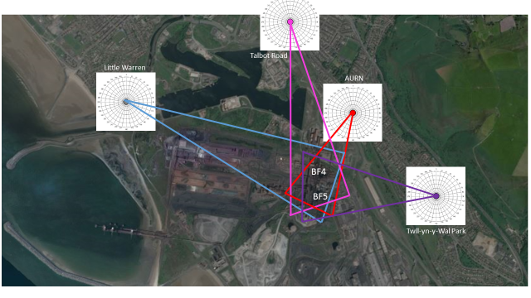
Microsoft product screen shot reprinted with permission from Microsoft Corporation. © 2017 Microsoft
Figure 5 - Wind sectors from which the Little Warren, Talbot Road, AURN and Twll-yn-y-Wal Park monitors are impacted with PM₁₀ particles from the direction of the Blast Furnaces.

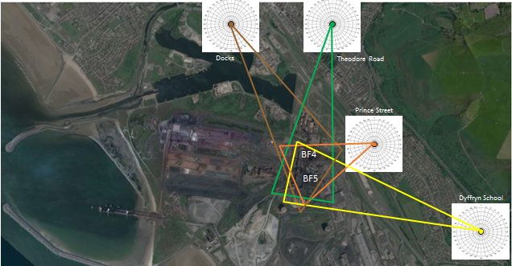
Microsoft product screen shot reprinted with permission from Microsoft Corporation. © 2017 Microsoft
Figure 6 - Wind sectors from which the Docks, Theodore Road, Prince Street and Dyffryn School monitors are impacted with PM₁₀ particles from the direction of the Blast Furnaces.

Pivot charts were then used to compare the average PM₁₀ concentration for each 10° wind sector for the whole dataset (2013- 2016) against the average PM₁₀ concentration for each 10° wind sector at times when Cast House emissions were reported (via EIFs) over the same time period. Finally, the average results were compared to the average PM₁₀ concentrations for each 10° wind sector at times when no Cast House emissions were reported. This process was repeated for all eight monitors. The literature review has informed chosen method with the assumption being made that if Cast House emissions reach the monitoring network, they would do so within the hour in which it occurred. This view is supported by research finding atmospheric PM₁₀ remains suspended for only a short time – minutes up to a few hours (Ohmsen 2001; Dylos Corporation 2018).

The comparison of average PM₁₀ concentrations for each wind sector for the whole dataset against the average concentrations at times of Cast House emissions demonstrates the impact of the emission upon the monitor. The second comparison (to average PM₁₀ concentrations at times when no Cast House emissions are recorded compared to the whole dataset) is used to quantify the potential contribution of Cast House emissions to the average background PM₁₀ concentration at the monitor (2013-2016). This analysis is presented in Section 5.1. This analysis is used to establish which of the eight monitors are impacted (and to what extent) by Cast House emissions. A monitor is deemed as impacted if PM₁₀ concentrations at the monitor (from the direction of the BFs) are higher at times of Cast House emissions compared to times of no emissions and the full dataset average for the respective wind sector. Cast House emissions are deemed as contributing to background concentrations if average PM₁₀ concentrations for the whole dataset (from the direction of the BFs) are higher than the average concentrations at times of no emissions.

4.3 Distance from Source and PM₁₀ Trajectory Path

The AURN and Theodore Road monitors were selected for further analysis to assess the extent to which PM₁₀ released in Cast House emissions decreases in concentration with distance and the potential trajectory taken by the emission across Port Talbot. These monitors were selected because the results presented in Section 5.1 demonstrate that the AURN is the most impacted by Cast House emissions of all the monitors, whilst the Theodore Road monitor is impacted the least. At a glance, it is not clear why this should be the case as both monitors are impacted from the BFs from approximately 190˚ to 200˚ and the monitors are not a great distance apart (approximately 700m).
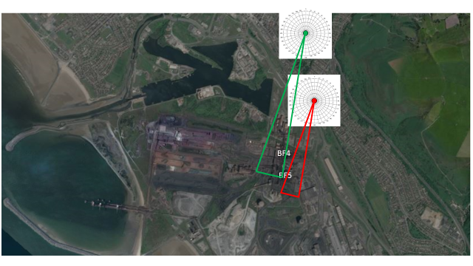
Pollution roses were plotted to depict spatially how PM₁₀ impacts each monitor, presented in percentiles (10th to 99th). Pollution roses are used in many applications to highlight directions of key pollutant sources (Hodges et al. 2006). A comparison is made between the whole dataset (2013 to 2016) for the AURN and Theodore Road monitors and also between the data collected at times of Cast House emissions. The trajectory of PM₁₀ is then identified and consideration given to weather conditions and other factors to consider why the AURN is impacted but the Theodore Road monitor is not. It must be noted that weather data is only available for the AURN monitor and not the Theodore road monitor. The AURN and Theodore Road monitor locations and the overlapping wind sector (190˚ to 200˚) are presented in Figure 7.
Microsoft product screen shot reprinted with permission from Microsoft Corporation. © 2017 Microsoft
Figure 7 – AURN and Theodore Road monitor locations and the wind sector from which both monitors are impacted from the Blast Furnaces (190˚ to 200˚)

4.4 Influence of Weather Conditions

Weather conditions (wind direction, wind speed, temperature, relative humidity and rainfall) are considered in the distance from source analysis but taken further in Section 5.3 to establish their impact upon PM₁₀ for the whole dataset and also their relationship with PM₁₀ at times of Cast House emissions. The AURN was selected for this further analysis as it is the monitor gathering the most weather data. In addition, the daily mean PM₁₀ objective is set upon the AURN monitor. This research executes a very similar approach to Middleton and Dixon (2001) who meticulously studied hourly meteorological data from multiple UK AURN sites to allow the correlation with various pollution events to be established. Here, the same approach is used to establish the effect of AURN meteorological data upon PM₁₀ emissions associated with Cast House operations. Middleton and Dixon (2001) do carry out statistical analysis upon their dataset, however, this is only to assess the frequency of certain weather conditions rather than taking the analysis further to establish the relationship between PM₁₀ and each meteorological factor as described in Section 4.4.1.
Pivot charts are used to identify average PM₁₀ concentrations for each isolated weather factor (e.g. temperature). Each weather factor has been banked, with the average PM₁₀ concentration for each bank of data (e.g. 12.1° to 13.0° for temperature) being established. In addition, scatter charts are used to plot the PM₁₀ concentrations and meteorological conditions at play at times of Cast House emissions.

4.4.1 Statistical Analysis

Statistical analysis methods aim to quantifiably establish the effects of a study and whether it can be confidently concluded that the effect in the observed sample is representative of the whole (Townend 2002). Correlation (correlation coefficient and correlation matrix analysis), linear regression and polynomial regression analyses have been undertaken in this research, to establish the relationship between PM₁₀ and weather conditions at times of Cast House emissions. This method is validated as it has been used in recent studies concerning similar subject matter. For example, Filonchyk et al. (2016) undertook analysis to determine if linear relationships existed between particulate concentrations and various weather conditions in numerous Chinese cities over three month period. This study period is considered to be rather short to ascertain if relationships exists and whether the significance of the relationship observed is truly representative of pollutant and meteorological conditions in the areas of study. By contrast, the research presented here uses four years’ worth of hourly data to ensure the statistical analysis is representative of conditions in Port Talbot. A further recent study utilising this method of statistical analysis to fulfil a similar research aim is that of Czernecki et al. (2017) who analysed the influence of atmospheric conditions upon PM₁₀ in Poznań, Poland over a much longer period (2006–2013). A linear regression analysis technique was also employed by Pantazaras et al. (2018) to assess the relationship between the variables of interest before feeding the resulting information into a decision tool for staff utilisation in a very similar way to the method presented here, thereby providing validation for the method proposed.
Correlation matrices for the whole data set and data collected at times of Cast House emissions are created using R Studio® software (‘corPlot’ function). This method shows by three means the correlation between all variables at once. Firstly by colour, ranging from red to green in traffic light fashion which red representing the strongest correlation. Secondly by shape, with ellipses representing strong correlation and circles representing little to no correlation. Finally, the numerical values represent the r value e.g. 90 equating to an r value of 0.9 and a strong correlation. The perfect line of positive correlation is plotted on the matrix at 45˚. Correlation matrices are an effective way of understanding relationships between many variables quickly and in a very visual way to ease interpretation (Carslaw 2015).
Barmpadimos et al. (2011) remind us that relationships between PM₁₀ and meteorological factors can in fact be non-linear, and this was also found to be true in this research. The 2011 study considered the effect of meteorological factors separately (the same approach taken as presented here) however, a generalised additive model (GAM) was used to analyse the non-linear relationships. A GAM was not selected as a method of analysis for this research as it was beyond the resources of the study. This research, however, utilises polynomial regression analysis to investigate the existence of non-linear relationships between the variables ranging from 2nd order to 6th order polynomial regression as described below. Polynomial regression analysis allows for the analysis of the relationship between two variables in Microsoft Excel without the need for a complex model. GAMs are, however, an effective and flexible means of determining non-linear relationships in many applications (Dominici et al. 2002). However, issues such as trend overfitting (Wood 2008) and prediction error when considering a significant number of smoothing parameters (Reiss and Ogden 2009) can occur.

The polynomial regression analysis undertaken in this research used not only the x value but also the x² as independent variables. The significance of the r value shows whether a quadratic relationship exists between the x and y variables. By extension, a third independent variable was then added (x³) to assess if a cubic relationship existed between x and y. Further independent variables (x⁴, x⁵ and x⁶) were also added and best-fit curves added to the scatter plots. A review of the literature has revealed this technique is not used frequently to assess non-linear relationships between PM₁₀ and meteorological factors. However, this technique has been used in the field of PM₁₀ prediction models, with a 2nd order polynomial regression analysis being used by Janssen et al. (2008) to identify the relationship between aerosol optical depth data and PM₁₀ in-situ measurements. This method of analysis provides complex equations for the y value which are useful in the development of mathematical models. However, it must be noted that this form of analysis is of little help in explaining the chemical, physical or biological mechanisms at play in a given relationship (Townend 2002). However, this method was very useful in ordering the meteorological factors by significance in the decision tool described in Section 4.5. Further advantages and pitfalls of polynomial regression analysis are discussed in Section 5.3.

4.4.2 Atmospheric Stability

Pasquill Atmospheric Stability Class data is also examined and discussed in this research. This data is not available for Port Talbot, with the most local station recording this data located at the St Athan MET Office Weather Station, approximately 26 miles south-east of Port Talbot (51.405, -3.440). The location of the St. Athan station in relation to the Port Talbot Steelworks is shown in Figure 8.
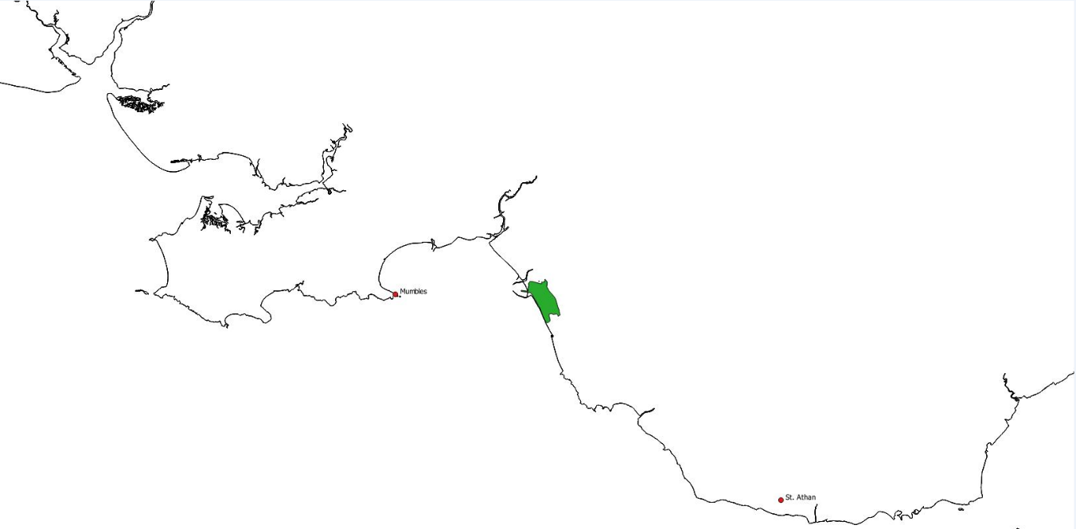
Scale 1.5cm: 10km
Port Talbot Steelworks
St. Athan
Mumbles
Contains OS data © Crown copyright and database right 2018
Figure 8 – Location of Tata Steel Port Talbot in relation to the St. Athan Weather Station

Six Pasquill Stability Classes (Pasquill 1961) are utilised to categorise the atmospheric turbulence, which range from A (most turbulent) to F (least turbulent). Pasquill’s Stability Classes and the conditions which define the classes are presented in Table 6.
Table 6 – Pasquill’s Stability Classes
Stability Class | Definition
A | Very Unstable
B | Unstable
C | Slightly Unstable
D | Neutral
E | Slightly Stable
F | Stable
The Pasquill data for 2016 was obtained from the MET Office. It is not advisable to extrapolate the St. Athan data to the AURN, as highlighted by Noon (2000) and Overton (2009), owing to the significant distance between the monitors, differences in typographical conditions between the two locations and the different weather systems likely in existence. However, the data is useful in indicating the general atmospheric stability of the South Wales area during 2016, with the percentage of time in each class over the year being established.

4.5 Decision Tool Development

The method of decision tool development described here is similar to that of Pantazaras et al. (2018) as both pieces of research required the strength multiple relationships to be established before the information could be integrated into a decision tool. Here, the relationship between PM₁₀ and meteorological factors at times of Cast House emissions is required (as described in Section 4.4) to establish the worst case (‘very high’ severity rating) conditions for each meteorological factor - in terms of contributing to elevated PM₁₀ concentrations at times of Cast House emissions. In addition, the conditions required for ‘low’, ‘medium’, and ‘high’ severity ratings are also established. The outcome of this investigation was then fed into a decision tool for assigning emission severity. Currently, Cast House emission severity is assigned based on operational conditions and the volume of dust generated as perceived by the observer - which is experience dependent. The proposed decision tool will aid the Cast House emission observer to assign emission severity (which is required on the EIF) with consideration to risk of public exposure to elevated PM₁₀ concentrations and also risk of breach of the daily mean objective at the AURN based on the weather conditions at the time of the emission.
Within the decision tool, ‘severity’ relates to the potential for a BF4 or BF5 Cast House emission to contribute to a particular hourly average PM₁₀ concentration during the hour in which the emission is recorded. Particular weather conditions are rated as low severity when the analysis shows that the conditions contribute to PM₁₀ concentrations between 0-50µg/m³ at times of Cast House emissions. This band has been select as ‘low’ severity because the daily mean PM₁₀ objective limit is set at 50µg/m³. The PM₁₀ bands assigned for the ‘medium’, ‘high’ and ‘very high’ severity ratings can be seen in Table 7.
Table 7 – Decision Tool ‘Low’, ‘Medium’, ‘High’ and ‘Very High’ PM₁₀ Bands

Low Severity | Medium Severity | High Severity | Very High Severity
0-50µg/m³ | 51-100µg/m³ | 101-150µg/m³ | >150µg/m³

The strength of the statistical relationships between meteorological factors and PM₁₀ concentrations at times of Cast House emissions (based on the outcome of the polynomial regression analysis) determines the order of consideration of factors in the decision tool.

Results and Discussion

5.1 Effect of Cast House Emissions upon Port Talbot Air Quality

Figures 9 to 16 below present, for each monitoring station, the average PM₁₀ concentration for each ten degree wind direction sector when Cast House emissions are recorded compared to the average PM₁₀ concentration between 2013 and 2016, also compared to times when no Cast House emissions are recorded. The wind sectors from which the monitors are impacted with PM₁₀ from the direction of the BFs are highlighted by the thick black boarders on the figures below.

5.1.1 AURN (Margam Fire Station)

The AURN monitor is directly impacted from the BFs between approximately 190˚ and 220˚. As can be seen from Table 8 and Figure 9 below, the average PM₁₀ concentrations for 200˚ and 210˚ are significantly higher at times of Cast House emissions being recorded compared to times when no emissions are recorded and the four year average PM₁₀ concentration for 200˚ and 210˚. There appears to be no impact of BF Cast House emissions at the AURN monitor from 190˚ and 220˚ as the average PM₁₀ concentration at times of Cast House emissions is lower than times when no emissions are recorded and the four year average (full dataset).

It is possible that the difference in PM₁₀ concentration between times when no emissions are recorded between 2013 and 2016 and the average PM₁₀ concentration for the full dataset could be attributed to the volume of PM₁₀ released during Cast House emissions – 0.66µg/m³ in the 200˚ direction and 0.47µg/m³ in the 210˚ direction (as presented in Table 8. However, it must be noted that there are other sources of PM₁₀ within and external to the Steelworks boundary that may have contributed to this difference in average PM₁₀ concentrations. The potential contribution found here is higher than the potential contribution to background suggested by Hodges (2005) which was 0.024µg/m³ and 0.012µg/m³ respectively for BF4 and BF5 (0.036µg/m³ combined) at the NETCEN site. The NETCEN site was located in close proximity to the current locations of the AURN, Prince Street and Twll-yn-y-Wal Park Monitors.

A possible explanation for the higher potential contribution presented here is that only wind directions from the direction of the BFs are considered, whereas Hodges’ suggested contribution does not distinguish by wind direction. As a result, Hodges considers wind directions from which the monitor is not impacted from the Furnaces. Therefore, the contribution presented here is more realistic. Other possible reasons for the discrepancy include the AURN monitor not being deployed on the exact location of the NETCEN site and operational conditions of the Furnaces have likely changed in the thirteen years since Hodges study. Another significant factor is the building of the Harbour Way peripheral distributor road on previously Tata Steel-owned land which likely contributed to PM₁₀ concentrations during construction (AQEG 2011). In addition, and as a result of this build, a significant number of trees and foliage were removed. Research has shown that trees have been knows to act as dust barriers (Malone and Donnelly 2001; Shah et al. 2002) and this could have been the case in Port Talbot with the removed trees acting as a barrier between the Furnaces and the town.
Table 8 – Comparison of PM₁₀ Concentrations for the AURN Monitor

10˚ Wind Direction Sector | Average PM₁₀ Concentration (µg/m³) [2013-2016 Full Dataset] | Average PM₁₀ Concentration (µg/m³) [at times of Cast House Emissions 2013-2016] | Average PM₁₀ Concentration (µg/m³) [at times when no Cast House Emissions recorded 2013-2016] | Potential contribution of Cast House Emissions to Background Concentrations (µg/m³) [2013-2016]
190˚ | 60.48 | 48.30 | 60.59 | No contribution
200˚ | 85.04 | 113.34 | 84.38 | 0.66
210˚ | 66.71 | 103.97 | 66.24 | 0.47
220˚ | 57.76 | 46.28 | 57.91 | No contribution
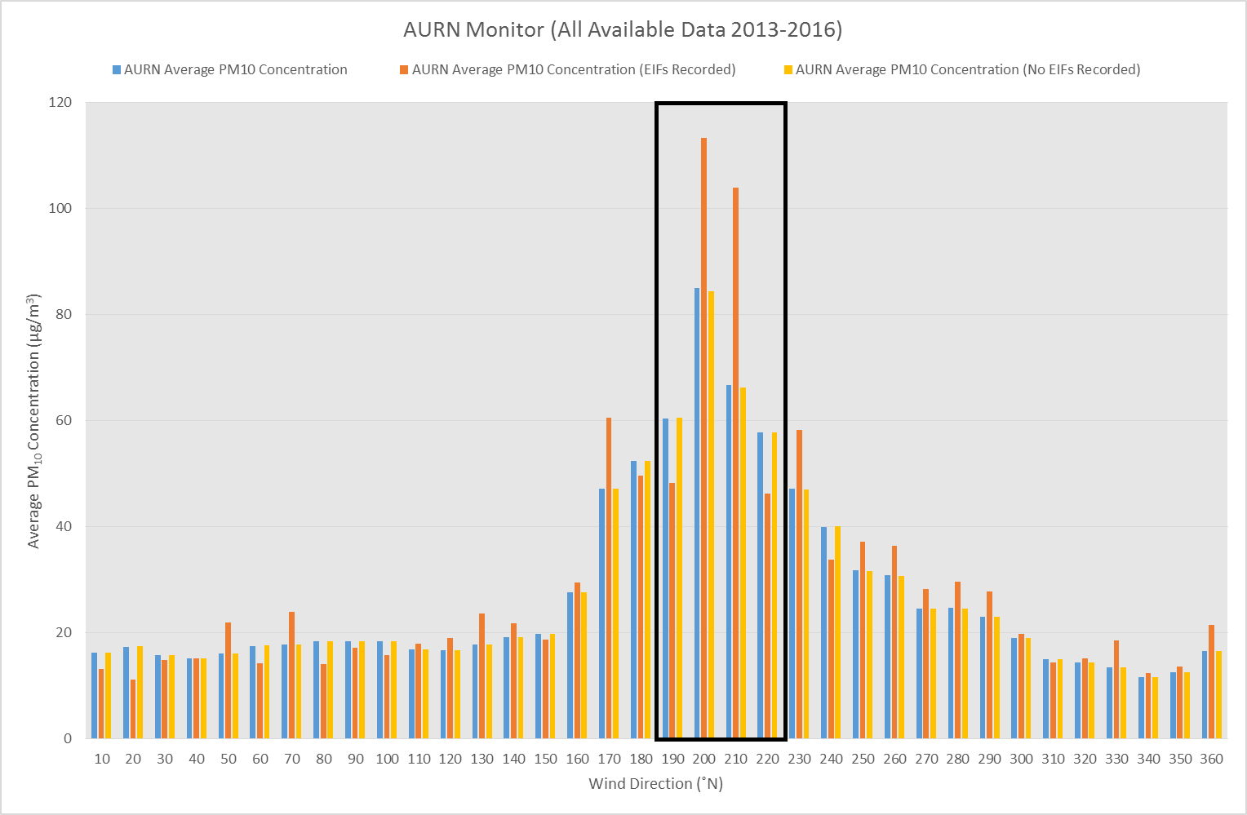
Figure 9 - AURN (Margam Fire Station) Monitor average PM₁₀ v wind direction

5.1.2 Little Warren

The Little Warren monitor is impacted from the BFs between 100˚ and 120˚. As can be seen from Table 9 and Figure 10, the average PM₁₀ concentrations for 100˚ and 110˚ are higher at times of Cast House emissions (significantly higher at 110˚) compared to times of no emissions and the full dataset. However, there appears to be no impact of Cast House emissions at the monitor from 120˚, with the average PM₁₀ concentration at times of emissions being lower than times when emissions are recorded and the full dataset. The potential contribution of Cast House emissions to background concentrations (2013-2016) is presented in Table 9.
Table 9 – Comparison of PM₁₀ Concentrations for the Little Warren Monitor
10˚ Wind Direction Sector | Average PM₁₀ Concentration (µg/m³) [2013-2016 Full Dataset] | Average PM₁₀ Concentration (µg/m³) [at times of Cast House Emissions 2013-2016] | Average PM₁₀ Concentration (µg/m³) [at times when no Cast House Emissions recorded 2013-2016] | Potential contribution of Cast House Emissions to Background Concentrations (µg/m³) [2013-2016]
100˚ | 41.23 | 53.41 | 41.06 | 0.17
110˚ | 54.71 | 95.04 | 54.27 | 0.44
120˚ | 56.03 | 34.01 | 56.24 | No contribution
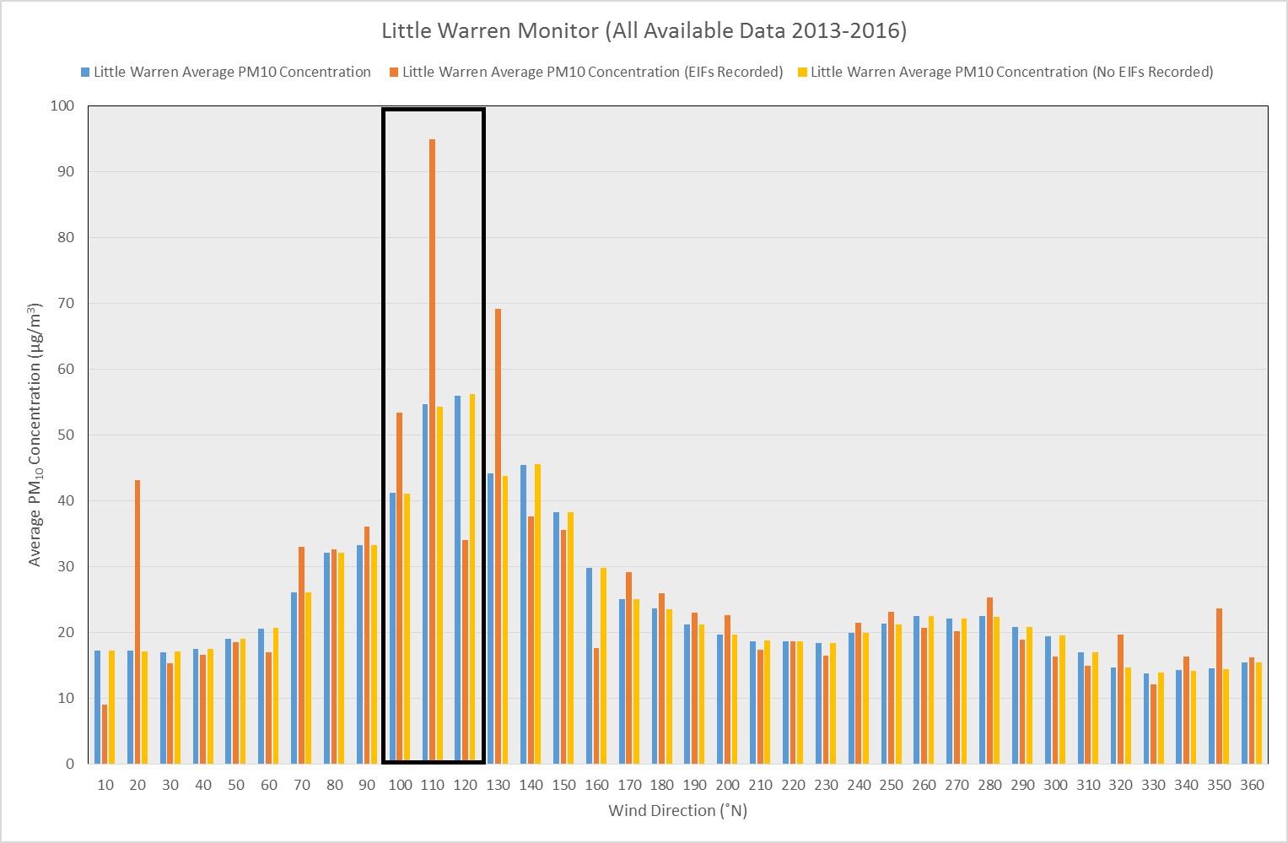
Figure 10 - Little Warren Monitor average PM₁₀ v wind direction

5.1.3 Docks Monitor

The Docks monitor is impacted from the BFs between 140˚ and 160˚. As can be seen from Table 10 and Figure 11 below, the average PM₁₀ concentrations for 140˚ and 160˚ are higher at times of Cast House emissions compared to times when no emissions are recorded and the full dataset. Unexpectedly, there is no impact of Cast House emissions at the Docks monitor from 150˚. This is because the average PM₁₀ concentration at times of emissions is lower than times when no emissions are recorded and the full dataset average for 150˚. A potential reason for this is the number of data points collected for each 10˚ sector i.e. the number of times an EIF is recorded for Cast House emissions at a time when the wind is impacting the monitor from a certain direction. An EIF was recorded for Cast House emissions 23 times when the wind was impacting the monitor from 150˚ between 2013 and 2016 compared to 6 and 12 times for 140˚ and 160˚ respectively. Therefore, it is possible that the average PM₁₀ concentrations for 150˚ are more representative of general conditions at the monitor. Therefore, it is possible that Cast House emissions have less of an impact upon the Docks monitor than the results for 140˚ and 160˚ would lead one to believe. The potential contribution of Cast House emissions to background concentrations (2013-2016) is presented in Table 10.
Table 10 – Comparison of PM₁₀ Concentrations for the Docks Monitor
10˚ Wind Direction Sector | Average PM₁₀ Concentration (µg/m³) [2013-2016 Full Dataset] | Average PM₁₀ Concentration (µg/m³) [at times of Cast House Emissions 2013-2016] | Average PM₁₀ Concentration (µg/m³) [at times when no Cast House Emissions recorded 2013-2016] | Potential contribution of Cast House Emissions to Background Concentrations (µg/m³) [2013-2016]
140˚ | 29.30 | 39.53 | 29.23 | 0.07
150˚ | 40.01 | 37.83 | 40.05 | No contribution
160 | 35.01 | 38.58 | 34.97 | 0.04

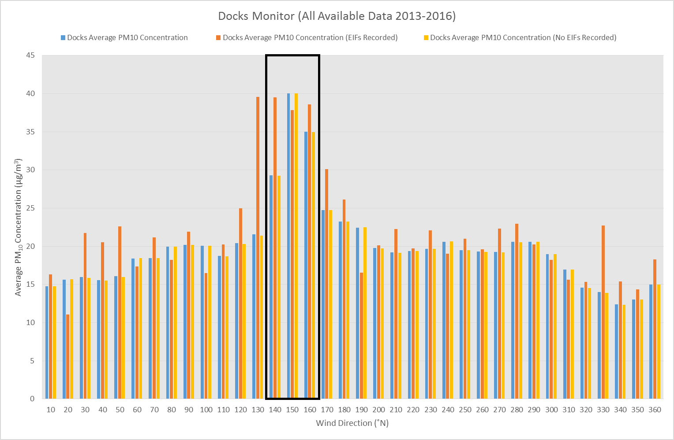
Figure 11 – Docks Monitor average PM₁₀ v wind direction

5.1.4 Talbot Road

The Talbot Road monitor is impacted from the BFs between 170˚ and 190˚. As can be seen from Table 11 and Figure 12, the average PM₁₀ concentration for 170˚ is higher at times of Cast House emissions compared to times of no emissions and the full dataset average for 170˚. There appears to be no impact of Cast House emissions at the Talbot Road monitor from 180˚ or 190˚ as the average PM₁₀ concentration at times of emissions is lower than times when no emissions and the full dataset average. The potential contribution of Cast House emissions to background concentrations (2013-2016) is presented in Table 11.

Table 11 – Comparison of PM₁₀ Concentrations for the Talbot Road Monitor
10˚ Wind Direction Sector | Average PM₁₀ Concentration (µg/m³) [2013-2016 Full Dataset] | Average PM₁₀ Concentration (µg/m³) [at times of Cast House Emissions 2013-2016] | Average PM₁₀ Concentration (µg/m³) [at times when no Cast House Emissions recorded 2013-2016] | Potential contribution of Cast House Emissions to Background Concentrations (µg/m³) [2013-2016]
170˚ | 31.94 | 44.05 | 31.87 | 0.07
180˚ | 25.39 | 22.97 | 25.42 | No contribution
190˚ | 25.62 | 14.1 | 25.72 | No contribution

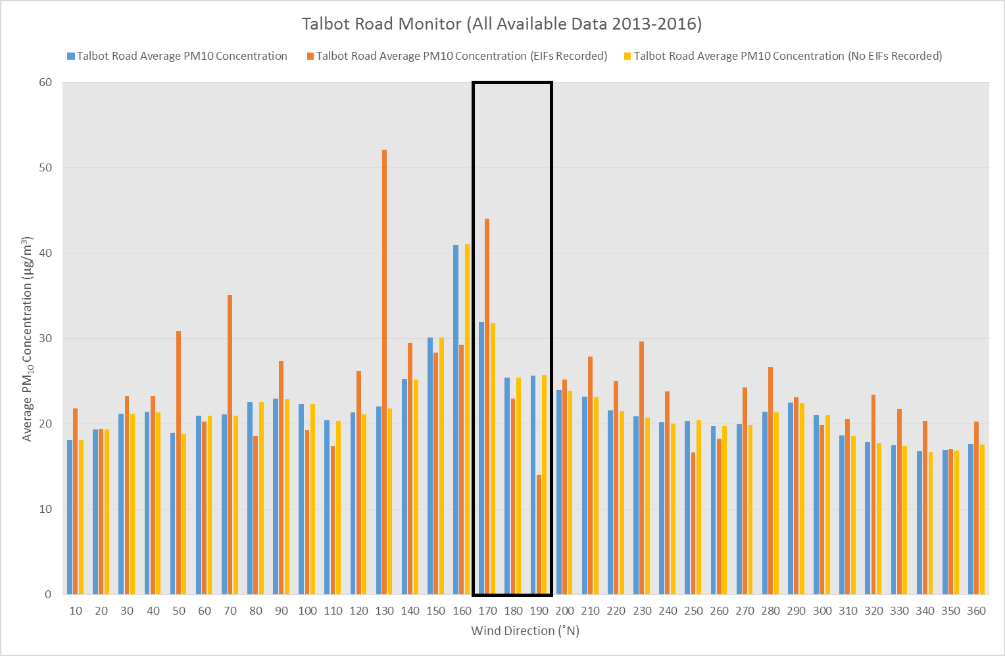
Figure 12 - Talbot Road Monitor average PM₁₀ v wind direction

5.1.5 Theodore Road

The Theodore Road monitor is impacted from the BFs between 180˚ and 200˚. Table 12 and Figure 13 show that the average PM₁₀ concentration for 200˚ is marginally higher at times of Cast House emissions compared to times of no emissions and the full dataset average. There is no impact of Cast House emissions at the Theodore Road monitor from 180˚ and 190˚ (like the Talbot Road monitor) as the average PM₁₀ concentration at times of emissions is lower than times of no emissions and the full dataset average. The potential contribution of Cast House emissions to background concentrations (2013-2016) is presented in Table 12.
Table 12 – Comparison of PM₁₀ Concentrations for the Theodore Road Monitor
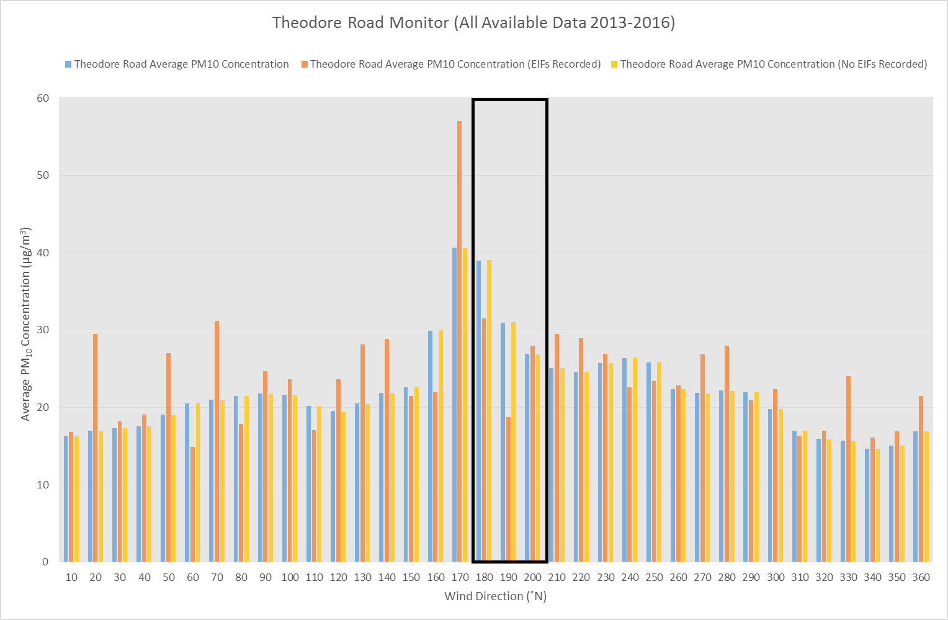
10˚ Wind Direction Sector | Average PM₁₀ Concentration (µg/m³) [2013-2016 Full Dataset] | Average PM₁₀ Concentration (µg/m³) [at times of Cast House Emissions 2013-2016] | Average PM₁₀ Concentration (µg/m³) [at times when no Cast House Emissions recorded 2013-2016] | Potential contribution of Cast House Emissions to Background Concentrations (µg/m³) [2013-2016]
180˚ | 39.01 | 31.49 | 39.09 | No contribution
190˚ | 30.97 | 18.75 | 31.08 | No contribution
200˚ | 26.91 | 27.96 | 26.88 | 0.03
Figure 13 - Theodore Road Monitor average PM₁₀ v wind direction

Of all the monitors in Port Talbot, Cast House emissions appear to have the least impact upon PM₁₀ concentrations at the Theodore Road monitor. Perhaps a contributing factor is distance from source. Therefore, in Section 5.3, the measured concentrations of PM₁₀ at the Theodore Road monitor will be considered alongside the AURN monitor to assess how distance from source (amongst other factors) effects PM₁₀ concentrations in the atmosphere.

5.1.6 Prince Street

The Prince Street monitor is impacted from the BFs between 230˚ and 270˚. Table 13 and Figure 14 show that the average PM₁₀ concentrations for 230˚, 240˚, 260˚ and 270˚ are higher (240 very marginally and 260 significantly) at times of Cast House emissions compared to times of no emissions and the full data set averages. Unexpectedly, there is no impact of Cast House emissions at the Prince Street monitor from 250˚ (a similar situation to the Docks monitor discussed above). This is because the average PM₁₀ concentration at times of emissions is lower than times when no emissions are recorded and the full dataset average. This is not explained when the number of data points is considered for each wind direction at times of Cast House emissions as a greater number of EIFs were recorded at times when the wind was impacting the Prince Street monitor from 250˚ compared to 230˚ or 240˚, therefore, the unexpected result is not due to a low number of data points. A far larger number of data points were collected for 260˚ and 270˚ as the prevailing wind in Port Talbot is predominately west-south-westerly to westerly, as affirmed by this research. The potential contribution of Cast House emissions to background concentrations (2013-2016) is presented in Table 13.
Table 13 – Comparison of PM₁₀ Concentrations for the Prince Street Monitor

10˚ Wind Direction Sector | Average PM₁₀ Concentration (µg/m³) [2013-2016 Full Dataset] | Average PM₁₀ Concentration (µg/m³) [at times of Cast House Emissions 2013-2016] | Average PM₁₀ Concentration (µg/m³) [at times when no Cast House Emissions recorded 2013-2016] | Potential contribution of Cast House Emissions to Background Concentrations (µg/m³) [2013-2016]
230˚ | 36.46 | 38.00 | 36.45 | 0.01
240˚ | 47.20 | 47.50 | 47.19 | 0.01
250˚ | 76.86 | 63.00 | 77.09 | No contribution
260˚ | 74.91 | 94.85 | 74.45 | 0.46
270˚ | 40.05 | 46.93 | 39.93 | 0.12

The potential contribution found here is of a similar order of magnitude for the 230˚-240˚ and 270˚ directions as suggested by Hodges (2005) but higher for 260˚. At 260˚, the Prince Street monitor is impacted from the direction of the Cast House of BF4 – the furnace closest to the monitor. Potential reasons for the discrepancies between Hodges’ (2005) suggested contribution and those presented here are put forward in the AURN monitor discussion above.

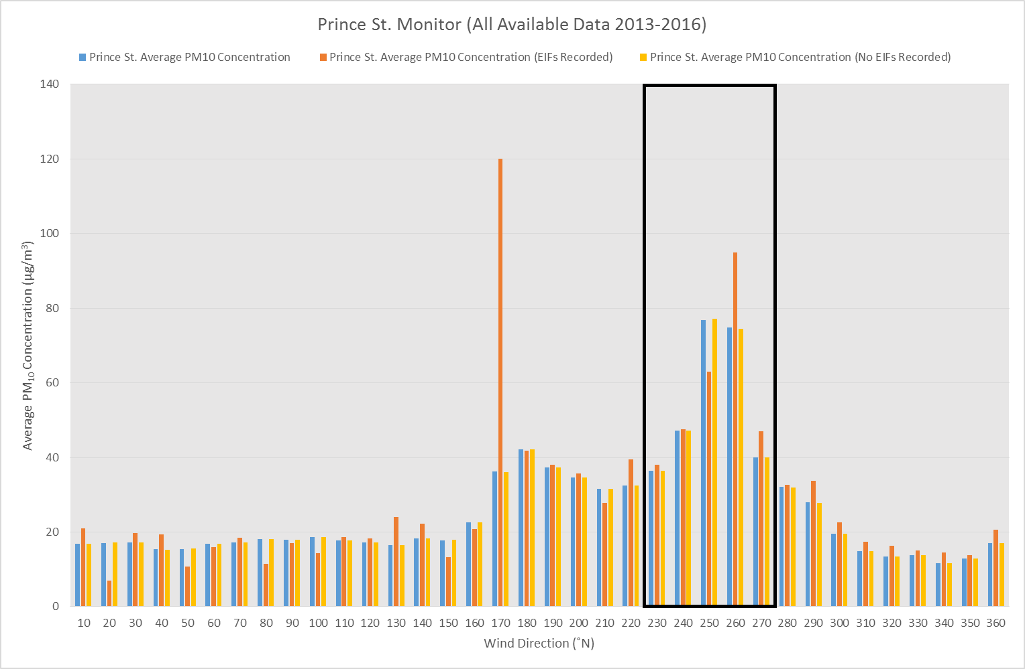
Figure 14 - Prince Street Monitor average PM₁₀ v wind direction

5.1.7 Twll-yn-y-Wal Park

The Twll-yn-y-Wal Park monitor is impacted from the BFs between 260˚ and 290˚. Table 14 and Figure 15 show that the average PM₁₀ concentrations for 260˚ to 290˚ are each higher at times when Cast House emissions are recorded compared to times when no emissions are recorded and the full dataset averages. The potential contribution of Cast House emissions to background concentrations (2013-2016) is presented in Table 14.
Table 13 – Comparison of PM₁₀ Concentrations for the Twll-yn-y-Wal Park Monitor

Table 14 – Comparison of PM₁₀ Concentrations for the Twll-yn-y-Wal Park Monitor
10˚ Wind Direction Sector | Average PM₁₀ Concentration (µg/m³) [2013-2016 Full Dataset] | Average PM₁₀ Concentration (µg/m³) [at times of Cast House Emissions 2013-2016] | Average PM₁₀ Concentration (µg/m³) [at times when no Cast House Emissions recorded 2013-2016] | Potential contribution of Cast House Emissions to Background Concentrations (µg/m³) [2013-2016]
260˚ | 29.44 | 31.68 | 29.39 | 0.05
270˚ | 32.73 | 38.30 | 32.63 | 0.10
280˚ | 36.01 | 39.23 | 35.97 | 0.04
290˚ | 30.16 | 31.68 | 30.13 | 0.03

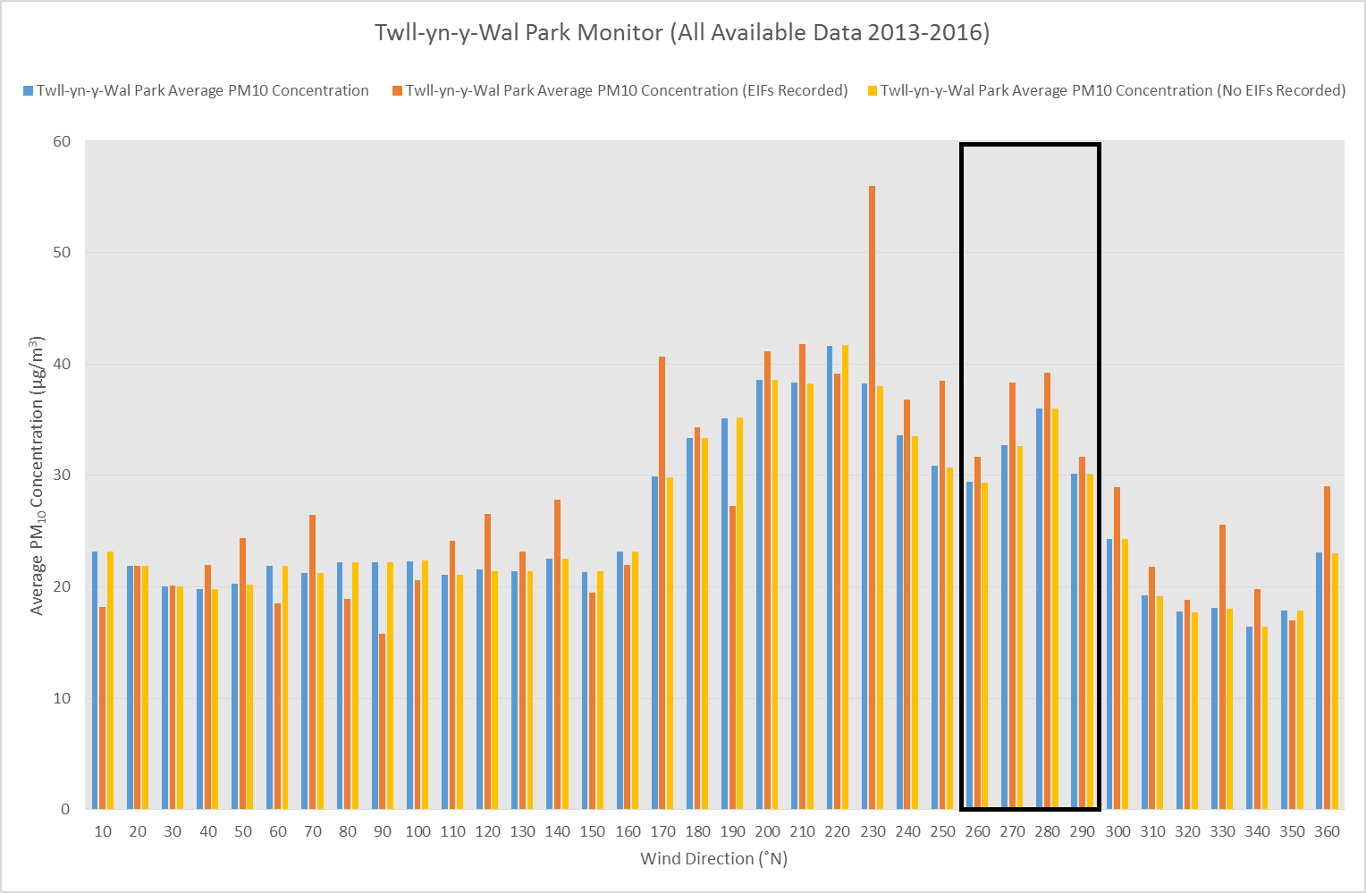
The potential contribution found here is of a similar order of magnitude for the 260˚, 280˚ and 290˚ directions as suggested by Hodges (2005) but higher for 270˚. At 270˚, the Prince Street monitor is impacted from the direction of the Cast House of BF5 – the furnace closest to the monitor. Potential reasons for the discrepancies between Hodges’ (2005) suggested contribution and those presented here are put forward in the AURN monitor discussion above.
Figure 15 - Twll-yn-y-Wal Park Monitor average PM₁₀ v wind direction

5.1.8 Dyffryn School

The Dyffryn School monitor is impacted from the BFs between 280˚ and 300˚. Table 15 and Figure 16 show that the average PM₁₀ concentrations for 280˚ to 300˚ are all higher at times when Cast House emissions are recorded compared to times when no emissions are recorded and the full dataset averages (this was also the case with the Twll-yn-y-Wal Park monitor). The potential contribution of Cast House emissions to background concentrations (2013-2016) is presented in Table 15.
Table 15 – Comparison of PM₁₀ Concentrations for the Dyffryn School Monitor

10˚ Wind Direction Sector | Average PM₁₀ Concentration (µg/m³) [2013-2016 Full Dataset] | Average PM₁₀ Concentration (µg/m³) [at times of Cast House Emissions 2013-2016] | Average PM₁₀ Concentration (µg/m³) [at times when no Cast House Emissions recorded 2013-2016] | Potential contribution of Cast House Emissions to Background Concentrations (µg/m³) [2013-2016]
280˚ | 25.82 | 28.82 | 25.78 | 0.04
290˚ | 28.67 | 37.86 | 28.51 | 0.16
300˚ | 24.01 | 28.00 | 24.01 | No contribution
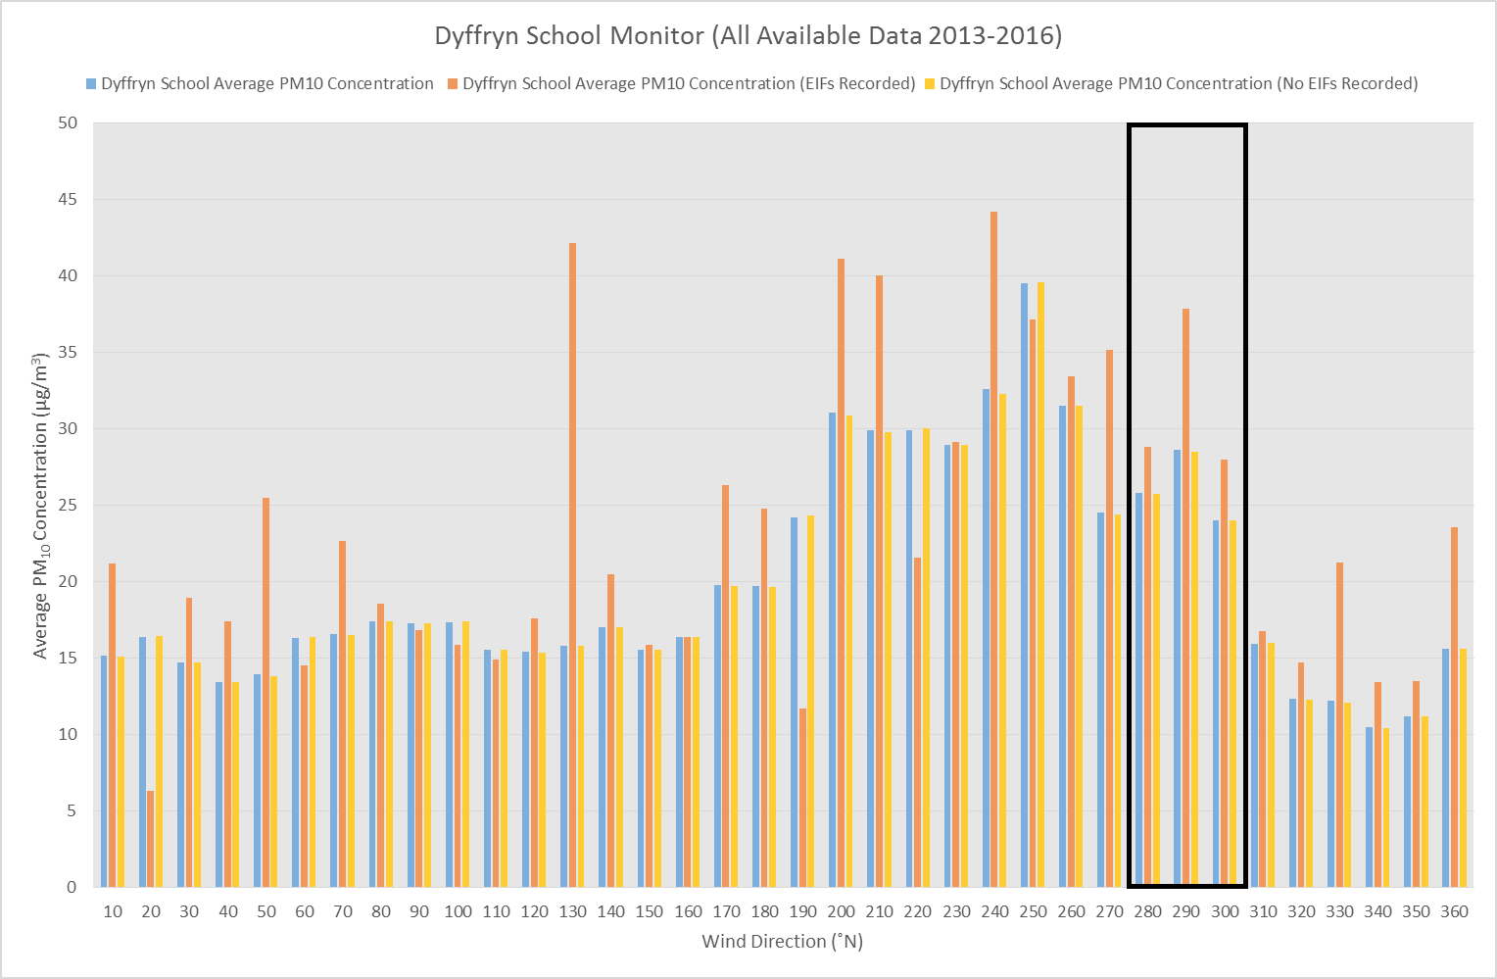
Figure 16 - Dyffryn School Monitor average PM₁₀ v wind direction

5.2 Influence of distance from source and Port Talbot PM₁₀ Trajectory

As demonstrated above, the AURN monitor is impacted by elevated PM₁₀ concentrations from the direction of the BFs when Cast House emissions are recorded whereas the Theodore Road monitor is not – despite the Furnaces being located at 190-200˚ relative to both monitors. The AURN is located ~700m north-east of BF4 (the closer of the two furnaces to the site boundary). The Theodore Road monitor is approximately 725m north of the AURN monitor and therefore much further away from the Cast Houses. The AURN being affected by Cast House emissions whilst the Theodore Road monitor is not supports the finding of Chow et al. (1999) that the zone most impacted by PM₁₀ is within 1km of the fugitive source of interest.
This section investigates the extent to which the concentration of PM₁₀ produced in a Cast House emission decreases with distance and the trajectory path of PM₁₀ across Port Talbot. PM₁₀ pollution roses have been plotted for the AURN and Theodore Road monitors for the full data set (top left and right in Figure 17 respectively) and also for the AURN and Theodore Road monitors for the data collected at times of Cast House emissions (bottom left and right in Figure 17 respectively). The pollution roses are plotted on a map of Port Talbot in Figures 18, 19 and 20 below.

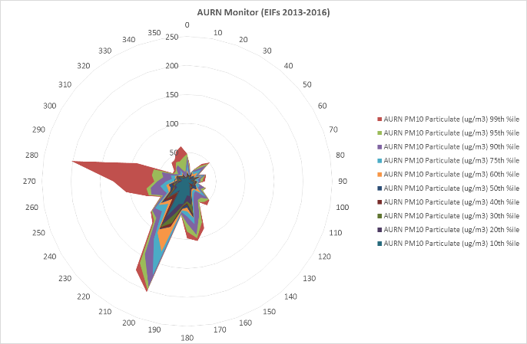
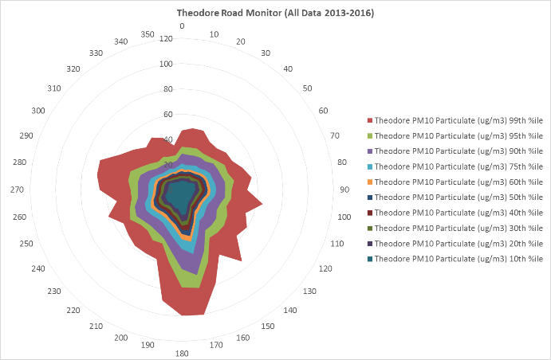
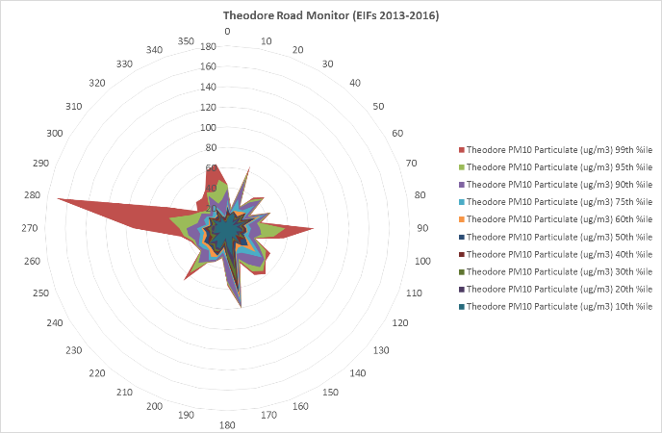
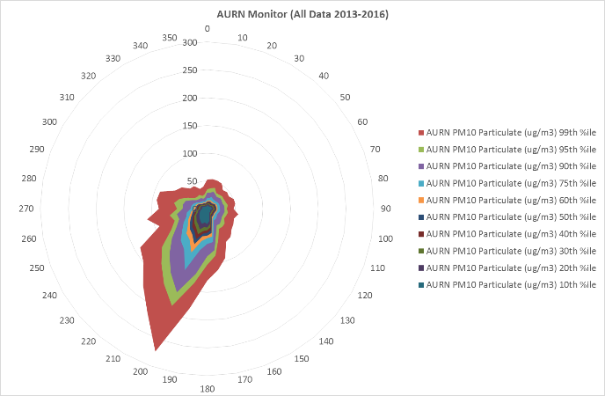
Figure 17 – PM₁₀ Pollution Roses for the AURN and Theodore Road monitors

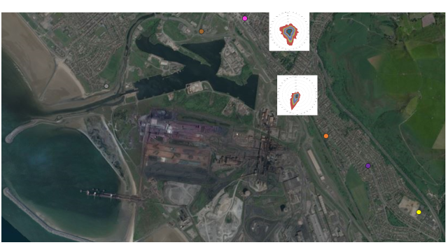
Microsoft product screen shot reprinted with permission from Microsoft Corporation. © 2017 Microsoft
Figure 18 – AURN and Theodore Road Monitor PM₁₀ Pollution Roses (full dataset) on Port Talbot Map

AURN Monitor
Theodore Road Monitor
Blast Furnaces

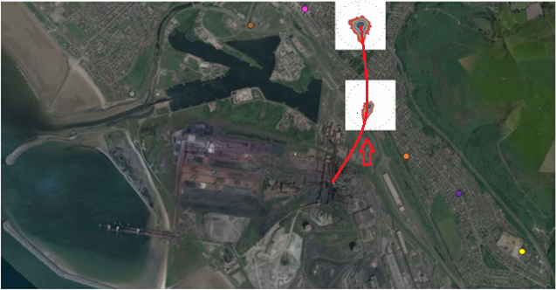
Figure 18 shows (between 2013 and 2016) the highest PM₁₀ concentrations impact the AURN between 190-210˚ before travelling north to north-eastwards to impact the Theodore Road monitor between 170-200˚, possibly deflected by the hills to the east of the town. Therefore, supporting the findings of AQEG (2011), presented in Figures 2 and 3 in Section 3.2. The observed trajectory from the BFs to the AURN monitor and on to the Theodore Road monitor is illustrated in Figure 19.
AURN Monitor
Blast Furnaces
Theodore Road Monitor
Microsoft product screen shot reprinted with permission from Microsoft Corporation. © 2017 Microsoft
Figure 19 – AURN and Theodore Road Monitor Pollution Roses with trajectory line (full dataset)

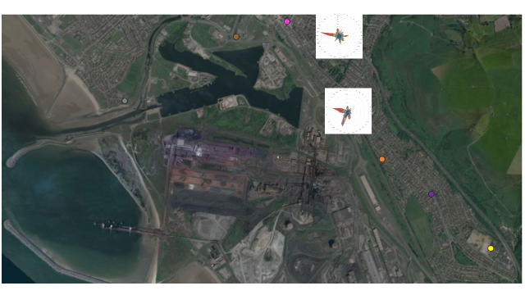
Figure 20 shows the AURN monitor is impacted to a great extent from the direction of the BFs at times of Cast House emissions. However, presuming PM₁₀ from Cast House emissions take a similar trajectory of that shown in Figure 19, there is no more impact at the Theodore road monitor at 170˚ (from the direction of the BFs on the curved trajectory) than 90˚ (from the direction of the motorway and residential areas). Therefore, it is concluded, potentially due to distance from source, the Theodore Road monitor is not impacted by Cast House emissions supporting the analysis above.
Microsoft product screen shot reprinted with permission from Microsoft Corporation. © 2017 Microsoft
Figure 20 – AURN and Theodore Road Monitor Pollution Roses (data collected at times of Cast House emissions)

Blast Furnaces
AURN Monitor
Theodore Road Monitor

It should be noted that both monitors are impacted a high PM₁₀ concentration from 280˚ – from the direction of the Docks, Aberafan and Sandfields residential areas and the coast. An in depth investigation revealed very high PM₁₀ concentrations were impacting both monitors during one particular hour on 12th April 2016. The day’s PM₁₀ data was compared to the PM_{2.5} data and the proportion of PM₁₀ from PM_{2.5} was found to be 62.9% (AURN) and 74.6% (Theodore Road). The Theodore Road PM₁₀ had to be compared with AURN PM_{2.5} data as the Theodore Road monitor does not record PM_{2.5}. Particles between 2.5 and 10μg/m³ (i.e. PM₁₀) are generally agreed to emanate from industrial fugitive emissions and roads and are deposited over short distances. By comparison, the smaller fraction (<2.5μg/m³ i.e. PM_{2.5}) are capable of transportation over long distances – possibly thousands of kilometres (WHO 2006). This is supported by AQEG (2012) concluding elevated PM_{2.5} concentrations are often associated with trans-boundary pollution transportation from Central Europe. This typically occurs during the spring in the UK and is known to occur in Port Talbot (Welsh Government 2013). The medium-high PM₁₀:PM_{2.5} proportion here indicates influence of trans-boundary pollution on 12th April 2016, especially as both monitors were impacted from the coast. Figure 21 illustrates the difference in the pollution roses for both monitors with the 12th April 2016 data included and removed.
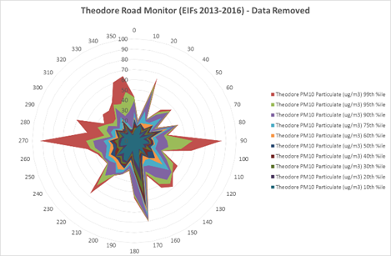
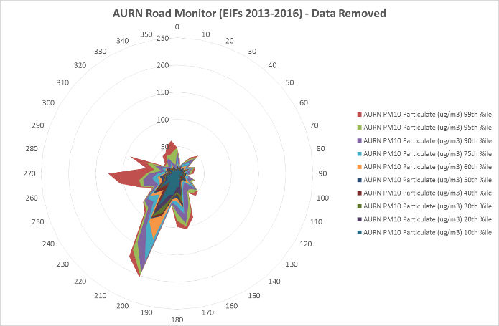
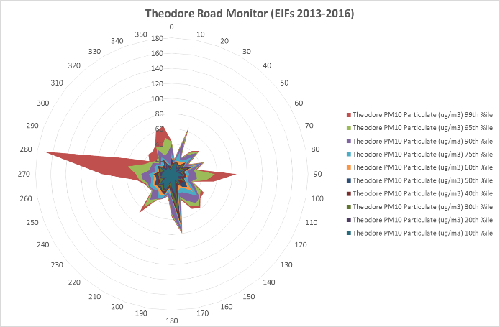
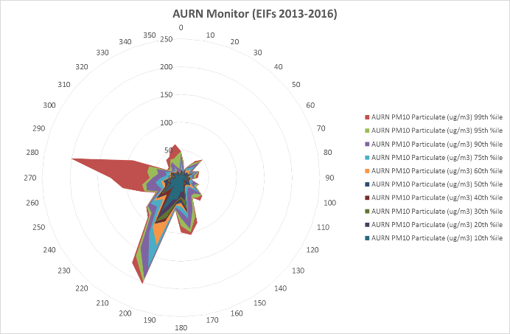
Figure 21 – Comparison of the AURN and Theodore Road Monitor Pollution Roses with 12th April 2016 data included and removed

Table 16 shows PM₁₀ concentrations and weather conditions during hours when Cast House emissions were recorded. It is clear hourly average PM₁₀ concentrations are higher at the AURN (much higher in most cases) than at the Theodore road monitor during the same hour. Thus suggesting the conditions at the time are preferable for the dispersion of PM₁₀ over the 700m distance between the monitors.
However, it is difficult to identify patterns in the data with so few data points - due to there being only sixteen hours (2013-2016) when Cast House emissions were recorded and the wind impacted the AURN from the BFs. Therefore, it was necessary to undertake detailed analysis to understand the relationship between PM₁₀ concentrations and meteorological parameters at the AURN (Section 5.3). It was not possible to replicate this analysis for Theodore Road as the monitor does not record site specific weather data. This issue is discussed in Chapter 6 - Evaluation and Conclusions.
Table 16 - Concentrations of PM₁₀ and Weather Conditions at times of Cast House Emissions – AURN and Theodore Road Monitors

Date & Time | PM₁₀ Concentration (µg/m3) [AURN] | PM₁₀ Concentration (µg/m3) [Theodore Road] | Wind Direction (˚N) | Wind Speed (m/s) | Rainfall (mm) | Relative Humidity (%) | Ambient Temperature (˚C)
21/04/2013 16:00 | 45.2 | 18.7 | 210 | 3.4 | 0.2 | 91.8 | 9.3
12/06/2013 07:00 | 186.1 | 19.2 | 200 | 4.2 | 0.2 | 98.6 | 13.7
21/06/2013 21:00 | 159.1 | 35.2 | 200 | 4.5 | 0.0 | 83.2 | 13.8
19/10/2013 16:00 | 52.3 | 22.5 | 200 | 3.4 | 0.0 | 81.1 | 16.7
31/12/2013 13:00 | 92.7 | 36.9 | 210 | 4.4 | 0.0 | 74.4 | 9.7
25/02/2014 12:00 | 204.4 | 34.4 | 200 | 5.2 | 0.0 | 74.3 | 11.0
16/07/2014 10:00 | 37.0 | 7.4 | 190 | 3.2 | 0.0 | 90.5 | 18.8
07/01/2015 13:00 | 83.4 | 28.8 | 200 | 4.7 | 0.0 | 87.5 | 9.9
25/02/2015 00:00 | 25.6 | 24.5 | 200 | 2.0 | 0.4 | 94.1 | 8.3
19/07/2015 04:00 | 59.6 | 30.1 | 190 | 3.9 | 0.2 | 81.0 | 15.7
01/12/2015 18:00 | 106.2 | 26.1 | 210 | 4.8 | 0.0 | 85.7 | 13.0
05/12/2015 11:00 | 179.6 | 39.5 | 210 | 5.6 | 0.0 | 75.6 | 12.7
29/01/2016 16:00 | 95.5 | 26.7 | 210 | 4.4 | 0.2 | 94.8 | 11.1
10/07/2016 18:00 | 86.0 | 35.9 | 210 | 5.3 | 0.0 | 84.6 | 17.3
06/08/2016 19:00 | 82.5 | 31.1 | 200 | 3.7 | 0.0 | 83.6 | 19.9
09/09/2016 01:00 | 122.6 | 22.7 | 210 | 4.0 | 0.0 | 87.3 | 17.9

5.3 Influence of weather conditions upon PM₁₀ concentrations in Port Talbot

The AURN was chosen for in depth analysis of weather condition influence upon PM₁₀ concentrations as it is the only monitor in the town measuring a range of meteorological parameters on hourly frequency. In addition, the daily mean PM₁₀ objective is set solely on the AURN. Figure 22 shows a time plot of the AURN full dataset (daily averages) created using R Studio® Software (R Development Core Team 2008).
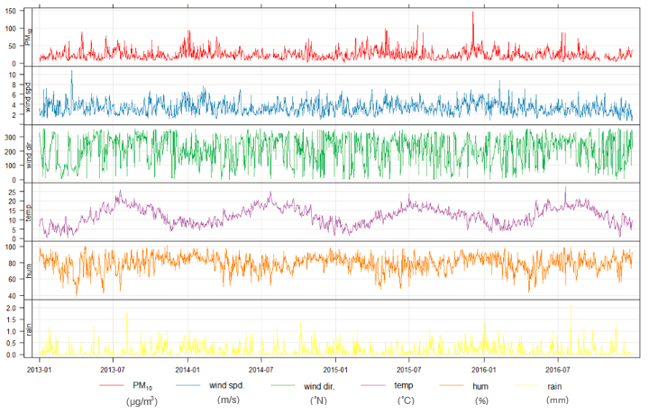
Figure 22 - Full Dataset Time Plot for the AURN Monitor (Daily Averages)

It is extremely difficult to identify relationships between datasets with the data presented in this way. Therefore, in the following sections, the relationship between PM₁₀ and each individual weather factor are discussed in turn.

5.3.1 Influence of Wind Direction

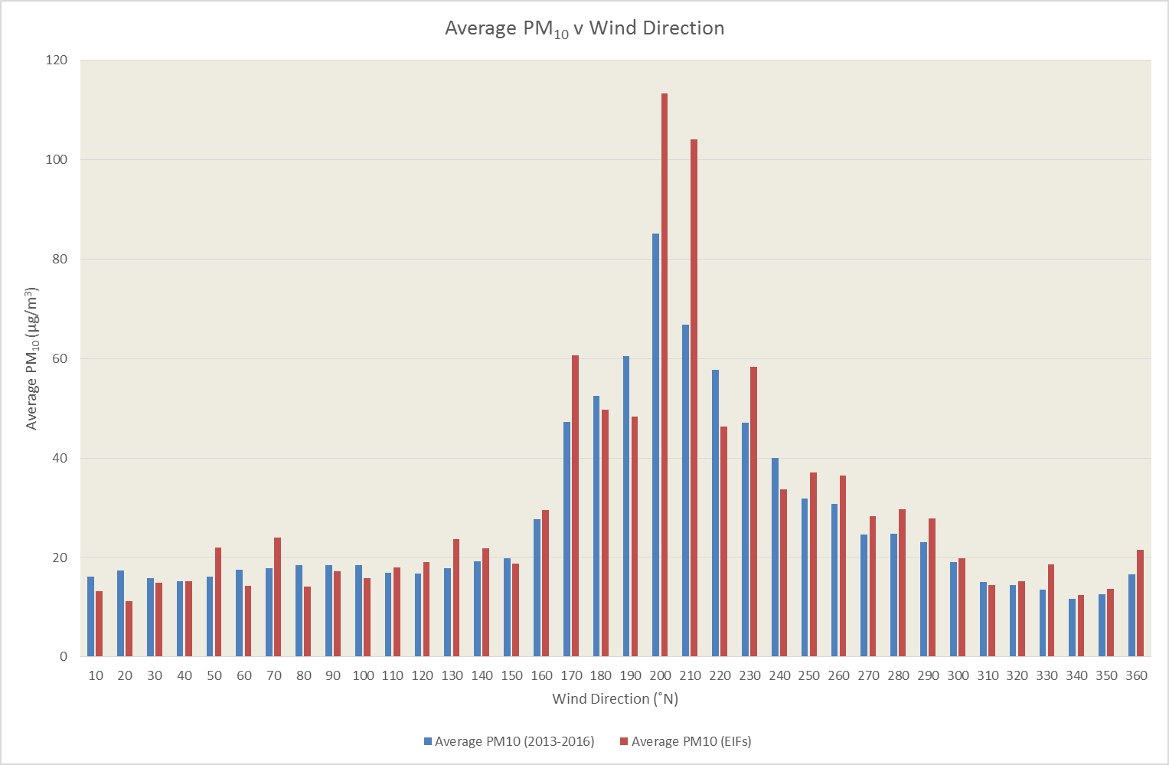
Figure 23 shows the highest average PM₁₀ concentrations are recorded from 200-210˚, thus supporting the analysis above that the AURN is impacted with elevated PM₁₀ from the direction of the BFs and concentrations are higher still at times of Cast House emissions. These findings support Hutchison et al. (2005) and Hodges et al. (2006) who found higher particulate concentrations in samples taken downwind of a BF compared to upwind.
Figure 23 - Average PM₁₀ Concentration v Wind Direction

The same data is presented as a scatter chart in Figure 24 with a linear regression trend line added. The output of the linear regression analysis is presented in Figure 25. The same analysis for wind speed, ambient temperature, relative humidity and rainfall is presented in Figures 27 and 28, 30 and 31, 33 and 34, and 36 and 37 respectively.

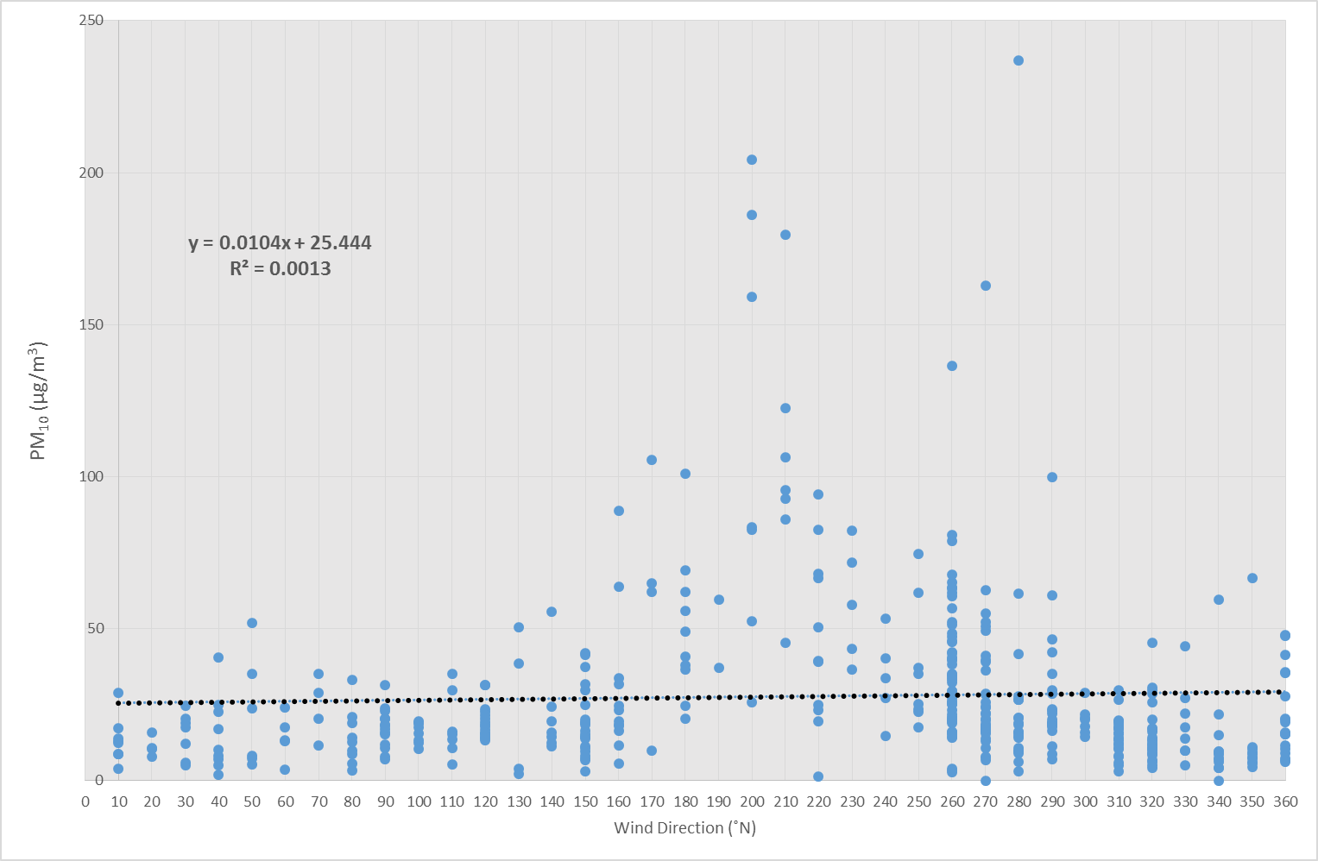
Figure 24 – Scatter Chart with Linear Regression Trend Line (PM₁₀ vs Wind Direction)

Figure 25 – Summary Output of Linear Regression Analysis (PM₁₀ vs Wind Direction)

5.3.2 Influence of Wind Speed

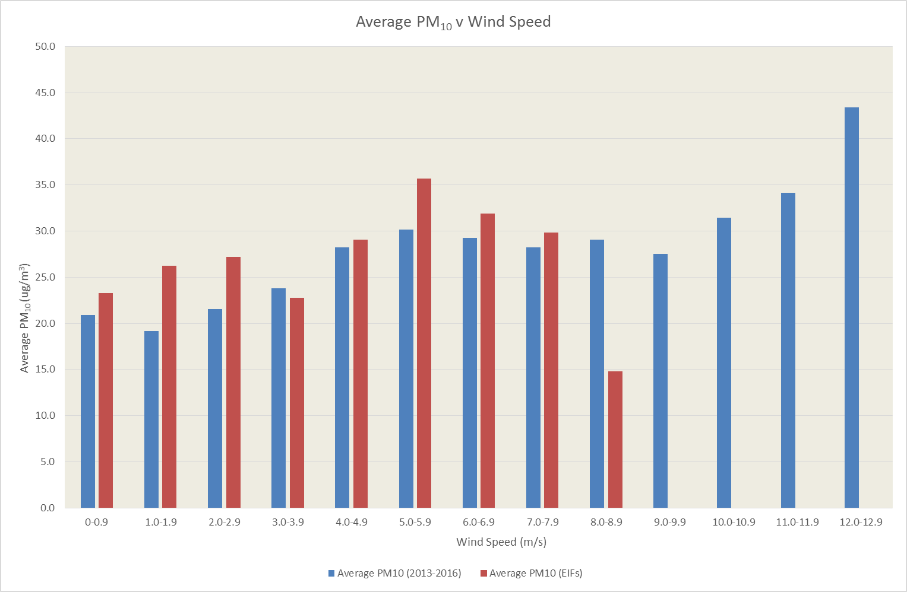
Figure 26 shows in general (for the full dataset) PM₁₀ increases as wind speed increases i.e. a positive linear relationship exists between the variables. This finding conflicts with those of Filonchyk et al. (2016) and Czernecki et al. (2017) who found the existence of a negative linear relationship. However, this does not appear to be the case for the data collected at times of Cast House emissions, with average PM₁₀ concentrations peaking at the 5.0-5.9m/s wind speed band. As was the case with the full dataset, Figures 27 and 28 do not support Filonchyk et al. (2016) and Czernecki et al. (2017) as a very weak positive linear relationship was found at times of Cast House emissions. As discussed further below, this finding supports Ohmsen (2001) with regards to plume behaviour. At higher wind speeds, it is possible the hot emission travels to within the vicinity of the monitor rather than directly upwards due to thermal energy induced buoyancy.
Figure 26 - Average PM₁₀ Concentration v Wind Speed

Figure 26 - Average PM₁₀ Concentration v Wind Speed

Figure X - Average PM₁₀ Concentration v Wind Speed
F

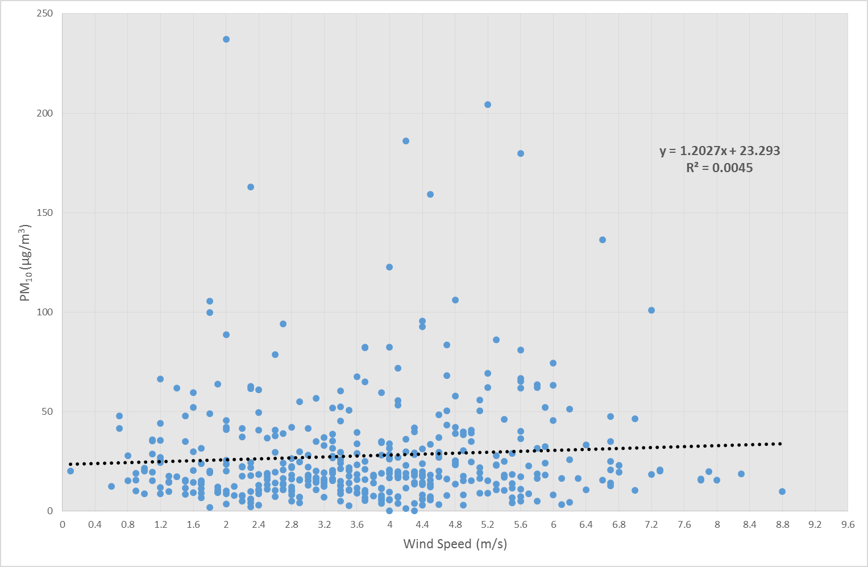
Figure 27 – Scatter Chart with Linear Regression Trend Line (PM₁₀ vs Wind Speed)

Figure 28 – Summary Output of Linear Regression Analysis (PM₁₀ vs Wind Speed)

5.3.3 Influence of Temperature

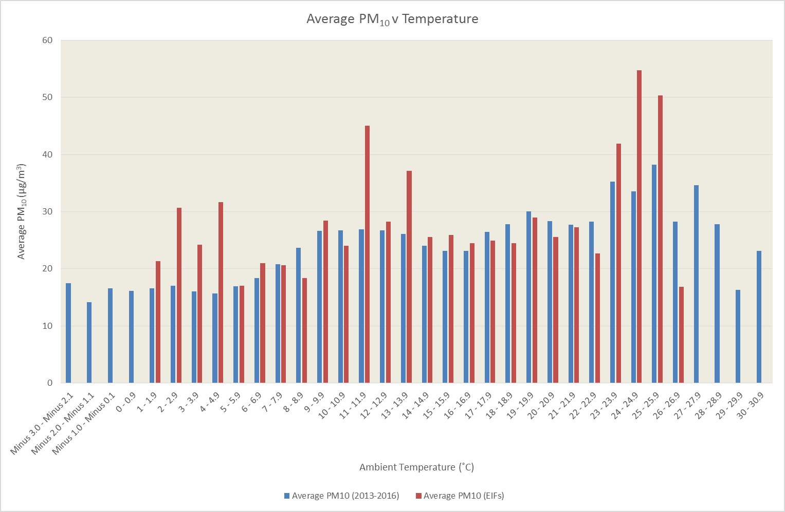
No obvious linear relationship is apparent from Figure 29 and this is confirmed in Figures 30 and 31. This is similar to the findings of Filonchyk et al. (2016) who found either no relationship or a weak/very weak positive linear relationship at all locations studied. This finding, however, does not support Li et al. (2015) and Czernecki et al. (2016) who each found negative relationships of fair significance in their study locations.
Figure 29 - Average PM₁₀ Concentration v Temperature

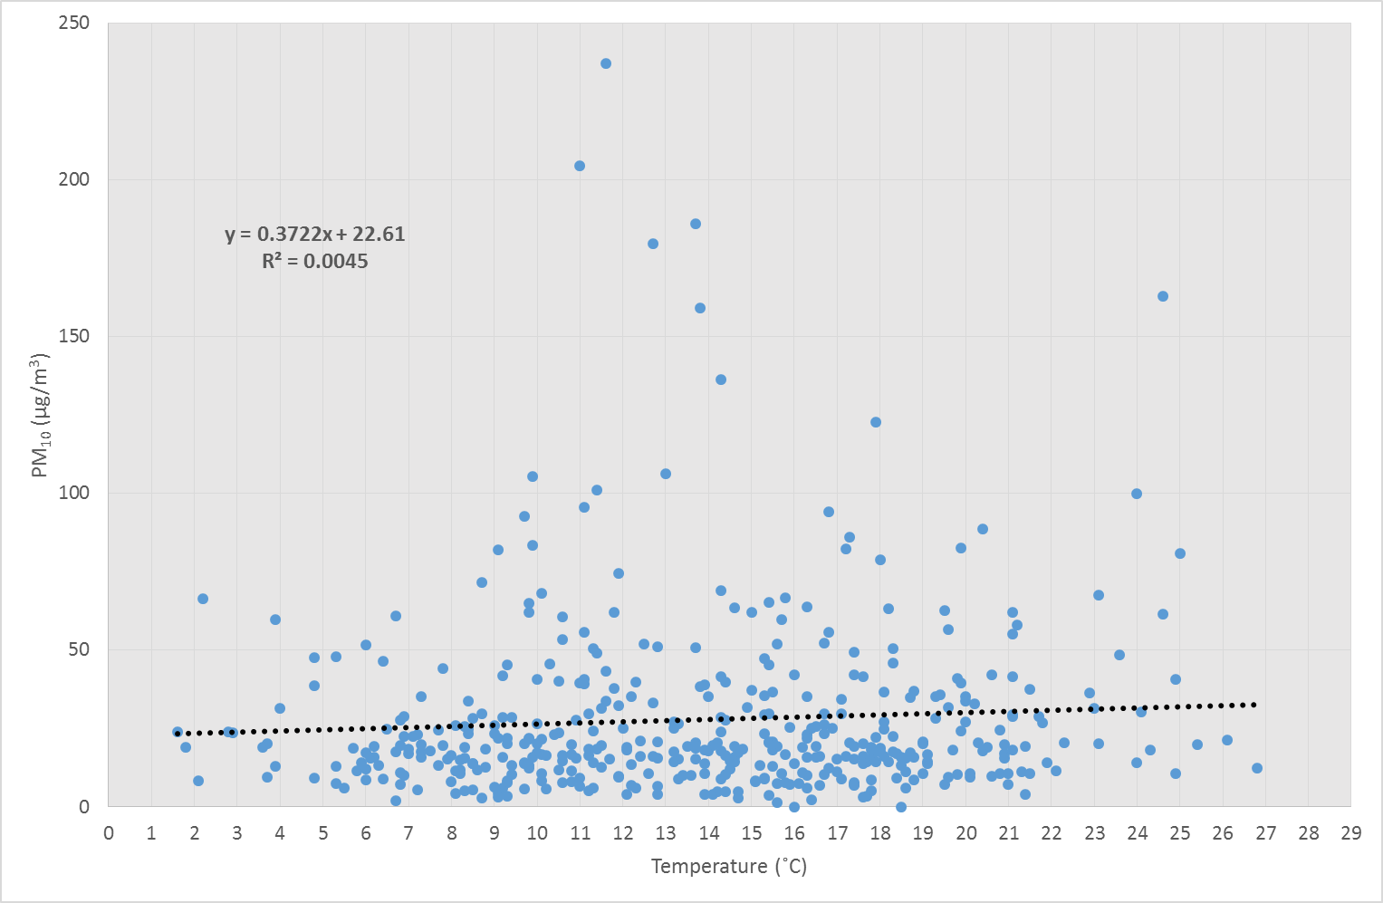
Figure 30 – Scatter Chart with Linear Regression Trend Line (PM₁₀ vs Temperature)

Figure 31 – Summary Output of Linear Regression Analysis (PM₁₀ vs Temperature)

5.3.4 Influence of Relative Humidity

Figure 32 shows average PM₁₀ concentrations increasing as relative humidity increases until 70.1-80% is reached. Figure 33 and Figure 34 reveal a weak positive correlation in support of Filonchyk et al. (2016) but contrasting with Giri et al. (2008) who found a significant negative correlation between the two variables.
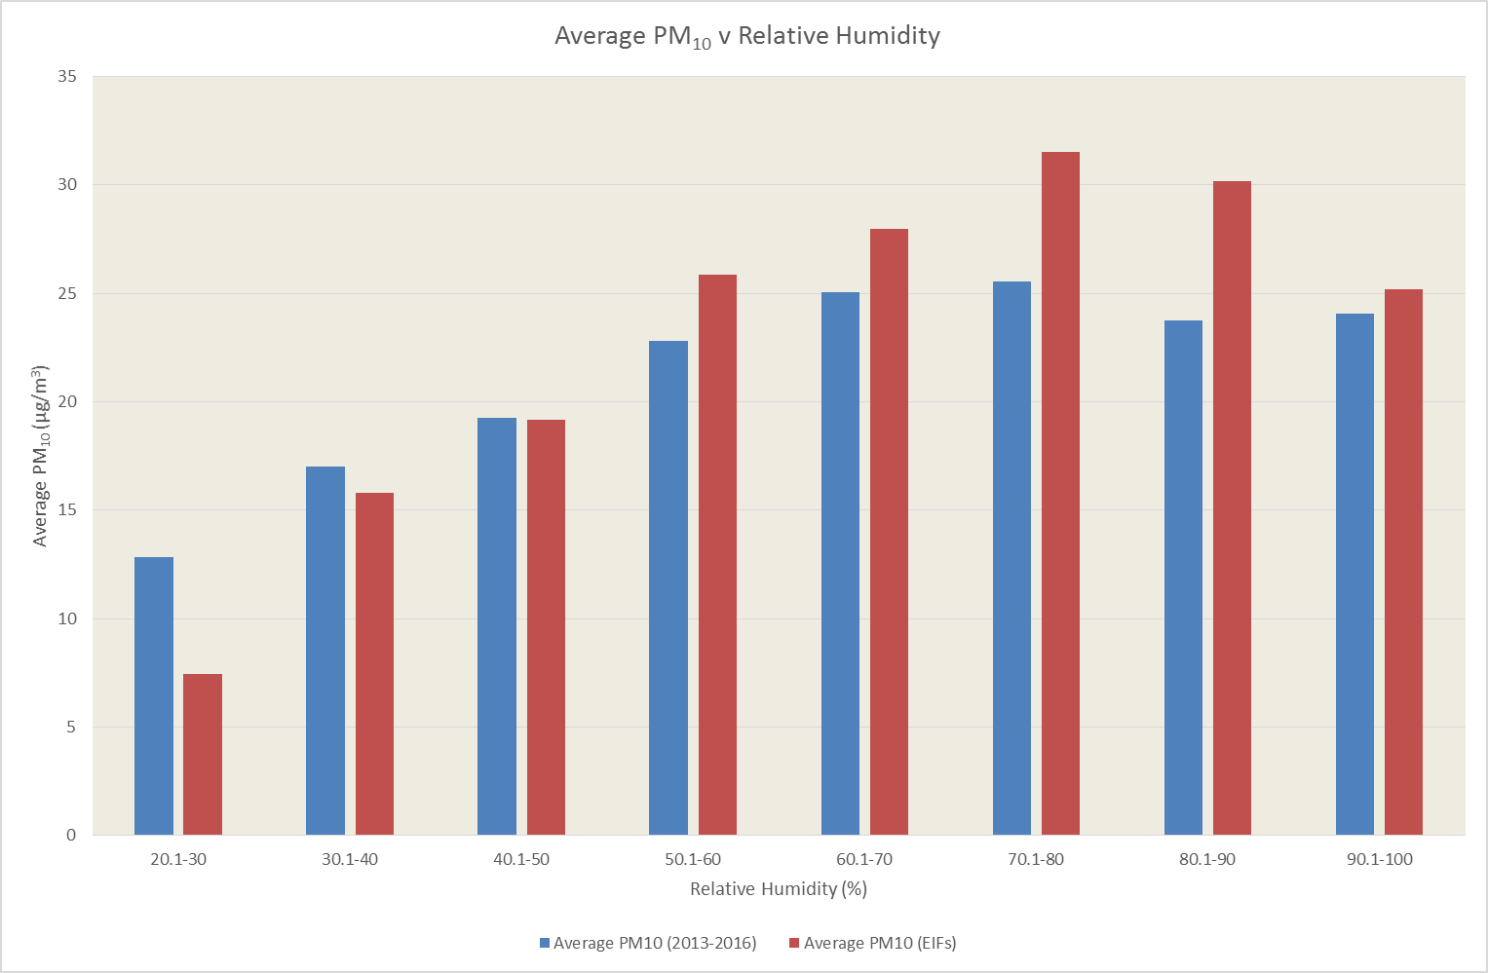
Figure 32 - Average PM₁₀ Concentration v Relative Humidity

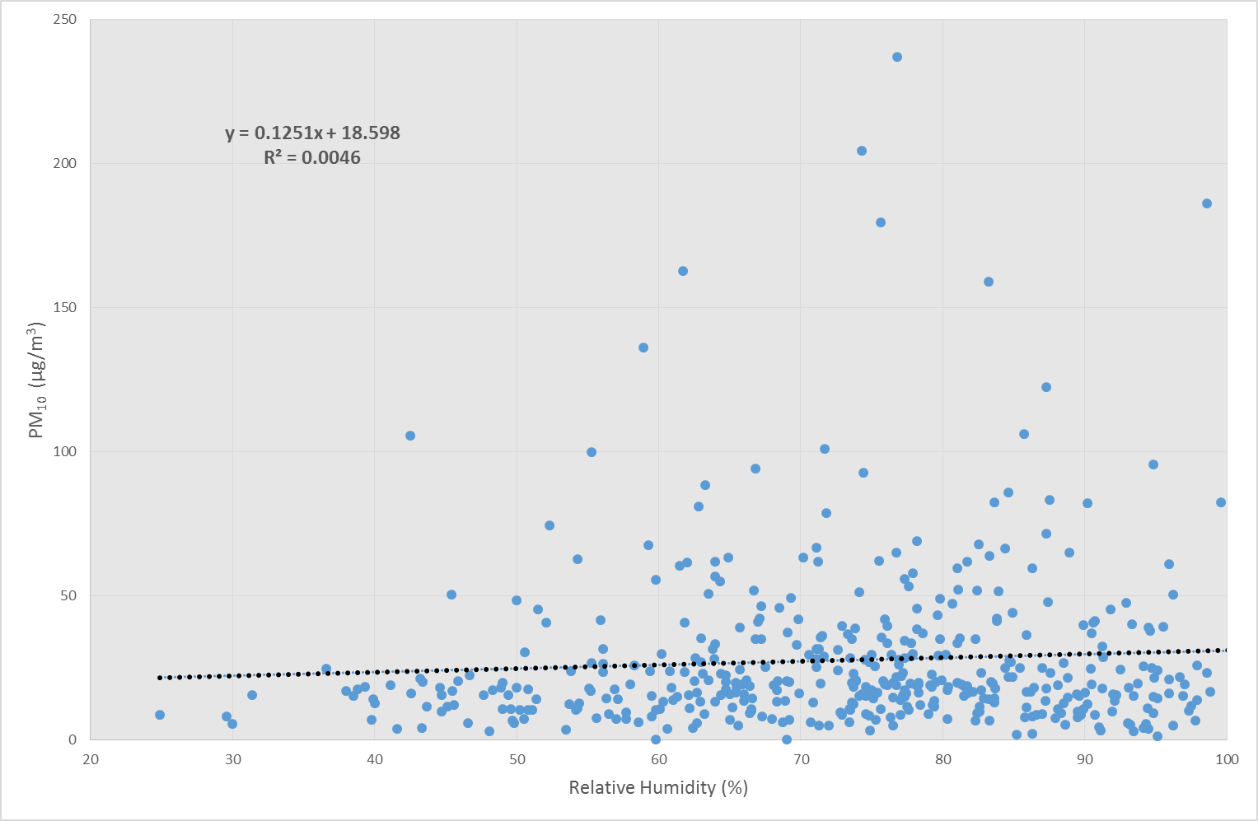
Figure 33 – Scatter Chart with Linear Regression Trend Line (PM₁₀ vs Relative Humidity)

Figure 34 – Summary Output of Linear Regression Analysis (PM₁₀ vs Relative Humidity)

5.3.5 Influence of Rainfall

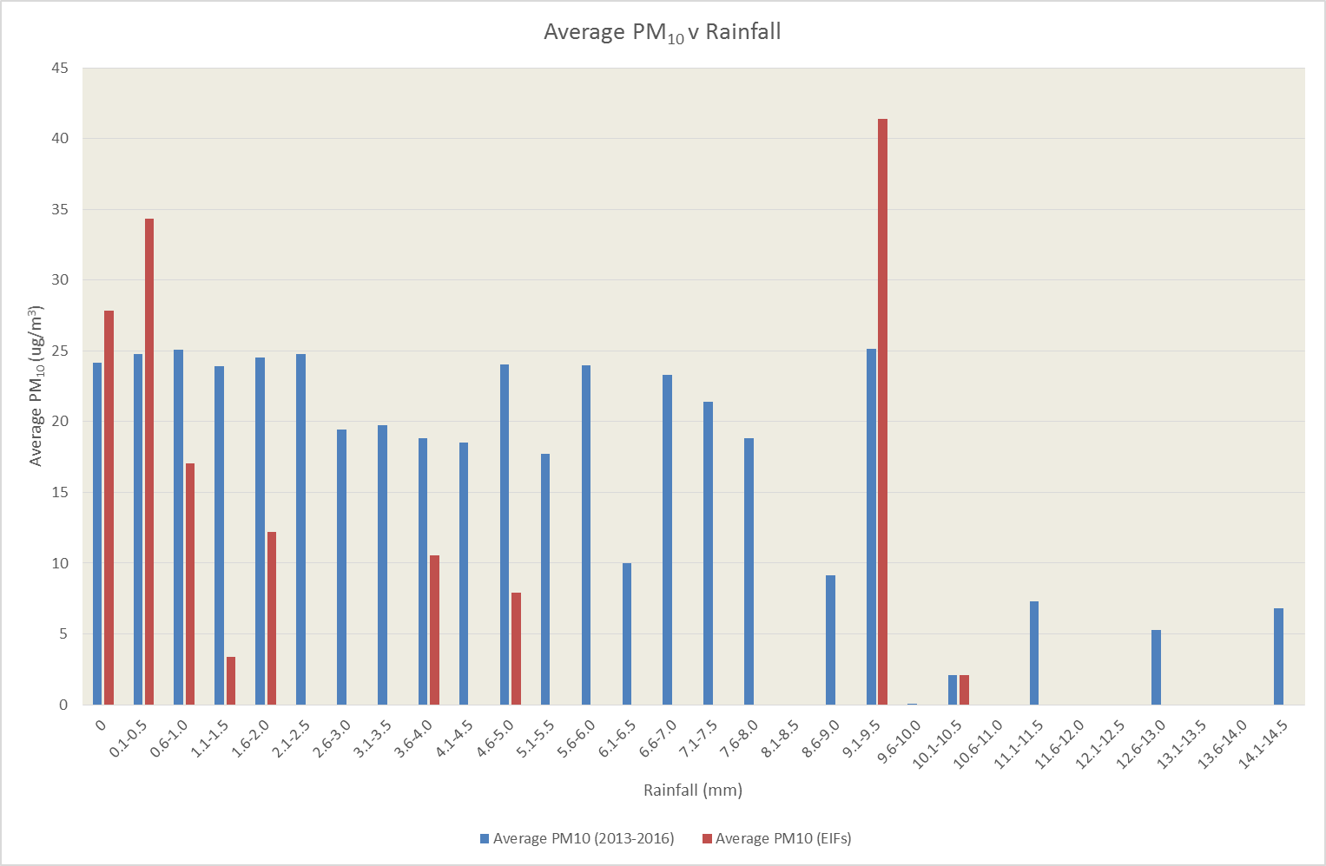
Figure 35 appears to show a negative correlation between rainfall and PM₁₀ concentration for the whole data set, but less so for the data collected at times of Cast House emissions. This is supported by the following linear regression analysis which reveals a very weak negative correlation between the two variables. Thus supporting the findings of Giri et al. (2008) who also found a weak negative correlation, but contrasting with Yoo et al. (2014) who found a far more significant negative correlation in their study. Therefore, it is possible that PM₁₀ released in a Cast House emission undergoes a washing effect from the atmosphere when the emissions coincide with rainfall (Shaheen et al. 2005; Giri et al. 2008; Yoo et al. 2014).
Figure 35 - Average PM₁₀ Concentration v Rainfall

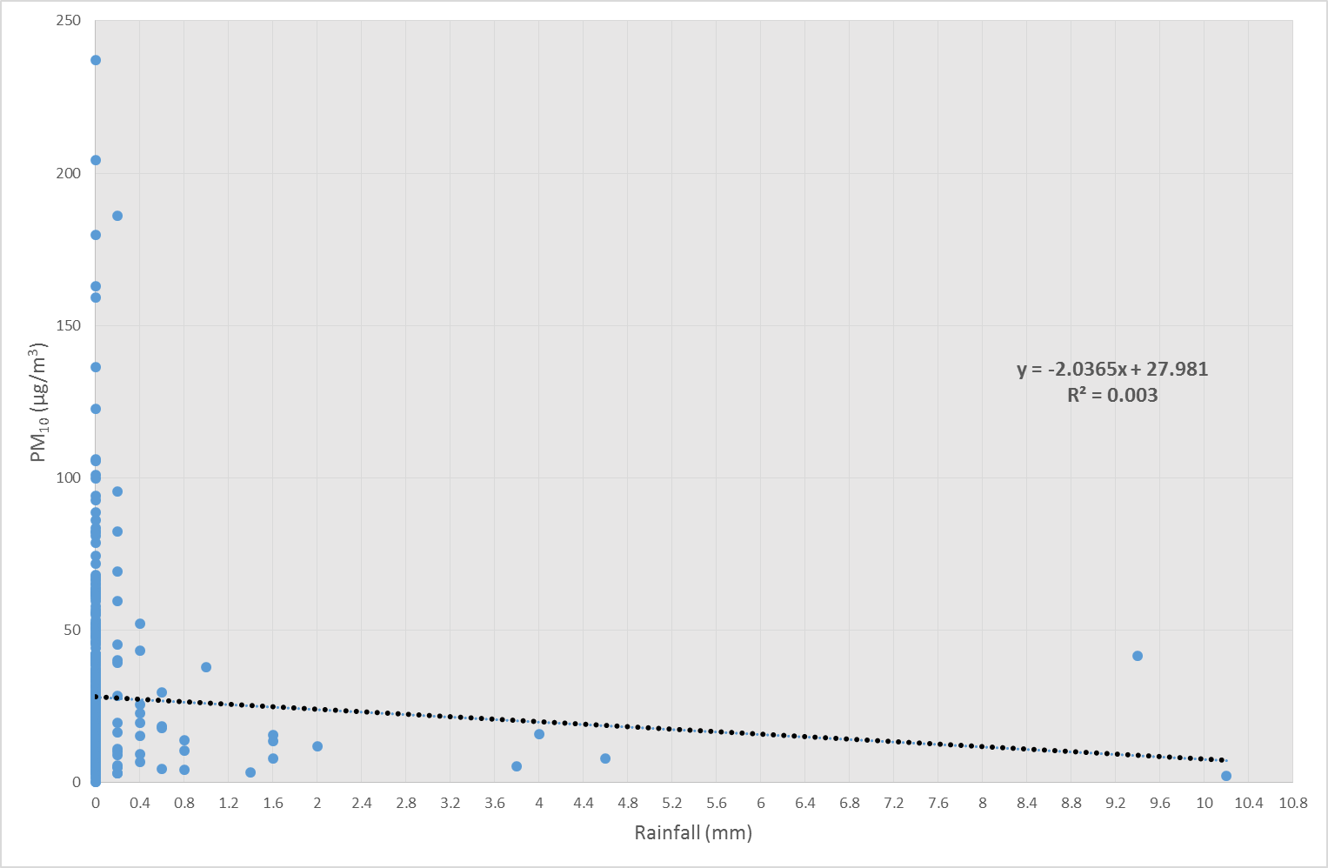
Figure 36 – Scatter Chart with Linear Regression Trend Line (PM₁₀ vs Rainfall)

Figure 37 – Summary Output of Linear Regression Analysis (PM₁₀ vs Rainfall)

5.3.6 Summary and Discussion - Statistical Analysis

5.3.6.1 Linear Regression

Table 17 presents the linear regression analysis r values and P values for the data collected at times of Cast House emissions. The P values (Significance F value) are taken from the ANOVA tables in Figures 25, 28, 31, 34 and 37. A P value of >0.05, as can be seen in all cases below, confirms there is no significant linear correlation between PM₁₀ concentrations and each meteorological factor (Townend 2002).
Table 17 – Linear Regression Analysis Results
Weather Factor | Linear Regression - r Square | P Value/Significance F
Y Value - PM₁₀  X Value - Relative Humidity | 0.00463158 | 0.153178296
Y Value - PM₁₀  X Value - Temperature | 0.00451914 | 0.158271193
Y Value - PM₁₀  X Value - Wind Speed | 0.00448982 | 0.159630704
Y Value - PM₁₀  X Value - Rainfall | 0.00302701 | 0.248380597
Y Value - PM₁₀  X Value - Wind Direction | 0.00092719 | 0.523144905

5.3.6.2 Correlation

Table 18 summarises the correlation coefficient analysis for the relationship between PM₁₀ concentrations and each meteorological parameter for the full dataset and the data collected at times of Cast House emissions. If the r value is close to +1/-1, a strong correlation exists, whereas, r vales close to zero indicate no correlation (Townend 2002). Table 18 shows the existence of no strong correlations.

Table 18 – Correlation Coefficient Analysis Results
 | Y – PM₁₀  X – Wind Direction | Y – PM₁₀  X – Wind Speed | Y – PM₁₀  X – Relative Humidity | Y – PM₁₀  X - Temperature | Y – PM₁₀  X - Rainfall
Correlation Coefficient (r) Analysis - Full Dataset | 0.001638 | 0.157024 | 0.016611 | 0.130026 | -0.017280
Correlation Coefficient (r) Analysis - Cast House Emissions | 0.035708 | 0.067000 | 0.068056 | 0.067225 | -0.055020

The above data is presented in correlation matrices in Figures 38 and 39, created using R Studio® software (R Development Core Team 2008) using the ‘corPlot’ function.
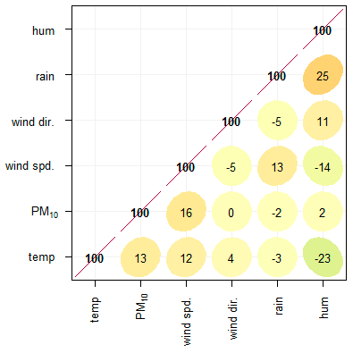
Figure 38 – Correlation Matrix (AURN Full Dataset)

Figure 38 shows, for the full dataset, poor correlation exists between all variables. The most significant relationship exists between relative humidity and rainfall (r value - 0.25). However, this is not a strong relationship. PM₁₀ has the strongest relationship with wind speed (r value - 0.16), however, this is still a very weak relationship.

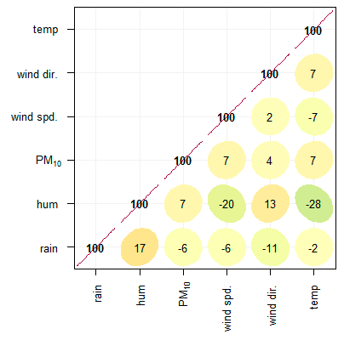
Figure 39 – Correlation Matrix (Data collected at times of Cast House Emissions)

Figure 39 shows, for data collected at times of Cast House emissions, there is even poorer correlation between all variables. Once again, the most significant relationship is between relative humidity and rainfall (r value - 0.17). It is generally accepted that rainfall and humidity are reasonably closely related, with relative humidity being as high as 100% during rainfall as clouds are saturated (Smart Fog 2018). However, this is not reflected in Figures 38 and 39. Figure 39 shows PM₁₀ has the strongest correlation with relative humidity, wind speed and temperature (r values - 0.07) although these are a very weak relationships.
Correlation and linear regression analyses can be criticised as an analysis tool because the outcome of the analysis can suffer from outlier distortion. In addition, casual relationships can be incorrectly inferred between variables (Boddy and Smith 2009). For example, care must be taken to avoid concluding a weak linear relationship when in fact the relationship between two variables is a clear curve (Townend 2002). This section has proved statistically that there is no (or at best an extremely weak) linear relationship between PM₁₀ concentrations and each meteorological parameter. This result is supported by Barmpadimos et al. (2011) who found non-linear relationships between meteorological parameters and PM₁₀ at multiple monitoring locations.

5.3.6.3 Non-Linear Relationship Analysis

If scatter graphs (like those above) show relationships which are not linear, a straight line will not illuminate the relationship between variables (Townend 2002). Table 19 presents the polynomial regression analysis for data collected at times of Cast House emissions.
Table 19 – Polynomial Regression Analysis Results
Independent Variables | Y = PM₁₀  X = Wind Direction | Y = PM₁₀  X = Humidity | Y = PM₁₀  X = Rainfall | Y = PM₁₀  X = Wind Speed | Y = PM₁₀  X = Temperature
X & X² | y = -0.0011x² + 0.4536x - 6.0777 | y = -0.0112x² + 1.6914x - 33.134 | y = 0.7189x² - 7.9044x + 28.255 | y = 0.0105x² + 1.1202x + 23.428 | y = 0.0033x² + 0.28x + 23.16
X & X² | R² = 0.1233 | R² = 0.0179 | R² = 0.0063 | R² = 0.0045 | R² = 0.0045
X & X³ | y = -3E-06x³ + 0.0005x² + 0.1841x + 4.0527 | y = -9E-05x³ + 0.0071x² + 0.5052x - 8.9956 | y = -0.1757x³ + 2.949x² - 12.932x + 28.375 | y = -0.3422x³ + 4.3388x² - 14.717x + 39.196 | y = 0.01x³ - 0.4153x² + 5.517x + 4.5045
X & X³ | R² = 0.1314 | R² = 0.0182 | R² = 0.0071 | R² = 0.0119 | R² = 0.0102
X & X⁴ | y = 1E-07x⁴ - 8E-05x³ + 0.0206x² - 1.5994x + 42.805 | y = 5E-06x⁴ - 0.0014x³ + 0.1309x² - 4.4665x + 61.844 | y = -0.1275x⁴ + 1.9131x³ - 6.2052x² - 3.1748x + 28.233 | y = -0.1204x⁴ + 1.7483x³ - 7.8383x² + 12.569x + 20.506 | y = 0.0017x⁴ - 0.085x³ + 1.3813x² - 7.6962x + 34.687
X & X⁴ | R² = 0.2035 | R² = 0.0187 | R² = 0.01 | R² = 0.0167 | R² = 0.0171
X & X⁵ | y = 7E-10x⁵ - 5E-07x⁴ + 0.0001x³ - 0.0114x² + 0.282x + 14.057 | y = 3E-07x⁵ - 0.0001x⁴ + 0.0127x³ - 0.7194x² + 19.991x - 204.68 | y = 0.0258x⁵ - 0.7477x⁴ + 6.7992x³ - 19.815x² + 6.2487x + 28.148 | y = 0.0467x⁵ - 1.141x⁴ + 9.877x³ - 36.63x² + 56.329x - 1.0645 | y = -0.0004x⁵ + 0.0283x⁴ - 0.7693x³ + 9.3256x² - 47.731x + 100.04
X & X⁵ | R² = 0.2307 | R² = 0.0195 | R² = 0.0106 | R² = 0.0205 | R² = 0.0312
X & X⁶ | y = -8E-12x⁶ + 9E-09x⁵ - 4E-06x⁴ + 0.0009x³ - 0.0884x² + 3.4968x - 22.664 | y = 7E-09x⁶ - 2E-06x⁵ + 0.0003x⁴ - 0.0234x³ + 0.8751x² - 15.957x + 117.1 | y = -0.0339x⁶ + 0.9216x⁵ - 8.9623x⁴ + 37.432x³ - 63.341x² + 23.4x + 28.068 | y = 0.007x⁶ - 0.1368x⁵ + 0.7072x⁴ + 0.8966x³ - 15.033x² + 32.976x + 7.2183 | y = -5E-05x⁶ + 0.0038x⁵ - 0.1095x⁴ + 1.4472x³ - 8.7152x² + 20.267x + 13.399
X & X⁶ | R² = 0.2565 | R² = 0.0196 | R² = 0.0123 | R² = 0.021 | R² = 0.0414

These equations and polynomial trend lines are presented graphically in Figures 40 – 44.
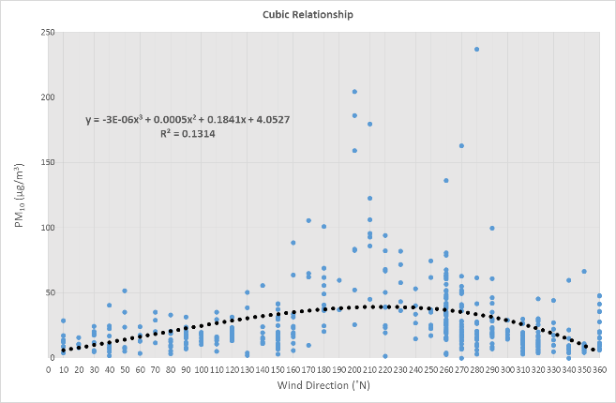
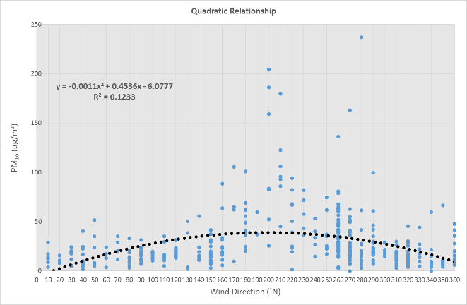
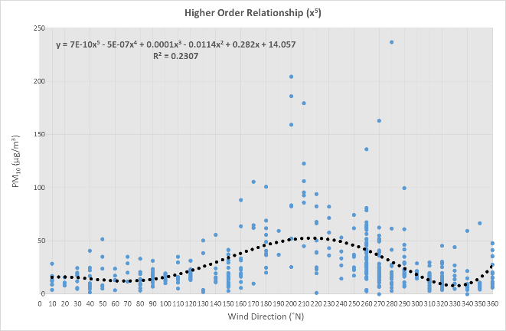
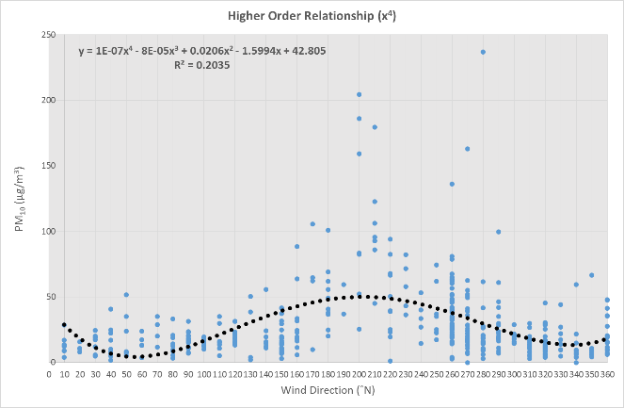
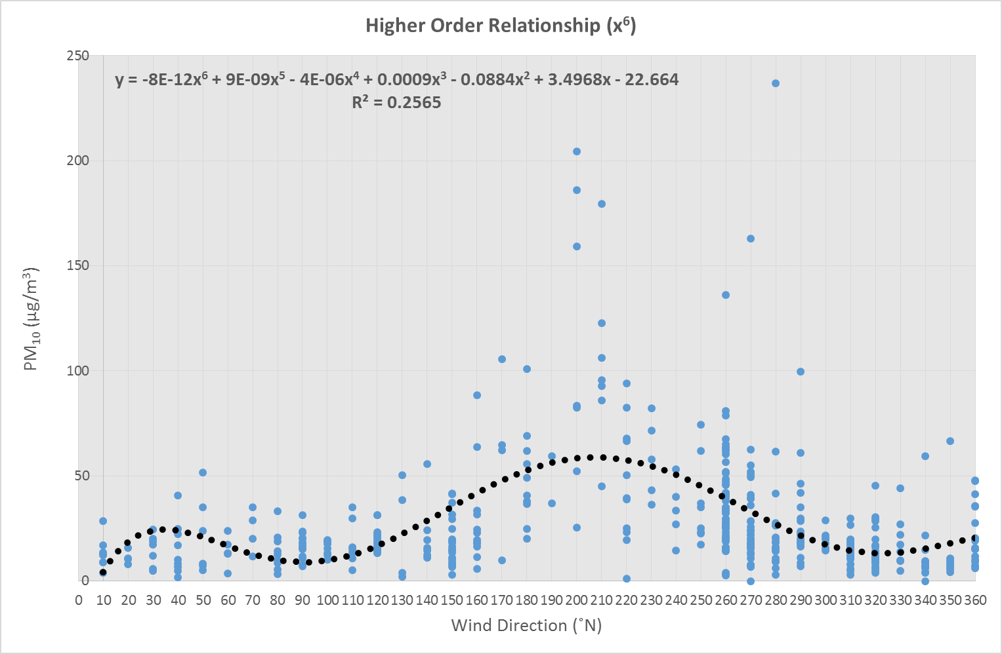
Figure 40 – PM₁₀ and Wind Direction Polynomial Trend Lines - Quadratic (independent variables - x and x²), Cubic (independent variables - x and x³) and Higher Order Relationships (independent variables x and x⁴, x⁵ or x⁶)

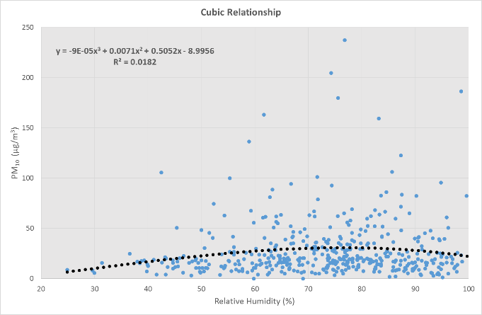
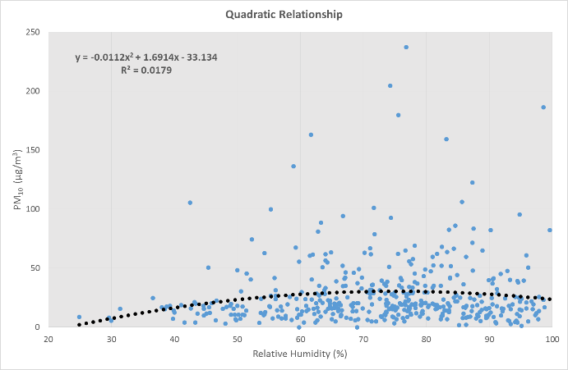
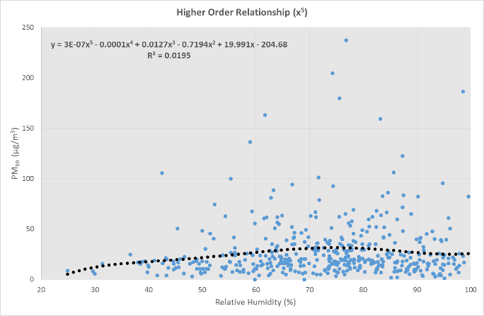
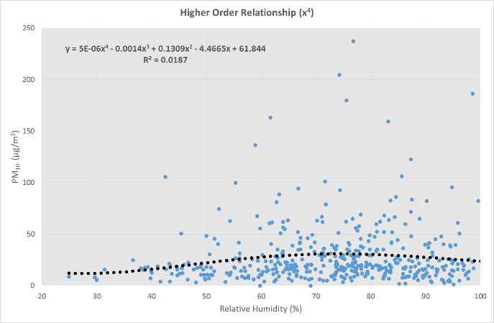
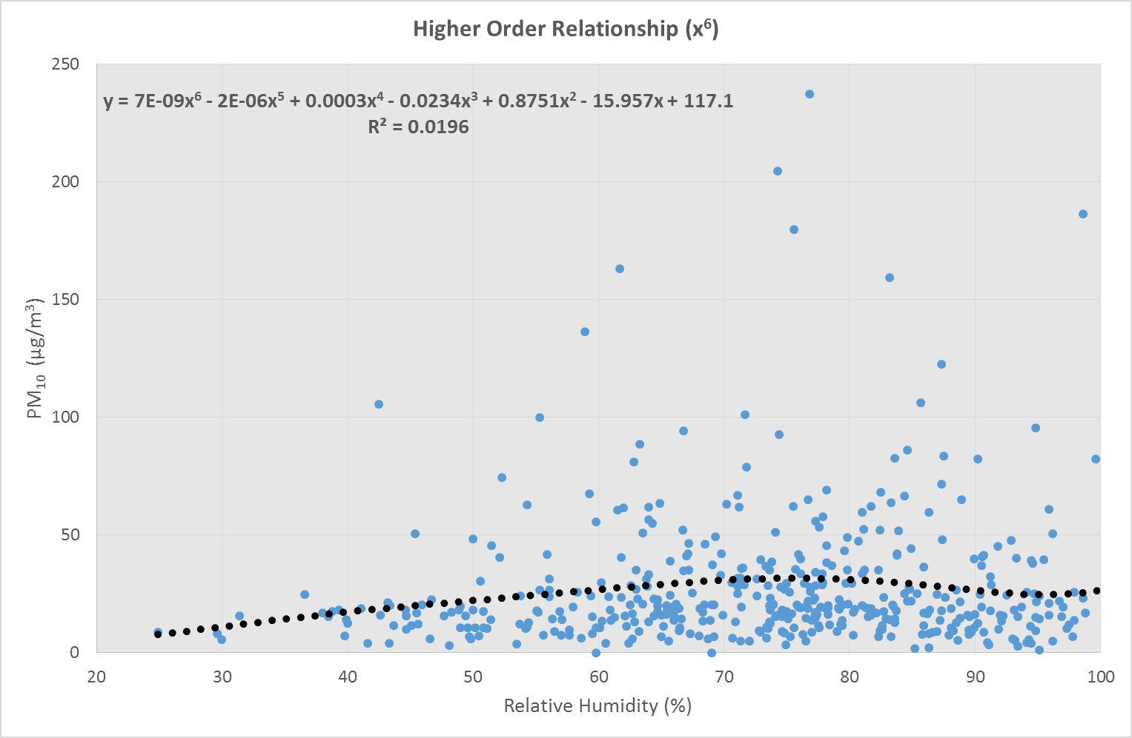
Figure 41 – PM₁₀ and Relative Humidity Polynomial Trend Lines

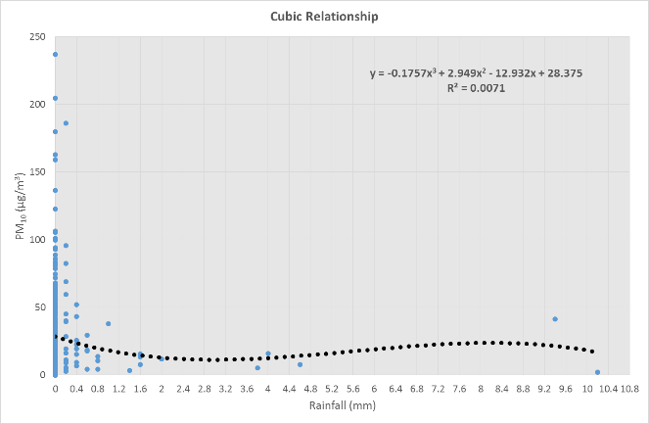
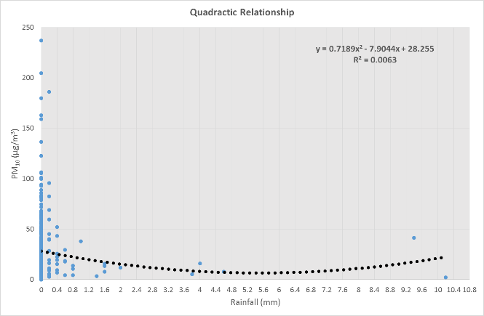
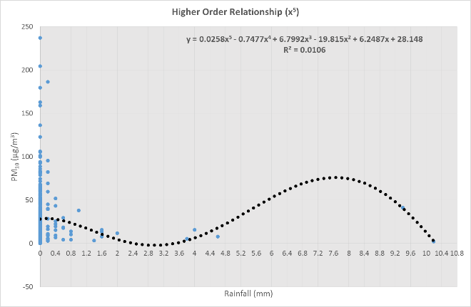
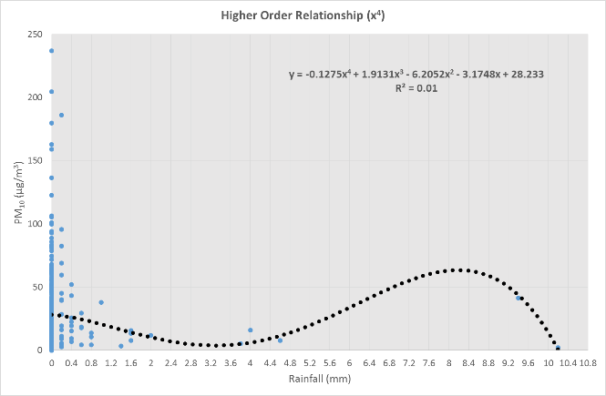
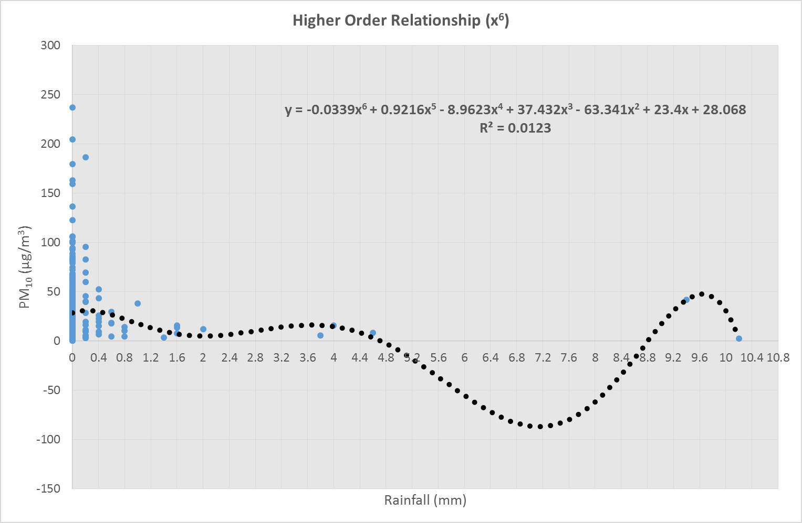
Figure 42 – PM₁₀ and Rainfall Polynomial Trend Lines

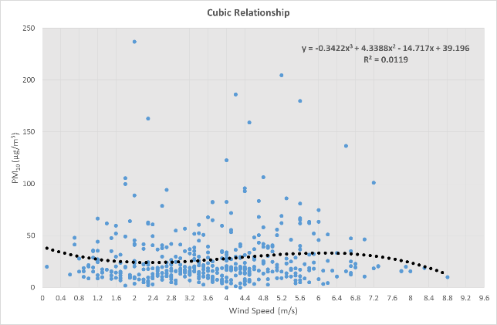
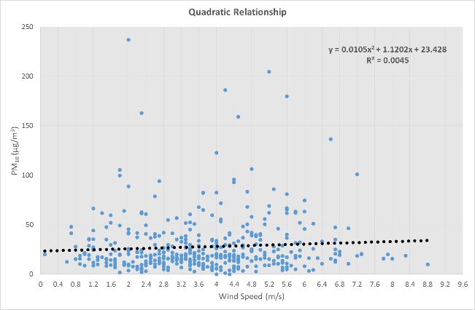
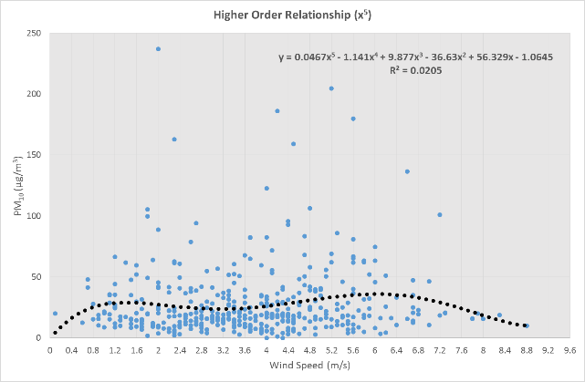
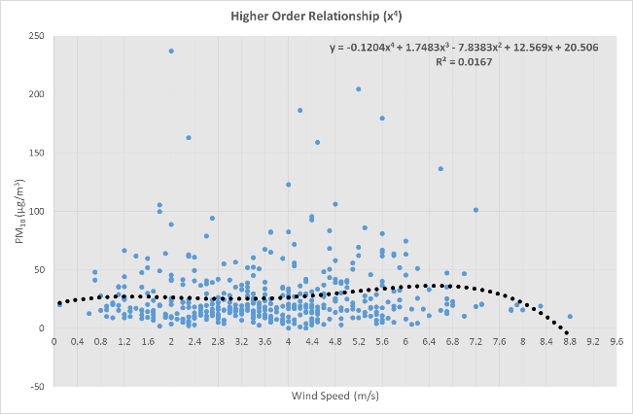
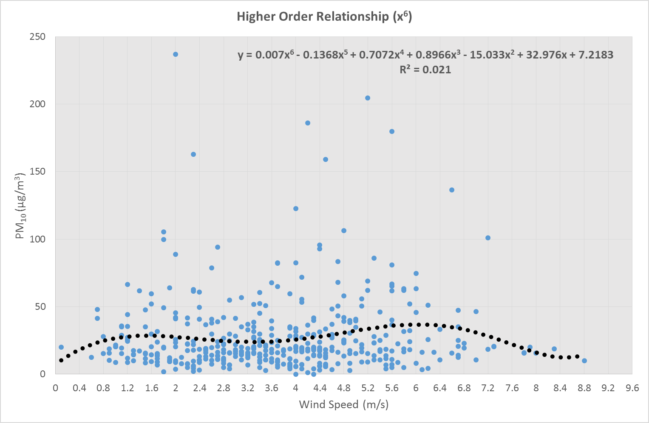
Figure 43 – PM₁₀ and Wind Speed Polynomial Trend Lines

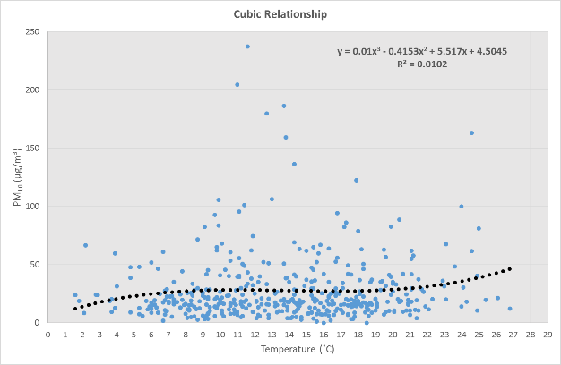
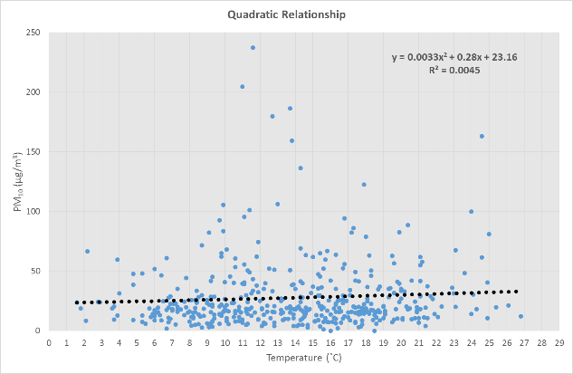
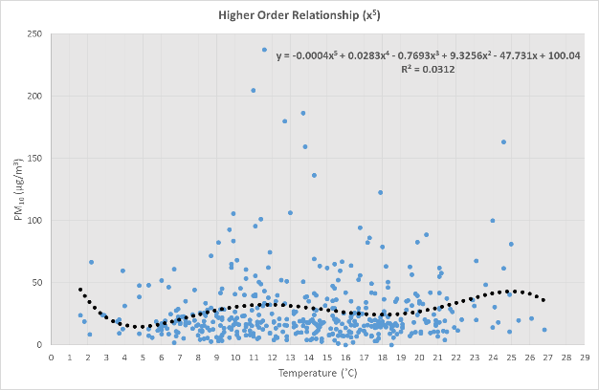
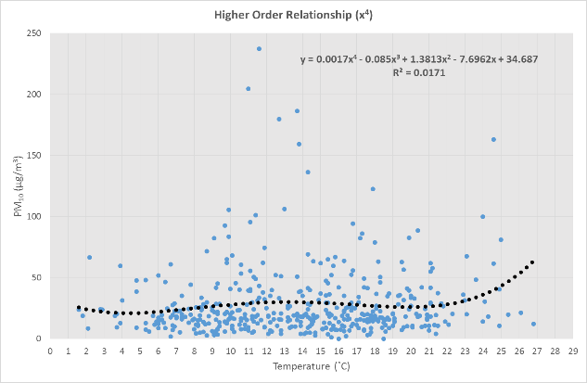
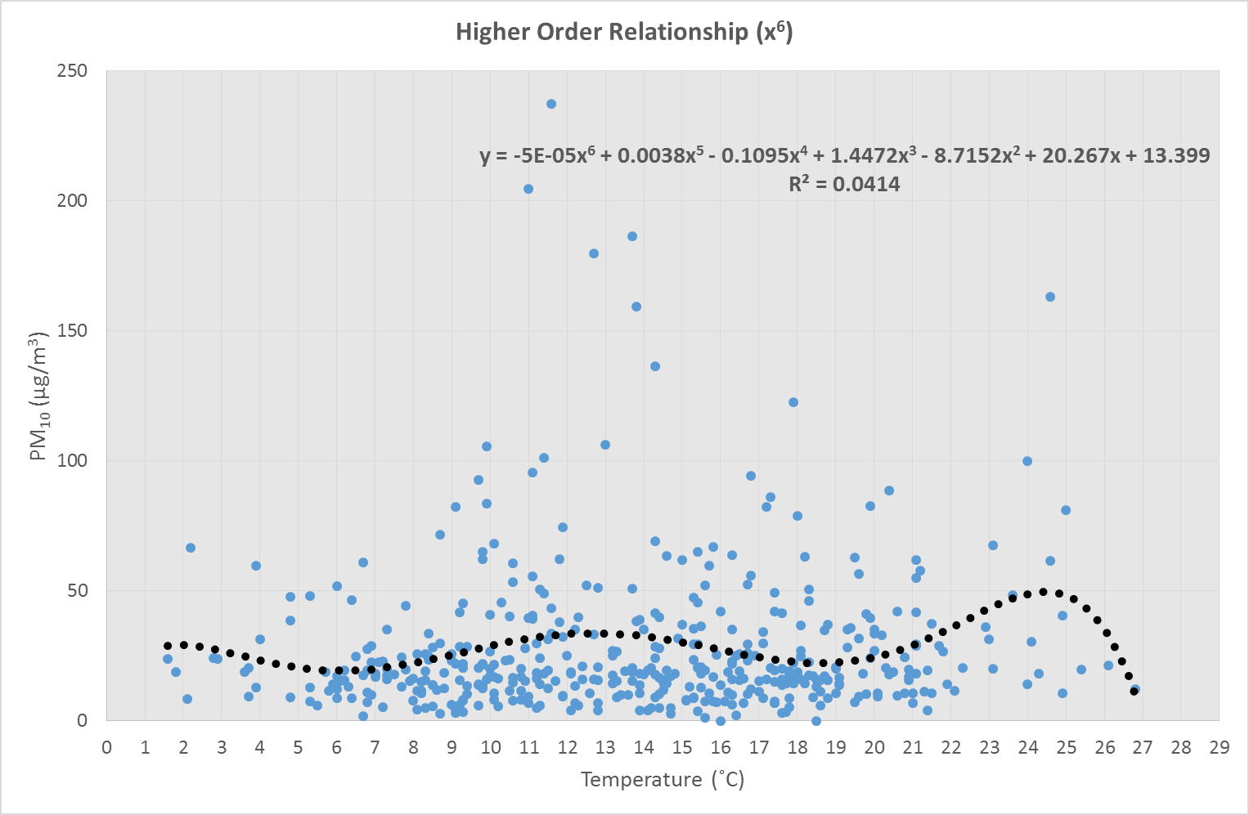
Figure 44 – PM₁₀ and Temperature Polynomial Trend Lines

5.3.6.4 Polynomial Relationships - Discussion

The existence of cubic or higher order relationships are likely the result of multiple ongoing underlying processes (Townend 2002). When compared to the linear regression analysis, the polynomial relationships are of greater significance. Despite this, even at higher order polynomial relationships (x⁴, x⁵ and x⁶), each meteorological factor has a poor statistical relationship with PM₁₀ at times of Cast House emissions. This suggests the absence of one or more very significant meteorological factors/processes which are not measured at the AURN. These should be studied for understanding of PM₁₀ transportation and dispersion in Port Talbot. It is likely a combination of interdependent processes are occurring. For example, Pasquill (1961) explains that atmospheric stability is dependent upon solar radiation and vertical mixing. Therefore, consideration of statistical relationships between just two variables will unlikely reveal significant relationships. Multiple variable consideration (via a dispersion model) and inclusion of missing meteorological variables (e.g. atmospheric stability) are suggested as areas for further work in Chapter 6. Atmospheric stability is discussed further in Section 5.3.6.5.
Pitfalls do exist in polynomial regression analysis, as is the case with linear regression and correlation coefficient analysis. Frost (2015) highlights that overfitting a trend line to a dataset can become a problem, allowing the R² value to become misleading i.e. the trend line becomes more complicated than the dataset can support. In addition, if the trend line is fitted too closely, anomalies in the dataset will be tailored to rather than the line being reflective of the overall population. In this case, the trend line will not fit new data points added in the future. It is for these reasons that the polynomial regression analysis undertaken has been utilised solely to order the meteorological parameters’ relationship with PM₁₀ in order of significance, rather than to create models for the relationship between PM₁₀ and each meteorological parameter - especially as the observed relationships are very weak.

5.3.6.5 Influence of Atmospheric Stability

As discussed above, it is not advisable to extrapolate the St. Athan Pasquill stability data to the AURN location (Noon 2000; Overton 2009). However, the data gives an indication of atmospheric turbulence in the South Wales Area. The St. Athan data (Table 20) shows for the majority of 2016, the atmospheric stability class was D – neutral. Zoras et al. (2006) rate classes D-F as the worst case for atmospheric PM₁₀ build up. However, this study was undertaken in Northern Greece, therefore, it is unlikely representative of South Wales. However, atmospheric stability is undoubtedly a key factor in PM₁₀ transportation and dispersion (Zoras et al. 2006) which requires measurement on an hourly frequency to establish the effect upon PM₁₀. Care must be taken when drawing conclusions based upon the St. Athan stability data as only one year’s data is available to this research.

Table 20 - Atmospheric Stability Analysis
Pasquill Atmospheric Stability Class | Percentage of Time % (2016 Calendar Year)
A  (very unstable) | 0.057
A-B  (very unstable/unstable) | 0.857
B  (unstable) | 2.914
B-C  (unstable/slightly unstable) | 2.777
C  (slightly unstable) | 16.819
C-D  (slightly unstable/neutral) | 1.954
D  (neutral) | 58.341
E (slightly stable) | 8.341
F (stable) | 7.941
Total | 100.00

5.4 Decision Tool Development

5.4.1 Introduction

Tables 21 and 22 show that if high severity is assigned to a Cast House emission when recorded via an EIF, it does not necessarily follow that the AURN PM₁₀ concentration recorded during that same hour is more elevated than if a medium/low severity was assigned. This suggests there are other factors at play (such as weather conditions) which contribute to PM₁₀ concentrations when a Cast House emission is recorded rather than the perceived size of the emissions. Tables 21 and 22 therefore provide justification for reconsideration of the method for assigning severity for Cast House emissions.
Table 21 displays the mean, minimum and maximum PM₁₀ concentrations for low, medium and high severity rated Cast House emissions (2013-2016). The same information is displayed in Table 22 but only for the 200-210˚ wind band (from the direction of the BFs).
Table 21 - Mean, Minimum and Maximum PM₁₀ Concentrations for Low, Medium and High Severity Cast House Emissions

 | Blast Furnace No.4 Cast House Emission Severity Level |  |  | Blast Furnace No.5 Cast House Emission Severity Level
 | Low | Medium | High | Low | Medium | High
Mean PM₁₀ Concentration (µg/m³) | 29.0 | 28.9 | 29.6 | 25.5 | 27.4 | 25.3
Minimum PM₁₀ Concentration (µg/m³) | 3.9 | 2.7 | 2.9 | 1.3 | 4.3 | 3.3
Maximum PM₁₀ Concentration (µg/m³) | 237.0 | 204.4 | 162.9 | 179.6 | 105.5 | 67.6
Count of Data Points | 145 | 86 | 25 | 131 | 51 | 12

Table 22 - Mean, Minimum and Maximum PM₁₀ Concentrations for Low, Medium and High Severity Cast House Emissions (200-210˚ Wind Band)

 | Blast Furnace No.4 Cast House Emission Severity Level |  |  | Blast Furnace No.5 Cast House Emission Severity Level
 | Low | Medium | High | Low | Medium | High
Mean PM₁₀ Concentration (µg/m³) at 200˚ | 119.2 | 148.7 | No occurrences | 25.6 | 83.4 | No occurrences
Minimum PM₁₀ Concentration (µg/m³) at 200˚ | 52.3 | 82.5 | No occurrences | 25.6 | 83.4 | No occurrences
Maximum PM₁₀ Concentration (µg/m³) at 200˚ | 186.1 | 204.4 | No occurrences | 25.6 | 83.4 | No occurrences
Count of Data Points (200˚) | 2 | 3 | 0 | 1 | 1 | 0
Mean PM₁₀ Concentration (µg/m³) at 210˚ | 103.6 | No occurrences | No occurrences | 123.9 | 45.2 | No occurrences
Minimum PM₁₀ Concentration (µg/m³) at 210˚ | 92.7 | No occurrences | No occurrences | 86.0 | 45.2 | No occurrences
Maximum PM₁₀ Concentration (µg/m³) at 210˚ | 122.6 | No occurrences | No occurrences | 179.6 | 45.2 | No occurrences
Count of Data Points (210˚) | 3 | 0 | 0 | 3 | 1 | 0

5.4.2 Low to Very High Severity Weather Conditions

Table 23 shows weather conditions which contribute to particular bands of PM₁₀ concentrations (0-50µg/m³, 51-100µg/m³, 101-150µg/m³ and >150µg/m³) being recorded at the AURN at times of Cast House emissions. ‘Very high severity’ represents the worst case weather conditions which are associated with the highest PM₁₀ concentrations.
Table 23 – Weather Conditions Contributing to Low, Medium, High and Very High PM₁₀ Concentrations at the AURN Monitor

 | Low Severity (0-50µg/m³) | Medium Severity (51-100µg/m³) | High Severity (101-150µg/m³) | Very High Severity (>150µg/m³)
Wind Direction (˚N) | 360 - 40 | 50 - 160  270 - 350 | 170 - 190  220 - 260 | 200 - 210
Relative Humidity (%) | 0 - 45.3 | 45.4 - 58.8 | 58.9 - 74.2 | 74.3 - 100
Rainfall (mm) | >0.4 | 0.3 - 0.4 | 0 - 0.2 | 0 - 0.2
Wind Speed (m/s) | 0 - 1.1  >7.3 | 1.2 - 1.7  5.7 - 6.5 | 1.8 – 1.9  6.6 - 7.2 | 2.0 - 5.6
Temperature (˚C) | 0 - 2.1  >25.0 | 2.2 - 9.8  14.4 - 25.0 | 9.9 - 10.9  13.9 - 14.3 | 11 - 13.8

In support of the previous analysis, Table 23 shows the worst possible wind directions at times of Cast House emissions are 200-210˚ (from the direction of the BFs). Figure 45 shows the low, medium, high and very high wind direction conditions presented as a radar chart.

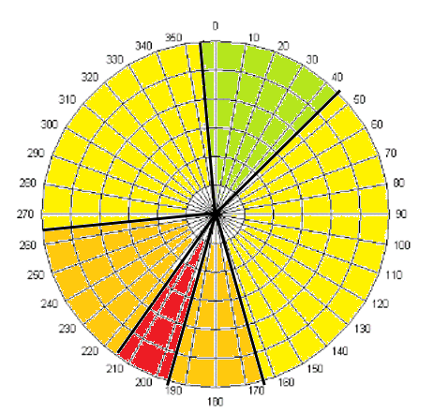
Figure 45 – AURN Monitor Radar Chart

Table 23 shows that very low wind speeds (0-1.1m/s) are one of two best possible wind speed conditions for low PM₁₀ at the time of Cast House emissions (the other being >7.3m/s). It is generally agreed that very low wind speeds lead to atmospheric PM₁₀ build up. It is possible at very low wind speeds, the hot particulate Cast House emission does not get carried the 700m north-east to the AURN monitor and travels directly upwards. This is supported by Ohmsen (2001) who studied thermal effect upon plume buoyancy at a Lead Smelting Plant BF. Ohmsen also found at higher wind speeds (in excess of 2m/s), plumes remain closer to ground level resulting in increased ambient PM₁₀ concentrations, also supporting this research. The high wind speed condition (>7.3m/s) contributing to low PM₁₀ concentrations is not supported by AQEG (2005) and Giri et al. (2008) who found gales transporting foreign particulates into the area. However, it is generally agreed that high wind speeds aid PM₁₀ dispersion (Filonchyk et al. 2016; Czernecki et al. 2017) supporting this research. Table 23 shows there is a narrow band of ambient temperature 11-13.8˚C which contributes to the highest PM₁₀ concentrations at times of Cast House emissions. There appears to be no published literature on this topic to support or dispute this finding.

Table 23 also shows that PM₁₀ is higher at times of Cast House emissions with increased humidity, with the worst case condition being >74.3%. This exceeds the worst case humidity conditions identified by Giri et al. (2008) (40-60%). It must be noted that Giri et al.’s study took place in Kathmandu Valley which experiences a very different climate and weather systems to Port Talbot. A potential reason for greater humidity resulting in elevated PM₁₀ is that mass is gathered by the particles during humid conditions, therefore they remain at ground level rather than dispersing into the atmosphere (Giri et al. 2008). In addition, this finding does not support the existence of a washing effect for PM₁₀ during high humidity conditions (Shaheen et al. 2005; Giri et al. 2008; Yoo et al. 2014).
Finally, Table 23 shows that low levels of rainfall (0-0.2mm per hour) contributes to high and very high concentrations of PM₁₀ being recorded when Cast House emissions occur. This is supported by Shaheen et al. (2005), Giri et al. (2008) and Yoo et al. (2014) who found a washing effect upon PM₁₀ with increased rainfall.
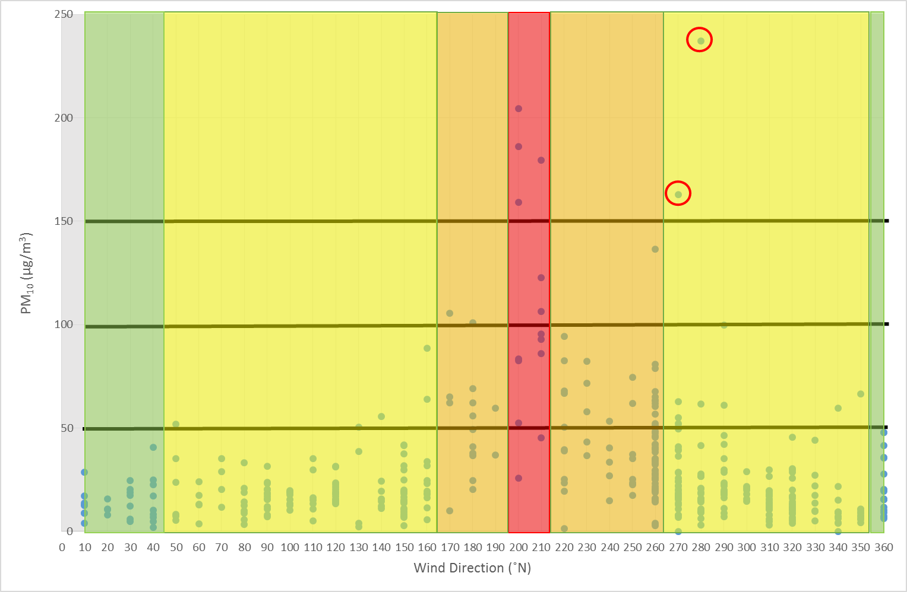
Table 23 is presented graphically in Figures 46–50 with any outliers to the observed pattern circled in red.
Figure 46 – Low to Very High Severity Conditions (Wind Direction)

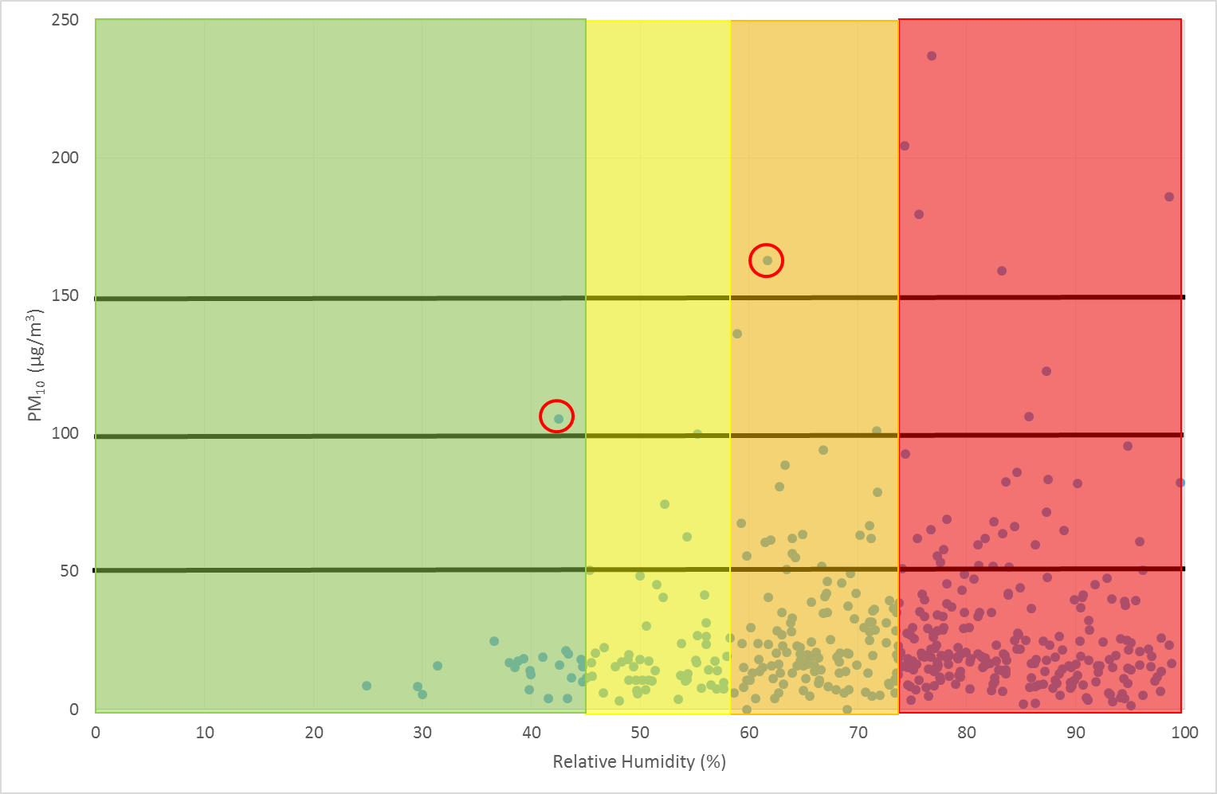
Figure 47 – Low to Very High Severity Conditions (Relative Humidity)

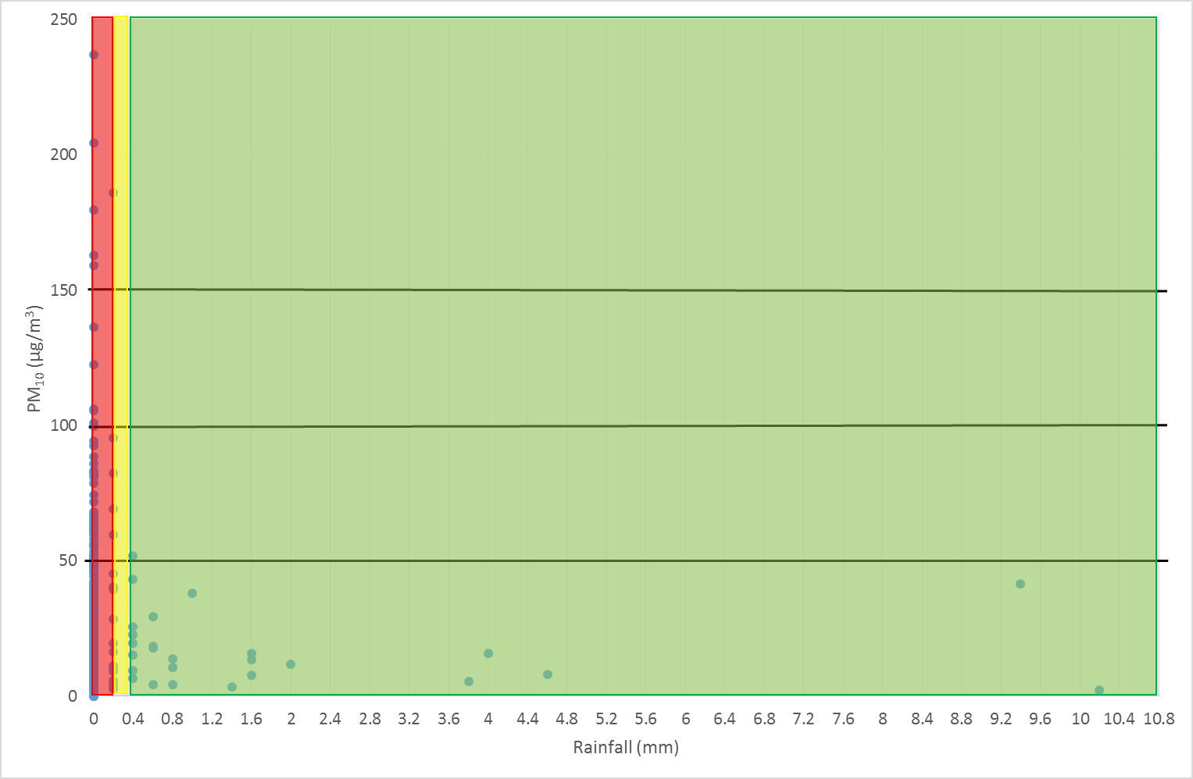
Figure 48 – Low to Very High Severity Conditions (Rainfall)

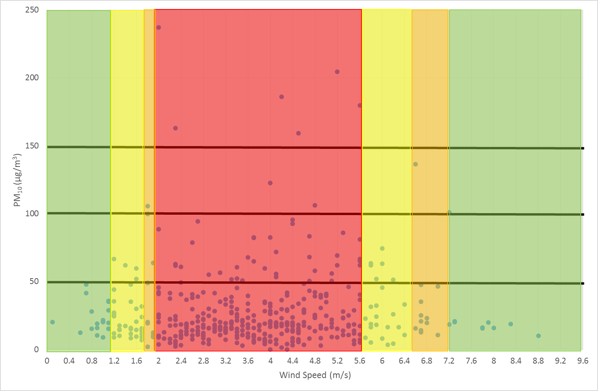
Figure 49 – Low to Very High Severity Conditions (Wind Speed)

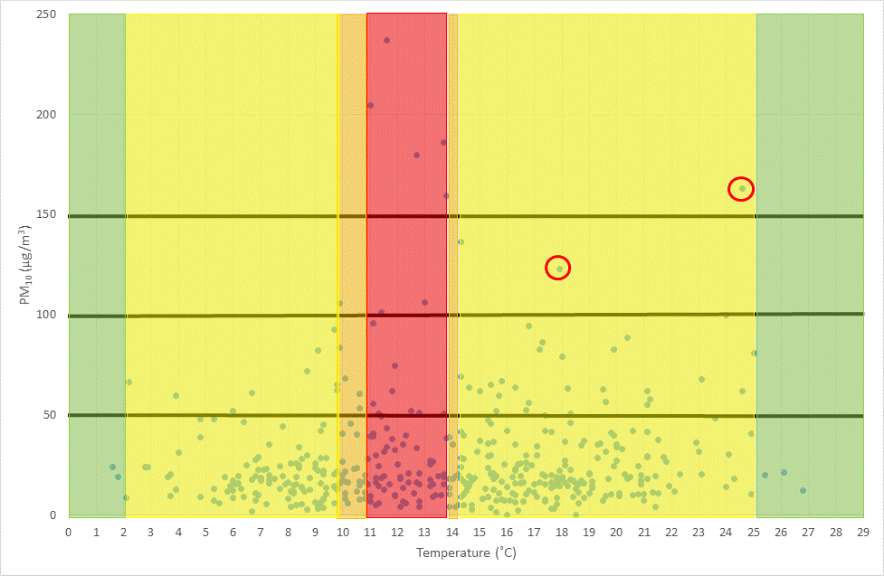
Figure 50 – Low to Very High Severity Conditions (Temperature)

5.4.3 Creation of the Decision Tool

The previous analysis has been used to develop a decision tool to aid those recording EIFs for Cast House emissions in assigning a severity rating for the emission. The polynomial regression analysis presented in Table 19 has been used to determine the order in which weather conditions are considered in the decision tool. The decision tool is presented in Figure 51.

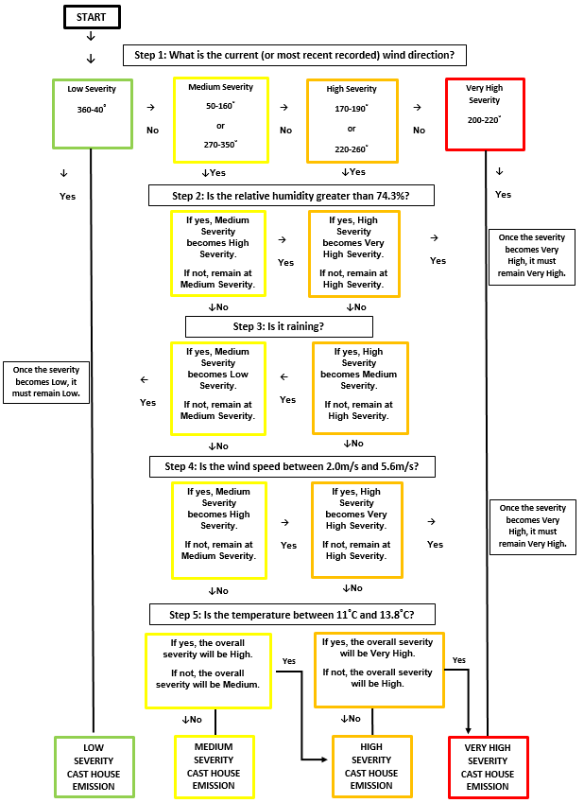
Figure 51 – Decision Tool Flow Chart

Evaluation and Conclusions

6.1 Assumptions

Many general assumptions can be made during research. For example, the assumption that participants will conduct themselves in an honest manner (Wargo 2015). Assumptions relating to this point and additional assumptions made in this research are outlined in Table 24.
Table 24 - Assumptions

Assumption 1 | In the context of this research, it has been assumed that the observers of Cast House emissions actually did, to the best of their recollection, observe the emission when they say they did and were not recording fictitious emissions for another motive e.g. to justify capital investments in the process. It has also been assumed that each emission from the Cast Houses has been recorded on the EIF system. It is possible that Cast House emissions have occurred within the study period which do not have a corresponding EIF denoting the date and time of the emission e.g. as a result of production pressures or human error.
Assumption 2 | For the majority of the analysis carried out in this research, it had to be assumed that PM₁₀ travels in straight lines. This is the methodology adopted by Tata Steel’s Environment Department when carrying out investigations into breaches of the daily mean PM₁₀ objective. However, this is unlikely to be the case in Port Talbot owing to deflection from the hills (AQEG 2011) and the obstacles in the path of the PM₁₀ and the many heat sources on the Steelworks site (Hayes and Chatterton 2009). An illustration of this can be seen in Figure 19 above which presents the likely trajectory path of PM₁₀ taken between the AURN and Theodore Road monitors. This is discussed further in the following suggestions for further work.
Assumption 3 | This research has considered the impact of Cast House emissions upon the Port Talbot monitoring network in isolation. The impact of other sources of PM₁₀ emission within the Steelworks boundary have been excluded from consideration but it is possible that there were other emissions of PM₁₀ occurring simultaneously with Cast House emissions i.e. during the ~450 hours of analysed PM₁₀ and meteorological data. In addition it is possible that there was an influence of transboundary particulate pollution from the coastline impacting the monitoring network during a proportion of the 450 hours studied. For example, as discussed above in Section 5.2, the AURN and Theodore Road monitors were likely impacted by transboundary pollution from the direction of the coast in April 2016.
Assumption 4 | Further sources of fugitive PM₁₀ exist in Port Talbot, in addition to that of Cast House emissions. There are also important meteorological variables missing from this research. This may go some way to explain why poor statistical relationships were found between PM₁₀ at the time of Cast House emissions and the meteorological data. Therefore, this research (by the nature of the resources available) has had to assume that Cast House emissions are occurring, and the resulting PM₁₀ emitted is being measured, in a vacuum. In reality, the Steelworks and Port Talbot town exist in a very complex coastal area with interesting typography, many additional industrial sites and road and rail networks, construction projects, trans-boundary pollution and sea spray all contributing to the background PM₁₀ concentration (Welsh Government 2013). The removal of this assumption is suggested as an area for further work in the following section.

6.2 Limitations and Recommendations for Further Work
Research limitations have been described by Roberts (2004) as areas of the study the researcher has no control over, with examples from Wargo (2015) including sample size and time and methodological constraints. In the context of this research, the following limitations were encountered and recommendations to address the limitations are presented.

6.2.1 Purpose of the Decision Tool

For a decision tool to be useful it must allow the user to make a decision or fulfil a purpose. As BF iron production is a twenty-four hour process, it is not possible to bring a furnace off-line each time the high/very high severity weather conditions are in existence. This would introduce process instability which could result in other emissions such as bleeder valve releases (Sarna 2013). However, it is recommended that the tool is utilised for the following purposes.
Table 25 – Recommendation 1
Recommendation 1 | - Were the high/very high severity conditions often in existence during Cast House emissions, justification could be made to senior management regarding the need for capital investment for dust capture improvements and allocation of research resources.  - The output of this tool could also be used to justify improvements in BF dust capture technology globally.  - It is also possible that this tool could be used by the Welsh Government, NPTCBC and NRW to inform the ‘airAware’ notification system. If the weather conditions found by this research to contribute PM₁₀ build-up in the AQMA are in existence, notifications could be sent to ‘airAware’ recipients - Port Talbot residents with asthma, chronic obstructive pulmonary disorder (COPD), or heart disease (Lyons et al. 2016).

In March 2018, the decision tool was presented to the Tata Steel BF area Fire and Environment Manager and an informal interview was conducted. The Fire and Environment Manager explained that in order for the decision tool to be incorporated into daily works management, it is necessary that the tool is as simple to understand as possible (with margin for error removed) and cannot be time consuming to use (A. Townsend, personal communication, 21st March 2018), concurring with Harding (2003). Upon reflection of the information provided, support is to be sought from the Tata Steel Central Environment function (Group Environment) in automating the decision tool. Group Environment have the expertise and software to automate the decision tool in such a way that available weather parameters can be input directly from weather forecasting websites and provide the output level of severity at the click of a button. This allows the tool to be extremely simple and quick to use and removes any chance of error, thus incorporating the builds of the Fire and Environment Manager. In its current form, BF operators are required to have ready access to the necessary PM₁₀ and meteorological data.

6.2.2 Data Points

This research is limited to a certain extent by the relatively small number of data points i.e. there were ~450 Cast House emissions (2013-2016) and, therefore, only 450 hours of PM₁₀ and meteorological data for analysis and incorporation into the decision tool. Analysis could not be conducted prior to 2013 as the EIF system went live in late 2012. In order for the decision tool to remain relevant, it requires an annual review.
Table 26 – Recommendation 2
Recommendation 2 | This research should be continued into the future by updating the analysis annually as more recent PM₁₀ and meteorological data becomes available. Therefore, increasing the number of data points and adjusting the low, medium, high and very high severity weather conditions with the addition of each new year’s data (once ratified).

6.2.3 Missing Variables and Transboundary Pollution

This research has identified that very important variables are missing from the analysis, for example, atmospheric stability, wind gust, transport wind speed and mixing height data. This data is unfortunately unavailable for the Port Talbot monitoring network, therefore, its impact upon Cast House PM₁₀ transportation and dispersion cannot be assessed to inform the subject literature. This is troubling as a large area of Port Talbot is designated an AQMA and therefore an area of concern regarding public exposure to elevated PM₁₀ concentrations. Therefore, it is suggested the Port Talbot monitoring network is not fit for purpose and recommendations are made in Table 27. A recommendation with regards to transboundary pollution is made in Table 28.
Table 27 – Recommendation 3
Recommendation 3 | Investments should be made by NPTCBC to upgrade the network and install the technology to provide measured (or at least modelled) data for atmospheric stability, wind gust, transport wind speed and mixing height at the AURN monitoring station initially, followed by the other monitors in the town. This study should be repeated if or when the data identified above becomes available in addition to the exploration of this data in a dispersion model as suggested by AQEG (2011), discussed below.

Table 28 – Recommendation 4
Recommendation 4 | Further work could also consider the impact of transboundary pollution upon PM₁₀ concentration and trends in Port Talbot. The influence of transboundary pollution is touched upon in this research (Section 5.2) but is not considered fully as it was beyond the research scope.

6.2.4 Monitoring Location Weather Data

The AURN is the only Port Talbot monitor to record a (limited) suite of weather data. Site specific meteorological data is preferable (Noon 2000; Overton 2009) and can allow more accurate and reliable analysis to be conducted.
Table 29 – Recommendation 5
Recommendation 5 | The Port Talbot monitoring network should be upgraded to allow a full suite of location specific meteorological data to be gathered at all eight monitoring stations.

Were Recommendation 5 to be fulfilled, the analysis for Research Objectives 2, 3 and 4 (Table 1) could be expanded to encompass all the Port Talbot monitors. This would allow a heat map of PM₁₀ hot spots in the AQMA to be created (i.e. areas of high PM₁₀ concentrations where dispersion is inhibited) and the suitability of the AURN location to be assessed.
Table 30 – Recommendation 6
Recommendation 6 | An investigation should be carried out (following the development of a heat map) to ascertain if there is sufficient coverage of PM₁₀ monitors in Port Talbot and whether the AURN monitor is located in the best place to provide a representative measurement of the number of PM₁₀ daily mean objective breach days recorded annually.

The fact that the AURN was found to be most impacted is encouraging considering that this monitor is used for measuring the official count of breaches of the daily mean objective.

6.2.5 Investigation of Emission Mass

The decision tool and research in general could be improved by incorporating PM₁₀ mass (or at least concentration) data measured on the Cast Houses to assess the size of the emission and volume of PM₁₀ emitted. As described in Chapter 3 - Literature Review, technology is not currently available (and certainly not installed on BFs globally) to quantifiably measure the volume/mass of particulate released in Cast House emissions. Researchers are generally forced to reply upon developing emission factors derived from particulate sampling, time lapse photography and production data. It is clear this method and the technology available has not advanced significantly in the last forty years with similar approaches utilised by May (1977), Hodges and Horne (2005), Boscolo and Padoano (2011) and Mueller et al. (2013). Light scattering technology (Matta 2011), LIDAR (Holmen et al. 1998; Fitz et al. 2003) and optical remote sensing (Du et al. 2011) technologies have been developed however, emission factors and algorithms (along with other data) are still required to ascertain mass emission. Therefore, there is no technology or sampling device in existence which can, by a simple method, measure the entire mass and size distribution of particulate matter released in Cast House emissions, let alone a device that could withstand the harsh environment of the BF Cast House.
Table 31 – Recommendation 7
Recommendation 7 | At this stage it is recommended that either a permanent monitor is installed, or a lengthy sampling campaign conduced, to measure PM₁₀ concentrations during emissions and the data coupled with as much meteorological data as can be obtained (including the missing variables discussed above) in order to derive accurate emission factors for each Blast Furnace Cast House. These emission factors should be encompassed into the risk of exposure decision tool to make for a complete and accurate measure of the severity of a Cast House emission at a given time.

Without a way of reliably measuring emission mass, severity in terms of perceived emission size as determined by the observer cannot currently be considered within the decision tool. Its inclusion would introduce subjectivity and, therefore, uncertainty, bias and inaccuracy (Redmill 2002) making the output not replicable. A reason for this is perception of emission size and severity will inevitably vary with experience.
The fulfilment of Recommendation 7 would allow a comparison of BF4 and BF5 Cast Houses to be made in terms of PM₁₀ emissions. This would be an interesting piece of research to inform the literature considering that BF4 was rebuilt during 2012/2013 with significant environmental improvements made, including improved fume extraction. This research could be used to support or contest the work of Hodges and Horne (2005) and Boscolo and Padoano (2011) who found a reduction in PM₁₀ concentrations in the neighbouring town and emissions from the Cast House respectively in their BFs of study following improvements to fume extraction. However, as discussed in Chapter 3 - Literature Review, there are issues with the reliability and validity of the results of these studies owing to insufficient study period length (Hodges and Horne) and lack of meteorological factor consideration (Boscolo and Padoano).
Establishing PM₁₀ mass emitted by each BF Cast House would be particularly useful in moving forward the analysis undertaken on the effect of distance decay upon PM₁₀ concentrations (Section 5.2) and develop the decision tool. Especially as PM₁₀ mass emitted in a Cast House emission is not always the same, depending upon the cause (May 1977).

6.2.6 PM₁₀ Behaviour and Additional Sources
As discussed in Section 6.1, research on the subject considers it unlikely that PM₁₀ would travel in straight lines across Port Talbot.
Table 32 – Recommendation 8
Recommendation 8 | A further suggestion for further work is to consider the impact of obstacles, heat sources and other relevant factors upon the dispersion of PM₁₀ particles in the area surrounding the Steelworks.

Consideration has been given to a potential method for carrying out this further work. In 2011, AQEG advised the Welsh Environment Agency that a Computational Fluid Dynamics (CFD) model would be of little benefit as this method is more suited to modelling over short distances (10-100m). Therefore, it is not appropriate to apply the technique to model PM₁₀ dispersion from the Steelworks to observe the impact upon distant receptors in the town. A dispersion model has been determined as a more suitable method for establishing the general movement of PM₁₀ in the area, with CFD limited to running meteorological factors individually rather than being able to assess the effect of interdependent variables and processes likely in existence (AQEG 2011; Pasquill 1961).
A final recommendation is made in Table 33 below with regards to additional sources of emission.
Table 33 – Recommendation 9
Recommendation 9 | A further recommendation is made to replicate this methodology to investigate other emission sources both within and outside the Steelworks boundary.

For example, the date and time of BOS Plant roof fugitive emissions can be extracted from the EIF system in exactly the same way and analysed against meteorological factors. This would allow weather conditions required for low to very high PM₁₀ concentrations at times of these emissions to be established and a decision tool to be developed. However, care must be taken to isolate influences of other PM₁₀ sources when expanding this research as identified by Mueller et al. (2013) and discussed in Chapter 3 - Literature Review. It is also recommended that PM₁₀ emission sources outside the Steelworks boundary are built into the research. For example, Barmpadimos et al. (2011) noted the impact of traffic emissions upon observed relationships in their study. This could be an important factor in the Port Talbot AQMA, which is encircled by two busy roads and with the M4 Motorway to the east and north.

6.3 Conclusions

In Port Talbot, the BFs are acknowledged as a notable source of PM₁₀ that generally contribute to elevated PM₁₀ concentrations in the town (Moreno et al. 2004; Hodges and Horne 20005; Hayes and Chatterton 2009). However, until now, there has been no published study into the effect of Port Talbot BF Cast House emissions using date and time logged emission data to assess the impact upon local monitoring stations. Owing to the fact that each Cast House is different (May 1977) and Port Talbot has interesting typographical features (Hayes and Chatterton 2009; AQEG 2011) affecting the transportation and dispersion of PM₁₀, this research is justified, novel and contributes to the global literature on the subject. The research aim and objectives of this research have been met as outlined below.
The AURN was most impacted of all of the monitors by Cast House emissions with the emissions potentially contributing 0.66µg/m³ (at 200˚) and 0.47µg/m³ (at 210˚) to the background concentration (2013-2016). The contribution found here is higher than that suggested by Hodges (2005). The Theodore Road monitor was least impacted by Cast House emissions. The trajectory of PM₁₀ across Port Talbot between the AURN and Theodore Road monitors (2013-2016) has been established, with highest concentrations impacting the AURN from the south-south-west to south-west (190-210˚) before travelling north to north-eastwards to impact the Theodore Road monitor between 170-200˚, possibly deflected by the hills to the east of the town, supporting the findings of AQEG (2011).
Through multiple statistical techniques (linear regression, correlation coefficient and polynomial regression) very weak relationships were observed between each meteorological factor and PM₁₀, supporting the work of Ohmsen (2001), Shaheen et al. (2005), Giri et al. (2008), Csavina et al. (2014), Yoo et al. (2014) and Filonchyk et al. (2016). The analysis illuminated that there are variables missing which are not measured at the AURN - atmospheric stability, wind gusts, transport wind speed and mixing height (US Bureau of Land Management 1994; Zoras et al. 2006; and Barmpadimos et al. 2011). In addition, it is likely there are a combination of interdependent factors and processes in existence (Pasquill 1961; Csavina et al. 2014) possibly explaining why weak relationships were observed. However, this analysis was essential in establishing worst case conditions for each meteorological parameter in contributing to elevated PM₁₀ concentrations at times of Cast House emissions. The analysis was also useful in ordering the significance of meteorological parameters in a decision tool for utilisation by Steelworks personnel in assigning a severity for Cast House emissions in terms of risk of public exposure to elevated PM₁₀ and risk of breaching the daily mean objective.
It is suggested the decision tool is used to justify Cast House dust abatement investment requirements to senior management and the need for allocation of resources for research if the worst case weather conditions were often in existence at times of emissions. It is also important in informing global discussions on the requirement for improved BF emission capture globally as impacts of Cast House emissions were observed in the town of Port Talbot. It is also recommended that this research informs the ‘airAware’ notification system. An extensive discussion of improvements to this research, the assumptions made and suggestions for further work can be found in Sections 6.1 and 6.2. Examples of suggested improvements include incorporation of missing meteorological variables, installation of site specific weather data, investigation of emission mass and investigation of PM₁₀ behaviour and other PM₁₀ sources.
This research contributes to global debate on the effect of BF particulate emissions upon nearby residential areas and contributes to the justification argument for continuous improvements and investment in casting technology and consistent tapping performance to reduce emissions as far as possible across the world. The findings of the proposed research may be contextualised outside the steel industry to other sectors (e.g. quarrying) in which particulates are emitted. Further, the methodology developed may be used to assess the effect of particulate emissions from other industrial processes globally where date and time data is available for process emissions. This methodology may also be utilised to assess the impact of road vehicles upon pollutant concentrations as many cities in the UK are part of the AURN of monitors - with data from the network readily available for download (DEFRA 2017). The decision tool may be adapted for use in other BF operations around the world or contextualised to other emission sources in a Steelworks or entirely different industries where air emissions are of concern.

References

Air Quality Expert Group [AQEG] (2005) Particulate Matter in the United Kingdom – Summary. Prepared for:
Department for Environment, Food and Rural Affairs; Scottish Executive; Welsh Assembly Government; and Department of the Environment in Northern Ireland. Crown Copyright 2005 (online) available at: https://uk-air.defra.gov.uk/assets/documents/reports/aqeg/pm-summary.pdf [accessed on 12th March 2018]

Air Quality Expert Group [AQEG] (2011) Understanding PM₁₀ in Port Talbot. Advice note prepared for Department for Environment, Food and Rural Affairs; Scottish Government; Welsh Government; and Department of the Environment in Northern Ireland (online) available at: https://www.gov.uk/government/uploads/system/uploads/attachment_data/file/69339/pb13465-pm10-port-talbot-110322.pdf [accessed on 1st March 2018)

Air Quality Expert Group [AQEG] (2012) Fine Particulate Matter (PM_{2.5}) in the United Kingdom. Report from the Air Quality Expert Group to the Department for Environment, Food and Rural Affairs; Scottish Government; Welsh Government; and Department of the Environment in Northern Ireland. Crown Copyright 2012 (online) available at: https://uk-air.defra.gov.uk/assets/documents/reports/cat11/1212141150_AQEG_Fine_Particulate_Matter_in_the_UK.pdf [accessed on 17th February 2018]

Ayanlade, A., Oyegbade, E. F. (2016) Influences of wind speed and direction on atmospheric particle concentrations and industrially induced noise. Springerplus (online) available at: https://www.ncbi.nlm.nih.gov/pmc/articles/PMC5084142/ [accessed on 8th March 2018]
Barmpadimos, I., Hueglin, C., Keller, J., Henne, S., Prévôt, A. S. H. (2011) Influence of meteorology on PM₁₀ trends and variability in Switzerland from 1991 to 2008. Atmos. Chem. Phys., vol. 11, pp. 1813-1835

Basu, G.S., Sharma, R.P., Dhillon, A.S. (1996) Dust collecting technologies for blast furnace and steel melting shops. Proceedings: NGS: NS-EWM 1996. NML Jamshedpur, pp. 129-139 (online) available at: http://eprints.nmlindia.org/2794/1/129-138.PDF [accessed on 17th December 2016]

Bennett, P., Fukushima, T. (2003) Impact of PCI Coal Quality on Blast Furnace Operations. Coaltech (online) available at: http://www.coaltech.com.au/LinkedDocuments/Bennett_Fukushima.pdf [accessed on 23rd February 2018]

Boddy, R., Smith, G. (2009) Statistical Methods in Practice: For Scientists and Technologists. First Edition. John Wiley & Sons, Ltd: New Jersey
Boscolo, M., Padoano, E. (2011) Monitoring of Particulate Emissions to Assess the Outcomes of Retrofitting Measures at an Ironmaking Plant. ISIJ International, vol. 51 (2011), no. 9, pp. 1553–1560

Carslaw, D.C. (2015). The openair manual — open-source tools for analysing air pollution data. Manual for version 1.1-4, King’s College London.

Csavina, J., Field, J., Félix, O., Corral-Avitia, A. Y., Sáez, A, E., Betterton, E. A. (2014) Effect of Wind Speed and Relative Humidity on Atmospheric Dust Concentrations in Semi-Arid Climates. Sci Total Environ. vol. 15; no. 487, pp. 82–90

Chambers, A. (2004) Optical Measurement Technology for Fugitive Emissions from Upstream Oil and Gas Facilities. Alberta Research Council (online) available at: https://clu-in.org/characterization/technologies/pdf/envp0403.pdf [accessed on 26th February 2018]
Chow, J. C., Watson, J. G., Green, M. C., Lowenthal, D. H., DuBois, D. W., Kohl, S. D., Egami, R. T., Gillies, J., Rogers, C. F., Frazier, C. A., Cates, W. (1999) Middle- and Neighborhood-Scale Variations of PM₁₀ Source Contributions in Las Vegas, Nevada. Journal of the Air & Waste Management Association, vol. 49, issue 6, pp. 641-654
Czernecki, B., Półrolniczak, M., Kolendowicz, L., Marosz, M., Kendzierski, S., Pilguj, N. (2017) Influence of the atmospheric conditions on PM₁₀ concentrations in Poznań, Poland. Journal of Atmospheric Chemistry, vol. 74, issue 1, pp. 115–139

Dai, Q., Bi, X., Wu, J., Zhang, Y., Wang, J., Xu, H., Yao, L., Jiao, L., Feng, Y., (2015) Characterization and Source Identification of Heavy Metals in Ambient PM₁₀ and PM_{2.5} in an Integrated Iron and Steel Industry Zone Compared with a Background Site. Aerosol and Air Quality Research, vol. 15, pp. 875–887

Dall'Osto, M., Booth, A., Smith, W., Fisher, R., Harrison, R.M., (2008) Study of the size distributions and the chemical characterization of airborne particles in the vicinity of a large integrated Steelworks. Aerosol Sci Technol, vol. 42, pp. 981–91

Dayan, U., Miller, J.M., (1989) Meteorological and climatological data from surface and upper air measurements for the assessment of atmospheric transport and deposition of pollutants in the Mediterranean Basin: a review. Map Tech Rep Ser, vol. 30, pp. 137.

DEFRA [Department of Environment, Food and Rural Affairs] (2002) Neath Port Talbot AQMA Taibach/Margam - Neath Port Talbot County Borough Council (online) available at: https://uk-air.defra.gov.uk/aqma/details?aqma_id=98 [accessed on 30th November 2016]

Department of Food and Rural Affairs [DEFRA] (2017) Automatic Urban Rural Network (AURN) (online) available at: https://uk-air.defra.gov.uk/networks/network-info?view=aurn [accessed on 8th December 2017]
DISA India (2013) Clean Air Solutions (online) available at: https://www.disagroup.com/it-it/equipment/disa-clean-air-filters [accessed on 29th November 2017]

Dominici, F., McDermott, A., Zeger, S. L., Samet, J. M. (2002) On the Use of Generalized Additive Models in Time-Series Studies of Air Pollution and Health. American Journal of Epidemiology, vol. 156, issue 3, pp. 193–203
Douchanov, D. (2002) Environmental problems and control of pollution in iron industry. J. Environ. Prot. Ecol., vol. 3, pp. 92

Du, K., Rood, M. J., Welton, E. J., Varma, R., Hashmonay, R. A., Kim, B. J., Kemme, M. R. (2011) Optical Remote Sensing To Quantify Fugitive Particulate Mass Emissions from Stationary Short-Term and Mobile Continuous Sources: Part I. Method and Examples. Environ. Sci. Technol., vol. 45, no. 2, pp. 658–665

Dylos Corporation (2018) What is Particulate Matter? (online) available at: http://www.dylosproducts.com/whispama.html [accessed on 3rd March 2018]
East Devon District Council (2015) Particulate Matter (PM₁₀). 9th March 2015 (online) available at: http://eastdevon.gov.uk/environment/air-quality/common-pollutants-and-health-effects/particulate-matter-pm10/ [accessed on 3rd March 2018]
Fan, M., Chau, C.K., Chan, E. H. W., Jia, J. (2017) A decision support tool for evaluating the air quality and wind comfort induced by different opening configurations for buildings in canyons. Science of the Total Environment, vol. 574, pp. 569-582.
Filonchyk, M., Yan, H., Yang, S., Hurynovich, V. (2016) A study of PM_{2.5} and PM₁₀ concentrations in the atmosphere of large cities in Gansu Province, China, in summer period. Journal of Earth System Science, vol. 125, no. 6, pp. 1175–1187

Fitz, D., Pankratz, D., Philbrick, R., Li, G. (2003) Evaluation of Fugitive Dust Deposition Rates Using LIDAR (online) available at: https://www3.epa.gov/ttnchie1/conference/ei12/dm/fitz.pdf [accessed on 26th February 2018]

Frost, J. (2015) The Danger of Overfitting Regression Models. The Minitab Blog, 3rd September 2015 (online) available at: http://blog.minitab.com/blog/adventures-in-statistics-2/the-danger-of-overfitting-regression-models [accessed on 14th February 2018]
Frumau, K. F. A., Weijers, E. P., Strak, M., Dijkema, M. B. A. (2015) JOAQUIN Decision Support Tool for air pollution reduction measures. NWE Europe (online) available at: https://en.vmm.be/projects/joaquin/reports/air-quality-measures-in-nw-europe/decision-support-tool-for-air-pollution-reduction-measures/@@download/attachment/Joaquin_WP2A5_report_TW.pdf? [accessed on 11th March 2018]
Geiger, A., Cooper, J. (2010) Overview of Airborne Metals Regulation, Exposure Limits, Health Effects and Contemporary Research. Cooper Environmental Services (online) available at: https://www3.epa.gov/ttnemc01/prelim/otm31appC.pdf [accessed on 13th December 2017]
Ghenai, C., Lin, C. X. (2006) Dispersion modeling of PM₁₀ released during decontamination activities. Journal of Hazardous Materials, vol. 132, issue 1, pp. 58-67.
Giri, D., Krishna Murthy, V., Adhikary, P. R. (2008) The Influence of Meteorological Conditions on PM₁₀ Concentrations in Kathmandu Valley. Int. J. Environ. Res., vol. 2, no. 1, pp. 49-60

Goel, P.K., Trivedy, R.K., (1998) An Introduction to Air Pollution. Technoscience Publication: India
Guinot, B., Gonzalez, B., Perim De Faria, J., Kedia, S. (2016) Particulate matter characterization in a Steelworks using conventional sampling and innovative LIDAR observations. Particuology, vol. 28, pp. 43–51
Hansard, R., Maher, B. A., Kinnersley, R. P. (2012) Rapid Magnetic Biomonitoring and Differentiation of Atmospheric Particulate Pollutants at the Roadside and around Two Major Industrial Sites in the U.K. Environ. Sci. Technol., vol. 46, no. 8, pp. 4403–4410
Harding, W. (2003) BI crucial to making the right decision: business intelligence is all about collecting useful information from multiple sources and then presenting it in an easy to understand format. (Special Report: Business Intelligence)." Financial Executive, March - April 2003, p. 49. Academic OneFile (online) available at: http://go.galegroup.com/ps/anonymous?id=GALE%7CA99131410&sid=googleScholar&v=2.1&it=r&linkaccess=fulltext&issn=08954186&p=AONE&sw=w&authCount=1&isAnonymousEntry=true [Accessed on 11 March 2018]
Hayes, E., Chatterton, T., (2009) An independent review of monitoring measures undertaken in Neath Port Talbot in respect of particulate matter (PM₁₀). Report prepared for the Welsh Assembly Government by the University of the West of England, Bristol; 2009 (online) available at: http://eprints.uwe.ac.uk/12159/1/Independent_Review_-_Port_Talbot.pdf [accessed on 19th December 2016]

Hayes, E., Chatterton, T.J., Barnes, J.H., Longhurst, J.W.S., (2013) Utilising Openair to support multi-stakeholder engagement and the resolution of air quality issues. Clean Air Journal, vol. 23, no. 1, pp. 23-31

Hleis, D., Fernandez-Olmo, I., Ledoux, F., Kfoury, A.A., Courcot, L., Desmonts, T., Courcot, D., (2013) Chemical profile identification of fugitive and confined particle emissions from an integrated iron and steelmaking plant. Journal of Hazardous Materials, vol. 250, pp. 246–255

Hleis, D., Keyrouz, R., ElAkoum, R., Elkhatib, W., Kobeisi, M., (2016) Sources Apportionment of Total Suspended Particulates at a Costal City in France. International Journal of Development Research, vol. 6, issue 6, pp. 8085-8091

Hodges, J. S. (2005) Environmental impact assessment of particulate emissions from individual process areas on Port Talbot Works. Corus Research, Development and Technology. Copyright 2005 Corus UK Limited.

Hodges, J. S. (2006) Chemical characterisation of PM_{2.5} and PM_{2.5-10} at the Port Talbot NETCEN site. Corus Research, Development and Technology. Copyright 2006 Corus UK Limited.

Hodges, J. S., Haines, A. N., Schofield, M. J. (2006) Sources and impacts of particulates from Port Talbot Works. Corus Research, Development and Technology. Copyright 2006 Corus UK Limited.

Hodges, J. S., Horne, A. (2005) An assessment of the impact of the installation of Cast House fume extraction on Blast Furnace No.5 on the Port Talbot PM₁₀ issue. Corus Research, Development and Technology. Copyright 2005 Corus UK Limited.

Holmén, B. A., Eichinger, W. E., Flocchini, R. G. (1998) Application of Elastic LIDAR to PM₁₀ Emissions from Agricultural Nonpoint Sources. Environ. Sci. Technol., vol. 32, no. 20, pp. 3068–3076
Hutchison, G. R., Brown, D. M., Hibbs, L. R., Heal, M. R., Donaldson, K., Maynard, R. L., Monaghan, M., Nicholl, A. and Stone, V., (2005) The Effect of Refurbishing a UK Steel Plant on PM₁₀ Metal Composition and Ability to Induce Inflammation. Respiratory Research, vol. 6, no. 1, pp. 43

International Finance Corporation [IFC] (2007) Environmental, Health, and Safety Guidelines for Integrated Steel Mills (online) available at: http://www.ifc.org/wps/wcm/connect/3f2646804168623e8ec0af9e78015671/2007+-+Integrated+Steel+Mills.pdf?MOD=AJPERES [accessed on 7th December 2017]

Janssen, S., Viaene, P., Fierens, F., Dumont, G., Mensink, C. (2008) Meris AOD and PM₁₀ In-Situ Measurements: Data Fusion in an Operational Air Quality Forecast Model. Proc. of the '2nd MERIS / (A)ATSR User Workshop', Frascati, Italy 22–26 September 2008 (ESA SP-666, November 2008) (online) available at: https://pdfs.semanticscholar.org/e5cc/880e4a4970edff1b14835cddec1f6c3aee9b.pdf [accessed on 3rd February 2018]

Jayamurugan, R., Kumaravel, B., Palanivelraja, S., Chockalingam, M. P. (2013) Influence of Temperature, Relative Humidity and Seasonal Variability on Ambient Air Quality in a Coastal Urban Area. International Journal of Atmospheric Sciences Volume 2013, Article ID 264046 (online) available at: https://www.hindawi.com/journals/ijas/2013/264046/ [accessed on 12th March]

Li, G., Sun, J., Jayasinghe, R., Pan, X., Zhou, M., Wang, X., Cai, Y., Sadler, R., Shaw, G. (2012) Temperature Modifies the Effects of Particulate Matter on Non-Accidental Mortality: A Comparative Study of Beijing, China and Brisbane, Australia. Public Health Research, vol. 2, no. 2, pp. 21-27

Li, H., Guo, B., Han, M., Tian, M., Zhang, J. (2015) Particulate Matters Pollution Characteristic and the Correlation between PM (PM_{2.5}, PM₁₀) and Meteorological Factors during the summer in Shijiazhuang. Journal of Environmental Protection, vol. 6, pp. 457-463

Liu, J., Wyatt, J. C., Altman, D. G. (2006) Decision tools in health care: focus on the problem, not the solution. BMC Medical Informatics and Decision Making, vol. 6, no. 4

Lyons, R. A., Rodgers, S. E., Thomas, S., Bailey, R., Brunt, H., Thayer, D., Bidmead, J., Evans, B. A., Harold, P., Hooper, M., Snooks, H. (2016) Effects of an air pollution personal alert system on health service usage in a high-risk general population: a quasi-experimental study using linked data. J Epidemiol Community Health, vol. 70, pp. 1184–1190.

Malone, G. W., Donnelly, D. (2001) The benefits of planting trees around poultry farms. University of Delaware Extension Bulletin #159 (online) available at: www.rec.udel.edu/poultry/publications [accessed on 9th March 2018]

Masaitis, J. (1998) Iron and Steel Industry. Encyclopaedia of Occupational Health and Safety. Fourth Edition. Part XI – Industrial Based on Natural Resources, Chapter 73. International Labour Office: Geneva (online) available at: http://www.ilocis.org/documents/chpt73e.htm [accessed on 8th January 2018]
Matta, A. (2011) Monitoring Fugitive Dust. Thermo Fisher Scientific Application Note: FugitiveDust_04.11 (online) available at: https://tools.thermofisher.com/content/sfs/brochures/D02465~.pdf [accessed on 26th February 2018]

May, W. P. (1977) Blast Furnace Cast House Emission Control Technology Assessment. Betz Environmental Engineers Inc. on behalf of the United States Environmental Protection Agency. EPA-600/2-77-231 November 1977 (online) available at: https://nepis.epa.gov/Exe/ZyNET.exe/91016YMK.txt?ZyActionD=ZyDocument&Client=EPA&Index=1976%20Thru%201980&Docs=&Query=&Time=&EndTime=&SearchMethod=1&TocRestrict=n&Toc=&TocEntry=&QField=&QFieldYear=&QFieldMonth=&QFieldDay=&UseQField=&IntQFieldOp=0&ExtQFieldOp=0&XmlQuery=&File=D%3A%5CZYFILES%5CINDEX%20DATA%5C76THRU80%5CTXT%5C00000024%5C91016YMK.txt&User=ANONYMOUS&Password=anonymous&SortMethod=h%7C-&MaximumDocuments=1&FuzzyDegree=0&ImageQuality=r75g8/r75g8/x150y150g16/i425&Display=hpfr&DefSeekPage=x&SearchBack=ZyActionL&Back=ZyActionS&BackDesc=Results%20page&MaximumPages=1&ZyEntry=4 [accessed on 13th December 2017]
Mazzei, F., Prati, P., (2009) Coarse Particulate Matter Apportionment around a Steel Smelter Plant. Journal of the Air & Waste Management Association, vol. 59, no.5, pp. 514-519

Microsoft (2017) Port Talbot, Wales. Aerial Map, Scale 2.5cm: 500m (online) available at: https://www.bing.com/maps [accessed on 12th December 2017]

Middleton, D. R., Dixon, J. (2001) Final Report Pollution Climate Modelling Contract (EPG 1/3/128) on the Recurrence of Air Pollution Episodes. Crown Copyright 2001 (online) available at: https://uk air.defra.gov.uk/assets/documents/reports/cat13/PrintReport8.pdf [accessed on 5th March 2018]

Mohiuddin, K., Strezov, V., Nelson, P.F., Evans, T.J., (2014) Mass and elemental distributions of atmospheric particles nearby blast furnace and electric arc furnace operated industrial areas in Australia. Science of the Total Environment, vol. 487C, no. 1, pp. 323-334

Moreno, T., Jones, T. P., Richards, R. J., (2004) Characterisation of aerosol particulate matter from urban and industrial environments: examples from Cardiff and Port Talbot, South Wales, UK. Sci. Total Environ, vol. 334, pp. 337–346.
Mueller, S. F., Mallard, J. W., Mao, Q., Shaw, S. L. (2013) Fugitive particulate emission factors for dry fly ash disposal. Journal of the Air & Waste Management Association, vol. 63, issue 7, pp. 806-818
Neath Port Talbot County Borough Council [NPTCBC] (2002) Air Quality Action Plan for the Taibach Margam Air Quality Management Area – 2002 (online) available at: https://www.npt.gov.uk/PDF/aqap.pdf [accessed on 30th November 2016]

Neath Port Talbot County Borough Council [NPTCBC] (2013) Air Wise – Clean Air for Everyone. Neath Port Talbot Air Quality Strategy (online) available at: https://www.npt.gov.uk/media/4170/airwise.pdf [accessed on 8th December 2017]

Neath Port Talbot County Borough Council [NPTCBC] (2017) Air Quality in our Area (online) available at: https://www.npt.gov.uk/2510 [accessed n 8th December 2017]

Neath Port Talbot County Borough Council (NPTCBC) (2018) Monitoring Sites. Pollution Monitoring (online) available at: http://pollution.npt.gov.uk/sitedetails.asp?network=All [accessed on 17th January 2018]

Noon, R. K. (2000) Forensic Engineering Investigation. First Edition. CRC Press: Florida
Ohmsen, G. S. (2001) Characterization of Fugitive Material within a Primary Lead Smelter. Journal of the Air & Waste Management Association, vol. 51, no. 10, pp. 1443-1451

Overton, A. K. (2009) A Guide to the Siting, Exposure and Calibration of Automatic Weather Stations for Synoptic and Climatological Observations. Version 3.1 (online) available at: https://www.rmets.org/sites/default/files/pdf/guidelines/aws-guide.pdf [accessed on 11th March 2018]

Pantazaras, A., Santamouris, M., Lee, S. E., Assimakopoulos, M. N. (2018) A decision tool to balance indoor air quality and energy consumption: A case study. Energy and Buildings, vol. 165, pp. 246-258
Pasquill, F. (1961) The estimation of the dispersion of windborne material. The Meteorological Magazine, vol. 90, no. 1063, pp. 33-49

Passant, N.R., Peirce, M., Rudd, H.J., Scott, D.W., Marlowe, I., Watterson, J.D., (2002) UK particulate and heavy metal emissions from industrial processes. A report produced for the Department for Environment, Food & Rural Affairs, the National Assembly for Wales, the Scottish Executive and the Department of the Environment in Northern Ireland; 2002. AEAT-6270 Issue 2 (online) available at: https://uk-air.defra.gov.uk/assets/documents/reports/empire/AEAT6270Issue2finaldraft_v2.pdf [accessed on16th April 2018]

Pope, C.A., (1989) Respiratory Disease Associated with Community Air Pollution and a Steel Mill, Utah Valley. American Journal of Public Health, vol. 79, pp.623-628

Pope, C.A., Schwartz, J., Ransom, M.R., (1992) Daily mortality and PM₁₀ pollution in Utah Valley. Arch. Environ. Health, vol. 47, pp.211-217.

Pope, C. A. 1996. Particulate Pollution and Health: A Review of the Utah Valley Experience. J. Exposure Anal. Environ. Epidemiol., vol. 6, no. 1, pp. 23–34.
Proctor, D. M., Fehling, K. A., Shay, E. C., Wittenborn, J. L., Green, J. J., Avent, C., Bigham, R. D., Connolly, M., Lee, B., Shepker, I. O., Zak, M. A. (2000) Physical and Chemical Characteristics of Blast Furnace, Basic Oxygen Furnace, and Electric Arc Furnace Steel Industry Slags. Environ. Sci. Technol., vol. 34, pp. 1576-1582

R Development Core Team (2008) R: A language and environment for statistical computing. R Foundation for Statistical Computing, Vienna, Austria (online) available at: http://www.R-project.org [accessed on 3rd February 2018]

Reiss, P. T., Ogden, T. R. (2009) Smoothing parameter selection for a class of semiparametric linear models. Journal of the Royal Statistical Society, Series B, vol. 71, pp. 505–523

Ren, C., Williams, G. M., Tong, S. (2006) Does Particulate Matter Modify the Association between Temperature and Cardiorespiratory Diseases? Environ Health Perspect., vol. 114, no. 11, pp. 1690–1696

Ricketts, J. A. (2005) How a Blast Furnace Works. American Iron and Steel Institute (online) available at: https://web.archive.org/web/20070510164459/http://www.steel.org/AM/Template.cfm?Section=Home&template=%2FCM%2FHTMLDisplay.cfm&ContentID=5433 [accessed on 2nd October 2017]
Roberts, C. M. (2004) The Dissertation Journey: A Practical and Comprehensive Guide to Planning, Writing, and Defending Your Dissertation. First Edition. Corwin Press: California
Sajjadi, S.A., Bridgman, H.A., Sadeghi, N., (2012) Changes in Air Quality due to Closure of a Major Industry. International Journal of Collaborative Research on Internal Medicine and Public Health, vol. 4, no. 6, pp. 1196-1214
Sarna, S. K. (2013) Irregularities in Blast Furnace during operation. Ispat Guru (online) available at: http://ispatguru.com/irregularities-in-blast-furnace-during-operation/ [accessed on 9th March 2018]
Schwartz, J., Dockery, D. W., Neas, L. M. (1996) Is Daily Mortality Associated Specifically with Fine Particles? Journal of the Air & Waste Management Association, vol. 46, pp. 927-939
Seaton, A., Godden, D., MacNee, W., Donaldson, K., (1995) Particulate air pollution and acute health effects. The Lancet, vol. 345, issue 8943, pp. 176-178
Seinfeld, J., Spyros, N. (1998) Atmospheric chemistry and physics from air pollution to climate change. First Edition. John Wiley & Sons, Inc: New York

Shah, M. G., Kale, C. M., Patki, S. Y. (2002) Building Drawing: With an Integrated Approach to Built Environment. Tata McGraw-Hill Education: New York

Shaheen, N., Shah, M. H., Jaffar, M. (2005) A study of airborne selected metals and particle size distribution in relation to climatic variables and their source identification. Water, Air, and Soil Pollut., vol. 164, pp. 275–294

Sharan, M., Yadav, A.K., Singh, M.P., Agarwal, P. and Nigam, S. (1996) A Mathematical Model for the dispersion of air pollutants in low wind conditions. Atmospheric Environment, vol. 30, pp. 1209–1220

Sharma, S., Patil, K.V., (2016) Emission Scenarios and Health Impacts of Air Pollutants in Goa. Aerosol and Air Quality Research, vol. 16, pp. 2474–2487
Smart Fog (2018) How are rain and humidity connected? 17th November 2016 (online) available at: http://www.smartfog.com/how-rain-and-humidity-connected.html [accessed on 11th February 2018]
Suh, J., Choi, Y. (2017) Methods for Converting Monthly Total Irradiance Data into Hourly Data to Estimate Electric Power Production from Photovoltaic Systems: A Comparative Study. Sustainability, MDPI, Open Access Journal, vol. 9, no. 7, pp. 1-19

Suzdalev, I. P., Imshennik, V. K. and Novichikhin, S. V., (1993) Nuclear Instruments and Methods in Physics Research Section B: Beam Interactions with Materials and Atoms. Science Direct, vol. 76, issues 1-4, pp. 421-427.

Tai, A. P. K., Mickley, L. J., Jacob, D. J. (2010) Correlations between fine particulate matter (PM_{2.5}) and meteorological variables in the United States: Implications for the sensitivity of PM_{2.5} to climate change. Atmospheric Environment, vol. 44, pp. 3976–3984

Taiwo, A.M., Beddows, D.C.S., Calzolai, G., Harrison, R.M., Lucarelli, F., Nava, S., Shi, Z., Valli, G. and Vecchi, R. (2014). Receptor Modelling of Airborne Particulate Matter in the Vicinity of a Major Steelworks Site. Sci. Total Environ., vol. 490, pp. 488–500.

Tata Steel (2011) Port Talbot Works Visitor Guide (online) available at: http://www.tatasteeleurope.com/static_files/StaticFiles/Business_Units/CSPUK/Tata-PT-Visitor-Leaflet%20Interactive.pdf [accessed on 13th March 2018]

Tate, B., Hollingsworth, P., Leonard, R., Ng, B., Shi, J. P. (2003) Air Quality Monitoring, Assessment and Management at Port Talbot UK. Joint report by the Environment Agency, Neath Port Talbot County Borough Council and Corus Strip Products UK (online) available at: https://www.jstage.jst.go.jp/article/isijinternational/51/9/51_9_1553/_pdf [accessed on 25th February 2018]

The Economist (2016) Why the world has too much steel. 5th May 2016 (online) available at: http://www.economist.com/blogs/economist-explains/2016/05/economist-explains-4 [accessed on 16th December 2016]

Townend, J. (2002) Practical Statistics for Environmental and Biological Scientists. First Edition. John Wiley & Sons Ltd.: West Sussex

United States Bureau of Land Management (1994) Klamath Falls Resource Area Resource(s) Management Plan (RMP): Environmental Impact Statement, Volume 1. Northwestern University, Illinois.

United States Environmental Protection Agency [US EPA] (1999) Interpretation of the Definition of Fugitive Emissions in Parts 70 and 71. Memorandum, 10th February 1999 (online) available at: https://www.epa.gov/sites/production/files/2015-07/documents/fug-def.pdf [accessed on 25th February 2018]

Wargo, W. G. (2015). Identifying Assumptions and Limitations for Your Dissertation. Academic Information Center. Menifee, California (online) available at: http://www.academicinfocenter.com/identifying-assumptions-and-limitations-for-your-dissertation.html [accessed on 13th February 2018]

Welsh Government (2013) Clean Air for Port Talbot - Short Term Action Plan 2012. Crown Copyright 2013 (online) available at: http://gov.wales/docs/desh/publications/130620clean-air-for-port-talbot-en.pdf [accessed on 1st March 2018]

Wood, S. N. (2008) Fast stable direct fitting and smoothness selection for generalized additive models. Journal of the Royal Statistical Society, Series B, vol. 70, no. 3, pp. 495–518

World Bank (2016) Death in the Air: Air Pollution Costs Money and Lives. Press Release: 8th September 2016 (online) available at: http://www.worldbank.org/en/news/infographic/2016/09/08/death-in-the-air-air-pollution-costs-money-and-lives [accessed on 14th January 2017]

World Health Organisation [WHO] (2006) Health risks of particulate matter from long-range transboundary air pollution. Joint WHO / Convention Task Force on the Health Aspects of Air Pollution. European Centre for Environment and Health Bonn Office (online) available at: http://www.euro.who.int/__data/assets/pdf_file/0006/78657/E88189.pdf [accessed on 17th February 2018]

Wu, Y., Zhang, J. (2009) Interactive Effects of Particulate Matter and Temperature on Daily Non-Accidental Deaths in Beijing, China. Epidemiology, vol. 20, issue 6, pp. 230

Wu, S., Deng, F., Hao, Y., Wang, X., Zheng, C., Lv, H., Lu, X., Wei, H., Huang, J., Qin, Y., Shima, M., Guo, X. (2014) Fine particulate matter, temperature, and lung function in healthy adults: Findings from the HVNR study. Chemosphere, vol. 108, pp. 168-174

Yoo, J., Lee, Y., Kim, D., Jeong, M., Stockwell, W. R., Kundu, P. K., Oha, S., Shin, D., Lee, S. (2014) New indices for wet scavenging of air pollutants (O₃, CO, NO₂, SO₂, and PM₁₀) by summertime rain. Atmospheric Environment, vol. 82, pp. 226-237

Zoras, S., Triantafyllou, A. G., Deligiorgi, D. (2006) Atmospheric stability and PM₁₀ concentrations at far distance from elevated point sources in complex terrain: Worst-case episode study. Journal of Environmental Management, vol. 80, issue 4, pp. 295-302

Bibliography

Dunea, D., Iordache, S., Liu, H., Bøhler, T., Pohoata, A., Radulescu, C., (2016) Quantifying the impact of PM_{2.5} and associated heavy metals on respiratory health of children near metallurgical facilities. Environmental Science and Pollution Research, vol. 23, issue 15, pp. 15395–15406
Gladtke, D., Volkhausen, W., Bach, B. (2009) Estimating the contribution of industrial facilities to annual PM₁₀ concentrations at industrially influenced sites. Atmos. Environ., vol. 43, pp. 4655–4665

Johnson, A., Moira, C. Y., MacLean, L., Atkins, E., Dybuncio, A., Cheng, F., Enarson, D. (1985) Respiratory abnormalities amongst workers in iron and steel industry. Br. J. Ind. Med., vol. 42, pp. 94–100

Maddocks, T., Heatman, J., Thomas, S., Haines, N., Quinn, P., (2012) Review of General, Coke, Sinter, Iron and
Steel processes against Iron and Steel BAT Conclusions (online) available at: http://naturalresources.wales/media/2469/tata-reg-60-bat-response.pdf [accessed on 17th December 2016]

Neath Port Talbot County Borough Council [NPTCBC] (2016) Pollution Monitoring (online) available at: http://pollution.npt.gov.uk/sitedetails.asp?region=1&bulletin=hourly&site=&bulletindate=20/12/2016 14:00:00&network=All&level=&closed=N [accessed on 20th December 2016]

Prati, P., Zucchiatti, A., Lucarelli, F., Mandò, P.A., (2000). Source Apportionment near a Steel Plant in Genoa (Italy) by Continuous Aerosol Sampling and PIXE Analysis. Atmos. Environ., vol. 34, pp. 3149–3157.

Sammut, M. L., Noack, Y., Rose, J., (2006) Zinc speciation in steel plant atmospheric emissions: a multi-technical approach. Journal of Geochemical Exploration, vol. 88, pp. 239–242
Tata Steel (2010) Blast furnace rebuild strengthens future of steelmaking in Wales. Press Release: 16th August 2016 (online) available at: http://www.tatasteeleurope.com/en/news/news/2010/2010_blastfurnace_rebuild [accessed on 9th December 2016]

Tata Steel (2012) Tata Steel invests in a new blast furnace to improve health, safety and environment standards. Press Release: October 2012 (online) available at: http://www.europe.tata.com/Section/Article/Tata-Steel-invests-in-a-new-blast-furnace-to-improve-health,-safety-and-environment-standards?sectid=eLiVfqUiZks%3D [accessed on 9th December 2016]

Winfield, D., Paddison, D., Cross, M., Croft, N., Craig, I., (2013) Performance comparison of a blast furnace gravity dust-catcher vs. tangential triple inlet gas separation cyclone using computational fluid dynamics. Sep Purif Technol, vol. 115, pp. 205–215

Winfield, D., Cross, M., Croft, N., Paddison, D., Craig, I. (2013) Performance comparison of a single and triple tangential inlet gas separation cyclone: A CFD Study. Powder Technology, vol. 235, pp. 520–531

