Task 1: Locating Sources
Identify and locate three different sources (a report, a journal article, and a website) related to the question
“What employability skills do university graduates need to succeed in the workplace?”
Show how you used keywords, search terms, and Boolean operators to find them, and explain how you know which type of source each one is and why it is appropriate for the research question.

Source Type & Why It Is Appropriate | URL/DOI | What search engine did you use? Google/Online Library/Library AI Assistant | Keywords/Boolean Operators Used
Article journal | https://librarysearch.uwtsd.ac.uk/permalink/44WHELF_UWTSD/oc9jb5/cdi_crossref_primary_10_1016_j_ijme_2018_03_002 | UWTSD library | University,  Employability,  Succeed,  workplace
Article  report | https://librarysearch.uwtsd.ac.uk/permalink/44WHELF_UWTSD/oc9jb5/cdi_proquest_journals_1790896804 | UWTSD library | University,  Employability,  Succeed,  workplace
Article journal | https://librarysearch.uwtsd.ac.uk/permalink/44WHELF_UWTSD/oc9jb5/cdi_gale_infotraccpiq_444308369 | UWTSD library | University,  Employability,  Succeed,  workplace

Task 2: Evaluating Information (CRAAP Test)
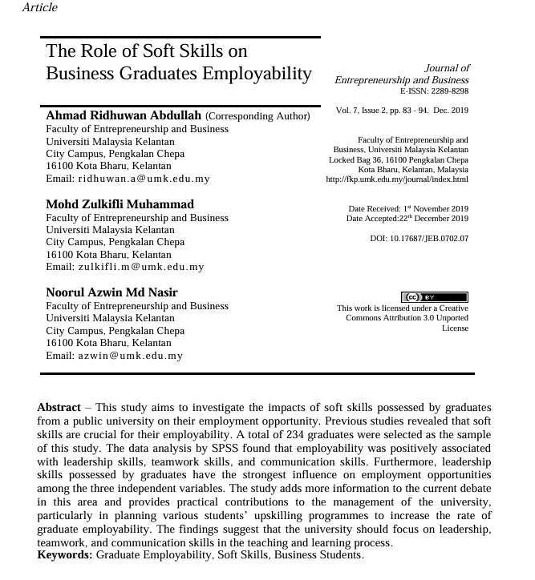
Your colleague has forwarded you a source from a peer reviewed journal, and they are not sure whether it is appropriate to use and has asked for your help. Your task is to evaluate the source by using the CRAAP Test to assess its appropriateness for the following question “What employability skills do business university graduates need to succeed in the workplace?”

CRAAP Test
Currency | This article is from 2019, there may some information found inside that has been updated since it was published.
Relevance | The article is called “The role of soft skills on business graduates employability”, this a key indicator of the relevance and upon reading into the abstract there is information that holds relevance to the subject question at hand.
Authority | This article is from a licensed publisher as is more than likely recognised by one or more major publisher authorities.
Accuracy | There is plenty of information to be found in this article and I would say a good majority of it is accurate and sound information.
Purpose | The purpose of this article is to “investigate the impacts of soft skills possessed by graduates from a public university”. I believe it does this well.
Task 3: Source Analysis
Your manager has provided you with a short extract from a source and has asked you to analyse the source by Identifying one strength, one weakness, and providing a brief explanation of the strength and weakness identified.
If you want to read the article online, please click the following link: https://www.universitiesuk.ac.uk/latest/news/strong-demand-graduates-employers

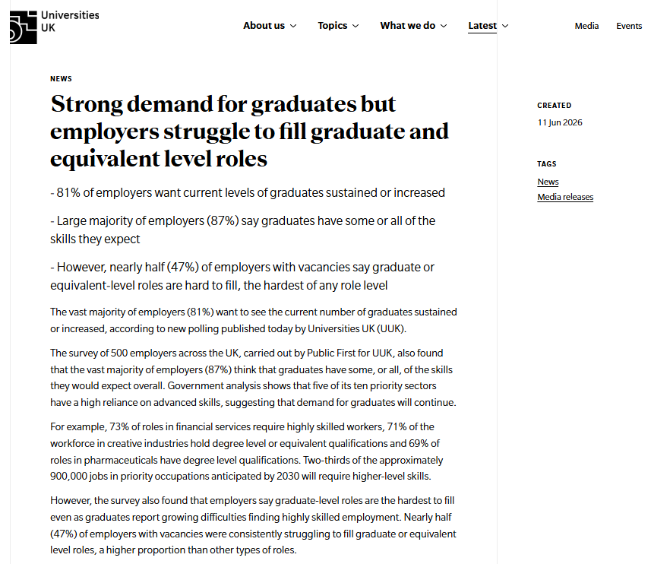
.

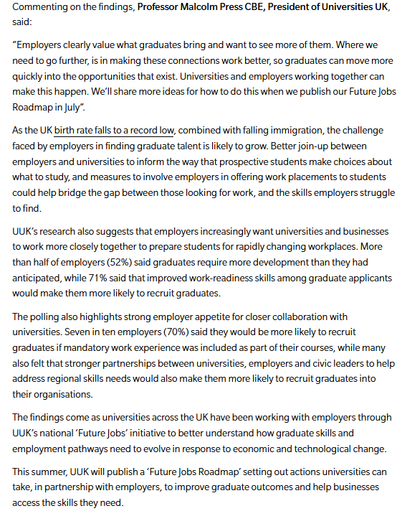

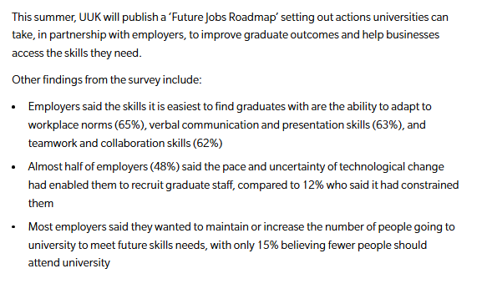

Strength of the Source: it is accurate and there is plenty of helpful information.

Weakness of the Source:

It is quite focused on its subject matter and some of the info isn’t relevant.

