(Projectsmart, 2014)
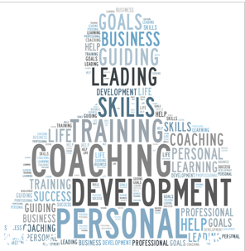  emerging leadership development programme for Sports Direct  Leadership and Management, Theory and Practice (SBUS6114) | Abstract  Leadership implement and drive change in the organisation, they motivate others to accomplish organisational goals through a transformational process.  Adekoyejo Sobola (1601748)  Leadership and Management, Theory and Practice (SBUS6114)

Contents
Executive summary 2
1.0 Introduce 3
2.0 Background literature ‘emerging leadership development programme’ for aspiring leaders of the future. 3
2.1 The skills and competencies required for effective leaders in the modern business environment. 4
3.0 The approach to developing skills in aspiring leaders 7
3.1 Consultancy methods- Variety of methods and techniques 9
3.1.1 Mentoring 9
3.1.2 Coaching 9
3.2 Kirkpatrick Model: Four Levels of Learning Evaluation 11
3.3 Programme aims 12
3.4 Time Scale- the timeline for delivering and evaluating the approach taken with the business leaders. 13
3.4.1 Module 1: Foundational skill building 13
3.4.2 Module 2: Cross-functional business approach 13
3.4.3 Module 3: Strategy formulation and implementation 14
3.4.4 Module 4: Leading change 14
3.4.5 Module 5: Personal leadership (Optional) 14
4.0 The benefits the business organisation should expect to achieve as a result of investing in the development of its aspiring leaders. 15
5.0 Why Ade and Associates is the right consultant to manage the implementation of this programme. 16
6.0 Conclusion 16
7.0 Recommendation 17
8.0 Appendix 17

Executive summary
When Sports-Direct was summoned to the commons' business, innovation and skills (BIS) select committee in 2016 of creating a culture of fear, among several other accusations at the meeting, Ashley admitted Sports-Direct ’failings. However, after the inquest and agreed to constitute an impartial people to carry out a review of the company (BBC, 2016a; CMI, 2016; Reynolds Porter Chamberlain LLP, 2016). Hence, the need for leadership training for the managers. Leadership is a difficult topic to define, and many themes have emerged from 1900 to date
Leadership implement and drive change in the organisation, they motivate others to accomplish organisational goals through a transformational process. As the organisation is growing, new leaders could be emerging, and they can only emerge as Leaders when there are followers. Usually, there are different leadership styles and qualities that are required in different circumstances. Therefore, the training programme will be designed for participants and tailored to meet the trainee's needs. A form of Survey of Training Needs was issued to all participants and the participants need will be established. Sir John Whitmore's GROW Model will be used to structure the mentoring conversation. The SF coaching model ‘OSKAR’ developed by (Jackson & McKergow, 2006) will be used as well. Kirkpatrick (1994) model of training evaluation will be used for analysing and evaluating the results of training and educational programs. Sports-Direct and its employees will benefit from the training programme in the development of emerging leaders

Introduction

Leadership is a difficult topic to define, and many themes have emerged from 1900 to date (Northouse, 2016). Notwithstanding, Bass (1990), regarded leadership as central to any group’s activity and is the focus of the group process. So, many authors view leadership from a personality perspective, by postulating that leadership is a combination of traits or characteristics. Traits are the innate or inborn qualities or characteristics that made the leaders who they are, and it distinguishes them from non-leaders (Bryman, 1992). But authors like Jogo (1982) argued that leadership skills could be observed in a leader.
But an important aspect of leadership is to implement and drive change. Leadership motivates others to accomplish organisational goals through a transformational process. As the organisation is growing, new leaders could be emerging, and they can only emerge as Leaders when there are followers (Burns, 1978; Heller and Til, 1982; Hollander, 1992; Jago, 1982). The emergent-leaders have influence over a group irrespective of their position or power. The emergent-leaders have communication ability, well informed, they can mobilise others, they are proactive, they generate new ideas, and very agile (Fisher, 1974). Equally, according to Smith and Foti (1998), the emergent-leaders usually have big personality trait dominant and confident.
Some authors contended that skills are core to leadership by concluding that knowledge and skills influence effective leadership (Northouse, 2016). But if CIPD (2019) definition is considered, leadership is the “ability to influence people by demonstrating positive personal attributes and behaviours. Different leadership styles and qualities may be needed in different circumstances.” Therefore, the point of this exercise is to develop the skills of emerging leaders for Sports Direct, in order to for them to influence their group to achieve organisational goal.

2.0 Background literature ‘emerging leadership development programme’.

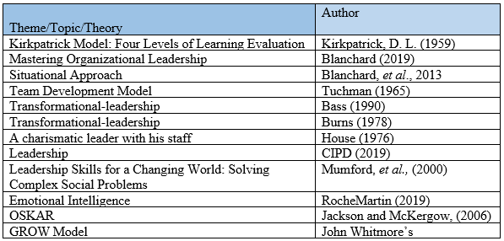

2.1 The skills and competencies required for effective leaders in the modern business environment.

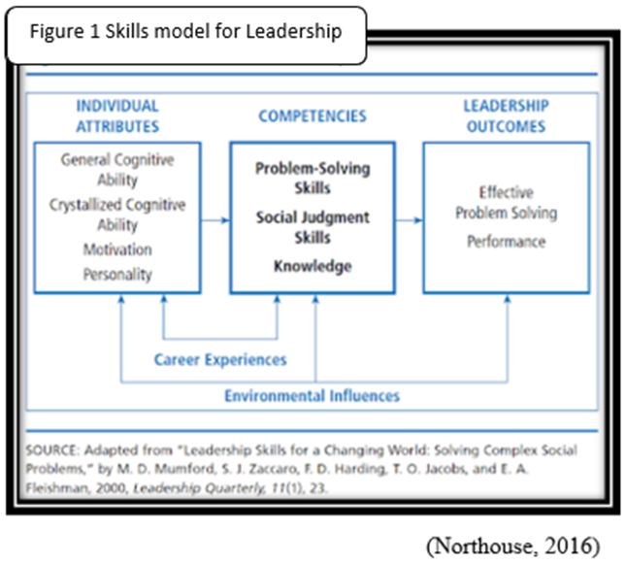
Katz (1955) suggested that Leadership skills can be acquired and developed. He hypothesised and contended that Leaders need three skills and the importance of each skill depends on the level of management responsibility. Their skills modules are Technical (analytical usually at a lower level), Secondly, Human (people skills) and lastly, Conceptual (strategic level).
Furthermore, in figure 1, Mumford, et al., (2000) suggested five components that are essential for skill-based leadership model. They are individual attributes, competencies, experience, leadership outcomes, and environmental influences. Problem-solving skills are the emerging-leaders ability to creatively solve problems. And the social judgment is about emotional intelligence and emotional intelligence is the foundation of critical skills. It enables a leader’s ability to work with others in solving problems.
Besides, Mumford, et al., (2000) expounded on Katz work on capability model Mumford, et al., (2000) suggested that Capacity to understand people and social systems, (Perspective taking, Social perceptiveness, Behavioural flexibility and Social performance). Leadership at every level requires skills in any organization.

2.1.1 Transformational Leadership
. The transformational-leadership according to Burns (1978; Bass, 1990) is a leadership that sets goals, that motivates others, they provide support and recognises achievement, they utilise emotional intelligence, inspiring, makes people pull towards achieving organisational goal and not self-interest. Transformational-leadership impacts individuals' self-growth, innovation, create change and thereby shaping the future success of the company.

2.1.2. Situational Approach
Figure 1a Situational approach
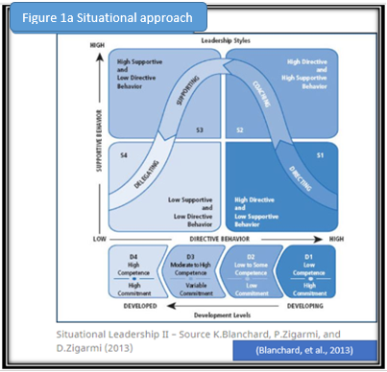
The situational approach has always been used in organisational leadership training and development. Situational-approach focuses on situations because the theory assumes that different situation requires a different kind of leadership, therefore, the leader must be adaptable and especially in the volatile, and ever-changing market that requires agility.
Blanchard, et al., (2013) described the situational approach model in figure 1a. The leadership approach is in two dimensions: directive and supportive. And to determine the training or support required by each staff, the leader must evaluate the emerging leaders (followers) in order to determine the follower’s commitment and competence to complete a task (Hersey and Blanchard, 1993). In Figure 1a, the situational-leadership model helps managers to diagnose the need of emerging leaders and provide the appropriate leadership style to meet their needs.
Emerging managers could learn in four stages of development. From DI (the enthusiastic beginner) to D4 (self-reliant). There are different directive and supportive behaviour styles for each developmental-level, and by directing (S1) to delegating (S4), situational leaders must give and match exactly the developmental need of the follower or the emerging-leader. The benefits of situational-leadership include being tried and tested. It is
practical, easy to understand sensible and easy to apply. Also, situational-leadership is prescriptive, unlike other methods. There is a different style to match different developmental level (Northouse, 2016). One major criticism is of situational-leadership is that only a few research study was undertaken to justify the assumptions and propositions.
It is equally important to recognise the importance of Tuckman (1965) four stages of development – forming, storming, norming and performing. Every team goes through the four stages. The emerging-leaders must recognise the importance of each role before the unit they lead can perform to their optimum. At the forming stage, there is the uncertainty of role, at the storming stage, members are growing in confidence. At the norming stage, members want to be in-group i.e. accepted and at the performing stage, they want to get the job done. These stages are similar to DI, D2, D3, D4 above.

The approach to developing skills in aspiring leaders

It is essential the participants need are determining for the program's effectiveness at meeting the trainee's needs. A form of Survey of Training Needs (appendix 1) will be issued to all participants and the participants need could be established by:
1. Asking the participants.
2. Asking the participants line-managers.
3. Ask experienced colleagues that acquainted with the job and how it is being
performed, including subordinates, peers, and customers.
4. Test the trainee.
5. Analysing the performance appraisal forms.
We will liaise with direct line-managers as well (Kirkpatrick and Kirkpatrick, (2009).

.

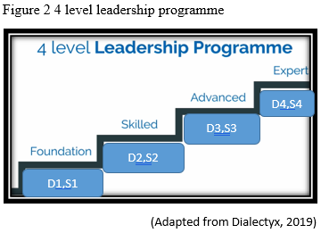
We understood the importance of creating a culture that will engage and inspire emerging leaders. It is important to build leaders at every level of ability (figure 2). It is critical to building emotional intelligence and our programme is suitable to develop leaders at the four levels in the organisation. Good leadership is about good decision making, we will utilise Gamification and simulation to improve decision making, and our focus is in three parts, namely
Theory- the e-academy, Practice- role simulation and Feedback-your progress. We believe there is a minimum of nine skills to be an effective leader in the contemporary market place Figure 3.
• Self-awareness
• Problem-solving
• Enterprising
• Team player
• Business awareness
• Decision judgement
• Communicating: this covers how to get the message across, working with people, and team improvement.
• Technology appreciation and thinking innovation
• Self-management

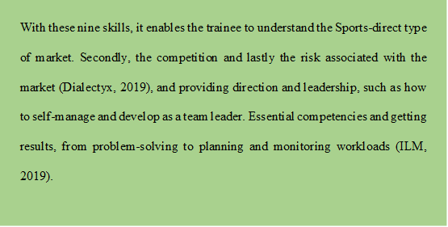
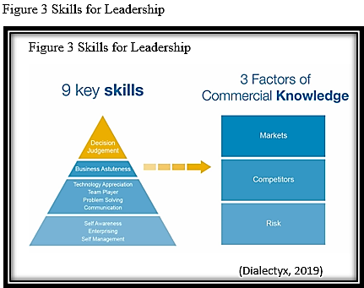
Our methodology skills and knowledge development for highlights integration to exciting and new data processes it enables the company to breed a new set of leaders and this programme is backed by research by University of Cambridge (Dialectyx, 2019), personal biases are explored as it limits our ability to make sound decisions. The skills development and nurtures the capabilities (knowledge and skills) in the Emerging-leader to becoming an effective leader (Mumford, et al., 2000).

3.1 Consultancy methods- Variety of methods and techniques

3.1.1 Mentoring
Sir John Whitmore’s GROW Model will be used to structure the mentoring conversation. Goals both short-term and long-term goals will be set for each emerging-leader, after evaluation of the current situation. All alternative course of actions will be established especially what is to be done, when and by whom and the will to do it. The set-goal must be Specific, Measurable, Agreed, Realistic and Time-phased (SMART). The goal must be PURE that is Positively stated, Understood, Relevant and Ethical and it must be clear.

Secondly, after setting the goal, there will be reality checking. That is evaluating the facts and feelings of surrounding the goal or the present situation, what are the hinderance/obstacle to the goal being achieved. One vital point here is determining and raising awareness and self-awareness of the participant. The idea is to tap into emotions. Emotional intelligence even at this stage the RocheMartin Emotional Capital Report (ECR) will be useful in defining, measuring and developing employee’s Emotional Intelligence. The ECR assists emerging-leaders to assess and build their own emotional intelligence and leadership skills (RocheMartin, 2019). They will be able to develop more effective communication and influencing strategies among others.
Thirdly, Options here the mentees will need to develop action, or ideas that will help them in moving forward or to reach their goal. They will have to embark on what is called 'Obstacles Exploration.'(we will avoid making suggestions on the coachee's behalf).
And lastly, what is to be done or Way Forward? After the way forward plan has been agreed, it’s about what is next. This is about 'Will' or 'Wrap-Up.' it is vital that mentee has self-confidence and be committed to the action plan and a follow-up if required plan could be instituted. The mentoring must be Challenging, Legal, Environmentally sound, Appropriate and Recorded.

3.1.2 Coaching

The GROW model, developed by Sir John Whitmore in the classic book ‘Coaching for Performance’, 1990 is a popular coaching method. Nonetheless, efforts will not be wasted on identifying what’s wrong or looking for barriers to progress, but the coaching is focused on discovering what works. So, the SF coaching model OSKAR developed by Jackson and McKergow (2006) is preferred. As depicted in Figure 4.
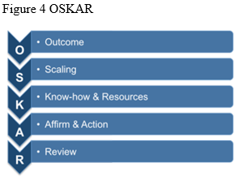
Outcome: this is the outcome, what the coachee wants to achieve from the meeting or coaching session
Scale: this is about starting to find what's working. How close the coachee is to achieve the desired outcome will be measured or quantify by using a scale (often of one to 10.)
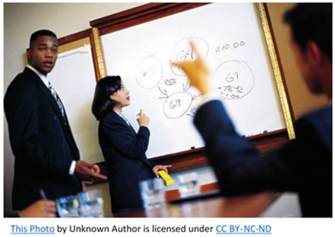
Know-how: The "know-how" is the skills, knowledge, qualifications, and attributes that enable the coachee to move forward. The scale will be used to decide how far a particular solution will get enabling the coachee to get closer to the outcome, and what else needs to be done for the coachee to progress even further.
Affirm: here based on coaches’ observation, the coach affirms the positive qualities of the coachee, during the coaching conversation. The focus is about the progressive actions the coachee needs to take, and postulating solutions to identified problems.
Action Review: Your focus throughout the session should be on what next steps, ITS about building on what is working best and the help and support available to the coachee through our organisation and Sports Direct.
Coaching provides the benefits of energy and focuses being directed on what works that could generate sustainable results. Secondly, coaching shift focus on the know-how of what works thus encouraging shared with Sports-Direct and deployed throughout the organisation.
Benefits for employers
It empowers employees with the skills and knowledge needed to develop mentoring/ and coaching practice within their own roles and responsibilities.
Secondly, we hope to develop a mentoring/ coaching culture in the organisation has gained key mentoring/ coaching skills and techniques.

3.2 Kirkpatrick Model: Four Levels of Learning Evaluation
Kirkpatrick (1994) Kirkpatrick's model of training evaluation is a popular model for analysing and evaluating the results of training and educational programs. The model deploys four “levels” of training evaluation criteria: reactions, learning, behaviour, and results.
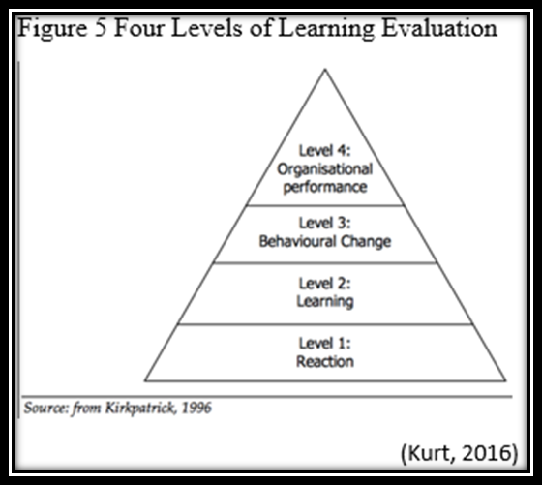
Level 1 Reaction: the point here is to establish the degree of enthusiasm the emerging-leaders to the training model. It’s about asking the trainees if they enjoyed the experience and if the material in the program useful for their work.
Level 2 Learning: the focus is gauging the learning event is benefiting the participants in terms of knowledge, skills, and attitudes.
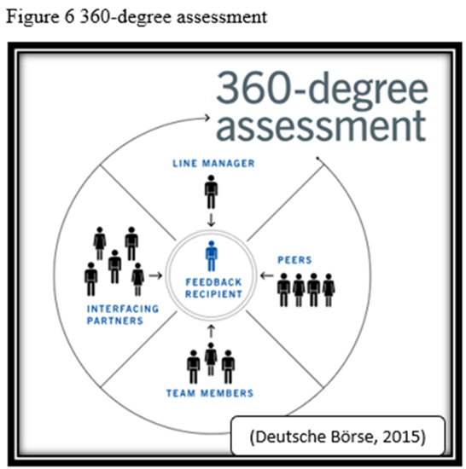
Level 3 Behaviour the focus here is establishing the degree of how the emerging-leaders are applying what they learned during training on their job. This level starts 3–6 months after training, and could be done through observations, interviews, online-evaluations and 360-degree feedback could be used especially after training because it enables participants to self-evaluate.
Also, it allows for long-time observation and the participant’s performance can be reviewed by others for proper assessment (i.e. figure 6-direct supervisors, peers at the same level and with the same reporting line, team members and other contacts within the company) (Deutsche Börse , 2015). The customised 360-degree assessment enables the evaluation of current skills and could reveal potential leadership and management strengths and areas for improvement for the trainee.
Level 4 Results: the point here is establishing the degree of occurrence of the targeted outcomes as a result of the learning event(s).
The point of the training is in recognition that leading a team is more complicated than one-on-one leadership, hence Blanchard (2019) argued the importance of organizational leadership because an effective leader influences an organisation and mobilise and synchronise people and systems into a unit.

3.3 Programme aims
Our aim is to develop leadership capability and capacity, through:
• Developing emerging leaders with a critical understanding of leadership styles and being business aware.
• The emerging leadership development programme is designed to add value to the trainees' personal development.
• Facilitating trainee’s ability to influence and make a positive, lasting change in the work environment.
• Develop learning agility which is the ability and willingness to learn from experience, and the ability to successfully apply the learning to a new situation (De Meuse, et al., 2010).

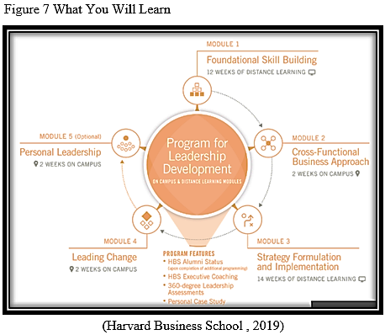

3.4.1 Module 1: Foundational skill building
Format: Individual distance learning (12 weeks for 10 to 12 hours per week) to build knowledge and business terminology
- An introductory course in accounting, finance, and quantitative methods
- Connecting with professional Executive Coach, (phone/online) that will guide the trainee in identifying and building a tailored personal action plan (Harvard Business School, 2019).

3.4.2 Module 2: Cross-functional business approach
On the Sports-Direct campus (2 weeks)
• Develop a holistic diagnosis /view of business—and the interrelationship in all functions
• Developing a deeper understanding of strategy, marketing, operations, finance and accounting, leadership and corporate accountability, and more
• Expounding the relationships among functional strategy, business-unit strategy, and strategy implementation
• Understand the PESTEL forces that are shaping the global business environment (Harvard Business School, 2019).

3.4.3 Module 3: Strategy formulation and implementation
Format: Distance learning as new knowledge is being applied to work (14 weeks)
• Complete self-directed work at participants own pace while engaging in scheduled exercises and group sessions
• Ensuring participants understanding of strategy and improving the business economics for Managers via Online
• Participant to continue to work on a customized case and personal action plan
• Develop a solution for a real project

3.4.4 Module 4: Leading change
Format: On the Sports Direct campus (2 weeks)

- Trainee to evaluate the organisation to find what needs to change
- Expand trainee’s repertoire of change management processes and approaches
- Trainee to think innovation, openness to change, and an entrepreneurial mindset
- Trainee to present an overview of the customized action plan to assigned coach and group, get feedback, refine and write up a personal case (Harvard Business School, 2019).

3.4.5 Module 5: Personal leadership (Optional)
Format: On the Sports-Direct campus (2 weeks) trainee to:
• Improving corporate finance skills
• Cultivating authentically leadership and with integrity
• Decision-making to benefit the organization's financial needs, legal requirements, and ethical obligations
• Recognising and Satisfying the competing demands of all stakeholders
• Create value-proposition for the business and society
• Negotiating and decision-making skills

4.0 The benefits of the emerging leadership development programme
Impact for organisations
- Effective team leaders and motivated teams
- Increased productivity
- The workplace-based assessment ensures new skills are effectively transferred to the job (ILM, 2019)
- This programme acts as a catalyst for change, helping good leaders through mindset changes to understand what it takes to deliver high performance and results from their teams (Henley Business School, 2019a)
- Achieve increased success in business pitches and negotiations (Henley Business School, 2019b).
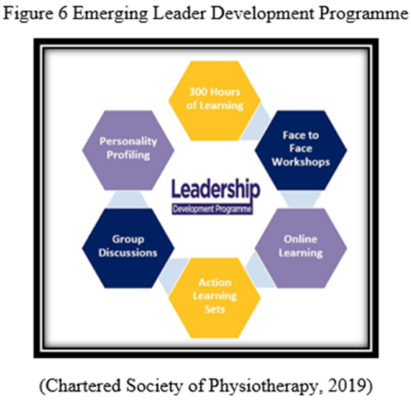
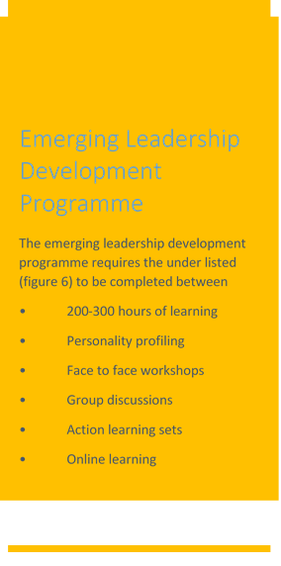

For participants
- A better understanding of participant as a leader; participants’ behaviours, strengths and weaknesses in this role, and how to utilise these qualities effectively.
- Develop focus through clear goals and a commitment to participants’ next steps to develop leadership impact and pathway in the organisation.
- Work and network with a supportive peer network facing similar challenges across different employment sectors.
- Participants will gain the ability to adapt their communication style to make an impact in any given business situation, and the skills and confidence to influence, present and negotiate with credibility.
The drawback to the training is cost, training time and commitments as well as participants learning agility.

5.0 Why Ade and Associates is the right consultant to manage the implementation of this programme.
- The training programme is tried and tested.
- Expand the skills of your leaders, which will be impactful on your organization.
- Our proven and best practice is available, and We will partner with you each step of the way result in the greatest return on your investment.
- We will equip the emerging leaders with the right framework and tools to be successful.
- We are confident that our training will result in more effective managers, boost in morale and engagement, team members will feel supported, employees, becoming more creative problem solvers, and consequently, company productivity will increase.

Who should attend? Individuals in leadership roles who want to increase their effectiveness, Executives and senior-level managers, Mid-level or new managers, or supervisors

- Conclusion
The situational approach has always been used in organisational leadership training and development. Situational-approach focuses on situations because the theory assumes that different situation requires a different kind of leadership, therefore, the leader must be adaptable and especially in the modern volatile ever-changing market, agility is needed. Nine skills are essential for the emerging leader’s development, especially emotional intelligence among others. Each trainee will be assessed, and a customised training programme will be developed for each trainee. The progress will be monitored through 360-degree feedback. This emerging-leadership development-programme will increase the skills of emerging-leaders with great impact on the firm which will be impactful on your organization.

Recommendation
• We hope the firm develops and maintains a mentoring/ coaching culture that will impact and influence future emerging-leader.
• Encourage diversity in leadership training
• Empowering Women in Leadership: How to Develop Female Talent
• Develop and encourage colleague/ employee resource groups (ERGs) to help developing leaders

8.0 Appendix
Survey of Training Needs
(Kirkpatrick and Kirkpatrick, 2009) 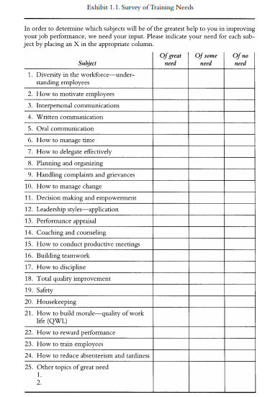

9.0 References
Bass, B. M., 1990. Bass and Stogdill’s handbook of leadership theory, research, and managerial applications. 3 ed. New York: The Free Press.
Blanchard, K., 2016. Set Up First-time Managers for Success. [Online]
Available at: https://www.clomedia.com/2016/05/13/set-up-first-time-managers-for-success/
[Accessed 15 2 2019].
Blanchard, K., 2017. Servant Leadership in Action. [Online]
Available at: https://www.clomedia.com/2017/10/20/servant-leadership-action/
[Accessed 15 2 2019].
Blanchard, K., 2019. Mastering Organizational Leadership. [Online]
Available at: https://www.clomedia.com/2019/02/14/mastering-organizational-leadership/
[Accessed 15 2 2019].
Blanchard, K., Zigarmi, P. & Zigarmi, D., 2013. Leadership and the one minute manager: increasing effectiveness through Situational Leadership II. New York: William Morrow.
Blanchard, K., Zigarmi, P. & Zigarmi, D., 2013. Leadership and the one minute manager: increasing effectiveness through Situational Leadership II. New York: William Morrow.[Image]
Burns, J. M., 1978. Leadership. New York: Harper & Row.
Blanchete, L., n.d. 1.bp.blogspot.com/-[Image]YTKgcuO3zR0/Uj8F__fphII/AAAAAAAAArA/hJ4eVD9EdUE/s1600/24175-Clipart-Illustration-Of-Two-Light-Blue-Business-Men-Sitting-Across-From-Eachother-At-A-Table-During-A-Meeting.jpg. [Art] (ClipartOf.com/24175).
Chartered Society of Physiotherapy, 2019. Leadership Development Programme. [Online]
Available at: https://www.csp.org.uk/professional-clinical/leadership/leadership-development-programme
[Accessed 19 4 2019].
Chieflearningofficer, 2018. Diamonds in the Rough. [Online]
Available at: https://www.clomedia.com/2018/12/26/diamonds-in-the-rough/
[Accessed 15 2 2019].
CIPD, 2017. Human capital theory: assessing the evidence for the value and importance of people to organisational success, London: CIPD.
CIPD, 2019. Leadership. [Online]
Available at: https://www.cipd.co.uk/knowledge/strategy/leadership
[Accessed 1 3 2019].
De Meuse, K. P., Dai, G. & Hallenbeck, G. S., 2010. THE MANY FACES OF LEARNING LEARNING AGILITY. Scottsdale, AZ, Korn/Ferry Korn/Ferry International.
Deutsche Börse, 2015. An evaluation from every level. [Online]
Available at: http://unternehmensbericht2015.deutsche-boerse.com/reports/deutscheboerse/annual/2015/gb/English/104050/360-degree-assessment.html
[Accessed 28 4 2019].
Deutsche Börse, 2015. An evaluation from every level. [Online][Image]
Available at: http://unternehmensbericht2015.deutsche-boerse.com/reports/deutscheboerse/annual/2015/gb/English/104050/360-degree-assessment.html
[Accessed 28 4 2019].
Dialectyx, 2019. Leadership Programme. [Online]Available at: https://www.dialectyx.com/
[Accessed 20 4 2019].
Dialectyx, 2019. Leadership Programme. [Online][Image] Available at: https://www.dialectyx.com/
[Accessed 20 4 2019].
Fisher, A., 1974. Small group dicision making : communication and the group process. New York : McGraw-Hill.
Harvard Business School, 2019. Program for Leadership Development: Accelerating the Careers of High-Potential Leaders. [Online]
Available at: https://www.exed.hbs.edu/leadership-development/curriculum
[Accessed 20 4 2019].
Heller, T. & Til, J. V., 1982. Leadership and Followership: Some Summary Propositions. The Journal of Applied Behavioral Science, 18(3), p. 405–414.
Henley Business School , 2019b. Influence and Impact. [Online]
Available at: https://www.henley.ac.uk/executive-education/course/influence-and-impact
[Accessed 20 4 2019].
Henley Business School, 2019a. The Leadership Programme. [Online]
Available at: https://www.henley.ac.uk/executive-education/course/the-leadership-programme
[Accessed 20 4 2019].
Hersey, P. & Blanchard, K. H., 1993. Management of organisational behaviour: utilising human resources. 6 ed. Englewood Cliffs New Jersey: Prentice Hall.
Hollander, E. P., 1992. Leadership, followership, self, and others. The Leadership Quarterly, 3(1), pp. 43-54.
ILM, 2019. Level 2 Leadership and Team Skills. [Online]
Available at: https://www.i-l-m.com/Learning-and-Development/management/team-leading/8000-level-2-leadership-and-team-skills
[Accessed 19 4 2019].
Jackson , P. Z. & McKergow, M., 2006. The Solutions Focus: Making Coaching and Change SIMPLE. 2 ed. s.l.:Nicholas Brealey Publishing.
Jago, A., 1982. Leadership: Perspectives in theory and research. Journal of management science, 28(3), pp. 315-332.
Katz, L., 1955. Skills of an Effective Administrator. Harvard Business Review, Volume 33, pp. 33-42.
Kirkpatrick, D. L., 1994. Evaluating training programs: the four levels. San Francisco:: Berrett-Koehler.
Kirkpatrick, L. D. & Kirkpatrick, J. D., 2009. Evaluating Training Programs. s.l.:Berrett-Koehler Publishers.
Kurt, S., 2016. Kirkpatrick Model: Four Levels of Learning Evaluation. [Online]
Available at: https://educationaltechnology.net/kirkpatrick-model-four-levels-learning-evaluation/
[Accessed 5 4 2019].
Kurt, S., 2016. Kirkpatrick Model: Four Levels of Learning Evaluation. [Online][image]
Available at: https://educationaltechnology.net/kirkpatrick-model-four-levels-learning-evaluation/
[Accessed 5 4 2019].
MarketLine, 2016. Sports Direct Working conditions scandal fallout must be managed to minimize damage. [Online]
Available at: file:///C:/Users/koyes/AppData/Local/Packages/Microsoft.MicrosoftEdge_8wekyb3d8bbwe/TempState/Downloads/MLAI0001-076%20(1).pdf
[Accessed 1 3 2019].
MarketLine, 2018b. Sports Direct staff abused. [Online]
Available at: https://advantage-marketline-com.ezproxy.uwtsd.ac.uk/Product?ptype=Company+News&pid=062A9DA2-F459-4B15-9164-A4C1B0E68DAA
[Accessed 13 3 2019].
Mumford, M. D. et al., 2000. Leadership Skills for a Changing World: Solving Complex Social Problems. The Leadership Quarterly, 11(1), pp. 11-35.
Northouse, P., 2016. Leadership : theory and practice. 7 ed. Los Angeles: SAGE.
Northouse, P., 2016. Leadership : theory and practice. 7 ed. Los Angeles: SAGE.[Image]
Projectsmart, 2014. Better Coaching Using the GROW Model. [Online]
Available at: https://www.projectsmart.co.uk/better-coaching-using-the-grow-model.php
[Accessed 20 4 2019].
RocheMartin, 2019. Emotional Intelligence Development Programs. [Online]
Available at: https://www.rochemartin.com/landing-page/emotional-intelligence-development-programs/
[Accessed 19 4 2019].
Smith, J. A. & Foti, R. J., 1998. A pattern approach to leader emergence. The Leadership Quarterly, 9(2), pp. 147-160.
Tuckman, B. W., 1965. Developmental Sequence in Small Groups. Psychological Bulletin, Volume 63.
Unknown, n.d. s.l. Patent No. CC BY-NY-ND[Image]

