
Problem Analysis and Solution Development
Module Name: Analysing and Solving Problems Module Code: ACCA 4019
Student Name:  Zacharias Lambrou | Student ID: 2435234 Group:2 | Lecturer’s Name:  Dr Redhwan Al-amri



Table of Contents
Table of Contents 0
1. Introduction 2
2. Deconstruct the Problem 2
2.1 MoSCoW Technique Requirement 3
2.2 Variables Identification 4
3. Proposed Solution 5
3.1 Flowchart 6
3.2 Flowchart Explanation 7
4. Reflection and Justification 13
4.1 Abstract thinking 13
4.2 Sub-dividing 13
4.3 Justification of solution 13
4.4 Limitation 13
4.5 Assumption 13
5. Conclusion 14
References 15



Introduction
The local college is dealing with a complex problem regarding classroom allocation. Some rooms are completely full while others are barely used at all. This inefficiency also includes timetable clashes, affecting staff and students in rushing between buildings, and sometimes even delays to the start of lessons. The college aims to make better use of the teaching space and improving everyone’s day-to-day experience. This report will dissect the problem, provide a practical solution, and explain the approach taken in solving this. [1]

Deconstruct the Problem
The problem is a classic-constrained challenge with multiple hard constraints (no overlaps), capacity compliance and soft objectives (minimising movement) system thinking frames the college as an interconnected system where allocation decisions affect availability travel and satisfaction.

The college is finding difficulty with classroom management. Some rooms end up packed with students while others sit almost empty. This causes timetable clashes, last-minute changes, and a lot of wasted time as staff and students rush between buildings. In the end, it affects everyone’s learning experience. The aim is to allocate rooms more sensibly based on class sizes, cut down on unnecessary movement, and ensure lessons start on time without overlaps. To understand this better, the problem was broken down into smaller parts. At its core, there are several key elements: class size, available rooms (each with its own capacity and location), the weekly timetable availability and groups of students (who cannot be in two places at once). These all interact, so a change in one area, like moving a large lecture, can create problems elsewhere



MoSCoW Technique Requirement
Key requirements and constraints are prioritised using the MoSCoW technique. It is a really useful way of prioritising requirements into what is essential right now and what can wait. Its usefulness has been identified in project management modules, and can help maintain focus instead of trying to fix everything at once.

Must have (these are the non-negotiable components):
No two classes can be booked into the same room at the same time.
Every class must fit comfortably in its assigned room – student numbers cannot exceed room capacity.
Teachers and student groups cannot be scheduled in two different places at once.
All classes have to be allocated into the available weekly timetable slots

Should have (things that would make a big difference):
Cut down the time wasted moving between rooms by trying to keep back-to-back classes in nearby locations.
Balance the use of rooms therefore avoiding serious overcrowding or empty spaces.

Could have (useful extras if time is available):
Spread classes more evenly across the day or week therefore reducing wasted travel time.
Keep classes from the same department clustered in the same building.

Won’t have (out of scope for now):
Real-time changes during the week or letting individual students select their favourite rooms.

The MoSCoW framework prioritisation, made the whole problem feel more manageable straight away

Variables Identification
Variables: | Description:
Class size | Number of students in the class
Room capacity | Maximum students per room (integer)
Class time slot | Day+ start/end time (e.g. Mon 09:00-10:30)
Room location | Building/floor/coordinates for distance calculation
Travel time matrix | Minutes between room pairs (pre-computed integer matrix)
Teacher ID/Group ID | Identifiers for conflict detection
Walking distance | A simple measure of how long it takes to get from one room to another
Room availability | Booked slots per room (updated dynamically)
Fig 1: Variables Identification table
All the variables are linked. For example, putting a big lecture in a small room causes overcrowding, while scheduling the same group’s next class halfway across the campus wastes time. Understanding these variables helped identify the college as one integrated system rather than separate parts. [2]

Proposed Solution
The proposed solution divides into two main stages:
Firstly, sorting out where classes happen to avoid clashes, then deciding which room each class is assigned to (to match size and reduce walking) depending on capacity usage. Use of a basic graph colouring concept for the timing part.
Secondly, a step-by-step matching process for rooms. This seems practical for a college without needing expressive software.




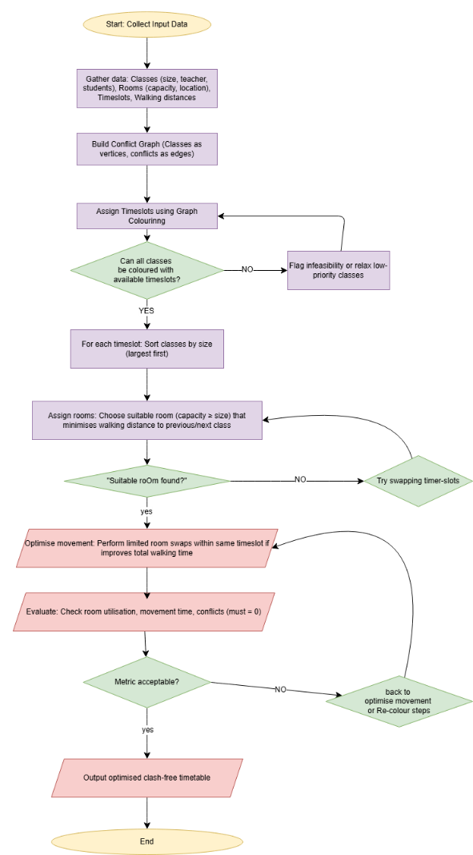
Flowchart

Fig 2: Flowchart of the proposed classroom allocation process
The flowchart was created for the proposed solution utilising draw.io, using rectangles for process steps and diamond shapes for decision points. It walks through the whole process logically from start to finish.

Flowchart Explanation

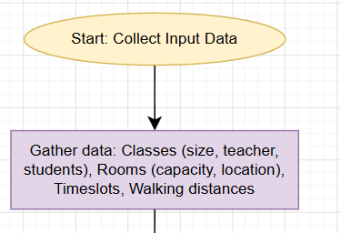
Fig 3.

The flowchart starts at the top with an oval labelled "Start: Collect Input Data " as shown in Fig 3. The first step is a rectangle that says: "Gather data: Classes(size, teacher, students),Rooms(capacity, location), Timeslots, walking distances "– this means to include details of all classes (students numbers, teachers, duration), all available rooms (what capacity and which location), the weekly timeslots, and a simple walking distance map between rooms/classes.

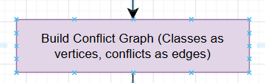

Fig 4.

Next, on Fig. 4 an arrow leads down to "Build Conflict Graph". Here, each class becomes a vertex (dot), and an edge (line) indicate any two classes that cannot happen at the same time - for example, if they share the same teacher or the same group of students.

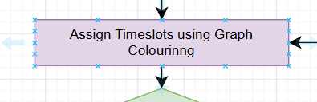
Fig 5.

After that, on Fig 5, comes the key part: "Assign Timeslots using Graph Colouring". The Welsh-Powell algorithm proved influential in dissecting information and creating the flowchart (sort classes by how many conflicts they have, then assign timeslots so no conflicting classes get the same slot). This stage makes sure there are no timetable clashes

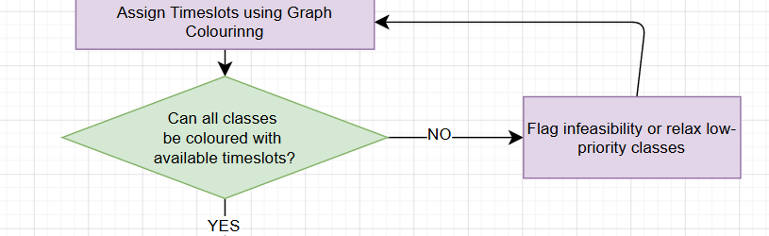

Fig 6.

Then, on Fig 6, there is the first decision diamond: "Can all classes be coloured with the available timeslots?" If Yes, it continues down. If No, an arrow loops back with the label "Flag problem or relax low-priority classes".

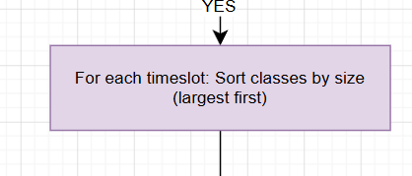

Fig 7.
Once timeslots are assigned, on Fig 7, the flowchart moves to the next main phase: "For each timeslot – Sort classes by size (largest first)". This helps make sure larger classes are allocated the most suitable rooms first.

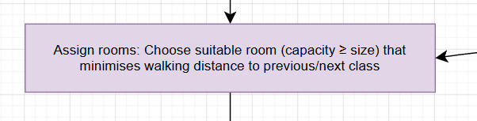
Fig 8.

The next rectangle on Fig 8, is the "Assign rooms: Match capacity and minimise walking distance". For every class in that timeslot, the system picks a room that is big enough and, if possible, close to where the students or teacher came from or are going next.
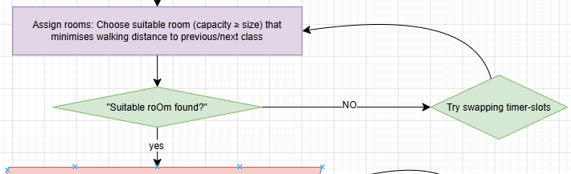

Fig9.

On Fig 9, there is another decision diamond here: "Suitable room found?". If Yes → move forward. If No → the arrow curves back (loops) to an earlier step with the label "Try swapping timeslots". This is the loop that required – it shows what happens when a room is not available and the process needs to try a different combination.

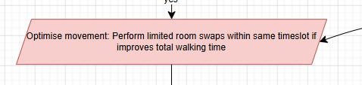
Fig 10.

After assigning the rooms, there is a step on Fig 10, called "Optimise movement: Quick room swaps within the same timeslot" to reduce walking time even more if possible.

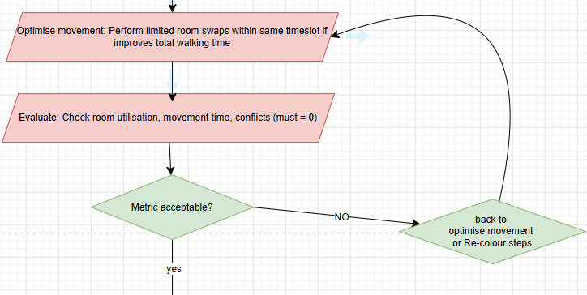
Fig 11.
Finally, on Fig 11, it reaches the Evaluate: Check room utilisation, movement time, conflict (must = 0) stage where it will check and calculate everything and come to a 0 result (room usage, total movement time, and check that conflicts = 0). This means that all rooms are allocated efficiently with no negative impact.

Fig 12.
Here on Fig 12, is one last decision diamond: "Metrics acceptable?"
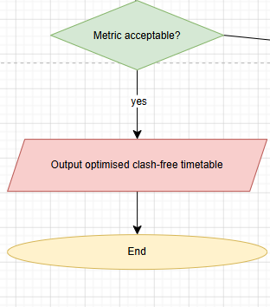
Fig 13.

On Fig 13 shows that If Yes, it goes to the "End" oval: "Output optimised clash-free timetable".

Fig 14.
Fig 14.
And on Fig 14. If No, it loops back to the optimise movement stage for further improvement



Reflection and Justification

Abstract thinking

Abstract thinking was used by turning the real-life college room allocation issue into a graph model – classes as points and conflicts as connecting lines. It made the messy situation feel much clearer and easier to work with. [3], [5]

Sub-dividing

Sub-dividing the whole thing into two stages (timing first, then rooms) was very beneficial. It helped maintain focus and retain details, allowing the solving of one component at a time before moving to the next part.

Justification of solution

This approach works well as graph colouring is a standard way of handling timetable clashes and is straightforward enough for a local college to actually use. Adding the room size and location checks directly tackles the overcrowding, underuse and movement problems the college is facing. It feels practical and could even be put into a spreadsheet if they wanted something simple.

Limitation

One limitation is that the method uses a fairly, straightforward (greedy) way of assigning rooms, so it may not always find the absolute best possible timetable, especially with a really large number of classes. It also depends heavily on having accurate data to start with – if student numbers or walking distances are reduced, the results will not be reliable.

Assumption

The assumption that the timeslots are fixed and all the same length provides reliable information about class sizes and campus layout, and that movement time can be calculated at group level rather than for every single person. These assumptions keep things realistic for a first-version solution.



Conclusion

Overall, by breaking the classroom allocation issue down with MoSCoW and a step-by-step approach, it is possible to create a much reliable timetable that uses space efficiently, cuts down on wasted movement and avoids clashes. The techniques used help turn a complicated real-world problem into something logical and solvable. While there are a few limitations, this gives the college a solid starting point they could build on later.



References

[1] | “. p. D. P. F. 2. Agile Business Consortium, 2023. [В Интернете]. Available: https://www.agilebusiness.org/dsdm-project-framework/moscow-prioritisation.html.
[2] | B. F. e. al, Systems thinking to transform schools: Identifying levers that lift educational quality, Washington, DC: Brookings Institution, 2022.
[3] | H. Alghamdi, A review of optimization algorithms for university timetable scheduling,, Т. %1 из %2vol. 10,, p. 6410–6417, Ред., England : Technol,Appl. Sci. Res, Dec. 2020, p. pp. 6410–6417.
[4] | B. Hussin, Exam timetabling using graph colouring approach, i. P. I. I. C. Comput., Ред., England: Appl. Ind. Electron., 2011, pp. 172-176.
[5] | B. Hussin, “Exam timetabling using graph colouring approach, A. I. Electron, Ред., england: in Proc. IEEE Int. Conf. Comput, 2022, p. 172–176..





