The use of glass in worship through the ages

Worship: ‘to show profound religious devotion and respect to; adore or venerate (God or any person or thing considered divine)’

Humans have always needed to worship something or someone, be it an idol or king, a pharaoh or Caesar, or a god or gods. Throughout history certain buildings have been used specifically for worship. In Britain as in many other countries for many centuries Christianity has been the prevalent faith and the buildings normally used specifically for worship have been churches or cathedrals.
Benedict Biscop is attributed to have introduced stained glass to Britain when he brought in French workers to help build two monasteries in the late 7th Century.
http://www.st-benets.durham.sch.uk/about-us/st-benet/
During this period in history around 90% of the population were illiterate
David Mitch, “Education and Skill of the British Labour Force,” in Roderick Floud and Paul Johnson, eds., The Cambridge Economic History of Modern Britain, Vol. I: Industrialisation, 1700-1860, Cambridge: Cambridge University Press, 2004. p. 344.
Since most of the population couldn’t read or write one way that was utilised to teach people was using images. The church window was as such simply a window, a partition made of glass to allow light in but keep the elements out. However this simple object was enhanced to become something far more than a simple window by the inclusion of coloured glass pieces which together created an image. This coloured glass panel which was backlit became a new stalwart in the modern age of worship, often portraying a person who one should emulate for a successful life.
One of the added benefits of these buildings was their ability to bring people together as a community, sometimes for special occasions such as a wedding or a funeral but every week these buildings were used for their original purpose, worship, after all the church itself was normally built by the community. This situation continued relatively unaffected until everything began to change in the 1960’s.

In his book entitled ‘The religious crisis of the 1960s ‘ the author Hugh McLeod concluded .’’the study also draws out the gradual effects of home ownership, television sets in the home, Sunday sport for children, and an increased emphasis on companionate marriage, all of which provided reasons for the previously loosely committed to stay at home (pp. 169-75).’’ It was as if there was a new god in town, in fact a whole array of new gods began to appear and none of them relied on a church or cathedral to satisfy mans need for worship. One such was what I recall as a child being referred to as ‘the one-eyed god sitting in the corner ‘. This new god was television. No longer were people in awe of the natural light streaming through magnificent stained-glass windows in a holy building to create the ambience of the presence of God. Now they could sit in the comfort of their own homes as entertainment was miraculously beamed into their living rooms as if directly from the heavens. The new stained-glass windows were still made of glass and still shone light into the building interior, but they were miniscule in comparison to their church or cathedral relatives. These tiny ‘windows’ only emitted light in the grayscale spectrum but were gazed upon with the same religious reverence. The TV screen had arrived and was here to stay. Ironically although coloured glass had been around for centuries it wasn’t until 1968/69 that the new god television produced colour images here in Britain.
http://news.bbc.co.uk/onthisday/hi/dates/stories/march/3/newsid_2514000/2514719.stm
Meanwhile in the United States TV was even more popular and proliferated into society at a rate that religious leaders could only dream of. In the article ‘How Television is Changing Our Children’ by Dr. Leslie J.Chamberlin & Dr. Norman Chambers these following alarming facts are noted. ‘96% of American homes as of 1970 had at least one television set…… by aged six many children had been exposed to 3000 to 4000 hours of television and…… the average American child sees 250,000 television ads by the age of ten’. This new religion was for everyone, both young and old, no matter what race or creed you belonged to. Now the people worshipped idols celebrating the one-eyed god, the most revered idol being of gold, and his name was Oscar.
For the next decade or so television was serving the needs of the many around the globe until in the early 1980’s a new contender emerged, also one eyed but almost childlike in its simplicity in comparison to television but would ultimately conquer the world. This latest small glass window belonged to a machine called the computer. In 1985/86 a new operating system for the computer was launched by Microsoft, this new system was called Windows. http://lowendmac.com/2018/personal-computer-history-1985-1994/
On the 6th of August 1991 the internet became publicly available https://thenextweb.com/insider/2011/08/06/20-years-ago-today-the-world-wide-web-opened-to-the-public/
Originally designed as a platform simply to easily exchange information globally the internet soon blossomed into a font of eternal knowledge and as well as the system called Windows there was another manufacturer called Apple.
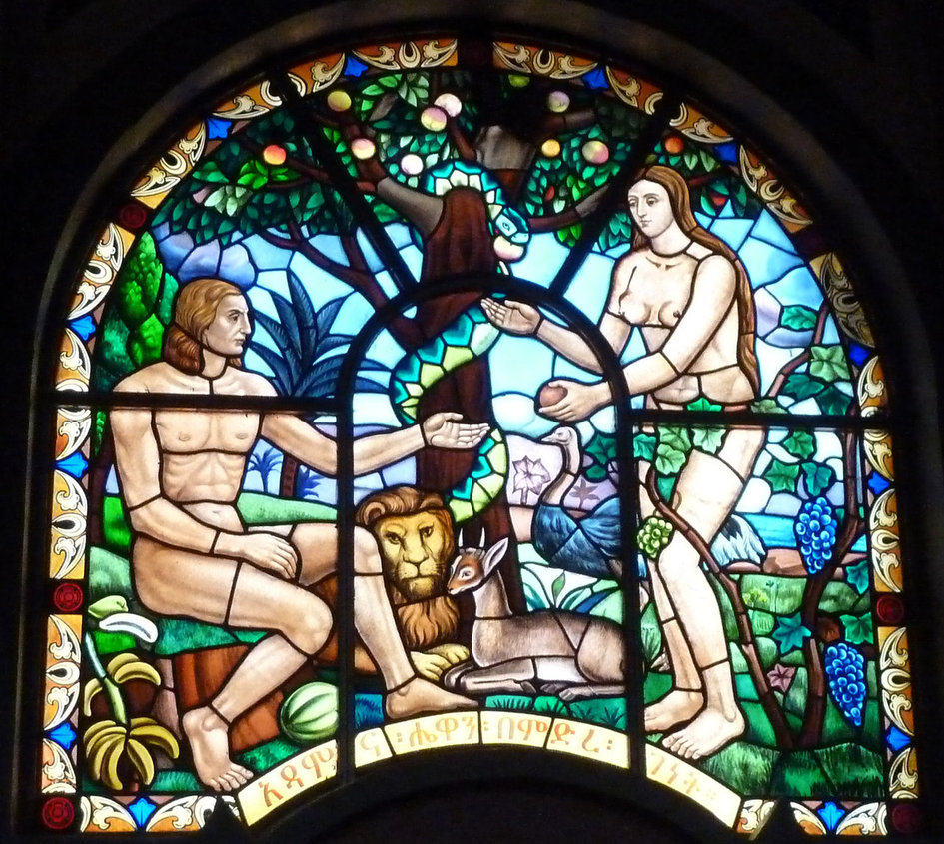
It is interesting to see the above image of a stained-glass window in a church in Ethiopia which depicts Adam and Eve committing the original sin of eating an Apple from the forbidden Tree of the Knowledge of Good and Bad (Genesis 2:17)
(Even the Apple logo suggests forbidden fruit that has been bitten into.)
Despite the proliferation of computers and the internet and the billions of ardent followers who worshipped before their glass screens every day the drawback in this modern busy age was the fact that these computers were static, plugged into the grid. Laptop computers helped to alleviate this problem to a degree but were still large and unwieldy. A new device was needed to save mankind from the chains of the power grid and to create access wherever one was.
The smartphone was here, like a mobile mini altar that could be taken anywhere, accessible to the masses and could contain all the wisdom of the world encapsulated in a small bright glass screen. This simple object had taken on a whole new meaning elevating it above its basic purpose which was a mobile telephone.
The author Andrew J. Becevich wrote an interesting article in 2011 entitled ‘Of Idolatry & iPhones ‘. He stated in this article ‘… Anyone who today works with or near young people cannot fail to see this: for members of the present generation, the smartphone has become an amulet. It is a sacred object to be held and caressed and constantly attended to. Previous generations fell in love with their cars or became addicted to TV, but this one elevates devotion to material objects to an altogether different level. In the guise of exercising freedom, its members engage in a form of idolatry. Small wonder that aficionados of Apple’s iPhone call it the Jesus Phone.’

For those who still want to follow a standard religion there are a myriad of religious apps available which enable one to worship without the need to visit a holy building. A prayer, a mantra or a sermon for every day are available at the swipe of a glass screen whether that be from a holy person or godlike singer, entertainer, sports star or YouTube personality.
And finally, as if to complete the circle where we started with a beautiful stained-glass window centuries ago Caventou is a 21st century company which produces stained glass windows with inbuilt solar panels which harvest energy to charge devices such as smartphones.
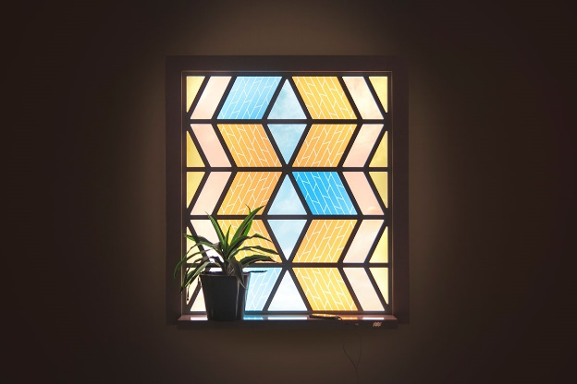
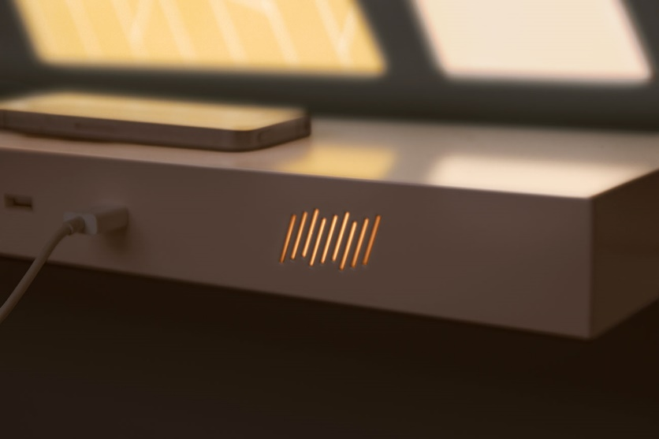
Throughout history since around the 7th century large backlit pieces of coloured glass in church and cathedral walls instructed us how to live our lives, through the introduction of the television, the computer and the smartphone we now 14 centuries later carry around small pieces of coloured glass which tell us how we should live our lives. Strange world!

Bibliography

Reference List

Books, Articles, Journals
Becevich, A. J. (2011) ‘Of Idolatry & Iphones’,,(),pp. .
Chamberlain, Dr. L. J. and Chambers, Dr. N. (n.d) ‘How television is changing our children’,, (), pp. .
McLeod, H. (n.d)’’, in McLeod, H. (ed.) The Religious Crisis of the 1960’s.:, pp. 169.175.
Mitch, D. (2004) ‘Education and still of the British Labour force’, in Floud, R. and Johnson, P. (ed,) The Cambridge economic history of modern Britain. Cambridge: Cambridge University press, pp. 344. Vol 1.

Websites
http://www.st-benets.durham.sch.uk/about-us/st-benet/
http://news.bbc.co.uk/onthisday/hi/dates/stories25140002514719.stm
http://lowendmac.com/2018/personal-computer-history-1985-1994
https://thenextweb.com/insider/2011/08/06/20-years-ago-today-the-world-wide-web-opened-to-the-public/

