Student: Thomas Cole
Student Number: 2117366
Module: Research in Context ADAD5004/C
Programme of Study: Illustration (BA)
Tutor: Delyth Lloyd-Evans
Word Count: 2627

Keywords: Personification, Movement & Folklore.

Who’s pulling the strings? Explore the process and principles needed for bringing puppets to life.

In this essay I intend to explore the theories and practices involved in storytelling through the medium of traditional puppetry, with an aim to gain an understanding of the design processes key to creating compelling characters to be used for communicating folklore through said medium.

Personification
When we think of the puppets we loved as children many of us don’t think of crafted objects, but who or what they are as characters and creatures. Whereas an actor in a film can be the face, the voice and body of a character, a puppet is often a combination of a puppeteer (sometimes more than one), a puppet maker and a voice actor all contributing towards making constructions of cloth, paper, wood, or other materials seem alive. Despite this complexity we suspend our disbelief and allow ourselves to acknowledge the personalities of these characters to allow ourselves to enjoy the stories they play a part in. Narrative Theorist Howard Sklar wrote about our ability to relate to fictional characters in literature saying:
“By real, of course, I do not imply a factual, living reality; rather, I believe that characters that are rendered realistically can be considered similar to people we might encounter in life—indeed, life-like—and that readers frequently regard them and respond to them as such.” (Sklar, 2009)
If we can apply the same thinking about characters beyond the scope of literature, then we can begin to understand how we rationalise and relate to them. If the puppets in a show have characteristics that we can recognise then they become more believable to us, and we may become more willing to empathise with them. Similarly, if a character or creature depicted displays exaggerated traits that we find distasteful or frightening, then we may also allow ourselves to perceive them as a villain (McMullen 1989).

In the seventeenth century travelling puppet theatres gained popularity across Britain and Europe, often depicting religious stories told by clergy members to proselytize Christianity, telling stories from history, or acting out popular plays (Victoria & Albert Museum, 2009). Punch & Judy Shows became popular across Europe as a means of telling stories to the delight of both king and commoners (Victoria and Albert Museum, 2012). These shows would often feature the titular character Punch, usually depicted as whimsical man with a long nose and dressed in jesters’ clothing (fig 1), acting in a boorish and subversive manner towards the other characters in the play in a frequently violent manner, sometimes even fighting the devil (Victoria and Albert Museum, 2012). Although these shows often depicted very cavalier and slapstick shows of violence, author Charles Dickens is quoted as saying in a letter:
“In my opinion the street Punch is one of those extravagant reliefs from the realities of life which would lose its hold upon the people if it were made moral and instructive. I regard it as quite harmless in its influence, and as an outrageous joke which no one in existence would think of regarding as an incentive to any kind of action or as a model for any kind of conduct. It is possible, I think, that one secret source of pleasure very generally derived from this performance… is the satisfaction the spectator feels in the circumstance that likenesses of men and women can be so knocked about, without any pain or suffering.” (Dickens, 1849)
This would suggest that even though the spectators empathised with these characters, they could hold safe in the knowledge that no real harm was done, and the performance was in the spirit of good humour.

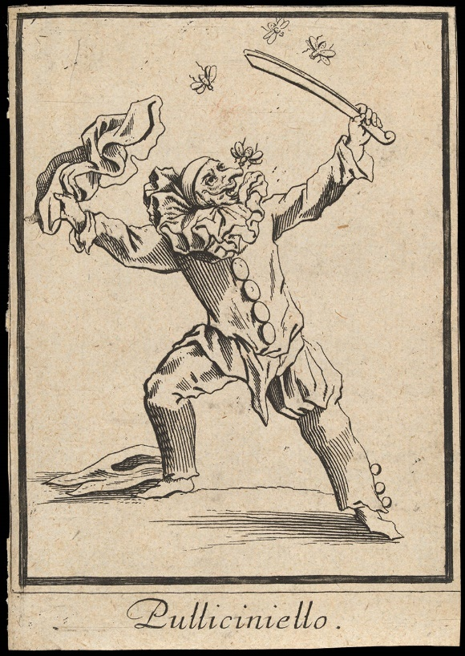
Fig. 1. - Danckerts (1622) Pulliciniello. Victoria & Albert Museum, London.
Here we see an illustration depicting Pulliciniello - the name given to Punch in Italy prior to the show’s introduction to the shores of Britain, seemingly fending off a swarm of insects whilst one bites him on his comically long nose. This style of slapstick humour would be the trademark of Punch & Judy Shows (Victoria & Albert Museum. 2012).

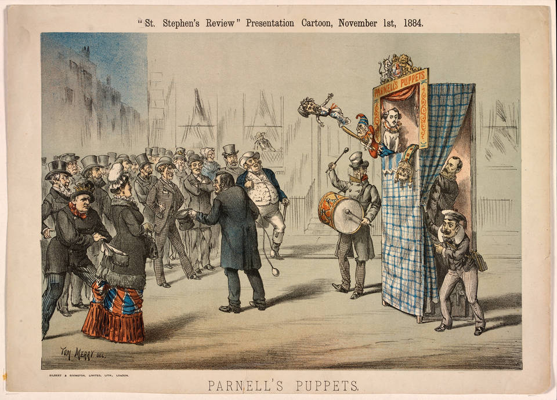
Fig 2. - Merry (1884) Parnells Puppets. Victoria & Albert, London.
Puppet shows received a rise in popularity again in the late nineteenth century with the introduction of bank holidays, allowing people to travel and experience the entertainment they offered (Victoria & Albert, 2009).

In two thousand and eight, Tamar Szábo Gendler, a professor of philosophy at Yale university in Connecticut proposed the concept of alief; a state of conscious or unconscious thinking where an individual accepts what they see as truth despite logically knowing otherwise. Gendler says about her concept:
“Alief is a more primitive state than either belief or imagination: it directly activates behavioural response patterns (as opposed to motivating in conjunction with desire or pretended desire.” (Gendler, 2007, Pg. 1)
If we were to employ this thinking regarding viewers watching a puppet show or animation, we could surmise that when they feel an emotional response to characters, they can reason are not real they are experiencing a cognitive state altogether different to belief. It is this state that allows characters not wholly played by actors to become more than objects or images to the audience.
There is another phenomenon that we can consider when asking why we allow ourselves to characterize objects in our minds called pareidolia (Jonas, 2019). Pareidolia is our mind’s ability to see familiar shapes in similarly shaped objects, landscapes, or collections of objects, such as when we see recognisable shapes in clouds, or animals and faces in rock formations. A popular example of this is The Face on Mars (fig 3.).

Fig 3. NASA (1976) The Face on Mars.
This photograph taken by NASA’s Viking 1 spacecraft in nineteen seventy-six seemingly shows a human like face on the surface of Mars that captivated the public and garnered attention for the agency’s ongoing research (NASA, 2001). Images taken since have shown the face to be a trick of the light (NASA, 2001).

I would conclude that whilst pareidolia may play a part in helping us on the road to personifying puppets and accepting them as characters, much more than a face is needed and the previously looked at factors are crucial in creating believable, life like creations.

Movement
Without motion, puppets are little more than dolls or mannequins, and while we can argue that some of us personify these objects, some of us even attributing a heightened emotional response of fear to them such as in the case of pediophobia- the fear of dolls (Cafasso, 2019) or Automatonophobia- the fear of human like objects (Lockett, 2019), it is ultimately the conceptual or actual movement of these objects that “move” our emotions.

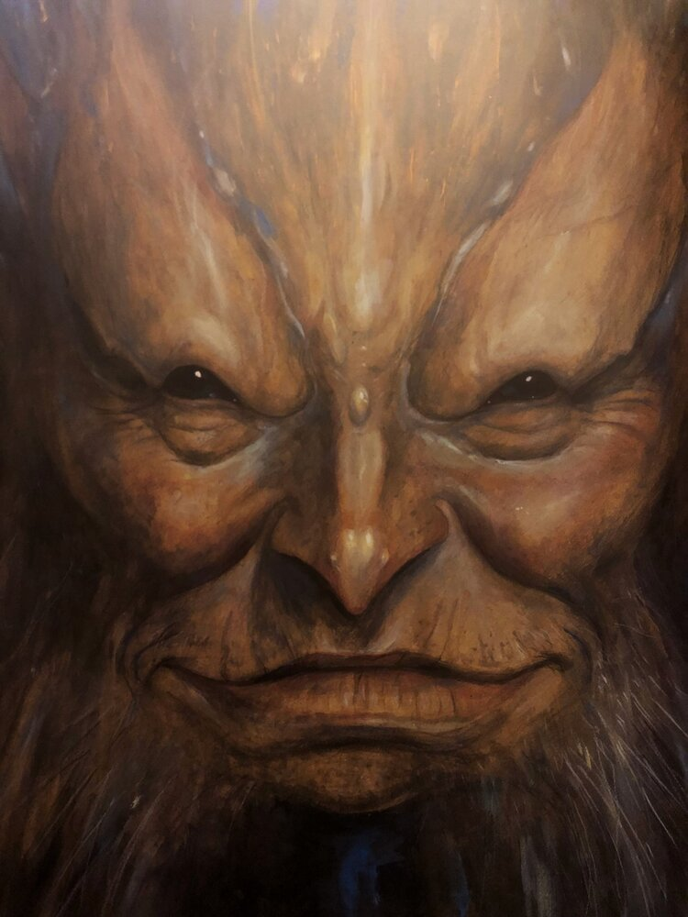
Fig 4.) Froud, B (n.d.) The Soul of Faerie. Fernie Brae, Portland, OR.

Many puppets start their lives as drawings, but in illustration motion is often challenging to express in static works. With puppetry, this isn’t the case, as articulated limbs and soft tangible materials can be used to lift illustrations off the page. One such example of this is the work of husband-and-wife artists Brian & Wendy Froud whose illustrations & sculptures explore the hidden worlds of Faeries and fantastical worlds (fig 4.)(fig 5.). Both worked with legendary puppeteer Jim Henson as lead concept artists and puppet designers on the films The Dark Crystal (1982) and Labyrinth (1986), as well as later revisiting the world of the prior film in the twenty-nineteen Netflix Series- The Dark Crystal: Age of Resistance. These films and the Froud’s work on them are relevant because they all feature comprehensive and complicated puppetry that brings the artists work to life on the screen (Little White Lies, 2019).

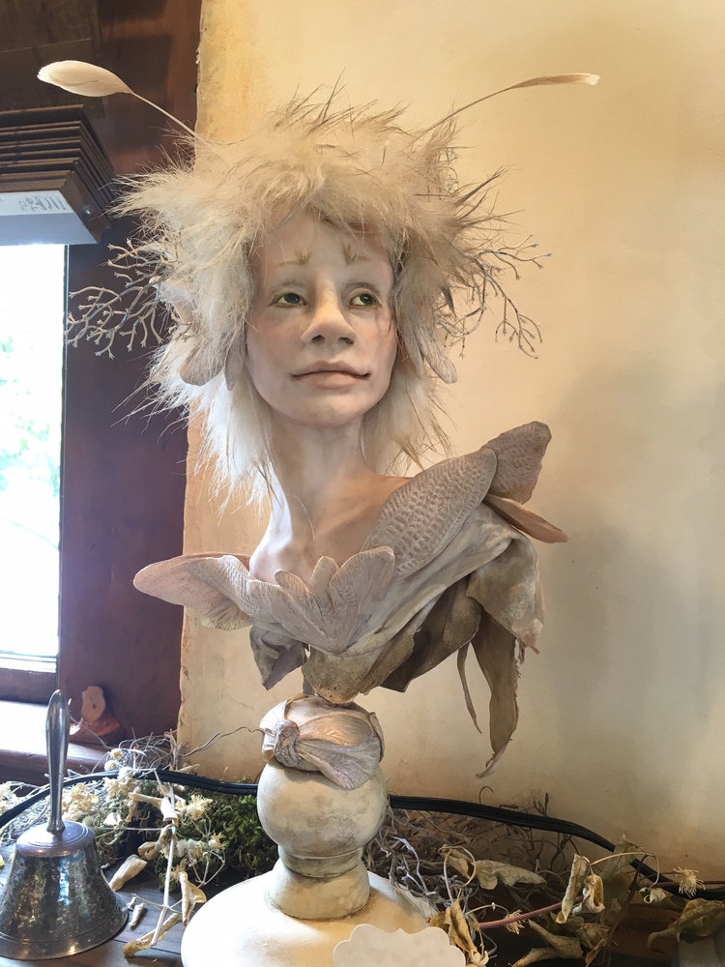
Fig 5.) Froud, W (n.d.) White Faery. [Mixed Media] Fernie Brae, Portland, OR.

Modern techniques like green screen enabled the creators of The Dark Crystal: Age of Resistance to create complex scenes with dynamic movements by having puppeteers inside and outside of the puppets, that could then be removed in post-production (Little White Lies, 2019) (Vanity Fair, 2019). This style of having puppeteers outside of the puppets is reminiscent of the Japanese style of Bunraku puppetry, where in 3 individuals operate a single puppet, two or sometimes all of them dressing in black clothing and hoods (Turner, 2018). Donald Keene- a professor of Japanese literature at Columbia University, U.S., said of Bunraku theatre: “The spell of Bunraku is irresistible to anyone who allows himself to be moved” (Turner, 2019). It is from this that we could theorize that through complex action and direction, the movement of puppets on the stage or screen we observe, travels through our senses and translates into an emotional movement within our minds, as our empathy grows deeper with the characters they portray and the stories they tell.
A trick that puppet makers use to help breath life into their creations is to add sympathetic movements to their creations; subtle motions that happen without direct action from the puppeteer (Adam Savage's Tested, 2016). These can include feathers, long fur, tendrils or other flexible materials and appendages that all add another dimension of movement to a puppet. We can see a lot of good examples of this in Jim Henson’s work on The Muppets franchise (1955).
Another artist who encapsulates movement using puppets especially well is Barnaby Dixon. Dixon creates lifelike puppets using his studies in anatomy as a basis for his work, looking at the way limbs move and connect as well as incorporating elements of sympathetic movement into his designs (Jordan, 2023).
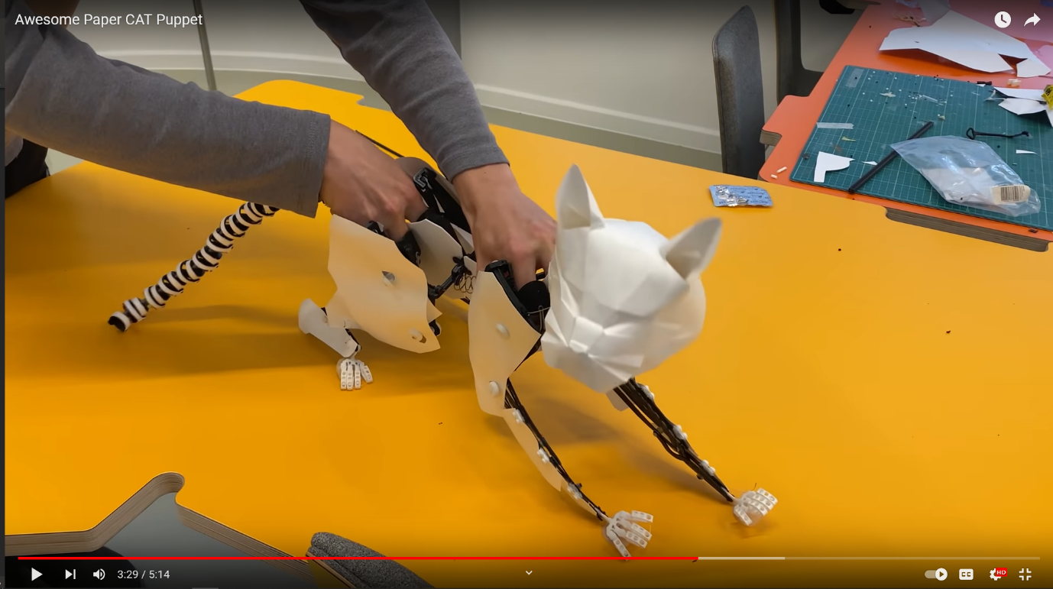Fig.6) Dixon, B. (2021). Awesome Paper CAT Puppet. Youtube.
These techniques of incorporating high degrees of realism into puppets clearly helps to trick our minds into the “alief” that what we are watching has a life all its own. When this technique is carried over into telling fantastical tales, we start to see the real magic of this storytelling medium show itself.

Folklore
Folklore is a term with a loose definition and one that encompasses a large territory. Barre Toelken describes it in his book Dynamics of Folklore (1996, pg. 32) saying “folklore is a word very much like culture; it represents a tremendous spectrum of human knowledge and expression that can be studied in a number of ways and for a number of reasons.” I aim to explore and discuss the section of folklore that holds stories, and the tradition of telling them through performance.

Puppetry around the world has always enjoyed a deep relationship with the world of folklore, with many countries and cultures boasting rich traditions in the field.
India boasts at least nineteen forms of traditional puppet theatre including one of the most well-known forms: Kathputli, which takes its name from the Hindi word for puppet (Serman, 2020). Whilst the art form originated in Rajasthan, performers travelling to Delhi settled there in the early nineteen-sixties and their art form gave their new home its name; Kathputli Colony (atlasofhumanity, n.d.). This settlement would grow to become a hub of street performers and artists and remain until its destruction by the government in 2017, displacing the peoples there (atlasofhumanity, n.d.). Indian puppetry in many of its forms involves storytelling, music, and dance (Serman, 2020).
Egypt is another country with a rich history of puppetry stretching back all the way to the time of the pharaohs, evidenced by funeral figurines found in tombs (Saad, 2009). These link into the folklore of the ancient people as many were believed to be intended for use by children in the afterlife as toys, as well as there being accounts of puppets being used by priests and revellers during religious ceremonies and rituals, some representative of fertility and childbirth, and some for the purposes of divination, with processions taking directions by following the head movements of a puppet-idol (Saad, 2009).
In China, shadow puppetry is an ancient form of performance art that dates back over 2000 years where it is said to have originated (Great Big Story, 2019). Performers of the art form tell stories with puppets crafted from translucent painted animal skins against a backlit cloth screen, often for large audiences at religious festivals, funerals, and weddings (UNESCO, 2011).
One such artist is Master Fan Zheng’an, who keeps this art form alive today by entertaining tourists and visitors to Mount Taishan- one of Chinas five sacred mountains. Master Fan employs techniques he learned as part of his apprenticeship as a young man, and does so solo as puppeteer, musician, puppet maker and storyteller in one for guests at his family’s teahouse, as well as training up to thirty apprentices in the art of traditional Chinese shadow puppetry (Chinese Shadow Puppetry, 2011) (Yang, 2020).

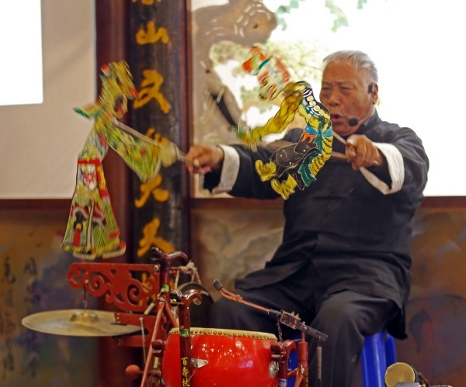
Fig 7.) China Daily (2020). Fan Zheng’an. [Photograph]

Within the folklore of the western world, fairy tales are prominent. Princesses in castles, knights, and fire-breathing dragons all have a part to play in these stories that are often pedagogic in nature; acting as vehicles for morality and warning to those who put a foot wrong.
“Myths and fairy tales seem to know something that we do not know. They also appear to hold our attention, to keep us in their sway, to enchant our lives. We keep returning to them for answers. We use them in diverse ways as private sacred myths or as public commercial advertisements to sell something. We refer to myths and fairy tales as lies by saying, “oh, that’s just a fairy tale,” or “that’s just myth.” But these lies are often the lies that govern our lives.” (Zipes, 1994, pg. 3)
A prominent leitmotif in western folk and fairy tales is that of the frog prince; a character that despite initially appearing as diminutive, lowly, and often repugnant creature, displays hidden qualities (often when kissed by a princess and transformed into a handsome prince) like honour, kindness, and bravery. Philosopher-poet Fred Hornaday writes on this saying:
“The role of frogs and toads in folklore and fairy tales is widespread and well-documented throughout the world. As a window into the collective unconscious, fairy tales serve as a kind of secular scripture, and it is no exaggeration to say that the frog takes a preeminent place in this light-hearted yet deep-seeking genre.” (Hornaday, 2019)
The Muppets (1955) creator Jim Henson took the frog-prince trope one step further with his banjo-toting protagonist puppet, Kermit the Frog. Henson’s famous character often finds himself playing the easy going, level-headed, moral compass amongst the frequently unpredictable and zany cast of The Muppets (1955) and heavily contrasted by his strong willed and high maintenance, “princess-like” romantic interest, Miss Piggy. Sometimes called “Henson's soft-spoken alter-ego” (latimes.com, n.d.), Kermit was one of his earliest creations and was originally voiced and controlled by the puppeteer himself. The character has been used over the years to promote messages of racial tolerance like in his songs Bein’ Green (Kermit, Henson, 1970) and following one’s dreams in Rainbow Connection (Kermit, Henson, 1979), as well as more recently in the fight against climate change in Kermit The Frog | Dear Earth (2021). If Kermit the frog is argued to be a figure in contemporary global folklore, then we can acknowledge how puppets and folklore are being used as a positive force in the modern age.
Conclusion & Practice
Now having researched and explored all the aforementioned ideas and topics, I can conclude that there are in fact complex factors involved in the creation of successfully empathetic characters intended to be portrayed by puppets. An onlooker must be able to identify within these creations’ recognisable traits and forms, yet still be able to feel enchanted by the mystifying illusion of self-locomotion. Puppets fall into the realm of ‘uncanny’, as unliving crafted objects whose soul purpose is to convince us otherwise.
As part of my future practice, I intend to develop on the ideas that I have looked at in this essay and to deliver the concepts and designs for multiple puppet characters, as well as crafting one or more tangible crafted puppets of my own making. These characters will be intended for the purpose of recreating a folklore telling of my choice.
I end with my constructed question: Who’s pulling the strings? Explore the process and principles needed for bringing puppets to life.

Bibliography
- Adam Savage's Tested (2016). Adam Savage’s One Day Builds: Making a Puppet! Youtube. Available at: https://www.youtube.com/watch?v=JYwNuP7cwJs [Accessed 22 Apr. 2023].
- atlasofhumanity.com (n.d.). India, Kathputli Colony. [online] Atlas Of Humanity. Available at: https://www.atlasofhumanity.com/kathputli [Accessed 18 Apr. 2023].
- Cafasso, J. (2019). Pediophobia or Fear of Dolls: What Causes It & How to Make It Stop. [online] Healthline. Available at: https://www.healthline.com/health/mental-health/pediophobia.
- Cesare, A. (2020) The Dark crystal Bestiary. London: TITAN BOOKS LTD.
- China Daily (2020). Fan Zheng’an. [Photograph] Available at: https://img2.chinadaily.com.cn/images/202011/17/5fb30f2ca31024adbda23ebe.jpeg [Accessed 23 Apr. 2023].
- Chinese Shadow Puppetry (2011). Master Fan, Shandong Province. [online] Available at: https://www.chineseshadowpuppetry.com/master-fan-shandong-province [Accessed 23 Apr. 2023].
- ‌Dickens, C. (1849). Charles Dickens’ letters to Mary Tyler.
- Dixon, B. (2021). Awesome Paper CAT Puppet. Youtube. Available at: https://www.youtube.com/watch?v=Pj2xOHyLN1E [Accessed 22 Apr. 2023].
- Froud, B. (n.d.). The Soul of Faerie. Available at: https://www.ferniebrae.com/brian-froud [Accessed 22 Apr. 2023].
- Froud, W. (n.d.). White Faery. [Mixed Media] Available at: https://www.ferniebrae.com/wendy-froud [Accessed 22 Apr. 2023].
- Gendler, T. S. (2007). In March 2007, the Hualapai tribe has recently built a glass pavilion that is suspended over the Grand Canyon. [online] Available at: http://www.pgrim.org/philosophersannual/pa28articles/gendleraliefbelief.pdf.
- Great Big Story (2019). The Master of Shadow Puppets. YouTube. Available at: https://www.youtube.com/watch?v=2IwhLjj9Hkk.
- Hornaday, F. (2019). Archetypal Dimensions of Kermit the Frog. kingoflimericks. Available at: https://kingoflimericks.com/archetypal-dimensions-of-kermit-the-frog/ [Accessed 24 Apr. 2023].
- Jonas, C (2019) Why we see faces in inanimate objects | Dr Clare Jonas. [online] Available at: https://www.thatthinkingfeeling.co.uk/blog/pareidolia-faces-inanimate-objects [Accessed 22 Mar. 2023].
- Jordan, C. (2023). How This Guy Makes Puppets That Move Like Real Creatures. WIRED. Available at: https://www.wired.com/video/watch/obsessed-puppets [Accessed 22 Apr. 2023].
- Kermit the Frog and Henson, J. (1970). Bein’ Green.
- Labyrinth. (1986). [Live Action/Puppetry] UK: Warner Bros. Entertainment Inc.
- Little White Lies (2019). Designing The Dark Crystal’s Magical Puppets. Youtube. Available at: https://youtu.be/3opno5kBB1o [Accessed 22 Apr. 2023].
- Lockett, E. (2019). Understanding Automatonophobia: Fear of Human-Like Figures. [online] Healthline. Available at: https://www.healthline.com/health/anxiety/automatonophobia [Accessed 21 Apr. 2023].
- McMullen, W.C. (1989) Villainy, Humor, and Heresy. Theology Today, 46(3), pp. 283.
- NASA (1976). The Face on Mars. [Photograph] Available at: https://science.nasa.gov/science-news/science-at-nasa/2001/ast24may_1 [Accessed 21 Apr. 2023].
- Nasa.gov. (2019). Unmasking the Face on Mars | Science Mission Directorate. [online] Available at: https://science.nasa.gov/science-news/science-at-nasa/2001/ast24may_1.
- Saad, S. (2009). Egypt. Translated by A. Cloarec. In: World Encyclopedia of Puppetry Arts. [online] Available at: https://wepa.unima.org/en/egypt/ [Accessed 23 Apr. 2023].
- Serman, T. (2020). All Major Forms of Puppetry in India. [online] Auchitya. Available at: https://www.auchitya.com/indian-puppetry-a-rich-ancient-art-that-is-slowly-fading/.
- Sklar, H. (2009). Believable Fictions: On the Nature of Emotional Responses to Fictional Characters – Howard Sklar. [online] Helsinki English Studies: Electronic Journal. Available at: https://blogs.helsinki.fi/hes-eng/volumes/volume-5/believable-fictions-on-the-nature-of-emotional-responses-to-fictional-characters-howard-sklar/.
- The Dark Crystal. (1982). [Puppets] U.S.: Universal Pictures.
- The Dark Crystal: Age of Resistance, (2019). Netflix. 30 Aug.
- The Fernie Brae. (n.d.). The Fernie Brae. [online] Available at: https://www.ferniebrae.com/ [Accessed 22 Mar. 2023].
- The Muppets (2021). Kermit The Frog | Dear Earth. Youtube. Available at: https://www.youtube.com/watch?v=jWOFEImPnQI [Accessed 23 Apr. 2023].
- ‌The Muppets. (1955). United States: The Jim Henson Company.
- Toelken, B. (1996). Dynamics of Folklore. Logan, UT: Utah State University Press.
- Turner, J. (2018). History and Sustainability of Bunraku, the Japanese Puppet Theater. [online] Association for Asian Studies. Available at: https://www.asianstudies.org/publications/eaa/archives/history-and-sustainability-of-bunraku-the-japanese-puppet-theater/.
- UNESCO (2019). UNESCO - Chinese shadow puppetry. [online] Unesco.org. Available at: https://ich.unesco.org/en/RL/chinese-shadow-puppetry-00421. [Accessed 23 Apr. 2023].
- Vanity Fair (2019). Puppetry in The Dark Crystal: Age of Resistance Explained by Creators | Vanity Fair. YouTube. Available at: https://www.youtube.com/watch?v=e-6XUIJDh-Y [Accessed 4 Dec. 2019].
- Victoria & Albert Museum (2012). Punch and Judy: The Past. Youtube. Available at: https://youtu.be/ybeImnbTM4s [Accessed 21 Apr. 2023].
- Victoria and Albert Museum. (2009). V&A · That’s the Way to Do it! A History of Punch & Judy. [online] Available at: https://www.vam.ac.uk/articles/thats-the-way-to-do-it-a-history-of-punch-and-judy.
- Victoria and Albert Museum. (n.d.). V&A · A history of puppets in Britain. [online] Available at: https://www.vam.ac.uk/articles/a-history-of-puppets-in-britain#slideshow=21816336&slide=0.
- Yang, F. (2020). Making a present of the past. China Daily. [online] Available at: https://www.chinadaily.com.cn/a/202011/17/WS5fb30f2ca31024ad0ba94790_4.html [Accessed 23 Apr. 2023].
- Zipes, J. (1994). Fairy Tale as Myth/Myth as Fairy Tale. [online] Kentucky: University Press of Kentucky. Available at: https://www-jstor-org.ezproxy.uwtsd.ac.uk/stable/j.ctt2jcw6s [Accessed 23 Apr. 2023].

