Portfolio

Student Name: Andleeb Saeed
Student Number: 2506509
Module Name: Professional Development in Health and Social Care
Module Code: LCHS4009-BIRM
Tutor Name: Besty Jose

TABLE OF CONTENTS:
Contents | Page No.
Job Advertisement (Care Assistant Vacancy – Avery Healthcare) | 3-4
Task 1: Curriculum Vitae (CV) | 5-6
Task 2: Personal Statement | 7-8
Task 3a: SWOT Analysis | 9-10
Task 3b: Personal Development Plan (PDP) | 11-13
Task 4: Gibbs Reflective Cycle (Critical Reflection) | 14-16
References | 17

Job Advertisement:
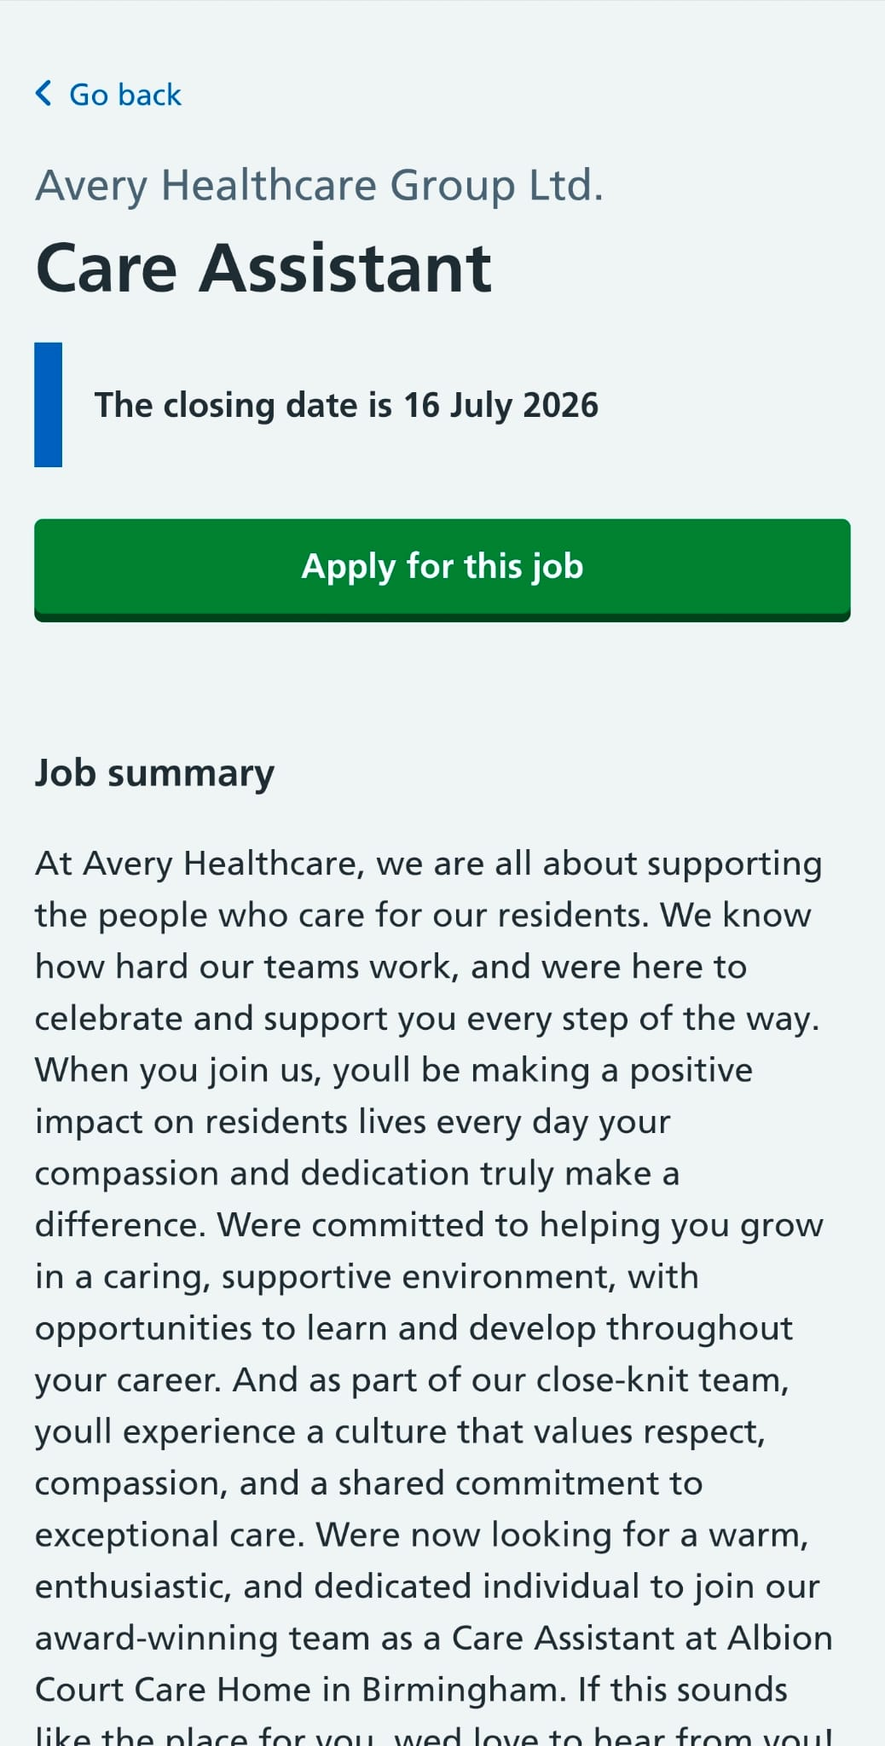
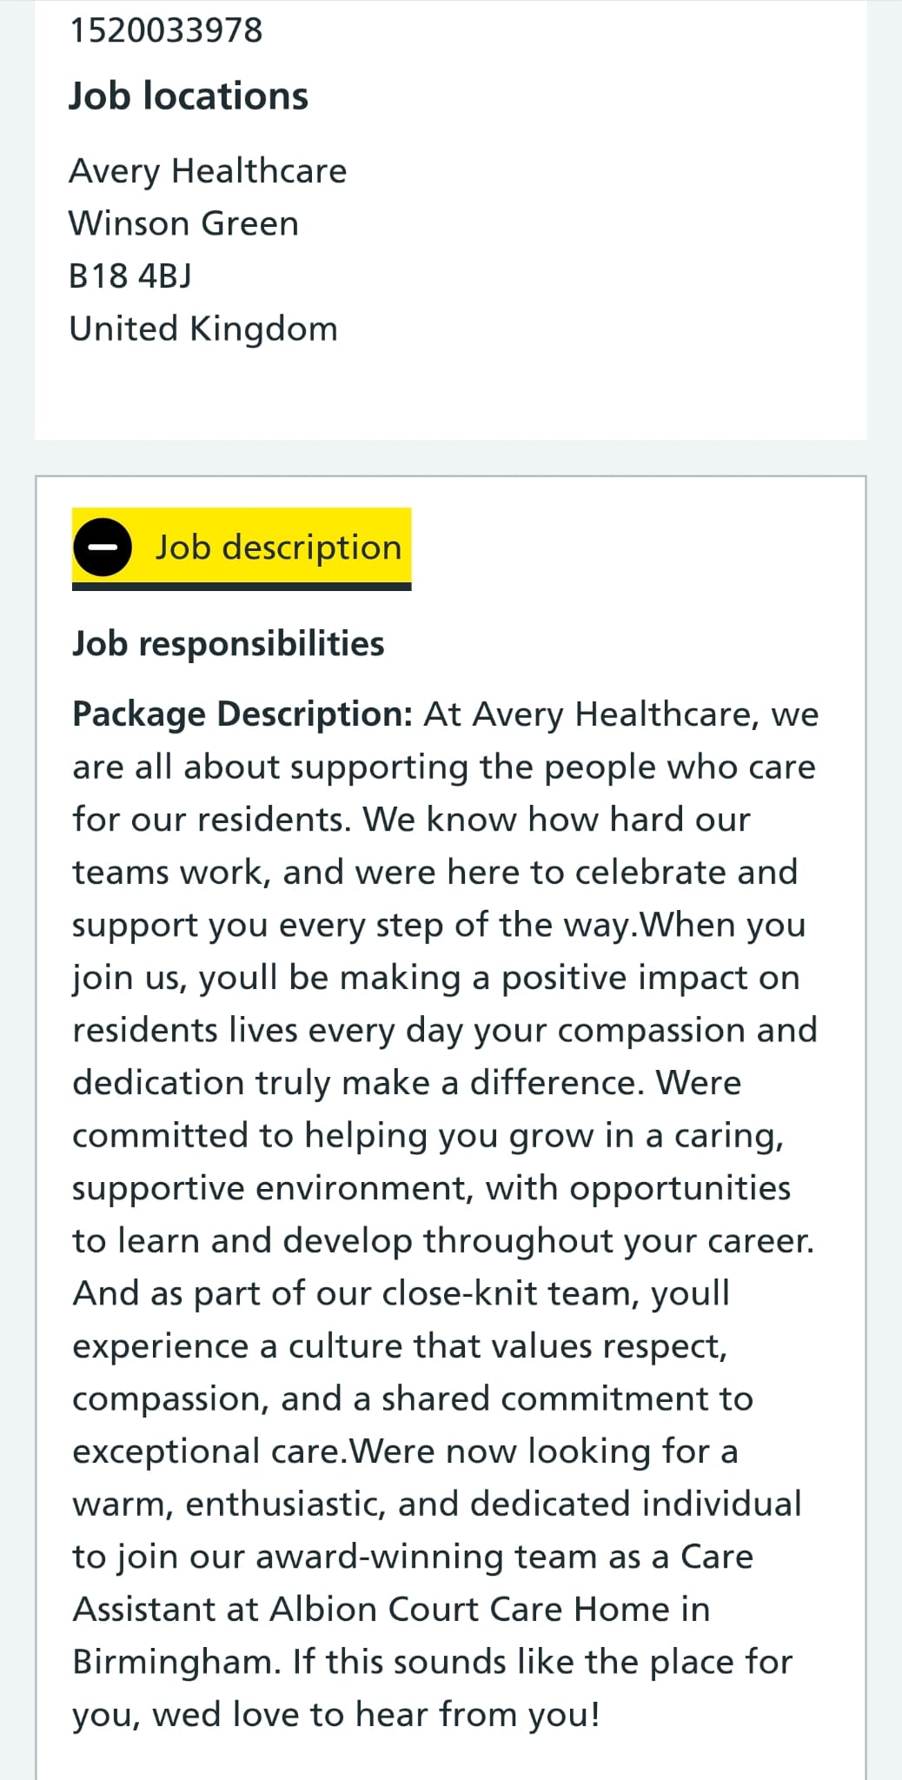
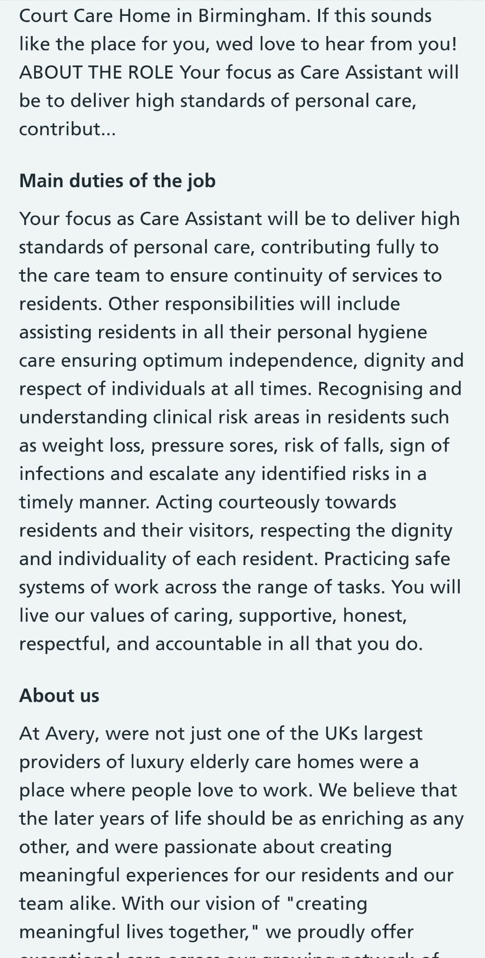
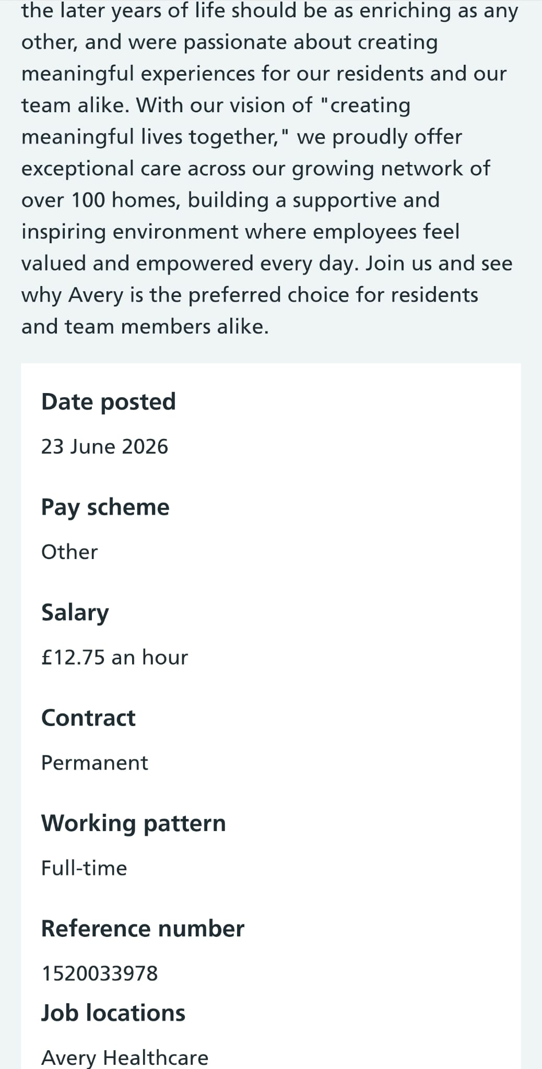
https://share.google/OQF7qQMGJA9dxz80s
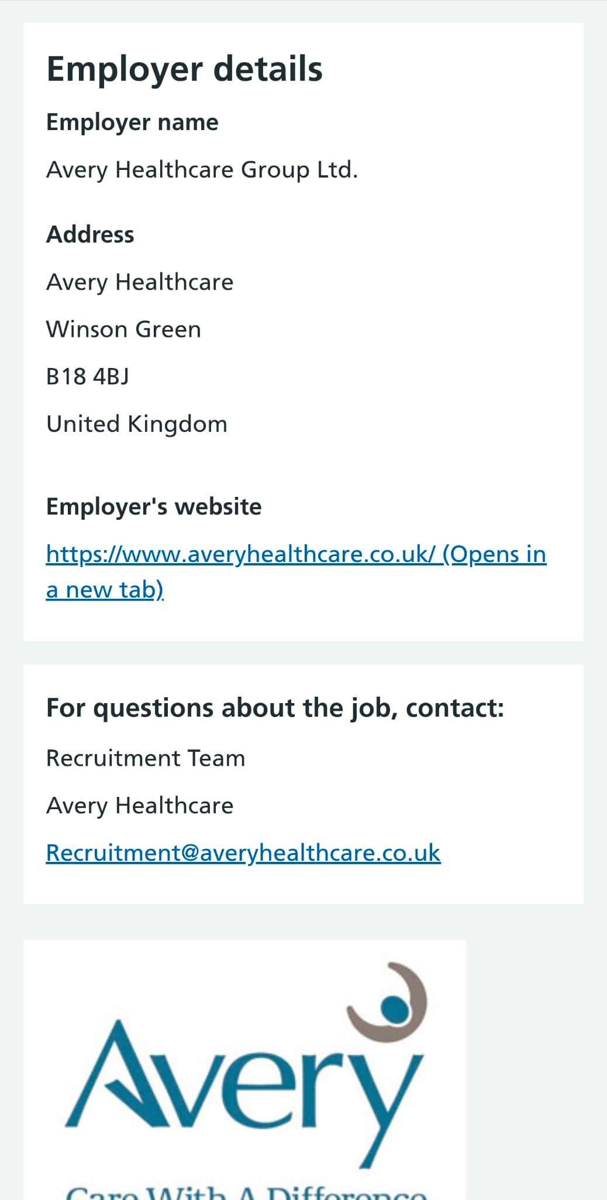
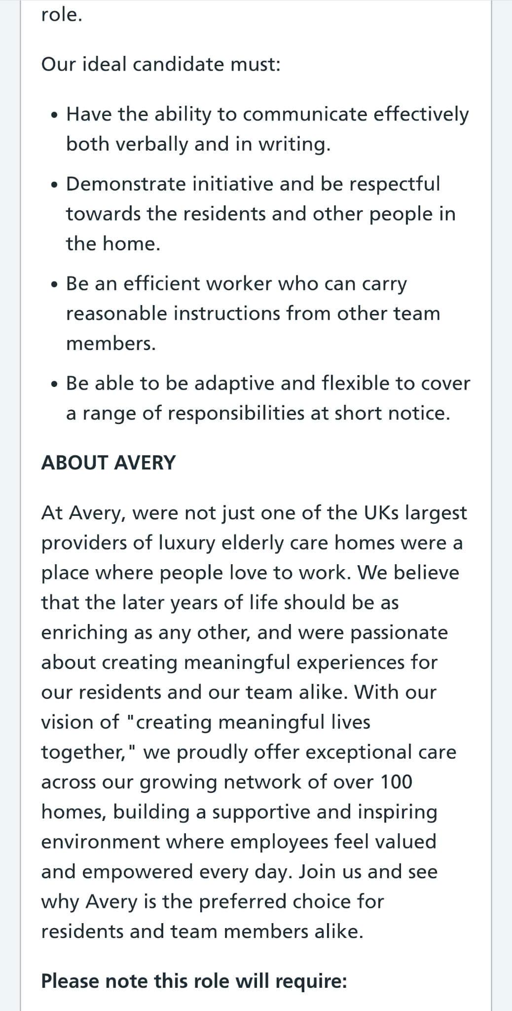
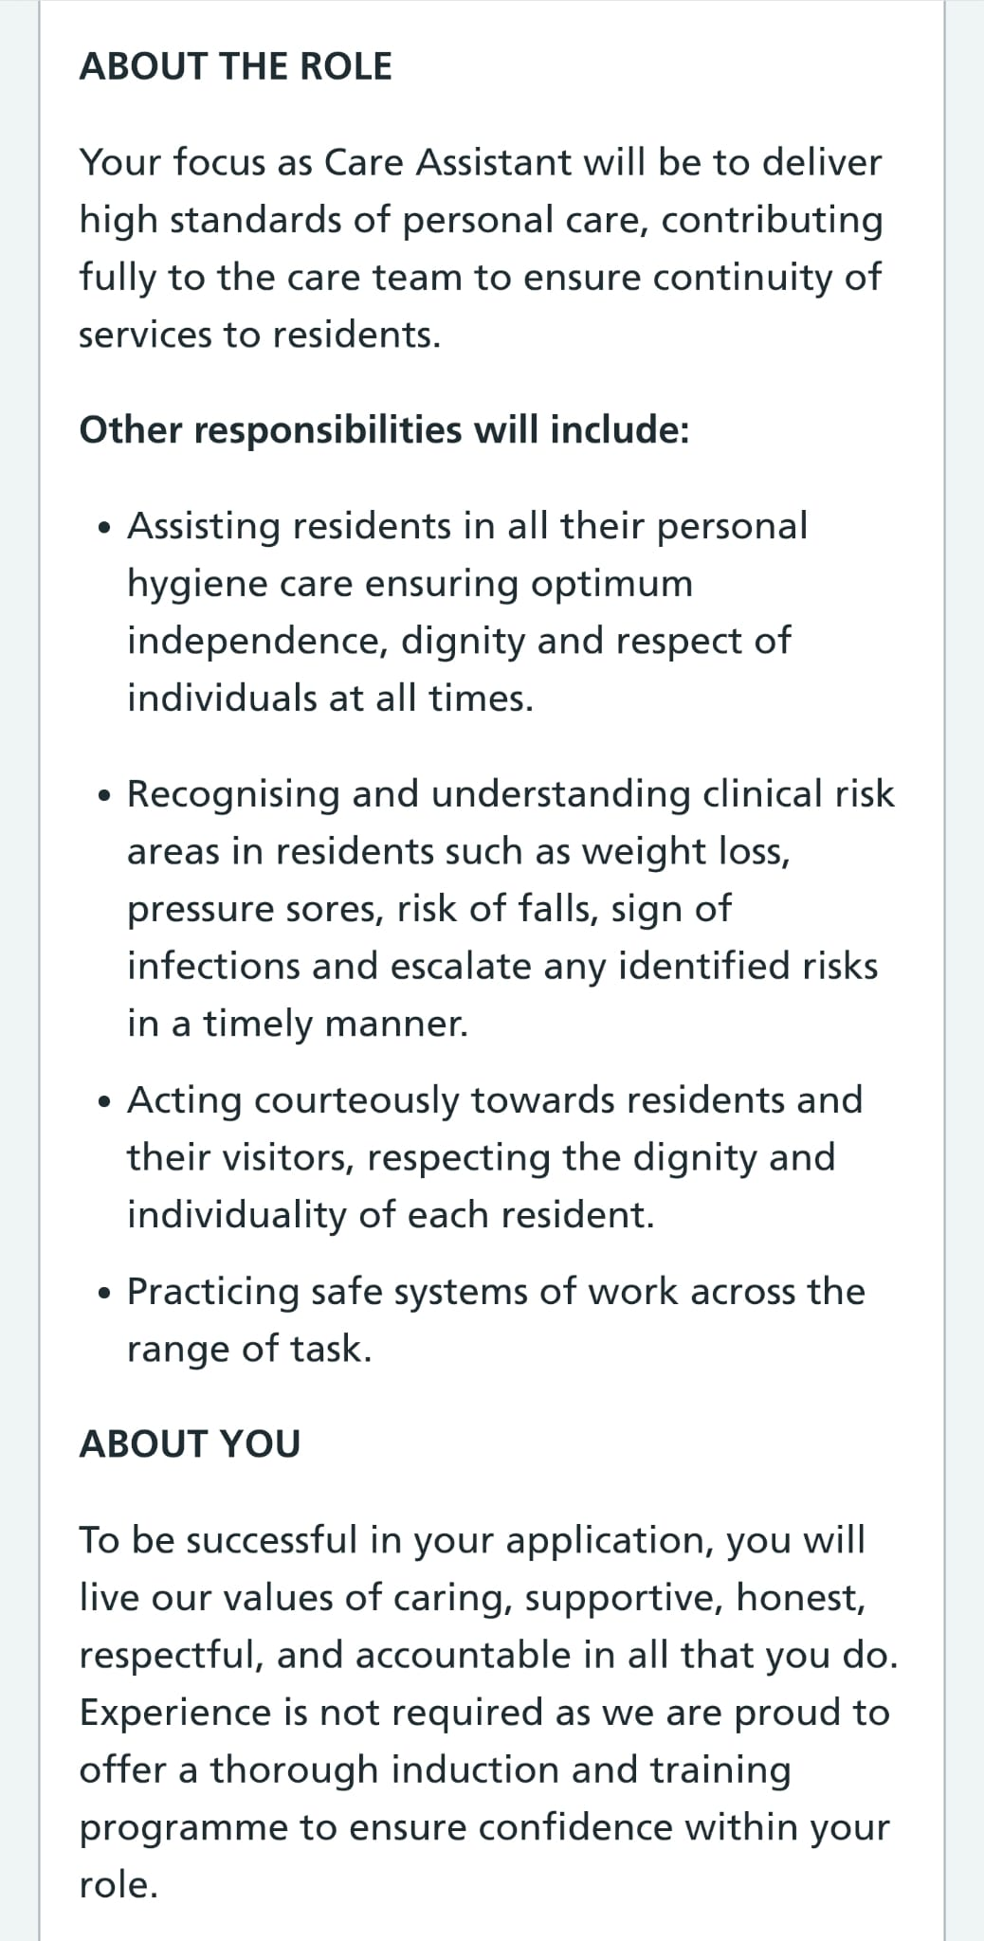
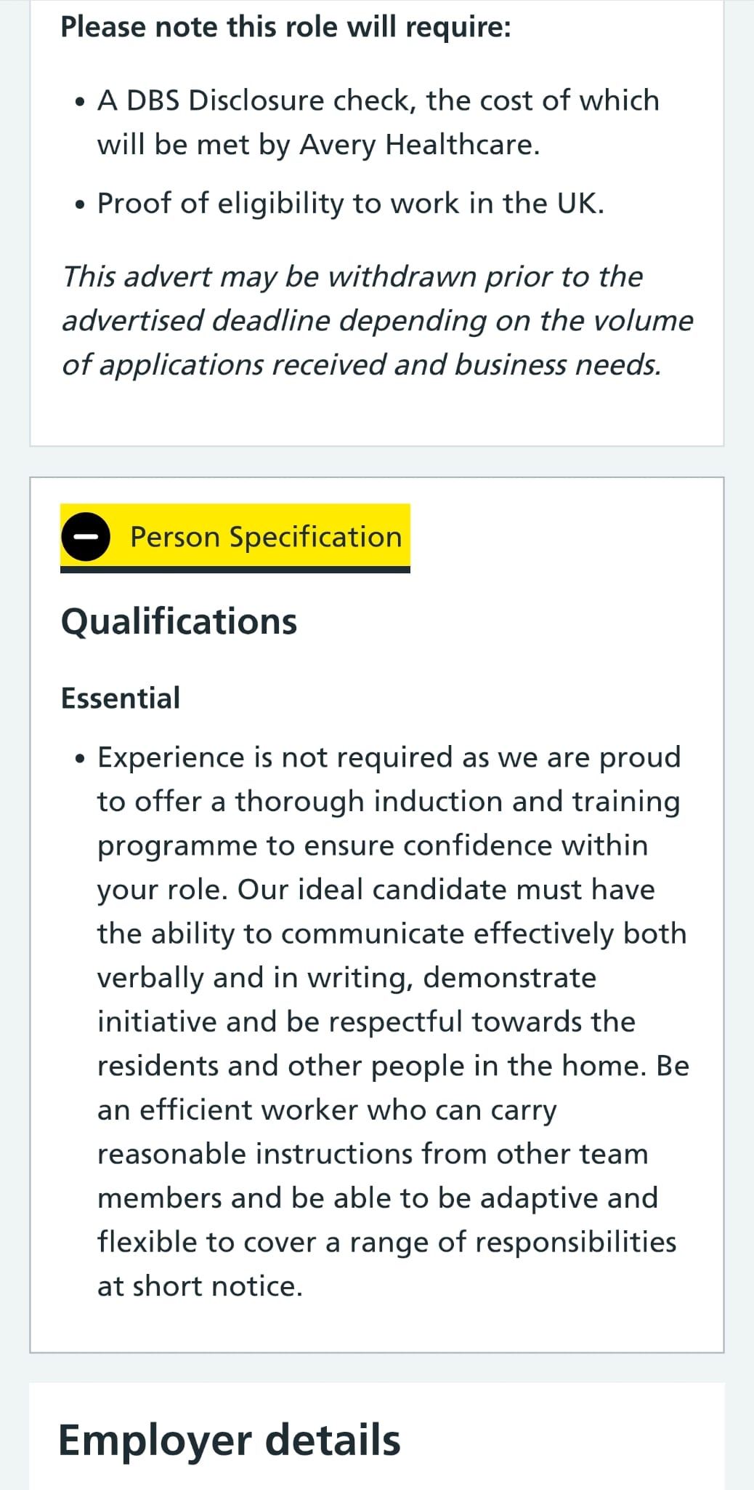
Task 1: CV

Personal Details:
Name: Andleeb Saeed
Address: Dudley, UK
Phone: 0897654778
Email: s.381@hotmail.co.uk

Personal Profile:
A dedicated and compassionate Health & Social Care Level 4 student with over five years of private care experience, supported by experience in reception and retail. Passionate about delivering person-centred care while promoting dignity, respect and independence. A reliable team player with strong communication skills and a commitment to supporting individuals with their daily needs.

Skills:
- Person-centred care – Developed through private care experience.
- Communication skills – Developed through my Receptionist role.
- Teamwork – Developed through B&M Retail and Receptionist roles.
- Compassion and empathy – Demonstrated through private care.
- Safeguarding – Gained through Health & Social Care Level 4.
- Health & Safety – Developed through retail and private care experience.

Work Experience:
Private Care Assistant | 2021–2026
- Provided person-centred care in a private setting.
- Supported daily living activities, including mobility, meal preparation and companionship.
- Encouraged independence while maintaining dignity and respect.
- Observed changes in individuals’ wellbeing and reported concerns when appropriate.
- Followed safeguarding, confidentiality, infection prevention and health & safety practices.
Receptionist – Deadly Learning Centre | 2017–2021
- Answered telephone calls and responded to enquiries professionally.
- Welcomed visitors and maintained a friendly and professional front desk.
- Responded to emails and completed administrative tasks.
- Delivered professional customer service.
Store Assistant – B&M | 2021–2023
- Assisted customers and handled cash transactions.
- Replenished stock and maintained store standards.
- Worked effectively as part of a team.

Education:
- Level 4 Diploma in Health & Social Care (Completed)

Training:

First Aid Certified

Health & Safety Certified

Interests:
- Reading about Health & Social Care
- Supporting vulnerable people
- Community volunteering

References:
Available upon request.
Task 2: Personal Statement
I am applying for the Care Assistant job because I am committed to providing compassionate care and helping people live as independently and comfortably as possible. My goal is to build a rewarding career in Health and Social Care. I want to support people who need help and make sure they are treated with kindness, respect and dignity.
I have completed my Health and Social Care Level 4 qualification in the UK. During my course, I learned about person-centred care, safeguarding, communication, equality and diversity, health and safety, and the importance of supporting people in the right way. I have also completed First Aid and Health & Safety training, which has helped me understand how to keep people safe and respond in emergency situations.
I have five years of private care experience, where I supported friends and family members with their daily needs. I helped with personal care, preparing meals, companionship, mobility and everyday activities. This experience taught me to be patient, caring and understanding. It also helped me improve my communication skills and showed me how important it is to respect people's privacy, independence and choices. I also observed changes in their wellbeing and reported any concerns appropriately.
Before this, I worked as a receptionist for four years at Deadly Learning Centre. My duties included answering phone calls, welcoming visitors, booking appointments, replying to emails and keeping records organised. This job helped me become confident in communicating with different people and improved my customer service and organisational skills.
I also worked as a Store Assistant at B&M. In this role, I helped customers, arranged stock, handled cash and worked with other team members. This job helped me improve my teamwork, organisational, time management and problem-solving skills.
I am a friendly, reliable and hardworking person. I work effectively both independently and as part of a team. I am a good listener, treat everyone with kindness, dignity and respect, and carry out my responsibilities with care and professionalism. I understand the importance of following workplace rules, keeping information confidential and providing safe and high-quality care. I am flexible, punctual and always ready to take on new responsibilities. I enjoy learning from experienced colleagues and working with people from different backgrounds. I understand the importance of treating everyone equally and with respect. I am dedicated to delivering safe, high-quality care and supporting others with compassion and professionalism.
I believe I would be an excellent Care Assistant because of my care and customer service experience. I am eager to develop new skills and continue growing through training and experience. I always have a positive attitude and enjoy helping others to live as independently as possible.
My future goal is to continue working in Health and Social Care and develop my career by gaining more experience and qualifications. I would be proud to join your team and provide safe, compassionate and person-centred care to residents. I am confident that my skills, experience and personal qualities will enable me to make a positive contribution to your organisation.

Task 3:
Part A: SWOT analysis
A SWOT analysis is a planning tool used to evaluate an individual's or organisation's strengths, weaknesses, opportunities, and threats that may influence personal and professional development (Gürel and Tat, 2017; CMI, 2023). It enables individuals to evaluate their existing abilities and identify areas for improvement and future growth.
A SWOT analysis is an essential tool that helps individuals evaluate their abilities, recognise areas for improvement, and make informed career decisions (Gürel and Tat, 2017). It helps individuals make the most of their strengths while identifying and improving areas of weakness that may influence their professional development. In health and social care, it also identifies opportunities for learning and career progression, as well as potential challenges that could influence job performance. Consequently, it enhances continuous professional development and helps deliver safe, high-quality, and person-centred care (NHS England, 2023).

Strengths | Weaknesses
- Compassionate  - Caring  - Good communication  - Teamwork  - Person-cantered care  - Time management  - First Aid  - Health & Safety  - Safeguarding awareness  - Empathy | - Limited care home experience  - Clinical knowledge  - Electronic care records  - Confidence in complex care  - Night shift experience
Opportunities | Threats
- Employer training  - Career progression  - Further qualifications  - CPD opportunities  - NHS employment | - Heavy workload  - Shift patterns  - Emotional stress  - Infection risks  - Staff shortages

Task 3_Part B: PDP plan
A Personal Development Plan (PDP) is a structured framework designed to help individuals evaluate their current abilities, identify areas for improvement, and establish realistic goals for their personal and professional development (Health Education England, 2022; Cottrell, 2019). It provides a clear approach to planning learning activities, developing new skills, and monitoring progress over time.
A Personal Development Plan (PDP) plays a key role in supporting continuous learning and motivating individuals to take responsibility for their own professional development (Cottrell, 2019). In the health and social care sector, a PDP enables professionals to strengthen their knowledge and skills, achieve their career goals, and improve the standard of care they deliver while regularly reviewing their progress and performance (Health Education England, 2022).
Goals | List the actions to complete to achieve the goal | Support/resources needed | Target date | Review date
Goal 1  - Complete Dementia Awareness training within 12 months. | - Attend Dementia Awareness training.  - Complete the training successfully.  - Apply the knowledge while supporting residents with dementia. | - Employer training programme.  - Online learning resources.  - Support from a supervisor or mentor. | July 2027 | January 2028
Goal 2  - Complete Moving and Handling of People training within 12 months. | - Attend Moving and Handling training.  - Practice safe moving and handling techniques.  - Apply the skills when assisting residents with mobility. | - Workplace training sessions.  - Practical demonstrations.  - Guidance from experienced staff. | July 2027 | January 2028
Goal 3  - Complete Medication Awareness training within the next two years. | - Enrol in a Medication Awareness training course.  - Complete all training sessions and assessments successfully.  - Apply the learning safely when supporting medication-related tasks under supervision. | - Employer training programme.  - Online learning resources.  - Guidance from senior staff or mentor | July 2028 | January 2029

Task 4:
Reflection is a process of carefully reviewing and evaluating personal experiences to understand what has been learned and identify ways to improve future practice (Gibbs, 1988). It encourages individuals to recognise their strengths, address areas for development, and enhance their knowledge and professional skills (Jasper, 2013). In health and social care, reflection is essential because it supports continuous professional development, improves decision-making, and supports the provision of safe, effective and person-centred care (Nursing and Midwifery Council (NMC), 2018).
Gibbs’ Reflective Model, developed by Graham Gibbs in 1988, provides a structured approach for reflecting on experiences and learning from them (Gibbs, 1988). The model consists of six stages: description, feelings, evaluation, analysis, conclusion, and action plan, which help individuals review experiences, identify learning, and improve future practice (Bulman and Schutz, 2013). In health and social care, Gibbs’ Reflective Model promotes critical thinking, continuous professional development, and better decision-making, supporting the delivery of safe, effective, and person-centred care (Jasper, 2013; Nursing and Midwifery Council (NMC), 2018).

Gibbs' Reflective Cycle
Description:
As part of my LCHS4009 Component 1 assessment, I delivered an individual presentation on Communication Skills in Health and Social Care. The presentation focused on the importance of effective communication and its role in promoting person-centred care, improving teamwork, and achieving positive outcomes for service users. During the presentation, I explained Berlo's Communication Model, discussed the advantages and disadvantages of communication, presented a practical example, and reflected on my own communication skills in relation to my future career as a social worker. I used relevant academic sources to support my presentation and organized the slides in a logical sequence to ensure that the information was clear, accurate, and easy for the audience to understand.
Feelings:
Before my presentation, I felt a little anxious because I wanted to perform well and present my ideas confidently. I was worried about speaking in front of the class and hoped that I would explain the topic clearly. Once I started presenting, I gradually became more relaxed and my confidence increased. I enjoyed discussing the topic and felt that I communicated most of my points effectively. After listening to my lecturer’s feedback, I felt encouraged because the overall presentation was considered good. At the same time, I understood that my practical example needed to be stronger, which made me realize the importance of using more realistic examples in future presentations.
Evaluation:
Overall, I consider my presentation to be a positive learning experience. I was able to present the topic in a logical and well-structured manner, and I explained the key concepts of communication in health and social care clearly. I used relevant academic references to support my discussion and remained focused throughout the presentation. My lecturer commented that the presentation was well prepared and that the overall content was appropriate. However, I was also advised that the practical example I included was not detailed enough and could have been more realistic. This feedback helped me recognize that stronger practical examples are essential for demonstrating a deeper understanding of the topic and improving the quality of future presentations.
Analysis:
Effective presentations combine theoretical knowledge with practical examples (Jasper, 2013). This presentation helped me recognize that having good subject knowledge alone is not enough to deliver an effective presentation. It is equally important to explain ideas through realistic examples so that the audience can understand how theory is applied in practice. Although I covered the key aspects of communication successfully, the feedback from my lecturer made me realize that my practical example was too brief and did not fully reflect a real health and social care situation. If I had used a more detailed and relevant example, it would have strengthened my presentation and demonstrated a better understanding of the topic. Reflecting on this experience has shown me the importance of combining academic knowledge with practical application to improve both my presentation skills and my professional development.
Conclusion:
Overall, this presentation has been a valuable opportunity to reflect on my performance and identify areas for future improvement. I realized that careful preparation and a clear understanding of the topic are important, but they should be supported by relevant and realistic practical examples to strengthen the overall presentation. The feedback from my lecturer has increased my awareness of the improvements I need to make and has motivated me to develop my presentation skills further. I believe that applying these lessons in future assessments will improve my confidence, communication, and ability to deliver more effective presentations in health and social care.
Action Plan:
This reflection has helped me identify the areas that I need to improve before delivering future presentations. I will focus on preparing more detailed and realistic practical examples that clearly demonstrate how theoretical knowledge can be applied in health and social care practice. I also plan to improve my presentation skills by rehearsing more frequently, managing my time effectively, and speaking with greater confidence. Furthermore, I will make better use of feedback from my lecturer and classmates to identify any weaknesses before my final presentation. By following these steps, I aim to enhance my presentation skills, increase my confidence, and continue developing as a future health and social care professional.

References:
Bulman, C. and Schutz, S. (2013) Reflective practice in nursing. 5th edn. Oxford: Wiley-Blackwell.
Chartered Management Institute (2023) SWOT analysis. Available at: https://www.managers.org.uk/management-library/swot-analysis⁠ (Accessed: 2 July 2026).
Cottrell, S. (2019) The study skills handbook. 5th edn. London: Red Globe Press.
Gibbs, G. (1988) Learning by doing: A guide to teaching and learning methods. Oxford: Oxford Polytechnic.
Gürel, E. and Tat, M. (2017) ‘SWOT analysis: A theoretical review’, The Journal of International Social Research, 10(51), pp. 994–1006.
Health Education England (2022) Personal development planning. Available at: https://www.hee.nhs.uk⁠ (Accessed: 2 July 2026).
Jasper, M. (2013) Beginning reflective practice. 2nd edn. Andover: Cengage Learning.
NHS England (2023) NHS Long Term Workforce Plan. Available at: https://www.england.nhs.uk/long-read/nhs-long-term-workforce-plan/ (Accessed: 2 July 2026).
Nursing and Midwifery Council (2018) The Code: professional standards of practice and behaviour for nurses, midwives and nursing associates. London: Nursing and Midwifery Council.

