

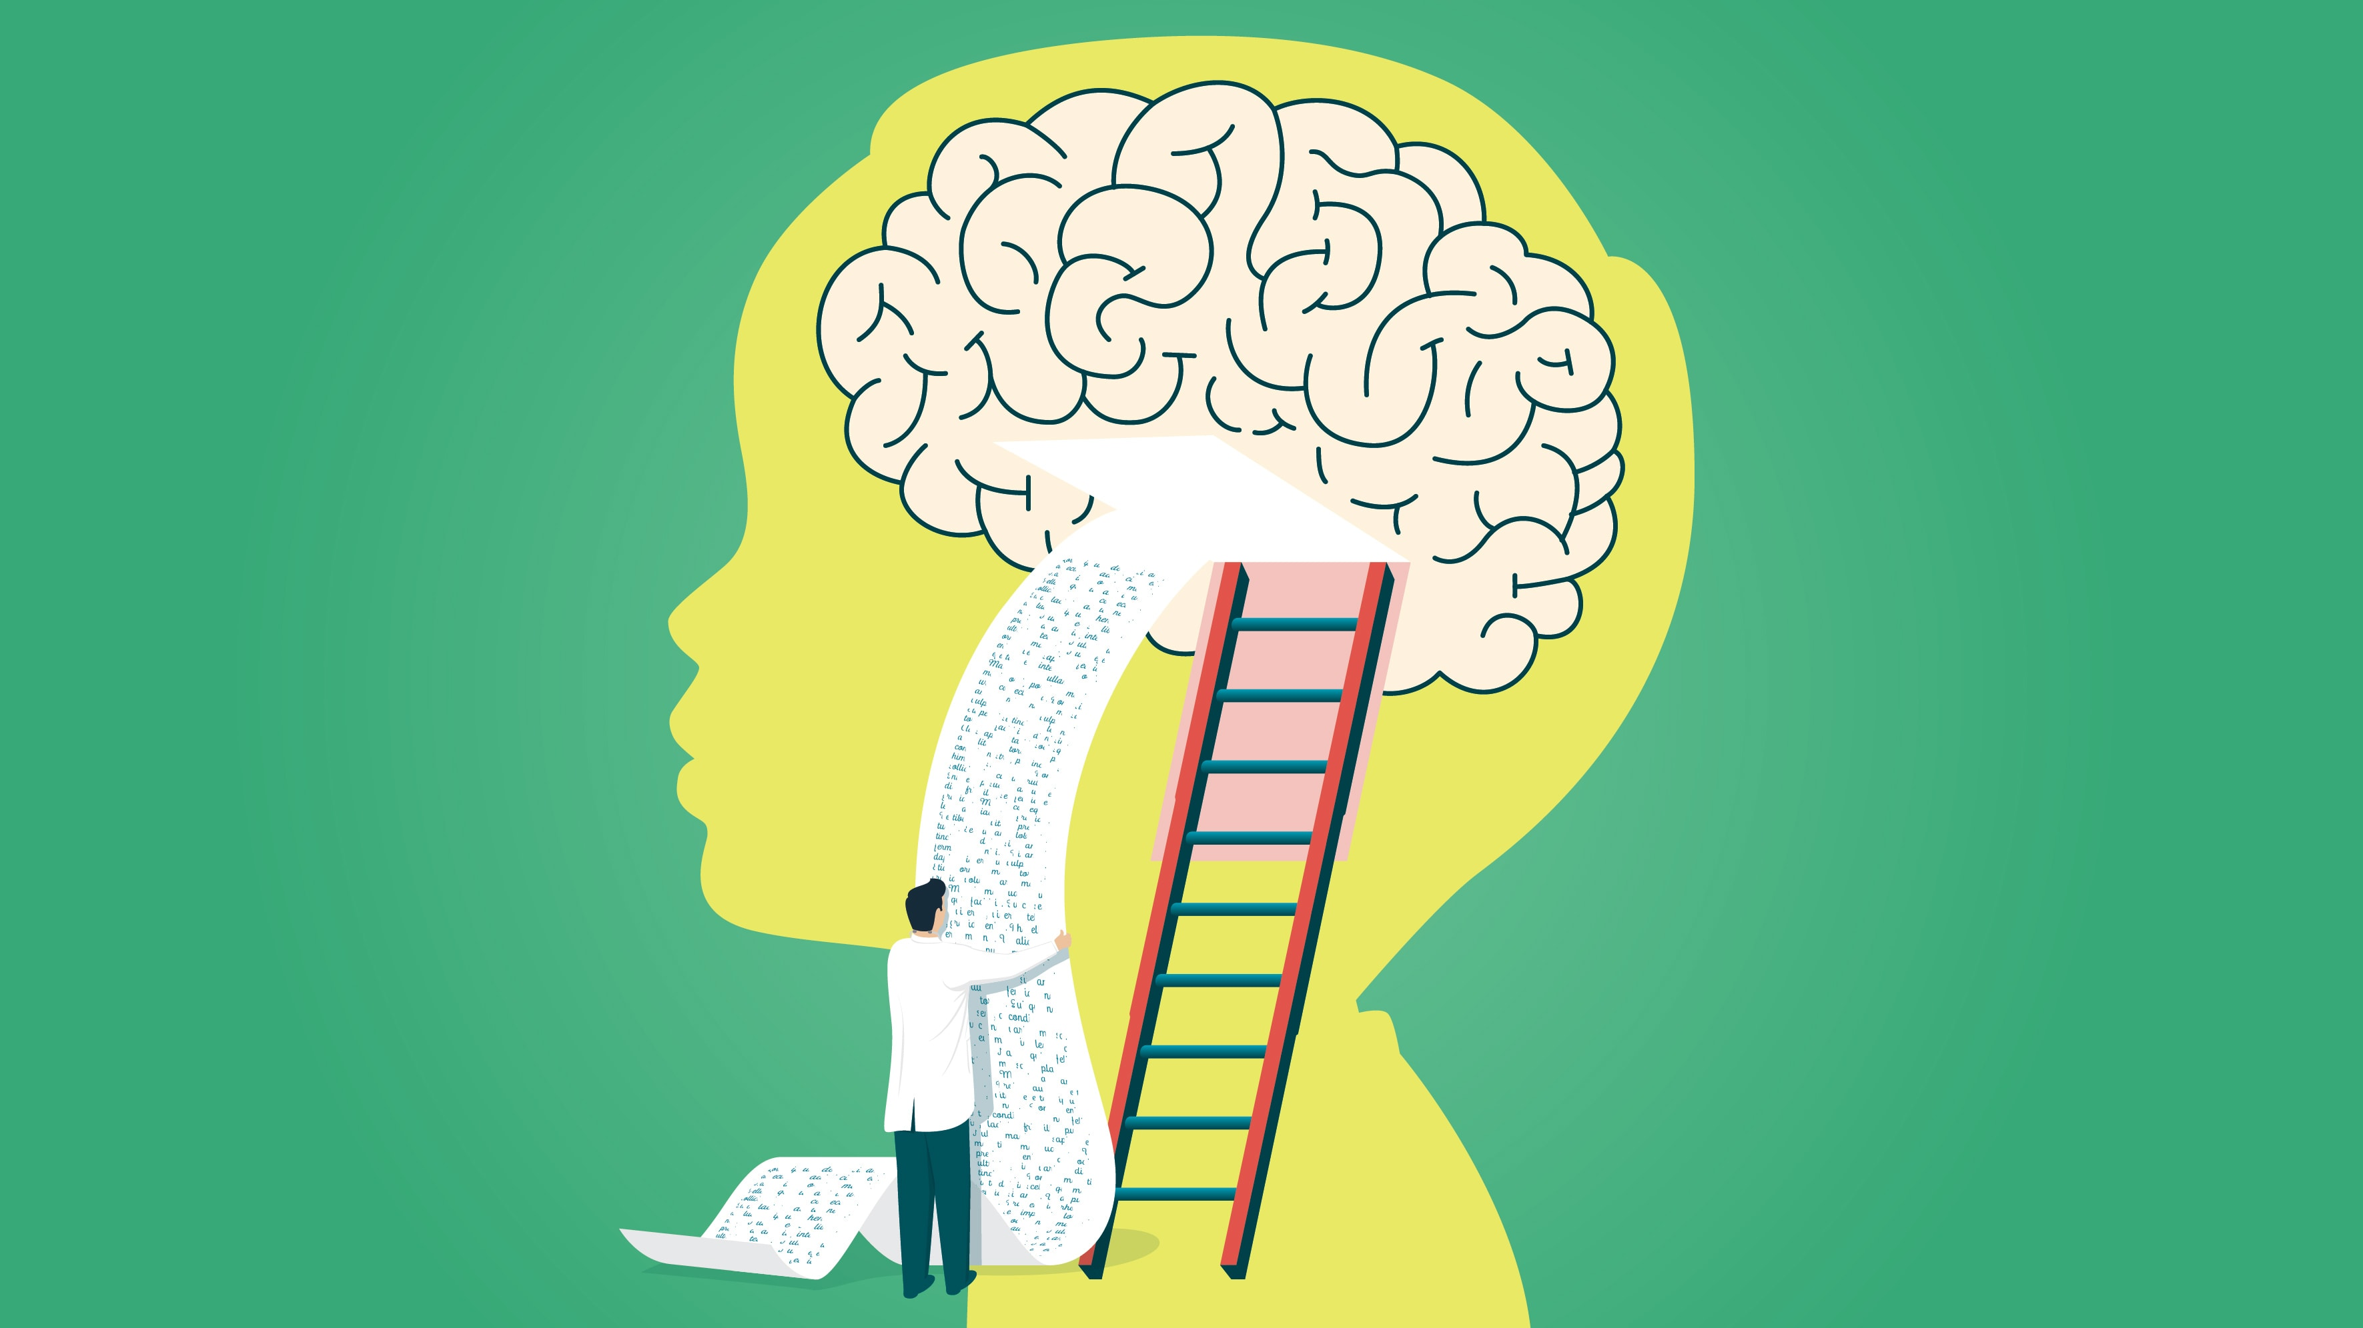



Brain Development
Blog 1 - 4
Growing a Brain

Building a Brain from Scratch
Fetus to Infancy

- 80% of the brain is development by age 3
- 90% of the brain is developed by age 5
Impressive?
Indeed it is! But this does not mean that the ability to learn and progress is limited at the age of 5 (obviously, as people continue to study for a lifetime is some cases). However, ages 0-5 are undeniably crucial ages for laying down pathways of the brain. According to Huey, (2017) the healthy relationship an infant has with their parent or caregiver is what promotes positive brain and body development for the child. So how can parents, like myself encourage this positive development? Let’s talk...
During pregnancy and early infancy the brain grows at an astonishing rate. According to Fett, (2019) a Biochemistry and Molecular Biology Graduate, on average the Brain grows by more than 250,000 nerve cells per minute during pregnancy, forming nearly 100 billion by the time the baby is born. For the first three months of the baby’s life, the process of brain development continues and grows by 1% per day and over the next 6 months the brains objective changes from building new cells to connecting them together in order to create a complex network of pathways. These pathways help the development of our ‘three brains’, yes, three!

Our Three Brains
According to Douglas, (2013) humans actually have three brains and each have its own unique and specific job. These three brains are connected to each other by an extensive network of connected pathways. Pathways are constantly being created, remade and pruned. These three parts control processes in the body, including movement, memory, and thinking (Kwik, 2018).
The Primitive Brain or Reptilian Brain

We share our Primitive Brain with creatures like reptiles as it is believed that areas of their brain have shared anatomical similarities to those of humans. The Primitive Brain has the important job of keeping us alive, breathing, heart beat as well as our other innate instincts such as, sensing danger that trigger a release of the hormone cortisol to help the body prepare for the fight or flight response (Douglas, 2013).

The Emotional Brain or Mammal Brain

This part of the brain leads us towards developing connections and relationships (Bryson, 2011). The Emotional Brain triggers feelings and emotions such as, sadness, anger and fear. These emotions are experienced by infants from birth; according to Ledoux, (2015) emotions are the threads that make the mental life together; they are what define us as individuals and how we are perceived by others.

The Thinking Brain

This part of the brain is the largest of the three and takes the longest time to mature (Douglas, 2013). We could argue that some never do LOL! This part of the brain provokes us to think things through, make decisions and control our actions and behaviour. This part of the brain has a close relationship with our emotional brain and helps control feelings like sadness and anger in our emotional brain.
For a baby, they have not yet developed a mature Thinking Brain; this is why it is firmly believed by child behaviour specialists that there is no such thing as a naughty baby. Babies have not developed the ability to manipulate or ‘wind up’, therefore their behaviour can be difficult for them to control and when they cry or ‘act out’ it is simply them trying to communicate that they are unhappy with something (Douglas, 2013).
How to Wire up our Babies Connections.

If your a mum/parent like myself then there is no doubt you want to help your baby’s brain to develop in the best way possible. So, how can we ensure that we doing our best to wire up our babies connections? Here are some things we should be doing again and again:
- Connecting Love - Smiles, cuddles, baby massage, kind and positive verbal interaction.
- Connecting Stress response - comforting when distressed, understanding your babies feelings, wants and needs.
- Connecting Speech - Reading, singing nursery rhymes, playing peekaboo, imaginative play, baby talk.
What Prevents Normal Brain Development?

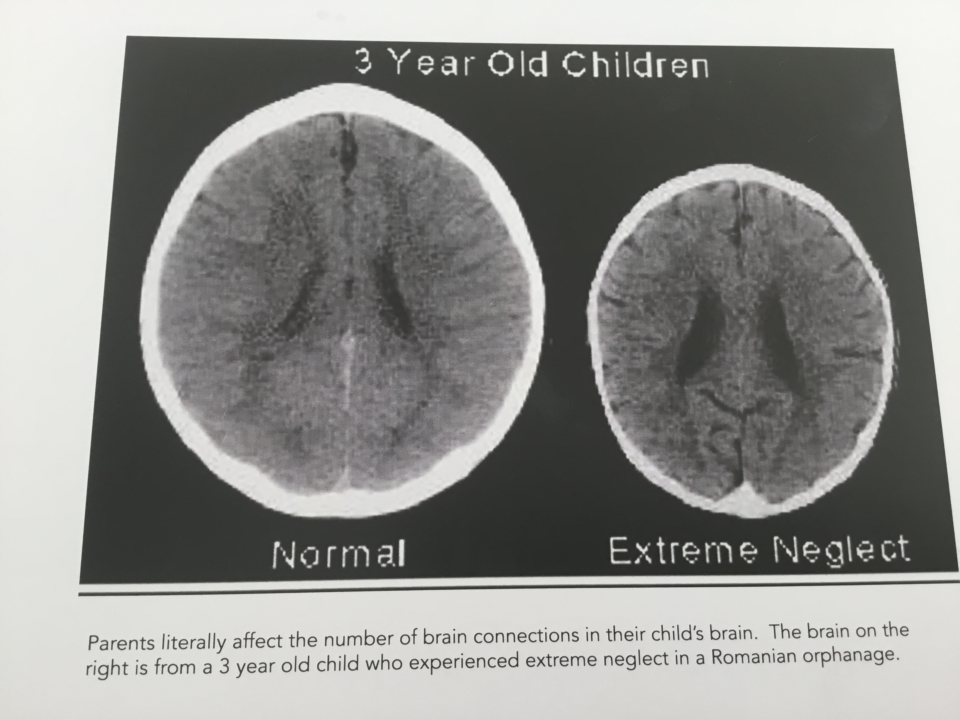
Children are born ready to learn; they heavily rely on parents and caregivers as their first teachers to develop the skills they need to have successful futures. Nurturing care for infants is crucial for the brain to grow. Children learn best from being in a safe environment where you he can explore and play freely (Early Brain Development and Health | CDC, 2020).
Children being exposed to stress and trauma can cause negative long-term affects for the child’s brain. Adequate parent and caregiver responsiveness is absolutely essential for stimulating brain growth; Reading, singing, baby talk and playing helps provide this stimulation.
Experiencing trauma and neglect can have major implications on how a baby’s brain develops. In order for babies to develop a healthy stress response it is important for the parent or caregiver to comfort them again and again. Babies learn that someone will come and help them and will then develop the ability to settle themselves and better control their behaviour and impulses (Douglas, 2013). My son often wakes up once or twice during the night, hunting for his misplaced pacifier. However, this need not be a concern as within a few minutes of upset and locating is beloved dummy he is able to calm himself down and return to a successful night’s sleep. This is the result of being a responsive parent from day one and assuring him that help and comfort is always nearby.
In Conclusion, the above literature tells us the importance of responsive parenting and caregiving is for healthy brain development. It is what helps the little brains of this world develop to become useful, happy citizens in our society. Fellow parents and caregivers have the simple and delightful job of smiling, playing, talking and cooing to our babies and in turn this will help connect the pathways of the three brains in our little ones and help develop a healthy brain that will allow them to reach their full potential in future. Unfortunately there are and always will be less fortunate children in the world that will face barriers in life that will prevent them from developing a healthy brain. In the year ending 2019, approximately 481,000 children were reported to have been victims of child abuse or neglect In the UK (Child neglect in England and Wales - Office for National Statistics, 2020). Children who suffer neglect or have poor responsiveness will have jeopardised brain growth that may limit their potential later in life (Douglas, 2013).
Bibliography:
Centers for Disease Control and Prevention. 2020. Early Brain Development And Health | CDC. [online] Available at: <https://www.cdc.gov/ncbddd/childdevelopment/early-brain-development.html> [Accessed 6 May 2020].

Christakis, E., 2018. The Dangers Of Distracted Parenting. [online] The Atlantic. Available at: <https://www.theatlantic.com/magazine/archive/2018/07/the-dangers-of-distracted-parenting/561752/> [Accessed 10 April 2020].

Douglas, C., 2013. Bonding And Brain Development. Basingstoke: Insight Parenting Ltd, pp.5, 8.

Fett, R., 2019. Brain Health From Birth. 1st ed. New York: Franklin Fox Publishing, LLC, New York.

Gallegos, J., 2017. Decoding The Mysteries Of A Child’S Developing Brain. [online] The Independent. Available at: <https://www.independent.co.uk/life-

Huey, M., 2017. Brain Development In Infants And Toddlers. [online] Thinksmallblog.org. Available at: <http://www.thinksmallblog.org/?p=772> [Accessed 11 April 2020].

Ons.gov.uk. 2020. Child Neglect In England And Wales - Office For National Statistics. [online] Available at: <https://www.ons.gov.uk/peoplepopulationandcommunity/crimeandjustice/articles/childneglectinenglandandwales/yearendingmarch2019> [Accessed 11 April 2020].

Sharma, A. and Cockerill, H., 2014. Mary Sheridan's From Birth To Five Years. 4th ed. London: Routledge, p.219.

Woollaston, V., 2014. Parents Distracted By Phones Could Be Harming The Bond With Children. [online] Mail Online. Available at: <https://www.dailymail.co.uk/sciencetech/article-2577634/Step-away-mobile-Parents-distracted-role-phones-harm-bond-child.html> [Accessed 11 April 2020].


Bonding and Attachment


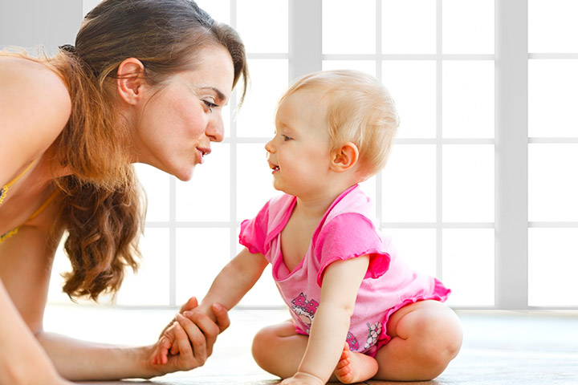
Social and Emotional Development

First things first...
We need to,
- Understand what Social and Emotional Development is
- How Bonding and Secure Attachment can be encouraged.
- Why it’s important.

Social and Emotional Development
Social interaction is established within a few days of birth between the infant and caregiver, through eye contact, imitative facial gestures and modulation of their sleep-wake fullness state (Sharma and Cockerill, 2014). The importance of bonding is that babies need to develop a close relationship or attachment with specific people that they are more often around than not. They need to be people the baby can rely on for love and nurture (Douglas, 2013). Children with strong bonds and attachment tend to have better self-esteem and fewer behavioural issues. Secure bonding and attachment is crucial for healthy brain development, not having a responsive caregiver that attends to a child’s trauma or distress effects the growth of the brain and implicates the child’s stress response.

How can Caregivers Encourage Social and Emotional Development?
- Set a consistent routine
- Give lots of smiles and cuddles
- Play peekaboo
- Skin to skin contact (first few months of life)
- Attend to your child’s distress promptly, giving cuddles and reassurance
Causes that may hinder Social and Emotional development.

Yes. Modern Technology! What I believe is the mass destruction of all social interaction. The current, extensive accessibility to the modern world’s offering at one’s fingertips. Can this modern day addiction cause a lapse in a young person’s cognitive/social development? “Toddlers cannot learn when we break the flow of conversations by picking up our cellphones or looking at the text that whizzes by our screens,” Hirsh-Pasek said (Christakis, 2018).
According to Christakis, (2018) child development is relational, this was demonstrated in one experiment where nine-month-old babies who received a few hours of instructions from a live human could isolate specific phonetic elements in the language while another group of babies who received the exact same instruction via video could not. According to Hirsh-Pasek, a professor, more and more studies are confirming the value of conversation. Hirsh-Pasek stated, “Language is the single best predictor of school achievement and the key to strong language skills are those back-and-forth fluent conversations between young children and adults.”
A study taken by researchers from Boston Medical Centre examined a total of 55 parent/caregivers and their children (all under the age of ten) eating at a fast food restaurant. The study found that 1 in 3 parents or caregivers used their phones almost continuously during the time they were eating with their children. Earlier research has shown that the lack of eye contact and interaction can reduce the bond with that child (Woollaston, 2014). Positive interaction is incredibly important to help the growth of the brain, especially in the earliest years; every time a parent or caregiver smiles and looks animated a happy hormone called oxytocin is released in the infants brain to make it grow (Douglas, 2013).
In Conclusion, as mentioned in the above literature child development relies heavily on the relationships the child has with parents and caregivers. The responsiveness of the caregiver is a detrimental factor in how well a young person’s brain develops, especially in the social - cognitive sense. Research has shown that from the ages of 0-5 the bond or lack of that is created by social interaction with parents and caregivers is what determines a young person’s brain development and future relationships.
Bibliography
Christakis, E., 2018. The Dangers Of Distracted Parenting. [online] The Atlantic. Available at: <https://www.theatlantic.com/magazine/archive/2018/07/the-dangers-of-distracted-parenting/561752/> [Accessed 10 April 2020].
Douglas, C., 2013. Bonding And Brain Development. Basingstoke: Insight Parenting Ltd, pp.5, 8.
Fett, R., 2019. Brain Health From Birth. 1st ed. New York: Franklin Fox Publishing, LLC, New York.
Gallegos, J., 2017. Decoding The Mysteries Of A Child’S Developing Brain. [online] The Independent. Available at: <https://www.independent.co.uk/life-style/health-and-families/why-understanding-how-a-childs-brain-works-at-different-ages-is-so-important-a7926111.html> [Accessed 11 April 2020].
Huey, M., 2017. Brain Development In Infants And Toddlers. [online] Thinksmallblog.org. Available at: <http://www.thinksmallblog.org/?p=772> [Accessed 11 April 2020].
Sharma, A. and Cockerill, H., 2014. Mary Sheridan's From Birth To Five Years. 4th ed. London: Routledge, p.219.
Woollaston, V., 2014. Parents Distracted By Phones Could Be Harming The Bond With Children. [online] Mail Online. Available at: <https://www.dailymail.co.uk/sciencetech/article-2577634/Step-away-mobile-Parents-distracted-role-phones-harm-bond-child.html> [Accessed 11 April 2020].


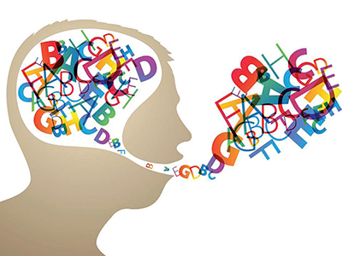


Speech and Language Development

What is Speech and Language Development?

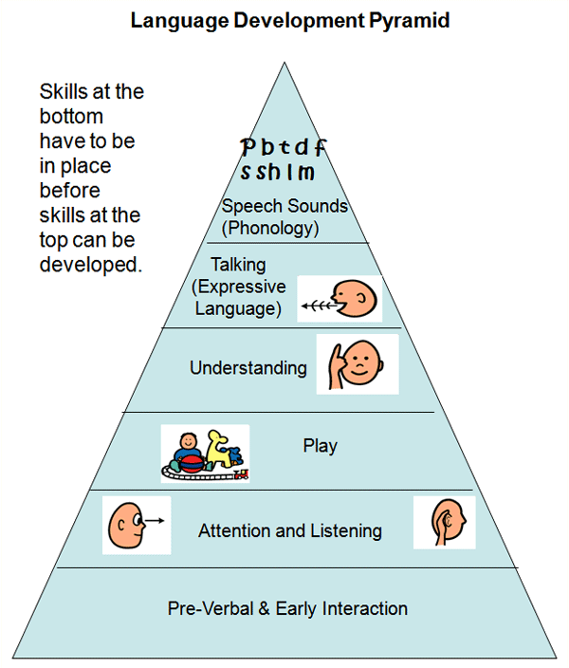
Speech and Language is what we use to enable us to communicate with others. We develop our speech and language skills from the our earliest years of life; by age six we tend to have our basics and are able to communicate our thoughts and feelings competently. Parents and caregivers like myself are encouraged from day one to talk and read with our infants, this starts laying down the connective pathways for our children to develop good communication skills (Healthwise Staff, 2018).

Baby Talk
Babies are born sociable and are wanting to relate to others, from following the comforting, familiar voices to smiling and making eye contact (Douglas, 2013).
Image - (0, 2013)
I remember my first visit from my health visitor and one of her most profound pieces of advice was, “talk, talk, talk to your baby as much as you can from the word go!”. According to Douglas, (2013) connecting with our babies by playing peekaboo, Reading and singing nursery rhymes; these all help the bonding and secure attachment our babies crave and encourage speech and language development. If we don’t talk to our babies this can delay their speech and language development and implicate their abilities when they start school.
Now, it’s not unusual for some new parents to feel clueless or silly in how to approach communicating with their baby, I certainly did. Fortunately, having a health visitor in the immediate family, concerns were answered promptly. So the professional advice is the following:
- Get your baby’s attention
- Make eye contact
- Speak with a positive, happy and smiley tone
- Have patience - give your baby a chance to respond
- Respond back by talking, cooing, smiling and laughing
- Play conversation, tell your baby what you thought he was trying to say
- Observe your baby’s attention. If they begin to turn their head or they find interest in something else they may need a little break.

When can we expect our little one’s Speech and Language to Begin?
This is such an exciting time for parents to learn all about their little one’s personality and character. According to Healthwise, (2018) infants begin learning in the womb as they start to recognise familiar voices and respond. The fast paced learning tends to occur between ages 2 - 5 years. Healthwise, (2018) suggests that Speech and Language milestones indicate whether they are developing as expected. Now, it is important to not immediately panic if they don’t say ‘mamma’ at 6 Months. There is a wide range of ‘normal’ and every child is different, however, there inevitably will come a time when a parent or caregiver will reach the point of concern if there are delays in expected milestones.

Why Some Children Have Issues with Speech and Language Development
Sometimes there’s is not always a clear cause for children having delayed Speech and Language development but sometimes there is, such as problems with hearing or a developmental disorder like autism (Healthwise, 2018). More often than not speech and language delay can be improved with treatment. However, if a child lacks a supportive and responsive caregiver this can have major implications on treating the problem. As discussed in my previous blogs, regarding Brain Development, Bonding and Emotional Attachment a parent/caregiver’s nurturing response is absolutely crucial for the development of our three brains. If the ‘Emotional Brain’ is hindered this will subsequently impact the development of the ‘Thinking Brain’, the part responsible for Speech and Language.
To Conclude, Speech and Language Development is a huge milestone in an Child’s life. Parents and caregivers have an incredibly important responsibility to ensure that their child has the deserved opportunity to reach their speech and language milestones. The nurture and play that the caregivers provide create a pathway for the ‘Thinking Brain’ to develop and allow children to learn good communication skills. Unfortunately, not all children are lucky to have the recourses they need to develop good speech and language development. Children that have hearing impairments or developmental disorders may suffer a delay in achieving the milestone. As well as biological factors, some children are victim to neglect and abuse. As the above literature suggests, children that have a lack of bond and secure attachment will likely have delays in their brain development which in result will impede on their speech and language development as well as other developmental milestones.

Bibliography:
Douglas, C., 2013. Bonding And Brain Development. Basingstoke: Insight Parenting Ltd, pp.18, 20
Healthwise Staff, 2018. Speech And Language Development. [online] HealthLink BC. Available at: <https://www.healthlinkbc.ca/health-topics/hw265266> [Accessed 12 May 2020].

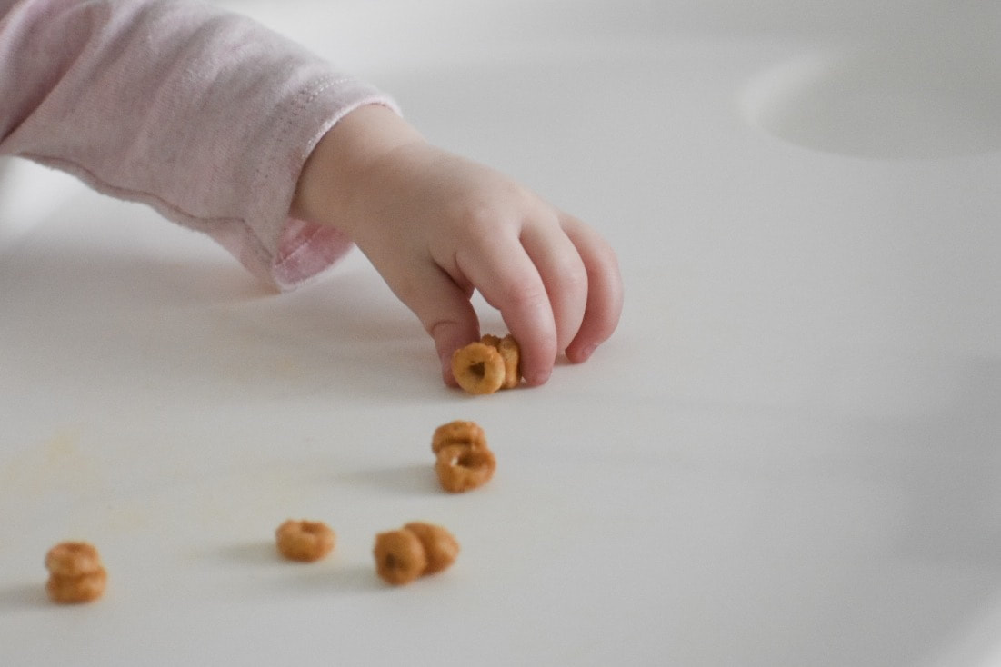


Physiological Development

physiological Development
From the Beginning

First things first, what is Physiological Development? Physiological refers to the biological functions of a living organism and individual aspects of the body. Physical development is the way in which our bodies develop skills, build and improve those skills. Building these skills from birth into later life allows our bodies to achieve more complex movement and performance (Meggitt, n.d.).
There are two main areas is Physiological Development, they are:

Gross Motor Skills -
These include the large muscles of the body like arms and legs. Gross motor skills allow us to perform activities such as running, jumping and squatting.

Fine Motor Skills -
These include using the smaller muscles and single limb movements which is known as Gross Manipulative Skills; using one arm to throw or perform sweeping movements. There is also Fine Manipulative Skills which involve more precise use of smaller body parts like fingers and exercising the pincer grip, drawing and pointing etc.

Physical Milestones from 1 Month

- Emerging, demonstrates a social smile.
- Preference for social stimuli, following familiar voices, faces and maintaining eye contact.
- Clear presence of primitive reflexes.
- Posture and Large movements like jerking larger muscles like arms and legs.

Let’s jump forward
(using our Gross Motor Skills)

Now that our precious little ones have developed the above stepping stones, we can explore where they go from there. Children grow and develop at an astonishing rate. We could discuss every milestone that occurs from 1 month to 3 years but that may take a while; so much occurs during these precious months/years but some of the most defining moments of development happen between the toddler years, (my personal opinion from experience with my own toddler). Around this time during infancy it is likely that they have developed speech and language skills, are walking and even climbing.
Relating back to my previous blogs about brain, social and emotional development; responsiveness and positive interaction most certainly play an important part in your child’s ability to develop gross motor skills such as walking and climbing. Secure attachment and bonding improves a young person’s confidence and self esteem which Spurs them on to take big leaps to develop these skills (Douglas, 2013). Physical development experiences and activities are crucial in the early years and are cited as one of the three prime areas of learning and development in the Early Years Statutory Framework (CREC, 2013).
The Toddler Years

This is such an exciting time for parents to watch their little ones turn into little people with progressing skill and character. From Anticipating the first little sentence to their first step. The toddler years include a vast variety of new observations and exciting milestones. According to the Children Centre for Growth and Development, (2019) there are some specific milestones we expect to see over the toddler years and are listed below:

Gross Motor Development
By 18 Months:
- Climbing up and standing on a chair
- Walking unassisted
- Walking up and down the stairs whilst holding hand or rail
- Kicking ball

By 24 Months:
- Walking with a better sense of direction and conviction
- Kicking a ball with secure balance
- Jumping and standing on tiptoes
- Walking up or down stairs using railing (supervision advised)
By 36 Months:
- Able to peddle a small bike or tricycle
- Jump, walk backwards and side to side steps
- Run with stability and hardly falling
- Play and climb on play playground apparatus with ease

Fine Motor Development
By 18 Months:
- Point to pictures
- Hold a crayon with fist and scribble back and fourth
- Pick up objects with precision e.g pincer grip
- Using both hands to put in or take out objects
- Using both hands to stack blocks or other items
By 24 Months:
- Turn pages of a book
- Able to hold crayon between finger and thumb
- Start using one hand more than the other whilst doing activities
- Stacking large blocks and putting Lego together
- Start self dressing with supervision
By 36 Months:
- Able to hold a small scissors and cut along a straight line
- Paint/colour with more specific movement of the wrist
- Play, roll and squeeze play dough
- Able to dress with supervision
Impressed? It’s truly amazing what these little people are capable of at such a young age. Of course parents and caregivers have an important part to play in helping these beautiful, developing creatures; using positive reinforcement like clapping and smiling, praising by saying how clever they are and of course the nurturing part which improves their confidence, self esteem and above all the growth and development of a health brain.
Bibliography:
Centers for Disease Control and Prevention. 2020. Early Brain Development And Health | CDC. [online] Available at: <https://www.cdc.gov/ncbddd/childdevelopment/early-brain-development.html> [Accessed 6 May 2020].

Crec.co.uk. 2013. The Importance Of Physical Development. [online] Available at: <http://www.crec.co.uk/announcements/the-importance-of-physical-development> [Accessed 11 April 2020].

Meggitt, C., n.d. Understand Child Development.

