Denislav Kostov
[ID: 2022464]
Abstract
This paper describes the communication models that have been used and their application to a variety of sectors where communication is a primary activity. Additionally, it compares the model's structure to that of its descendants and discusses some of the implications for the many fields of application to which it has been used.
communication skills
Lloyd Beharry [BMSW4002]

Table of Contents
Introduction 2
Models of Communication 2
1. Shannon and Weaver Model Of Communication 2
2. Schramm's Model Of Communication 4
3. Berlo's SMCR Model of Communication 5
Communication Skills 7
1. Verbal Communication 8
2. Non-verbal Communication 8
3. Listening 8
References 10

Introduction

Communication is the process through which meaning is generated, interpreted, and negotiated. Verbal, nonverbal, or written communication all constitute forms of communication. It might take the form of an auditory, visual, or tactile experience. While communication takes many forms, it is always a taught behaviour. While the majority of human beings are born with physical skills such as speaking, hearing and seeing, they must learn to communicate via codes, symbols, and linguistic systems. In this sense, communication is a communal activity in which individuals produce and interpret meaning via the use of symbols.

Models of Communication

Researchers have produced several models that may be used as explanations to describe the social process of communication. The three most well-known models of communication are the Linear, the Interactional, and the Transactional models of interaction. According to West and Turner (2007), each model offers insight into the evolution of communication, but each model stresses a different aspect of the communication process than the others. For example, modelling complicated relationships allows for the creation of images or visual representations. The reason they are beneficial is that they simplify the fundamental structure of communication and can aid us in comprehending that structure not just verbally but also visually. Most significantly, they distinguish between the many aspects of communication and provide a road map for illustrating how different portions of the communication process are interconnected.

Shannon and Weaver Model Of Communication

Based on the linearity of communication, Shannon & Weaver created this model in 1948. (See Figure 1) This model depicts how a speaker sends a message to a receiver. The sender is the message's source. Sound, words, or actions may all be messages. The message is sent via a channel, or communication line, to a target or recipient. Communication may be hampered by noise or obstructions. Noise is any disturbance in the channel or message distortion. A message is simply transferred from sender to recipient in this model.
As described by Shannon (1948), the engineering issue of replicating a message from point A to point B is a difficult one. Even though it is pretty straightforward to comprehend what is meant by "reproduction of selected material," the term "message" requires more explanation.
According to Shannon's theory of informational transmission, the concept of "impact" or "influence" extends to elements that are unrelated to the engineering challenge as well as factors that are important. Messages are defined as significant informative material that is transmitted from one sender to another over the Internet. During the process of transferring information from A to B, the informative content goes through a number of transformations (both explicit and implicit), however, it must be assumed that it is the information that has to be moved. Shannon's model, shown in Figure 1 below, serves as an illustration of this.

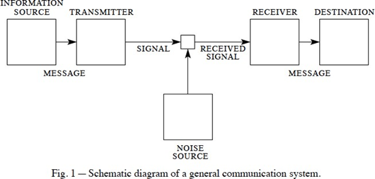

Since Shannon's time, his choice of a logarithmic base for measuring information has remained the standard for measuring information. Message distortion may be classified into two categories, according to Shannon: those that create the same distorted output of the message and those that generate various distortions. It is not always feasible to reconstruct a message or signal with confidence when the channel is noisy, as is the case with transmitting messages through telephonic systems, because "the process consists simply of altering sound pressure." Shannon provides strategies for dealing with background noise when sending signals. The number of symbol transmissions equals the quantity of informative transmission, resulting in 1symbol=1bit of data transfer (of information).

An excellent example of this is the Case study of 'Pedro and Maria'.
The fact that Pedro is a builder and that his workplace is extremely noisy causes him to misinterpret Maria's request that he stop and grab a chicken on his way home. Instead, he knows that they will meet in the kitchen simply because the two phrases sound identical when said together in the same voice.

Personal Example:
I had to prepare and send an invoice to our customer once I arrived at work, but the system didn't specify how much I needed to write. So I phoned my employer to find out how much I should put on the invoice.
We utilised internal VOIP phones at the firm to interact with one another. However, during my call with my employer, the connection was frequently interrupted, his voice was speeding up or slowing down, and it was not very clear what amount he told me to write, but I was sure that he told me the amount of £ 69.39.
So I created the invoice and submitted it to the client. Then email a copy of the payment imposed by the customer to my employer.
I later found that the invoice I had to enter was £ 669.39, not £ 69.39. Тhis is an excellent example of how poor communication can result in a perplexing misunderstanding with repercussions.

Schramm's Model Of Communication
Schramm (1954) developed the use of feedback to direct the informative transaction to its intended destination. The technical noise component has been reduced, and the channel has become unimportant as a result of this. Schramm's model of communication theory is the most widely used representation of communication theory in the world today.

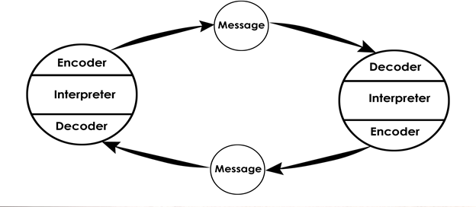
Figure 2. The feedback-function.

Schramm's approach has been criticised for portraying communication as an equal-opportunity process and failing to consider the social fact of power, among other things. There is a problem in this situation since the message itself travels (in an undefined manner) from sender to recipient and implants itself into the interpreter's interpretive system. Assuming that the transmission is assumed to be a simple conveyance of information, and that the interpretational actions are predictable, it may be easier to arrange a lecture or correctly transmit a message.
However, it suggests that the only form of behavioural output that may occur during a communication activity is a response to the communication. The act of imposing the agency role (the process of interpretation, encoding and decoding) on a receiver of an informational transfer is what we mean by placing constraints on the agency role on a recipient of an informational transfer.
The case study of Maria and Pedro serves as an excellent illustration of this. - Pedro must provide Maria with feedback by phone call or text message and inquire what she meant to avoid misunderstandings in communication.

Berlo's SMCR Model of Communication
In 1960, David Berlo developed the SMCR model of communication. It is based on the Shannon-Weaver communication model, which has a source-message-channel-receiver structure. In terms of communication models, there are three categories to choose from: linear, interactive, and transactional communication models. The SMR model is also a linear model.

Case Study:
THE PROFESSOR and THE VILLAGE PEOPLE
Lloyd b. 7/19
In his everyday interactions with others, the professor is accustomed to using complicated phrases due to his high level of education and employment at a university. In the event that his house was destroyed by fire late at night, the only location he could turn to for assistance was the adjacent hamlet where he lived and the people who resided within. Upon arriving at the town to seek assistance, he used too complicated language to explain what was going on, but these phrases were not understood by the less educated residents of the hamlet, and the home was destroyed as a result. This information was necessary to avoid misunderstandings during the conversation between the lecturer and the village peopple.

Personal Example:
When I started a private business in the field of Artificial Intelligence and Machine Learning Engineering and was required to deal with clients directly, I frequently encountered difficulties as a result of my excessive use of sophisticated terms, phrases, and concepts.
Frequently, the customer did not comprehend what I was saying and was perplexed. He agreed with the majority of the things I discussed with him and offered as services for his project, and it frequently turned out that he didn't need these things and that they only raised the product's worth.

According to Berlo's SMCR model of communication, the four fundamental aspects are as follows:
- Source
- Message
- Channel
- Receiver

- Source
The source is the sender of the message, who begins communication by transmitting data to the recipient.
David Berlo defines the source as Communication Skills, Attitude, Knowledge, Social Systems, and Culture.

- Message
The message is the principal content sent from the sender to the Receiver.
Content, Elements, Treatment, Structure, and Code are Berlo's five message-related factors.

- Channel

The channel is the medium that transmits the message from source to recipient. Berlo emphasised the five senses as the channel's communication factor: hearing, seeing, touching, smelling, and tasting.
Communication channels include telephone, TV, radio, newspapers, etc. These five elements are part of human communication.

- Receiver

Finally, the R-Receiver is the one who receives the communication's message or information.
Berlo imbued the Receiver with the same factors as the sources, such as communication abilities, attitudes, knowledge, social systems, and culture.

Communication Skills

The goal of communication is to establish contact with people and to be understood. It entails individuals sending and receiving'messages.' We are all constantly communicating, or'sending messages.' The communication cycle is depicted in Figure below. It demonstrates that a communication cycle happens when the following occurs:

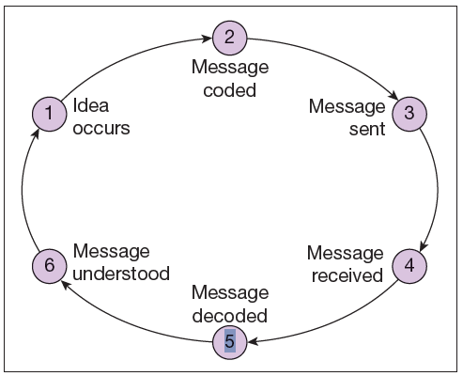

- A person has an idea.
- They code their ‘message’ (using words or non-verbal means).
- They send their message to someone else (e.g. by speaking).
- A second person then receives the message (e.g. by hearing what has been said or by noticing non-verbal communication).
- The second person decodes the message.
- The message is understood.

Once the initial communication is comprehended, the cycle is repeated if the second person answers or reacts.
Repetition of the communication cycle is a necessary component of our interactions and occurs every time we speak.

Verbal Communication

When one person speaks and another listens, this is called verbal communication.
The communication cycle illustrates that effective verbal communication requires a two-way exchange of information — both speaking and listening must take place. Listening is far more difficult than speaking, and it entails more than simply waiting for the other person to finish talking.

Non-verbal Communication

Along with words, individuals communicate in a number of non-verbal ways. Body language is a term that refers to several of them. This is because they need the individual to communicate in some way through their body and look. For instance, a care worker's behaviour, look, and attitude convey'messages' about their thoughts and feelings to those receiving care (as well as to coworkers). Similarly, a person's body language may communicate to a caregiver that they are unhappy or in pain, even though they state, 'I'm OK.' Non-verbal communication is a 'always-on' mode of communication.

Listening

Listening is the capacity to comprehend and understand the person who is speaking with you, whether in person or over the telephone. Perhaps the most crucial aspect of communication is this sort of interaction. All effective communication is dependent on the capacity to listen attentively; without this skill, messages are readily misinterpreted. Being able to hear and listening are two very different things. Keeping your mouth shut and listening intently to the words of the person who is speaking to you is insufficient. A good listener is one who is attentive to what is being said to him or her as well as to the nonverbal communication of the person speaking.
The process of listening may be broken down into five phases.
Receiving Understanding Remembering Evaluating Feedback
As with any kind of communication, there can be background noise, and this is no exception (Barriers to listening).
A variety of things can have an impact on an individual's capacity to successfully communicate. Due to the fact that they hinder or interfere with the capacity of a person to send, receive, or interpret a'message', these variables are referred to as barriers to communication in certain circles.
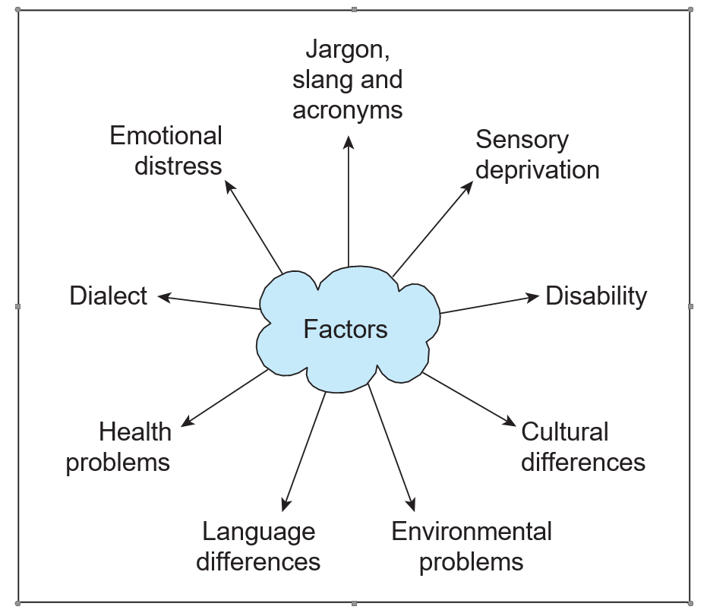

References

Belbin, Dr Meredith. “Belbin's Team Roles: How Understanding Team Roles Can Improve Team Performance.” Belbin's Team Roles - Leadership Training From MindTools.com
MindTools. “Understanding Communication Skills: Applying the Seven Stages Of the Communications Process.” Understanding Communication Skills - From MindTools.com
West, R., & L.H. Turner. (2007). Introducing communication theories: Analysis and application (3rd ed.) New York: McGraw-Hill.

