Managing Projects in the Workplace
Project management plan for opening Bumblebee nursery in Coventry

Student Name: David Marian Beltic Student ID: 2020289
Student Name: Vladislav Erhan Student ID: 2111920
Student Name: Madalin Iliuta Student ID: 2007277
Student Name: Vitalie Erhan Student ID: 2111917
Lecturer’s Name: Abel Agoba

Module Code: BMSW5104

Contents
1. Introduction 3
2. Project Description and Scope 3
3. Stakeholders Analysis 3
4. PESTELE Analysis 5
5. Quad Chart 7
6. Work Breakdown structure 8
7. Cost Accounts estimation 10
8. Gantt Chart 11
9. Risk Assessment 12
10. Conclusion 13
References 14

Introduction
One of the essential characteristics of the project is uniqueness, and each project varies by size and complexity (Mir and Pinnington, 2019); hence it is tough to establish the project's success by comparing it with other projects.
Creating and completing any project requires a team with specific and defined roles and responsibilities. Therefore, this PP has four members to form a team to complete the project.

Project Description and Scope
Life started to go back to normality, and many businesses decided to ask their employees to return to the office. This factor will boost the crises already existing regarding what parents should do with their children when they need to go to work. In Coventry, for example, there are around 7,174 places in nursery registered in Coventry when there are approximately 23,300 children under five (Gouk and Hallam, 2018). Therefore, there is a real need for more nurseries in the Coventry area.
This project will: 1. Tackle the needs of nursery spaces in Coventry.
2. Helps parents to return to work and solve their childcare issue
3. Provided a safe and comforting environment with passionate teachers that will help children to learn in an active learning environment.

Stakeholders Analysis
Examining stakeholders is crucial for project planning, as understanding their interests and influences can lead to more fruitful outcomes. (Bryson, 2004). For this nursery construction project, identifying important stakeholders includes:
Parents are an important stakeholder group since they are the service's main customers and so directly benefit from it. The majority of their choices about the project will be based on their requirements, expectations, and preferences. Therefore, the level of care, education, and safety given, as well as the general atmosphere of the nursery, are going to be the aspects that parents will be most interested in (Mir and Pinnington, 2014). In addition, the fees that they pay will provide the primary source of revenue for the nursery.
Children despite the possibility that children would not directly affect the decisions that are made about the project, children constitute an important category of stakeholders. Their health, personal growth, and physical protection need to be the project's top priorities.
Members of the staff, such as teachers and administrators, are included in this category of workers. The use of their knowledge, experience, and enthusiasm is essential to the profitable functioning of the nursery.
Regulatory agencies: Both governmental and professional regulatory agencies are in charge of determining the rules and norms that nurseries must follow in order to be considered legitimate businesses. (Freeman, 2010). The legal functioning of the nursery as well as its reputation depend on the employees' ability to comply with these laws.
Investors: These stakeholders will be keen on the company is profitability and the return on their financial investment if the project requires external funding.
Surrounding Community: The surrounding community's acceptance and support of the project may be crucial to the business's successful operation because factors like increased traffic and noise may have a negative impact on them.
Suppliers: These stakeholders provide the nursery with the required resources for its functioning, such as food, instructional materials, and furnishings. They are also considered stakeholders.
Depending on how their respective interests are handled, each of these stakeholders has the potential to either favourably or adversely affect the project. Since this is the case, continuous contact, consultation, and negotiation are required in order to bring their interests and expectations into line with the goals of the project (Bryson, 2004). Also, it is crucial to understand that the interests and impact of stakeholders might change during the course of the project, which is why it is necessary to update the stakeholder analysis on a frequent basis.

PESTELE Analysis
PESTEL analysis is an important strategy framework used to analyse the external factors of a business (Johnson et al., 2008). There are six factors that may affect the performance and the environment of the business, Political, Economic, Social, Technological, Environmental and Legal (Alanzi, 2018). It is important to identify these factors, which may affect the performance of the business. Pestel analysis was applied to detect the external factors that may affect the business in a positive or negative way. The result will help management to make better decision making for the future of the business.
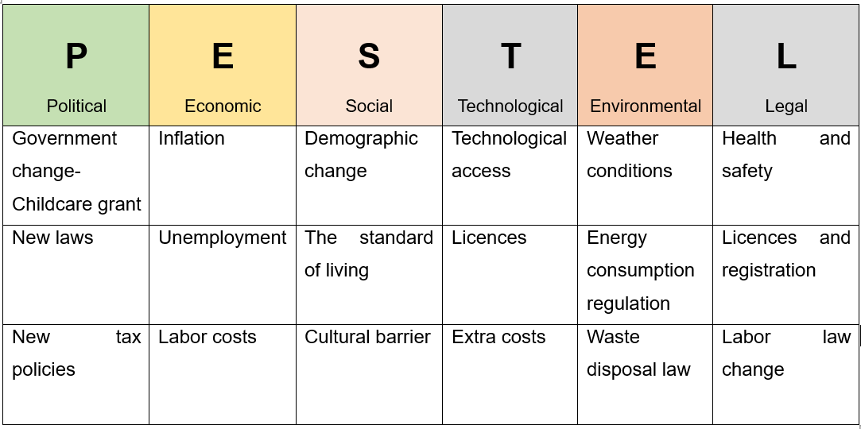
Figure 1: made by learner.

It is very important to be up to date with all external factors, that may significantly affect the business (Shatskaya et al., 2016). It can influence the business financially or competitively, the quality of the offered services, or the influence it has on the community environment (Matovic, 2020).
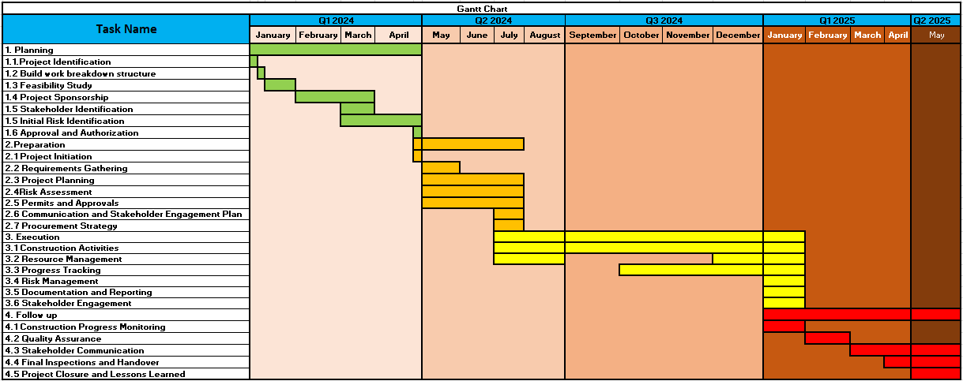
Political factors that may influence the business, are Government change- Childcare grant and New laws that offers paid childcare for parents, which is a very favourable factor for businesses financial situation. As well from September 2024, free childcare 15 hours will be offered from the age of 9 months, and 30 hours from September 2025, which is very convenient for nurseries, as more parents will have the possibility for paid childcare (The education hub, 2023). New tax policies that may be implemented by the government may affect negatively, as the nursery will have to pay more taxes to run the business, which may lead to extra financial involvement.
Economic factors as Inflation may lead to people Unemployment, so as a result people may take care of their children at home, and don’t spent money on nurseries. Higher Labour costs can influence Bumblebee nursery negatively, so it will be too expensive to keep more teachers working more hours, and therefore working hours will be cut.
Social factors as Demographic change may lead to less children in nursery’s care. As it may happen that due to The standard of living people will not have so many children, due to increased prices and unemployment. Cultural barrier is an important aspect as well, as parents of different cultures and religious may take their children in an appropriate care, which speak their language, and teach their culture.
Technological aspect, which in this Century is present in every type of business, may introduce Technological access to children that are in Bumblebee care, which involve Extra costs (for ex: to buy tablets, Smart tv, other appliances). Licences needed to run the business can take a lot of time and money, so this can cause problems to the nursery.
Environmental factors as Weather conditions, cold or warm weather can prevent parents from taking their children to the nursery. In conclusion, less children, less profit. Energy consumption regulation is beneficial, and money saving for the business, as all the lighting products must have a re-scaled energy label on their pack, showing an A-G scale. Waste disposal law has a positive effect on nursery and the environment. The nursery has enough waste disposal bins, to respect the imposed law.
Legal factors Health and safety regulation influence positively the business. Every employee will feel secure and protected in the working environment and will be happier and more productive in the nursery. Licences and registration are time and money consuming. Can stop the nursery from its activity till any of the licence or registration is received. Labor law change may affect Bumblebee financially negatively. Higher wage rates may cause financial loss for the business, and less working hours.

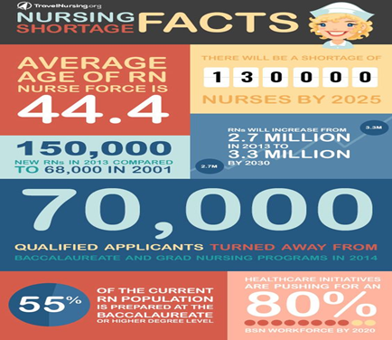
Quad Chart
Project Overview: Filling the Nursery Gap in Coventry
Our proposal aims to build a cutting-edge nursery in Coventry to satisfy the city's critical childcare demand. This nursery will provide kids with a safe, loving, and exciting environment. Our facility's 300-child expansion will alleviate the current nursery space shortage. After the outbreak, working parents are finding it harder to get reliable, high-quality childcare. Our programme offers flexible childcare options that fit typical working hours, making this change simpler.
Our group strives to foster active learning. Since the first few years of a child's life are the most important for cognitive and social development, our facility will be staffed by enthusiastic and experienced educators who are dedicated to offering a comprehensive, individualised curriculum that meets each child's needs.
Expanding nursery places, supporting working parents, and promoting a strong early education system helps Coventry's socio-economic resilience and gives our youngest people the best start in life. We also increase childcare places to give our children the best start.

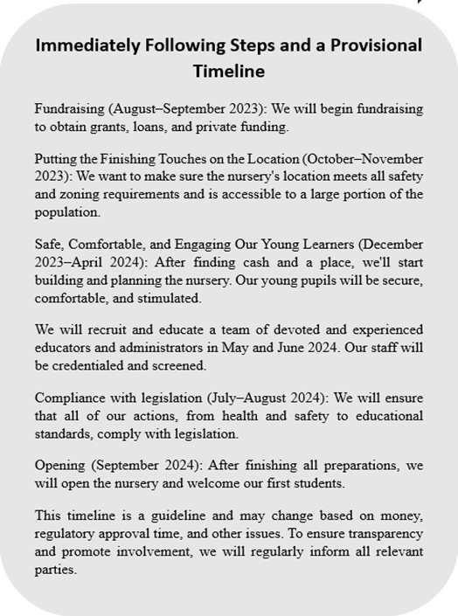
Stakeholder Benefits: Enhancing Community Life in Coventry
Parents: Our nursery will offer flexible and reliable childcare, allowing parents to work with the peace of mind that their children are safe and loved. This aid relieves stress and boosts employment and economic activity in Coventry.
Children: High-quality early education enhances learning. A supportive environment may assist children's cognitive and social development. Our certified teachers will construct an active-learning programme to provide children with the core information and skills they need for academic success.
Job Seekers. Our nursery will add jobs. We want passionate teachers, administrators, and support personnel. New employment improves the community's economy.
Local Community: Our service helps both users and the community. A dynamic local nursery may promote community cohesion, serve as a centre for family-oriented events, and make Coventry a more desirable place to live and work.
Our goal is to enhance people's lives, boost socioeconomic progress, and foster Coventry's future.

Figure 2: made by authors.

Work Breakdown structure
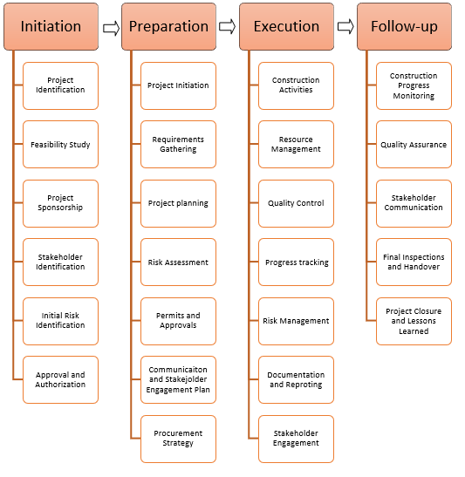
Figure 3: made by authors.
Initiation
- Project Identification: The need for building a nursery in Coventry area is identified for a new facility. This project will take into consideration the demographic changes according to Post Codes, increased demand, and community requirements.
- Feasibility Study: To determine whether constructing the nursery is feasible, a feasibility study is carried out. This study examines various factors such as market demand, financial analysis, regulatory requirements, site suitability, and potential risks and constraints.
- Project Sponsorship: A project sponsor/s need to be identified. The project sponsor will be a senior executive or a stakeholder with the authority and resources to support the project.
- Stakeholder Identification: Key stakeholders who are involved or impacted by the nursery project are identified.
- Initial Risk Identification: Potential risks and uncertainties that may affect the project's success are identified during the Initiation stage.
- Approval and Authorization: Based on the findings of the feasibility study, project objectives, and scope definition, the project is presented to relevant decision-makers for approval and authorization.
Preparation
- Project Initiation: The project is formally initiated.
- Requirements Gathering: The project team conducts a comprehensive analysis to gather and document the requirements of the nursery.
- Project Planning: The project team creates a thorough project plan that specifies the strategy, timetable, and materials needed to construct the nursery.
- Risk Assessment: Potential risks and uncertainties that may affect the successful completion of the nursery construction project are identified and assessed.
- Permits and Approvals: The necessary permits, licenses, and approvals required to start the construction of the nursery are identified, and the application process is initiated.
- Communication and Stakeholder Engagement Plan: A communication plan is developed to establish effective communication channels and strategies with stakeholders throughout the project.
- Procurement Strategy: The project team assesses the need for procuring external resources, such as contractors, suppliers, or consultants, and develops a procurement strategy.
Execution
- Construction Activities: The primary focus of the Execution stage is on carrying out the construction activities conducted by contractors.
- Resource Management: The project team manages and coordinates the resources required for the execution stage.
- Progress Tracking: The project team monitors and tracks the progress of construction activities against the project schedule.
- Risk Management: The project team continues to identify, assess, and manage risks during the Execution stage.
- Documentation and Reporting: Accurate and up-to-date documentation is maintained throughout the Execution stage.
- Stakeholder Engagement: The project team engages with stakeholders during the Execution stage, providing updates, addressing concerns, and obtaining feedback as necessary.
Follow-up
- Construction Progress Monitoring: The project team tracks the progress of construction activities.
- Quality Assurance: Quality control methods are put in place to ensure that construction work complies with the necessary standards and specifications.
- Stakeholder Communication: Regular communication and reporting to stakeholders, including project sponsors, regulatory bodies, and future users of the nursery, are essential during the follow-up stage.
- Final Inspections and Handover: Towards the end of the construction phase, final inspections are conducted to ensure that the nursery meets all necessary building codes, safety standards, and regulatory requirements.
- Project Closure and Lessons Learned: The follow-up stage concludes with project closure activities, including finalizing financial accounts, conducting project reviews, and documenting lessons learned.

Cost Accounts estimation

Figure 4: made by authors.

Cost accounts estimation is the process of predicting expenses for a project or activity based on available information and analysis (Drury, 2018). According to Figure 4, the project's total cost will be £3,430,700, and the project will need 1850 hours to complete the project activities such as research, project planning, construction activity and resource management.
The main cost of the project will be used in construction activity that the contractor will carry out, and we estimate that the cost per pupil will be around £9,850 (Romanova, 2022), and project planning that cost around 14% of the total cost of the construction (Iconic, n.d.).

Gantt Chart
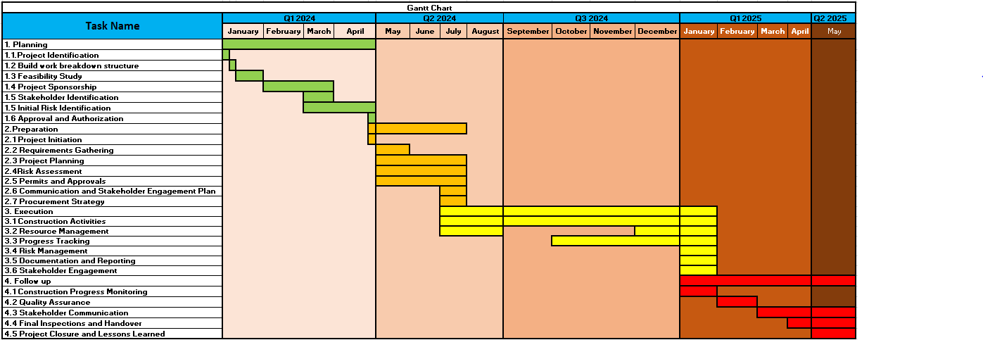
Figure 5: made by authors.

Risk Assessment

The planning process for a project must always include a risk assessment. However, it provides the teams working on the project with the ability to foresee possible issues that might have a negative effect on the project and prepare for ways to address such issues (Chapman, 2001). The following is a list of possible dangers that might be associated with the nursery project, as well as potential solutions to those risks:
One of the main hazards associated with any project is the potential for insufficient funding or unexpected cost overruns. In order to mitigate the potential risk, we propose conducting a comprehensive budget analysis, securing multiple financing sources, and maintaining a contingency fund to account for unforeseen expenses.
The potential risks associated with regulatory measures. The potential for non-adherence to the regulations governing childcare services may lead to legal consequences and damage to our reputation (Hillson and Murray-Webster, 2007). To ensure adherence to regional and national regulations, we will appoint a compliance officer and undertake regular reviews and updates of our policies and processes.
The Perils of Recruitment. The acquisition of competent and devoted staff members is imperative for the nursery's success. There exists the potential that we may encounter a shortfall in the identification of a sufficient number of suitably qualified candidates. To mitigate the potential adverse consequences, we will develop an enticing employment package and execute an extensive recruitment strategy encompassing regional and national job advertising.
The location in question presents a hazardous environment. There exists a potentiality that the selected location may not possess the anticipated level of accessibility or appropriateness. To address this potential hazard, a comprehensive analysis of the location will be conducted, encompassing various factors such as transportation, safety measures, and community consensus.
Potential risks to our operations encompass a range of factors, spanning from the potential occurrence of malfunctions in our surveillance system to the potential challenge of attracting an adequate number of young individuals to occupy the available positions. In order to address these hazards, our approach involves comprehensive operational planning, encompassing contingency measures for system malfunctions, alongside an assertive marketing strategy to ensure maximum occupancy.
The potential hazards and threats to the well-being and physical integrity of individuals. A health and safety risk refers to any potential hazard that has the potential to jeopardise the well-being and safety of children, employees, or visitors (Kerzner, 2017). Also, we will ensure compliance with rigorous health and safety regulations, conduct regular inspections and drills, and provide ongoing training for all personnel.
Enhancing the likelihood of project success and protecting the interests of all stakeholders can be achieved by proactively identifying and adequately preparing for potential risks.

Conclusion
The nursery construction project aims to create a safe and stimulating environment for children's growth and development. It involves careful planning, designing, and execution of infrastructure, incorporating child-friendly facilities, ensuring regulatory compliance, and emphasizing security measures. The project contributes to fostering a nurturing and educational setting for young learners.
The success of this project plan will be shown when the program will fulfil stakeholders' requirements and needs. Once the project is completed, the team will conduct a research analysis and identify the main points impacting all project stakeholders.

References
Alanzi, S. (2018) ‘PESTEL analysis’, Project Management.
Bryson, J. M. (2004). What to do when stakeholders matter. Public management review, 6(1), 21-53.
Chapman, R. J. (2001). The controlling influences on effective risk identification and assessment for construction design management. International journal of project management, 19(3), 147-160.
Drury, C. (2018). Management and Cost Accounting. 10th ed. Andover: Cengage Learning.
Freeman, R. E. (2010). Strategic management: A stakeholder approach. Cambridge university press.
Gouk, A. and Hallam, K. (2018). There are more children than childcare places in Coventry. (online) CoventryLive. Available at: https://www.coventrytelegraph.net/news/coventry-news/more-children-childcare-places-coventry-15055275 (Accessed: 26 June 2023).
Hillson, D., & Murray-Webster, R. (2007). Understanding and Managing Risk Attitude. Gower Publishing, Ltd.
Iconic. (n.d.). Pricing | Iconic - How much will my construction project cost? (online) Available at: https://www.iconicprojectmanagement.com/pricing (Accessed 8 Jul. 2023)
Johnson, G., Whittington, R. and Scholes, K. (2008) Exploring corporate strategy. Text and cases. Prentice Hall Higher Education.
Kerzner, H. (2017). Project management: a systems approach to planning, scheduling, and controlling. John Wiley & Sons.
Matovic, I.M. (2020) ‘PESTEL analysis of external environment as a success factor of startup business’, ConScienS, pp. 96.
Mir, & Pinnington, A. H. (2014). Exploring the value of project management: Linking Project Management Performance and Project Success. International Journal of Project Management, 32(2), 202–217. https://doi.org/10.1016/j.ijproman.2013.05.012
Romanova, O. (2022). Average Building Costs in the UK. [online] PlanRadar. Available at: https://www.planradar.com/gb/calculating-construction-costs-in-the-uk/.
Shatskaya, E., Samarina, M. and Nekhorosheva, K. (2016) ‘PESTEL Analysis as a tool of strategic analysis in international markets’, Scope academic house B&M publishing, pp. 47.
The education hub (2023) Free childcare: How we are tackling the cost of childcare. Available at: https://educationhub.blog.gov.uk/2023/06/01/free-childcare-how-we-tackling-the-cost-of-childcare/ (Accessed: 23 June 2023)

