University of Wales Trinity Saint David

Business and management

Component 1 – Coursework (Individual Report)

Ionela Dobrin

2111156

Dr Eric Osei

Data Handling and Business Intelligence

LCBB5000_BIRM

Table of Contents
Introduction: 3
Discussion: 3
-The meaning of Data Warehousing (DW) 3
-The meaning of business intelligence (BI) 4
-The importance of DW and BI, including the DW architecture 4
-Examples of BI tools being used by businesses 5
-Impact of DW and BI on Modern Business 5
Conclusion: 6
References: 7
Appendix: 8

Introduction:
In today's highly competitive and statistics business world, organisations face an increasing challenge in transforming vast quantities of information in to other meaningful intelligence that inform decision-making processes. (Kimball, 2002). To meet this challenge, organisations have turned to Data Warehousing (DW) and Business Intelligence (BI) as critical components of their data strategy. DW and BI refer to a set of technologies, tools, and practices organisations use to collect, store, manage, and analyse large amounts of data (Inmon, 2005). This report will be presented the significance and importance of DW and BI in contemporary organisations, the DW structures, examples of BI tools used by companies, and the impact of DW and BI on modern business will be presented. This information will help organisations to understand the critical role these components play in turning data into actionable insights that inform decision-making processes.

Discussion:

-The meaning of Data Warehousing (DW)
Data Warehousing (DW) refers to accumulating, loading, and controlling substantial amounts of data from several sources in a centralised repository (Kimball and Ross, 2002). The primary purpose of DW is to support decision-making and strategic planning by providing a single, unified, and organised view of data that can be used for business intelligence and analytics (Inmon, 2002). In a DW system, data is collected from various sources, such as transactional databases, spreadsheets, or other data sources, and is integrated and cleansed to ensure consistency and accuracy (Kimball and Ross, 2002). The data is then stored in a highly optimised format, known as a star or snowflake schema, to facilitate fast querying and analysis (Chaudhuri and Dayal, 1997). DW systems are designed to handle large amounts of data and support complex queries, reporting, and data analysis. They provide a centralised repository of data that is easily accessible to users across the organisation, eliminating the need for users to access multiple data sources (Kimball and Ross, 2002).

-The meaning of business intelligence (BI)
Business Intelligence (BI) describes the understandings, tools, and practices used by organisations to turn data into actionable insights that inform and support decision-making processes (Turban, Sharda, & Delen, 2011). BI comprises a wide range of activities, including data collection, management, data analysis and visualisation, and the delivery of insights to decision-makers (Turban et al., 2011). BI aims to provide organisations with a complete and accurate view of their operations, customers, and market trends, allowing them to make informed decisions that drive business success (Turban et al., 2011).
BI systems typically integrate data from multiple sources, such as transactional databases, spreadsheets, and external data sources, to create a unified and centralised repository of data (Turban et al., 2011). In recent years, technological advances have led to the development of new BI tools and techniques, such as data mining, predictive analytics, and dashboards, which have further improved the ability of organisations to turn data into actionable insights (Turban et al., 2011). BI has become an essential tool for organisations looking to stay competitive and make data-driven decisions (Turban et al., 2011).

-The importance of DW and BI, including the DW architecture
DW and BI are crucial for businesses as they offer a comprehensive view of an organisation's data and allow better decision-making. A well-designed DW architecture provides data integration, analysis, performance, scalability, and security features (Inmon, 2005; Kimball and Ross, 2013).
However, there are potential weaknesses, including high implementation and maintenance costs, data quality issues, limited user adoption or training, and legal or ethical considerations (Anoop Singhal 2006). An example of a company benefiting from DW and BI is Amazon. Amazon uses a DW to integrate data from various sources, such as online purchases, customer reviews, and shipping data and utilises BI tools to analyse customer behaviour and preferences, improving the customer experience and increasing sales (Turban et al., 2019).

-Examples of BI tools being used by businesses
Tableau has a convenient interface that allows users to quickly create visualisations and analyse data without requiring extensive technical knowledge. Tableau maintains a wide range of information sources, including worksheets, records, and cloud-based services such as Salesforce. Tableau's interactive dashboards permit users to explore data in real time, filter it on the fly, and drill down into specific details. Tableau provides a wide range of expertise, including trend analysis, forecasting, categorization, and geographic mapping. Tableau is scalable, and it can be used by individuals, small teams, and large corporations.
However, the cost of this instrument can be classified as a disadvantage, especially for small businesses or individuals. Tableau is simple to use, but mastering the software and taking full advantage of its capabilities can take some time. Tableau's visualisations may be limited in terms of customization for some users. Tableau provides some collaboration features, but they are not as robust as those found in other data visualisation tools. Tableau can be slow and require significant computing resources when working with very large datasets. (Murray, D. G.2016)

-Impact of DW and BI on Modern Business
Improved Decision Making: DW and BI have enabled organisations to make data-driven decisions by providing timely and accurate information. Businesses can use BI tools to analyse large amounts of data from a variety of sources, such as sales data, customer feedback, and social media, to gain insights into customer behaviour, market trends, and business performance. This data can help make educated decisions about product development, marketing strategies, and resource allocation. (Kimball and Ross, 2002; Turban et al., 2011). Increased Efficiency: by automating data collection and analysis, DW and BI can help organisations streamline their operations. This reduces the amount of time and effort required to generate reports and insights, allowing organisations to focus on more important tasks. (Kimball and Ross, 2002; Turban et al., 2011). Optimised customer experience: by evaluating customer records, businesses can gain understandings into their requirements, preferences, and behaviours, which they can then use to personalise their offerings and improve the customer experience. A retailer, for example, can use business intelligence tools to analyse customer purchasing patterns and provide personalised recommendations to customers. (Kimball and Ross, 2002).

Conclusion:
In conclusion, this essay has provided an overview of the concepts of DW and BI, their trends and developments, and their importance to businesses, in particular small companies. DW and BI offer a wide range of benefits to modern businesses, including improved decision-making, increased efficiency, and reduced costs. However, they also come with potential weaknesses, such as high implementation and maintenance costs, data quality issues, and legal or ethical considerations. Organisations must carefully consider these factors when implementing DW and BI systems. Small businesses may face challenges in implementing these solutions, as mentioned the Tablou tool having also weaknesses, but their benefits make them worthwhile investments. Overall, the impact of DW and BI on modern business cannot be overstated. As technology continues to advance, organisations that invest in DW and BI will be better positioned to succeed in today's data-driven business environment.

References:

Bertino, E., and Martino, L. (2016). Data warehousing and data mining: Techniques for cybersecurity. Springer.
Chaudhuri, S., and Dayal, U. (1997). An overview of data warehousing and OLAP technology. SIGMOD Record, 26(1), 65-74. Available at: https://www.microsoft.com/en-us/research/wp-content/uploads/2016/02/sigrecord.pdf (Accessed: February 3, 2023).
English, Vincent and Hofmann, Markus. (2018). Business Intelligence as a Source of Competitive Advantage in SMEs: A Systematic Review. DBS Business Review. 2. 10.22375/dbr.v2i0.23. (Accessed: February 2, 2023). (English,2018)
Inmon, W. H. (2002). Building the Data Warehouse (3rd ed.). John Wiley and Sons. Available at: https://dl.acm.org/doi/10.5555/560407 (Accessed: February 3, 2023).
Inmon, W. H. (2005). Building the data warehouse. John Wiley and Sons. Retrieved from: Building the Data Warehouse - W. H. Inmon - Google Cărți (Accessed: February 3, 2023).
Kimball, and Ross, M. (2013). The data warehouse toolkit the definitive guide to dimensional modeling (3rd ed.). Wiley. Available at: https://r1.vlereader.com/Reader?ean=9781118530771 (Accessed: February 9, 2023).
Kimball, R. (2002). The Data Warehouse Toolkit: The Definitive Guide to Dimensional Modeling. John Wiley and Sons. Inmon, W. H. Available at: https://aatinegar.com/wp-content/uploads/2016/05/Kimball_The-Data-Warehouse-Toolkit-3rd-Edition.pdf (Accessed: February 3, 2023).
Microsoft. (2021). What is Business Intelligence? Retrieved from https://powerbi.microsoft.com/en-gb/what-is-business-intelligence/ (Accessed: February 3, 2023).
Murray, D. G. (2016). Tableau your data!: Fast and easy visual analysis with Tableau software. John Wiley & Sons. Available at: https://tanthiamhuat.files.wordpress.com/2015/07/tableau-your-data.pdf
Talend. (2021). What is a Data Warehouse? Retrieved from https://www.talend.com/resources/what-is-a-data-warehouse/ (Accessed: February 3, 2023).
Turban, E., Sharda, R., and Delen, D. (2011). Business intelligence: A managerial perspective on analytics. Available at: http://www.eiilmlibrary.com/library/29396_Ramesh%20Sharda_%20Dursun%20Delen_%20Efraim%20Turban%20-%20Business%20Intelligence,%20Analytics,%20and%20Data%20Science_%20A%20Managerial%20Perspective-Pearson%20(2017).pdf (Accessed: February 3, 2023).
Turban, E., Sharda, R., and Delen, D. (2019). Decision support and business intelligence systems. Pearson.
Tong-On, P., Siripipatthanakul, S. and Phayaphrom, B. (2021) The implementation of business intelligence using data analytics and its effects towards on performance in the hotel industry in Thailand, SSRN. Available at: https://papers.ssrn.com/sol3/papers.cfm?abstract_id=3944077 (Accessed: February 2, 2023). (Tong

Appendix:
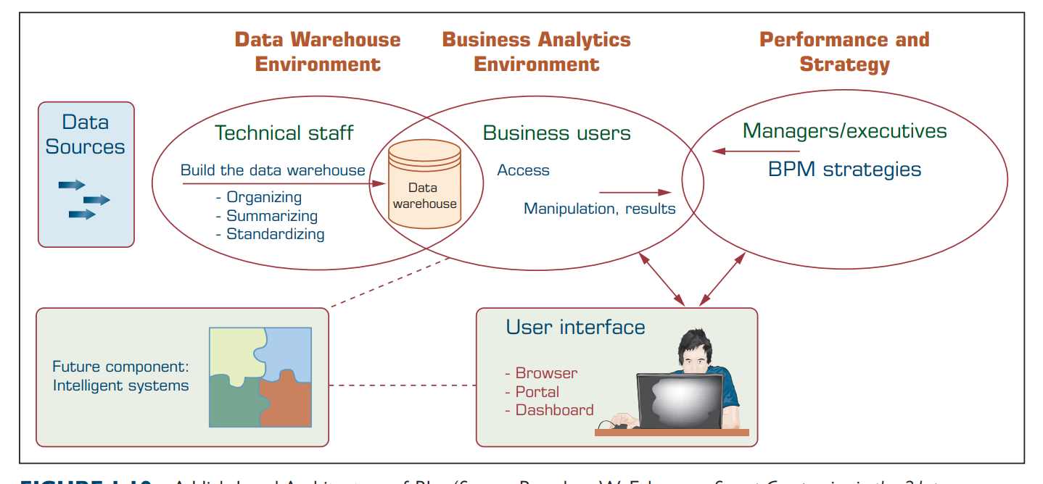
Figure 1 A High-Level Architecture of BI. (Source: Based on W. Eckerson, Smart Companies in the 21st century : The Secrets of Creating Successful Business Intelligent Solutions. The Data Warehousing Institute, Seattle, WA, 2003, p. 32, Illustration 5.) Business Intelligence, Analytics, and Data Science: A Managerial Perspective (eiilmlibrary.com)

