

BA (Hons) Leadership and management Skills for the Workplace
Module : Research Methods for Business LCLM 6004
Assignment Title:
Component 1: Business Research Proposal
Lecturer: Dr Ashikul Alam
Student Name: Leila Zougui
Student ID: 2321811

Abstract
The present study employs the qualitative approach using secondary data and document analysis to examine how organisations create sustainability information, and how AI, governance and regulations work together to prevent greenwashing. The choice of this methodology is justified by the nature of greenwashing and sustainability reporting, which are interpretive activities that manifest themselves in corporate documents, legal acts and academic literature. The present research is highly relevant to the problem of greenwashing, as it addresses an obvious gap that existed within the literature about the role of AI in strengthening ESG governance and regulations.

Table of Contents
1. Introduction 4
1.1 Identification of a Business Problem 4
1.2 Aims and Objectives 5
1.2.1 Aim 5
1.2.2 Objectives 5
1.3 Research questions and hypothesis 5
1.3.1 Research questions (RQ) 5
1.3.2 Exploratory hypothesis 6
1.4 Indicative thesis structure 7
1.5 Project timeline 8
2. Critical Literature Review 9
2.1 Greenwashing: definitions, Drivers and Effects 9
2.2 ESG Governance and Sustainability Reporting 10
2.3 Artificial Intelligence and Sustainability Monitoring 10
2.4 Regulatory Frameworks and Compliance Requirements 11
3. Research Methodology and Design (Secondary Data) 13
3.1 Research Philosophy 13
3.2 Research approach 13
3.3 Methods of Data Collection 13
3.4 Sampling Technique 13
3.5 Data Analysis 13
3.6 Ethical Considerations 14
3.7 Reliability and Validity 14
4 Results and analysis 14
4.1 Integrating AI, ESG Governance and Regulations 14
4.2. Practical implication and Business Relevance 15
5 Discussion and Conclusion 15
5.1 Conclusion 16
6 References 16

1. Introduction

1.1 Identification of a Business Problem
The problem of greenwashing has emerged in today’s world as one of the key businesses’ problems. With increased pressure towards sustainability, the companies are more dependent on their environmental claims in order to attract customers, investors and regulators. However, at the same time, intensive development of sustainability communication leads to excessive use of misleading information. Greenwashing is, therefore, understood as a situation where misleading information is provided in relation to environment to affect perceptions of stakeholders (de Freitas Netto et al, 2020).
The consequences are significant. Companies practising greenwashing are subject to reputational risk, regulatory penalties and loss of investor confidence. False statements create mistrust of the stakeholders, reduce both brand loyalty and competitive advantage (Parguel et al, 2020). Once the trust is lost, all sustainability efforts will be perceived as false (Smolenska and Faur, 2025). From a strategic perspective, greenwashing deters investments in real sustainability changes and leads to inefficiency and lack of innovations (Baumgartner and Rauter, 2020). In today’s world where investors base their capital allocation decisions on ESG criteria, any dishonesty can lead to divestment and exclusion from sustainable investment portfolios (Koch & Denner, 2025).
Because of the growing number of sustainability rules, the regulatory frameworks such as the CSRD and ISSB (IFRS, 2023), the wide range of ESG indicators and the large environmental data that the companies must handle, the firms find reporting more difficult to implement these procedures. Therefore, many companies has difficulties min providing consistent and credible reports (Kotsantonis and Serafeim, 2019). Because of this problem and as the stakeholders expect an accurate sustainability disclosure, the companies are encouraged to seek technology-based solutions (Michelon et al, 2020).
Artificial Intelligence (AI) can provide a valuable opportunity to improve the accuracy of reporting through data processing, analysis of inconsistencies and identification of patterns of falsification (Khan et al, 2024). However, traditional governance methods cannot produce an accurate sustainability report. Studies show that board oversight, internal control systems and external procedures fail to stop impression management that the companies use to hide their weaknesses in their sustainability performances by selecting only the positive aspects. This highlights the need to use technological tools that can help in supporting governance and to reduce the risk of crafting their disclosure to create a positive image of the company.
Thus, this study analyses the complex issue of greenwashing reduction via AI-based monitoring and efficient governance measures.

1.2 Aims and Objectives

1.2.1 Aim
The aim of this research is to develop an integrated strategic framework for greenwashing prevention using AI, ESG governance, and regulatory compliance. The study, also, seeks to examine how artificial intelligence (AI), internal governance mechanisms and regulatory frameworks can work together to support an accurate and transparent sustainability disclosures.

1.2.2 Objectives
1. To examine the organisational factors and consequences of greenwashing within modern business environments.
2. To analyse the existing literature on greenwashing monitoring with the help of AI and ESG governance and environmental disclosure regulations.
3. To find out the possibilities of integrating the application of AI and ESG governance to promote transparency and accountability.
4. To identify the required regulations for sustainability reporting and find ways of organisations’ compliance.
5. To develop a strategy that would incorporate technology, governance and regulation aspects to eliminate greenwashing.

1.3 Research questions and hypothesis

1.3.1 Research questions (RQ)
- What are the organisational factors behind the emergence of greenwashing and what are its strategic implications?
- How can artificial intelligence be applied for the detection and monitoring of greenwashing?
- What are the ESG governance mechanisms promoting the most transparent and accountable sustainability reporting?
- How does environmental disclosure regulation influence the strategies adopted by organisations to combat greenwashing?
- How can AI, ESG governance and environmental disclosure regulation be integrated into an organisational strategy to prevent greenwashing?

1.3.2 Exploratory hypothesis
As for the absence of hypothesis(H) tests in qualitative research, there may be exploratory hypotheses that could help in defining the conceptual direction of the research.
H1: Firms applying AI in the process of sustainability reporting have more chances to detect and prevent greenwashing (Khan et al,2024).
H2: Corporate ESG governance assist in preventing misleading sustainability communication (Michelon et al,2020).
H3: A strong regulatory enforcement reduces the likelihood of greenwashing by increasing external accountability (Christensen et al,2021).
H4: The combined power created by AI, ESG governance and regulatory compliance increases the ability of organisations to prevent greenwashing, as verified ESG performance and regulatory stringency act as complementary safeguards ( Yadav & Asongu, 2026).
It can be stated that the research aim, objectives and questions correlate highly with the anticipated outcomes of the research. The research aim implies developing an integrated strategic framework, while its objectives involve analysing certain aspects related to it, namely organisational drivers, technologies, governance and regulatory compliance (Eccles et al. 2020). Expected outcomes include a better understanding of reasons and consequences of greenwashing, information on AI and governance and guidance on compliance with regulations (Bergougui et al, 2026).

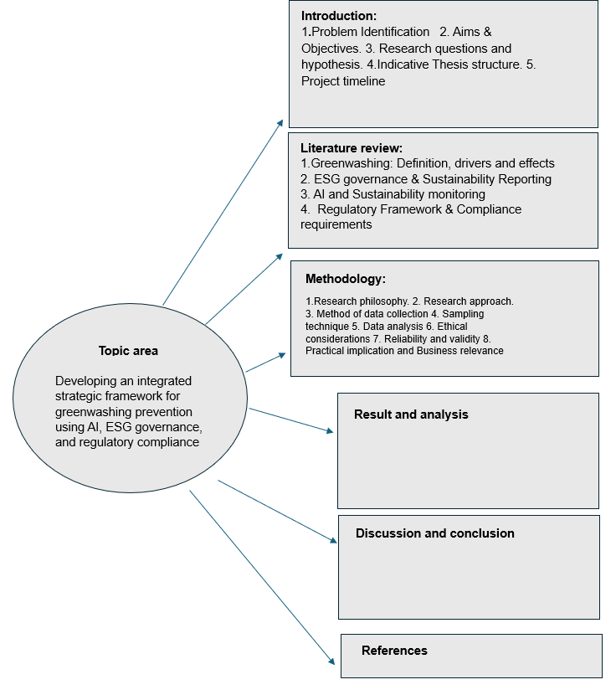
1.4 Indicative thesis structure

1.5 Project timeline
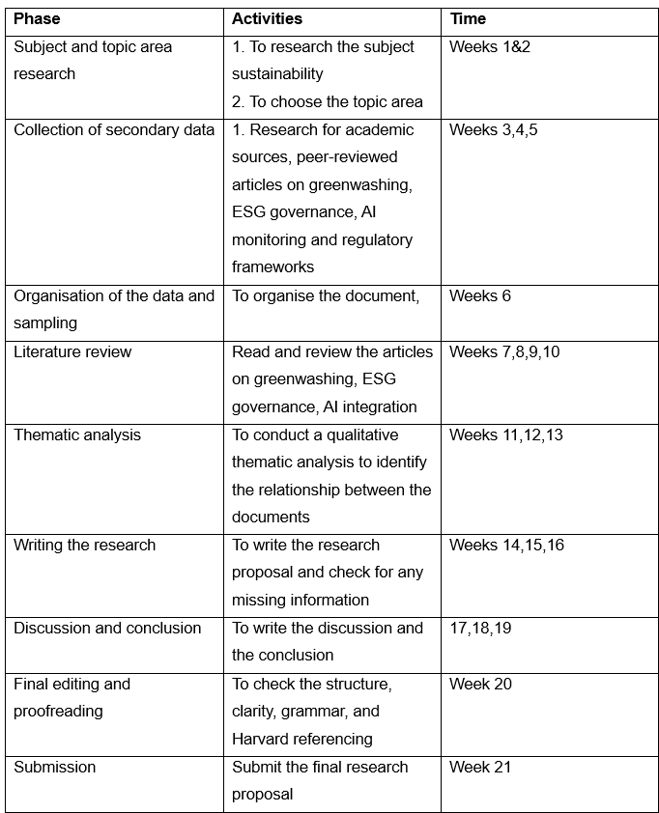
The table above shows the research project’s timeline. It will run for 21 weeks starting with choosing the subject and topic area and formulating the research structure. Followed by a research and collection of accredited peer-reviewed articles on greenwashing, ESG governance, regulatory frameworks, and AI enabled sustainability monitoring in Harvard referencing that have been literally reviewed. The findings have been written in a qualitative approach. In week 20 have been dedicated for checking the whole research proposal to see if anything is missing followed by the submission in week 20.

2. Critical Literature Review

2.1 Greenwashing: definitions, Drivers and Effects
Greenwashing is described as a misleading of stakeholders about the environmental performance of organisations (Delmas and Burbano, 2019). Competitiveness pressures, weak regulatory system and improvements to a company’s reputation are the reasons of greenwashing identified by researchers (Lyon and Montgomery, 2019). Information asymmetry plays and important role in the case of greenwashing since it is clear that firms know more about their environmental performance than other stakeholders (Spaniol et al, 2024). It is worth to make a comparison between the articles by Lyon and Montgomery (2019) and Koch and Denner(2025). According to the first articles, greenwashing is defined as the deliberate exaggeration of organisations’ environmental performance in order to gain competitive advantage. In addition, the authors regard greenwashing as an opportunity since organisations are willing to engage in greenwashing because it is beneficial for them under conditions of ineffective regulation. On the contrary, according to Koch and Denner(2025) shows that greenwashing is caused by reporting complexity, conflicting stakeholders expectations. The authors highlight that sustainability terminology, measurement methods, and reporting frameworks remain inconsistent making it hard for firms to make an accurate disclosure. Organisations are forced to greenwash not because they want to mislead stakeholders but because the complexity of the reporting.
According to research, greenwashing reduces trust of consumers in organisations and their brands, exposes firms to possible sanctions and jeopardises the sustainability agenda in general (Parguel et al. 2020; Marquis et al, 2020)
Greenwashing impacts are profound and have been widely researched. It has been shown that greenwashing lowers consumer trust, harms brand credibility and reputation and poses risks in terms of reputation (Parguel et al, 2020). Once stakeholders suspect the company of deception, the situation becomes rather hard to manage, especially in the industries when the environmental responsibility of the organisation is part of its identity. Furthermore, when the organisations are accused of greenwashing, sustainability initiatives become unreliable for the stakeholders. As a result, stakeholders tend to question other environmental goals. In recent research, financial impacts have also been highlighted since companies involved in greenwashing operations suffer from increased costs of capital and increased attention on the side of investors (Broadstock et al, 2021). The diesel gate incident confirms those results showing that deceptive environmental communications lead to sanctions and legal liability issues.

2.2 ESG Governance and Sustainability Reporting
It would be appropriate to describe ESG governance as organisational systems, procedures and practices of ESG management. ESG governance is associated with improved transparency, accountability and sustainable business performance (Eccles et al. 2020). However, many organisations do not follow uniform approaches to ESG reporting due to fragmentation of standards and voluntary approach to disclosure (Kotsantonis and Serafeim, 2019).
The measures to reduce the risk of greenwashing include board oversight, sustainability committees, internal audit procedures and external verifications (Michelon et al, 2020). Nonetheless, such measures can prove ineffective without technological support due to growing volumes of sustainability-related information.

2.3 Artificial Intelligence and Sustainability Monitoring
Artificial intelligence(AI) becomes an effective tool for enhancing sustainability reporting and detecting cases of greenwashing. This technology helps analyse large amounts of data, identify inconsistencies and patterns, which could indicate greenwashing practices (Moodaley and Telukdarie, 2023). Machine learning algorithms powered by AI ensure continuous monitoring of environmental performance of the organisation (Bai et al, 2020).
Nevertheless, regardless of all of above advantages, there are several downsides identified in academic literature, among others, the requirement for a high-quality data to feed AI tools and the lack adequate infrastructure at organisations level for analysis (Searcy, 2021). Moreover, algorithmic bias, transparency and ethical issues connected with decision-making processes are becoming more relevant (Floridi and Cowls, 2019). Thus, AI should be incorporated into the framework of broader governance strategy.
It is important for the academic literature to stress that AI should be understood in the context of an overall governance system rather than being an end in itself. The successful integration of AI depends on the compatibility of technological potential, organisational process and regulation requirements.

2.4 Regulatory Frameworks and Compliance Requirements
It is obvious that regulatory frameworks play a significant role in the development of sustainability reporting within and organisation. The recent changes reconnected with the introduction of new regulatory frameworks like the EU Corporate Sustainability Reporting Directive (CSRD), the Sustainable Finance Disclosure Regulation (SFDR) and the ISSB standards (IFRS, 2023).
As mentioned in the scientific literature, the tightening of regulatory standards will help reduce the number of cases of greenwashing due to increased accountability and punishment of organisations for lying about it (Christensen et al, 2021). Nevertheless, compliance with sustainability regulations can be difficult due to the complexity of reporting standards and necessity of a data management system (Vilchez Olivares& Astorga De La Cruz, 2026).
For small businesses, complying with such regulations is difficult because of costs and technical issues. For big businesses, compliance entails challenges related to integrating reporting requirements. Regulations have to do with market expectations too. With investors increasingly using ESG criteria to make decisions, the use of regulation helps to standardise the information and avoid misinterpretation. Yet experts warn that greenwashing cannot be prevented by regulations alone.
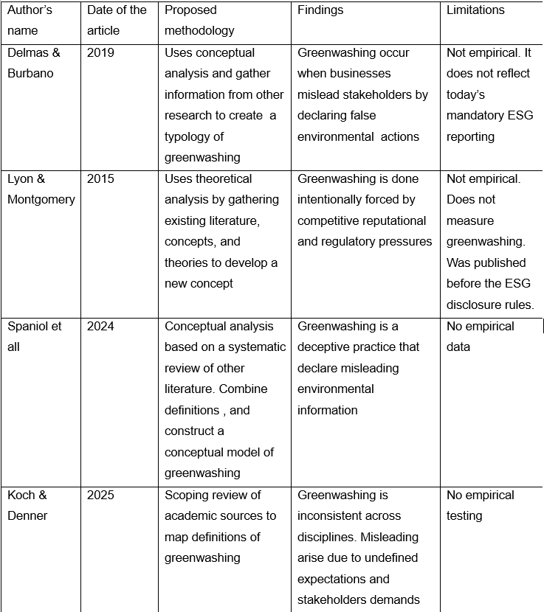

3. Research Methodology and Design (Secondary Data)

3.1 Research Philosophy
The interpretivist approach will be used in this research. It is the most appropriate choice as this research is dedicated to the analysis of the socially constructed phenomena of sustainability reporting ESG, governance and greenwashing.

3.2 Research approach
The use of this methodology in this study is appropriate because the analysis of available sustainability reporting, regulating framework and ESG governance literature will be conducted to determine the ways in which companies can utilise AI, governance and regulatory mechanisms to avoid greenwashing. Include
Sources for secondary data collection will include:
1. Corporate sustainability reports
2. ESG disclosure reports
3. Regulations (CSRD, ISSB, SFDR)

3.3 Methods of Data Collection
The method of data collection in this research paper will consist of documents analysis, which is a recognised qualitative method of text analysis. Documents analysis is a good tool to apply because of the sustainability reports, ESG governance framework and regulatory standards are mostly represented in written form.

3.4 Sampling Technique
In the research paper, a purposive sampling technique is used to collect secondary documents related to the topics of greenwashing, AI, ESG governance and regulatory compliance. Credibility of all selected documents should be high.

3.5 Data Analysis
Data in this research paper will be analysed using thematic analysis. It implies theme identification within a document. Thematic analysis fits into interpretivist paradigm because it allows for interpretations of meanings in documents.

3.6 Ethical Considerations
This research does not involve human participants or the collection of personal data. All the information and document that has been used in the study is publicly available. Ethical integrity will be maintained by accurately citing all the articles and documents that have been used.

3.7 Reliability and Validity
The reliability will be achieved by taking an organised approach to the selection and analysis of the documents. The validity will be reached through using multiple sources of the information from greenwashing articles, documents and reports.

4 Results and analysis

4.1 Integrating AI, ESG Governance and Regulations
New research shows that effective sustainability governance needs a more integrated effort involving technology development, strong oversight structures and proper regulation. While there are separate studies on AI, ESG governance and regulation, their synergistic power in terms of increasing sustainability performance and decreasing greenwashing has been not yet explored. Recent findings show that AI can help to increase the credibility of ESG data by making it more accurate and providing continuous monitoring and timely detection of inaccuracies in sustainability disclosures (Gomaa, 2026). If such technological tools are incorporated into effective governance structures, such as sustainability boards at corporate levels, internal audits and effective reporting practices, they can provide an extra tool for proper oversight and decrease misrepresentations (Yadav & Asongu, 2026).
The regulatory framework, including such regulations as Corporate Sustainability Reporting Directive (CSRD), ISSB and other sustainability-related regulations, adds to the process by introducing mandatory disclosures and external oversight instruments. The research proves that regulatory enforcement plays a very important role in disciplining sustainability disclosures and preventing greenwashing, especially with good verification and governance procedures (Yadav & Asongu, 2026).
When all three of these elements are combined, this leads to an interrelated approach where the AI technology enhances the accuracy of the data related to sustainability, while governance will ensure proper analysis and decision-making, while regulation will serve as external means of enforcing standards. Overall, this combination will help organisations improve their ability to spot, prevent and counteract greenwashing. Although Mio, Panfilo and Blundo (2020) do not discuss AI or greenwashing, the authors’ recommendation regarding interdisciplinary regarding interdisciplinary innovation in corporate governance support the need for such an approach.

4.2. Practical implication and Business Relevance
This research offers specific and practical measures for the organisations to follow to reduce greenwashing behaviours in their sustainability reports. Being under pressure from the stakeholders that demand more actional steps to save the environment, the presence of a weak governance, and the inconsistent rules can encourage the firms to declare false information in their sustainability reports. Recent studies show that better and stricter enforcement help prevent false sustainability claims(Christensen et all, 2021; Yadav & Asoongu,2026). By integrating AI in monitoring, with a strong ESG governance, and following the new regulatory framework can make sustainability data more accurate. This integration between AI tools, ESG governance, and regulatory compliance encourages transparency and reduces the behaviour of greenwashing.

5 Discussion and Conclusion
It was found that sustainability reporting, ESG governance, greenwashing and innovative technology tools are highly interconnected with one another. Notably, greenwashing is not necessarily deliberate as it can arise from the fragmented nature of reporting frameworks, unclear definitions and the increasing sustainability pressures imposed on organisations. It further provide the findings of recent studies that sustainability communication is affected by institutional pressures and organisation’s interpretations. Many organisations lack sufficient accountability, governance or proper reporting procedures. In the case where governance is inefficient or decentralised, sustainability information is inconsistent and difficult to verify. It adds credibility to existing studies on the need for efficient governance to produce trustworthy ESG disclosures.
Despite being a promising tool for enhancing sustainability monitoring, AI is adopted unequally by different organisations. While some organisations adopt AI-based systems to increase accuracy and detect inconsistencies, others prefer manual systems. The barriers to adoption include high costs, insufficient knowledge and lack of clarity regarding regulatory requirements.
The CSRD, ISSB and SFDR regulatory frameworks are becoming more specific and mandatory. The frameworks attempt to increase the transparency of the reporting process and eliminate false claims. However, they create the challenge of interpretation of the framework and adaptation of reporting systems to the changing expectations. One of the insights obtained in the research is the lack of integration of the AI, ESG governance and regulatory frameworks into a single system. Separate management of these aspects decreases their efficiency. The unified system consisting of the governance structure, regulatory framework and AI-enabled monitoring can ensure more accurate reporting and decrease greenwashing.
Thus, the results of the research demonstrate that the efficient reporting process is associated with the implementation of effective governance, regulation and technological processes.

5.1 Conclusion
The research proposal above describes an intended qualitative and document-based study that is intended to examine the ways in which organisations could avoid greenwashing through utilising artificial intelligence, ESG governance frameworks and regulatory compliance when engaging in the practice of sustainability reporting. Through the analysis of secondary sources of information, the research is intended to find out the key problems that organisations encounter during sustainability reporting and measures that should be taken in order to overcome such challenges. The research framework described above will assist in providing useful insights for developing good governance frameworks and high-quality data.

6 References
Bai, C., Sarkis, J. and Dou, Y. (2020) ‘Corporate sustainability development in the context of Industry 4.0’, International Journal of Production Economics, 229, pp. 1–12.
Bansal, P. and Song, H.C. (2019) ‘Similar but not the same: Differentiating corporate sustainability from corporate responsibility’, Academy of Management Annals, 13(2), pp. 1–43.
Baumgartner, R.J. and Rauter, R. (2020) ‘Strategic perspectives of corporate sustainability management to develop a sustainable organisation’, Journal of Cleaner Production, 277, pp. 1–12.
Bergougui, B., Sulimany, H.G.H. and Alharbi, A.A., 2026. Combating ESG Greenwashing Through AI Models: Evidence From Disaggregated AI Technologies, Mechanisms, and Thresholds. Corporate Social Responsibility and Environmental Management.
Bernini, F. and La Rosa, F. (2023) ‘Research in the greenwashing field: concepts, theories, and potential impacts on economic and social value’, Journal of Management and Governance.
Christensen, H.B., Hail, L. and Leuz, C. (2021) ‘Mandatory sustainability reporting and its consequences’, Journal of Accounting Research, 59(3), pp. 1–45.
Eccles, R.G., Lee, L.E. and Stroehle, J.C., 2020. The social origins of ESG: An analysis of Innovest and KLD. Organization & environment, 33(4), pp.575-596.
de Freitas Netto, S.V., Sobral, M.F.F., Ribeiro, A.R.B. and da Luz Soares, G.R. (2020) ‘Concept and forms of greenwashing: A systematic review’, Environmental Sciences Europe, 32(1), pp. 1–12.
Delmas, M.A. and Burbano, V.C. (2019) ‘The drivers of greenwashing’, California Management Review, 62(2), pp. 1–33.
Floridi, L. and Cowls, J. (2019) ‘A unified framework of five principles for AI in society’, Harvard Data Science Review, 1(1), pp. 1–15.
IFRS Foundation (2023) IFRS Sustainability Disclosure Standards (ISSB). London: IFRS Foundation.
Gomaa, A., 2025. Applications of Industry 4.0 in Smart Manufacturing (Manufacturing 4.0): A Comprehensive Review, Gap Analysis, and Strategic Framework. Innovative Computing Perspectives, 1(1), pp.1-14.
Khan, M.K., Huo, C., Zahid, R.A. and Maqsood, U.S., 2024. The automated sustainability auditor: does artificial intelligence curtail greenwashing behavior in Chinese firms?. Business Strategy and the Environment, 33(8), pp.9015-9039.
Koch, T. and Denner, N., 2025. What is greenwashing-a scoping review of greenwashing definitions and development of the need-for-balance model. Journal of Sustainable Business, 10(1), pp.1-13.
Kotsantonis, S. and Serafeim, G. (2019) ‘Four things no one will tell you about ESG data’, Journal of Applied Corporate Finance, 31(2), pp. 1–8.
Lyon, T.P. and Montgomery, A.W. (2019) ‘The means and end of greenwash’, Organization & Environment, 32(3), pp. 1–27.
Michelon, G., Pilonato, S. and Ricceri, F., 2015. CSR reporting practices and the quality of disclosure: An empirical analysis. CRITICAL PERSPECTIVES ON ACCOUNTING, 33, pp.59-78.
Moodaley, W. and Telukdarie, A., 2023. Greenwashing, sustainability reporting, and artificial intelligence: A systematic literature review. Sustainability, 15(2), p.1481.
Parguel, B., Benoit-Moreau, F. and Larceneux, F. (2020) ‘How sustainability ratings mislead consumers’, Journal of Business Ethics, 162(2), pp. 1–18.
Siano, A., Vollero, A., Conte, F. and Amabile, S., 2017. “More than words”: Expanding the taxonomy of greenwashing after the Volkswagen scandal. Journal of business research, 71, pp.27-37.
Smoleńska, A. and Levi‐Faur, D., 2025. Greenwashing and Trust via Enhanced Self‐Regulation: The Case of ESG Rating Providers in Sustainable Finance. Regulation & Governance.
Spaniol, M.J., Danilova-Jensen, E., Nielsen, M., Rosdahl, C.G. and Schmidt, C.J., 2024. Defining greenwashing: A concept analysis. Sustainability, 16(20), p.9055.
Vilchez Olivares, P.A. and Astorga De La Cruz, B.J., 2026. AI and data analytics in sustainable financial reporting and ESG disclosure: A systematic literature review. Sustainability, 18(11), p.5393.
Yadav, A. and Asongu, S.A., 2026. The AI Sustainability Paradox: How Verification and Regulation Synergize to Curb Greenwashing in Emerging Markets. Corporate Social Responsibility and Environmental Management.

