Dylan Samuel
Sustainable development
Assignment 1

Introduction
As part of this sustainable development assignment, I have been set the task to assess a current housing development in wales. The housing development consists of 67 new build houses ranging from 2 to 4 bedrooms. In addition to this there are also 8 new 1 bed apartments to be constructed as part of the affordable housing scheme and will be sold to the local council.
I will be assessing the developments sustainability practices and identifying areas in which there are room for changes or further development to the project’s sustainability. Areas in particular I will be assessing are; water, energy, transport, health and wellbeing, land use and ecology, pollution, materials and lastly waste. These sustainability factors all contribute to a project’s sustainability rating.
The site layout shown below highlights the different house types and the layout of the Saint Sannans field site constructed by Llanmoor homes.
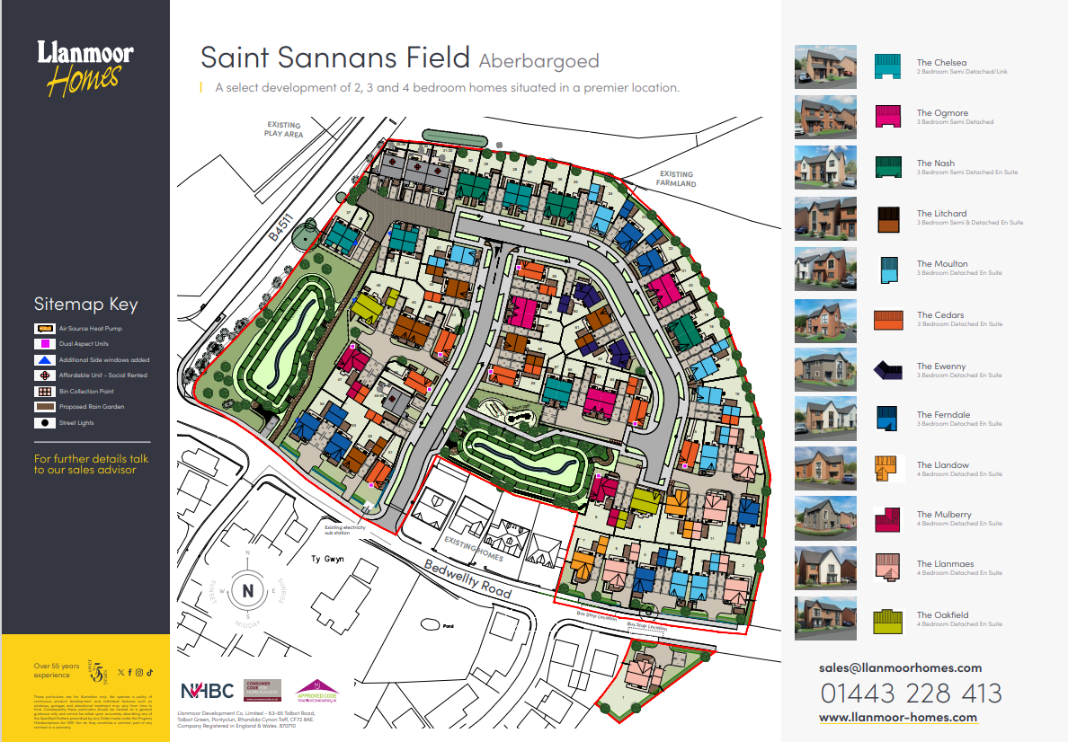

(Llanmoor Homes, 2024)

The Saint Sannans Project
As mentioned, the site is made up of 67 new build houses ranging from 2 to 4 bedrooms and 8 new 1 bed apartments as part of the affordable housing scheme. The site layout above gives a better image on the project showing how the development will look upon completion. There is a key to the plan above which helps us to identify certain houses and key areas of the project. From looking at the site plan I can identify sustainable practices used as part of this project such as air sourced heat pumps, access to public transport.
Looking further into the project on the company’s website, Llanmor homes give further details on the development, highlighting sustainability practices used as part of the project. Highlights shown on their website include;
- ‘Reuse of existing stone walling as landscape features’
- ‘A Local Equipped Area of Play within the development for the use of the Residents and existing nearby community’
- ‘Sustainable urban drainage systems – Integrating ecological mitigation and biodiversity enhancement measures.’ (Llanmoor Homes, 2024b)
It is great to see that a new build project like ‘Saint Sannans’ has re used some existing materials to create a new stone wall which will be apart of their landscape in addition too their local equipped area of play. The re-use of materials is great practice as it reduces landfill, carbon emissions, energy usage and also reduces cost. The locally equipped area of play also shows the consideration for sustainability as llanmoor homes took the decision to find locally sourced equipment for their area of play instead of sourcing a product from overseas or even from the wider UK. There is no information on where the equipment was sourced from so, we can’t guarantee how local this is.
There is further information on the llanmoor homes website regarding sustainability on all their projects. Their website states that they take all environmental responsibilities seriously. They take pride in reducing the environmental impact on your home from the day you start building. We all take our environmental responsibilities seriously.
Below are just some of the measures Llanmoor Homes have implemented to help our environment whilst building your home:
- Environmental and ecological surveys are carried out and protection measures are put in place prior to building works starting to ensure that the local environment is protected.
- Some of Llanmoors current and numerous previous developments have had a previous use. Re-using derelict sites not only saves the countryside, but the derelict sites are also often contaminated from years of heavy industrial use. The contamination is removed or isolated, ensuring the local community and the environment is safe from possible harm in the future.
- Much of the timber used in the construction of a new home is sourced from responsibly managed FSC approved sustainable forests. Meaning that we can be assured that we are not contributing to the destruction of the world’s forests
- All waste produced in the process of building a new home is segregated on site. Gypsum, plastic, card and timber waste is sent to local recycling centres. Waste bricks/blocks and inert material is re-used on site where possible.
- Materials are sourced from local suppliers where possible. Reducing the environmental impact of transportation
- The cavity wall construction of the new home are made from energy efficient insulation blocks. Not only do they help to keep the home warm, but the blocks are also made from pulverized Fuel Ash (PFA), which is a recycled waste product. (Llanmoor Homes, 2023)
These statements highlight the commitment to environmental sustainability in processes of development, reducing ecological impacts, reusing resources and land, and encouraging energy efficiency. In order to preserve biodiversity and natural reserves, the ecological and environmental assessments completed before construction guarantee that harm to the nearby eco systems are minimised. By cleaning up contamination from past industrial uses and preventing the expansion of cities into rural areas, reusing abandoned sites benefits both the environment and public health. In order to promote beneficial forestry practices and stop deforestation, these developments use timber from sustainable forests that obtained the FSC certification. The on-site waste management processes show a dedication to the environment, with recycling and segregation actions reducing the amount of waste that ends up in landfill. Using local suppliers contributes to a reduction in transportation-related carbon emissions, which further reduces the construction's environmental impact. In addition, by recycling industrial waste and enhancing thermal performance, the energy-efficient insulation block which are created from recycled materials like Pulverised Fuel Ash—improve the sustainability of the house. When taken as a whole, these methods show how to develop sustainably while giving equal commitment to community safety and protection of the environment.
Project assessment and area for improvement
After assessing the projects use of sustainability practices, I believe there are multiple areas in which they can improve as a developer and achieve a higher overall sustainability rating. As a housing developer llanmoor homes do consider sustainability and environmental impacts, however I believe there is much more that can be done to reduce the impact on the environment.
Sustainable Water management systems
The only mention of any sustainability practices associated with water management is sustainable urban drainage systems (SUDS). SUDS is now a legal requirement for all new build construction projects. As this a legal requirement this does not show that llanmoor housing, take additional steps using their own initiative to help sustainability. There are multiple sustainability practices that could implemented into the project.
Rainwater harvesting is a useful system that captures and stores rain to then use throughout the site when required. Rain can be reused to assist with landscaping and toilet use which prevents the reliance on mains water. Rainwater harvesting reduced water bill costs by as much as 40%. ‘If you have a water meter then you can reduce the cost of your bills by as much as 40% by having a good rainwater harvesting system installed.’ (Richardson, 2019). Alongside rainwater harvesting, there a multiple new water efficient appliances and systems which have been adopted by new construction projects and housing developments. Although these systems may be installed within the new homes, they are not stated on the llanmoor homes website. Water efficient systems are typically standard throughout new homes and the retail market. For this reason, they may not have included this on their website. As llanmoor housing are already Implementing sustainable drainage systems (SUDS, it reduces the risk of flooding and encourages natural water filtering by managing surface water runoff. Additionally, in keeping with the objectives of the UK's environmental laws and building standards, the construction industry is putting more emphasis on on-site water reuse and recycling in order to reduce waste. By encouraging the management of water resources in the context of climate change, these strategies help to lower the carbon footprint of building projects.
Energy sources and management services
In order to meet the required environmental objectives and construction regulations like BREEAM (Building Research Establishment Environmental Assessment Method), sustainable energy sources are a crucial component of new build homes in the UK. BREEAM promotes the use of renewable energy technology to lower carbon emissions and increase building energy efficiency. The use of solar panels is a sustainable method of energy resource which is not included in the Saint Sannans project. The conversion of sunlight into electrical power through photovoltaic (PV) panels is a popular sustainable energy source for new developments. By decreasing a building's dependency on fossil fuels, PV system integration lowers a building's carbon footprint and helps earn BREEAM credits in areas like "Energy" and "Materials." PV panels could be utilised as part of the street lighting system running throughout the site. Street lighting columns only come on during dark period of the day which is typically around 9 hours during summer and around 14 hours during the wintertime. A PV system with integrated storage could be utilised to reduce the use of standard energy sources. The daylight would provide the street lighting columns enough energy to run throughout the night. This would be a great start to using additional energy sources which are sustainable. If the developer wanted to improve this again they could look including additional solar panels which could potentially power individual houses or other areas of the project.
In addition to solar power, heat pump systems, both air-source and ground-source are increasingly utilised in new build housing developments. These systems extract heat from the air or ground, providing an energy-efficient method for heating and hot water production. There is mention of the Saint Sannans project using ground source heat pumps as part of their sustainable energy practice. The use of ground source heat pump helps the projects overall BREEAM rating. BREEAM have a highly positive outlook on ground source heat pumps as they require significantly less energy than traditional gas boilers, they align well with BREEAM’s emphasis on energy efficiency and sustainable operation. The use of highly efficient insulation, triple-glazed windows, and other energy-saving technologies in combination with heat pumps enhances performance and contributes to a reduced demand for external energy sources.
Transport and access
The Saint Sannans project includes access to public transport for the new and residents on this project. The website states that the location of project and the provided public transport gives easy access to the town centre where there are several shops and facilities. Each home seems to have their own private parking spaces to reduce overcrowding cars on the streets, however there is no sign or mention of any EV chargers implemented on to the site to charge electric vehicles. Electric cars are becoming increasingly more popular with the UK government setting targets to have 0 emissions by 2035. If this target is reached, it would mean that all houses as part of this development would be required to have an electric car charger station installed which will result in a cost to the tenant.
Health and wellbeing
The llanmoor homes website has a section on community building where they state; ‘We build quality homes that are built to last. But not just that, we build communities. Our developments not only include our popular house styles, but they accommodate for varying families – from first time buyers to large families. Most developments benefit from open green space and play areas for the little ones – after all this is not just your house, it’s home. Everything is planned with your family in mind, and several of our neighbourhoods come together to form a strong sense of community and kindness.’ (Llanmoor Homes, 2022).
In addition to this there is also a section on their website which states the construction of a locally sourced area of play. It is great to give an area to the local children for them to play and keep active contributing to the local communities’ health and wellbeing. The site is located nearby a local leisure centre.
To improve Llanmoor’s contribution to the community’s health and wellbeing it would be beneficial to potentially include a local gardening patch where the local community can all contribute in growing local home grown fruit and vegetables. This would encourage healthy relationships between tenants in addition to keeping the community active.
Health and wellbeing can also be priorities when selecting building materials. There are many materials on the market which have a negative impact on health. An example of this would be High VOC paints and toxic insulation. There are many alternatives on the market which can replace these materials. Using low VOC paints instead of the higher VOC paint can have a huge impact on tenant’s health.
Impact on reducing pollution
As previously mentioned, the project provides locals access to public transport in which travels to and from the local town centre. Providing easy access to public transportation promotes the use of buses which is a highly effective way to reduce pollution and promote a sustainable lifestyle. Public transit encourages people to leave their cars at home, significantly decreasing traffic congestion and lowering the overall number of vehicles on the road. This results in reduced levels of carbon dioxide, nitrogen oxides and other pollutants which all contribute to air pollution and climate change.
I believe this project would contribute a lot more to the environment by implementing car chargers for every household. This would then attract a much wider market of tenants with electric vehicles which also helps reduce pollution. If a number of people in the new local community opt out in using public transport, the chances of them owning an electric vehicle would be much higher with electric charging stations available.

Material selection and waste
As part of this development I believe that llanmoor homes have contributed to the sustainable environment the most within their material selection. They have highlighted within their project information that they have selected locally sourced materials, when possible, to use as part of their project’s construction. In addition to this, they state on their website that much of the used timber is sourced from responsibly managed FSC approved sustainable forests. Meaning that they can be assured that they are not contributing to the destruction of the world’s forests. As a developer they have also carefully selected sustainable and energy efficient insulation. They have chosen to use pulverised fuel ash (PFA) which does not only assist in keeping the home warm, but the material is a recycled product.
In addition to utilising these 2 materials, I believe that they could use other alternatives on site to again contribute to sustainability and help improve the environment as much as possible. There are several different materials which van be use on site to construct new homes, all of which have the same performance and durability if not better. Some examples of this are recycled glass, recycled aggregate and recycled plastic in which can be used for cladding.
Regarding the sites recycled waste. Llanmoor homes ensure that all waste on site is separated accordingly and recycled when possible. This includes materials such as gypsum, plastic, card and timber waste which are all sent to local recycling centres. In addition to this, they also state on their website that bricks, blocks and inert material is re used on site when possible. This is great site practice and complies with the waste regulation within the uk construction industry.

Conclusion
In conclusion, the Saint Sannans project constructed by Llanmoor Homes demonstrates commitment to sustainability through several different practices, such as the reuse of existing materials, the integration of energy-efficient systems like ground-source heat pumps, and the use of responsibly sourced timber. The development also prioritises community wellbeing by providing a local equipped play area, and easy access to public transport. However, there are clear opportunities for improvement. The use of rainwater harvesting systems and solar energy solutions, such as photovoltaic panels for street lighting or residential energy needs, could further reduce the environmental impact of the development. Additionally, introducing electric vehicle charging stations could support the transition to cleaner transport options, benefiting both the environment and the local community. Despite these areas for improvement, the project's focus on sustainable building materials, waste management, and ecological protection represents a step towards more environmentally responsible housing development, contributing positively to both the local community and the broader environmental targets.

References
Llanmoor Homes. (2022). About | New Housing Developments South Wales | Llanmoor Homes. [online] Available at: https://www.llanmoor-homes.com/about/ [Accessed 17 Dec. 2024].
Llanmoor Homes. (2023). Energy Efficiency in New Build Homes | Llanmoor Homes. [online] Available at: https://www.llanmoor-homes.com/energy-efficiency/ [Accessed 17 Dec. 2024].
Richardson, J. (2019). Rainwater Harvesting in the UK. [online] The Renewable Energy Hub. Available at: https://www.renewableenergyhub.co.uk/main/rainwater-harvesting-information/rainwater-harvesting-information.

