Learning in the Digital Era – Assignment 1
Table of contents:
Contents
E-Portfolio 2
Essential Skills for Study and Employment………………………………………………………………………. 3
Becoming a Lifelong Learner 7
Online Identity and Safety 9
Becoming a Team Player 10

E-Portfolio
Link to E-portfolio: https://stevenmoore536.wixsite.com/website
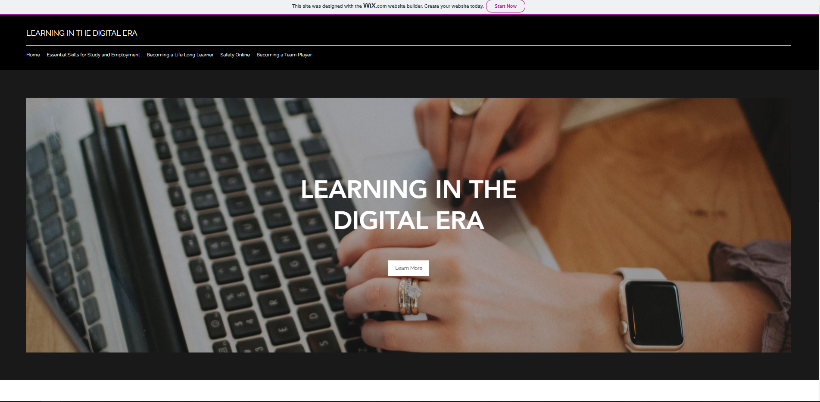

Essential Skills for Study and Employment
Introduction
This is a summary of some of the essential skills required for successful study and employment. https://stevenmoore536.wixsite.com/website/essential-skills-for-study-and-empl

Communication

Communication is an essential skill which is required for all the skills in in this summary. Communication can be broken down into two important parts. Listening and speaking. It is important to listen and fully understand what someone is saying. It is also important to speak clearly and concisely so that they may do the same. Adapted from CARNEVALE, A. P. [1].

Teamwork
Wels [2] Notes that teamwork consists of contributing to a productive workplace, defining team roles and identifying the strengths / weaknesses of team members. It also requires an open mind to new and opposing ideas.
[3]

Problem Solving
Wels [2] Problem solving is all about applying your self to a problem. This allows you to come up with innovative solutions and it also allows you to develop practical skills.

Independence

Independence is about working independently and taking charge of your own work. It can also include personal management such as personal goals, planning and timing.
[4]

Technology
More and more organisations are becoming reliant on technology, so it is important to at least have some basic IT skills or be willing to learn new ones.

Learning
Learning requires you to be open to new ideas and building upon old ones. It is important to use multiple mediums to learn such as independent learning or with online medias. Having a positive attitude and enthusiasm is also very important.

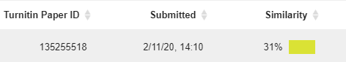
Reflection
As shown in the screenshot below the similarity percentage for the summary was 31%.

At first this does appear to be quite high however, this is due to the inclusion of the bibliography. The actual content of the summary had no similarity matches to other documents on Turnitin.
Based on the assessment criteria Steven Moore could be awarded 60-69%. Steven has shown a very good understanding of the topic. He has also shown the ability to conduct and interpret his own research.

  - Bibliography
[1]A. Carnevale, Workplace basics. Available online[ https://books.google.co.uk/books?id=oDb9--A7ukMC&printsec=frontcover&dq=essential+skills+for+study+and+employment&hl=en&sa=X&ved=2ahUKEwiPucCZ6ePsAhUEQhUIHU8aDe4Q6AEwBXoECAIQAg#v=onepage&q&f=false ]: Amer Soc For Training &, 1989, p. 11.

[2]B. Wels, "8 essential employability skills - Career Ready", Career Ready, 2020. [Online]. Available: https://career-ready.blogs.latrobe.edu.au/2013/08/16/8-essential-employability-skills/ [Accessed: 01- Nov- 2020].

[3]Sloanreview.mit.edu, 2020. [Online]. Available: https://sloanreview.mit.edu/wp-content/uploads/2018/06/FR-Hill-Global-Virtual-Team-Communication-1200x627-1200x627.jpg. [Accessed: 01- Nov- 2020].

[4]1training.org, 2020. [Online]. Available: https://www.1training.org/wp-content/uploads/2015/01/Information-Technology-and-Cloud-Computing-1024x870-e1422276882760-1.jpg. [Accessed: 01- Nov- 2020].

"Your skills and qualities: Employability skills and OU study | Help Centre | The Open University", Help.open.ac.uk, 2020. [Online]. Available: https://help.open.ac.uk/employability-skills-and-ou-study[Accessed: 02- Nov- 2020].

B. Wels, "How to match your university capabilities with employability skills - Career Ready", Career Ready, 2020. [Online]. Available: https://career-ready.blogs.latrobe.edu.au/2013/09/26/how-to-match-your-university-capabilities-with-employability-skills/ [Accessed: 02- Nov- 2020].

[7]"Skills employers seek | Careers Network | Loughborough University", Lboro.ac.uk, 2020. [Online]. Available: https://www.lboro.ac.uk/services/careers/students-and-graduates/applications/skillsemployersseek/ . [Accessed: 02- Nov- 2020].

Becoming a Lifelong Learner
https://stevenmoore536.wixsite.com/website/becoming-a-life-long-learner
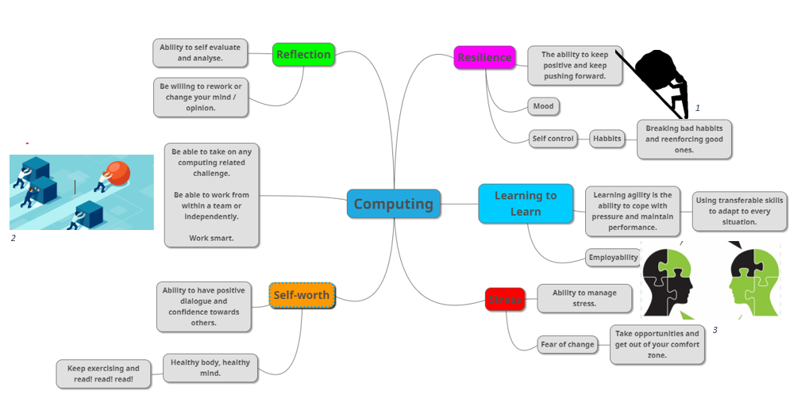

  - Bibliography
A. Carnevale, Workplace basics. Available online[ https://books.google.co.uk/books?id=oDb9--A7ukMC&printsec=frontcover&dq=essential+skills+for+study+and+employment&hl=en&sa=X&ved=2ahUKEwiPucCZ6ePsAhUEQhUIHU8aDe4Q6AEwBXoECAIQAg#v=onepage&q&f=false ]: Amer Soc For Training &, 1989, p. 11.
"Your skills and qualities: Employability skills and OU study | Help Centre | The Open University", Help.open.ac.uk, 2020. [Online]. Available: https://help.open.ac.uk/employability-skills-and-ou-study[Accessed: 02- Nov- 2020].
B. Wels, "How to match your university capabilities with employability skills - Career Ready", Career Ready, 2020. [Online]. Available: https://career-ready.blogs.latrobe.edu.au/2013/09/26/how-to-match-your-university-capabilities-with-employability-skills/ [Accessed: 02- Nov- 2020].

[1]Logikcull.com, 2020. [Online]. Available: https://www.logikcull.com/public/blog/_800x418_crop_center-center_82_none/PushingForward.png?mtime=1565044056. [Accessed: 25- Nov- 2020].
[2]Miro.medium.com, 2020. [Online]. Available: https://miro.medium.com/max/3840/1*O-IzvP_7L0Rvbq2rMxfAIQ.png . [Accessed: 25- Nov- 2020].
[3]Pinclipart.com, 2020. [Online]. Available: https://www.pinclipart.com/picdir/middle/74-748436_transferable-skills-clipart.png . [Accessed: 25- Nov- 2020].
https://app.mindmup.com/map/_free/2020/11/417af8e02f1c11eb83472d49061f1969

Online Identity and Safety
Link to presentation:
https://youtu.be/WbmaR_q-CI8
https://stevenmoore536.wixsite.com/website/safety-online
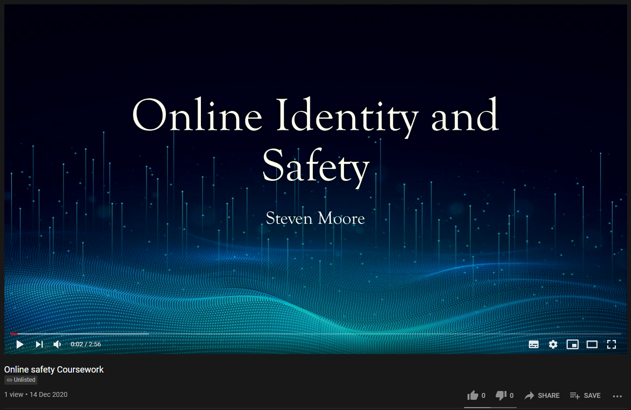

Becoming a Team Player
https://stevenmoore536.wixsite.com/website/becoming-a-team-player


