Certificate of Higher Education in Skills for the Workplace

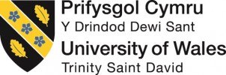

Academic and Employability Skills

Module Code: BMSW4001
Module Lecturer: Shao – Lan Yuen
Student Name: Filipe Selvatici
Student ID: 1921657
Word Count: (1,978)

CONTENTS

- INTRODUCTION ………………………………………………………………………………………….3
- AIM………………………………………………………………………………………………………….3
- EMPLOYABILITY SKILLS………………………………………………………………………………...3
- LEADERSHIP SKILLS………………………………………………….……………………………...….4
- TEAM BUILDING SKILLS …………………………………………………………………………….….4
- ORGANISATIONAL SKILLS ………………………………………………………………………..…5
- ANALYSIS OF OWN EMPLOYABILITY SKILLS……………………………………………………..5

- CONCLUSION ………………………………………………………………………………………..….6
- APPENDIX …………………………………………………………………………………………….…7-9
- REFERENCE ……………………………………………………………………………………………10-11

INTRODUCTION

Being involved in the Transportation and Logistics field over nine years and working as a private chauffeur driver I enjoy the aspects of the job as I can be my boss and also interact with the public in a way that makes my job satisfying. Advantages of this involves meeting and dealing with famous people who today are my clients, and by that, I have built trust and reputation.
I plan to work on a business plan proposal and establish long term contract with hotels and business companies to provide private services in London or anywhere within the UK. My aim is to be more significant in the market and be able to employ others o support me in this journey, building my Business and be successful.
However, to be able to tackle obstacles and achieve my dream, I came across a wide range of skills that together can build a solid foundation for my Business, the five essential capabilities that I find vital are: Communication Skills, Leadership Skills, Team Building Skills, Organizational Skills and Marketing Skills.
Employability Skills can be defined as skills required for gaining employment and enhancing progress within a given enterprise. These skills are particularly valuable for employees to achieve their full potential at their workplaces. Over the years, many skills have been attributed, but they can be categorised under broad groupings (Rao, 2010).
- AIM
On this report, I will be discussing about the importance of employability skills using articles reviews to prove the importance, efficiency and positive outcome that can be applied to my Business and reflect this using my own personal and professional development.
- EMPLOYABILITY SKILLS
Jim Collins (2001), one of my inspirational writers of the ‘Good to Great’ book’, used the speech that sums up my vision about a successful business. “Great Vision Without Great People is Irrelevant”. He speaks about the importance of a perfect team that with the adequate skills together, can build up the company and lead to success. A positive and sympathetic work setting requires ‘good quality, social communications and effective interpersonal within the workplace’ which can impact, and help team working performance (Gellman & Turner, 2012). ICE (2017) state that it is crucial co-workers work together and convey well in a team, as practical team skills improves plan supply (Gerrard & Kings, 2015).
This introduces the question as to what constitutes team relationship effective? According to Nunamaker et al., (2014), productive relationship within teams change on the splitting of their knowledge. However, McCuen et al. (2011), argued that excellent teamworking communication skills involves individuals to be more than an effective communicator. That to share understanding and work collaboratively in depend on interpersonal skills.
In support to this, Article 1 – “ Why Communication is Key to Supply Chain Success” suggested that when co-workers when working together in collaboration between supplies and stakeholders, more creative ideas can be drawn improving the process by bringing different points and insights into question. The article also points out that if limited communication is present, so does the ability of the team to influence the project. (Oxford College of Procurement & Supply, 2015).

- LEADERSHIP SKILLS

Another essential skills that I believe to be crucial is the Leadership and that Article 2 – ‘Leadership and Management’ define and convey, is the overall vision of what if going to be achieved, by inspiring others and bringing members of the team to reach their full potential and ability. Leadership involves setting up requirements to make sure stands, performance, budget and timeframes perform at its best in a business organisation (Targetjobs, 2019). Leadership skills is something that I find incredibly challenging sometimes, because it required a lot of attention, influencing skills and ability to give and receive constructive ideas from others. I am an individual that likes to be involved in group activities and be the leader when I take responsibility for something I consider to be the best way to learn the skills needed to flow well in any business situation.
Chaleff (2009), refer by reporting that leadership practice is a cooperation among followers and leader, a two-way communication had become gradually more common since the 1980s when communication models recognised the value and importance of active communication cycles within teams (Hollnagel et al., 2005). At my workplace, I always make sure to have a relationship with my colleagues and building this along the way, and the nest managers are best team players. It is considered that this skill is ore highly valued and recognise than the other thing in a unique way, work with innovation and helps promote a healthy work environment.

- TEAM-BUILDING SKILLS
For me, another new skills are team building, and the is not only essential activities performed by a group of people, but also the kills in a group, bonding and communication that results from it. Saji Ljiyemi a biomedical researcher who wrote a book to influence his audience quoted “You are either supporting the vision or supporting division” – (Don’t Die Sitting, ” to me, this quote represents that leader is only as good as the team who supports them. The skills of a team-building improve productivity and motivation in the workplace. Example of this is when at my workplace, I give initiatives to drivers who meet a certain number of clients in a period giving them bonus and vouchers. In support to this statement, In Article 3, Dane Collns who is an expert in team building suggested that programmes and initiatives “helps break down personal barriers and help maintain employees satisfaction” (Dane Collns, 2019). In other hands, the benefits of team-building skills is that accordance with some organisation strategies are being implemented in trainings, this help improve leadership skills, improve production, increase the ability to solve problems, and help identify and work with weakness and strengths. T. to be someone excellent theses skills, an individual must know how to use, verbal communication, written communication non-verbal communication, advice listening, clarity skills to be able to solve issues. Team Building and Leadership works parallel and being a good team player, and it can support well to build a strong team and group ( Doyle,2019).

- ORGANISATIONAL SKILLS

Organisational skills in personal or Business setting is a crucial part of any life activity, and this helps establish a sense of professionalism, trust in any workplace of life commitment. In Article 4 – “Advantages of Organisational Skills” – appoints and suggests that a well-organised individuals with this skills transmit an image of control and reliability projects an image of reliability and control, supporting to gain the trust of clients, colleagues and associates. Good outcome for organisation skills certainly reduces the stress in the company. This helps him to win the trust of clients and associates more easily. This ability also refers to being able to stay focus in different tasks efficiently using wisely the time frame, strengths, capital of the mind and the space limit, working efficiently to accomplish the primary outcome ( Chron,2020).

When applying this skills in my workplace, I find this very important as to make sure the scheduling and booking are running or time and clients are satisfied with the service, I need to be accountable is mastering the organisation to avoid delays and disappointments. Arrivals and departure of clients can be a big issue if organisation skills are not taking the right place. Payment attention to detail work parallel to these skills as being organised and paying attention to even the smallest details makes a huge difference in place.

According to a medical article, the study reveals a link between organisational skills and mental and physical health also plays a part. When an individual is disorganised, the feeling of anxiety and stress increases with time, causing mental exhaustion leading a toll on the body. And this can be supported in evidence that stress-induced headaches and back problems which are common symptoms that is more prevalent in individuals with poor organisational skills (Mayo Clinic, 2020).

- ANALYSIS OF OWN EMPLOYABILITY SKILLS
As a mature individual, and learning a different concept in Business, I am happy with how some of this skills are coming together, I can identify more clearly some of the names and link up with what I already have but didn’t know the meaning behind it. An example of this is the SWOT analysis that stands for:
- Strengths
- Weaknesses
- Opportunities
- Threats
During my employment skills and research, I came across this method which supervising I have been following, but will come across on the second term.
As I reflect on my personal and professions strengths, I can analyse the current situation and what I can improve or connections that I need to take with certain things. Reflection for my learning crucial as it helps me identify areas that need to be improved. Reflecting on, my weakness helps me improve my knowledge and self-development. The opportunities upon reflection leaned to improvement in my professional life. Analysing threats in my workplace allows me to recognises ( Shewan,2020).
Upon learning about SWOT during my current research, and applying all this for skills mentioned in this report, I was able to appreciate more the importance of this to continue to grow my business and be more prominent in the future. This analysis helps me address new problems and develop new ideas and continue to do both personally and professionally.
My self-reflection altogutnc contributed to my learning, the time to reflect on ideas is the main furl to my motivation to keep me going and aim for more significant projects and partnership with others. In my academic aspects, also apply to how I study and the outcome this can lead, for instance at the end of each task of homework semination I ask the questions to myself of “What I am doing right, how can I improve, What when wrong?” certainly helps me to identify my mistakes and help me improve how I deal with this in the future ( The Open University, 2019).

- CONCLUSION
In conclusion to my article’s reviews, reading, research and personal analysis, I was able to analyse published topics within teamwork and employability skills and produce a fully referenced and appreciate structure report. Classes taught how to reflect in y learning using and recognise models of reflection with the skills I already use in my daily life.
Also, I could finalise the work knowing that communication procedures supports common area of employability skills in business function in any workplace setting, the attributes and abilities as we learn speaking on the field of transportation where working attentat can affect the environment and clients that I work with, Management, organisational, leadership and team-building can result in behaviours that can impact to any day to day projects.
My research was able to review the importance and performance of theses skills improving team performance promoting two-way communication to help me as individuals but also my colleague to work well as part of a team and meet the success my Business has the aim to achieve this. To close my report, I would like to share a very inspiring quote by Simon Sinek “ When a leader embraces the responsibility to care for people instead of numbers, then people will follow, solve problems and see to it that that leader’s vision comes to life the right way, a stable way and not the expedient way.” – (Sinek, 2004). Doing what we can for passion and empathy enable us to more significant accomplishment and satisfying results.

Appendix – Class Evidence Work

Image one: Initial Drapf of Assignment (Covid19 new arrangement)

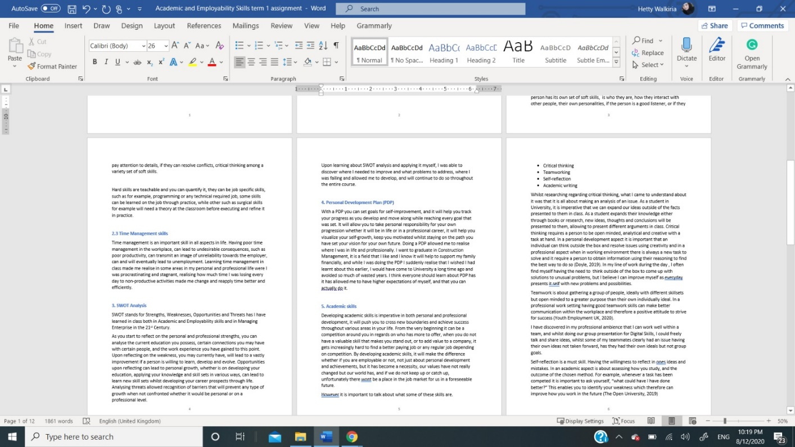

Image two: Interaction of Assignment Support (Covid19 new arrangement)

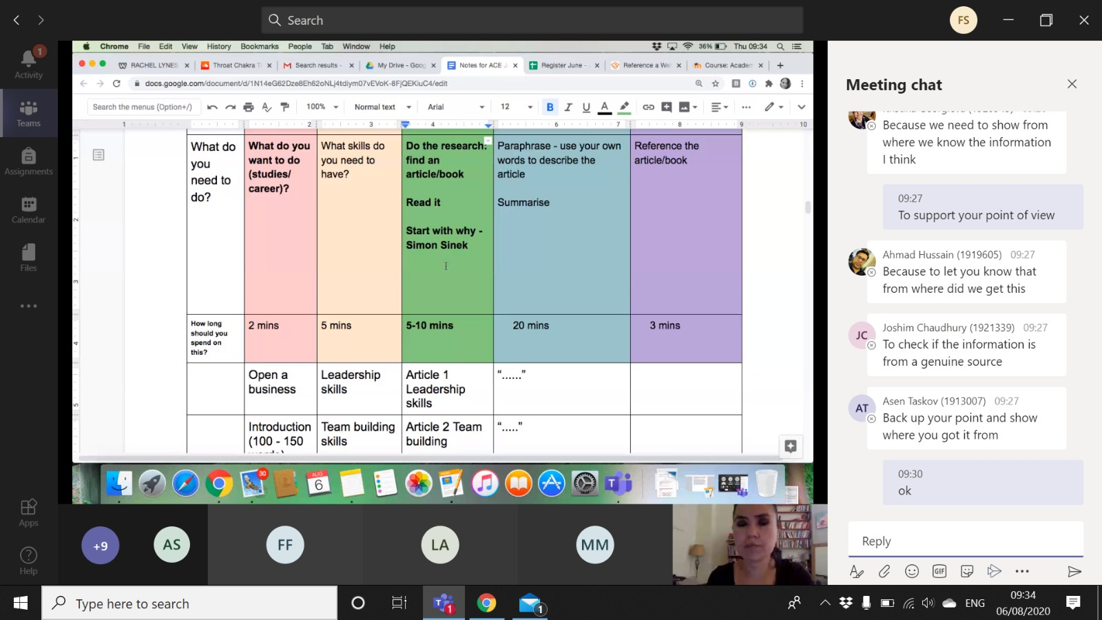

Image three: Revision notes for Assignment (Covid19 new arrangement)
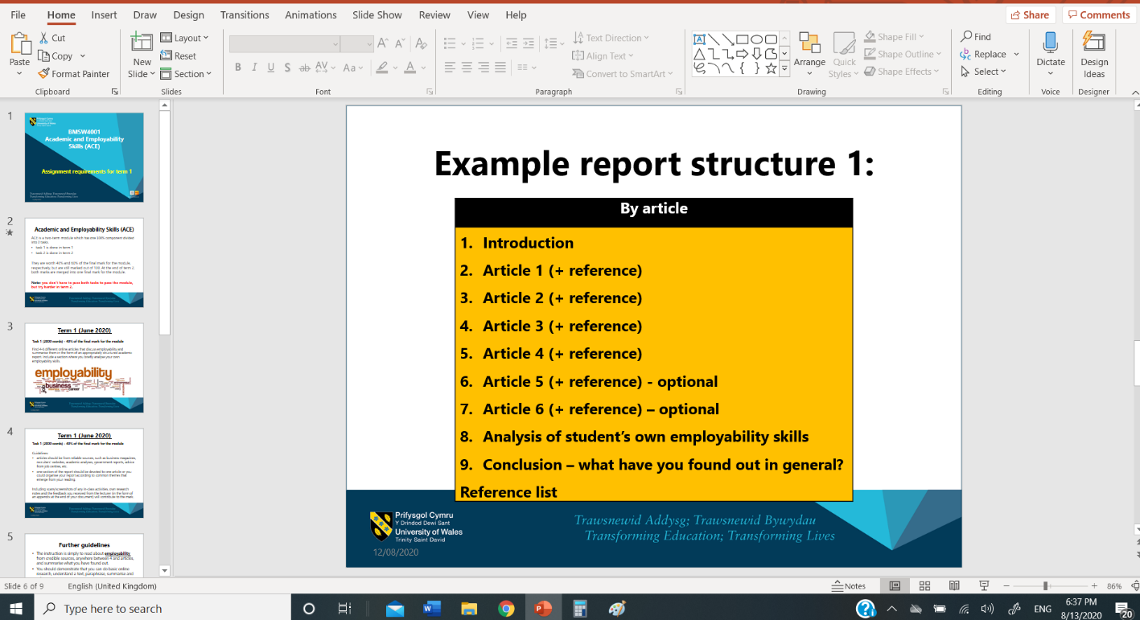

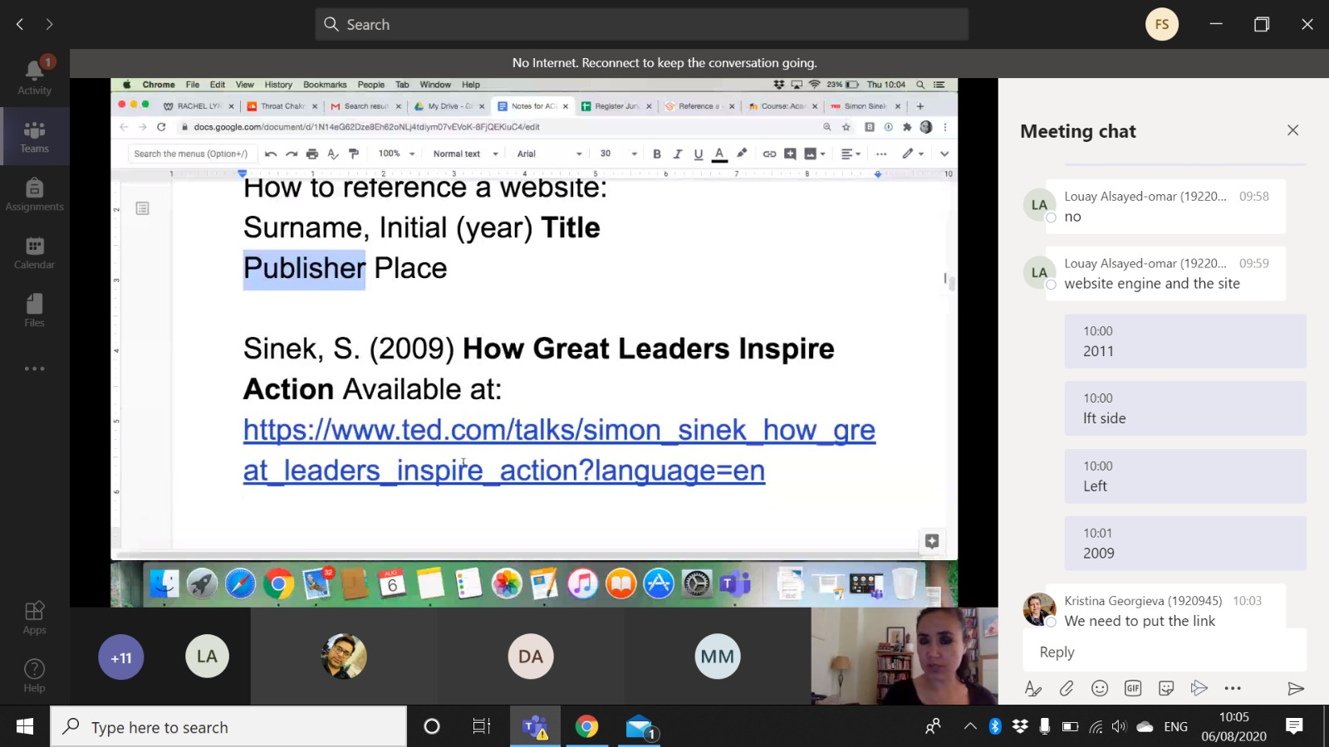
My Business Logo – Part of my Business Proposal


Referencing

Chaleff, I (2009) The courageous follower: Standing up to & for our leaders. , 3rd edn., San Francisco: Berrett-Koehler Publishers.
Dan Collns (03/08/2018) Benefits of Teambuilding, Available at: http://www.innovativeteambuilding.co.uk/benefits-of-teambuilding/ (Accessed: 05/08/2020).
Doyle, A (2019) Important Team Building Skills That Employers Value, Available at: https://www.thebalancecareers.com/list-of-team-building-skills-2063772 (Accessed: 03/08/2020).
Gellman, M., & Turner, R. J. (2012) Encyclopedia of Behavioral Medicine., 2st Edition edn., New York: Springer-Verlag.
Gerrard, R. A., & Kings, S. (2015) Clients, Collaboration and Connections â€“ Improving How Civil Engineers Work. [Online]. Available at: https://www.ice.org.uk/disciplines-and-resources/information-sheet/clients-collaboration-and-connections. (Accessed: 10/08/2020).
Hollnagel, E., Woods, D. D., & Woods, D. (2005) Joint cognitive systems: Foundations of cognitive systems engineering., 1st edn., Boca Raton, FL: Taylor & Francis.
ICE (26/02/2017) The home of civil engineering, Available at: https://www.ice.org.uk/. (Accessed: 13/08/2020).
Jim Collins (2001) Good to Great, 1st Edition edn., US: Collins Business.
Mayo Clinic (2020) Stress Management, Available at: https://www.mayoclinic.org/healthy-lifestyle/stress-management/basics/stress-basics/hlv-20049495 (Accessed: 04/08/2020).
McCuen, R. H., Ezzell, E. Z., Wong, M. K., & Mongan, D. (2011) Fundamentals of civil engineering: An Introduction to the ASCE Body of Knowledge, 2011 edn., Boca Raton, FL, United States: CRC Press.
Nunamaker, J.F., Briggs, R.O. and Romano, N.R.C. (2014) Collaboration Systems: Concept, Value, and Use., Volume 4 edn., United States: Armonk, NY : M.E. Sharpe.

Rao, M (2010) Soft skills: Enhancing Employability : Connecting Campus with Corporate. , 1st Edition edn., New Delhi: I.K Publishing.
Rao, M (2010) Soft skills: Enhancing Employability : Connecting Campus with Corporate. , 1st Edition edn., New Delhi: I.K Publishing.
Shewan. D (2020) How to Do a SWOT Analysis for Your Small Business (with Examples), Available at: https://www.wordstream.com/blog/ws/2017/12/20/swot-analysis (Accessed: 04/08/2020).
Sinek.S (2017) Leaders Eat Last: Why Some Teams Pull Together and Others Don't , 1st edn., USA: Penguin.
The Open University (2020) The Open University, Available at: http://www.open.ac.uk/choose/unison/develop/my-skills/self- (Accessed: 04/08/2020).
Articles:
Article 1: Oxford College of Procurement & Supply Success (April 2019) Why Communication is Key To Supply Chain, Available at: https://www.oxfordcollegeofprocurementandsupply.com/why-communication-is-key-to-supply-chain-success/ (Accessed: 09/08/2020).
Article 2: Target Jobs (20/04/2019) LEADERSHIP AND MANAGEMENT: PROVE YOUâ€™RE MORE THAN AN ENTRY-LEVEL HIRE, Available at: https://targetjobs.co.uk/careers-advice/skills-and-competencies/300842-team-management-prove-youre-a-bit-more-than-an-entry-level-hire (Accessed: 08/08/2020).

Article 3: Dan Collns (03/08/2018) Benefits of Teambuilding, Available at: http://www.innovativeteambuilding.co.uk/benefits-of-teambuilding/ (Accessed: 05/08/2020).
Article 4: Chron (2020) The Advantages of Organizational Skills, Available at: https://smallbusiness.chron.com/advantages-organizational-skills-276.html (Accessed: 03/08/2020).

