LCBB5015 Principles of Marketing
Component 1: Coursework: Individual Report
Company: Admiral Group
Student Name: Iceland Foods Ltd
Student ID: 2422706

Table of Contents
1. Introduction 3
Organisation Overview 3
Purpose Analytical Approach 3
2. Situational Analysis 4
Application of PESTLE analysis 4
3. Critical Analysis and Evaluation 6
Critical Analysis of Findings 6
Impact on Strategic Decision-Making and Success 6
Application of Academic Theories and Industry Examples 6
4. Conclusion 7
5. References 8

1. Introduction

Organisation Overview
Iceland Foods Ltd. is the selected organisation. It is one of the major UK-based retail food stores that deals with the grocery and frozen food retailing business, with its headquarters in Deeside. The company was founded in 1970, and it focuses on frozen foods with an increasing line of grocery products and owns label brands (About Iceland, 2026). Its scale of operation is large as it has around 26,000-27,000 employees who work in 900 stores in the UK (About Iceland, 2026). This firm has recorded annual revenues of approximately £4.2billion in 2024, with a market share of about 3% in the UK grocery market (The Telegraph, 2025).
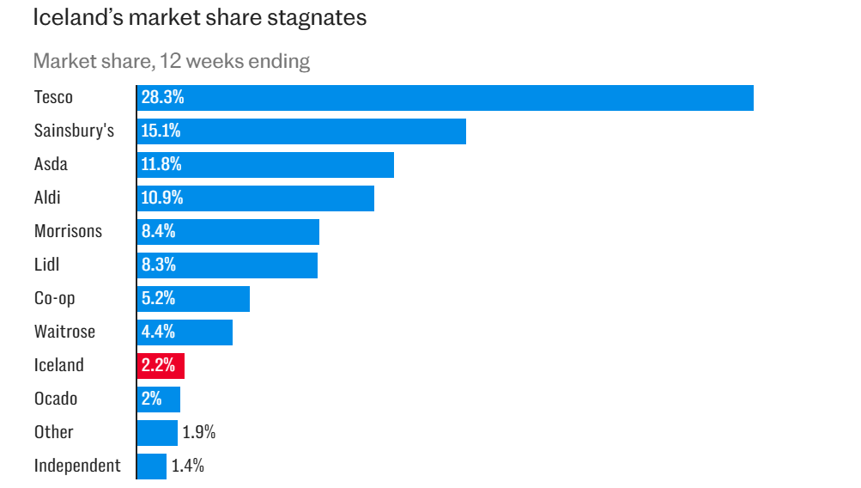
Figure 1: Market share of Iceland
Source: (The Telegraph, 2025)

Purpose Analytical Approach
This report will be aimed at undertaking a situational analysis of Iceland Foods in order to assess the external forces affecting its marketing decisions and performance in general. The PESTLE analysis model will be used in the report to ensure that the various elements are analysed to make a complete analysis of the strategic environment encountered by the firm.

2. Situational Analysis

Application of PESTLE analysis
The chosen model for situational analysis of the organisation is the PESTLE model. This is a strategic model used for evaluating the external macro-environment factors (Political, economic, social, technological, legal, and Environmental) that impact the organisation (Heubel, 2024).
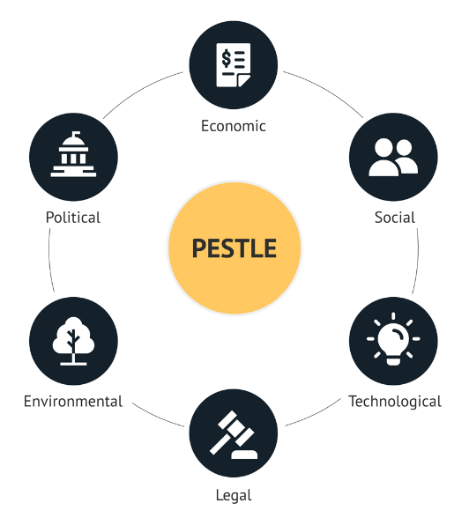
Figure 2: PESLTE Analysis
Source: (Heubel, 2024)
Political Factors: The government policies have a great influence on the operation of Iceland Foods. After Brexit, in 2024, new importation controls were announced, which made food retailers more administratively responsible (Race, 2024). These amendments have increased the complexity of compliance with frozen food imports. Also, the government pressure to keep food prices low affects the value-based marketing and promotion strategies in the Icelandic market.
Economic Factors: Iceland's performance is highly influenced by the economic conditions. In 2020, UK food inflation was recorded at 19.2%, which increased the costs of the supply chain (GOV.UK, 2026). Despite a moderation in inflation in 2024, the decrease in consumer purchasing power will still lead to demand for low-cost retailers. Moreover, the increase in the National Living Wage to 11.44/hour in 2024 has raised the cost of labour, and this affects the price decision (GOV.UK, 2025).
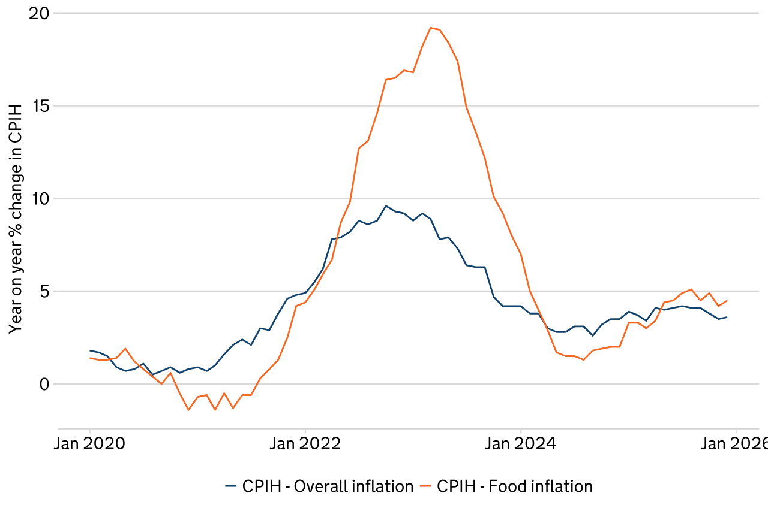
Figure 3: CPIH, 2020
Source: (GOV.UK, 2026)
Social Factors: Iceland has a business model which is favoured by social trends. The demand for UK frozen food has increased where the industry expected to reach USD 19.395.1Million before the year of 2026 (Future Market Insights, 2025). The affordability issue in the cost-of-living crisis and busy lifestyles has contributed to the use of frozen meals. Moreover, increased health consciousness is pushing Iceland to increase the production of healthier and vegetarian products.
Technological Factors: Iceland has been highly competitive due to technology. There is a strong emphasis on e-commerce and online grocery sales in the UK, which reached about £24 billion by 2029 (Investing.com, 2025). Iceland has invested in online delivery and mobile platforms to promote customer experience. The application of data analytics also contributes to the prediction of demand and personalised digital marketing strategies.
Legal Factors: The operations of Iceland are influenced by legal regulations. The Food Standards Agency imposes strict food safety, labelling, as well as hygiene standards. Failure to comply may lead to fines and loss of reputation. Also, the UK packaging laws, such as Extended Producer Responsibility (EPR), make waste management more responsible, and it affects operations and marketing (GOV.UK, 2026).
Environmental Factors: The pressure on the environment is getting more serious. Iceland Foods Ltd is highly environmentally committed with the reduction in carbon emissions of 15% nd absolute reduction of 8% by the year 2015 (About Iceland, 2026). Energy costs were cut by half with investments in LED lighting, and energy-saving refrigeration systems and systems saved 25- 30% of the unit consumption, which contributes to sustainability.

3. Critical Analysis and Evaluation

Critical Analysis of Findings
According to the PESTLE analysis, Iceland Foods Ltd can be characterised by growing cost pressure and the sustainability expectations. In 2025, the company recorded a loss of £4.7 million, which indicates financial pressures of increasing operational costs (Grocery Gazette, 2025). Simultaneously, such environmental commitments like the implementation of 100% of seafood certified by MSC prove strategic adjustment to consumer and regulatory demands (About Iceland, 2026).

Impact on Strategic Decision-Making and Success
These are the factors which have a direct effect on the strategic decisions of Iceland and its performance outcomes. As an illustration, the company increased its value-based product line of £1, which led to a growth of sales by 2.8%, which can be seen as a reaction to price-sensitive buyers (About Iceland, 2026). Non-labour-related costs are also estimated to increase the costs by an estimated £50 million per year, and this is straining the margins (About Iceland, 2026). It has, in turn, prompted Iceland to put its emphasis on the cost-effectiveness and marketing to stay competitive. At the same time, sustainability efforts, like a 35-tonne/year plastic reduction by means of packaging innovation (Qureshi, 2024). This facilitates brand differentiation and customer long-term trust.

Application of Academic Theories and Industry Examples
The analysis represents major strategic theories like Porter’s generic strategy, where Iceland is a cost leader providing low prices whilst incorporating differentiation by incorporating sustainability. Iceland is using niche positioning in frozen foods and value retailing as compared to its competitors, such as Tesco (Don, 2024). Also, the Resource-Based View describes the way that the ability to create competitive advantage is realised by resources like the efficiency of the supply chain and the innovation of sustainability. Indicatively, the introduction of MSC-certified products in 30-46 lines by Iceland enhances the company's positioning in the market (Machin, 2025). These theoretical frameworks show how the external forces influence strategic alignment and organisational success.

4. Conclusion
It is revealed in the analysis that Iceland Foods Ltd is functioning in a very dynamic environment due to the economic pressures, changes in regulations and changes in consumer behaviour. Although operations are made difficult due to cost inflation and legal regulations, there are growth opportunities through social and technological trends, that are especially in value retailing and digital expansion.
Iceland needs to enhance cost-effectiveness by optimising its supply chains and developing digital opportunities and customised marketing to stay competitive. Increased investment in more sustainable packaging and healthier lines will improve brand differentiation and longer-term loyalty of customers in an ever-more competitive grocery market.
Situational analysis is critical in strategic planning because it helps organisations to foresee the external changes, mitigate the risks and comprehensively align the marketing strategies with the environmental conditions such that informed decisions are undertaken, and a sustainable competitive advantage is achieved.

5. References
About Iceland (2026) Protecting our environment, About Iceland. Available at: https://about.iceland.co.uk/doing-it-right/protecting-our-environment/ (Accessed: 20 March 2026).
About Iceland (2026) The iceland story, About Iceland. Available at: https://about.iceland.co.uk/our-story/ (Accessed: 20 March 2026).
Don, A. (2024) Iceland rapped by ASA over Tesco price comparison ads, The Grocer. Available at: https://www.thegrocer.co.uk/news/iceland-rapped-by-asa-over-tesco-price-comparison-ads/597421.article (Accessed: 20 March 2026).
Future Market Insights (2025) UK Frozen Food Market Outlook & Trends 2025-2035, Future Market Insights. Available at: https://www.futuremarketinsights.com/reports/united-kingdom-frozen-food-market (Accessed: 20 March 2026).
GOV.UK (2025) The National Minimum Wage in 2024 and Forecast National Living Wage in 2025, GOV.UK. Available at: https://assets.publishing.service.gov.uk/media/66043e0991a320001a82b0e7/The_National_Minimum_Wage_in_2024.pdf (Accessed: 20 March 2026).
GOV.UK (2026) Extended producer responsibility for packaging: Who is affected and what to do, GOV.UK. Available at: https://www.gov.uk/guidance/extended-producer-responsibility-for-packaging-who-is-affected-and-what-to-do (Accessed: 20 March 2026).
GOV.UK (2026) Food statistics in your pocket, GOV.UK. Available at: https://www.gov.uk/government/statistics/food-statistics-pocketbook/food-statistics-in-your-pocket (Accessed: 20 March 2026).
Grocery Gazette (2025) Iceland delivers loss in full-year results, Grocery Gazette. Available at: https://www.grocerygazette.co.uk/2025/08/11/iceland-delivers-loss-in-full-year-results/ (Accessed: 20 March 2026).
Heubel, M. (2024) Pestle analysis: The macro-environmental analysis explained, Consulterce. Available at: https://consulterce.com/pestle-analysis/ (Accessed: 20 March 2026).
Investing.com (2025) UK’s online grocery market to hit £24 billion through 2029: Morgan Stanley by Investing.com, Investing.com. Available at: https://in.investing.com/news/stock-market-news/uks-online-grocery-market-to-hit-24-billion-through-2029-morgan-stanley-93CH-4621041 (Accessed: 20 March 2026).
Machin, P. (2025) Iceland foods sets global benchmark for seafood sustainability - Iceland – doing it right, sustainability.iceland.co.uk. Available at: https://sustainability.iceland.co.uk/news/iceland-foods-sets-global-benchmark-for-seafood-sustainability/ (Accessed: 20 March 2026).
Qureshi, W. (2024) Iceland cuts plastic & carbon with vacuum packed Mince Range, Packaging News. Available at: https://www.packagingnews.co.uk/news/markets/food/iceland-cuts-plastic-carbon-with-vacuum-packed-mince-range-05-08-2024 (Accessed: 20 March 2026).
Race, M. (2024) Post-brexit controls on food and farm imports start, BBC News. Available at: https://www.bbc.com/news/business-68126880 (Accessed: 20 March 2026).
The Telegraph (2025) Iceland under pressure as supermarket price war intensifies, The Telegraph. Available at: https://www.telegraph.co.uk/business/2025/08/03/iceland-pressure-supermarket-price-war-intensifies/ (Accessed: 20 March 2026).

