Discuss some of the creative strategies available to sound designers/composers when designing solutions for moving image project

This essay will focus on the famous composer, John Towner Williams. His career has been going strong for over 6 decades. He has composed for many famous films such as Jaws, E.T., and Star Wars. The film that this essay will mainly focus on is John Towner Williams’ role in the Harry Potter franchise and his work on the first three films. This essay will include information on how John Towner Williams brought the music to life.
Aside from composing for many famous films, one of the most notable may be considered to be the theme tune for Harry Potter - "Hedwig's Theme". It is a leitmotif for the film series. Often labelled as the series’ main theme, it was featured in the first Harry Potter film, the Philosopher's Stone in the tracks "Prologue".
The term ‘leitmotif’ was first used in operas of Richard Wagner, to describe a recurring melody that can be associated with a certain character, person, object, place, emotion or an idea. Leitmotif has long been used as a standard technique, it was especially popular in the early 1930s and 1940s Hollywood film, with famous composers’, Erich Korngold and Max Steiner. A leitmotif has three features: Short, distinctive, and consistent.
Feature 1 : Short length
A short leitmotif does not mean it can not be developed into something longer, in fact, many leitmotifs in classical hollywood are true ‘Themes’ of more than a bar, or two of music. If you think of the Indiana Jones theme for instance, the theme song is given a full-blown presentation as the ‘Raiders March', but usually all people hear are the first few notes of its melody, and that’s enough for individuals to recognize the leitmotif.
Feature 2 : Distinctiveness
Individuals are expected to remember this when it comes back, a leitmotif is always made distinctive, in way or another. This is usually done using a melodic string of notes in a certain rhythm, but the accompanying harmony is always important because it gives an emotional quality of the leitmotiv. In the Darth Vader’s theme, the chord progression in the first couple of bars moves between in a minor key, I and IV. The minor key VI is a major chord. It’s appearance as a minor chord creates a dark atmosphere.
Feature 3 : Consistency
A leitmotif is always consistent in its presentation in order for the statement to be recognizable. There is nothing to say that leitmotif is played exactly the same way. When their orchestration, harmony and accompaniment style that is drastically changed, they stay identifiable because of their consistent melody and rhythm. For example, in Ennio Morricone’s score of Once Upon A Time. The villain, Frank, is introduced with a threatening melody on an electric guitar, but as the film goes on, near the end the same theme is heard with a low trumpet with a funeral march accompaniment.
John williams composed many compositions for the Harry Potter franchise. Of the several that he had created, ‘Hedwig’s theme’ is far most prominent than others. The theme was primarily created for the snowy owl which Harry had owned named Hedwig. Its common use throughout the film captures the general air of mystery, and makes you feel what a child like Harry is thinking in becoming part of the wizardry and witchcraft world.
In the concert version of the theme it incorporates two themes: Hedwig’s theme and flying theme (nimbus 20000, Harry's broomstick). The theme breaks down into two sections, A and B.
Section A
The opening to the theme is probably the most noticeable and memorable, which is all down to the orchestration. It opens with a solo that has a combination of synthesized and real sound of celeste, a keyboard instrument whose keys connect with metal bars that give of a sound of small bells. In ‘Hedwig’s theme’, the sound we hear is electronically manipulated and therefore is unreal. The biggest influence on this theme is the ‘Dance Of The Sugar Plum Fairy’ composed by Pyotr Ilyich Tchaikovsky, from the Tchaikovsky’s ballet, The Nutcracker.
‘Hedwig’s theme’ is played in E minor but the chord progressions are anything but typically in minor. As the example shows underneath, the first two bars outline the E minor chord but then the bass extends the E into bar 5. However, when it comes to bar 6, it changes into a curious chord:
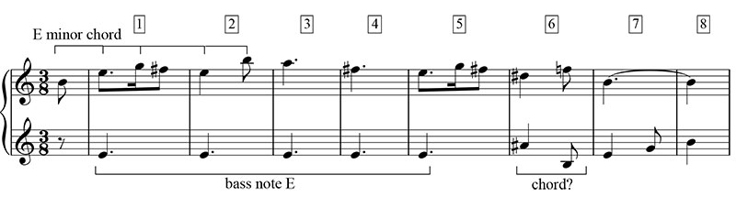The notes for bar 6 are B-D#-F-A#, which is very similar to the E minors seventh chord which is B-D#-F#-A. In fact, if Williams had actually given us a dominant seventh, the music most probably would have been in the realm of the ordinary. By subtracting F# with F and A with A#, he creates a chord that can't be explained fully. This could be Williams reflecting the unexpected world of Harry Potter. These slight nuances highlight how the ordinary world of Harry Potter has changed.
As we reach bar 9 and bar 10 of the theme, it returns to the original E minor chord followed by the opening melody. When bars 11 and 12 come in, it takes a whole new direction sounding out three new chords, which seem to all be in minor, but have no relation to one another. Despite the subtle discord, the resulting sound isn't unusual. The progression is mysterious, however, and it gives off an aura of many wonders suitable for a world full of magic.
After the string of minor chords in ‘Hedwig’s theme’, Williams ends it with two chords. Most themes or sections are normally closed with the cadence chords: dominant and tonic. The Hedwig theme does end in tonic in the last bar, and the chord preceding is not the dominant. We are lead to believe this is to be followed up, but instead Williams heads straight back into the tonic:
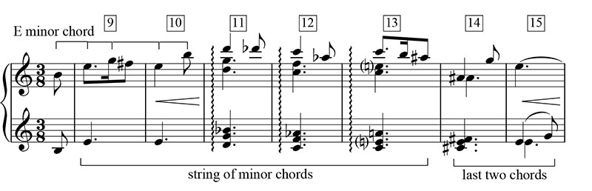
This movement back to the tonic (key note) presents us with a return to equilibrium reflecting the resolution at the end of each of the Harry Potter films.
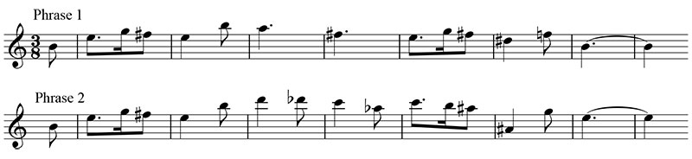
The melody for section A divides itself into two phases. The first five bars are entirely in E minor. When coming to the sixth bar it’s as if it’s in F natural, which is the lowered form of scale degree two. It is part of the strange dominant-like harmony, but at the exact same time it also builds up an odd sounding interval within the melody. The previous D# and the F take the minor and “squash” it leaving us with a diminished third, and with the following B chord it “squashes” an impeccable fifth into a diminished fifth. A constriction of sound creating a sense of struggle which clearly relates to the difficulties Harry and many of the characters face.

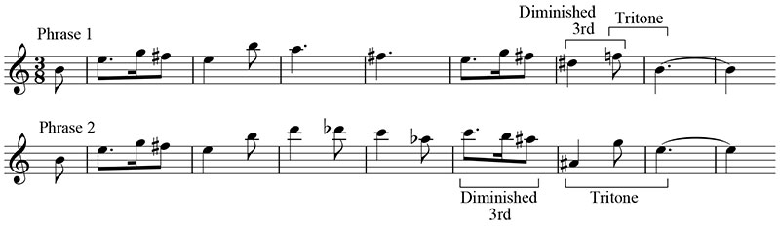

Williams adds another foreign note to E minor, A#, it comes as a raised fourth scale degree, which appears in the melody of bar thirteen. These notes comes in as a half step down from the proceeding B, which is degree scale five.This semitone act form 5 to 4# in a minor key is another feature that associates with mystery. You could compare this to Saint-Saëns famous piece, “aquarium” from carnival of animals, with the melody swinging back and forth from 5 to 4#. Another example of the same chords being used is in the film “harmonica” where it goes from 5 to 4# back to 5 in a minor key giving it that eerie mystery about a character you know only little about. I’ve noticed that in the melody in section A, Williams uses all twelve notes of the chromatic scale.
There is a pattern when John williams writes and composes his work as he seems to stick with marches, which are set in two or four beats. In ‘Hedwig’s theme’ it is different, because he has set it in a three beat meter which gives it a completely different feel. The tempo for the theme has got a waltz feeling to it. The three beat meter structure evokes the elegance and grace that benefits, the characters ability of getting out of tricky situations, for example it can be as easy as casting a spell.
Section B
The second section to ‘Hedwig’s theme’ isn't much of a difference to section A, with the same sixteen bar structure, it retains the same orchestration in the celestron, and it essentially ends in the same six bar passage.
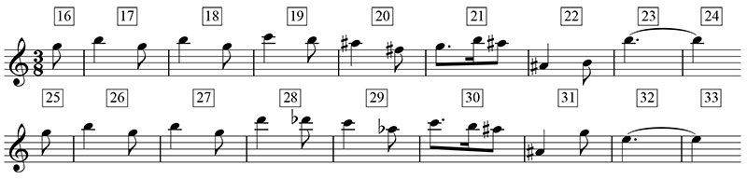
Inspite of this, there are some compelling changes in section B. For instance the harmonies at the start of bars 20 and 22 are a form of chords called “augmented sixths” which tend to have an abnormal sound when along with a sustained tonic note, in the bass.
The melody of section B contrats with the A section, where it does not sound then tonic of E minor till the very end of the note, alternatively it hovers around the dominant note. Considering the dominant is the fifth note on the scale, it is, in a manner higher up from the ground tonic note with which the theme began. With this being said williams’ deliberate avoidance of the tonic note gives the theme that it is being pendulous in the air.
The A and B sections are duplicated, with A being stated for the final time before the section moves into the ‘Nimbus 2000’ theme. John Williams adds an outstanding figure of accelerated scales in the strings, harp, and celeste that is a more memorable picture of the sort of aerobatics that wizards, witches and their owls engage in. The closing repetition of section A sustains this rushing amount in the strings, but pushes the melody into the french horns. In the Harry potter films, this energetic scoring of the melody used by the horns is accordingly identified with Hogwarts School.
Conclusion
To conclude, William’s composition reflects the journey we take when watching and experiencing a film. The amount of work that goes into writing and composing music is astonishing. It animates the story in just the first few chords. We immediately recognise the genre, themes and this helps us to generate our own expectations of what we are about to watch. Through unusual melodies and atypical chords, Hedwig’s leitmotif creates an eerie yet fantastical world. The Harry Potter storyworld is brought together through the changing shape and form. The return to the tonic (key note) at the end, helps to create a sense of unity across the film, and for Harry and his fans, a reminder that the dark days end, and he will finally be where he belongs.
Bibligogathy
Mark richards. 2013. Film music notes. [ONLINE] Available at: http://www.filmmusicnotes.com/john-williams-themes-part-6-of-6-hedwigs-theme-from-harry-potter/. [Accessed 5 December 2017].
Mark Richards. 2012. Film music notes. [ONLINE] Available at: http://www.filmmusicnotes.com/what-is-a-leitmotif-and-how-does-it-work-in-films/. [Accessed 5 December 2017].
Alex Marshal. 2017. BBC. [ONLINE] Available at: https://www.bbc.co.uk/music/articles/e8b2196f-3efd-4476-9072-4683e60a648f. [Accessed 5 December 2017].
Unknown. 2017. Wikipedia. [ONLINE] Available at: https://en.wikipedia.org/wiki/John_Williams. [Accessed 5 December 2017].

