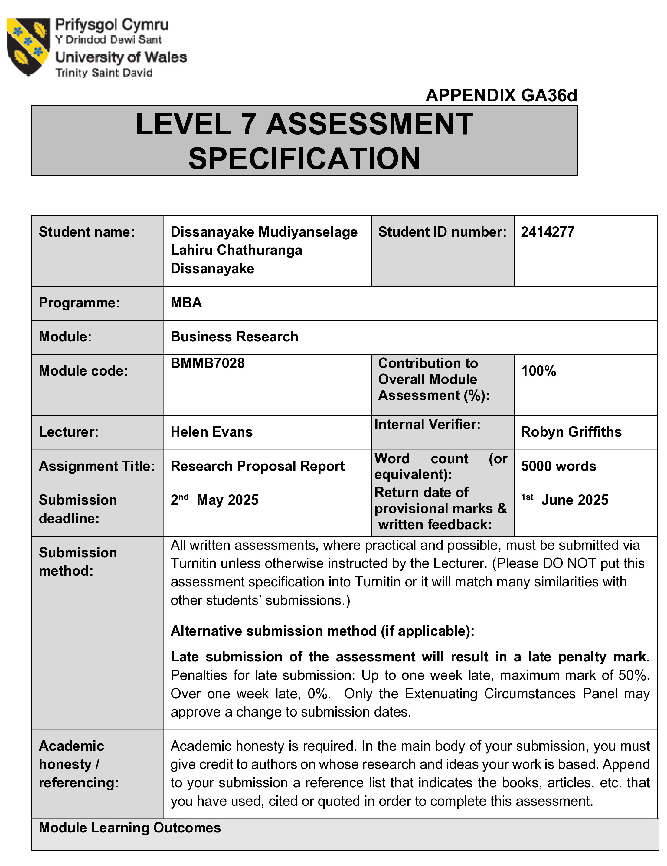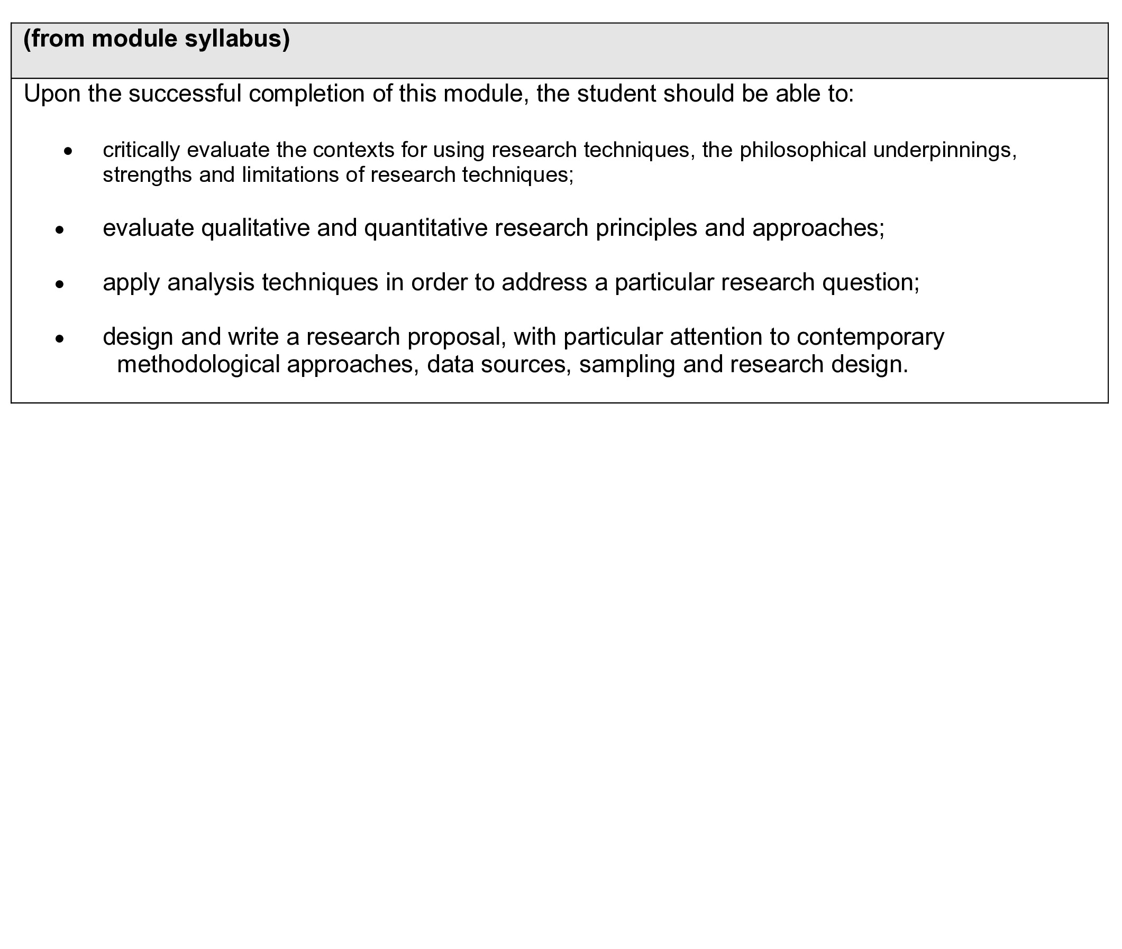

Table of Contents
List of Figures 5
List of Table 5
Abbreviations 5
1. Research rationale 7
2. Research Questions, Aim, and Objectives 9
2.1 Research Questions 9
2.2 Research Aim 9
2.3 Research Objectives 10
3. Literature Review 11
3.1 Impact of COVID-19 on Hotel Operations 11
3.2 Digitalisation and Technology Adoption 13
3.3 Workforce and Human Resource Challenges 14
3.4 Sustainability and Resilience 15
3.5 Strategic Recovery and Policy Directions 16
3.6 Methodological Justification: Use of Questionnaires 17
4. Methodology 18
4.1 Research Design 18
4.2 Data Collection Method 18
4.3 Sampling Strategy 19
4.4 Data Analysis 19
4.5 Justification of Methodology 19
5. Advantages and disadvantages of the methods 20
5.1 Advantages 20
5.2 Disadvantages 21
6. Present and Evaluate Effective Methods/Tools for Data Collection 23
6.1 Structured Questionnaires 23
6.2 Online Survey Tools 24
6.3 SPSS 24
6.4 Evaluation of Effectiveness 25
7. Resource implications and needs (cost/time etc.) 26
7.1 Financial Costs 26
7.2 Time Implications 26
7.3 Human Resources 27
7.4 Technological Resources 27
7.5 Mitigating Resource Challenges 28
8. Time plan for the research process (Gantt Chart) 29
9. Ethical considerations 31
10. Bibliography 32

List of Figures
Figure 1-Average spending per tourist per day 7
Figure 2-Tourist Arrivals in Sri Lanka 2008 – 2020 11
Figure 3-Monthly Tourist Arrivals Reports 2020 12

List of Table
Table 1-Gantt Chart 31

Abbreviations
GDP - Gross domestic product
SPSS - Statistical Package for the Social Sciences
GDPR - General Data Protection Regulation

“Exploring the Hotel Industry in Sri Lanka: Challenges and Opportunities in the Post-Pandemic Era”



MASTER OF BUSINESS ADMINISTRATION
Research Proposal

Student Name – Dissanayake Mudiyanselage Lahiru Chathuranga Dissanayake
Student ID - 2414277

Research rationale
The hotel industry is a key component of Sri Lanka's economy. It also contributes significantly to foreign exchange earnings, employment opportunities, and local development, and tourism, the main driver of this industry, contributed more than 5% of Sri Lanka's GDP before the COVID-19 pandemic (Press Trust of India, 2022).
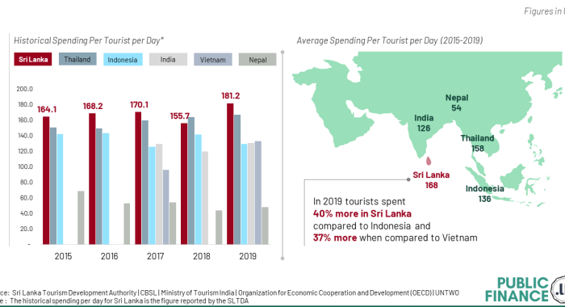
(Public Finance, 2025).
Figure 1-Average spending per tourist per day

Figure 1 shows the average daily expenses per tourist, demonstrating the high revenue generation potential of the sector. However, there have been profound disruptions in the past few years, with tourist arrivals falling by around 70% following the 2019 Easter Sunday terrorist attacks (BBC, 2025). The global COVID-19 pandemic that followed, which completely stopped international travel and seriously impacted hotel occupancy rates, drove many operators to the verge of bankruptcy (Aghaei, 2021).
However, the 2019 Easter attacks and the subsequent global health pandemic caused a severe setback for the sector, and as Sri Lanka gradually recovers from such disruptions, an understanding of where its hotel sector stands and how it can be developed is essential.
The aim of this research is to examine how the Sri Lankan hotel sector is managing post-pandemic challenges, including digitalisation, human resource issues, evolving preferences among tourists, and sustainability demands. It is crucial to critically examine the current state and prospects of the industry to assist investors, policymakers, and hoteliers in making strategic decisions.
Similarly, tourism demand has also changed, with a greater demand for eco-friendly accommodation, wellness tourism and in-depth local experiences (europa.eu, 2024). As hotels become more profitable and face increasing pressure to reduce their environmental footprint, sustainability is now not an option but a necessity (Earthstays, 2025).
With such complex dynamics, critical examination of the current state of Sri Lanka and the future prospects of its hotel industry can provide valuable insights. These results are important for investors looking for business opportunities in growth economies, governments developing recovery strategies for the tourism sector, and hoteliers who want to adapt to emerging operating conditions. In a context of highly competitive global dynamics, strategic decisions based on practical facts are essential to ensure the sustainable recovery and growth of the industry.

Research Questions, Aim, and Objectives

Research Questions
- What impact has the COVID-19 pandemic had on the operational performance of hotels in Sri Lanka?
- How are hotels in Sri Lanka using digital technologies to improve customer experience and operational efficiency?
- What are the current challenges facing Sri Lankan hotel operations in managing the workforce and delivering services?
- What is the key role of sustainability in the recovery and future growth of the Sri Lankan hotel industry?
- What are the proposed strategies to strengthen the resilience and sustainable long-term growth of Sri Lanka's hotel sector?

Research Aim
To critically assess the current condition of the Sri Lankan hotel sector, against the backdrop of recent socio-economic and global health events, to identify areas of common problems and potential opportunities.

Research Objectives
- To evaluate how the COVID-19 pandemic has affected small, medium, & large hotels in Sri Lanka in terms of operations, finances, and human resources.
- To assess the key workforce & service-related issues facing the Sri Lankan hotel industry, such as training gaps, employee retention issues, and labour shortages.
- To examine the use and effectiveness of digital technologies in Sri Lankan hotels, including digital marketing, online reservation platforms, and AI-based services.
- To evaluate how hotels' use of ecotourism, waste reduction, and energy management strategies affects their ability to compete.
- To provide strategic recommendations to lawmakers, investors, and hotel managers in order to support the sector's sustainable growth and ensure its stability.

Literature Review
The hospitality industry is a prominent part of Sri Lanka's economy, and before the COVID-19 pandemic, tourism was a significant source of the nation's GDP, employment, and infrastructure development (Thavapraba, 2021). However, the 2019 Easter bombings and the global health crisis greatly disrupted the hotel industry. Also, the literature review discusses the evolving challenges and opportunities for the hotel sector in Sri Lanka, covering digital transformation, labour dynamics, sustainability, and the trajectory of recovery in the post-pandemic context. It also confirms the use of a questionnaire-based primary data collection method in this research.

Impact of COVID-19 on Hotel Operations
The COVID-19 pandemic strictly affected the global hospitality industry as well as Sri Lanka, with tourist arrivals falling significantly due to lockdowns, international travel restrictions, and travel bans. The occupancy rate in Sri Lanka's hotels fell by more than 10% in the first year of the pandemic, with independent and small hotels with the least financial security being the most affected (Jayawardena, 2020).
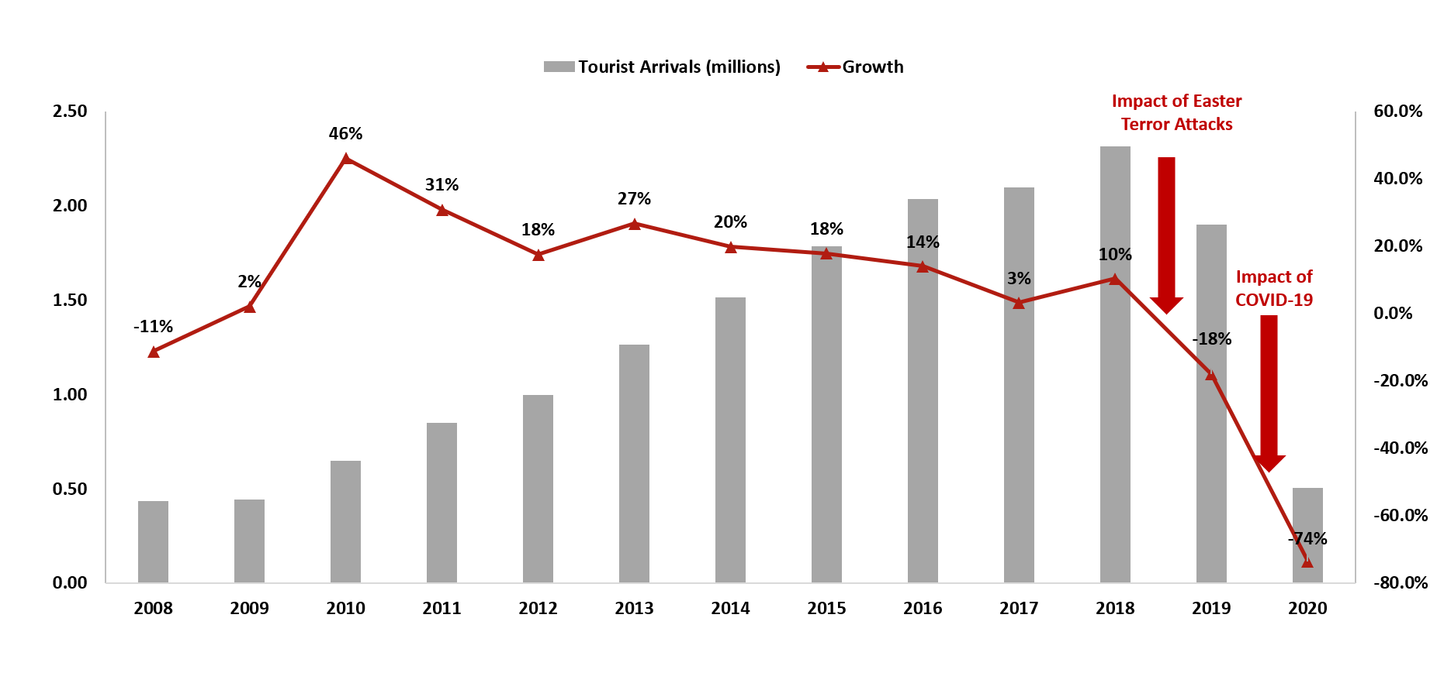
(HVS, 2025).
Figure 2-Tourist Arrivals in Sri Lanka 2008 – 2020
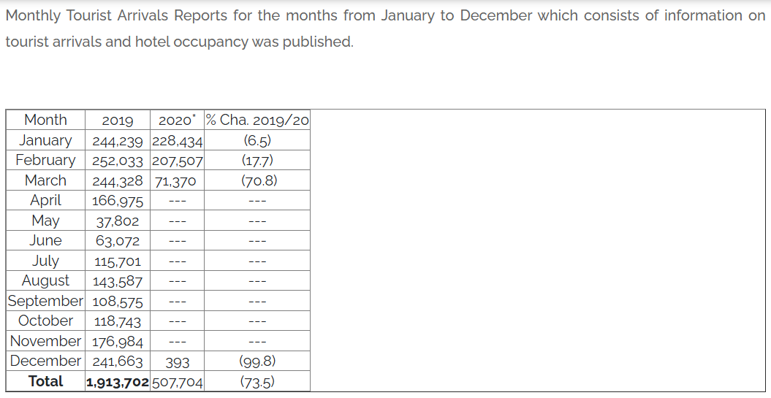
(Sri Lanka Tourism Development Authority, 2025).
Figure 3-Monthly Tourist Arrivals Reports 2020
Financial crisis, reduced operational capacity, and layoffs were common responses to the shock, with the United Nations Development Program reporting that over 500,000 workers in Sri Lanka's tourism and hospitality sectors lost income during the pandemic (United Nations Development Programme, 2021). Small and medium-sized hotels also lacked digital infrastructure and strategic adaptation to shift operations to local tourism or virtual connections.
In addition to the initial setbacks, the prolonged duration of the pandemic prompted many Sri Lankan hotels to reconsider their business models. Nearly 60% of small hotels in major tourist areas such as Galle and Ella reported business losses even in 2022, indicating a slower than expected recovery (Sri Lanka Tourism Alliance, 2025).
In addition, the latest report from the United Nations Development Programme in Sri Lanka highlights that many workers have migrated to the informal sector or for foreign employment, further depleting the local hospitality workforce (International Labour Organization (ILO), 1996-2025).

Digitalisation and Technology Adoption
The pandemic accelerated the digitalisation of the hotel industry, with hotels in Sri Lanka introducing online booking, contactless check-in, digital menus, and mobile-based guest services to comply with health guidelines and improve customer experience. The use of digital tools improved the efficiency of operations, thereby enabling data-informed decision-making (Fernando, 2022).
However, there are differences in digital usage between small-scale hotels and large hotel chain operators, with larger hotels using artificial intelligence, customer relationship management systems, and cloud-based property management systems (Gunawardena, 2023). But training employees to use such technologies in an industry with high staff turnover is always a problem, as small companies face cost and skill barriers.
According to the latest statistics from the Sri Lanka Tour Operators Association, internet-based booking platforms are showing a 40% growth among mid-sized hotels. Furthermore, luxury hotel chains have incorporated artificial intelligence-based personalization for European and Gulf tourists (SLAITO, 2024). However, a survey conducted by the University of Colombo revealed that rural hotels are lagging behind due to the lack of quality internet infrastructure and limited access to technical training among employees (University of Colombo, Sri Lanka, 2016).

Workforce and Human Resource Challenges
The hospitality sector, which has a large workforce, was hit hard by the pandemic, with many employees permanently laid off due to falling demand. So, during the crisis, sector-specific issues such as low wages, staff retention, seasonal employment, and skills mismatches were exacerbated, resulting in a shortage of skilled professionals during the recovery (Ranasinghe, 2021).
Training and development initiatives are weak, especially for budget and mid-scale hotels, and the World Bank (2021) points to skills-based training frameworks and improved public-private partnerships to address the skills shortage. In addition, job insecurity during the pandemic has prevented new workers from entering the sector, further contributing to the labor shortage.
The pandemic caused a "skill drain" as skilled staff left the industry, and less-trained casual workers were employed as a benefit of tourism demand (International Labour Organization (ILO), 1996-2025). Additionally, student enrolment in hospitality training courses fell by 30% between 2020 and 2022, reducing the number of new talent entering the industry (SLITHM, 2025).

Sustainability and Resilience
While the pandemic has focused attention on sustainable tourism development, Sri Lanka's hotel sector is increasingly adopting green practices such as energy efficiency, waste management, and sustainable sourcing. Furthermore, hotels are redefining themselves as sustainable hotels as expatriates place more importance on environmentally sustainable accommodations (Bandara, 2022).
In addition to environmental issues, socio-economic sustainability is gaining importance, so this includes purchasing from small enterprises, committing to local community support, and ensuring fair employment conditions. Furthermore, the viability of this sector depends on balancing profitability with long-term environmental and social sustainability.
Sustainability has become a competitive differentiator during the recovery phase. The Sri Lanka Tourism Development Authority has already certified 120 hotels under its new "Green Hotel" certification program, focusing on water conservation, solar energy use, and waste reduction (Sri Lanka Tourism Development Authority, 2023). Moreover, according to a Dilma Conservation report, green tourists are increasingly opting for properties that invest in local supply chains and community projects (Dilmah Ceylon Tea Company PLC, 2023).

Strategic Recovery and Policy Directions
Recovery is not just about re-entering the market, but also about a strategic transformation. Furthermore, government initiatives such as the Sri Lanka Tourism Strategic Action Plan include financial assistance for small and medium-sized enterprises, digital marketing campaigns, and infrastructure improvements (Sri Lanka Tourism Development Authority, 2022).
Public-private partnerships are necessary for the sector's long-term growth and resilience to crises. Some hotels in Sri Lanka have experimented with wellness tourism, digital travel packages and agritourism resorts in line with new preferences after the pandemic.
According to the 2023 Tourism Resilience Roadmap, SLTDA recommends diversifying tourism flows beyond traditional beach resorts into niche markets such as wellness resorts, Ayurvedic tourism, and agro-eco-lodges (Sri Lanka Tourism Development Authority, 2023). Also, government-sponsored loan guarantees and tax relief programs for small and medium-sized businesses help rebuild capacity. Furthermore, the Asian Development Bank (2023) emphasizes public-private partnerships to improve tourism infrastructure (Asian Development Bank, 2023).

Methodological Justification: Use of Questionnaires
A questionnaire is expected to be used for this study, as it has the potential to collect quantitative data from a wide range of stakeholders, including hotel managers and employees. The questionnaire provides insights into issues such as scale, labor practices, digitalisation, and sustainability practices. Structured questions also provide consistency, while open-ended questions allow for more detailed comments. Ethical principles such as informed consent, anonymity, and voluntary participation are respected during the data collection process.
The questionnaire remains a useful tool in Sri Lanka's diversified hotel industry, with stakeholders ranging from family-owned guesthouses to international conglomerates. A mixed-methods questionnaire can cover both operational facts and subtle feelings about recovery and innovation in post-pandemic situations (University of Peradeniya, 2023). Ethical practices, particularly with regard to anonymity and data confidentiality, are supported by national guidelines for research.

Methodology
This research follows a positivist research paradigm supported by a quantitative approach, in line with the research objective of critically assessing the measurable determinants of the Sri Lankan hotel industry in the post-pandemic period. The positivist paradigm is best suited to examining relationships and patterns through observable and measurable data, and therefore offers a systematic framework for testing hypotheses and drawing generalizable conclusions. The study aims to objectively evaluate the use and effectiveness of digital technologies and sustainable practices in the hospitality sector, prioritizing quantitative data collected through a formal questionnaire.

Research Design
This study applies a descriptive and exploratory research design, which is crucial to assess current conditions and identify new opportunities and challenges in the hotel industry. This research provides a detailed description of current practices in hotels in Sri Lanka while analyzing new trends such as digital transformation and the adoption of eco-tourism. It mainly focuses on research objectives such as evaluating the effectiveness of digital technology and the impact of sustainable management (e.g.- waste reduction and energy policy) on business competitiveness.

Data Collection Method
Data for this research will be collected using a structured questionnaire, which will be distributed electronically to managers and staff of star-rated and boutique hotels in Sri Lanka. Using a questionnaire is consistent with the quantitative nature of the study and allows for efficient collection of standardized data from a large sample. This is intended to involve a random sample of approximately 200 respondents to provide statistical significance and diverse perspectives within the hospitality industry. Likert scale questions, closed-ended questions, & multiple-choice questionnaires are used to gain measurable insights into the use & sustainable use of digital tools.

Sampling Strategy
A probability purposive sampling procedure is used, directly targeting experts within the hotel industry who are actively involved in operational or strategic decision-making. This is done taking into account the need to obtain good quality responses from experts with experience and familiarity with hotel management. Geographical expansion is expected from Colombo, Kandy and Galle, important tourist destinations in Sri Lanka, to access diversity in terms of operational settings.

Data Analysis
The collected data is processed and analyzed using SPSS software, and descriptive statistics are used to summarize information and identify patterns. Inferential statistical techniques such as correlation and regression analysis will be used to explore the relationship between variables such as digital usage and perceptions of competitiveness, or sustainability practices and guest satisfaction. The analytical strategy supports hypothesis testing and helps generate actionable conclusions.

Justification of Methodology
Quantitative methods are best used in research where it is important to compare groups, identify relationships between variables, and measure trends. Focusing on quantitative data gives the research greater credibility and replicability. Furthermore, this is crucial for validating findings and making recommendations based on facts for policy and strategic development within the hotel industry.

Advantages and disadvantages of the methods
This research uses a quantitative technique involving a structured questionnaire that supports an appropriate positive model to extract quantitative and generalizable data on the hotel industry in Sri Lanka in the post-pandemic era. Although this methodology has several advantages, it is also associated with certain disadvantages that should be critically examined.

Advantages
A key advantage of using a structured questionnaire is the ability to provide quantifiable information from a large sample, with statistical analysis to uncover trends and correlations between different hotel categories and geographic areas (Saunders, 2019). This increases the objectivity of the investigation and is consistent with the positivist philosophy, which is designed to uncover observable facts and empirical relationships.
Another advantage of submitting a questionnaire is cost savings and increased efficiency. Moreover, a systematic questionnaire allows for consistency in data collection, which increases reliability and allows the study to be replicated in other contexts or countries. For example, data can be collected quickly and distributed to a wide audience at minimal cost, without the logistical difficulties associated with online surveys. Furthermore, pre-coded questionnaires are very convenient for statistical programs like SPSS, which can process large data sets with precision.
Closed-ended and Likert scale questions yield standardized responses and can be analyzed through statistical software such as SPSS. This allows research to draw specific conclusions about the relationships between variables such as digitalization and service quality or sustainable practices and competitiveness (Pallant, 2020).
The ethical principles for implementing questionnaire-based studies are also simple and can ensure both voluntary responses and anonymity, thereby improving the quality of responses and response rates (Bell, 2018).
In addition, the structured design eliminates interviewer bias and thus exposes each respondent to similar questions, which improves the consistency and reliability of the information (Saunders, 2019).

Disadvantages
In addition to the advantages, a quantitative questionnaire can also present several disadvantages. These include narrow depth of responses, labor shortages, or cultural barriers to digitization, which can limit the researcher's ability to capture the contextual nuances of complex issues (Creswell, 2018). Open-ended questions were included to address this shortcoming, but their analysis is still time-consuming and conducted on a small scale.
Another limitation is the threat of non-response bias, where if key stakeholders, such as senior hotel managers, fail to respond, the results may not reflect the strategic perceptions of the industry. Since the data is self-reported, there is also a threat of social desirability bias, where respondents may report an overly positive picture of sustainability initiatives or technology use (Dillman, 2014). Moreover, self-reported data is also subject to social desirability bias, as over-reporting of good practices, e.g. the extent of sustainability activities or digital innovation, can occur as a means of presenting one's organization in a favorable light (Fisher, 1993). This reduces the validity of the results.

In addition, although the use of purposive sampling is convenient in the sense of targeting experienced respondents, the findings may limit their generalisability to the entire hotel sector, especially to informal or unregistered hotels that are typical of the rural tourism context in Sri Lanka (Goodman, 2011). While purposive sampling improves the quality of responses from experienced professionals, it sacrifices randomness and is prone to sampling bias.
Similarly, while SPSS and other statistical programs enable rigorous analysis, interpreting only numerical data without qualitative insights can overlook themes that are critical issues emerging during the dynamic recovery phase of the hotel sector. For example, quantitative data alone may not be able to understand the psychological impact that job insecurity has on employee morale or the creative strategies used by small-scale hotels to maintain local tourists (Quinlan, 2019).
In summary, the quantitative method, which uses a structured questionnaire, provides a robust, replicable, and statistically valid means of capturing post-pandemic trends in the Sri Lankan hotel industry. At the same time, there is a need to acknowledge and overcome its limitations through additional steps, such as including several open-ended questions or using mixed methods in future research. Properly designed questionnaires, targeted sampling, and rigorous analysis can still yield highly relevant and actionable results for stakeholders in the Sri Lankan hospitality industry.

Present and Evaluate Effective Methods/Tools for Data Collection
Effective data collection is crucial to obtain good, valid, and practical results when analysing the challenges and opportunities of the Sri Lankan hotel industry post-pandemic. So, among several available techniques, a structured questionnaire is expected to be used for this purpose. Therefore, I hope to use the “Qualtrics” online survey tool and the SPSS technology platform for data analysis for this quantitative survey on quantitative trends in digitalisation, human resources, and sustainability.

Structured Questionnaires
A structured questionnaire is a first-rate and effective tool for collecting standardized data from a large heterogeneous sample (Pearson, 1996–2025). The questionnaire intended to be used in this research is intended to contain selected Likert scale items, closed-ended questions, and open-ended questions to strike a balance between depth and quantitativeness.
Structured questionnaires are advantageous for application in hospitality research because they allow for quantitative measurement of constructs such as service quality, operational issues, and level of digital adoption using statistical tests.
This method aligns with the positivist paradigm used in this research as it minimizes researcher bias by targeting observable and measurable data (Park, 2020). Standardization of responses improves reliability and facilitates comparative analysis by hotel size (small, medium, large) and geographical location (Colombo, Kandy, Galle). The questionnaire facilitates anonymity and voluntary responses. Therefore, it improves response rates and ethical compliance when conducting research among human subjects (Bell, 2020).

Online Survey Tools
Considering the limitations of the pandemic and the spatial distribution of hotel activities across Sri Lanka, internet-based survey tools provide a useful mechanism for data collection. Qualtrics is an online survey tool that allows users to develop and share surveys, collect responds, and analyse data all from the same platform. The mobile-friendly interfaces of these websites further facilitate access for hotel managers and staff, even in remote locations.
Internet-based surveys increase ease of access and minimize logistical problems that hinder large sample studies in developing countries (Wright, 2005). Also, the ability to skip logic and randomize the order of questions helps minimize response bias, further maximizing data quality.

SPSS
Once the data is collected, SPSS will be used to analyze the data as outlined in the methodology. SPSS supports both descriptive statistics (mean, frequency, standard deviation) and inferential techniques (regression, correlation). This makes the relationship between variables such as digitalization and operational performance suitable for hypothesis testing (Rahman, 2021).
In addition to standard statistical functions, SPSS supports sophisticated analytical functions such as factor analysis, ANOVA, and multivariate regression, which are essential when looking to explore complex relationships in hotel industry data (Field, 2018).

So, conducting a strict and replicable analysis using SPSS will help strengthen the validity of the results obtained from the post-pandemic trend of hotels in Sri Lanka. The user-friendliness of the software and its graphical output tools facilitate easy reporting of results to stakeholders such as policymakers and hotel investors.
Another advantage of using SPSS is that it has no difficulty in handling large data sets, making it an ideal application for analyzing responses obtained from different hotel categories across regions of Sri Lanka. By applying SPSS visualizations such as scatterplots, bar charts, and histograms, researchers can present findings in a clear and engaging way to support stakeholders' understanding and assist in data-driven decision-making (Hair, 2019).

Evaluation of Effectiveness
Although standardized questionnaires and Internet-based surveys have the advantages of scalability, cost savings, and standardization, they are not without limitations. Nonresponse and social desirability bias are more serious problems, especially with self-reported data (Latkin, 2017). For example, hotel managers may exaggerate digital acquisitions or sustainability initiatives to present their hotels in a positive light.
In addition, SPSS allows for robust quantitative analysis. Furthermore, the psychological effects of overstaffing or innovative crisis management efforts in small hotels cannot be adequately represented through numerical data alone.
So, while a mainly quantitative approach to data collection can be effective in identifying overall patterns and correlations, it is advisable to use mixed methods that allow for triangulation of findings and increased depth for future research (Ahmed, 2024). However, in this current research, systematic questionnaires enabled by electronic posting and statistical computing still offer the most workable solution.

Resource implications and needs (cost/time etc.)
It is necessary to intelligently assess whether it is feasible and compelling to conduct research under the title "Exploring the Hotel Industry in Sri Lanka: Challenges and Opportunities in the Post-Pandemic Era". Also, different resources come with implications including financial costs, time requirements, human capital, and technology demands.

Financial Costs
The cost of data collection and analysis software procurement is a major resource component. This research uses an online guided questionnaire and requires the use of the internet to obtain information. Therefore, the monthly connection fee can be mentioned as a major expense. It costs about £14.50 per month.
I already have SPSS software, so it doesn't cost me anything. That platform is crucial for conducting descriptive and inferential statistical tests, such as regression and correlation analysis, to test the hypotheses of the research. Although online distribution reduces physical costs (e.g., travel and printing), it can also require more time to encourage responses from busy hotel managers and staff.

Time Implications
Time is also a significant resource. Assuming adherence to survey research best practices, the entire process from questionnaire development to data analysis takes 2 to 3 months.
Questionnaire development, including pilot studies and ethics approval, may take approximately 2 weeks.
Due to potential delays in response from industry experts operating in post-pandemic recovery mode, it will take approximately 1 month to collect actual data, taking into account electronic dissemination and follow-up.
It is expected that it will take about another 2 weeks to analyze, code, and clean the data using SPSS. Strict checks for validity and reliability are required, especially when using inferential statistics in a planned manner. Therefore, time management is necessary to avoid excessive costs.

Human Resources
This research is primarily conducted by the principal researcher and also relies on other human capital inputs. For example, a statistical supervisor or consultant with expertise in SPSS and inferential analysis, particularly for regression modeling and hypothesis testing, may be needed. This monitoring ensures the strength of the methodology and increases the reliability of the results (Ahmed, 2024).
In addition, administrative support from university staff may be required to facilitate the distribution of consent forms, handle ethics clearance, and coordinate outreach to travel and hotel industry associations. Perhaps, the services of local facilitators with an understanding of the hotel sector in Sri Lanka could be useful in gaining access to geographically dispersed respondents in Colombo, Kandy, and Galle (Goodman, 2011). Their local knowledge and network capability are important to overcome trust and language barriers (Hennink, 2020).

Technological Resources
This study is also highly dependent on technology platforms. Aside from Qualtrics and SPSS, the researcher and respondents need a stable internet connection, especially since hotel managers in remote areas access online surveys. Additionally, data storage facilities are required to comply with data protection laws (e.g., GDPR) to keep responses confidential and maintain participant confidentiality (Bell, 2018).

Mitigating Resource Challenges
When considering the resources required, solutions to address cost and time issues include:
- Using university-provided licenses for survey tools such as Qualtrics when necessary.
- Use reminder systems to improve response rates and reduce delayed data collection times (Dillman, 2014).
- Schedule interim analyses during data collection to anticipate potential delays.

Engaging local industry professionals can alleviate recruitment issues and provide support for logistics in geographically remote areas.
Overall, this study involves wise planning of investment in survey websites and software, significant time spent on each step of the research, and coordination with human resources familiar with statistical analysis and industry approach. Although online tools reduce some logistical costs, their training time and licensing costs remain significant resource issues. By adequately meeting these requirements, findings on the recovery of Sri Lanka's post-pandemic hotel sector will be more reliable, valid, and compelling.

Time plan for the research process (Gantt Chart)
 | Months
 | February |  |  |  | March |  |  |  | April |  |  |  | May
 | 1st week | 2nd week | 3rd week | 4th week | 1st week | 2nd week | 3rd week | 4th week | 1st week | 2nd week | 3rd week | 4th week | 1st week
Select topic & initial planning
Making research questions & aim
Making research objectives
Literature review writing
Methodology writing
Questionnaire design
Final writing (conclusion, etc.)
Proofreading & editing
Research submission
Table 1-Gantt Chart

Ethical considerations
All responses to the Qualtrics survey tool used for this research are collected anonymously, and no responses are disclosed to third parties. In addition, this entire research cited references for instances where information was obtained from a particular source when searching for information for the proposal.
This research is guided by ethical principles to ensure participant safety and research integrity. All information collected with Qualtrics survey software is anonymous, and no personally identifiable information is collected. Participation in the survey is completely voluntary, and participants are informed that they are free to withdraw at any time without penalty. No responses will be disclosed to any third party, and the data will be stored securely and used for research purposes only.
As informed consent will be obtained from all participants before completing the survey, they will be fully aware of the nature, purpose, and use of the research. In addition, good academic practices have been followed in this study, with all sources of information appropriately cited according to Harvard referencing style. This helps prevent theft and respect intellectual property rights. Risks to participants were minimized as much as possible, and sensitive topics that could cause distress were not investigated in this research. Data security, anonymity, and confidentiality are the core principles followed in this study.

Bibliography
Aghaei, H. N. N. a. K. A., 2021. Designing a tourism business model on block chain platform. Tourism Management Perspectives, Volume 39.
Ahmed, A. P. L. a. J. K., 2024. Mixed Methods Research: Combining both qualitative and quantitative approaches.
Ahmed, T., 2024. Research Methods in Hospitality and Tourism: Mixed Methods Approaches. London and New York: Routledge.
Asian Development Bank, 2023. Sri Lanka and ADB | Asian Development Bank. [Online]
Available at: https://www.adb.org/where-we-work/sri-lanka
[Accessed 01 May 2025].
Bandara, H. M. &. S. W., 2022. Green Hospitality Practices in Sri Lanka: A Post-COVID-19 Outlook. Sustainability, 14(3), p. 1245.
BBC, 2025. Sri Lanka attacks: The beach paradise that wants its tourists back. [Online]
Available at: https://www.bbc.co.uk/news/world-asia-49674681
[Accessed 01 May 2025].
Bell, E. B. A. a. H. B., 2018. Business Research Methods. 5th edition ed. Oxford: Oxford University Press.
Bell, J., 2018. Doing Your Research Project: A Guide for First-Time Researchers. 7th edition ed. Maidenhead, UK: McGraw-Hill Education.
Bell, K. a. W. L., 2020. Research ethics committees, ethnographers and imaginations of risk. Ethnography, 24(4), pp. 537 - 558.
Creswell, J. a. C. J., 2018. Research Design: Qualitative, Quantitative, and Mixed Methods Approaches. 5th edition ed. Thousand Oaks: SAGE Publications.
Dillman, D., 2014. Internet, Phone, Mail, and Mixed-Mode Surveys: The Tailored Design Method. 4th edition ed. Hoboken, New Jersey, USA: Wiley.
Dillman, D. S. J. a. C. L., 2014. Internet, Phone, Mail, and Mixed-Mode Surveys: The Tailored Design Method. 4th edition ed. Hoboken, NJ: Wiley.
Dilmah Ceylon Tea Company PLC, 2023. Dilmah Conservation | Conserving Sri Lankan Biodiversity & Heritage. [Online]
Available at: https://www.dilmahconservation.org/
[Accessed 01 May 2025].
Earthstays, 2025. Why Focusing on Sustainability is Key to Innovating Your Hospitality Business | Earthstays. [Online]
Available at: https://earthstays.co.uk/why-focusing-on-sustainability-is-key-to-innovating-your-hospitality-business/#:~:text=In%20today's%20fast%20evolving%20business,regulations%2C%20and%20rising%20operational%20costs.
[Accessed 01 May 2025].
europa.eu, 2024. Sustainable Tourism - Adapting to Climate-Induced Holiday Trends. EU Tourism Platform.
Fernando, S. &. L. P., 2022. Digitalisation and service innovation in Sri Lanka's tourism sector post-COVID-19. Tourism Management Perspectives, Volume 42, p. 100940.
Field, A., 2018. Discovering statistics using IBM SPSS statistics. 5th edn. ed. London: Sage.
Fisher, R., 1993. ‘Social desirability bias and the validity of indirect questioning’. Journal of Consumer Research, 20(2), pp. 303-315.
Goodman, L., 2011. Comment: On respondent-driven sampling and snowball sampling in hard-to-reach populations and snowball sampling not in hard-to-reach populations. Sociological Methodology, 41(1), p. 347–353.
Goodman, L., 2011. Comment: On Respondent-Driven Sampling and Snowball Sampling in Hard-to-Reach Populations and Snowball Sampling Not in Hard-to-Reach Populations. Sociological Methodology, 41(1), pp. 347-353.
Gunawardena, A., 2023. Digital Gaps in Small Hotel Enterprises in Sri Lanka. Journal of Tourism Technology, 13(1), p. 34–47.
Hair, J. B. W. B. B. a. A. R., 2019. Multivariate data analysis. 8th edn. ed. Andover: Cengage Learning.
Hennink, M. H. I. a. B. A., 2020. Qualitative research methods. 2nd edn. ed. London: SAGE.
HVS, 2025. HVS | HVS Monday Musings: Sri Lanka Tourism – The Post-war Growth Story. [Online]
Available at: https://www.hvs.com/article/9113-HVS-Monday-Musings-Sri-Lanka-Tourism-The-Post-war-Growth-Story
[Accessed 01 May 2025].
International Labour Organization (ILO), 1996-2025. Sri Lanka | International Labour Organization. [Online]
Available at: https://www.ilo.org/regions-and-countries/asia-and-pacific/sri-lanka
[Accessed 01 May 2025].
International Labour Organization (ILO), 1996-2025. Workforce and migration patterns of Sri Lanka’s tourism industry: Implications for growth of the sector | International Labour Organization. [Online]
Available at: https://www.ilo.org/publications/workforce-and-migration-patterns-sri-lanka%E2%80%99s-tourism-industry-implications
[Accessed 01 May 2025].
Jayawardena, C., 2020. Post-COVID-19 tourism recovery strategies: insights from Sri Lanka. Worldwide Hospitality and Tourism Themes, 12(6), pp. 735-740.
Latkin, C. E. C. D.-R. M. a. T. K., 2017. The relationship between social desirability bias and self-reports of health, substance use, and social network factors among urban substance users in Baltimore, Maryland. Addictive Behaviors, Volume 73, pp. 133-136.
Pallant, J., 2020. SPSS Survival Manual: A Step by Step Guide to Data Analysis using IBM SPSS. 7th edition ed. London: Routledge.
Park, Y. K. L. a. A. A., 2020. The Positivism Paradigm of Research. Academic medicine : journal of the Association of American Medical Colleges, 95(5), pp. 690-694.
Pearson, 1996–2025. Pearson | The World's Leading Education Provider. [Online]
Available at: https://www.pearson.com/en-gb/subject-catalogue/business-management/research-methods-for-business-students.html
[Accessed 30 April 2025].
Press Trust of India, 2022. Sri Lanka Economic Crisis: Lucrative Tourism Industry Bears Major Brunt. [Online]
Available at: https://www.outlookbusiness.com/news/sri-lanka-economic-crisis-lucrative-tourism-industry-bears-major-brunt-news-209455
[Accessed 22 April 2025].
Public Finance, 2025. Earnings from Tourism: Are we getting it right?. [Online]
Available at: https://publicfinance.lk/en/topics/earnings-from-tourism-are-we-getting-it-right-1646204834
[Accessed 01 May 2025].
Quinlan, C. B. B. C. J. G. M. a. Z. W., 2019. Business Research Methods. 2nd edition ed. Andover: Cengage Learning EMEA.
Rahman, A. a. M. M., 2021. SPSS: An Imperative Quantitative Data Analysis Tool for Social Science Research. International Journal of Research and Innovation in Social Science, V(X), p. 300–302.
Ranasinghe, R. &. P. P., 2021. Human Resource Management Challenges in the Post-COVID-19 Hospitality Sector in Sri Lanka. South Asian Journal of Human Resources, 5(2), p. 118–132.
Saunders, M. L. P. a. T. A., 2019. Research methods for business students. 8th edn. ed. Harlow: Pearson Education.
Saunders, M. L. P. a. T. A., 2019. Research Methods for Business Students. 8th edition ed. Harlow: Pearson Education.
SLAITO, 2024. Home | SLAITO - Sri Lanka Association of Inbound Tour Operators. [Online]
Available at: https://www.slaito.com/
[Accessed 01 May 2025].
SLITHM, 2025. SLITHM – Sri Lanka Institute of Tourism & Hotel Management. [Online]
Available at: https://www.slithm.edu.lk/
[Accessed 01 May 2025].
Sri Lanka Tourism Alliance, 2025. Promoting Sustainable Tourism | Sri Lanka Tourism Alliance | Official Website. [Online]
Available at: https://www.srilankatourismalliance.com/
[Accessed 01 May 2025].
Sri Lanka Tourism Development Authority, 2022. Tourism Strategic Action Plan. [Online]
Available at: https://www.sltda.gov.lk/en
[Accessed 23 April 2025].
Sri Lanka Tourism Development Authority, 2023. SLTDA | Sri Lanka Tourism Development Authority. [Online]
Available at: https://sltda.gov.lk/en
[Accessed 01 May 2025].
Sri Lanka Tourism Development Authority, 2023. Sri Lanka Tourism Development Authority. [Online]
[Accessed 01 May 2025].
Sri Lanka Tourism Development Authority, 2025. Monthly Tourist Arrivals Reports 2020. [Online]
Available at: https://sltda.gov.lk/en/monthly-tourist-arrivals-reports-2020
[Accessed 01 May 2025].
Thavapraba, S., 2021. Impact of COVID-19 on Sri Lanka's Tourism Industry. KALAM – International Journal, 14(4), pp. 1391-6815.
United Nations Development Programme, 2021. Sri Lanka Tourism COVID-19 Impact Assessment. [Online]
Available at: https://www.lk.undp.org
[Accessed 23 April 2025].
University of Colombo, Sri Lanka, 2016. University of Colombo, Sri Lanka | Wisdom Enlightens. [Online]
Available at: https://cmb.ac.lk/
[Accessed 01 May 2025].
University of Peradeniya, 2023. University of Peradeniya – University of Peradeniya | Sri Lanka. [Online]
Available at: https://www.pdn.ac.lk/
[Accessed 01 May 2025].
Wright, K., 2005. Researching Internet-Based Populations: Advantages and Disadvantages of Online Survey Research, Online Questionnaire Authoring Software Packages, and Web Survey Services. Journal of Computer-Mediated Communication, 10(3).

