Employee Handbook
Park Hotel Barcelona

Student name: Sorin Ionut Boata
Student id: 2014248
Module: Cultural awareness
Code: BMIH5003
Lecturer: Mike Davies

Executive summary

The cultural differences between Spain, which represents the guest's destination, Park Hotel Barcelona, which is situated in Barcelona, and China, which indicates the guest's home culture and country, will be analysed.
The goal of this study is to collect information that will be used to develop a staff handbook for the Park Hotel Barcelona in Barcelona, which will contribute to providing outstanding customer service.
The first section will look at Country A and introduce its destination and culture; the second part will look at the guest's home culture and present a comparison between the two countries to define the differences that can help the hotel implement new strategies for their employees to welcome international guests with high standards, to retain them and achieve potential guests.
It will end with a set of recommendations and a list with dos and dots for the employee.

Contents

Executive summary 2
Introduction 4
Country A: Spain 5
Hofstede six dimensions of cultural differences 5
Country B: China (Guest’s culture) 6
Hofstede six dimensions of cultural differences 7
Countries analysis: Spain and China 8
Park Hotel Barcelona Employee Handbook 9
Conclusion and Recommendation 9
Reference list 10

Introduction

Employees and employers in the hospitality industry need to understand the culture to provide unique services to guests with different cultural backgrounds and other accommodation demands (Roque and Ramos, 2019).
Employees at Park Hotel Barcelona need to have a handbook because using it helps boost staff engagement and provide a better customer experience, leading to improved ratings and a favourable outcome for the organisation. To achieve positive feedback from customers, it is necessary to provide employees with the opportunity to participate in cultural sensitivity training, which will enable them to better understand the requirements of guests and how to treat them according to their cultures (Gallarza, Ruiz, Schlosser, 2020).
Employees benefit from training because it improves their abilities and interactions, which leads to the creation of a common language and deeper connections, which promotes learning communication and the development of culture and values.
Cultural intelligence is essential for understanding how to communicate successfully with people from other cultures. It is preferable to increase cultural intelligence because this will assist the employee in being more empathetic and aware of international visitors (Linkedin, 2021).
Employees will be able to understand cultural sensitivity and diversity if they have a greater understanding of various cultures.
It's vital to focus on Hofstede's six-dimensional model to understand the cultural differences between Spain and China (guests' home country).

Country A: Spain

Individualism and Orientation are encouraged culturally in West Europe; however, Power Distance is undervalued in Spain, which is part of the Globe Latin Europe cluster. This value pattern is typical of a liberal welfare government that show a high priority on cultural awareness.
The Park Hotel Barcelona is in Barcelona, Spain, and provides services to Chinese visitors from all cultural backgrounds. Therefore, the management team want to create a handbook for their personnel to inform them on the cultural diversity that exists amongst their visitors to fulfil and provide excellent services (Huang and Crotts, 2019).

Hofstede six dimensions of cultural differences

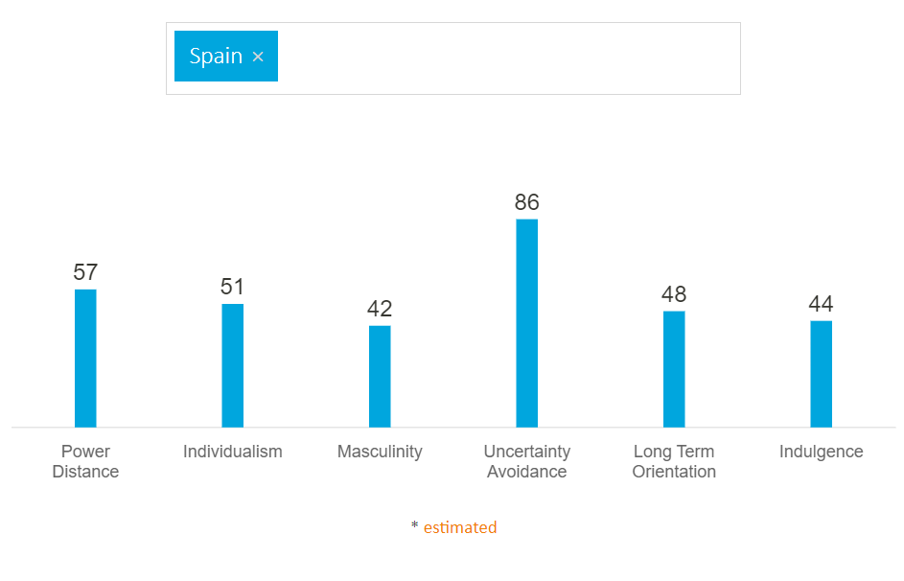
(Hofstede Insights. 2021)

In Spain, the power distance has a high score of 57, indicating that employees accept the hierarchical society and appreciate their position. The management must build confidence in their employees and offer them opportunities to express themselves, otherwise, they may feel underappreciated. As a result, customer feedback is important to them.
Individualism obtains a score of 51, indicating that employees may be perceived as blunt or aggressive, and is classified as a collectivist culture; nevertheless, in comparison to China, it is classified as an individualist culture. Otherwise, employees in the hotel industry usually operate in groups, indicating that their culture is likely collectivism.
Spain has a score of 42 on the masculinity model, indicating that it is likely to become a part of Feminine culture, and this is shown in the fact that employees are free to express their thoughts or any worries, allowing managers to analyse and prepare for employee requirements.
Uncertainty avoidance has a high score of 86 and tends to focus on the employee's expectations, requirements, and involved them in the activities are more likely to give good customer service, resulting in an advantage to the hotel.
Long-term orientation in Spain has a score of 48, indicating that employees anticipate hearing back from their managers about their jobs immediately and that 1-on-1 meetings may be arranged to provide fresh information and updates.
The low score of 44 is assigned to indulgence. Indulgence is not presented in Spain. Employees are categorised as being positive.

Country B: China (Guest’s culture)

China belongs to Confucian Asia and is defined by its poor interaction with others in terms of respect and harmony; the Chinese people do not even smile sufficiently.
Because they focus on messages with an important topic, aim, and tonality, Chinese people are contributing to the high context cultural dimension. They are concentrating on guest-employee communication in the context of hospitality ( Hsu, Woodside, and Marshall, 2013).
In China, a key feature of this cultural dimension is that everyone follows the same religion, has the same degree of education, and practises the same faith.

Hofstede six dimensions of cultural differences

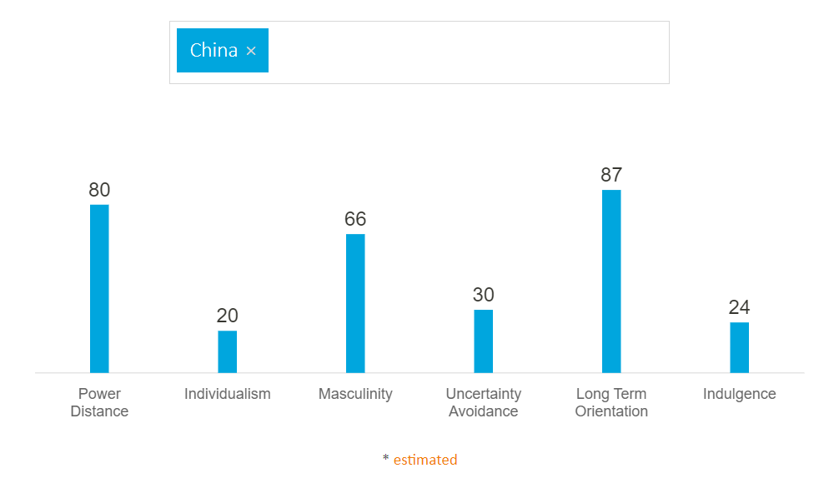
(Hofstede Insights. 2021)

In China, power distance is reflected by a score of 80, which denotes a high score that grants visitors the right to select high-quality products, services, and places based on their social position. Chinese visitors choose travel packages that incorporate recreational activities. They tend to complain and be arrogant about hotel services.
Individualism society has a low score of 20, indicating that the Chinese people are more inclined to follow a collectivist culture.
Masculinity is indicated by a high score of 66, which Chinese people want in terms of service quality.
Uncertainty avoidance is demonstrated by the Chinese visitor who has a low score of 30, indicating that they are not a loyal guest and are not willing to try new foods on the hotel menu, preferring to eat what they are familiar with.
Long-Term Orientation had a high score of 87, indicating that visitors place a premium on the quality of services and values.
As an indulgence community, Chinese tourists have a low score of 24, indicating that they are more restrained and categorised as a gloomy culture. They are less likely to provide comments online, or if they do, they will leave a negative rating.

Countries analysis: Spain and China

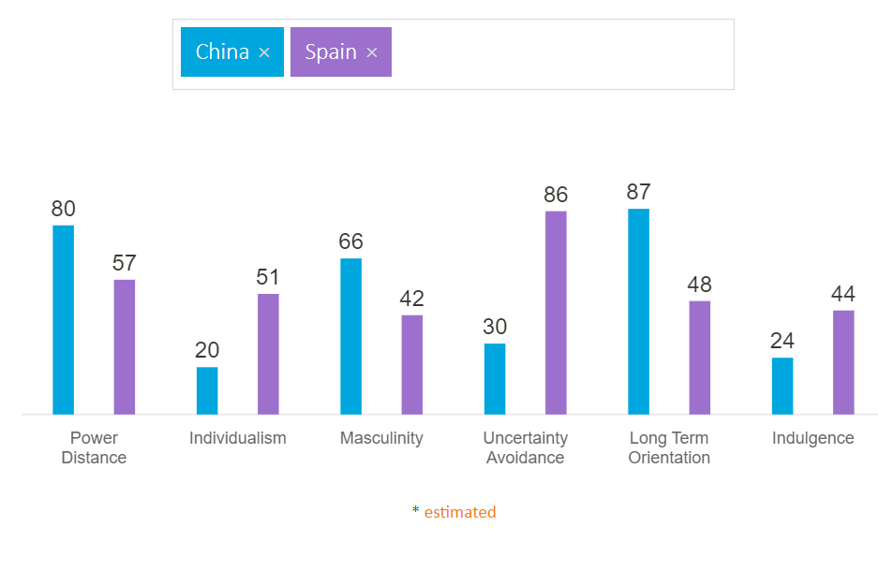
(Hofstede Insights. 2021)

The only difference between the two countries is the level of uncertainty avoidance, which shows a significant cultural gap because China has a score of 30 while Spain has a score of 86. This means that Spanish employees are concerned about change and require support to avoid feeling stressed, whereas Chinese visitors are looking to use services that are already familiar to avoid frustration. A difference across cultures indicates the indulgence of society. China has a low score of 24, whereas Spain has a score of 44, indicating that they are more optimistic and cheerful, but the Chinese are characterised as pessimistic.

Park Hotel Barcelona Employee Handbook
Department | Do’s | Don’t
Front Office | - knowledgeable of the shops' location, hours of operation, specials, and themed evenings.  - Control body language.  - Provide flexibility and consider their demands.  - Fast track of check-in and check-out | - Do not use negative feelings  - Do not allocate the rooms that include number four;
Restaurant & Bar | - Offer breakfast at 7 is and dinner around 6:30 PM.  - Speak the Chinese language  - Place them at the big table | - Don’t use products of milk  - Don’t put the chopsticks in the food  - Don’t place the teapot with the spout facing somebody, because this is considered bad luck.

Conclusion and Recommendation

Therefore, the Hofstede analysis of the six cultural aspects aims to supply employers at Park Hotel Barcelona in Spain with information about Chinese customers' needs and expectations to compile a hotel handbook for their personnel.
The handbook will feature information about the visitors' cultural backgrounds, as well as their wants and expectations, making it easier for staff to comprehend and follow to deliver exceptional customer service.
Employees must attend training and use the table of "do's" and "don't" for a better understanding of the culture of the guest according to the recommendation.

Reference list

China culturetour.com. 2021. Introduction to the Chinese Traditional Etiquette Customs. [online] Available at: <https://www.chinaculturetour.com/culture/etiquette-customs.htm> [Accessed 6 December 2021].
Gallarza-Granizo, M.G., Ruiz-Molina, M.-E. and Schlosser, C. (2020) 'Customer value in Quick-Service Restaurants: A cross-cultural study, International journal of hospitality management, 85, p. 102351–. Doi: 10.1016/j.ijhm.2019.102351.
Hofstede Insights. 2021. Country Comparison - Hofstede Insights. [online] Available at: <https://www.hofstede-insights.com/country-comparison/china,spain/> [Accessed 5 December 2021].
Hsu, S.-Y., Woodside, A.G. and Marshall, R. (2013) ‘Critical Tests of Multiple Theories of Cultures’ Consequences: Comparing the Usefulness of Models by Hofstede, Inglehart and Baker, Schwartz, Steenkamp, as well as GDP and Distance for Explaining Overseas Tourism Behaviour’, Journal of travel research, 52(6), pp. 679–704. doi:10.1177/0047287512475218.
Huang, S. (Sam) and Crotts, J. (2019) ‘Relationships between Hofstede’s cultural dimensions and tourist satisfaction: A cross-country cross-sample examination’, Tourism management (1982), 72, pp. 232–241. Doi: 10.1016/j.tourman.2018.12.001.
Insights. 2021. Understanding cultural differences in hospitality. [online] Available at: <https://insights.ehotelier.com/insights/2017/03/17/understanding-cultural-differences-hospitality/> [Accessed 4 December 2021].
Linkedin, 2021. Cultural Intelligence and Its Importance in the Workplace. [online] Available at: <https://www.linkedin.com/pulse/cultural-intelligence-its-importance-workplace-margot-paz> [Accessed 4 December 2021].
Liu, A., Fan, D.X.F. and Qiu, R.T.R. (2021) ‘Does Culture Affect Tourism Demand? A Global Perspective’, Journal of hospitality & tourism research (Washington, D.C.), 45(1), pp. 192–214. doi:10.1177/1096348020934849.
Roque, H.C. and Ramos, M. (2019) 'The importance of cultural training in the hospitality sector, European journal of tourism, hospitality and recreation, 9(2), pp. 58–67. doi:10.2478/ejthr-2019-0007.
Spain culture. 2021. Guide to Spain | Spanish Etiquette, Customs & Culture | Kwintessential. [online] Available at: <https://www.kwintessential.co.uk/resources/guide-to-spain-etiquette-customs-culture-business> [Accessed 3 December 2021].

