Module title: Changemakers: Creativity and Value Creation
Module code: BMHP5014
student name: Hinna Hussain
student ID: 2419356

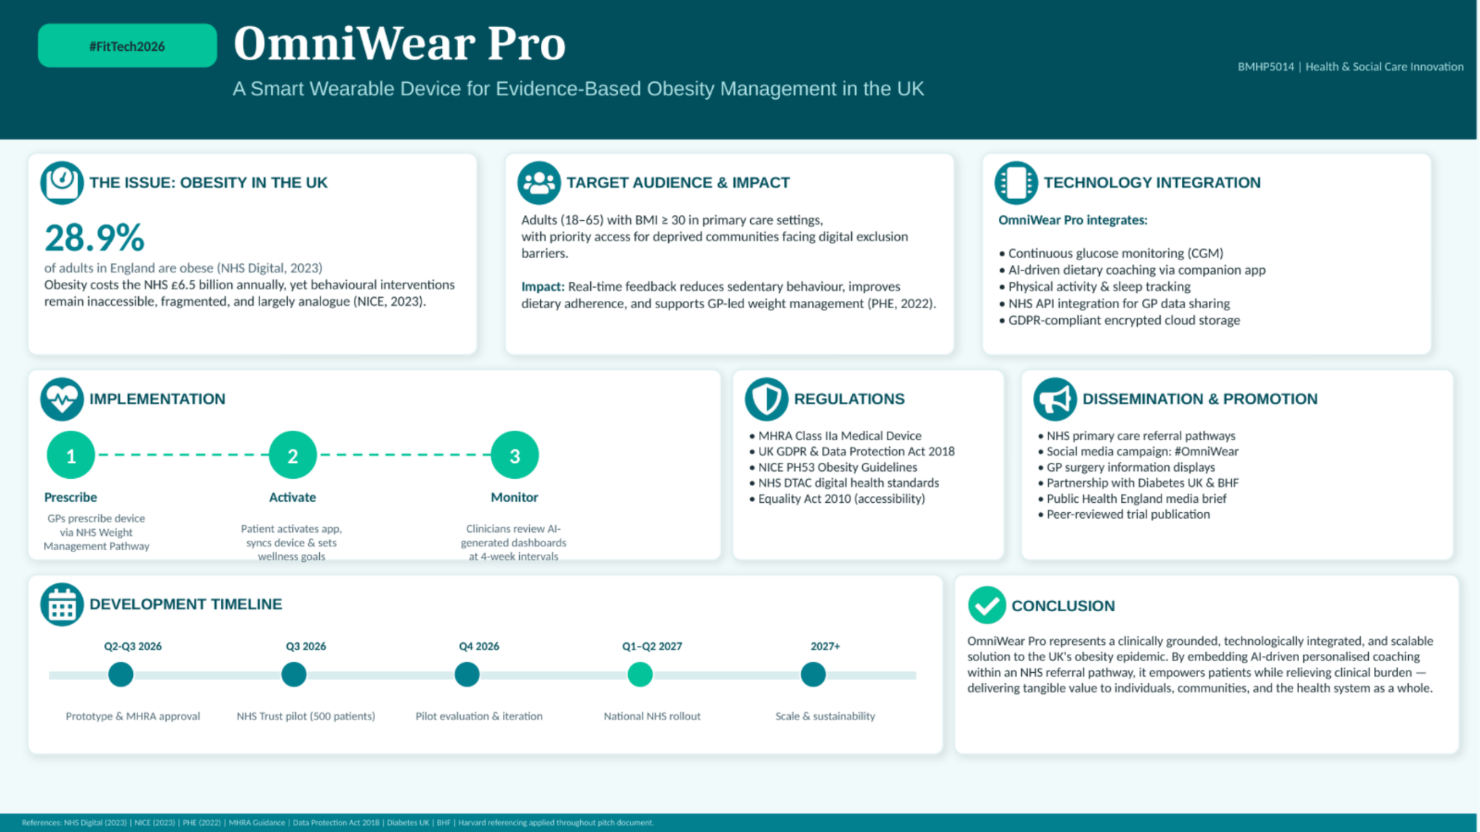

Omniwear Pro: The Case for Innovation
Obesity is one of the greatest public health threats faced by the United Kingdom in the twenty-first century. The proportion of adults classified as obese in England has remained higher than ever over the last 20 years and, according to NHS Digital (2023), will continue to grow to 31.7% unless any meaningful structural change happens. The economic cost is also of great concern, with the estimated cost to the National Health Service of obesity-related conditions of £6.5 billion per year, and the figure is predicted to be £9.7 billion by 2050 if current obesity trends remain (NICE, 2023). Current interventions (dietary counselling, pharmacotherapy, and bariatric surgery) are either resource-intensive and not widely available in socioeconomically deprived areas (Public Health England, 2022) or lack personalisation to facilitate sustained behaviour change.
I propose OmniWear Pro: a clinically integrated smartwear technology designed to deliver real-time, AI-personalised coaching for individuals struggling with obesity. This innovation directly responds to the gap between clinical recommendations and lived patient experiences with a scalable, evidence-based solution that is consistent with NHS England’s LonTerm Plan (2019), which calls for prevention, personalised care, and digital transformation.

The Community this Innovation Impacts
OmniWear Pro is aimed at adults (aged 18 to 65) with a Body Mass Index (BMI) of 30 or over who are registered with a GP practice in England and have been referred via the NHS Weight Management Service. The device is intentionally based on equity, however. Research shows that obesity is much more common in poorer communities; for example, people in the poorest 20% of England are more than twice as likely to be obese as those in the richest 20% (Public Health England, 2022). In addition, there is a higher proportion of obesity-related co-morbidities (Type 2 diabetes, cardiovascular disease) seen in Black, Asian, and Minority Ethnic (BAME) communities at lower BMI cut-offs (Diabetes UK, 2021).
To prevent these groups from being left behind by the technology that’s designed for them, OmniWear Pro will offer a subsidised device lending plan with NHS Integrated Care Boards, multilingual interfaces for AI coaching, and offline capabilities for those without internet access. This approach affirms the principle of innovation outlined in this module (Carlile and Jordan, 2012), emphasising that innovation should serve the common good.

Health and Wellbeing Outcomes
OmniWear Pro offers more than just health benefits. The device continuous glucose monitoring (CGM) feature will let users see changes in their blood sugar levels right after eating, which was once only available to people with diabetes but can greatly help those who are pre-diabetic, obese, or just want to understand how their food affects them (Doupis et al., 2022). This AI companion app will employ machine learning based on anonymous NHS data to give personalised advice on nutrition, activities, and sleep routines, all of which can help with weight management.

Moreover, the secure API that connects OmniWear Pro data to the NHS GP record will help shift the way care is delivered by allowing practitioners to access patient progress dashboards during their scheduled appointments instead of episodic, reactive care. This is in line with the NHS Five Year Forward View aim to deliver a ‘radical upgrade in prevention’ and NICE Clinical Guideline PH53 on obesity management in adults (NICE, 2023; NHS England, 2014). Preliminary results from similar wearable interventions suggest that 5–10% of the weight lost is maintained for 12 months in populations of engaged users, which is the range that correlates with clinically significant decreases in cardiovascular and metabolic risk (Jensen et al., 2019).

Policy, Legislation, and Professional Services
OmniWear Pro will be regulated and legislated to a strong degree. It is a device that includes physiological monitoring and falls under the scope of the UK Medical Devices Regulations 2002 (as amended after Brexit) and is subject to regulation by the Medicines and Healthcare products Regulatory Agency (MHRA). Any patient information stored on the platform must follow the UK General Data Protection Regulation (UK GDPR) and the Data Protection Act 2018, which ensures that patients have control over their health information and that sharing data with NHS systems is safe and approved (ICO, 2021).
There is a multidisciplinary ecosystem for professional delivery. Referrals are initiated by GPs, supplementary consultations are offered by NHS dietitians and health coaches; and commissioning at a regional scale is managed by ICSs (Integrated Care Boards). The Equality Act 2010 also stipulates that OmniWear Pro should be accessible to people with disabilities, facilitated by its tactile feedback, screen reader compatibility and adaptive coaching features. The NHS Digital Technology Assessment Criteria (DTAC) framework offers extra assurance of the clinical safety, data standards, and interoperability of digital technologies before deployment (NHS England, 2021).

Public Engagement and Campaign Involvement
I believe that the success of OmniWear Pro isn't just about clinical adoption; it's about meaningful community engagement. There are three reasons why the public should be at the centre of this campaign, which include legitimacy, reach, and sustainability.
Public participation in innovation in health first increases the legitimacy and the cultural appropriation of the intervention. The device coaching content will be culturally sensitive, language-accessible, and motivating for target communities (including deprived neighbourhoods and BAME groups) through participatory co-design workshops (Greenhalgh et al., 2017). Second, a social media campaign using the hashtag #OmniWear will leverage the existing social media networks of the public to normalise obesity as a systemic health problem rather than a personal failing, addressing one of the most significant factors that prevents individuals from seeking obesity treatment: the stigma associated with obesity (Puhl and Heuer, 2010). The campaign will be pitched at the combined membership of over two million with Diabetes UK and the British Heart Foundation.
Third, public engagement has the power to continue momentum after the clinical encounter. The spread of OmniWear Pro is rapid within communities as the social proof from others in the community increases, which is a mechanism already proven in the theory of health behaviours (Bandura, 1986). Recruited from NHS Volunteer Responders, community health champions will be peer advocates in their communities who provide short educational sessions in GP waiting rooms, community centres and faith spaces.

Conclusion
OmniWear Pro is more than just a technology product — it's a public health intervention that puts patients' power in their hands and empowers professionals to provide proactive, preventative health care. OmniWear Pro embodies the principles of creativity, value creation, and innovative thinking for the common good that this module promotes and values; it aligns with the existing NHS infrastructure, is supported by evidence, complies with all relevant legislation, and targets the communities most affected by obesity. I hope other healthcare commissioners, doctors, and patients alike will recognise the value of OmniWear Pro in moving toward a healthier and fairer UK.

References
Bandura, A. (1986) Social Foundations of Thought and Action: A Social Cognitive Theory. Englewood Cliffs, NJ: Prentice Hall.
Deng, Y., Manninen, M., Hwang, Y., and Taewoo, K.A. (2019) ‘Efficacy of lifestyle interventions to treat pediatric obesity: A systematic review and multivariate meta-analysis of randomized controlled trials’, Obesity Reviews, 20(4), pp. 576–588. Available at: https://onlinelibrary.wiley.com/doi/10.1111/obr.13817
Diabetes UK (2021) Us, Diabetes and a Lot of Facts and Stats. London: Diabetes UK. Available at: https://keep-healthy.com/wp-content/uploads/2020/06/diabetes-facts-stats.pdf
Equality Act 2010. Available at: https://www.legislation.gov.uk/ukpga/2010/15
Greenhalgh, T., Hinton, L., Finlay, T., Macfarlane, A., Fahy, N., Clyde, B. and Hussain, L. (2017) 'Frameworks for supporting patient and public involvement in research: Systematic review and co-design pilot', Health Expectations, 22(4), pp. 785–801. Available at: https://onlinelibrary.wiley.com/doi/10.1111/hex.12888
Information Commissioner's Office (ICO) (2021) Guide to the UK General Data Protection Regulation (UK GDPR). Available at: https://ico.org.uk/for-organisations/guide-to-data-protection/guide-to-the-general-data-protection-regulation-gdpr/
NHS Digital (2023) Health Survey for England 2022: Overweight and Obesity in Adults and Children. Leeds: NHS Digital. Available at: https://digital.nhs.uk/data-and-information/publications/statistical/health-survey-for-england
NHS England (2014) NHS Five Year Forward View. London: NHS England. Available at: https://www.england.nhs.uk/wp-content/uploads/2014/10/5yfv-web.pdf
NHS England (2019) The NHS Long Term Plan. London: NHS England. Available at: https://www.longtermplan.nhs.uk/wp-content/uploads/2019/08/nhs-long-term-plan-version-1.2.pdf
NHS England (2021) Digital Technology Assessment Criteria (DTAC). Available at: https://www.nhsx.nhs.uk/key-tools-and-info/digital-technology-assessment-criteria-dtac/
NICE (2023) Obesity: Identification, Assessment and Management. Clinical Guideline PH53. London: National Institute for Health and Care Excellence. Available at: https://www.ncbi.nlm.nih.gov/books/NBK588750/
Public Health England (2022) Adult Obesity and Type 2 Diabetes. London: PHE. Available at: https://fingertips.phe.org.uk/profile/obesity-physical-activity-nutrition
Puhl, R.M. and Heuer, C.A. (2010) 'Obesity stigma: Important considerations for public health', American Journal of Public Health, 100(6), pp. 1019–1028. Available at: https://ajph.aphapublications.org/doi/full/10.2105/AJPH.2009.159491
UK Medical Devices Regulations 2002 (SI 2002/618, as amended). Available at: https://www.legislation.gov.uk/uksi/2002/618

