

LOCATION: SWANSEA | LLEOLIAD: ABERTAWE
LEVEL 4 | LEFEL 4
EXAMINATION PERIOD | CYFNOD ARHOLIADAU
2023 | 2023
MODULE CODE: ACCB4017
SOFTWARE DEVELOPMENT
(IN-CLASS TEST – time to BE ARRANGED BY MODULE LECTURER)
TIME: 2 HOURS
answer all questions

Equipment or materials required. Please select from the following:
Adnoddau neu ddefnyddiau sydd eu hangen.

Cyfrifiannell/Calculator ☐
Llyfr Agored/Open Book ☒
Arall/Other ☐

Nodwch/Please Note: Students will answer the questions below using the programming language they have studied during the module. The questions/solutions shown below refer to the Python language, but some groups may be studying the module using other programming languages (such as C). Therefore the paper will be adapted to reflect this if required.

Additionally, at some delivery locations, where the test is delivered via electronic means such as Moodle, questions may be drawn from a random pool, but will be in the style and of a similar difficulty level to those listed below.

ANSWER ALL QUESTIONS

1. a) Which variable type would be most suitable to store each of the following values?

p string

-41 integer

Gemma string

2.56 float

G5 complex

34.62 float

[1 mark each - 6 marks total]

1 b)

What errors are present in the following code for welcoming a user to a program? Line numbers are included for easy reference

1 print(Welcome to my program")
2
3 print("Please enter your name: ")
4 myName = int(input())
5
6 print("Welcome, " myName)
7
8 print("I shall say hello to you 10 times: ")
9
10 for counter in range(0, 11)
11 print("Hello")

[5 marks]
- In line 1 there is not a starting “ for what is to be printed to the user
- In line 6 there is no additional sign like a comma to concatenate the printed string and variable myName
- In line 10 there is no incrementation value present in the range as we know it is going from 0 to 11 but we don’t know if it is in 1s 2s etc.

1 c) How many iterations do the following loops have?

for i in range(2, 6, 1): 4
print("Hello")

for i in range(0, 12, 2): 5
print("Hello")

[4 marks – 2 marks each]
1. d) What is the value of the integer variable total after the following code is executed?

total = 1
for x in range(0, 9, 1):
total = total + x
if x == 5:
total = 0
total = total - 1

29 [3 marks]

This is because although the for loop adds up the numbers to make 46, the if statement resets the value of total so only the addition for 6, 7, 8 and 9 are counted. In addition to this, the final line in the code subtracts one from the total therefore making the value of total to be 29.

1 e) Logic

- Given the following values x=5, y=2, z=15 is the statement below true or false?
x<=y
false

- Given the following values x=5, y=3, z=12 is the statement below true or false?
x == z/y
false

[2 marks total]

[20 marks total for Question 1]

2. Calculating the volume of a cone

The volume of a cone is calculated using the formula shown below:
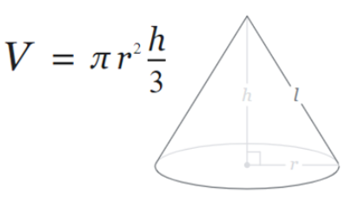

Task:
Write a program to calculate the volume using the above formula.

Allow the user to enter the measurements for r and h. Both r and h should be positive numbers. You can set pi to 3.142

Print the volume on the screen to 2 decimal places
[10 marks total for Question 2]

internal class Program
{
private static void Main(string[] args)
{
//VARIABLES
const double Pi = 3.142;
double ConeVolume;
double Radius;
double Height;

//User Input for Values Radius and Height
//Radius
Console.WriteLine("Please enter the radius of the cone");
Radius = Convert.ToDouble(Console.ReadLine());

//Range Check to ensure that a value is entered that is more than 0
do
{
if (Radius < 1)
{
Console.WriteLine("Error! Invalid value Entered. Value must be Positive!");
Console.WriteLine(" ");
Console.WriteLine("Please enter the radius of the cone");
Radius = Convert.ToDouble(Console.ReadLine());
}
}
while (Radius < 1);

Console.WriteLine(" ");

//Height
Console.WriteLine("Please enter the height of the cone");
Height = Convert.ToDouble(Console.ReadLine());

//Range Check to ensure that a value is entered that is more than 0
do
{
if (Height < 1)
{
Console.WriteLine("Error! Invalid value Entered. Value must be Positive!");
Console.WriteLine(" ");
Console.WriteLine("Please enter the height of the cone");
Height = Convert.ToDouble(Console.ReadLine());
}
}
while (Height < 1);

//Calculates the volume of the cone
ConeVolume = Pi * (Radius * Radius) * (Height / 3);

//Outputs the volume of the cone to 2 decimal places
Console.WriteLine("The volume of the cone is " + String.Format("{0:0.00}", ConeVolume));

Console.WriteLine("Press Enter to exit the program");
}
}
3. Using lists (Python) or arrays (C etc)

Task:
Declare an empty list in your program to hold some measurements, for example:

rainfall = [ ]

1. Prompt the user to enter five (valid) rainfall measurements (in millimetres) and store them in a list. (eg 3.3, 5.0, 2.6 etc)
2. Print each of the entered values on the screen using a loop.
3. Calculate the total rainfall (ie add all five measurements)
4. Also calculate the average rainfall and print it on the screen

Sample output:
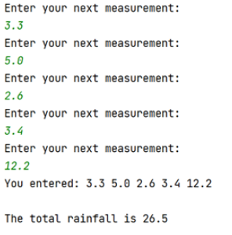
[15 marks total for Question 3]

#Using Lists/Arrays

TotalRainfall = 0.0

#Create the array
Rainfall = []

#For loop to populate the array with five measurements of rainfall
for Counter in range (0, 5, 1):
RainMeasurement = float(input("Please enter the measurement of rainfall in millimetres: ")) #Receive input from user of the measurements of rainfall to put into the array

#Range check to ensure that a number that is 0 or more is entered - 0 is a valid value if there is no rainfall
while (RainMeasurement < 0):
if(RainMeasurement < 0):
print("Invalid rainfall entered! Please enter a number that is 0 or more")
print(" ")
RainMeasurement = float(input("Please enter the measurement of rainfall in millimetres: "))

Rainfall.append(RainMeasurement) #Adds each measurement of rain to the array
TotalRainfall = TotalRainfall + RainMeasurement #Calculates the total rainfall as the loop collects values

print(" ")

print("Rainfall Measurements:")

#For loop prints each rainfall measurement to the user
for Counter in range (0, len(Rainfall), 1):
print(Rainfall[Counter], end=" ")
print("")

#Calculates the average rainfall
AverageRainfall = TotalRainfall / 5

#Outputs the total and average rainfall to the user
print(" ")
print("The total rainfall is " + str(TotalRainfall))
print("The average rainfall is " + str(AverageRainfall))
4. Using Functions

Task:
Write a function called entermeasurement() which will allow the user to enter a measurement for one side of a parcel and then return it to the main program. The function should also check that the measurement entered is greater than 0.

From the main program, call your entermeasurement() function 3 times - once for each of the length, width and height measurements, and print the measurements returned on the screen.

Also, calculate and print the volume of the parcel (length * width * height) on the screen.

Sample output:

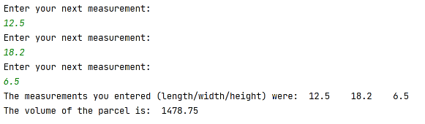
[15 marks total for Question 4]

#Using a function to measure the volume of a parcel - Assuming that each measurement is at least 1
#Creating the function
def entermeasurement(): #Defining the function
return float(input("Please enter your measurement: ")) #Establishing what the function returns to the main body of code

#Gets user measurements of the parcel form user by calling the function entermeasurement
print("Please enter the measurements of the parcel (length/width/height):")

#Length
Length = entermeasurement()

#Range check to ensure that a number that is more than 0 is entered
while (Length < 1):
if(Length < 1):
print("Invalid measurement entered! Please enter a number that is 1 or more")
print(" ")
Length = entermeasurement()

#Width
Width = entermeasurement()

#Range check to ensure that a number that is more than 0 is entered
while (Width < 1):
if(Width < 1):
print("Invalid measurement entered! Please enter a number that is 1 or more")
print(" ")
Width = entermeasurement()

#Height
Height = entermeasurement()

#Range check to ensure that a number that is more than 0 is entered
while (Height < 1):
if(Height < 1):
print("Invalid measurement entered! Please enter a number that is 1 or more")
print(" ")
Height = entermeasurement()

#Outputs the inputted measurements to the user
print(" ")
print("The measurements you entered (length/width/height) are: ")
print(Length)
print(Width)
print(Height)
print(" ")

#Calculates the volume of the parcel
ParcelVolume = Length*Width*Height

#Outputs the volume of the parcel to the user
print("The volume of the parcel is: " + str(ParcelVolume))

Diwedd/End

