STRATEGIC MANAGEMENT FOR HOLLAND AND BARRETT

NAZIA CHOUDHURY
STUDENT 1817657

STRATGIC MANAGEMENT FOR SME’S
BMSW6104

TUTOR: PAUL BOCIJ

Contents
INTRODUCTION 3
1: STRATEGIC MANAGEMENT: 4
1.1 PROCESS 4
1.2 MISSION / VISION 5
1.3 PORTERS 5-FORCES 7
2: INTERNAL AND EXTERNAL ANALYSIS: 9
2.1 SWOT ANALYSIS: 9
2.2 PESTLE ANALYSIS: 11
3 STAKEHOLDER ANALYSIS: 14
4:STRATEGIC GROWTH OPTIONS: 16
4.1 BCG GROWTH SHARE MATRIX: 16
4.2: SAFe Matrix (Suitability, Acceptability, Feasibility) 17
4.3: ANSOFF MATRIX: 19
5: KEY STRATEGIC RECOMMENDATIONS – LEWINS 3-STEP MODEL 20
5.1 FORCE FIELD ANALYSIS 22
6: COMPETITOR REACTIONS 23
CONCLUSION: 23
REFERENCES: 24

INTRODUCTION

This report will look at three strategic management strategies for sustainability for the organisation Holland and Barratt.
This report will look at how the organisation adapts its micro environment to external factors by applying internal functions of business, strategies and objectives (Eidizadeh, 2017) by using Porters 5-Forces framework, SWOT and PESTEL analysis and a stakeholder analysis to analyse the organisations competitive environment. he report will then go on to do a BCG Growth Share Matrix, SAFe Matrix and Ansoff matrix to identify the needs of the organisation to remain sustainable, competitive and keep its market share (Uchegbulam and Akinyele, 2015) of being a world leader in the health supplement industry. It will then propose strategies based on the findings of the BCG Growth Share Matrix, SAFe Matrix and Ansoff matrix analysis tools. The report will conclude by using Lewin’s 3 step strategy and Force Field Matrix to determine how to implement the chosen strategy.
With over 150 years of experience Holland and Barrett are the market leaders for health and wellness being, they sell supplements, vitamins, dietary requirement food, sports nutrition and natural beauty goods. They have 1,660 retail stores all over the world, generating a turnover of £700 million. However prior to the Corona virus lockdown, Holland and Barratt suffered a multi million pound loss of £25.9 million in the UK in 2019. This was due to rising distribution costs and administration expenses and ‘impairment of capitalised costs for a new IT project and some legal disputes’ (Cherubini, 2020). Business however turned around during the pandemic due to an increase in the demand for online shopping especially for vitamins and supplements as customers became more health conscious during the pandemic (Lordan, 2021).

1: STRATEGIC MANAGEMENT:

According to Fuetes et al (2020) Strategic management is developing a holistic understanding of an organisations strategic long term objectives and goals and plans of how to achieve them through their interaction with the internal and external environment. However they go on to say that whilst traditional formulation of strategies is ‘discrete, directional and differentiated’ they should also be ‘dynamic, uncertain and interactive’.
For example, currently Holland and Barrett’s competitive strategy is selling quality products at reasonable prices (Shevchenko, 2019). They use a multi-channel marketing strategy of stores, online and mobile app. They are also unique due to being environmentally responsible to be competitive (Zadek, 2006) through their ‘Plan-it Green’ campaign which recycles 90% of their waste making them a Green company.
1.1 PROCESS: in order to keep competitive advantage and market share, Holland and Barrett need to look at their long term survival with a strategic management plan. These can be planned intended strategies like the vision and mission statement or unplanned emergent strategies due to sudden changes which can be taken advantage of (Mintzberg and Waters, 1985). Systematic approaches looking at connecting the organisation to its environment to ensure continued success so that the organisation survives and grows into future and is sustainable. This is done by adding value to make profit (Ulrich, 1996), ie Holland and Barrett can do this by expanding their product range.
This is done through systematic process, which involves (Shujahat et al, 2017):
- Determining the purpose and aims of the organisation through its mission
- 5 year plan on how to achieve goals over time
- Assuring continued success in the future
- Protecting organisation from emergent situations ie pandemic
- Achieving competitive advantage

There are 5 basic steps to achieve this (Chang, 2006):
- Environmental scanning – external factors (i.e. Brexit, covid19 pandemic, etc)
- Internal scanning – strengths and weaknesses (SWOT)
- Strategy formulation (5yr plan)
- Strategy implementation (each year breakdown)
- Evaluation and control (looking at results to make sure plan works and take action to fix problems so on target).
This systematic approach is illustrated in the diagram below:
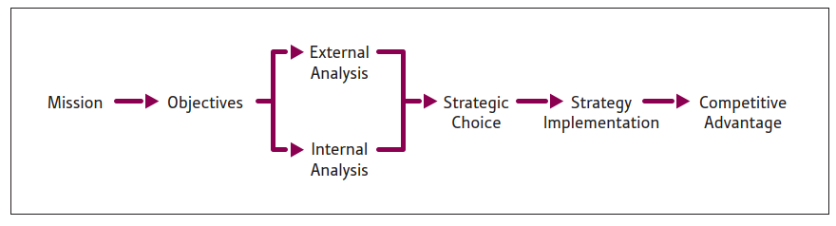 (Barney & Hesterly, 2018, p. 27)

Planned strategies can be looked at by the organisations functions which are at different levels:
- Operational: operational goals and decisions are shorter and specific (daily, store level) i.e. staff absence, special offers
- Tactical: strategic goals/objectives (1 year, regional) i.e. monthly promotions, seasonal products
- Strategic: vision / mission decisions are longer and broader (5 years, whole organisation) ie going green

1.2 MISSION / VISION
Strategy describes how to achieve the mission of the organisation by long term planning and is about competitive advantage, which is measured through achieving greater market share (Sial et al, 2013). The mission should be a statement of values and have strategic intent which should be clear and have a ‘polygon of purpose’ and impact on performance and profitability. It should also be measurable so progress can be achieved and specify when results will be achieved too (Darbi, 2012). The Vision should describe where the organisation wants to be in the future (5yrs).
Holland and Barrett’s mission statement is ‘to make health and wellness a way of life for everyone’ which is a good mission as it does indicate what they sell (Bart, 1998). However, it is not saying how it will be sustainable or giving a timeframe of results and is not specific to which people it is targeting – ie rich or poor people? A good mission statement will be ‘specific but not too constraining’ (Markides and Papadakis, 1998). They could improve their mission statement by saying instead ‘to live a more healthy and sustainable life’. The mission is also limiting of services or products they could branch out too. The mission is also limiting for the store staff as they have targets to push the vitamins and supplements more as this is the demand but they shouldn’t just stick to these products but branch out and push other products that the organisation has missed out on for example, keto products. Another weakness of the mission statement is that it does not focus on mental health which is a rising problem currently, although one would associate mental health with the mission statement, the organisation is not really doing anything about this problem by offering any services, they could pick up on the psychological side in the future, ie healthy mind; healthy body, but currently they are just focusing on healthy body. They have the scope in the future to work with the NHS for this. They could also expand in the future by selling vitamins to schools.
Their vision statement is ‘To enhance the well-being of our customers around the world by delivering the highest quality, best value nutritional supplements and wellness products, bringing wellness to the world one happy customer at a time’ (Holland and Barrett, 2022). This does not really meet SMART (Jung, 2007) objectives (specific, measurable, attainable, relevant, time based) as the vision doesn’t give a time frame or 5 year plan or say how it will increase its customer base. It also focuses on products and not services which is not innovative enough or sustainable as it is easy to be imitated and undercut by competitors (Casadesus‐Masanell and Zhu 2013). This is especially important as environmental factors like the current war with Russia, higher national insurance, Covid19 pandemic, has affected customers spending power and how they purchase. Although Holland and Barrett have had an increase in online sales, their store sales have declined during the pandemic as people were going out less (Dunn, 2020), therefore they need to be more ambitious in what they sell and branch out by being co-opetive and working with other organisations. For example, they could expand in the future by selling vitamins to schools or selling in gyms.
To keep a competitive advantage as market leaders in the health industry, Holland and Barrett are required to continuously adapt and innovate against their competitors like Superdrugs and Boots (Adams et al, 2016). This can be done through analysis of its structure using Porters 5-Forces to make strategies and control its behaviour in the environment.
1.3 PORTERS 5-FORCES is a framework which analyses the competitive market for profitability and growth by identifying each force to develop a competitive strategy (Goyal, 2020):
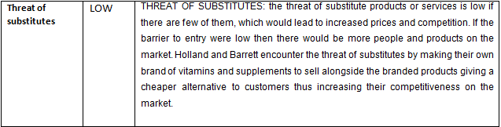
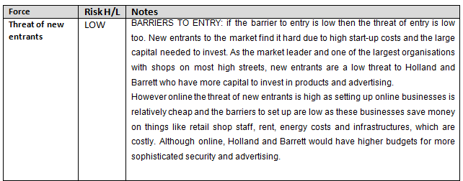

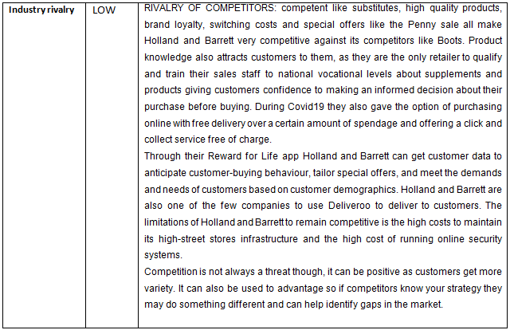
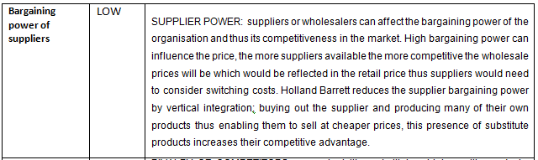
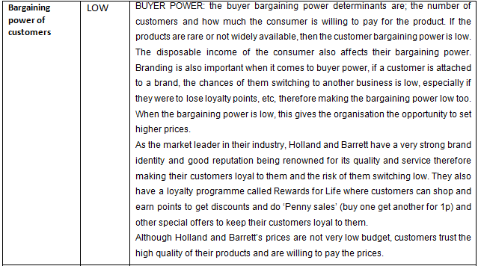
Table 1: PORTER’S 5 FORCES

Holland and Barrett can become more sustainable by looking at their competitive strategy using Porter’s Strategic Typology (Akan, 2006) :
- Cost reduction: based on reducing costs lower than competitors, ie through saving on labour costs by training store staff to multitask and reduce switching costs by locking in customers through loyalty reward cards/points.
- Differentiation: creating a unique product/service, ability to innovate and educate customers about what is special about the new product/service.
- Focus: specialising in a niche market, relying on brand loyalty thus making market unattractive to competitors.

2: INTERNAL AND EXTERNAL ANALYSIS:
The environment affects organisations, therefore the report will look at Holland and Barrett’s micro and macro environment using the tools Swot analysis for the micro environment and Pestle for the macro environment to analyse the changes that may happen in the future that would have an effect on their business (Bass et al, 1995).

2.1 SWOT ANALYSIS:
Swot analysis is done to understand the organisation and identify weaknesses, minimise threats, take advantage of opportunities and strengths to make business strategies and goals. However, it does have limitations like over simplification and not taking into account other organisations strengths and weaknesses (Jamali et al, 2017).
The ratings and importance are done on a scale of 1-5, 5 being the highest: the score is then found by multiplying the importance and rating.

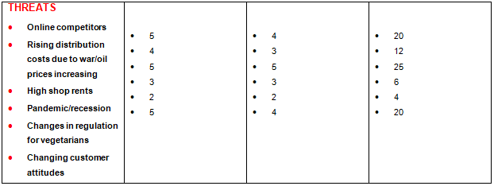
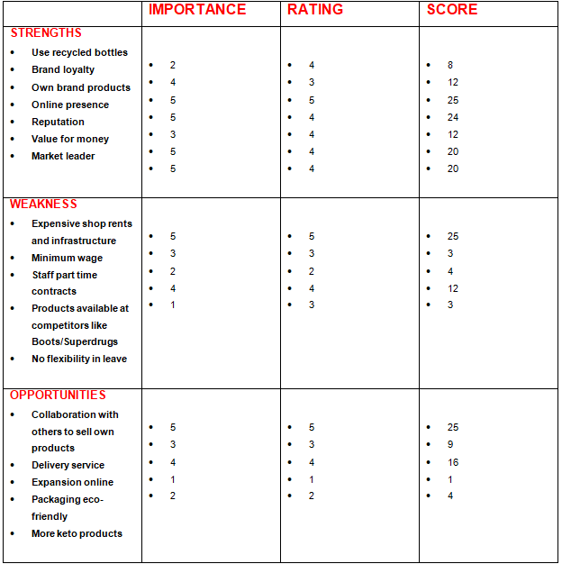
Table 2: SWOT Analysis

From the SWOT analysis, we can see that one of the highest score of 25 is for having their own brand products. This is very important for Holland and Barrett as it has enabled them to keep the supplier power low and profits high (Mills, 1995) , thus reducing costs at selling as they manufacture the products themselves which is cheaper and so they can sell the products cheaper too. Their own brand vitamins and supplements are also their most popular products and have enabled them to stay competitive, as their competitors cannot sell this exact product other than in another brand.
Another important factor identified is the opportunity to collaborate with others to sell their own products which scored 25 this is something that Holland and Barrett can capitalise on to innovate a new strategy as their own products are also their best selling products and exclusive to them (Huang and Huddleston, 2009).
With shop sales declining the threat of rising shop rents which scored 25 in the SWOT is worrying for Holland and Barrett as this could affect their market share if their competitors like Boots who are also a well know high street store take over the market if Holland and Barrett need to close down stores (Ball et al, 2021).
After looking at these factors, it is clear that Holland and Barrett need to come up with strategies to minimise the threats like high shop rents and take advantage of the strengths and opportunities like their own brand products and working with other organisations.

2.2 PESTLE ANALYSIS:
It is important for organisations to do a Pestle analysis to identify factors that will affect their organisation (Çitilci and Akbalık 2020). Although the disadvantage is that it only looks at the external environment, it is beneficial to summarise the status of the business quickly and to help to identify the organisation threats in the future and make strategies to avoid and reduce their impacts (Yüksel, 2012).

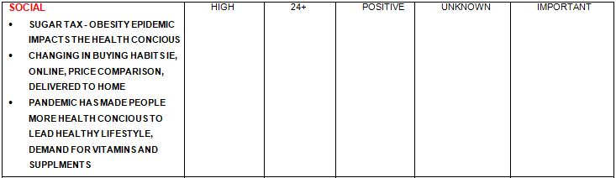
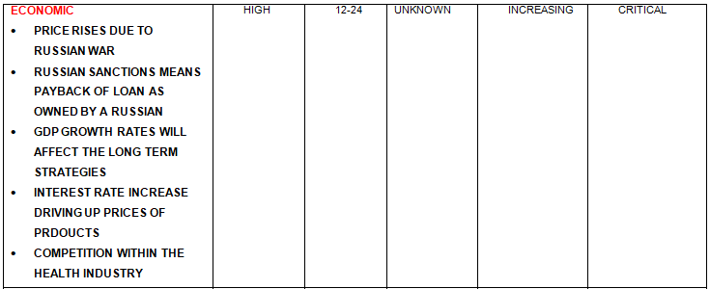
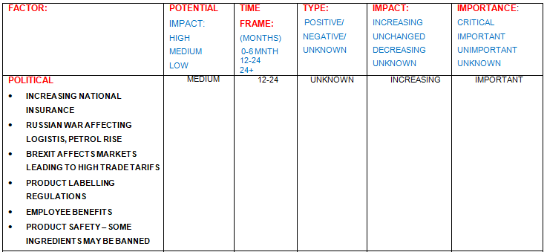

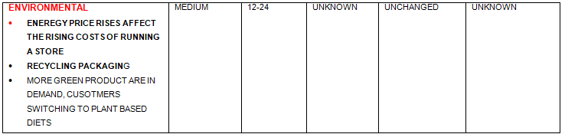
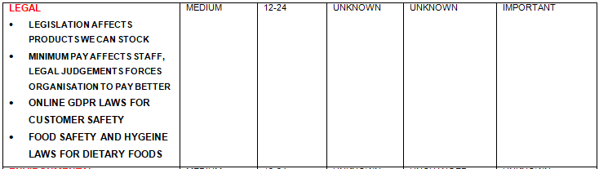
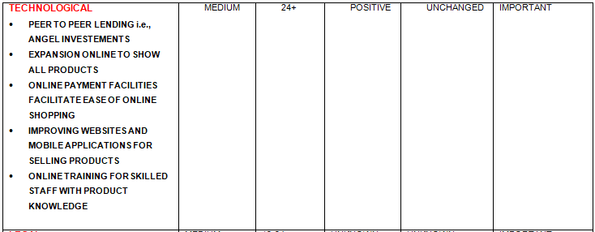
Table 3: PESTEL Analysis

The table above shows the factors that affect Holland and Barrett as well as looking at the level of importance, type, time frame, impact and potential on the company:
From the PESTLE analysis, shows that there are many factors that affect Holland and Barrett, for example, the changes in legislation and laws can affect new product launches (Shatskaya et al, 2016). The potential impact would be medium which would be seen in a 12-24 month time frame and is a negative type as it limits the production of products thus the impact is unknown if this is good or bad for the business as it limits the products but also reduces risks to customers so its importance is currently unknown. The rising energy prices is also an environmental factor that needs o be carefully considered as costs of running a store could be higher, this would have an impact on product prices unless other ways of cutting costs are looked at ie staff roles/intakes, alternative cheaper platforms of selling product i.e. online, etc. This will be seen over the next 12-24 months. Another legal factor would be minimum pay legislation, this would mean a smaller margin for Holland and Barrett and therefore less profit, however, well paid staff give loyalty and are motivated therefore give better service to the company and its customers (Ludviga and Kalvina, 2016).
Another important factor that the Pestle has identified is a social factor of people becoming more health conscious due to the pandemic, which has led to an increase in demand for vitamin and supplement sales at Holland and Barrett, therefore the potential impact is high and important which will be seen on over the next 24 months. The changing legislation laws of clear labelling (LeCong, 2007) have benefited the organisation, as customers are happy and confident to buy the good quality supplements and vitamins at Holland and Barrett as opposed to buying inferior substitutes from their competitors like Boots. Therefore, the potential impact is medium but is important as it affects the profits and customer loyalty. However, Economic factors like price rises due to the war in Russia are also important; we will know the full impact over the next 12-24 months. Nevertheless, the potential and current impact is high as customers are more careful in how they spend their money with rising living costs and job uncertainty so Holland and Barrett need to keep their prices competitive and meet customer expectations (Rodríguez-Díaz, 2018).

3 STAKEHOLDER ANALYSIS:
Stakeholder holder analysis is done to identify the stakeholders that will have an impact on the organisation and grouping them according to the interest and power, they hold (Varvasovszky and Brugha, 2000). It is a business strategy divides people into 2 groups: those that have direct contact with the organisation and those that done. Those that add value to the organisation is the most important all others are secondary. Stakeholders can be analysed by Power and Influence (Jepson and Eskerod, 2009). Power comes from their position in the organisation ie the CEO of Holland and Barrett would be the most powerful and the cleaner the least. Influence comes from social relations, for example, a personal assistant would be the gatekeeper to the CEO.
From the Mendelow Matrix analysis below (Van den Broek, 2020) it can be seen that customers of Holland Barrett have high power but low interest as they arnt involved in making decisions or the running of the organisation, they do have some interest but it is limited. To manage them the organisation needs to check on them and keep them involved in some decisions i.e. through feedback and keep them updated through newsletters. Customers would be kept satisfied by low prices and promotions.
The most important stakeholder with the most power would be the CEO as they have the most influence and is the key decision maker. They would be kept satisfied by keeping costs down and keeping profits high. They would need to be kept informed of profits, promotions and any arising problems this would be done through monthly meetings.

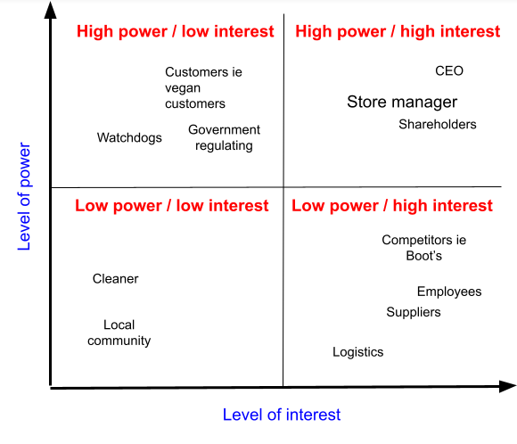
TABLE 4: Mendelow Matrix

4: STRATEGIC GROWTH OPTIONS:
In order to stay competitive in the market and remain sustainable, Holland and Barrett need to look at new growth strategies. Using the BSG (Boston Consulting Group) Growth Share Matrix to find out what the most profitable products are, the report will suggest three growth strategies and choose one using the SAFE tool, which will give Holland and Barrett more market share and profits long term. The report will then use Ansoff Matrix to define the strategy in relation to the market growth.

4.1 BCG GROWTH SHARE MATRIX:
The Growth Share Matrix helps to prioritise products / services to maximise profitability (Reeves et al, 2014). It identifies the least and the most profitable products using 4 categories
- Stars: HIGH SHARE / HIGH GROWTH
- Cash Cows: LOW SHARE / LOW GROWTH
- Dogs: LOW SHARE / LOW GROWTH
- Problem Child: LOW SHARE / HIGH GROWTH
These allow organisations to see where their most value can be attained from and what to remove for market growth and market share.
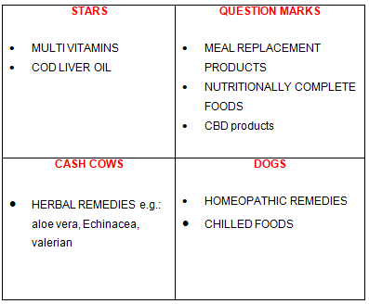
Table 5: BCG Growth Share Matrix
The matrix above shows that the Star category which generates long-term sale and high ROI (return on profit). The organisation needs to judge when market share will grow or shrink and invest when it is busy / high. The star is most desirable as it can be grown / developed and can be relied on long term (Mohajan, 2017). For Holland and Barrett this would be their multivitamins and Cod liver oil especially in demand since the Corona pandemic for the health conscious.
The Cash Cow category: usually needs less support and has less competition because of low growth. The profit from these however can be used to fund the ‘Stars’. For Holland and Barrett, this would their own range of herbal remedies like Aloe Vera. The matrix also shows that the products that are the Dogs can be a drain on organisation resources, which could be directed elsewhere, this is why Holland and Barrett have removed their chilled foods section.

4.2: SAFe Matrix (Suitability, Acceptability, Feasibility)
The three strategies that the report recommends are:
1) To go online and expand their problem child products of CBD which is becoming hugely popular as it is not available everywhere (due to Government guidelines of ingredients and strengths allowed) and in times of pandemic especially with new variants and illnesses emerging, CBD products (which are used to help with pain, anxiety, depression, etc) are increasing in demand.
2) To go into areas like mental health. Holland and Barrett’s mission statement hints about mental health and wellness, yet they do not offer any services for customers or staff. This could be addressed by offering counselling services in stores.
3) Selling their ‘Cash cow’ products of vitamins and supplements at gyms where people are already health conscious (Remus-Cristian, et al, 2015). Making deals with gyms around the country to supply them and in the future maybe to other countries as well. Customer would also be able to earn loyalty points on purchases.
Holland and Barrett use SAFe Matrix to select a strategy. It uses a top down approach for strategic planning, looking at strategic analysis, strategic choice and strategic implementation using the 3 R’s: RISK, RETURN, REACT balancing risk against high reward return using the categories below (figure 1) scoring each category on a scale of 1-10. The option with the highest score is the best one strategy to use.
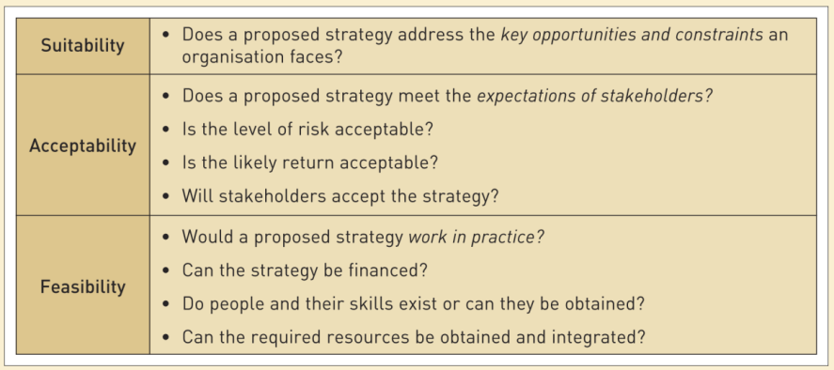
Figure 1: Source: Johnson, Whittington and Scholes, Exploring Strategy, 9th Edition, London: Pearson Education (Support Materials)

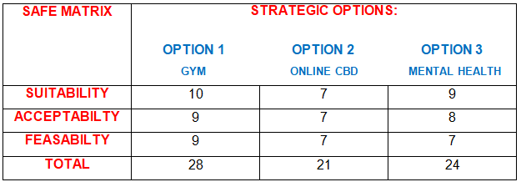
Table 7: SAFe Matrix
From the SAFe Matrix shows that Option 1 of the Gym strategy scored the highest mark showing that selling vitamin and supplements at gyms would be the best strategy for Holland and Barrett (Senekal et al, 2021). It meets the organisations vision and goals focusing on health and wellness for everyone delivering the best nutritional supplements, which most gym users see as a beneficial lifestyle choice and many people now are health conscious due to increasing illnesses and the pandemic. It also takes advantage of the Opportunity factor in the SWOT of working with other vendors as well as the Strengths factors of brand loyalty, good reputation, value for money for own brand products to ensure customers buy the products and the incentive of loyalty points scheme ensures that customers stay loyal and purchase (Berman, 2006). This strategy would also minimise the threats of high shop rents as it would cheaper to rent a small space or sell directly to the gym instead of paying high shop rents on high streets which would kep the main stakeholders, especially the CEO happy.
The other two options did not score high as the cbd products are still a problem child with no guarantees of high sales (Hossain and Kader, 2020). The mental health strategy may also not be feasible is it would need specialist counsellors and private space on shop floors which may not be possible.

4.3: ANSOFF MATRIX:
The Ansoff Matrix can further develop the winning strategy for market growth. It gives four strategic categories and highlights the levels of risk associated to them for the business (Hussain et al, 2013):
- Market penetration: targets existing market with existing products for greater market share ie through promotions
- Market development: targets new markets like other countries with existing products
- Product development: targets existing markets with new or improved products
- Diversification: targets new markets with new products
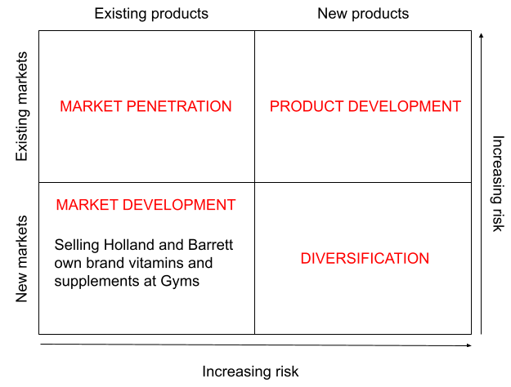
table 8: Ansoff Matrix
The Ansoff Matrix shows that the new strategy of selling vitamins and supplements at gyms would be through Market Development. Selling new products in new markets is risky; however, Holland and Barrett would be selling its existing products especially its ‘star’ and ‘cash cow’ products to a new market (Loredana, 2017). They could even sell their ‘problem child’ products of meal replacements products and nutritional complete food (which would be attractive to gym users who are the normal target market for these products) in the gym and in the future to gyms in other countries. There is some risk as it is a new market that they would be selling to, but they can reduce this risk by using existing products and staff.
There are however, limitations to the Ansoff Matrix, these are things like whilst risk is highlighted, reward is not. It does not account competitor actions who might copy and undercut prices. In addition, the creating new products category invalidates the diversification category as they cover the same thing (Patrick Sim, 2015).

5: KEY STRATEGIC RECOMMENDATIONS – LEWINS 3-STEP MODEL
When businesses are successful they are reluctant to make any changes, however in order to remain competitive and sustainable they need to innovate and implement strategies (Aaltonen and Ikävalko, 2002) that are both cost leadership strategies and differentiation strategies. They need to change their strategies to adapt to the changing environment as shown in the SWOT and PESTEL analysis. Lewin’s 3 Step model helps to implement the strategy by unfreezing the status quo to assess, implement change, then refreezing so that it becomes the norm (Bamford and Forrester, 2003). This involves planning, involvement and communication. The strategy will be implemented by starting selling in gyms in the UK in the first year, then go to Wales and Scotland the second year, then branch out abroad to Europe. Within 5 years, it will be available in gyms in the UK and Europe. In order to implement the plan, more sales forces will be needed to work at the gyms. A new website would also be needed for gyms to order online as well as a new finance system to deal with companies not the public. With any kind of change there is always resistance i.e, staff may not be happy that they need to learn the new finance system at the gyms, this could perhaps be countered by closing stores down to focus on change. Staffs need to be motivated to accept new ways of working for better results. For example, communicating with them through meetings and newsletters, so they feel included and do not resist (Genç, 2017). They need to feel power, influence and heard.
In order to unfreeze staff so that they are ready for change; they can be given training, be spoken to individually, or store employees can become sale people at the gym, splitting their shifts. We could make them happy to travel to the gyms by giving bonuses, paying for their travel, etc.

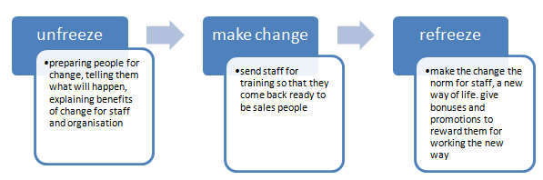
Table 9: Lewins 3-step model

Whilst change is being implemented, there would be a dip in productivity as staffs learn new processes and skills, however, if change is made in the correct way, productivity will increase more than before (Hussain et al, 2018).
After refreezing, the organisation becomes more stable and staffs are back to normal and become more efficient and productive.

5.1 FORCE FIELD ANALYSIS
Force Field Analysis also by Lewin is a quick and easy way of selecting strategy and making managerial decisions. It is used for general decision making; looking at forces in favour of and not in favour of change. If an organisation is stable and balanced, it will work to sustain the equilibrium / status quo. Forces can be adjusted and pushed towards the desired state (Burnes, 2020).
Force Field analysis looks at restraining forces that resist change and driving forces that affect the change and assigns a score of 1-10
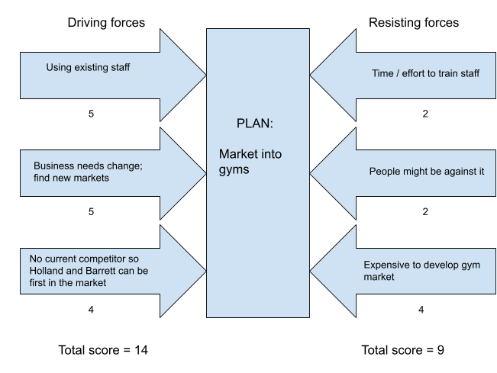
Table 10: Field Force Analysis

The side with the highest score (Driving Forces) pushes us to make change, however Holland and Barrett want to influence making the change, this can be done for example by reducing restraining forces by rewarding or offering bonuses (Rowley and Sherman, 2002). Driving forces can be increased by online training as that is a cheaper option.

6: COMPETITOR REACTIONS
When implementing a new strategy, competitors need to be considered and how they will react. For Holland and Barrett, their main competitor is Boots, who may want to move into this field as well when they see the market potential. Entry barriers can be set by, preventing Boots from entering the market through exclusive contracts (Degraba, 2013) with the gyms. Another approach would be to use only own brand products to limit the entry to market, so if one approach does not work the second approach can be used.

CONCLUSION:
The report looked at SWOT analysis from which it found the most important factors for Holland and Barrett was the strength of selling own brand vitamins and supplements and threat of high shop rents. From the Pestle it identified that consumers were more health conscious which led to a rise in the demand for good quality vitamins and supplements. The pestle also identified that vitamins are limited to selling to the public; however, the SWOT opportunities suggested expanding to other markets, which was shown in section 4 through broadening the market by using a competitive, sustainable strategy selling to gyms in the UK and abroad too which would ensure market share. The report also showed how the Ansoff Matrix expanded on this by showing how the strategy would be low risk for Holland and Barrett as it uses existing products in but in new market. It went on to show how through using Lewins 3-step model and Force Field analysis, the strategy would be implemented.
In the strategy section, the report developed an approach that Holland and Barretts competitor Boots does not use, of selling its products in gyms, the competition section identified that Boots would be naturally competitive. The report would offset this by suggesting exclusivity contracts and selling own brand products for sale only, thereby limiting the threat of competitor entry to market as shown in the Porters’ 5-Forces.
In conclusion, the report identified an opportunity, developed a strategy to take advantage of that, and made a plan that deals with possible competition. Therefore, this is the best strategy for Holland and Barrett for the next 5 years.

REFERENCES:
- Aaltonen, P. and Ikävalko, H., 2002. Implementing strategies successfully. Integrated manufacturing systems.
- Adams, R., Jeanrenaud, S., Bessant, J., Denyer, D. and Overy, P., 2016. Sustainability‐oriented innovation: A systematic review. International Journal of Management Reviews, 18(2), pp.180-205.
- Akan, O., Allen, R.S., Helms, M.M. and Spralls, S.A., 2006. Critical tactics for implementing Porter's generic strategies. Journal of business strategy.
- BALL, S., HIGGINS, D. and NASH, H.A., 2021. ROLE HISTORIC ASSETS CAN PLAY IN REVIVING THE RETAIL HIGH STREET: A CASE STUDY OF DERBY’S RETAIL HIGH STREET. WIT Transactions on The Built Environment, 203, pp.201-213.
- Bamford, D.R. and Forrester, P.L., 2003. Managing planned and emergent change within an operations management environment. International journal of operations & production management.
- Bart, C.K., 1998. Mission matters. The CPA Journal, 68(8), pp.56-57.
- Bass, S., Dalal-Clayton, B. and Pretty, J., 1995. Participation in strategies for sustainable development. London: IIED.
- Berman, B., 2006. Developing an effective customer loyalty program. California management review, 49(1), pp.123-148.
- Burnes, B., 2020. The origins of Lewin’s three-step model of change. The Journal of Applied Behavioral Science, 56(1), pp.32-59.
- Casadesus‐Masanell, R. and Zhu, F., 2013. Business model innovation and competitive imitation: The case of sponsor‐based business models. Strategic management journal, 34(4), pp.464-482.
- Chang, G.C., 2006. Strategic planning in education: Some concepts and steps. Paris: United Nations Educational, Scientific and Cultural Organization.
- Cherubini, E., 2020. Holland & Barrett slumps to multimillion loss ahead of coronavirus healthy eating boost. [online] The Grocer. Available at: <https://www.thegrocer.co.uk/results/holland-and-barrett-slumps-to-multimillion-loss-ahead-of-coronavirus-healthy-eating-boost/645410.article#:~:text=Holland%20%26%20Barrett%20slumps%20to%20multimillion%20loss%20ahead%20of%20coronavirus%20healthy%20eating%20boost,-By%20Elena%20Cherubini&text=Holland%20%26%20Barrett%20slumped%20to%20a,demand%20during%20the%20coronavirus%20crisis.> [Accessed 11 April 2022].
- Çitilci, T. and Akbalık, M., 2020. The Importance of PESTEL Analysis for Environmental Scanning Process. In Handbook of Research on Decision-Making Techniques in Financial Marketing (pp. 336-357). IGI Global.
- Darbi, W.P.K., 2012. Of mission and vision statements and their potential impact on employee behaviour and attitudes: The case of a public but profit-oriented tertiary institution. International Journal of Business and Social Science, 3(14).
- DeGraba, P., 2013. Naked exclusion by a dominant input supplier: Exclusive contracting and loyalty discounts. International Journal of Industrial Organization, 31(5), pp.516-526.
- Dunn, A., Hood, K. and Driessen, A., 2020. Measuring the effects of the COVID-19 pandemic on consumer spending using card transaction data. US Department of Commerce, Bureau of Economic Analysis.
- Eidizadeh, R., Salehzadeh, R. and Esfahani, A.C., 2017. Analysing the role of business intelligence, knowledge sharing and organisational innovation on gaining competitive advantage. Journal of Workplace Learning.
- Fuertes, G., Alfaro, M., Vargas, M., Gutierrez, S., Ternero, R. and Sabattin, J., 2020. Conceptual framework for the strategic management: a literature review—descriptive. Journal of Engineering, 2020.
- Genç, R., 2017. The importance of communication in sustainability & sustainable strategies. Procedia Manufacturing, 8, pp.511-516.
- Goyal, A., 2020. A Critical Analysis of Porter’s 5 Forces Model of Competitive Advantage. Goyal, A.(2021). A Critical Analysis of Porter’s, 5.
- Holland & Barrett. 2022. Our beliefs and values. [online] Available at: <https://www.hollandandbarrettcorporate.com/about-us/our-beliefs-and-values> [Accessed 11 April 2022].
- Hossain, H. and Kader, M.A., 2020. An Analysis on BCG Growth Sharing Matrix. International Journal of Contemporary Research and Review, 11(10).
- Hussain, S., Khattak, J., Rizwan, A. and Latif, M.A., 2013. ANSOFF matrix, environment, and growth-an interactive triangle. Management and Administrative Sciences Review, 2(2), pp.196-206.
- Hussain, S.T., Lei, S., Akram, T., Haider, M.J., Hussain, S.H. and Ali, M., 2018. Kurt Lewin's change model: A critical review of the role of leadership and employee involvement in organizational change. Journal of Innovation & Knowledge, 3(3), pp.123-127.
- Jamali, G., Asl, E.K., Zolfani, S.H. and Šaparauskas, J., 2017. Analysing larg supply chain management management competitive strategies in Iranian cement industries.
- Jepsen, A.L. and Eskerod, P., 2009. Stakeholder analysis in projects: Challenges in using current guidelines in the real world. International journal of project management, 27(4), pp.335-343.
- Jung, L.A., 2007. Writing SMART objectives and strategies that fit the ROUTINE. Teaching Exceptional Children, 39(4), pp.54-58.
- LeCong, F., 2007. Food supplements directive: An attempt to restore the public confidence in food law. Loy. LA Int'l & Comp. L. Rev., 29, p.105.
- Lordan, R., 2021. Dietary supplements and nutraceuticals market growth during the coronavirus pandemic–Implications for consumers and regulatory oversight. Pharmanutrition, 18, p.100282.
- Loredana, E.M., 2017. The use of Ansoff matrix in the field of business. Annals-Economy Series, 2, pp.141-149.
- Ludviga, I. and Kalvina, A., 2016. Exploring the relationships between job satisfaction, work engagement and loyalty of academic staff. International Journal of Economics and Management Engineering, 10(1), pp.99-101.
- Markides, C. and Papadakis, V.M., 1998. What constitutes an effective mission statement: an empirical investigation. New managerial mindsets: Organizational transformation and strategy implementation. United Kingdom: John Wiley and Sons, pp.35-54.
- Mills, D.E., 1995. Why retailers sell private labels. Journal of Economics & Management Strategy, 4(3), pp.509-528.
- Mintzberg, H. and Waters, J.A., 1985. Of strategies, deliberate and emergent. Strategic management journal, 6(3), pp.257-272.
- Mohajan, H., 2017. An analysis on BCG growth sharing matrix.
- Patrick Sim, M.M., 2015. An Investigative Model of Marketing Expansio n Strategies: PPL Shipyard, Singapore. J Account Mark, 4(144), p.2.
- Reeves, M., Moose, S. and Venema, T., 2014. The growth share matrix. BCG–The Boston Consulting Group.
- REMUS-CRISTIAN, V.Ă.I.D.Ă.H.Ă.Z.A.N. and IACOB, H., 2015. WEIGHT TRAINING IN GYMS AS LEISURE TIME PHYSICAL ACTIVITY: THE PRACTITIONER PROFILE. EDUCATIO ARTIS GYMNASTICAE, p.11.
- Rodríguez-Díaz, M., Rodríguez-Díaz, R., Rodríguez-Voltes, A.C. and Rodríguez-Voltes, C.I., 2018. Analysing the relationship between price and online reputation by lodging category. Sustainability, 10(12), p.4474.
- Rowley, D.J. and Sherman, H., 2002. Implementing the strategic plan. Planning for Higher Education, 30(4), pp.5-14.
- Senekal, M., Meltzer, S., Horne, A., Abrey, N.C., Papenfus, L., van der Merwe, S. and Temple, N.J., 2021. Dietary supplement use in younger and older men exercising at gyms in Cape Town. South African Journal of Clinical Nutrition, 34(1), pp.1-8.
- Shatskaya, E., Samarina, M. and Nekhorosheva, K., 2016. PESTEL analysis as a tool of strategic analysis in international markets. SCOPE ACADEMIC HOUSE B&M PUBLISHING, 47.
- Shevchenko, M.N., Dorofeev, A.F., Dobrunova, A.I., Chugay, D.Y. and Lebed, A.V., 2019. The choice of competitive strategy of agricultural enterprise. Инновации в АПК: проблемы и перспективы, (3), pp.105-116.
- Shujahat, M., Hussain, S., Javed, S., Malik, M.I., Thurasamy, R. and Ali, J., 2017. Strategic management model with lens of knowledge management and competitive intelligence: A review approach. VINE Journal of Information and Knowledge Management Systems.
- Sial, A., Usman, M.K., Zufiqar, S., Satti, A.M. and Khursheed, I., 2013. Why do public sector organizations fail in implementation of strategic plan in Pakistan. Public Policy and Administration Journal, 3(1), pp.33-41.
- Uchegbulam, P. and Akinyele, S.T., 2015. Competitive strategy and performance of selected SMEs in Nigeria.
- Ulrich, D., 1996. Human resource champions: The next agenda for adding value and delivering results. Harvard Business Press.
- van den Broek, K.L., Luomba, J., Onyango, H.O., Musobya, M. and Klein, S.A., 2020. A framework for co‐developing conservation research projects with stakeholders: A Lake Victoria case study. Lakes & Reservoirs: Research & Management, 25(4), pp.403-412.
- Varvasovszky, Z. and Brugha, R., 2000. A stakeholder analysis. Health policy and planning, 15(3), pp.338-345.
- Yüksel, I., 2012. Developing a multi-criteria decision making model for PESTEL analysis. International Journal of Business and Management, 7(24), p.52.
- Zadek, S., 2006. Responsible competitiveness: Reshaping global markets through responsible business practices. Corporate Governance: The international journal of business in society.

