

"One and Done?”
Therapists’ Perspectives Of Single Session Therapy And The Therapeutic Relationship: A Narrative Inquiry

This dissertation has been submitted by Louise Wright
to
the University of Wales Trinity Saint David
partial fulfilment of the requirements for a
Masters in Psychotherapeutic
Practice: Humanistic, under the supervision of
Dr. Beverly Cole

July 2026

Abstract

Since the Covid-19 pandemic, the demand for counselling has increased, leading to lengthy waits for psychological interventions. As a result, this has led to new approaches to psychotherapy being implemented and a rise in a Single Session Therapy (SST) approach to counselling. Existing research has explored the SST approach in relation to client outcomes. However, literature relating to therapists’ perceptions of working with clients in an SST setting is limited. To address the gap in current research, this study examined how therapists narrated their experiences of building the therapeutic relationship within SST.

A qualitative research approach was applied within this current research study in order to explore the experiences of five qualified counselling practitioners working in the field of SST. Data were collected via semi-structured interviews. Methodologically, this research was underpinned by a Paradigmatic Narrative Inquiry, which supported the researchers ontological stance in that knowledge was a socially constructed concept and that reality is created through relationships with others.

Participant narratives were analysed via a process of Reflexive Thematic Analysis which underpinned the identification of three core themes. The themes explored in this research project were: Intertwined Perspectives and Understanding Working Practice; Navigating Professional Identity and Being Heard as a Therapeutic Act.

Findings indicated time was a major factor in how therapy was perceived. Participant narratives revealed that time was perceived as a friend during long term therapy and conversely as an enemy during SST. Time was also connected to power and control. Findings also revealed that participants expressed confusion over which approach should be taken during the implementation of SST sessions.

This study concluded that the development of the therapeutic relationship was dependent as to how the counsellor approached the single session model and whether this method of working was one of personal choice or organisational requirement. The method of approach used by the counsellor within a single session approach determined to what degree the client-therapist relationship developed. Recommendations for practice and suggestions for future research are outlined at the end of this research project.

Key Words: Single Session Therapy; Counselling; Paradigmatic Narrative Inquiry

Declaration

This work has not previously been accepted in substance for any degree and is not being concurrently submitted in candidature for any degree.
Signed:  (candidate)
Date: 01/06/2026
Statement 1
This dissertation is being submitted in partial fulfilment of the requirements for the degree of Masters in Psychotherapeutic Practice: Humanistic.
Signed: (candidate)
Date: 01/07/2026
Statement 2
This dissertation is the result of my own independent work / investigation, except where otherwise stated. Other sources are acknowledged by footnotes giving explicit references. A bibliography is appended.
Signed: (candidate)
Date: 01/07/2026
Statement 3
I hereby give consent for my dissertation, if accepted, to be available for photocopying and for inter-library loan, and for the title and summary to be made available to outside organisations.
Signed: (candidate)
Date: 01/07/2026

I confirm that I have not used any AI tools in the research and creation of this assignment, and I have not presented any AI generated materials as my own work. I confirm I have copies of my drafts, notes, and other resources I used, which I may be asked to provide in evidence.

Dedication

This research is dedicated to Fay. The uplifting chats on Wednesday evenings helped me get to the finish line. A thank you to Bev for helping me through the process and for being there. Also, a huge thank you to Zoe for being my undeniable best friend through all of it.

Acronyms

NI: Narrative Inquiry
OAAT: One At A Time Therapy
PNI: Paradigmatic Narrative Inquiry
RTA: Reflexive Thematic Analysis
SST: Single Session Therapy
UWTSD: University of Wales Trinity Saint David

Figures and Tables

Figures
Chapter 3.4 Figure 3.1 : Clannadin and Connely Three-Dimensional Model of Narrative Inquiry
Chapter 3.11 Figure 3.2: Reflexive Thematic Analysis (RTA) Sequence
Chapter 3.11 Figure 3.3: RTA Phase 1: Example of Key Words, Coding, Reflective Notes and Quotations
Chapter 3.11 Figure 3.4: RTA Phase 2 : Illustration of Researcher Manual Coding/Sub-Coding and using Quotes Reflexively
Chapter 3.11 Figure 3.5 : RTA Phase 4 Initial Reflection on Themes Construction of Sub-Codes
Chapter 3.11 Figure 3.6: Phase 4 Revisited: RTA Refining and Defining Themes
Chapter 3.11 Figure 3.7: Phase 4 Revisited: RTA Refining and Defining Themes
Chapter 3.11 Figure 3.8: Phase 4 Revisited: RTA Refining and Defining Themes

Tables
Chapter 3.7 Table 3.1: Participant Demographics
Chapter 3.9 Table 3.2: Interview Questions
Chapter 3.11 Table 3.3: RTA Phase 3a Construction of Sub-Codes
Chapter 3.11 Table 3.4: RTA Phase 3b Construction of Main Codes
Chapter 4.1: Table 4.1: Final Themes
Chapter 5.1: Table 5.1: Findings and Theoretical Perspectives

Contents
Abstract i
Declaration iii
Dedication v
Acronyms vi
Figures and Tables vii
Chapter 1 : Purpose of Research 1
1.1 Introduction 1
Chapter 2 : Literature Review 3
2.1 Introduction to Literature Review 3
2.2 Literature Search Strategy, Inclusion and Exclusion Criteria 3
2.3 History, Evolution and Definition of Single Session Therapy 4
2.4 The OAAT/SST Mindset 6
2.5 OAAT/SST and the Therapeutic Relationship 8
2.6 OAAT/SST and Therapist Perceptions, Organisational Resistance and Ethical Implications 10
2.7 Literature Review Conclusion 13
2.8 Research Question 14
Chapter 3 : Research Methods and Methodology 15
3.1 Introduction 15
3.2 Research Paradigm 15
3.3 Ontological and Epistemological Position 15
3.4 Rationale for Paradigmatic Narrative Analysis 16
3.5 Ethical Considerations 18
3.6 Participant Criteria and Recruitment Strategy 18
3.7 Participant Demographic Information 19
3.8 Semi-structured Interview Protocol 20
3.9 Participant Interviews 21
3.10 Data Transcription 23
3.11 Data Analysis 24
Chapter 4 : Research Findings 31
4.1 Introduction 31
4.2 Theme One: Understanding Working Practice 32
4.2.1 Introduction to Theme One 32
4.2.2 Sub-Theme One: Understanding and Engagement 32
4.2.3 Sub Theme Two : Opinion and Choice 36
4.2.4 Sub Theme Three: Professional Boundaries and Ethical Responsibility 37
4.2.5 Sub Theme Four: Ways of Thinking and Mixing Methods 41
4.2.6 Theme One: Conclusion 42
4.3 Theme Two: Navigating Professional Individuality 43
4.3.1 Theme Two : Introduction 43
4.3.2 Sub-Theme One: Who Am I: Therapeutic Self-Identity 43
4.3.3 Sub-Theme Two: Peers, Belonging and Hierarchy 44
4.3.4 Sub-Theme Three: Therapy and Society 46
4.3.5 Theme Two: Conclusion 47
4.4 Theme 3: Being Heard as a Therapeutic Act 47
4.4.1 Theme Three : Introduction 48
4.4.2 Sub-Theme One : Witnessing, Validation and Making Connections 48
4.4.3 Sub-Theme Two: Letting Go 50
4.4.4 Theme Three: Conclusion 52
4.5 Conclusion to Findings 52
Chapter 5 : Discussion 54
5.1 Introduction to Discussion 54
5.2 Time as a Construct and the Management of the Therapeutic Relationship 55
5.3 OAAT/SST Practice is a Difficult Concept to Understand Professionally 60
5.4 Hierarchical Thinking and Inwardly Facing Beliefs Discourage Diversity and Equity 64
5.5 Discussion Conclusion 66
5.5.1 Implications for Future Practice 66
5.5.2 Recommendations 67
5.5.3 Limitations 68
Chapter 6 : Overall Conclusion 69
Reference List 70
Appendices I
Appendix 1: Participant Pack II
Appendix 2 : Researcher Analysis of Themes X

: Purpose of Research

Introduction

Since the COVID-19 pandemic, the demand for counselling has increased ( Romano, 2025; Chen et al., 2022). In the UK, long waiting lists have become common, affecting both public and third-sector services (Department of Health and Social Care, 2024; Welsh Government, 2024; Rethink Mental Illness, 2025). In response to demand, there has been an increase in Single Session Therapy (SST) delivery within the NHS, Universities and charity organisations (NHS, 2023; Bannon et al., 2025; University of Liverpool, 2025).

While single session counselling has become more commonplace in organisations, it has been a form of therapy used in private practice for some time (Cannistrà, 2024). Key figures in the field of SST propose this approach enables positive client change which challenges the idea that therapy should involve multiple sessions (Dryden, 2020; Cannistrà, 2022; Porter et al., 2025). However, academic research in this area has mainly focused on client outcomes rather than on therapist perceptions of single session working and the therapeutic relationship (Schleider et al., 2020; Mulligan et al., 2022; Finch et al., 2024).

The aim of this research project is to address the gap in literature. The current researcher will explore therapists’ views of the client-therapist relationship and examine perceived limitations and ethical implications in order to determine whether SST is regarded as a credible therapeutic approach within the counselling profession.

To achieve these aims, a Paradigmatic Narrative Inquiry (PNI) approach will be used to explore therapist narratives of SST working (Polkinghorne, 1995; Younas and Inayat, 2025). Semi-structured interviews will be conducted with five therapists to collect data, which will be analysed thematically to gain an understanding of how therapists perceive the client-therapist relationship in SST (Braun and Clarke, 2023).

This chapter has introduced the research project, outlining the aims and objectives proposed by the current researcher. Chapter Two charts the literature review examining SST practice. Chapter Three describes this researcher’s ontological and epistemological stance and provides an outline of the research methods that underpinned gathering and interpretation of data. Chapter Four summarises the research findings. Chapter Five provides a consideration of the data and outlines the limitations of this study. Chapter Six presents the conclusion and makes recommendations for future research.

: Literature Review

Introduction to Literature Review

This literature review provides an outline of current research into SST practice. It explores the historical context and definition of SST, the SST mindset, SST and the therapeutic relationship, organisational resistance, practical and ethical implications.

Literature Search Strategy, Inclusion and Exclusion Criteria

Databases Searched :

Academic Search Primer, APA PsycArticles PsycINFO, ECSBO, JSTOR, PubMed, ProQuest Central, Science Direct, SAGE Journals.

Search Terms :
Searches included combinations of the following keywords:
Single Session Therapy; One-At-A-Time Therapy; Short-term Therapy; Walk-In Therapy; Access to Psychological Therapies; Single Session Mindset; Pluralistic Therapy; Brief Psychotherapy; Therapeutic Relationship; Therapeutic Alliance.

Key words and symbols (for example, and/or/not and *) were used to both narrow and expand search results.
Inclusion Criteria:
Peer-reviewed journal articles (predominantly published between 2020–2025).
Research from counselling and psychotherapy that has explored SST, brief therapy, one-at-a-time-therapy, therapeutic relationship, therapeutic alliance, SST working, therapist and client experiences of SST, concerns and ethical implications surrounding SST working.

Exclusion Criteria:
Articles before 2020 unless seminal or vital to SST theory.
Grey literature unless used as suitable background material.

History, Evolution and Definition of Single Session Therapy

Early seminal figures within counselling and psychology demonstrated that a single therapy session could facilitate client change, meaning that no further intervention was necessary. Notable examples include the work of Fritz Perls, founder of Gestalt therapy (Perls, 1969); psychologist Milton Erickson (O’Hanlon and Hexum, 1990); Transactional Analysts Robert and Mary Goulding (Goulding and Goulding, 1997); psychoanalyst Sigmund Freud (Breuer and Freud, 2001) and Carl Rogers, founder of humanistic psychotherapy (Wickman and Campbell, 2003).

However, single session therapy did not emerge as a stand-alone counselling model until the 1990s. It was initially psychologist Moshe Talmon (1990) who noticed many of their clients ended therapy after their first session. When Talmon followed up with these clients, three-quarters of them stated they did not require any further sessions due to positive changes.

Later research has supported Talmons (1990) findings, with other studies across counselling modalities exploring client attendance reporting similar outcomes (for example: O’Keeffe et al., 2019; Oasi and Werbart, 2020; Leichsenring et al. , 2020; Bugatti et al., 2024). Several authors who have explored client drop out also conclude that the initial therapy session often has the greatest influence on overall client outcomes (Flückiger et al., 2018; del Río Olvera et al., 2022; Cooper et al., 2023). These findings support other studies in this area which conclude that many clients on average will attend just one session, even when more are available (Aafjes-van Doorn and Sweeney, 2019; Hoyt and Cannistrà, 2021; Pugh et al., 2023).

The research into client attendance and client drop out as outlined above has led to the ongoing development of SST its establishment as a credible counselling approach within contemporary society (Hoyt et al., 2018; Dryden, 2020; Cannistrà, 2022; Porter et al., 2025). However, as the terminology Single Session Therapy (SST) and One-At-A-Time Therapy (OAAT) are both used interchangeably which has contributed to some misunderstanding surrounding this way of working (Dryden, 2020; Cannistrà, 2024; Pugh, 2024; Żak and Pękala, 2025). To alleviate any confusion, single session theorists suggest that combining the terminology best supports the ethos of this approach. Therefore, from this point forward, the combined term OAAT/SST will be used in this study as this reflects how the model is defined.

OAAT/SST is defined as a single therapeutic client-therapist encounter capable of facilitating client change (Dryden, 2020). While clients may return for future sessions, the key principle is that each session is treated as an independent experience ( Dryden, 2020; Cannistrà, 2024; Porter et al., 2025). This sets OAAT/SST apart from traditional long term therapy approaches where change is considered an ongoing process relying on a client attending multiple sessions (Hoyt and Cannistrà, 2021).

While terminology is fundamental to understanding the ethos of OAAT/SST, authors argue how single session work is approached is central to its success (Porter et al., 2025). The following section explores this further.

The OAAT/SST Mindset

It is important to distinguish OAAT/SST from other brief therapies such as Solution-Focused Therapy (Iveson, 2002) or Short-Term Dynamic Psychotherapy (Michal et al., 2025). While these approaches minimise the number of sessions offered to a client, they are not single session approaches. OAAT/SST is designed around the principle of working in the present moment rather than pre-planning for further counselling sessions (Cannistrà, 2024).

Dryden (2020) emphasises that OAAT/SST is client-led. Building on this, other authors contend that if a further session is required, this should be viewed as a natural continuation of therapy rather than framed as therapist or client failure in that one session was not enough to address the issues raised (Hoyt and Rycroft, 2020; Porter et al., 2025).

Cannistrà (2022) and Porter et al. (2025) build on this philosophy, suggesting there are key principles of an OAAT/SST mindset including person-centredness and client autonomy. They argue these are key requirements that sit alongside therapist empathy and focus. Other writers maintain that prioritising the client’s current issues rather than focusing on a case history of past events is essential to working in the here-and-now (Hoyt et al., 2020; Cannistrà et al., 2024; Pugh, 2024; Porter et al., 2025).

Authors exploring the OAAT/SST mindset also support the use of a pluralistic approach, acknowledging different therapeutic strategies when used simultaneously contribute to the effectiveness of OAAT/SST (Cannistrà, 2022; Cannistrà, 2024; Pugh, 2024). Porter et al. (2025) conducted semi-structured interviews with experienced OAAT/SST practitioners and identified that drawing from multiple theoretical frameworks enhances the ability to achieve meaningful sessions. Other research supporting a pluralistic approach within OAAT/SST also acknowledges that combining different therapeutic strategies from various counselling modalities enhances the client-therapist relationship (Cannistrà, 2022; Cannistrà, 2024; Pugh, 2024).

Cannistrà (2024) concludes that as every client is unique, differing approaches used together celebrate difference which reinforces client autonomy, highlighting this as an extremely important point for therapists to be aware of when practicing OAAT/SST. Client diversity and equity are also recognised within the wider counselling arena. Several authors note that clients attending long term therapy often benefit from the application of a combination of therapeutic approaches from differing modalities in order to understand what is happening for them in the counselling room (Smith et al., 2021; Cooper et al., 2022; Murphie and Smith, 2025).

The following section examines SST and the therapeutic relationship in greater depth.

OAAT/SST and the Therapeutic Relationship

Authors exploring counselling practice agree that when common factors are present the client-therapist relationship has a greater influence on client change (Flückiger et al., 2018; Aafjes-van Doorn and Sweeney, 2019; Tschuschke et al., 2020; Finsrud et al., 2022; Cooper et al., 2023; Mahon et al., 2024). This aligns with Rogers’ (1957) person-centred philosophy, which emphasises that when a client feels accepted and genuinely heard, change happens naturally.

According to Dryden (2020), OAAT/SST relies on the concept of staying in the here-and-now, working with what the client brings and trusting that the interaction will be enough to facilitate positive change. Other OAAT/SST practitioners argue that when the therapist and client acknowledge that counselling will begin and end in that session, the relationship often leads to moments of relational depth due to the intensity of focus underpinning the therapeutic relationship (Cannistrà et al., 2020; Cannistrà, 2024; Porter et al., 2025 ). Mulligan et al. (2022) found that OAAT/SST in paediatric healthcare could deliver meaningful change, partly because time limitation sharpened therapist focus and client engagement. These findings are echoed within a systematic review of single‑session interventions which concludes that shorter, focused sessions can be more effective than longer interventions for issues such as loneliness (Juul et al., 2023). These results revealed that beneficial change was driven by the quality of the client-therapist interaction and the ability of the client to be able to tell their story and be witnessed, rather than the extension of counselling sessions.

Similarly, qualitative and quantitative studies which have focused on client-therapist attunement in long term therapeutic modalities also suggest the client-therapist relationship can develop rapidly and lead to relational depth, even in the first session (del Río Olvera et al., 2022; Mylona et al., 2022; Anderson et al., 2023).

Qualitative research and umbrella reviews exploring OAAT/SST client outcomes suggest client improvement is long lasting after one session ( Schleider et al., 2021; Finch et al., 2024; Schleider et al., 2025). These reviews are consistent with OAAT/SST research in relation to anxiety and depression (Bertuzzi et al., 2021; Venturo-Conerly et al., 2022 ), eating disorders (Rizvi and Kleiman, 2023; Schleider et al., 2023), addiction (Harris-Lane et al., 2023), family and couples therapy ( Westwater et al., 2020), child and adolescent therapy (Venturo-Conerly et al., 2022) and complex issues such as PTSD (Taylor-Miller et al., 2021; Figueroa et al., 2024).

Conversely, some authors express caution in relation to single session practice and argue only singular issues can be addressed (Erekson et al., 2022; Peipert et al., 2023; Joseph and Rajan, 2024; Joseph et al., 2024; Fiorentino et al., 2024; Guo et al., 2025). A systematic review exploring OAAT/SST effectiveness agrees with this research, contending positive outcomes are strongest for clients with non-complex conditions (for example, anxiety) rather than complex issues (Kim et al., 2023). This point is raised in reviews of early trauma interventions where it is argued that single session intervention can be harmful unless designed ethically and linked to follow-up care (Roberts et al., 2019; Taylor-Miller et al., 2021; Kanstrup et al., 2024).

These apprehensions have generated tension within the wider counselling profession (Peipert et al., 2023; British Psychological Society, 2025). These factors are discussed in the following section.

OAAT/SST and Therapist Perceptions, Organisational Resistance and Ethical Implications

Therapist perceptions of OAAT/SST are often shaped by deeper beliefs concerning what appropriate therapy should look like. Metanalysis (De Geest and Meganck, 2019) and qualitative research (Einboden, 2025) indicate traditional models of therapy are framed as long-term events, where clients are assumed to keep returning. A systematic review of the termination of therapy (Yocheved et al., 2025) suggests psychodynamic therapists view therapy as a continuous process.

Consistent with this, qualitative research does reveal counsellors often find it difficult to accept one session of therapy is ever enough (Kullgard et al., 2022; Knox et al., 2023; Matos and Dimaggio, 2023). Xiao et al. (2023) found that although therapist interpretations of drop-out varied, many attributed this to client unwillingness to change. McGovern et al.’s (2024) qualitative study supports this, concluding therapists often associate non-attendance with poor mental-health outcomes and client resistance. In contrast, other studies show therapists often blame themselves for client non-attendance due to a rupture in the therapeutic relationship (Oasi and Werbart, 2020; Kullgard et al., 2022; Babl et al., 2024). Other literature reveals therapists often fear criticism or experience self-judgment when clients disengage from therapy prematurely.

This may reinforce the belief that single session work may lead to failure rather than a positive ending (Gazzola and Iwakabe, 2022; Mylona and Paraskevopoulos, 2022). Other studies suggest that these factors may be supported by uneasiness in navigating client expectations and the difficulties of session closure within strict time constraints (Guo et al., 2025; Erekson et al., 2022). When exploring therapist perceptions of therapeutic endings, Vernon and Schweitzer (2023) report that therapists’ own attachment styles and anxieties can influence their practice, leading to discomfort concerning session closure and the termination of therapy. This finding is also reflected in a mixed-methods study of Italian psychotherapists which found that many counsellors admitted to prolonging therapy as they did not like endings (Oasi et al., 2024). In relation to the number of sessions attended, this suggests some tension between what is therapeutically sufficient for the client and what is emotionally acceptable for the therapist.

Dryden (2020) presents another argument and suggests that OAAT/SST represents a framework for client satisfaction rather than client failure. Similarly, some researchers contend that when therapists are aware that the client is there to attend only one session, they are not left questioning non-return (Bertuzzi et al., 2021; Souza et al., 2024).

In opposition to this position, other research indicates that the ethos of OAAT/SST is often challenging for counsellors to adapt to. Transitioning from multi-session therapy that relies on a multi-session approach to the idea of single session working has been highlighted by researchers to be challenging (Hoyt and Cannistrà, 2021; Cannistrà, 2024; Porter et al., 2025). The British Psychological Society (2025) observes that this has created a degree of scepticism and resistance within the professional community.

One study reflects that while organisations have introduced OAAT/SST, they do have concerns that single session delivery could be perceived as an insufficient model of client care by wider society (King et al., 2023). Shedler (2022) enlarges on this and remarks that therapy is viewed as a process that takes multiple sessions to achieve a positive outcome, not only by the counselling profession, but by wider society.

Research exploring organisations also reports concerns in relation to the suitability of OAAT/SST and argues counsellors often feel uncomfortable when services shift toward this way of working (Peipert et al., 2022; Peipert et al., 2023; Harris-Lane et al., 2023). This is consistent with other authors who argue therapists often face challenges within organisational settings as approaches towards OAAT/SST are CBT driven and very little training is offered to person-centred therapists tasked with adopting this approach (Hovland and Moltu, 2019; Markussen et al., 2020).

Empirical studies emphasise that this approach requires specific training and supervision (De Geest and Meganck, 2019; Curtin et al., 2023; Last et al., 2024). These authors suggest when practitioners are trained in OAAT/SST working, they report increased confidence in positive client outcomes. However, there may be some debate as to what training requirements should entail. Cannistrà (2024) reflects that the absence of a defined theoretical framework can create confusion in what approach should be taken to the OAAT/SST model.

Researchers point out that without appropriate training, this way of working risks being used as a cost-saving approach rather than a therapeutic intervention (Curtin et al., 2023; Kim et al., 2023; Milligan et al., 2024; Schleider et al., 2025). These are important factors to note, particularly as OAAT/SST is currently delivered in universities (University of Liverpool, 2025) and the NHS via the Improving Access to Psychological Therapies (IAPT) programme (NHS England, 2023).

Literature Review Conclusion

Despite the growing body of research exploring OAAT/SST, literature examining how therapists narrate and construct their lived experiences of this way of working is limited. Existing studies highlight that while a single session approach has become more commonplace, a high level of uncertainty remains surrounding its delivery (Peipert et al., 2023; Kim et al., 2023; Milligan et al., 2024; Schleider et al., 2025). However, there appears to be scant research that specifically explores how therapists themselves make meaning of the therapeutic relationship in relation to OAAT/SST practice. This study looks to fill that gap.

Research Question

Taking this literature review into consideration, this research project asks:
How do therapists narrate their experiences of building the therapeutic relationship within single session therapy?

: Research Methods and Methodology

Introduction

This chapter describes the methodological approach applied to this study. It presents the research paradigm (Aguzzoli et al., 2024), ontological (Kusch, 2021) and epistemological (Kabaji and Mukanzi, 2022) approach taken. It also discusses the rationale for using Paradigmatic Narrative Inquiry (PNI) as a methodological approach (Polkinghorne, 1995; Younas and Inayat, 2025).

Research Paradigm

A research paradigm provides a clear structure that offers guidance in respect of data collection (Brown and Dueñas, 2020; Omodan, 2022). To answer the research question, this study took a constructivist-interpretivist view of reality, assuming knowledge and truth were subjective rather than based on one singular fact (Kabaji and Mukanzi, 2022; Maksimović and Evtimov, 2023).

Ontological and Epistemological Position

Ontologically, this study took a relativist position (Pretorius,2024) in that knowledge and truth are socially constructed through interaction with others. Epistemologically, this research project took the view that multiple truths exist due to an individual’s differing life experience. This is compounded by relationships with others as well as socioeconomic and environmental backgrounds (Kabaj and Mukanzi, 2022; Burns et al., 2022; Weiss and Johnson-Koenke, 2023; Aguzzoli et al., 2024).

Consequently, the research paradigm adopted within this research study led to the current researcher taking the position that each therapist-participant account of OAAT/SST was a subjective interpretation of building the client-therapist relationship in working practice (Kusch, 2021; Matos and Dimaggio, 2023; Meadows, 2024; Mellado et al., 2024). Consequently, each participant’s story provided unique insight into their beliefs surrounding single session working (Foxall et al., 2021; Braun and Clarke, 2021).

Rationale for Paradigmatic Narrative Analysis

The ontological and epistemological perspective of the current researcher aligned with Narrative Inquiry (NI) (Rabelo, 2022) and supported the view that telling a story through the process of social interaction was how individuals communicated their life experiences (Foxall et al., 2021). In this study, Clandinin and Connelly’s (2004) three-dimensional model of NI (Figure 3.1) provided a structure to guide participant interviews and the understanding of therapist-participants experiences of OAAT/SST.
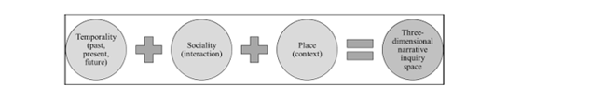
(Figure 3.1: Clandinin and Connelly (2004) Three-Dimensional Model of Narrative Inquiry; Image taken from Craig et al., 2024, p.4 )
Temporality (Younas and Inayat, 2025) aligned with how therapists drew on their professional experience to work in the here-and-now while being aware of the client’s future needs during a single session. In this study this dimension underpinned how single session working was influenced by therapist and client expectations (Cannistrà, et al., 2020).

Sociality (Younas and Inayat, 2025) aligned closely with this current researcher’s research paradigm, where participant accounts were understood to be shaped by the assumptions and social interactions in relation to clients within a single session framework (Macqueen and Patterson, 2021). This dimension supported the exploration of the therapeutic relationship and the processes of attunement and relational depth as well as the participants awareness of ethical responsibility (Curtin et al., 2023).

Finally, the dimension of place (Younas and Inayat, 2025) supported an exploration of how the therapeutic relationship was shaped by the settings within which OAAT/SST occurred.

In this current study Clandinin and Connelly’s (2004) three-dimensional model of NI offered a framework to answer the research question. However, NI is generally considered to align with individual story plots. In order to explore the participants combined narrative, Paradigmatic Narrative Inquiry (PNI) was adopted by the current researcher (Polkinghorne, 1995; Gusak and Lyutykh, 2025).

Using PNI allowed each story to be viewed both as a separate, stand-alone account and as a group experience (Pino-Gavidia and Adu, 2022; Rabelo, 2022; Gusak and Lyutykh, 2025). As a result, patterns that emerged across participant accounts added depth and breadth to the data collected, allowing space for a more informed study in order to answer the research question (Cable et al., 2023).

Ethical Considerations

Ethical approval was obtained from the university ethics committee. The current researcher followed University of Wales Trinity Saint David (UWTSD) data collection protocol (UWTSD, 2026), Data Protection Act 2018 and General Data Protection Regulation (GDPR) rules (Information Commissioners Office, 2026) ensuring personal data were kept safe and private.

Participant Criteria and Recruitment Strategy

Recruitment was conducted via professional networks, private practice and third-sector mental health organisations offering OAAT/SST. Purposive sampling involved the recruitment of five participants with specific knowledge and experience of OAAT/SST that was relevant to the research project (Gill, 2020; Morse, 2020). By recruiting therapists working within this area this ensured that participants were able to speak accurately about the establishment of the therapeutic relationship within a single session (Ahmad and Wilkins, 2025).

Participant criteria ensured that all were qualified humanistic counsellors holding a recognised qualification (for example, a diploma or master’s degree) and professional accreditation (BACP or equivalent). They were required to have been practising for at least one year and to have a minimum of six months experience of OAAT/SST. Additionally, participants were expected to be based in the UK and have conducted at least one OAAT/ SST session within the past 12 months. These criteria ensured participants could provide detailed accounts for data collection (Braun et al., 2022).

All participants received a participant information pack via email, including an information sheet outlining the research study aims and participation criteria, a consent form describing the interview procedure and ethical safeguards and a demographic questionnaire. Upon receipt of signed and dated consent and demographic forms, participants were provided with the interview questions and a debrief form prior to the interview (Appendix 1).

Participant Demographic Information

Participants were between forty-five and sixty-four years of age and were all females. One participant was based in Scotland, one in England and three in Wales. Each participant was given a unique pseudonym.

Three participants were self-employed and two worked in the third sector. All were accredited with the British Association of Counselling and Psychotherapy (BACP) (Table 3.1).

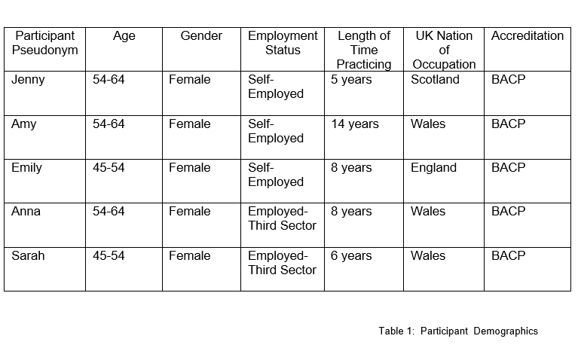

(Table 3.1 Participant Demographics)

Semi-structured Interview Protocol

Semi-structured interviews were used which allowed the flexibility for participants to tell their stories in depth (Barkhuizen and Consoli, 2021). This ensured that key areas such as the therapeutic relationship, therapist identity, ethical tensions and perceptions of OAAT/SST working were explored (Buys et al., 2022).

In order to determine the relationship between the interview questions and the data collected, the current researcher contemplated how the questions might have been experienced by participants. Central to this reflection was confirming the interview questions granted the information needed to answer the research question (Shotton, 2021). To ensure the questions aligned with the research question posed, a pilot study was carried out prior to the main data collection process with this researcher’s supervisor in clinical practice (Shoozan and Mohamad, 2024).

The pilot study allowed reflection of how participants understood and responded to the questions posed and whether they supported detailed storytelling (Shotton, 2021). Feedback gained from the pilot study undertaken led to the current researcher making revisions to question placement and wording (Cairns-Lee et al., 2022). This ensured that the final interview schedule would lead to thorough and appropriate data being collected (Morin, 2023). Data from the pilot interview were excluded in the final study as the participant did not meet the inclusion criteria.

Participant Interviews

All participants provided written consent prior to the collection of data (Subedi and Khanal, 2025). Ethical considerations outlined in the consent form were also discussed and verbally confirmed at the start of each recorded interview (Nii Laryeafio and Ogbewe, 2023).

Interviews were audio/video-recorded via Microsoft Teams, with participants given the choice to disable their camera, although all chose to remain on screen. Data were collected during the months of January and February 2026.

Participants were informed that participation was voluntary and withdrawal was allowed up to one month after the interview. Participants were also given the option to skip questions or withdraw from the interview at any point (Nii Laryeafio and Ogbewe, 2023).

All participants were asked the same open-ended questions (Table 3. 2 ), which allowed space for their personal narrative (Barkhuizen and Consoli, 2021). Questions were designed to enable participants to outline how they experienced and built the therapeutic relationship in OAAT/SST, identify moments within sessions that felt particularly significant and explore any ethical concerns or tensions (Buys et al., 2022). Within this research, interviews were viewed as interpretive, as narratives were affected by the current researcher’s presence and subjectivity (Rabelo, 2022; Younas and Inayat, 2025).

(Table 3.2: Interview Questions)

Prompts such as ‘are you able to elaborate on that’ guided the conversation in response to participants’ contributions and were considered an important part of the interview process (Caines-Lee et al., 2022). Prompts were open-ended to allow participants space to tell their stories in depth and expand the participants narrative rather than introduce new topics (Shoozan and Mohamad, 2024). Non-verbal responses also offered encouragement to support further explanation.

Interviews lasted between fifty to seventy minutes. Given the nature of sharing narratives and sensitive issues, participants were encouraged to engage in self-care throughout the interview (Haukås and Tishakov, 2024). At the conclusion of each interview participants were thanked for their contribution and a debriefing session was conducted. They were assured that all personal and professional information would be anonymised (Nii Laryeafio and Ogbewe, 2023). To guarantee participants did not leave the process experiencing undue distress, the debrief included signposting to appropriate emotional support if required (Haukås and Tishakov, 2024).

Data Transcription

Interview recordings were transcribed using the Microsoft Teams transcription tool. Transcripts were formatted to include page and line numbers to support later reference to citations. Transcripts were also edited by listening to the audio recording to address transcription errors and clarify unclear speech. All identifying details were removed from transcripts and each participant was given a pseudonym to protect their identity (Lahman et al., 2023).

All recordings and transcripts were stored securely on the UWTSD password-protected system (One Drive/Cloud), which was encrypted with a double verification process (UWTSD, 2026). All identifiable information was kept separately from data collected and any handwritten notes were kept securely in a locked filing cabinet at the researcher’s home.

Data Analysis

Narrative Analysis (NA), (Hammack and Josselson, 2025) was not adopted in this study as it was not the current researchers intention to produce individual case narratives or examine a single story.

Due to the constructivist-interpretivist paradigm applied to this study, interpretation of data collected was subjective, prompting the researcher to be critical but also reflective about the narrative generated by the participant group. As a result, data were analysed using Reflexive Thematic Analysis (RTA) (Braun et al., 2022; Braun and Clarke, 2023).

Using RTA was central to recognizing the subjectivity of the constructivist-interpretivist research paradigm employed. The current researcher was also considered to be an active participant in data collection and analysis, due to their own subjectivity when engaging with participants and also with the data collected (Cairns-Lee et al., 2022). Data were viewed interpretively and reflectively as outlined by Braun et al. (2022) prompting the researcher to be critical but also reflective about the narrative generated by the participant group.

Given the study’s focus on shared narratives across participant accounts, PNI supported by RTA was considered by this current researcher to be an appropriate method to follow (Pearson et al., 2025). By combining PNI and RTA the study identified themes across participant stories as a whole and also acknowledged individual accounts (Byrne, 2022). Using RTA, a ‘six-step’ process was followed for identifying themes and patterns across the data (Figure 3.2) (Braun et al., 2022, p. 432).
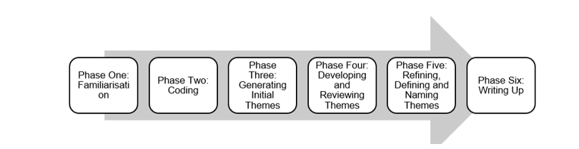
( Figure 3.2: Reflexive Thematic Analysis (RTA) Sequence, Braun et al., 2022)

The current researcher read the transcripts repeatedly and reflected on them to become familiar with each story (Buys et al., 2022; Pearson et al., 2025). Notes were taken so that any evolving codes were considered objectively an example of which can be seen in Figure 3 (Macqueen and Patterson, 2021). Initial codes created captured meaningful features of the data, including emotions, reflections, challenges and descriptions of key moments (Figure 3.3; Figure, 3.4; Table 3.3; Table 3.4) (Braun et al., 2022).

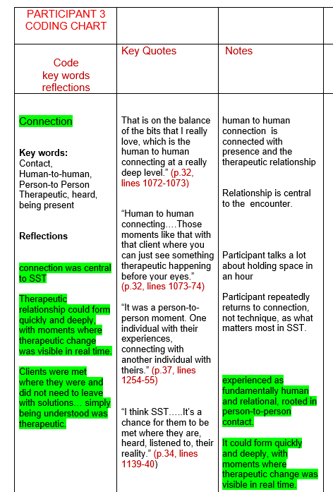
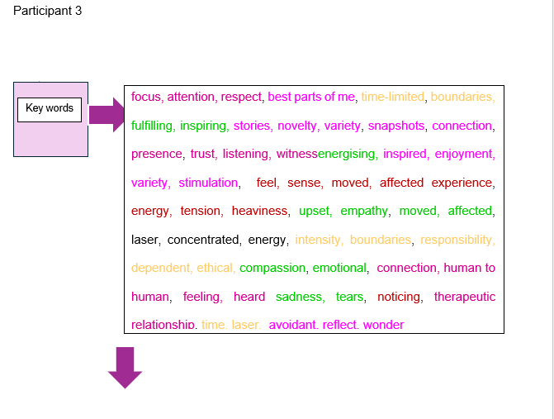

(Figure 3.3: RTA Phase 1: Example of Key Words, Coding, Reflective Notes and Quotations)

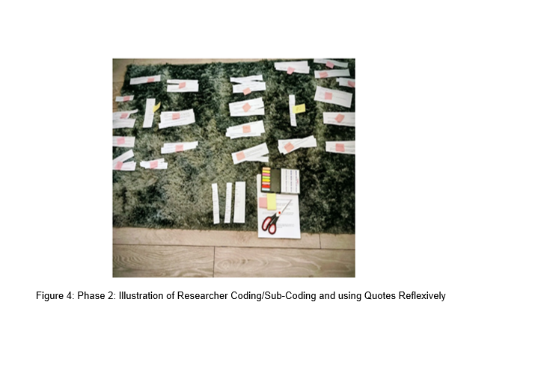

( Figure 3.4: RTA Phase 2 : Illustration of Researcher Manual Coding/Sub-Coding and using Quotes Reflexively}

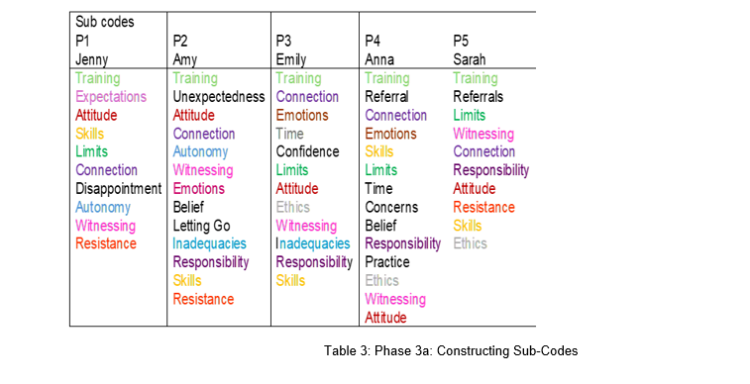
(Table 3.3: RTA Phase 3a Construction of Sub-Codes)

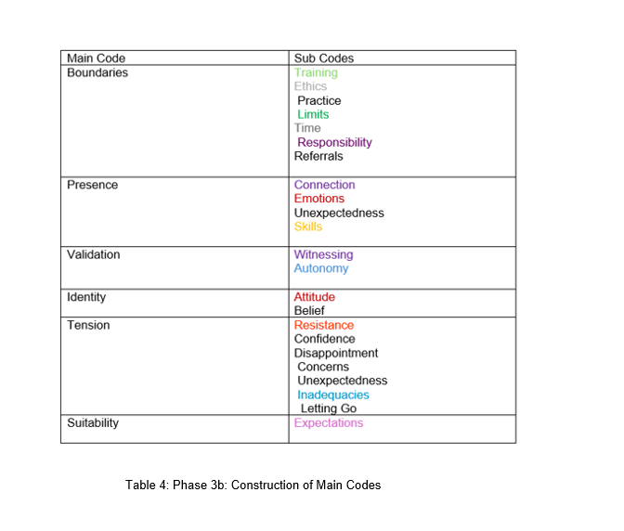

(Table 3.4: RTA Phase 3b: Construction of Main Codes)

Codes were reflected on in order to produce larger themes across the data. Themes were thoroughly considered and then after further reflection made final. As analysis progressed, themes were revisited a number of times, named and renamed in order to ensure they aligned with the research question and did not overlap with one another (Braun et al., 2022; Pearson et al., 2025) (Figures 3.5, 3.6, 3.7 and 3.8).

This stage of RTA involved a process of submersion in the three themes generated in order to contemplate their interrelation (Pearson et al., 2025). During this process codes were considered relatable between themes as not belonging independently to any one specific theme (Ahmed at al., 2025; Mishra and Dey, 2022).

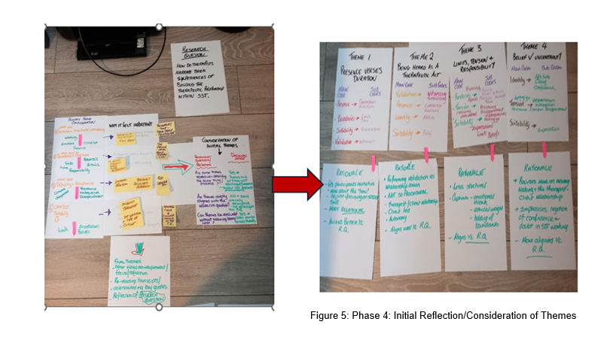
(Figure 3.5 : RTA Phase 4 Initial Reflection on Themes Construction of Sub-Codes)

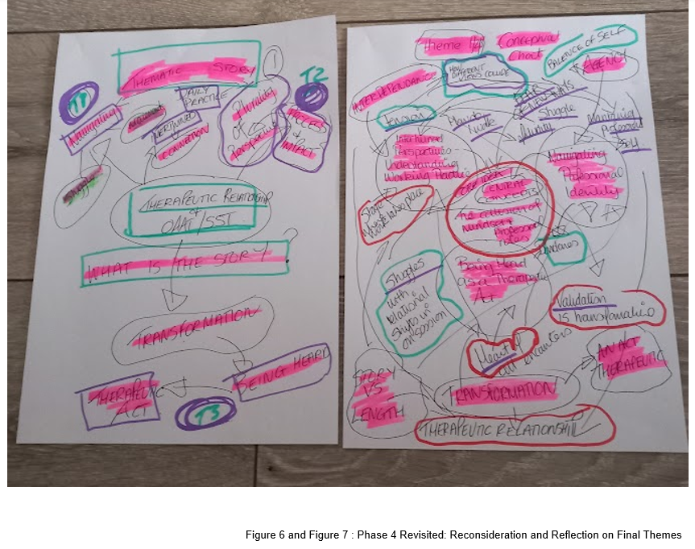
(Figure 3.6 and 3.7: Phase 4 Revisited: RTA Refining and Defining Themes)

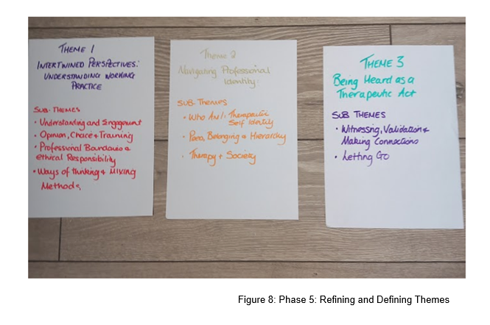
(Figure3.8 : Phase 4 Revisited: RTA Refining and Defining Themes)

These themes are discussed in depth in the next chapter.

: Research Findings

Introduction

The final stage of RTA was to outline the findings (Braun et al., 2022). The themes presented were: (1) Intertwined Perspectives: Understanding Working Practice, (2) Navigating Professional Identity, (3) Being Heard as a Therapeutic Act (Table 4.1).
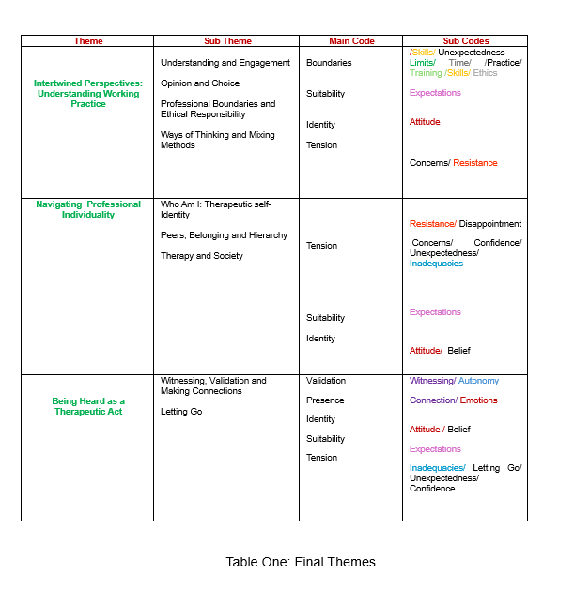
(Table 4.1: Final Themes)

Final themes reflected the richness of the data and illustrated how therapists made sense of single session working and the therapeutic relationship. Quotes were used to outline participants’ narratives and provide supportive evidence for each theme. The findings were also compared to existing academic literature which provided a theoretical lens and authenticity to the analysis and interpretation of data (Braun et al., 2022; Pearson et al., 2025).

Within this chapter participants were referred to using their unique pseudonyms: (Jenny (P.1); Amy (P.2); Emily (P.3); Anna (P.4); Sarah (P.5). Each theme and sub-theme were considered reflectively as part of this researchers involvement in the analysis process (Braun et al., 2022; Pearson et al., 2025). Examples of the analytic process can be seen in Appendix 2.

Theme One: Understanding Working Practice

Introduction to Theme One

This theme focused on how participants described their understanding of OAAT/SST and their perceptions of working during a single session.

Sub-Theme One: Understanding and Engagement

Analysis revealed that single session working was conceptualised as an extreme shift in mindset (Dryden, 2020). When interpreting this through a reflective lens it appeared clear that time on the clock in long term therapy was commonly seen as a helping hand in the establishment of the therapeutic relationship. On reflection and interpretation it was as if time became an enemy when it came to a single session approach. Interpretation of the narratives implied that the therapeutic relationship appeared to become something that was manufactured and controlled rather than established when it was measured against the clock (De Geest and Meganck, 2019):

…because it is just one session we have with somebody, we don't have the ongoing embedding of their stories where we've worked with them over a long period of time (Emily: p.14, lines 454-456)

The process of thematic analysis revealed how the metaphorical use of words such as “laser”, “concentrated” and “sharpened” across the group exposed how that in order to make up for the lack of future sessions the intensity of a single session approach was very focused. On hearting the group narrative, it appeared that OAAT/SST demanded a significant amount of emotional labour and focus from the participants to show authenticity, build trust and stay in the here-and-now (Porter et al., 2025):

I'm more like a laser… ….you’ve got 100% best of me in concentrated form and then time over, off we go (Emily; p.36, lines 1242–1244)

It sharpened that in me in actually, okay, what is actually going on here (Anna: p.3, line 77)

…with single session therapy you have to be so focused on exactly what they brought that if they start to go off then you bring them back… so you bring them back a lot quicker…I kind of give 110% of me. As in listening, you know, being authentic, doing everything I should do is condensed (Amy: p.35, lines 847-852)

Common to the group, focus was conceptualised as a skill. However on deeper reflection of participant narratives focus was interpreted as a form of storyline administration, where the need to gatekeeper client’s needs dominated the agenda. Phrases such as “what they are there for” and ”best interests” implied that the single session approach often became very prescriptive. The music behind the words suggested that this was a psychological shift from travel companion and explorer to professional advisor in the absence of indefinite time for the participants involved in this study(De Geest and Meganck, 2019):

To keep somebody on track of what they're there for. And that's a skill in itself sometimes (Anna: p. 5, lines 141-146)

…it takes a different kind of skill to find that space where you're holding that client (Amy: p.13, lines 420-421)

…the ability to hold that single session and what the client's bringing.
and to be thinking about what's in their best interests is a skill (Emily: p.18, lines 592-593)

…with single session therapy you have to be so focused on exactly what they brought that if they start to go off then you bring them back… so you bring them back a lot quicker (Amy: p.35, lines 847-852)

Further scrutiny of the group narrative exposed that keeping focused so heavily on outcomes could have meant the nuanced colours, shadows and tones of a client-therapist conversation may have become lost (Segal, 2025). It was as if freedom of speech for the client was exchanged for orders and direction :

…with single session therapy you have to be so focused on exactly what they brought that if they start to go off then you bring them back… so you bring them back a lot quicker (Amy: p.35, lines 847-852)

The idea of being in control appeared to flow consistently through the group narrative. The message underpinning the narratives gave the notion that to perform well, therapists moved from a slow lane to a fast lane mentality which was interpreted as being all consuming. It was as if compassion became a tool which appeared to inhibit the intimacy of the therapeutic bond as empathy seemed shifted from felt experience to clinical operation:

…it's a little bit more exhausting because you are giving more of yourself. You are keeping the client on track, you are enabling the client to get those tools and anything they need from that one session (Amy: p.35, lines 856-858)

As in listening, you know, being authentic, doing everything I should do is condensed if you like… (Amy: p. 35, lines 847-848)

I think it's one of those things that you're in a single session; you become aware quite quickly... you don't have the time to think, okay, well, we can build it up in the next relationship, which is normally what you do. You build a relationship over, you know, two or three sessions and then hopefully it goes from there (Anna: p. 10, lines 378-383)

Sometimes that can be difficult in single session therapy because we don't have the time to develop that compassion or that positive regard for our clients like we would if we were seeing someone week after week (Emily: p.11, lines 423-427)

Interestingly, when time was deemed spare in long term therapy, the message behind the group narrative implied it was acceptable that single sessions exist within long term therapy when the client is believed to have ‘gone off track’. When the context of participant words were thought about at a deeper level this suggested that participants had the belief that they managed the therapeutic termination policy which gave the impression of an underlying attitude of ‘they will stay until they are finished anyway’ so it did not matter if the client ventured off track for one session (Schleider et al., 2021):

Really every session of therapy you do is a single session therapy. Whatever model you're working with, every session you have is unique and in and of itself (Emily, p.10, lines 322-324)
.
Every time somebody starts, puts their bum in the seat, I'm like, what do you want today? What do you need from this? You know, and quite often they go, can we pick up from where we were last week? And we're like, okay, let's do that. Or it maybe they've got something completely different going on this week and they need that today. You know, so quite often when you're working long-term some sessions can be like single sessions (Sarah: p. 19, lines 634-640)

Sub Theme Two : Opinion and Choice

A divergence in the group narrative was noticed when reflecting on the data as participants’ workplace tended to influence perspectives of OAAT/SST. Private practitioner’s narrative underpinned a narrative of how they had developed their own approach to OAAT/SST:

I don't run a practise where you have to come weekly or you must be online or in person (Jenny: p. 11, line 355)

I just go with the client and what the client wishes….. (Amy: p.26, lines 618- 620)

Conversely, participants within organisational settings situated OAAT/SST alongside organisational compliance. The flavour of participant narratives moved therapy from a place of client re-invention to one of client limitation (Peipert et al., 2022). It seemed as if the use of a ‘takeaway leaflet’ organisational approach to therapy magnified participants lack of control and choice as to where therapy went to with a client in OAAT/SST :

They don't really understand counselling… they're not necessarily going to understand the difference between single session crisis and, you know, 6 to 12 weeks counselling (Anna: p.5, lines 164-168)

That’s part of the thing we give a certain number of leaflets to people... So they would have things that they could refer to afterwards, such as, you know, things about anxiety, grounding techniques (Anna: p. 17, lines 579-583)

….the sort of like CBT tools that you would usually use with some with a client…that you know people… can take with them.
(Sarah: p. 6, lines 196-200)

I think that's the thing is, being solution focus is quite a directive way of working. And I'm quite a collaborative person. not as opposed to being directive...It is quite a directive way of working… you need to be doing this, you should be doing that, you know (Sarah: p. 9, lines 286-290)

The music behind the words suggested a degree of apathy and dejection was experienced. Participants expressed a sense of defeat and a loss of agency as they did not dictate the rules of the OAAT/SST approach :

…it is what it is, isn't it…I mean, you can only do what you can do. And it's that whole thing of, you know, I think because I work within the organisation (Anna: p.16, lines 547-549)

So, you know, if SST requires somebody to be, I don't know, very much, no, we're not doing this, we have to do that, I don't think I'm the right person (Sarah: p. 22, lines 727-728)

Interestingly, one participant expressed resistance to organisational requirements in order to uphold their professional identity and reclaim their therapeutic identity (Yip, 2025). Approaching this finding reflectively while taking this risk could have jeopardised their position in the organisation it also demonstrated that the therapists own authenticity and therapeutic self-identify appeared more important:

…note to self, go with what the client really wants, you know. So I suppose, yet again, I've taken that as a harsh lesson of what do they need from me… they want me to listen and come in gently now and again (Anna: p.17, lines 586-593)

Sub Theme Three: Professional Boundaries and Ethical Responsibility

Central to all participants was the concept of what was considered safe or unsafe practice within a single session remit. The flavour of the narratives suggested that OAAT/SST became ethically unsound for participants as complex issues held high-stake consequences:

If they were really in a mental health crisis, suicidal …I would say single session therapy is not something we could offer them. The reasons would be, could that therapy session potentially be of harm to that client and actually make their situation worse? (Emily: p. 30, lines 1012-1019)

On further analysis, participant alignment to the OAAT/SST mindset appeared to involve the psychological construction of ‘safe walls’ in order to manage working practice ( Blundell et al., 2022). When considered thoughtfully, this implied OAAT/SST was not a safe shelter for the therapist, but a place where fear of survival replaced client’s needs:

I will intentionally spend some time bringing myself into that frame of mind before I do a single session therapy (p. 22, line 746)

The industry is so getting more and more litigious… complaints being made and people, you know, insurance companies and having to think about all that kind of stuff. I find all that side of the therapy quite stressful… And what if I, you know, I'm not taking this safeguarding action when it needs to be? (Emily: p.29, lines 965-970)

It can make you assess risk differently, feel more anxious, overthink things. That certainly does happen to me from time to time (Emily: p.21, lines 721-723)

Participants appeared extremely focused on self-preservation and staying back behind tightly drawn boundaries. The flavour of the narratives implied that the participants as a group became focused on hazard administration as the narratives underpinned tension and fear of doing harm. On reflection, there was a sense of paradox as OAAT/SST was repositioned as ‘good therapy’ based on what was left unsaid due to a deliberate departure away from danger:

This was a client who, because there were too many things, if you talked about this, there were too many things that were opening up for her, so it felt...A little bit unsafe, just working on. I say unsafe working on one thing, we could, what I did was I wasn't going to turn her away because then you sort of, you've got that, the ethical dilemmas, isn't it? …I didn't want to do her any harm by opening this can of worms …I explained to her that I felt that I, you know, I couldn't offer her enough really in that just that one session because she was aware it was only one session and but we could just work on relaxation, things to help with the stress…So I suppose from a professional point of view, it would have been dangerous to just have a session talking about her husband leaving ( Anna: p.14, lines 461-485)

For some people, that's what they use therapy for. Great. But I think if If you've got...a lot of deep trauma, no that that that needs to be worked at a very different level and very carefully (Sarah: p. 27, lines 897-908)

This appeared to create a moral dilemma where the client could only be helped or heard in OAAT/SST if they were not viewed as complicated. The story behind the words suggested complexity was navigated by the use of silencing in the name of fairness, as complication was outside the remit of what the group socially constructed single session therapy to be (Schleider et al., 2020):

Part of me would think at the start, oh, what if they want to talk about it, feels unfair if I don't let them talk about what they want to talk about. But then I was thinking, no, actually, it's not fair on them if I allow them to do that (Anna: p. 16, lines 549-552)

One participant gave a sense of panic in that complication overstepped boundaries and disallowed a client choice of what they could bring to a single session. On further reflection, this narrative conveyed conflict and tension in OAAT/SST working between time disparity compared to what clients might need, meaning the therapist became caught between the client's complicated life story and what they perceived to be the model's rigid constraints (Cannistrà, 2024):

…if somebody has more than that single thing…there's the alarm bells going off and thinking that's not, that's not what this is (Anna:, p.5, lines 161-163)

From the group narrative, it was clear that in longer term therapy no such rules over complexity existed. In interpreting this, the flavour of the narratives suggested there was a degree of comfort in having control over the therapeutic relationship during long term counselling (Schleider et al., 2021):

With clients that I'm working with over a number of sessions, I've got more of a steer on what I'll know a bit more about them (Emily: p.21, lines 690-695)

This appeared to suggest a contradiction between time constraint and not providing a completed ending which appeared uncomfortable for the participants (Rabinowitz et al., 2025). While participants offered clients further sessions, the actual meaning behind the words implied that the client may be prevented from feeling heard during their single session unless they came back:

I would say…we've got however long until the session ends, and this is something really big and really, you know, important, and actually this is sort of...a need for space and time to unpack that it (Amy: p.19, lines 625-627)

it will be my recommendation that the client might come and have some more therapy, if there's anything that they'd said that I might need to check back again (Emily: p.18, lines 586-587)

should you require more… after the session to give them a chance to just think about moving forward (Anna: p. 6, lines 203-206)

Participants narrated that OAAT/SST training mattered. However, when considered analytically the narratives gave the sense that some participants felt deprived of therapeutic competence due to its briefness, which implied this increased stress on its delivery to clients:

I'm very much a person that feels like if you're doing something you need to be 100% properly trained in it...I want proper training for it. I don't want like an hour online with Windy Dryden. I want a proper, you know, batch of training (Sarah, p.7, lines 212-217)

Some CPD’s you come away from and you think yes, I've got so much information from. That, that one I personally came away from feeling, well, I wanted more (Amy: p.7, lines 165-170)

RTA revealed underlying concern that OAAT/SST was being framed as an approach anyone could do within wider professional circles. The need of participants to safeguard and silo their own professionalism appeared important. However, the underlying message behind the words suggested while participants held some doubts about OAAT/SST it was still considered to be counselling :

I did go to a meeting some time ago about single session therapy… I was quite shocked because they were sort of like... that anybody could do it…..nurses, social workers… I did voice within that meeting………hang on, you know, the very term single session therapy is saying that it is therapy and should only be, you know, performed by a therapist who actually knows what they're doing… this isn't just a chat, you know, there is, there are procedures that you go through and you know, there's a way of working (Sarah: p.3, lines 93-101)

Sub Theme Four: Ways of Thinking and Mixing Methods

Analysis revealed a divergence in what methods should be used when working in the OAAT/SST framework. The refusal by some participants to become constrained by one specific approach or modality propelled the belief that working pluralistically not only supported client diversity and equity, but also reinforced the participants self-awareness and strong identity as counsellors (Cannistrà, 2024):

it's just not my experience that one-size-fits-all and that and that mixing them together in all the different ways, you know, eclectic integration (Jenny: p.4, lines 117-118)

If you just ate the same thing all the time, even if you really liked that thing, you would get bored, it would begin to lose its appeal, it doesn't nourish you in every way that you need to be nourished. We need a balanced diet and a variety of things and it's possible to like both two very different culinary experiences equally (Emily: p.38, lines 1292-1297)

For others, narratives underpinned a real sense of time as an obstruction that clashed with perceptions of how therapy should be (Firth et al., 2020). The words used by some participants appeared to hold the philosophy that therapy was only complete if it was lengthy which again reflection reinforced the concept that therapy is associated with an attitude of ‘they will stay until I say they can go’. Narratives consistently appeared to hide worry and clinical doubt over client complexity, which insinuated time was something that was needed for the participants to ‘feel safe’ in their way of working:

Well, I think it's that whole thing of you're just thinking, well, I don't think I'm going to be able to do much within this single session of therapy because you know it's going to take time to bring that person down in order for them to absorb information (Sarah: p.16, lines 541-544)

Theme One: Conclusion

Across the interviews, a consistent finding was that time could be interpreted both positively and negatively within therapy. The divergence between clinical approaches taken in respect of OAAT/SST affected its application in practice.

Theme Two: Navigating Professional Individuality

Theme Two : Introduction

Theme Two examined how participants approaches to single session practice shaped their professional identity and the structural and sociological pressures that impacted the therapeutic sense of self.

Sub-Theme One: Who Am I: Therapeutic Self-Identity

When approached analytically, it appeared that a single session approach was a way to end therapy and remain guilt-free over declining long-term relational attachment (Vernon and Schweitzer, 2023; Shir and Tishby, 2024). For some participants it was as if OAAT/SST provided the freedom to express true therapist identity :

Sometimes I think, am I drawn to the single session therapy because the people are not committing for a long time and they're going to latch on to me… which is not always something that I feel that comfortable with (Emily: p.31, lines 1010-17)

…when it comes to attachment styles, if I've reflected on mine, I'm secure attachment style, but under pressure I would go more to the avoidant rather than the anxious attachment … I do reflect and wonder, am I drawn to single session therapy as a way of avoiding that (Emily: p. 35, lines 1189-1202)

If I don't think I've got a great rapport with this person…or I just don't want to work with that person again…I've got the freedom to not do that. I've got that, I'm not making any commitment beyond that one day. And that's quite pleasant for me (Jenny: p. 29, lines 988-995)

For other participants on reflection of the meaning behind the words conveyed that a lack of time denied the ability to allow professional authenticity from being displayed:

I can only be me. You know, and that's the thing is that I can only be me because everybody else is taken, right? So I can't be anybody else. And even though SST requires you to be a bit more business-like, if you, you know, for want of a better word, I find it very difficult to just be business-like. I can't be a therapist. I can only be me and that's who I am (Sarah p. 21, lines 721-726)

For employed participants the one-hour contract often appeared to be a deal-breaker. It relayed the impression that the luxury of time, when taken away, contested their ability to see themselves as effective therapists, where this almost positioned them as dismissing the client due to lack of time :

…when you're working long term, you know you've got that space and time to build up that therapeutic relationship. Whereas when you're going into a SST session, you know you've only got that one. Whereas when you're going into long-term therapy, you can spend that first session on looking at the relationship (Sarah: p. 20, lines 666-671)

Sub-Theme Two: Peers, Belonging and Hierarchy

The analysis of data also introduced the concept of institutional hierarchy (Dryden, 2026), bringing to mind the proposition that long-term therapy was a form of sacred practice (Shedler, 2022) that should not be questioned:

I am super aware of the fact that…for many of the people in each of the areas, this is like the Holy Grail of therapy, this is the only way to do it (Jenny p.3, lines 98-100)

The thematic story appeared to illustrate the participant's inner rebellion against and the counselling profession's socially prescribed norms and the desire to de-medicalise the approach (Kaluzeviciute‐Moreton and Lloyd, 2024). This was interpreted as the participant displaying disappointment and fear in unwritten rules within the counselling profession which allowed no space for difference or the development of a unique professional identity:

So I suppose it's bumping up against that level of reality that part of me makes me want to go, yeah, I want to blow it all up. If I could practise in a different way, like going into the shopping centre and just sitting there, wait for people to come and talk to me, I would, but I'm about as close as I can manage whilst staying within the bounds of the law (Jenny p.17, lines 581-584)

A sense of needing to belong was common to the group. Analysis revealed a reluctance to disclose OAAT/SST practice to peers (Blundell et al., 2022). This gave the impression that counselling had a set of unwritten, inflexible rules regarding the length of therapy due to social norms surrounding its implementation. This gave the impression that counselling had a set of unwritten, inflexible rules regarding the length of therapy which implied working practice was not always a process of choice, but a need to belong to social norms surrounding its implementation (Faccio et al., 2026). On reflection, this gave the impression that the group often viewed OAAT/SST subjectively as less than or wrong compared to longer term therapy (Shedler, 2022). Participants appeared to be saying this made them fearful as practicing outside of counselling norms offered no protection against peer judgement and othering which led to OAAT/SST often becoming a hidden form of practice:

…it's not something I go into very often because other people who don't maybe do single session therapy or don't offer the chance of that, don't necessarily understand it… (Amy: p.32, lines 768-778)

There are kind of partisan groups within counselling and psychotherapy (Jenny: p.2 line 70)

I've got friends that really would not, peers that would really not do that because for them it would just be too much… (Amy, p. 37, lines 895-897)

Interestingly, the process of thematic analysis also exposed the hypothesis that therapy aligned with financial gain rather than therapeutic identity (Li et al., 2025). On reflection it was as if time became an adversary in OAAT/SST that blocked the continuation of marketable resources:

I do find that some people, and I'm not saying all some counsellors are there for the money and it's bottoms on seats and that's not necessarily the client being met part way (Amy: p.32, lines 774-778)

I do peer supervision and I've got a couple of peers that will not go into single session because they feel it's a waste of their time…It doesn't bring in the money (Amy: p.37, lines 909-912)

Sub-Theme Three: Therapy and Society

Findings indicated that the idea counselling was lengthy was also socially constructed by society and reinforced by the media (White and Hanley, 2025). For the current researcher, articulation of this felt as if counselling practice was a rigid script that was almost underwritten with the phrase ‘they have to come back’ (Li et al., 2025) as previously discussed, a rule that appeared very hard to rewrite:

I think what I am noticing just fairly recently is that people seem to not understand that it would be OK just to come for a single session… I don't know whether it's because it's being portrayed more often in the media… but the expectation seems to be much more around, so I'll be coming every week for a long time (Jenny: p..22, lines 760-768)

She said not many councillors were willing to give single session to therapy or single sessions for her to explore… ( Amy: p.11, lines 269-270)

However, some participant narratives that gave the flavour of bravery for stepping outside of counselling norms in order to focus on client need (Cannistrà, 2024):

She said not many counsellors were willing to give single session to therapy or single sessions for her to explore… I was willing to do it, that connection became deeper…as opposed to saying to her well, you know, I would prefer you to do 6 sessions ( Amy: p.11, lines 269-270)

…it's quite clear that for some clients a single session is fine and so we should learn how to manage that best… (Jenny: p.2 lines 62-65)

Theme Two: Conclusion

It was apparent from the findings that participants application of working practice related to identity, confidence in practice and ethical concerns. Professional hierarchy and societal understanding manipulated the premise of what counselling should be, rather than what it perhaps ought to be .

Theme 3: Being Heard as a Therapeutic Act

Theme Three : Introduction

This theme explored how participants acknowledged the importance of clients being heard after having their stories witnessed in OAAT/SST and examined how confidence and the ability to ‘let go’ of clients impacted on this.

Sub-Theme One : Witnessing, Validation and Making Connections

The resonance behind participant narratives implied that when time became irrelevant the therapeutic relationship held relational depth (Cannistrà, 2024). The sentiment behind the narratives suggested the realisation that therapy did not always require a a long-term script for clients to be truly heard :

It was almost as if it does what it says on the tin. It was a guy … … he was referred to help him to just deal, have a few techniques to help him to deal with some of the flashbacks he was having … I talked to him then about the connexion between stress, you know, and diabetes… I can still remember now, he just looked at me and he had tears in his eyes and he said, "So it's not my fault"… “it could be to do with because I'm so stressed at the moment after the attack”… coming in and talking about this and he didn't refer back in… (Anna: p.6, lines 197-223)

… probably been in the room then about half an hour at that point, 25 minutes, half an hour… whole process …it really can be quite powerful (Anna: p.7, lines 250-255)

He said “I won't be back”… “I don't know what you've done, but I feel 110% different and he walked out the door and he never came back… Yeah, it was super surprising, that definitely stayed with me. It's like, wow, single session. Who, who needs long term trauma therapy ( Jenny: p.10, lines 315-336)

And the tears rolled down her face and I have to be honest, tears came to my eyes because it was so powerful in that moment, and it was so important that I believed her (Amy: p.15, lines 354-356)

This researcher was struck by the way for one participant, the therapeutic relationship went beyond a single session where the client took a memento with them from their session as an enduring protection against social disbelief, which became enough for them to not return to therapy:

I just need one of your stones to always have with me in my pocket. To know that when somebody says I don't believe you, I could put my hand in my pocket and go somebody did (Amy: p.16, lines 470-474)

What permeated through the group narrative was that transformation did not just apply to clients but also to participants. Narratives suggested when participants moved away from preconceptions that good therapy equalled long-term engagement, quick exits were viewed as a sign of therapeutic success and not failure (Flückiger et al., 2020):

It kind of was quite inspiring in that way of what you can achieve in one session with somebody and it really can be life-changing (Emily: p.9, lines 329-330)

…he did blindside me… he wanted a safe space. He wanted to be able to just talk through his feelings, his emotions and his reactions to that trauma without going into the trauma. stated at the end of that session that was really great and for him it had worked and he just didn't want any further sessions. It was as simple as that. He didn't want any more sessions, thank you very much, wham bam and I'm gone. ( Amy: p.3, lines 63-74)

Analysis echoed the perception that embracing OAAT/SST where relinquishing the clock allowed participants to transition from a place of ‘I cannot listen ’ to ‘I hear your pain and bare witness’ (Finlay and Hewitt-Evans, 2022):

And the tears rolled down her face and I have to be honest, tears came to my eyes because it was so powerful in that moment, and it was so important that I believed her (Amy: p.15, lines 354-356)

And that was again one of these moments where I was like inside I was going oh (Jenny: p.10, lines 317-18)

I want to say felt possessed it. It sounds awful, but spiritually felt, possessed in a in a good way ( Amy: p.17, lines 403–405)

It was a painful, as well as a beautiful experience… I felt that pain that she was describing, it was so difficult to hear (Emily: p.17, lines 566- 569).

It was that moment where I remember him just looking at me and I remember thinking, oh, that's powerful (Anna: p.7, lines 220-25)

On further consideration when ‘now’ was accepted as all there was, the participant made space for client autonomy ( Young, 2020):

Single session therapy has taught me is that actually the client is in charge of change (Jenny: p.11, lines 353-354)

you want to give them all the space they need to tell their story ( Amy: p.22, lines 751-752)

Sub-Theme Two: Letting Go

Narratives also indicated a struggle with the ambiguity of OAAT/SST. This struck a chord with this current researcher, where the notion that there was tension between the therapist's hope for a breakthrough and actual client needs seemed to be apparent. The music behind the words suggested participants believed that clients always ‘kept the good stuff back’ and that therapy should be prolonged until determined sufficient by the therapist (Oasi et al., 2024). On further reflection this suggested that OAAT/SST raised conflict between ‘fixing’ and ‘witnessing’ :

During a single session… I became aware that the client was not fully disclosing her actual issue… I felt very frustrated and inadequate as a counsellor… I just wanted it to be a bit more (Amy: p. 21, lines 21-43)

…you don't always know, you don't always know …you have to be okay with that kind of uncertainty (Emily: p.13, lines 433-436)

…that feeling where you're doing loads of work and then I think, what am I doing here? (Emily: p.34, lines 1314-1317)

They’ll walk into the room and say I’m thinking it’s going to be this and at the end of it, it’s clear, No (Jenny: p.5, lines 153-154)

Interestingly, it transpired that different rules existed when time was not an issue in therapy delivery. Participants acknowledged that clients often did not come back to longer term therapy, however this was accepted quite readily when considered as client drop-out (Cooper et al., 2022):

You never know if they're going to come back. You never know if life events will mean that this is the one session they have with you. ( Emily: p.10, lines 327-329)

I think each experience is an individual experience... there's no guarantee that the person is going to come back (Sarah: p. 19, lines 627-630)

Theme Three: Conclusion

Clients often benefitted from being heard rather than undergoing a course of therapy, even for complex issues. However, analysis related this to the ability of the therapist to let go of the concept of time and be able to work in the here-and-now.

Conclusion to Findings

When interpreting the themes collectively, it became clear that time was seen as both an opponent and an adversary across the participant group. However, there appeared to be unwritten rules and a hierarchical expectation of what ‘good’ therapy should look like. This appeared to create a stereotype of what a typical counsellor’s identity should look like and how they should practice.

In long term therapy, time was guaranteed and was not considered important as therapy was about people always returning, whereas OAAT/SST shifted the therapeutic mindset where time mattered so much it often led to an extreme effort to perform as a therapist and create a therapeutic relationship. However, when time was ‘let go’ this intensity shifted the relationship to a place of therapeutic depth and client autonomy. The alteration of the therapeutic mindset to being a witness in the here-and-now suggested that even complexity could be held safely when the client was in charge of their own destiny. Nevertheless, analysis revealed there appeared to be unwritten rules and a hierarchical expectation of what therapy should be.

The next chapter discusses the main findings gathered from the process of RTA in more detail related these to extant literature. Recommendations for practice and suggestions for future research are also offered.

: Discussion

Introduction to Discussion

RTA is based upon ‘the researcher’s reflective and thoughtful engagement with their data and their reflexive and thoughtful engagement with the analytic process’ (Braun and Clarke 2019, p. 594). The following discussion interprets the main findings of the current researchers unique perceptions and analysis of the data collected (Table5.1) and outlined in Chapter Four in more theoretical depth.
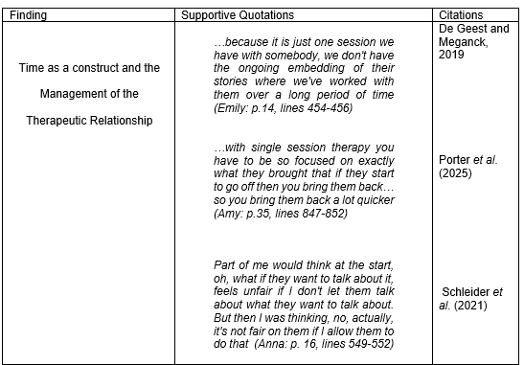

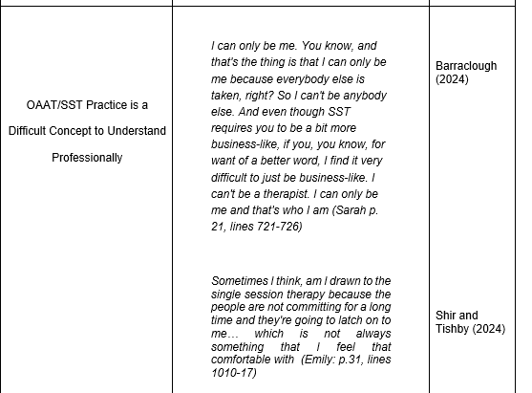

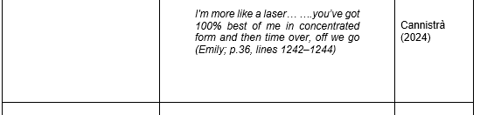

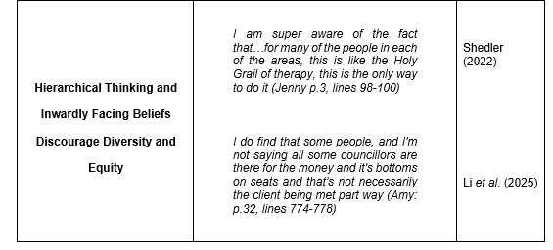

(Table 5.1: Findings and Theoretical Perspectives}

Time as a Construct and the Management of the Therapeutic Relationship

During the reflexive process of data analysis (Braun and Clarke, 2021; Braun et al., 2022) it was apparent that time was the major factor in how therapy was perceived by the therapist-participants who took part in this study. Interpretation of the group narrative suggested that participants viewed long-term therapy to be a comfortable space to sit in and harness a client-therapist therapeutic relationship. Multiple sessions were viewed as a place where clients returned time and time again to finish their story, examine their old endings and create new beginnings.

Consequently, during long term therapy time became a subjective concept. With no urgent need to fulfil an agenda within one therapeutic hour, therapy ebbed and flowed in a space where the awareness of time appeared to be inconsequential. This ideology is supported by Finley and Hewitt-Evans (2022), where long term therapy was argued to provide the ideal environment where clients can be held supportively, with acceptance, empathy and affirmation over time.

Conversely, the issue of time constraints within OAAT/SST was a major contention where the ability to work with client issues and structure a therapeutic relationship were set out as the main concerns. In single session working time took on a new role for the participants and lost its subjectivity. Counselling is viewed as a ‘dyadic process’ (Shir and Tisby, 2024, p.353). However, for the participants time was experienced as becoming the third person in the room, turning the counselling dyad into a triad. This appeared to change the client-therapist relationship where the ownership of minutes became prioritised over client needs. This finding has also been reflected in a systematic review of qualitative research where it was concluded that ‘a time limit exerts pressure on the therapy process’ (De Geest and Meganck, 2019, p.206).

This raised questions as to whether the lack of time in OAAT/SST could contribute to the exacerbation of therapist power and client suppression within the therapy room. Instead of the therapeutic space being open to all issues, data suggested that this was replaced by the negotiation of what was considered right or wrong for the therapist to address, rather than the freedom of the client to discuss. A similar conclusion is reached in De Geest and Meganck’s (2019) meta-analysis.

Research conducted by Blundell et al. (2022, p.13) adds another dimension weight to this discussion as they make the argument that ‘protection of self’ is paramount to professional therapeutic practice. They argue that boundaries offer safety and for both the client and the counsellor. Within the current study and in relation to OAAT/SST, time appeared to underpin the participants need to control client outcomes and became the overall boundary and the gatekeeper to what could or could not be possible to achieve during a single session.

The lack of control over time changed the humanistic response of self-autonomy to one where narratives added weight to the idea that clients needed to be fixed rather than witnessed in one session. If the issue was complicated, then no ‘fix’ was determined available at all. This finding was reflected by Oasi et al. (2024) and Yip (2025) who argue power sharing is never equal in a counselling relationship, with the therapist always holding the rules of contact. If the rules of contact change, then so does the manifesto of the therapist. As Einboden et al. (2025, p.259) point out, therapy remains ‘structured with prescribed roles and responsibilities of therapists and persons seeking care and unequal distribution of power between them’.

It was apparent that the need to get things right in an hour potentially blinkered the therapist’s ability to see or hear the client. Research suggests that psychotherapy is marked by the premise that it is ‘driven by struggle and conﬂict’ and ‘underlining danger’ (Peri Herzovich and Govrin, 2021, p.245). This studies literature review highlighted that counsellors find it difficult to let clients go when they feel there is more work to be done (Kullgard et al., 2022; Knox et al., 2023; Matos and Dimaggio, 2023). This was displayed in the words of the participants within this current study where narratives introduced a level of fear around being a good, safe therapist, which led to denying complexity as a result.

Indeed, this narrative is similar to published literature and the argument that OAAT/SST may or may not be suitable for complex issues. There is claim that supports single sessions only are suitable for issues such as anxiety and depression (Bertuzzi et al., 2021) and another that supports a single session can help with complex issues such as addiction (Harris-Lane et al., 2023) and PTSD (Figueroa et al., 2024).

Reinforcing this theoretical point of view, therapists often have a conceptual perspective that treatment must continue until a particular psychological progression point is reached while clients frequently see therapy as a tool for symptom relief (Kaluzeviciute‐Moreton and Lloyd, 2024; Yocheved et al., 2025). This raised the query when considering the group narrative as to whether the client is ever in control of where therapy goes and how long it lasts.

In their meta-analysis Rabinowitz et al. (2022) ask a similar question in who triggers the process of termination (counsellor or client) and what factors are used to make that decision. This argument is also supported by Xiao et al. (2023) who also questions whether therapists should decide when client improvement is enough, as this potentially puts the therapist into a position of power which dictates the terms encompassing termination of therapy. They ask if this corresponds to client autonomy, therapist inability to let go or to organisational rules that align counselling with a specific number of sessions.

It could be argued that this finding was not surprising as all participants in the current study were humanistic counsellors where their role was considered to be that of empathetic supporter and facilitator of client autonomy by the participants, where the therapeutic relationship was built on trust, honesty and empathy over time. These perceptions aligned with Wilcox and Almasifard’s (2023) systematic review which suggested that therapy needed to be long term to facilitate healing as it was argued only through time, therapist warmth and engagement that therapeutic depth could take place. However, a meta-analysis conducted by Schleider et al. (2021, p.5) suggests that ‘more therapy hours are not always productive hours’.

Research conducted by Anderson et al. (2023) adds weight to this argument. Exploring OAAT/SST and relational depth with cancer patients they discovered relational depth happened very often when the clients story is fully heard. Consistent with this research, in the current study when time stopped being a linear process of clock watching to become a meandering journey around human emotion relational depth became a natural process.

Participants recounted that it did not matter whether the client brought complexity with them and gatekeeping what could or could not be said became inconsequential. This is consistent with research conducted by Segal (2025) where when client stories are listened to and acknowledged as lived experience change can be profound.

Commonly, when time became an irrelevance participants became so attuned to the client that they experienced the clients emotions within themselves. What surprised these therapists was that when time was let go, it did not matter about complexity for the client. They appreciated that what the client needed was to be heard and tell their story. When this occurred, participants recounted that the client did not need anything else and did not wish to return.

This finding is supported by Schleider et al. (2021) who content therapy does not have to be consistent to produce the change a client wishes to achieve. Within the current research a question arises as to whether it is the therapist that wishes to change the client based on their own subjective views of what is best for the client rather than the client deciding what may be best for themselves. However, Kaluzeviciute-Moreton and Lloyd (2024) reinforce this philosophy that whatever the modality counselling is primarily about meeting the client where they are at and not where the therapist positions them to be. They add that it is only when the client is met that the therapeutic relationship is established.

Building on this research, Porter et al. (2025) make the argument that when the therapist is able to see a single session as complete in itself they share equal power with the client as time becomes irrelevant. They go on to suggest that OAAT/SST is not about direction and allowance of what a client may attend to but based on the mindset that the client brings what they bring and it is up to the client to decide if they return or not. While more sessions can be offered this is not a space where issues should be disallowed. This philosophy is reinforced by other authors who have written articles on OAAT/SST, who regard the time constraint attached to it as being empowering for client and therapist (Young, 2020; Dryden, 2020; Hoyt et al., 2020).

OAAT/SST Practice is a Difficult Concept to Understand Professionally

Throughout the participant group, OAAT/SST was viewed differently by each individual participant. Adjustment and embracement of OAAT/SST theory appeared to be impacted by several factors.

Findings indicated that training was restricted to half a day online, which across the group felt sub-standard and dissatisfying. It appeared to leave participants confused as to what approach the single session model adopted. As participants were all trained humanistically it raised doubt about how to effectively structure a beginning, middle and end as well as develop a productive therapeutic relationship. The apprehension and uncertainty surrounding how to work with OAAT/SST was also recognised by Cannistrà (2024). They go on to state ‘a therapist wondering what she or he needs to do to achieve this goal is faced with multiple possibilities’ (Cannistrà, 2024, p.106).

This factor was recognised in the analysis of the data in the current study where the endeavour to maximise the efficacy of the therapy session might have been limited by the absence of a comprehensive reference to theory.

Both Cannistrà (2024) and Dryden (2020) argue this is the strength of OAAT/SST. Cannistrà (2024, p.106) concludes that OAAT/SST is a ‘transtheoretical method, something that occurs and is located beyond the theoretical reference points of the practitioner’. Dryden (2020) supports this philosophy and states this encourages a certain mindset that acknowledges anything can be possible in one session if the counsellor is pluralistic in their thinking.

Interestingly, this study’s findings revealed that when participants became enveloped in the OAAT/SST mindset they became highly focused on the therapeutic relationship, even more so than within long term therapy. This was not only reflected in the narratives of the participants of this research but to that of Porter et al. (2025, p.18), where the words “laser” and on “track” were used in both the current study and the authors research by different participants. In both studies participants expressed concern about understanding client needs and the session ability to provide optimism and change.

The findings in this current research also suggested a new perspective on working practice. Some participants readily accepted that this way of working suited their outlook on life, their self-identity and the connection they made with people. Findings suggested that when the participants were more aware of their own selves and their responses to clients, this affected their ability to work positively with the OAAT/SST model. This finding is supported by Barraclough (2024) who in their study of humanistic counsellors states that counsellors who build a bridge between their evolving professional and personal selves are able to create a more effective therapeutic relationship.

Shir and Tishby (2024) emphasise that the attachment styles of the client and the therapist are essential elements of the therapeutic process. It appeared from the current study’s findings that the participants who were aware they had an avoidant attachment style enjoyed working within the OAAT/SST model. These participants expressed that the freedom to see a client for only one session enhanced their working practice and that seeing a client for just one session felt comfortable.

However, the point raised by Cannistrà (2024) regarding there being no set rules surrounding OAAT/SST and its approach to delivery was seen as an issue for those employed therapists within the participant group. As ‘anything goes’ when it comes to OAAT/SST application, organisations tend to use a CBT approach to delivery (Peipert et al., 2023). Within this study this was evidenced by the narratives of the employed participants. For them, moving from a humanistic mindset of co-creation and collaboration to that of task orientation was very difficult. Yip (2025, p. 337) states ‘in a therapy setting, structurally, the therapist holds more status, rank and, therefore, power than the client’. In a workplace setting this status is outranked by organisational procedure.

Power over the counsellors in this environment when working with a CBT approach to OAAT/SST appeared to exacerbate the loss of a sense of self, as analyses indicated they found it difficult to step outside of their modality to work with this model. For the employed participants in this study their sense of therapist-self did not align with this modality as humanistic theory focuses on the past, present and future aspects of a client’s self (Kaluzeviciute-Moreton and Lloyd, 2024).

Findings suggested that the therapeutic relationship became strangled as a result, due to OAAT/SST being task orientated and only focused on goal setting, which appeared to strangle the therapeutic relationship as the participants were unable to witness the clients story. This aligns with Firth et al. (2020) who argue therapist disconnection is reflected in organisational settings when therapists feel their work is unproductive.

With little or no training afforded to new working practices research shows that increased work pressure and changes in working practice can lead to therapist concern over single-session working for complex cases and re-referring clients back into the system (Peipert et al., 2022; Peipert et al., 2023). This may be why organisations face reluctance to roll out OAAT/SST as the model could be viewed as unproductive as client outcomes become reduced due to re-referral which influences future funding (King et al., 2023). Findings in this study aligned with this viewpoint.

Hierarchical Thinking and Inwardly Facing Beliefs Discourage Diversity and Equity

While some participants enjoyed working within an OAAT/SST some expressed fear within the group about ownership of practising within the framework. Perhaps this is not surprising as Shedler (2022) points out that counsellors who would be open to differing approaches that encourage diversity, equity and inclusion within the counselling profession have historically run up against inward-looking constraints from hierarchical counselling bodies.

In the case of OAAT/SST, the College of Registered Psychotherapists of Ontario in Canada refused to recognise single session practice as contracted therapy, arguing the therapeutic relationship formed gradually over multiple sessions up until 2019 (Young and Jebreen, 2019; Dryden, 2026). This stance was mirrored by the BACP in the UK. This reasoning aligned with rhetoric that client-therapist relationships could not be formed in a single session. However, there are a wide range of studies that provided a counter-argument to this, for example del Río Olvera et al.(2022) Mylona et al. (2022) and Anderson et al. (2023) as discussed in Chapter Two. Eventually, published research into client-outcomes meant the ruling was overturned in 2020 as the reasoning behind the decision was challenged judicially.

It may be that OAAT/SST remains the poor cousin of counselling as findings showed there was a general consensus within other professions that ‘anyone could do it’. A factor looked on unfavourably by one participant. This may explain why there was a general reluctance by participants to engage with their peers about single session working. The need to belong to a professional body in order to practise professionally appears sacrosanct for counsellors in the UK and may explain why some participants in this study held back due to fear of judgement. As Rabinowitz et al. (2025) point out, therapy is still consistently based on the historical ideology that therapy is a long-term process (Schleider et al., 2021), where the rules of engagement are underwritten by hierarchical professional bodies and training providers which have to be abided by to maintain professionality. Interestingly, according to the participants in this current study, universities and colleges offered no training into the concept of OAAT/SST within current curricula.

The findings of this study revealed that therapy remains a fixed idea within society about long term commitment. These findings were consistent with a study examining how counselling practices are socially reconstructed by therapists and clients (White and Hanley, 2025). The flavour of the narratives associated with the participants in this study also suggested preconceptions that clients attended therapy until they were told by the therapist they no longer needed to continue which coincided with financial gain. Baker and Gabriel (2020) point out that maintaining professional standards, accreditation and continuous professional development are costly. This may be why this study indicates that not many practitioners are willing to move over to this way of working as financial resources are not maintainable.

This finding echoes the results of existing research conducted by Li et al. (2025, p.705) who argue that very often therapy is not ‘personally relevant’ or ‘individually tailored’ to clients. They argue clients will keep coming to therapy until they are told not to as the therapist is in the more powerful position and dictates the terms of engagement and termination of therapy. This was apparent in this current study where the nuance behind participant narratives gave the impression that clients were supposed to stay until they were told they were finished.

For single session theorists, the OAAT/SST model offers a form of equity and diversity for clients. Cannistrà (2024) states that the ability of a theory, method, or even individual intervention technique to assist a client in achieving their intended result is what gives a session merit, not just the conceptual instrument itself. This implies that a single method, theory, or even epistemology can never be suitable for everyone. However, findings from this research suggest OAAT/SST is a long way off being embraced. Shedler (2022) and Schleider et al. (2021) state that tradition therapy modalities remain rigid in their approach and are embedded in the historical foundations of counselling itself.

Discussion Conclusion

On reflection across data analysis and discussion of the findings it was apparent that an invisible thread ran through participant narratives. Power and time are companion bedfellows in the therapy room. Time can be subjective in the development of the long-term therapeutic relationship and act as a third person in the counselling room within single session working. Within this current discussion it was evident that this affected the development of the therapeutic relationship.

Implications for Future Practice

Cannistrà (2024) argues OAAT/SST allows the freedom to align with differing modalities that suit the diversity of clients, making this an equitable approach to counselling. They state that differing techniques can be used to in a session as what works for the client remains the priority. However, the findings of this study indicate that the single session concept is not yet completely understood by therapists and organisations alike. The roll out of OAAT/SST suggests at some time or other therapists will encounter this model of counselling in their working practice, whether asked for by a client or rolled out by an employer. This would suggest that training needs to be underpinned by of the philosophy of the model for therapists to feel truly comfortable and understand working in this way.

Recommendations

Further research would be advantageous into therapists creation of the therapeutic relationship within OAAT/SST. Time was viewed as an important factor when considering the therapeutic relationship and the client. More research into time, power and counselling practice as a whole would lead to informing current practice.

Colleges and universities may need to look at time and power as factors that interlink counselling and the therapeutic relationship. The establishment of OAAT/SST training should be at the forefront of courses involving counselling so students can become self-aware of their own therapeutic identity and the power dynamic within the counselling dyad.

For organisations OAAT/SST appears to have been allocated a task orientated approach to simple mental health conditions, which, while it reduces waiting lists for therapy, may not be precisely what the philosophy of the model actually is. Organisations need to become less rigid in their approach to OAAT/SST as the concept itself is based on the freedom of approach used by the therapist to achieve positive results.

Professional bodies could also offer continuous professional development opportunities to qualified therapists in this area in order to highlight the ethos of this approach.

Limitations

This study involved only five participants, therefore the conclusion formed is based on a small population.

As RTA was applied to this study, the researcher’s own subjective opinion informed the analysis and discussion of data. Another researcher may have interpreted the data in a different way meaning the findings remained open to interpretation.

: Overall Conclusion

This research study asked: How do therapists narrate their experiences of building the therapeutic relationship within single session therapy?

In answer to the research question the ability of meeting the open approach of the OAAT/SST model coincides with how therapists form the therapeutic relationship with clients. Analysis of the data showed that the therapeutic relationship was viewed differently by all participants. For some participants the freedom to be allowed to only see clients once suited their therapeutic identity where the autonomy to drop the constraints of time and work closely in the here-and-now led to therapeutic depth and relational embodiment within the therapeutic relationship. These participants were able to let go of the worry over complexity of issues and concern over time restraints, the therapist was able to fully bear witness to the client’s story. When this occurred it was interesting that clients vocalised they did not need to come back.

For others, the fear of working with complexity appeared to distort the concept of time, where they felt only simple mental health issues could be addressed. Perhaps as there is little training in the area of OAAT/SST on offer and the fact that the model has a free approach to its delivery is a difficult concept to understand. What is apparent is that the premise therapy should be long term and remains embedded into counselling hierarchy, training programmes and society as a whole.

Reference List

Aafjes-van Doorn, K. and Sweeney, K. (2019) ‘The Effectiveness of Initial Therapy Contact: A Systematic Review’, Clinical Psychology Review, 74 (101786), pp.1-14. Available at : https://doi.org/10.1016/j.cpr.2019.101786
Aguzzoli, R., Lengler, J., Miller, S.J. and Chidlow, A. (2024) ‘Paradigms in Qualitative IB Research: Trends, Analysis and Recommendations’, Management International Review, 64 (2024), pp.165-198.Available at: https://doi.org/10.1007/s11575-024-00529-5
Ahmad, M. and Wilkins, S. (2025) ‘Purposive Sampling in Qualitative Research: A Framework for the Entire Journey’, Quality and Quantity, 59(2), pp. 1461–1479. Available at: https://doi.org/10.1007/s11135-024-02022-5.
Ahmed, S.K., Mohammed, R., Nashwan, A.J., Ibrahim, R.H., Barzan, A.Q.,. Ameen, M.M., Khdhir, R. (2025) ‘Using Thematic Analysis in Qualitative Research’, Journal of Medicine, Surgery and Public Health, 6(2025), p.1-6. Available at: https://doi.org/10.1016/j.glmedi.2025.100198
Anderson, R., Cooper, M. and Steffen, E.M. (2023) ‘Cancer Patients’ Experiences of Moments of Relational Depth During Psychological Therapy: A Qualitative Study’, Journal of Psychosocial Oncology, 41(6), pp. 704–720. Available at : https://doi.org/10.1080/07347332.2023.2184741
Babl, A., Rubel, J., Gómez Penedo, J. M., Berger, T., Holtforth, M. and Eubanks, C. F. (2024) ‘Can Session-by-Session Changes in Self-Reported Alliance Scores Serve as a Measure of Ruptures in the Therapeutic Alliance?’, Journal of Consulting and Clinical Psychology, 92(2), pp. 129–133. Available at : https://doi.org/10.1037/ccp0000861
Baker, C. and Gabriel, L. (2021) ‘Exploring how Therapists Engage in Self-Care in Times of Personal Distress’, British Journal of Guidance and Counselling, 49(3), pp. 435–444. Available at: https://doi.org/10.1080/03069885.2021.1885010
Bannon, S. M., Rapoport, A., Applebaum, A. J. and Schleider, J. L. (2025) ‘The Potential of Single Session Intervention Approaches to Enhance the Mental Health and Resilience of Older Adults, Care Partners, and Healthcare Systems’, Frontiers in Public Health, 13 (1515440), pp. 1-12. Available at : https://doi.org/10.3389/fpubh.2025.1515440
Barkhuizen, G. and Consoli, S. (2021) ‘Pushing the Edge in Narrative Inquiry’, System (Linköping), 102 (2021), pp. 1-9. Available at: https://doi.org/10.1016/j.system.2021.102656
Barraclough, S. (2024) “On Becoming a Counsellor: A posthuman Reconfiguring of Identity Formation for Counsellors-in-Training,” British Journal of Guidance and Counselling, 52(6), pp. 1054–1070. Available at: https://doi.org/10.1080/03069885.2023.2172550
Bertuzzi, V., Fratini, G., Tarquinio, C., Cannistrà, F., Granese, V., Giusti, E. M., Castelnuovo, G., and Pietrabissa, G. (2021) ‘Single-Session Therapy by Appointment for the Treatment of Anxiety Disorders in Youth and Adults: A Systematic Review of the Literature’, Frontiers in Psychology, 12 (721382), pp 1-10. Available at: https://doi.org/10.3389/fpsyg.2021.721382
Blundell, P., Oakley, L. and Kinmond, K. (2022) ‘Who are we Protecting? Exploring Counsellors’ Understanding and Experience of Boundaries’, European Journal for Qualitative Research in Psychotherapy, 12, pp. 13–28. Available at: https://doi.org/10.24377/EJQRP.article3036
Braun, V. and Clarke, V. (2019) ‘Reflecting on Reflexive Thematic Analysis’, Qual. Res. Sport Exerc. Health 11(4),pp. 589-597. Available at: https://doi.org/10.1080/2159676X.2019.1628806
Braun, V. and Clarke, V. (2021) ‘One Size Fits All? What Counts as Quality Practice in (Reflexive) Thematic Analysis?,” Qualitative Research in Psychology, 18(3), pp. 328–352. Available at: https://doi.org/10.1080/14780887.2020.1769238
Braun, V. and Clarke, V. (2023) ‘Is Thematic Analysis Used Well in Health Psychology? A Critical Review of Published Research, with Recommendations for Quality Practice and Reporting’, Health Psychology Review, (Ahead-of-Print), pp. 1–24. Available at : https://doi.org/10.1080/17437199.2022.2161594.
Braun, V., Clarke, V. and Hayfield, N. (2022) ‘“A Starting Point for your Journey, Not a Map”: Nikki Hayfield in Conversation with Virginia Braun and Victoria Clarke about Thematic Analysis’, Qualitative Research in Psychology, 19(2), pp. 424–445. Available at: https://doi.org/10.1080/14780887.2019.1670765
Breuer, J. and Freud, S. (2001) The Standard Edition of the Complete Works of Sigmund Freud (Vol. 2): Studies on Hysteria. London: Vintage.
British Association for Counselling and Psychotherapy (2018) Ethical Framework for the Counselling Professions. Available at: https://www.bacp.co.uk/media/3103/bacp-ethical-framework-for-the-counselling-professions-2018.pdf (Accessed 16 March 2026).
British Psychological Society (2025) Single Session Therapy: Exploring Global Perspectives. Available at: https://www.bps.org.uk/psychologist/single-session-therapy-exploring-global-perspectives (Accessed 4 October 2025).
Brown, M. E. L. and Dueñas, A. N. (2020) ‘ A Medical Science Educator's Guide to Selecting a Research Paradigm: Building a Basis for Better Research’, Medical Science Educator, 30(1), pp. 545–553. Available at : https://org/10.1007/s40670-019-00898-9
Bugatti, M., Owen, J., Richardson, Z., Rasmussen, W. and Newton, D. A. (2024) ‘Changes in Therapists’ Client Dropout Rates over Time: Findings from a Practice‐Research Group’, Journal of Counselling and Development, 102(3), pp. 361–369. Available at : https://doi.org/10.1002/jcad.12521
Burns, M., Bally, J., Burles, M., Holtslander, L., & Peacock, S. (2022) ‘Constructivist Grounded Theory or Interpretive Phenomenology? Methodological Choices Within Specific Study Contexts’, International Journal of Qualitative Methods, 21 (0), pp. 1-13. Available at: https://doi.org/10.1177/16094069221077758
Buys, T., Casteleijn, D., Heyns, T. and Untiedt, H. (2022) ‘A Reflexive Lens on Preparing and Conducting Semi-structured Interviews with Academic Colleagues’, Qualitative Health Research, 32(13), pp. 2030–2039. Available at: https://doi.org/10.1177/10497323221130832
Byrne, D. A (2022) ‘ A Worked Example of Braun and Clarke’s Approach to Reflexive Thematic Analysis’, Quality and Quantity, 56 (0), pp. 1391–1412 . Available at: https://doi.org/10.1007/s11135-021-01182-y
Cable, M., Watts, T., Reagon, C. and Kelly, D. (2023) ‘Experiences of Early‐Career Nurses Working in Specialist Adolescent/Young Adult cancer Units: A Narrative Inquiry’, Journal of Advanced Nursing, 79(8), pp. 2871–2885. Available at: https://doi.org/10.1111/jan.15488
Cairns-Lee, H., Lawley, J. and Tosey, P. (2022) ‘Enhancing Researcher Reflexivity About the Influence of Leading Questions in Interviews’, The Journal of Applied Behavioural Science, 58(1), pp. 164–188. Available at: https://doi.org/10.1177/00218863211037446.
Cannistrà, F. ( 2024) ‘How to Maximise a Single Session? From a Reflection on Theoretical Pluralism to the Definition of Five Goals’, Journal of Systemic Therapies, 43 (1), pp. 105–120. Available at : https://doi.org/10.1521/jsyt.2024.43.1.105
Cannistrà, F. (2022) ‘The Single Session Therapy Mindset: Fourteen Principles Gained Through an Analysis of the Literature’, Brief Therapy and Family Science, 12 (1), pp. 1-26. Available at : http://dx.Available at .org/10.35783/ijbf.12.1_1
Chen, S., She, Y., Qin, T., Kershenbaum, A., Fernandez-Egea, E., Nelder, J., Ma, X., Lewis, C., Wang, W. and Cardinal, R. (2022) ‘The Medium-Term Impact Of COVID-19 Lockdown On Referrals To Secondary Care Mental Health Services: A Controlled Interrupted Time Series Study’, Frontiers in Psychiatry, 11 (585915), pp. 1-11. Available at : https://doi.org/10.3389/fpsyt.2020.585915.
Clandinin, D. J. and Connelly, F. M. (2004) Narrative Inquiry: Experience and Story in Qualitative Research. London: John Wiley and Sons.
Cooper, A. A., Kline, A. C., Baier, A. L., & Feeny, N. C. (2023) ‘Rethinking Research on Prediction and Prevention of Psychotherapy Drop Out: A Mechanism-Oriented Approach’, Behaviour Modification, 47 (1), pp. 1195–1218. Available at: https://doi .org/10.1177/01454 45518792251
Cooper, M., van Rijn, B., Chryssafidou, E. and Stiles, W. B. (2022) ‘Activity Preferences in Psychotherapy: What do Patients Want and How does this Relate to Outcomes and Alliance?’, Counselling Psychology Quarterly, 35(3), pp. 503–526. Available at: https://doi.org/10.1080/09515070.2021.1877620
Craig, C. J., You, J., Zou, Y., Curtis, G. A. and Poimbeauf, R. (2024) ‘Fishing for Topics in Teaching and Teacher Education: Finding Publishable Research in Large Data Pools’, International Journal of Qualitative Methods, 23 (1), pp.1-15. Available at: https://doi.org/10.1177/16094069241281638
Culina, I., Fiscalini, E., Martin-Soelch, C. and Kramer, U. (2023) ‘The First Session Matters: Therapist Responsiveness and the Therapeutic Alliance in Treatment of Borderline Personality Disorder’, Clinical Psychology and Psychotherapy, 30(1), 131–140. Available at: https://doi.org/10.1002/cpp.2783
Curtin, E.L., D’Apice, K., Porter, A. and Byrne, L. (2023) ‘Perspectives On An Enhanced “Improving Access To Psychological Therapies” (IAPT) Service Addressing The Wider Determinants Of Mental Health: A Qualitative Study’, BMC Health Services Research, 23 (536), pp.1-14. Available at: https://doi.org/10.1186/s12913-023-09405-8
De Geest, R. M. and Meganck, R. (2019) ‘How Do Time Limits Affect Our Psychotherapies? A Literature Review’, Psychologica Belgica, 59(1), pp. 220-226. Available at : https://doi.org/10.5334/pb.475
del Río Olvera, F.J., Rodríguez-Mora, Á., Senín-Calderón, C. and Rodríguez-Testal, J.F. (2022) ‘The First Session is the One that Counts: An Exploratory Study of Therapeutic Alliance’, Front. Psychol. 13(1016963), pp. 1-10. Available at : https://doi.org/10.3389/fpsyg.2022.1016963
Department of Health and Social Care (2024) Independent Report: Independent Investigation of the National Health Service in England. Available at: https://assets.publishing.service.gov.uk/media/66f42ae630536cb92748271f/L (Accessed 30 November 2025).
Dryden, W. (2020) ‘Single‐Session One‐At‐A‐Time Therapy: A Personal Approach’, Australian and New Zealand Journal of Family Therapy, 41(3), pp. 283–301. Available at : https://doi.org/10.1002/anzf.1424
Dryden, W. (2026) ‘Is Single-Session Therapy Psychotherapy? Is it Counselling?’, Windy Dryden Blog. Available at: https://www.windydryden.com/post/is-single-session-therapy-psychotherapy-is-it-counselling (Accessed 14 March 2026).
Dupree, H. and Di Mattia, M. (2025) ‘The Professional Identity of Australian Counselling Psychologists: A Reflexive Thematic Analysis’, Australian Psychologist, 60(5), pp. 409–422. Available at: https://doi.org/10.1080/00050067.2025.2475773.
Einboden, R., Dawson, L., McCloughan, A. and Buus, N. (2025) ‘Power, Position and Social Relations: Is the Espoused Absence of Hierarchy in Open Dialogue Naïve?’, Health, 29(2), pp. 258–275. Available at: https://doi.org/10.1177/13634593241249101
Erekson, D. M., Bailey, R. J., Cattani, K., Klundt, J. S., Lynn, A. M., Jensen, D., Merrill, B. M., Schmuck, D. and Worthen, V. (2022) ‘Psychotherapy Session Frequency: A Naturalistic Examination in a University Counselling Centre’, Journal of Counselling Psychology’, 69(4), pp. 531–540. Available at : https://doi.org/10.1037/cou0000593
Faccio, E., Rocelli, M., Salamina, G. and Aquili, L. (2026) ‘How to Tell a Recovery Story ‘Professionally’? Issues Related to the Transformation of Personal Stories During a Training for Becoming a Peer Support Worker’, Health Expectations : An International Journal of Public Participation in Health Care and Health Policy, 29(1), pp. 1-12. Available at: https://doi.org/10.1111/hex.70528
Figueroa, R. A., Cortés, P. F., Miller, C., Marín, H., Gillibrand, R., Hoeboer, C. M and Olff, M. (2024) ‘The Effect of a Single Session of Psychological First Aid in the Emergency Department on PTSD and Depressive Symptoms Three Months Post-Intervention: Results of a Randomised Controlled Trial’, European Journal of Psycho-Traumatology, 15(1), pp. 1-14. Available at : https://doi.org/10.1080/20008066.2024.2364443
Finch, E. F., Kleiman, E. M., Bentley, K. H. and Bernstein, E. E. (2024) ‘Helpful for All? Examining the Effects of Psychotherapy Treatment History on Outcomes of Single Session, Transdiagnostic Cognitive Behavioural Interventions for University Students’, Psychological Services, 21(2), 347–354. Available at: https://doi.org/10.1037/ser0000781
Finlay, L. and Hewitt-Evans, J. (2022) The Transformative Experience of Finding a Relational Home with a Psychotherapist,” European Journal for Qualitative Research in Psychotherapy, 12, pp. 29–46. Available at: https://doi.org/10.24377/EJQRP.article3034
Finsrud, I., Nissen-Lie, H. A., Vrabel, K., Høstmælingen, A., Wampold, B. E. and Ulvenes, P. G. (2022) ‘It’s the Therapist and the Treatment: The Structure of Common Therapeutic Relationship Factors’, Psychotherapy Research, 32(2), pp. 139–150. Available at : https://doi.org/10.1080/10503307.2021.1916640
Fiorentino, F., Gualco, I., Carcione, A., Lingiardi, V., & Tanzilli, A. (2024) ‘Exploring the Outcomes of Psychotherapy Sessions: How do Therapists’ Responsiveness and Emotional Responses to Patients with Personality Disorders affect the Depth of Elaboration?’, Frontiers in Psychology, 15 (1390754), pp. 1-12. Available at: https://doi.org/10.3389/fpsyg.2024.1390754
Firth, N., Saxon, D., Stiles, W. B. and Barkham, M. (2020) ‘Therapist Effects Vary Significantly Across Psychological Treatment Care Sectors. Clinical Psychology and Psychotherapy, 27(5), 770–778. https://doi.org/10.1002/cpp.2461
Fleet, D., Reeves, A., Burton, A. and DasGupta, M. P. (2023) ‘Transformation Hidden in the Sand; a Pluralistic Theoretical Framework Using Sand-Tray with Adult Clients’, Journal of Creativity in Mental Health, 18(1), pp. 73–91. Available at: https://doi.org/10.1080/15401383.2021.1936738
Flückiger, C., Del Re, A. C., Wampold, B. E. and Horvath, A. O. (2018) ‘The Alliance in Adult Psychotherapy: A Meta-Analytic Synthesis’, Psychotherapy, 55(4), pp.316–340. Available at : https://doi.org/10.1037/pst0000172
Flückiger, C., Rubel, J., Del Re, A. C., Horvath, A. O., Wampold, B. E., Crits-Christoph, P., Atzil-Slonim, D., Compare, A., Falkenström, F., Ekeblad, A., Errázuriz, P., Fisher, H., Hoffart, A., Huppert, J. D., Kivity, Y., Kumar, M., Lutz, W., Muran, J. C., Strunk, D. R. and Barber, J. P. (2020) ‘The Reciprocal Relationship between Alliance and Early Treatment Symptoms: A Two-Stage Individual Participant Data Meta-Analysis’, Journal of Consulting and Clinical Psychology, 88(9), pp. 829–843. Available at : https://doi.org/10.1037/ccp00 00594F
Foxall, M., Sundin, D., Towell‑Barnard, A., Ewens, B., Kemp, V. and Porock, D. (2021) ‘Revealing Meaning from Story: The Application of Narrative Inquiry to Explore Decision‑Making in Intensive Care’, International Journal of Qualitative Methods, 20, pp. 1–14. Available at : https://doi.org/10.1177/16094069211028345
Gazzola, N. and Iwakabe, S. (2022) ‘Psychotherapy Failures: To Err is Human’, Counselling Psychology Quarterly, 35, pp. 719–723. Available at : https://doi.org/10.1080/09515070.2022.2142383
Gill, S.L. (2020) ‘Qualitative Sampling Methods’, Journal of Human Lactation, 36(4), pp. 579–581. Available at: https://doi.org/10.1177/0890334420949218
Goulding, M. M. and Goulding, R. L. (1997) Changing Lives through Redecision Therapy. New York: Grove Press.
Green, E., Ritchie, F., Bradley, P. and Parry, G. (2021) ‘Financial Resilience, Income Dependence and Organisational Survival in UK Charities’, Voluntas, 32(5), pp. 992–1008. Available at : https://doi.org/10.1007/s11266-020-00311-9
Guo, D.-Y., Chan, C. H.-Y., Leng, L.-L., Zhang, J.-H., Wang, X.-H. and Zhang, C.-X. (2025) ‘Efficacy of a Single-Session Intervention for Women Following Unsuccessful in Vitro Fertilization Treatment: A Randomized Controlled Trial’, Clinical Social Work Journal, 0(0), pp. 1-16. Available at : https://doi.org/10.1007/s10615-025-00999-6
Gusak, O. and Lyutykh, E. (2025) ‘A Story within Stories: Using an Analytic Framework to Move from Individual to Collective Storying in the Analysis of Academic Entrepreneurship Narratives’, The Qualitative Report, 30(10), pp. 1-23. Available at: https://doi.org/10.46743/2160-3715/2025.8432
Hammack, P.L. and Josselson, R. (2025) ‘Person-Centered Narrative Analysis: A Methodological Retrospective and Primer’, Qualitative Psychology , 12(3), pp. 416–434. Available at: https://doi.org/10.1037/qup0000341.
Harris-Lane, L. M., Keeler-Villa, N. R., Bol, A., Burke, K., Churchill, A., Cornish, P., Fitzgerald, S. F., Goguen, B., Gordon, K., Jaouich, A., Lang, R., Michaud, M., Mahon, K. N. and & Rash, J. A. (2023) ‘Implementing One-at-a-Time Therapy in Community Addiction and Mental Health Centres: A Retrospective Exploration of the Implementation Process and Initial Outcomes’, BMC Health Services Research, 23(982), pp. 1-13. Available at : https://doi.org/10.1186/s12913-023-09923-5
Hatchett, G.T. (2020) ‘Anticipating and Planning for the Duration of Counselling’, Journal of Mental Health Counselling, 42(1), pp. 1–14. Available at : https://doi.org/10.17744/mehc.42.1.01.
Haukås, Å. and Tishakov, T. (2024) ‘Sharing Interview Questions in Advance: Methodological Considerations in Applied Linguistics Research’, European Journal of Applied Linguistics, 12(1), pp. 54–68. Available at: https://doi.org/10.1515/eujal-2023-0045.
Heinonen, E. and Nissen-Lie, H.A. (2020) ‘The Professional and Personal Characteristics of Effective Psychotherapists: A Systematic Review’, Psychotherapy Research, 30(4), pp. 417–432. Available at: https://doi.org/10.1080/10503307.2019.1620366
Herzovich, Y. and Govrin, A. (2021) ‘Psychoanalysis and CBT: From Rivalry to Hospitality in Psychotherapy Integration’, British Journal of Psychotherapy, 37(2), pp. 244–262. Available at: https://doi.org/10.1111/bjp.12625.
Homan, J. B., Talbott, M. M. and Holliday, M. (2025) ‘Clients’ Reasons for Dropping Out of Therapy: A Qualitative Study’, Counselling and Psychotherapy Research, 25(1), pp. 1 -14.. Available at : https://doi.org/10.1002/capr.12882
Hovland, R. T. and Moltu, C. (2019) ‘Making Way for a Clinical Feedback System in the Narrow Space Between Sessions: Navigating Competing Demands in Complex Healthcare Settings’, International Journal of Mental Health Systems, 13(68), pp. 1-12. Available at: https://doi.org/10.1186/s13033-019-0324-5
Howard, R., Berry, K. and Haddock, G. (2021) ‘Therapeutic Alliance in Psychological Therapy for Post-Traumatic Stress Disorder: A Systematic Review and Meta-Analysis’, Clinical Psychology and Psychotherapy, 2022(29), pp. 373-399. Available at : https://doi.org/10.1002/cpp.2642
Hoyt, M. (2019) Single-Session Therapy: When the First Session May Be the Last. Available at: https://www.ericksoncongress.com/download/handouts/Michael-Hoyt-Single-Session-Therapy.pdf (Accessed 4 October 2025).
Hoyt, M. F., Bobele, M., Slive, A., Young, J. and Talmon, M. (2018) Single-Session Therapy by Walk-In or Appointment: Administrative, Clinical, and Supervisory Aspects of One-at-a-Time Services. Abingdon: Routledge.
Hoyt, M.F. and Cannistra, F. (2021) ‘Common Errors in Single Session Therapy’, Journal of Systemic Therapies, 40 (3), pp. 29–41. Available at : https://doi.org/10.4324/9781003307709-8
Hoyt, M. F., Young, J. and Rycroft, P. (2020) ‘Single Session Thinking 2020’, Australian and New Zealand Journal of Family Therapy, 41(3), pp. 218–230. Available at : https://doi.org/10.1002/anzf.1427
Information Commissioners Office (2026) The UK GDPR. Available at: https://ico.org.uk/for-organisations/data-protection-and-the-eu/data-protection-and-the-eu-in-detail/the-uk-gdpr/ (Accessed 09 January 2026).
Irvine, A., McKenzie, J., Sullivan, S. and Kelley, A. (2025) ‘‘Less Money, Less Time, More Complex Clients’: The Impacts of Short‐Term Funding for Third Sector Employability Programmes and Potential for Moral Distress’, Social Policy and Administration, 59(5), pp. 749–761. Available at: https://doi.org/10.1111/spol.13089
Iveson, C. (2002) ‘Solution-Focused Brief Therapy’, Advances in Psychiatric Treatment, 8(2), pp. 149–156. Available at: https://doi .org/10.1192/apt.8.2.149
Joseph, J. and Rajan, S. K. (2024) ‘Evolution of Single-Session Therapy: A Bibliometric Analysis’, Am J Psychother, 77 (2), pp. 71–78. Available at : https://doi.org/10.1176/appi.psychotherapy.20230054
Joseph, J., Sudhesh, N. T. and Krishnan, U. (2024) ‘Web-Based Single Session Therapy Training For Mental Health Support Providers: A Mixed-Methods Evaluation Study Protocol’, Discover Mental Health, 4 (68), pp. 1-16. Available at: https://doi.org/10.1007/s44192-024-00122-0
Juul, S., Jakobsen, J. C., Jørgensen, C. K., Poulsen, S., Sørensen, P. and Simonsen, S. (2023) ‘The Difference Between Shorter- Versus Longer-Term Psychotherapy for Adult Mental Health Disorders: A Systematic Review with Meta-Analysis’, BMC Psychiatry, 23(438), pp1-23. Available at: https://doi.org/10.1186/s12888-023-04895-6
Kabaji, E. and Mukanzi, C. (2022) ‘Qualitative Research Methodology in Social Science Research: Towards Relativist Ontology and Interpretivist-Constructivist Epistemology’, Strategic Journal of Business and Change Management, 5(4), pp.1808–1815. Available at: https://doi.org/10.20319/pijss.2019.43.13861394
Kaluzeviciute‐Moreton, G. and Lloyd, C.E.M. (2024) ‘’Meeting the Client Where They Are Rather Than Where I’m At’: A Qualitative Survey Exploring CBT and Psychodynamic Therapist Perceptions of Psychotherapy Integration’, British Journal of Psychotherapy, 40(2), pp. 150–174. Available at: https://doi.org/10.1111/bjp.12894.
Kanstrup, M., Singh, L., Leehr, E. J., Göransson, K. E., Pihlgren, S. A., Iyadurai, L., Dahl, O., Falk, A.-C., Lindström, V., Hadziosmanovic, N., Gabrysch, K., Moulds, M. L. and Holmes, E. (2024) ‘A Guided Single Session Intervention To Reduce Intrusive Memories Of Work-Related Trauma: A Randomised Controlled Trial With Healthcare Workers In The COVID-19 Pandemic’, BMC Medicine, 22 (403), pp. 1-22. Available at : https://doi.org/10.1186/s12916-024-03569-8
Kim, J., Ryu, N. and Chibanda, D. (2023) ‘Effectiveness of Single-Session Therapy for Adult Common Mental Disorders: A Systematic Review’, BMC Psychology, 11(1), 373. https://doi.org/10.1186/s40359-023-01410-0
King, A., Harris-Lane, L. M., Bérubé, S., Burke, K., Churchill, A., Cornish, P., Goguen, B., Jaouich, A., & Rash, J. A. (2023) ‘Provider Perceptions of the anticipated benefits, barriers, and facilitators associated with implementing a Stepped Care Model for the Delivery of Addiction and Mental Health Services in New Brunswick: A Mixed-Methods Observational Implementation Study’, International Journal of Mental Health Systems, 17(40), pp.1-29. Available at : https://doi.org/10.1186/s13033-023-00611-9
Kleiven, G. S., Hjeltnes, A., Råbu, M. and Moltu, C. (2020) ‘Opening Up: Clients’ Inner Struggles in the Initial Phase of Therapy’, Frontiers in Psychology, 11( 591146), pp. 1-11. Available at: https://doi.org/10.3389/fpsyg.2020.591146
Knox, S., Miller, C., Twidwell, R. E. and Knowlton, G. (2023) ‘Client Perspectives on Psychotherapy Failure’, Psychotherapy Research, 33(3), pp. 298–315. Available at: https://doi.org/10.1080/10503307.2022.2110020
Kullgard, N., Holmqvist, R. and Andersson, G. (2022) ‘Premature Dropout From Psychotherapy: Prevalence, Perceived Reasons and Consequences as Rated by Clinicians’, Clinical Psychology in Europe, 42(2), p. 1-16. Available at : https://doi.org/10.32872/cpe.6695
Kusch, M. (2021) ‘Disagreement, Certainties, Relativism’, Topoi, 40(5), pp. 1097–1105. Available at: https://doi.org/10.1007/s11245-018-9567-z.
Lahman, M.K.E., Thomas, R. and Teman, E.D. (2023) ‘A Good Name: Pseudonyms in Research’, Qualitative Inquiry, 29(6), pp. 678–685. Available at: https://doi.org/10.1177/10778004221134088.
Last, B.S., Mirhashem, R. and Yang, Y. (2024) ‘From Plan to Practice: A Qualitative Study of Public Mental Health Therapists’ Session-Planning Practices’, Psychological Services, 21(4), pp. 893-907. Available at : https://doi.org/10.1037/ser0000840
Le Gros, J., Wyder, M. and Brunelli, V. (2019) ‘Single Session Work: Implementing Brief Intervention as Routine Practice in an Acute Care Mental Health Assessment Service’, Australasian Psychiatry : Bulletin of the Royal Australian and New Zealand College of Psychiatrists, 27(1), pp. 21–24. Available at : https://doi.org/10.1177/1039856218815756
Lee, E. and Tratner, M. (2020) ‘Make Every Session Count for Clients! Rethinking Clinical Social Work Practice from Single Session Therapy (SST): A Case Illustration of Emotion-Focused Therapy’, Journal of Social Work Practice, 35(4), pp. 447–467. Available at : https://doi.org/10.1080/02650533.2020.1835846
Leichsenring, F., Sarrar, L. and Steinert, C. (2020) ‘Dropouts in Psychotherapy: A Change of Perspective’, World Psychiatry, 18(1), pp. 32–33 Available at : https://doi.org/10.1002/wps.20588
Li, E., Kealy, D., Aafjes-van Doorn, K., McCollum, J., Curtis, J. T., Luo, X., and Silberschatz, G. (2025) ‘It felt like I was being Tailored to the Treatment rather than the Treatment being Tailored to Me: Patient Experiences of Helpful and Unhelpful Psychotherapy’, Psychotherapy Research, 35(5), pp. 695–709. Available at: https://doi.org/10.1080/10503307.2024.2360448
Lincoln, Y.S. and Guba, E.G. (1985) Naturalistic Inquiry. London: Sage Publications.
Liu, C. and Tseng, M.-Y. (2021) ‘Paradigmatic Variation in Hedging and Boosting: A Comparative Study of Discussions in Narrative Inquiry and Grounded Theory Research’, English for Specific Purposes (New York, N.Y.), 61 (1), pp. 1–16. Available at: https://doi.org/10.1016/j.esp.2020.08.002
Lopes, R. T., Gonçalves, M. M., Sinai, D. and Machado, P. P. (2018) ‘Clinical Outcomes of Psychotherapy Dropouts: Does Dropping out of Psychotherapy Necessarily Mean Failure?’, Revista Brasileira de Psiquiatria, 40(2), pp. 123–127.Available at : https://doi.org/10.1590/1516-4446-2017-2267
Macqueen, S. and Patterson, C. (2021) ‘Reflexivity in a Longitudinal Narrative Inquiry: In Pursuit of Clarity of Interpretations’, International Journal of Research and Method in Education, 44(2), pp. 125–134. Available at: https://doi.org/10.1080/1743727X.2020.1724279
Mahon, D., Minami, T. and Brown, (G. S.) (2024) ‘The Psychometric Properties and Treatment Outcomes Associated with Two Measures of the Adult Therapeutic Alliance using Naturalistic Data’, Counselling and Psychotherapy Research, 24(4), pp. 1219–1231. Available at: https://doi.org/10.1002/capr.12734
Maksimović, J. and Evetime, J. (2023) ‘Positivism and Post-Positivism as the Basis of Quantitative Research in Pedagogy’, Research in Pedagogy, 13(1), pp. 208–218. Available at: https://doi.org/10.5937/IstrPed2301208M
Malkomsen, A., Røssberg, J., Dammen, T., Wilberg, T., Løvgren, A., Ulberg, R. and Evensen, J. (2022) ‘How Therapists in Cognitive Behavioural and Psychodynamic Therapy Reflect upon the use of Metaphors in Therapy: A Qualitative Study’, BMC Psychiatry, 22(433), pp. 1-12. Available at: https://doi.org/10.1186/s12888-022-04083-y
Markussen, H. V., Aasdahl, L. and & Rise, M. B. (2020) ‘Professionals’ Perceptions of the Establishment of a Specialized Brief Therapy Unit in a District Psychiatric Centre - A qualitative study’, BMC Health Services Research, 20(1056). Pp. 1-15. Available at: https://doi.org/10.1186/s12913-020-05926-8
Matos, M. and Dimaggio, G. (2023) ‘The Interplay Between Therapeutic Relationship and Therapeutic Technique: “It Takes Two to Tango”’, Journal of Clinical Psychology, 79(7), pp. 1609–1614.Available at : https://doi.org/10.1002/jclp.23500
McGovern, C., Athey, A., Beale, E. E., Overholser, J. C., Gomez, S. H. and Silva, C. (2024) ‘Who Will Stay and Who Will Go? Identifying Risk Factors for Psychotherapy Dropout’, Counselling and Psychotherapy Research, 24(4), 1432–1441. Available at : https://doi.org/10.1002/capr.12783
Meadows, K. A. (2024) The Role of Philosophical Tools in Nursing Research. Clinical Nursing Research’, 33(7), pp. 581–588. Available at: https://doi.org/10.1177/10547738241267159
Mellado, A., del Río, M. T., Andreucci-Annunziata, P. and Molina, M. E. (2024) ‘Psychotherapy Focusing on Dialogical and Narrative Perspectives: A Systematic Review from Qualitative and Mixed-Methods Studies’, Frontiers in Psychology, 15 (1308131), pp, 1-21. Available at : https://doi.org/10.3389/fpsyg.2024.1308131
Michal, M., Emmenegger, P.-A. and Brehm, M. (2025) ‘Intensive Short-Term Dynamic Psychotherapy for Chronic Pain’, Schmerz, 39(4), p. 263. Available at: https://doi.org/10.1007/s00482-025-00884-8.
Milligan, G., Bernard, A., Dowthwaite, L., Vallejos, E. P., Davis, J., Salhi, L. and Goulding, J. (2024) ‘Developing a Single‐Session Outcome Measure Using Natural Language Processing on Digital Mental Health Transcripts’, Counselling and Psychotherapy Research, 24(3), pp. 1057–1068. Available at : https://doi.org/10.1002/capr.12766
Mishra, S. and Dey, A.K. (2022) ‘Understanding and Identifying ‘Themes’ in Qualitative Case Study Research’, South Asian Journal of Business and Management Cases, 11(3) pp. 187–192. Available at: https://doi.org/10.1177/22779779221134659
Morin, K.H. (2023) ‘Clarifying the Importance of Pilot Studies,” The Journal of Nursing Education, 62(9), pp. 487–488. Available at: https://doi.org/10.3928/01484834-20230712-03.
Morse, J. (2020) ‘The Changing Face of Qualitative Inquiry’, International Journal of Qualitative Methods, 19 (2019), pp.1-7. Available at: https://doi.org/10.1177/1609406920909938
Mulligan, J., Olivieri, H., Young, K., Lin, J. and Anthony, S. J. (2022). Single Session Therapy in Paediatric Healthcare: The Value of Adopting a Strengths-Based Approach for Families Living with Neurological Disorders’, Child and Adolescent Psychiatry and Mental Health, 16(59), pp. 1-11. Available at: https://doi .org/10.1186/s13034-022-00495-6
Murphie, M-C. and Smith, K. (2025) ‘The Effectiveness of Pluralistic Counselling in a Primary Counselling Setting: A Pilot Study’, Pluralistic Practice, 0(0), pp. 1-24. Available at: https://doi.org/10.57064/2164 /25551
Mylona, A., Avdi, E. and Paraskevopoulos, E. (2022) ‘Alliance Rupture and Repair Processes in Psychoanalytic Psychotherapy: Multimodal In-Session Shifts from Momentary Failure to Repair’, Counselling Psychology Quarterly, 35(4), pp. 814–841. Available at: https://doi .org/10.1080/09515070.2021.2013162
NHS England( 2023) The Improving Access to Psychological Therapies Manual. Available at: https://www.rcpsych.ac.uk/docs/default-source/improving-care/nccmh/iapt/the-iapt-manual-v6.pdf?sfvrsn=79ece7e5_2 (Accessed 17 November 2025).
Nii Laryeafio, M. and Ogbewe, O.C. (2023) ‘Ethical Consideration Dilemma: Systematic Review of Ethics in Qualitative Data Collection Through Interviews’, Journal of Ethics in Entrepreneurship and Technology, 3(2), pp. 94–110. Available at: https://doi.org/10.1108/JEET-09-2022-0014
O’Hanlon, W. H. and Hexum, A. L. (1990) An Uncommon Casebook: The Complete Clinical Work of Milton H. Erickson MD. New York: WW Norton and Co.
O’Keeffe, S., Martin, P., Target, M. and Midgley, N. (2019). ‘I Just Stopped Going’: A Mixed Methods Investigation Into Types of Therapy Dropout in Adolescents With Depression. Frontiers in Psychology, 10 (75), pp. 1-14. Available at : https://doi.org/10.3389/fpsyg.2019.00075
Oasi, O. and Werbart, A. (2020) ‘Editorial: Unsuccessful Psychotherapies: When and How Do Treatments Fail?’, Frontiers in Psychology, 11 (578997), pp. 1-3 .Available at : https://doi.org/10.3389/fpsyg.2020.578997
Oasi, O., De Salve, F., Rossi, C., Maggio, S., Casabona, I. and Molgora, S. (2024) ‘Rethinking Treatment Failures: Research on a Group of Italian Psychotherapists’, Frontiers in Psychology, 15 (1403736), pp. 1-10, Available at : https://doi.org/10.3389/fpsyg.2024.1403736
Omodan, B. I. (2022) ‘A Model for Selecting Theoretical Framework through Epistemology of Research Paradigms’, African Journal of Inter/Multidisciplinary Studies, 4(1), pp. 275-285. Available at: https://doi.org/10.51415/ajims.v4i1.1022
Pearson, H., Myall, M., Darlington, A.-S. and Gibson, F. (2025) ‘The Approach and Application of Analysing Inductive and Deductive Datasets: A Worked Example using Reflexive Thematic Analysis’, Qualitative Research in Psychology, pp. 22(4), 842–886. Available at: https://doi.org/10.1080/14780887.2025.2499265
Peipert, A., Adams, S. and Lorenzo-Luaces, L. (2023) ‘“I Would not Want the Mechanic to Direct Me to an Engine Repair Manual”: A Qualitative Analysis of Provider Perspectives on Low-Intensity Treatments for Patients on Waiting Lists’, BMC Psychiatry, 23(600), pp. 1-8. Available at : https://doi.org/10.1186/s12888-023-05055-6
Peipert, A., Krendl, A.C. and Lorenzo-Luaces, L. (2022) ‘Waiting Lists for Psychotherapy and Provider Attitudes Toward Low-Intensity Treatments as Potential Interventions: Survey Study’, JMIR Formative Research, 6(9), pp. 1-13. Available at : https://doi.org/10.2196/39787
Perls, F. S. (1969) Gestalt Therapy Verbatim. Lafayette: Real People Press.
Pino-Gavidia, L.A. and Adu, J. (2022) ‘Critical Narrative Inquiry: An Examination of a Methodological Approach’, International Journal of Qualitative Methods, 21 (0), pp. 1-5. Available at : https://doi.org/10.1177/16094069221081594
Polkinghorne, D. E. (1995) ‘Narrative Configuration in Qualitative Analysis’, International Journal of Qualitative Studies in Education, 8(1), pp. 5–23. Available at: https://doi.org/10.1080/0951839950080103
Porter, S., Pitt, T., Eubank, M., Butt, J. and Thomas, O. (2025) ‘An Expert Understanding of the Single Session Mindset’, Journal of Systemic Therapies, 0(0), pp. 1-38. Available at: https://researchonline.ljmu.ac.uk/id/eprint/25628/3/An%20Expert%20Understanding%20of%20the%20Single%20Session%20Mindset.pdf
Pretorius, L. (2024) ‘Demystifying Research Paradigms: Navigating Ontology, Epistemology, and Axiology in Research’, Qualitative Report, 29(10), pp. COV1-2715. Available at : https://doi.org/10.46743/2160-3715/2024.7632
Pugh, M. (2024) ‘Single-Session Chairwork: Overview and Case Illustration of Brief Dialogical Psychotherapy’, British Journal of Guidance and Counselling, 52(4), pp. 777–795. Available at : https://doi.org/10.1080/03069885.2021.1984395.
Pugh, M., Dixon, A. and Bell, T. (2023) ‘Chairwork and the Therapeutic Relationship: Can the Cart Join the Horse?’, Journal of Clinical Psychology, 79(7), pp. 1615–1626. Available at : https://doi.org/10.1002/jclp.2347
Punton, G., Dodd, A.L. and McNeill, A. (2022) “You’re on the Waiting List’: An Interpretive Phenomenological Analysis of Young Adults’ Experiences of Waiting Lists within Mental Health Services in the UK,” PloS One, 17(3), p. e0265542. Available at: https://doi.org/10.1371/journal.pone.0265542
Rabelo, A.O. (2022) ‘The Importance of Narrative Inquiry in Education’, Journal for Critical Education Policy Studies, 19(3), p. 112-138. Available at: 2022narrative.pdf
Rabinowitz, Y.L., Yim, B. and Muran, C. (2025) ‘Termination of Psychotherapy: A Systematic Review’, Cogent Mental Health, 4(1), pp. 1-25. Available at: https://doi.org/10.1080/28324765.2025.2535626
Ratnayake, S. and Dunn, E. (2025) ‘ The ‘Push and Pull’ of NHS Talking Therapies: A Qualitative Study of Adaptations and Accommodations in a UK Mental Health Workforce Pilot’, Counselling and Psychotherapy Research, 25(4), pp. 1-11. Available at : https://doi.org/10.1002/capr.70053
Rethink Mental Illness (2025) New Analysis of NHS Data on Mental Health Waiting Times. Available at: https://www.rethink.org/news-and-stories/media-centre/2025/02/new-analysis-of-nhs-data-on-mental-health-waiting-times#:~:text=New%20analysis%20of%20NHS%20data%20by%20Rethink%20Mental%20Illness%20suggests,compared%20to%20physical%20health%20care. ( Accessed 5 August).
Rizvi, S. L. and Kleiman, E. M. (2023) ‘The Promise of Single‐Session Interventions to Inform Stepped Care Approaches for Complex Mental Health Problems: Commentary on Schleider et al. (2023)’, The International Journal of Eating Disorders, 56(5), pp. 885–887. Available at : https://doi.org/10.1002/eat.23959
Roberts, N. P., Kitchiner, N. J., Kenardy, J., Lewis, C. E. and Bisson, J. I. (2019) Early Psychological Intervention Following Recent Trauma: A Systematic Review and Meta-analysis’, European Journal of Psychotraumatology, 10(1), pp. 1-26. Available at: https://doi.org/10.1080/20008198.2019.1695486
Romano, O. (2025) COVID-19 Pandemic Referral Changes: Analysis of Changes in Referrals Pre and Intra the COVID-19 Pandemic, PhD Thesis: Chestnut Hill College. Available at: https://www.proquest.com/openview/8f52e33dc19e387e30f21bdf7bff1e25/1?pq-origsite=gscholar&cbl=18750&diss=y (Accessed 6 August 2025).
Roos, C.A., Postmes, T. and Koudenburg, N. (2023) ‘Feeling heard: Operationalizing a Key Concept for Social Relations,” PloS one, 18(11), p.1-29. Available at: https://doi.org/10.1371/journal.pone.0292865
Schleider, J. L., Dobias, M. L., Mullarkey, M. C. and Ollendick, T. (2021) ‘Retiring, Rethinking, and Reconstructing the Norm of Once-Weekly Psychotherapy’, Administration and Policy in Mental Health and Mental Health Services Research, 48(1), pp. 4–8. Available at: https://doi.org/10.1007/s10488-020-01090-7
Schleider, J. L., Smith, A. C. and Ahuvia, I. (2023) ‘Realizing the Untapped Promise of Single-Session Interventions for Eating Disorders’, International Journal of Eating Disorders, 56(5), pp. 853–863. Available at : https://doi.org/10.1002/eat.23920W
Schleider, J. L., Zapata, J. P., Rapoport, A., Wescott, A., Ghosh, A., Kaveladze, B., Szkody, E. and Ahuvia, I.L. (2025) ‘Single-Session Interventions for Mental Health Problems and Service Engagement: Umbrella Review of Systematic Reviews and Meta-Analyses’, Annual Review of Clinical Psychology, 21 (1), pp.79-303. Available at : https://doi.org/10.1146/annurev-clinpsy-081423-025033
Schleider, J.L., Dobias, M.L., Sung, J.Y. and Mullarkey, M.C. (2020) ‘Future Directions in Single-Session Youth Mental Health Interventions’, J Clin Child Adolesc Psychol, 49(2), pp.264-278. Available at : https://doi.org/10.1080/15374416.2019.1683852
Segal, S. (2025) ‘The Lived Experience of Practical Wisdom in Therapy: An Aristotelian Perspective’, The Humanistic Psychologist, 0(0), pp. 1-16. Available at: https://doi.org/10.1037/hum0000383
Shedler, J. (2022) ‘That Was Then, This Is Now: Psychoanalytic Psychotherapy For The Rest Of Us’, Contemporary Psychoanalysis, 58(2–3), pp. 405–437. Available at: https://doi.org/10.1080/00107530.2022.2149038.
Shir, R. and Tishby, O. (2024) ‘Therapy Matchmaking: Patient-Therapist Match in Personality Traits and Attachment Style’, Psychotherapy Research, 34(3), pp. 353–365. Available at: https://doi.org/10.1080/10503307.2023.2195054
Shoozan, A. and Mohamad, M. (2024) ‘Application of Interview Protocol Refinement Framework in Systematically Developing and Refining a Semi-structured Interview Protocol’, SHS Web of Conferences, 182 (1), pp. 1-12. Available at: https://doi.org/10.1051/shsconf/202418204006.
Shotton, L.H. (2021) ‘Navigating the Narrative Space: Insights, Experiences and Emotions of the Novice Researcher,” Qualitative Research Journal, 21(3), pp. 334–348. Available at: https://doi.org/10.1108/QRJ-10-2020-0123
Smith, K., McLeod, J., Blunden, N., Cooper, M., Gabriel, L., Kupfer, C., Mcleod, J., Murphie, M., Oddli, H. W., Thurston, M. and Winter, L. A. (2021) ‘A Pluralistic Perspective on Research in Psychotherapy: Harnessing Passion, Difference and Dialogue to Promote Justice and Relevance’, Front. Psychol, 127(42676). pp. 1-15. Available at: https://doi.org/10.3389/fpsyg.2021.742676
Souza, L. V., Vidotto, L., Oliveira, J., Batista, J., & Gonçalves, M. (2024) ‘Therapeutic Improvement in Single-Session Therapy: Innovative Moments as Change Markers’, Clinical Psychology and Psychotherapy, 31 (1), pp, 1-10. Available at : https://doi.org/10.1002/cpp.70005
Stige, S. H., Binder, P.-E., Stiegler, J. R., Schanche, E., Hummelslund, D. A. and Hjeltnes, A. (2021) ‘Clients’ Perspective on Predetermined Time Limits for Therapy in the Context of the Norwegian Welfare System’, SAGE Open, 11(2), pp. 1-14. Available at: https://doi.org/10.1177/21582440211009506
Subedi, K.R. and Khanal, P. (2025) ‘Navigating the Ethical Landscape: A Field Reflection on the Dynamics of Informed Consent in Qualitative Research’, Qualitative Report, 30(11), pp. 4703-4720. Available at: https://doi.org/10.46743/2160-3715/2025.7004.
Talmon M (1990) Single-Session Therapy: Maximizing the Effect of the First (and Often Only) Therapeutic Encounter. San Francisco, Jossey Bass.
Tambling, R. R., Johnson, L. N., Anderson, S. R., Mennenga, K. and Oka, M. (2021) ‘A Thematic Analysis of between Session Activities of Counselling Clients’, Journal of Couple & Relationship Therapy, 20(3), pp. 303–318. Available at : https://doi.org/10.1080/15332691.2020.1867683
Taylor, F., Galloway, S., Irons, K., Mess, L., Pemberton, L., Worton, K. and Chambers, M. (2022) ‘Barriers and Enablers to Implementation of the Therapeutic Engagement Questionnaire in Acute Mental Health Inpatient Wards in England: A Qualitative Study’, International Journal of Mental Health Nursing, 31(6), pp. 1467–1479. Available at: https://doi.org/10.1111/inm.13047
Taylor-Miller, P. G., Sinclair, M., Gillen, P., McCullough, J. E. M., Miller, P. W., Farrell, D. P., Slater, P. F., Shapiro, E. and Klaus, P. (2021) ‘Early Psychological Interventions for Prevention and Treatment of Post-Traumatic Stress Disorder (PTSD) and Post-Traumatic Stress Symptoms in Post-Partum Women: A Systematic Review and Meta-Analysis’, PloS One, 16(11), pp.1-12. Available at : https://doi.org/10.1371/journal.pone.0258170
Tschuschke, V., Koemeda-Lutz, M., von Wyl, A., Crameri, A. and Schulthess,P. (2020) ‘The Impact of Patients' and Therapists' Views of the Therapeutic Alliance on Treatment Outcome in Psychotherapy’, Journal of Nervous and Mental Disease, 208(1), pp. 56–64.Available at : https://doi.org/10.1097/NMD.00000 00000 001111
University of Liverpool (2025) What is Single Session Therapy and How Can it Help You? Available at: https://www.liverpool.ac.uk/studentsupport/mental-wellbeing/counselling-service/single-session-therapy/#:~:text=Single%20session%20therapy%20is%20a,to%20gain%20from%20the%20experience. (Accessed 17 November 2025).
University of Wales Trinity Saint David (2026) Research Data Management Policy. Available at: https://www.uwtsd.ac.uk/media/1675/download?attachment (Accessed 09 January 2026).
Venturo-Conerly, K. E., Osborn, T. L., Alemu, R., Roe, E., Rodriguez, M., Gan,J., Arango, S., Wasil, A., Wasanga, C. and Weisz, J.R.(2022) ‘Single Session Interventions for Adolescent Anxiety and Depression Symptoms in Kenya: A Cluster-Randomized Controlled Trial’, Behaviour Research and Therapy, 151 ( 104040), pp. 1-12. Available at : https://doi.org/10.1016/j.brat.2022.104040
Vernon, J. and Schweitzer, R.D. (2023) ‘Learning to End: Trainee Therapists’ Experiences of Imposed Therapeutic Endings’, European Journal for Qualitative Research in Psychotherapy, 13 (0), pp. 121-135. Available at: https://doi.org/10.24377/EJQRP.article3081
Weiss, C.R. and Johnson-Koenke, R. (2023) ‘Narrative Inquiry as a Caring and Relational Research Approach: Adopting an Evolving Paradigm’, Qualitative Health Research, 33(5), pp. 388–399. Available at: https://doi.org/10.1177/10497323231158619
Welsh Government (2024) NHS Activity and Performance Summary: April and May 2024. Available at: https://www.gov.wales/nhs-activity-and-performance-summary-april-and-may-2024-html (Accessed: 3 August 2025).
Westwater, J., Murphy, M., Handley, C. and McGregor, L. (2020) ‘A Mixed Methods Exploration of Single Session Family Therapy in a Child and Adolescent Mental Health Service in Tasmania, Australia’, Australian and New Zealand Journal of Family Therapy, 41 (1), pp. 258–270. Available at : https://doi.org/10.1002/anzf.1420H
White, E. and Hanley, T. (2025) “‘What I Share is not the Same as Therapy’: Psychologist Experiences of Instagram use as a Mental Health Influencer,” Psychology and Psychotherapy, 98(3), pp. 624–642. Available at: https://doi.org/10.1111/papt.12585
Wickman, S.A. and Campbell, C. (2003) ‘An Analysis of How Carl Rogers Enacted Client‐Centered Conversation With Gloria’, Journal of Counselling and Development, 81(2), pp.187-189. Available at : https://doi.org/10.1002/j.1556-6678.2003.tb00239.x
Wilcockson, M. (2022) ‘Conflicts of Identity – How Counsellors Practice CBT 5 Years Post Qualification’, Psychology and Behavioural Sciences, 11(2) pp. 42-50. Available at: https://doi/10.11648/j.pbs.20221102.11
Wilcox, H. and Almasifard, S. (2023) ‘Facilitating the Client’s Experience of Relational Depth in Counselling and Psychotherapy: A Thematic Review’, Counselling and Psychotherapy Research, 23(3), pp. 603–616. Available at: https://doi.org/10.1002/capr.12595
Xiao, H., Castonguay, L. G., Hayes, J. A., Janis, R. A. and Locke, B. D. (2023) ‘Reconstructing Dropout: Building from Multiple Definitions, Therapist Effects, and Centre Effects’, Psychotherapy Research, 33(2), pp. 146–157. Available at: https://doi .org/10.1080/10503307.2022.2082897
Yip, S.L. (2025) ‘Power and Psychotherapy: An Exploration Through a Psychosynthesis Lens’, European Journal of Psychotherapy and Counselling, 27(3–4), pp. 332–351. Available at: https://doi.org/10.1080/13642537.2025.2539092
Yocheved, L., Yim, R.B and Muran, C. (2025) ‘Termination of Psychotherapy: A Systematic Review’, Cogent Mental Health, 4(1), pp. 1-25. Available at: https://doi.org/10.1080/28324765.2025.2535626
Younas, A. and Inayat, S. (2025) ‘Choosing an Analytical Approach in Narrative Inquiry’, Creative Nursing, 31(3), pp. 315–317. Available at: https://doi.org/10.1177/10784535251360782
Young, J. (2018) ‘Single-Session Therapy: The Misunderstood Gift that Keeps on Giving’, in Hoyt, M.F., Bobele, M., Slive, A., Young, J. and Talmon, M. (Eds.) Single-Session Therapy by Walk-in or Appointment: Administrative, Clinical, and Supervisory Aspects of One-at-a-Time Services. Abingdon: Routledge, pp. 40-58.
Young, J. (2020) ‘Putting Single Session Thinking to Work: Conceptual, Practical, Training, and Implementation Ideas’, Australian and New Zealand Journal of Family Therapy, 41(3), pp. 231–248. Available at: https://doi.org/10.1002/anzf.1426
Young, K. and Jebreen, J. (2019) ‘Recognizing Single-Session Therapy as Psychotherapy’, Journal of Systemic Therapies, 38 (4), pp. 31–44. Available at : https://guilfordjournals.com/Available at /10.1521/jsyt.2019.38.4.31
Żak, A.M. and Pękala, K. (2025) ‘Effectiveness of Solution-Focused Brief Therapy: An Umbrella Review of Systematic Reviews and Meta-Analyses’, Psychotherapy Research, 35(7), pp. 1043–1055. Available at : https://doi.org/10.1080/10503307.2024.2406540

Appendices

Appendix 1: Participant Pack

Appendix 1a: Participant Recruitment Sheet

Appendix 1b: Participant Consent Form

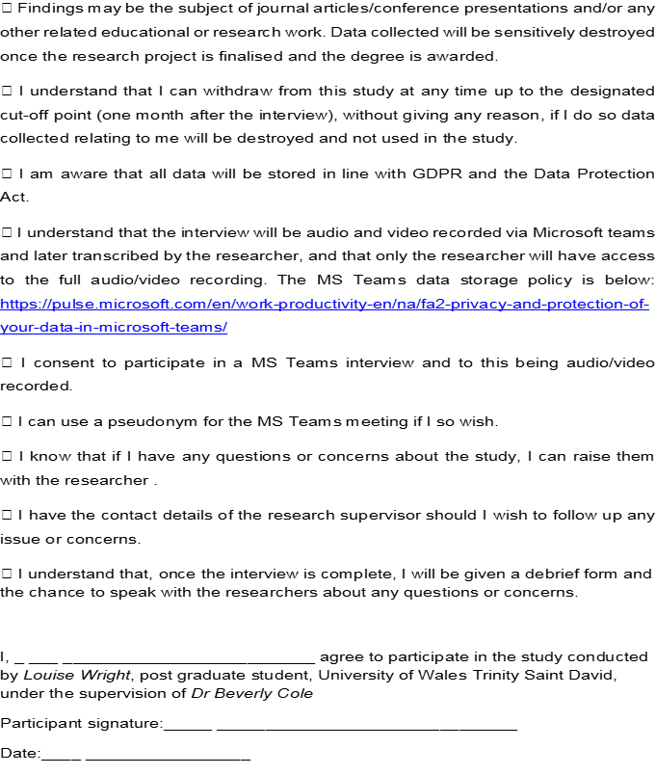

Appendix 1c: Participant Demographic Form

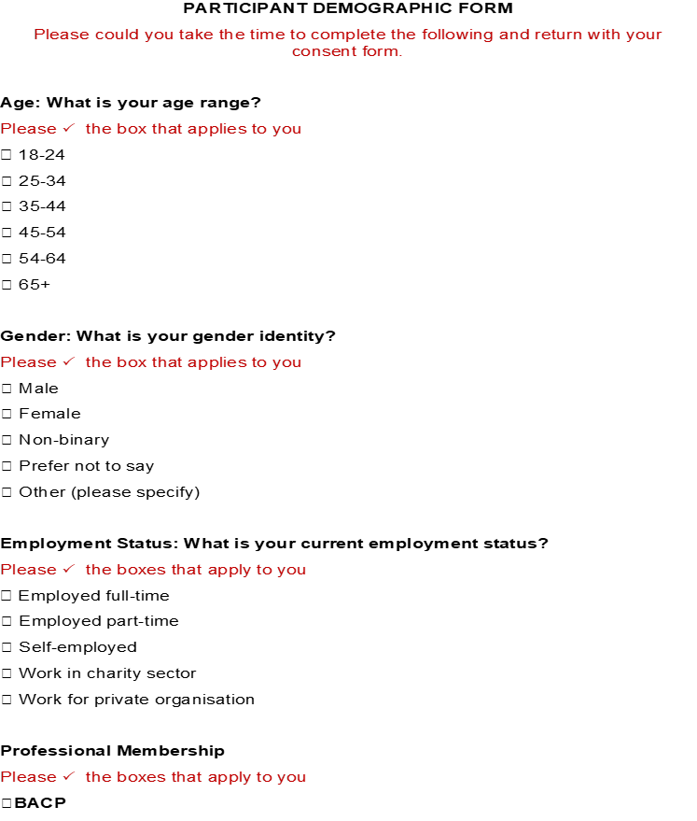

Appendix 1d: Interview Schedule
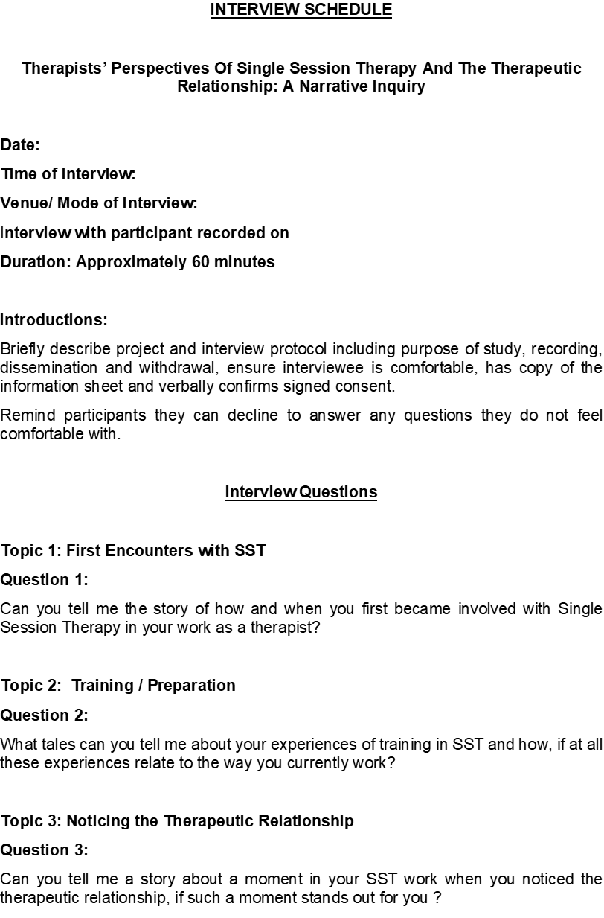
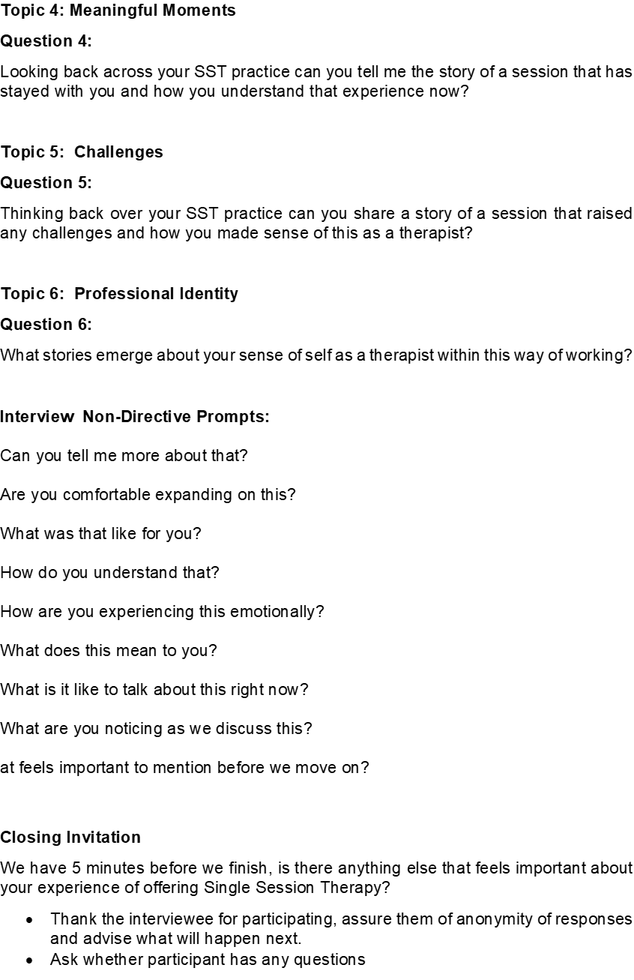

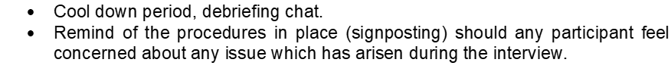

Appendix 1e: Participant De-Brief Form

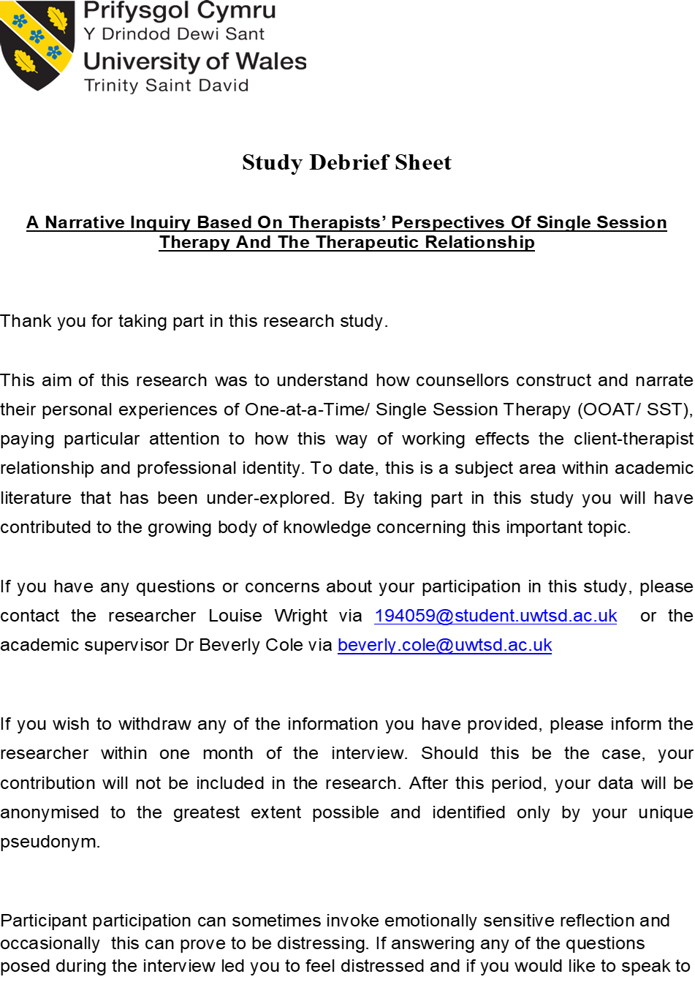
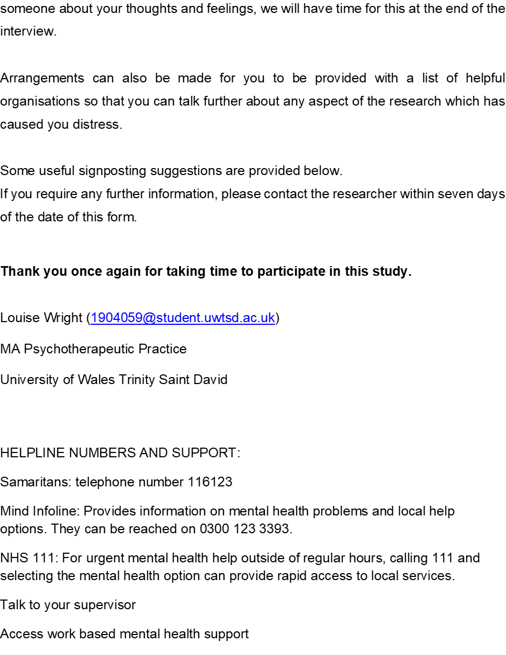

Appendix 2 : Researcher Analysis of Themes



