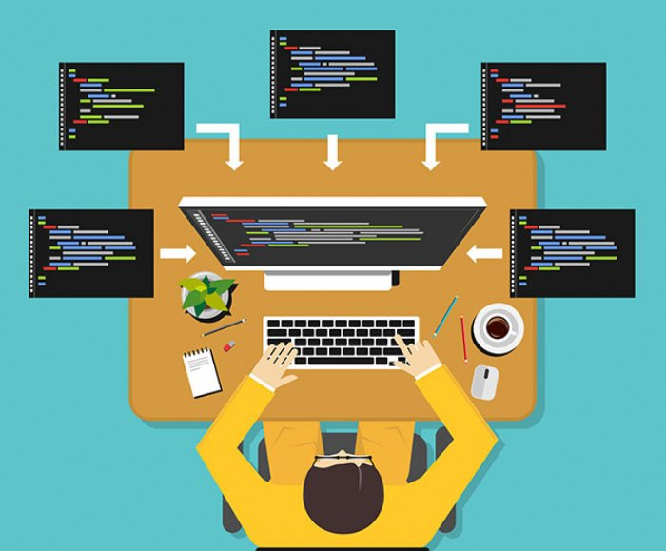

Image [1]

Assignment 1
Name: Zaeem
Student No.: 1902036
Course: Applied Computing (Web Development)
Module: Software Development
Title: Programming in C
Date: 1/4/2020

Table Of Contents
Content Page Number
Introduction 3
Exercise 1 5
Exercise 2 7
Exercise 3 10
Exercise 4 13
Exercise 5 16
Appendix 17
References 33

Introduction
In this documentation, students have been given from the lecturer to do five different exercises to show how well students can code using the language C++ on Microsoft Visual Studio. The first three exercises will be at a standard difficulty while the other two exercises will be at a hard difficulty. The five exercises were not very easy to complete but it is possible to complete.

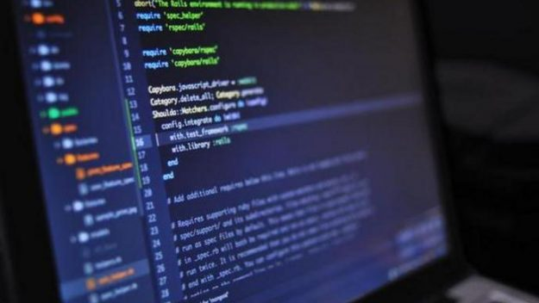

Image [3]
Image [2]
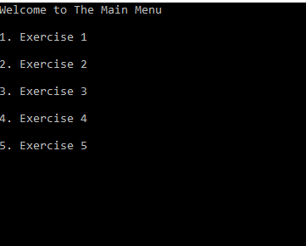

Image [4]

The image above shows the Main Menu from the program that was created on Microsoft Visual Studio. The Main Menu will show when the user starts the program on Microsoft Visual Studio.
This process was easy to complete as the technique was from the class work and the lecturer PowerPoint presentations during this process.
The image below is evidence from class work that has been adapted to create the Main Menu for this program.
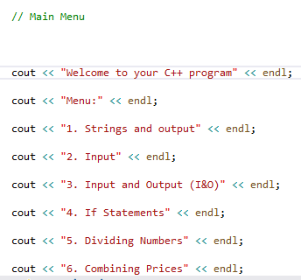
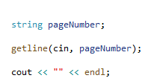

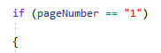

Images [6]

Exercise 1
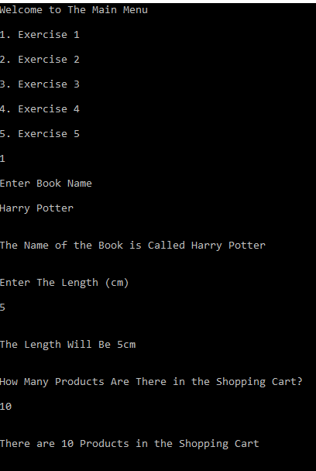

Image [4]

The first exercise will be to show what the user can type to answer the specific question and how the program can display what the user types in a sentence after the question three times.
This exercise was easy to complete as the technique was from the class work and the lecturer PowerPoint presentations during this exercise.

The image below is evidence from class work that has been adapted to create the Exercise 1 for this program.
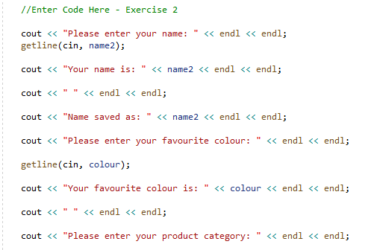

Image [7]

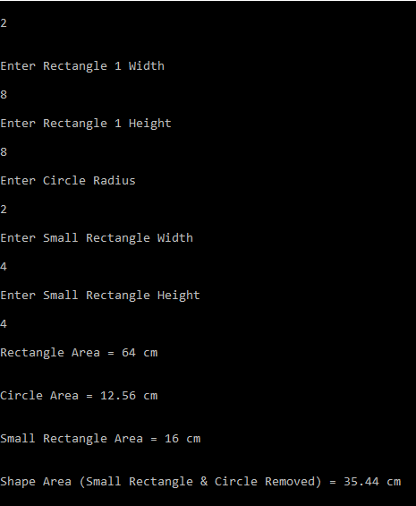
Exercise 2

Image [4]

The second exercise will be to show that the user can type the dimensions of a shape that has been provided by the lecturer brief and it will also show that the program can calculate the numbers and display the area of the shape.
This exercise was little bit easy to complete as the technique was from the class work and the lecturer PowerPoint presentations during this exercise.

The image below is evidence from class work that has been adapted to create the Exercise 2 for this program.
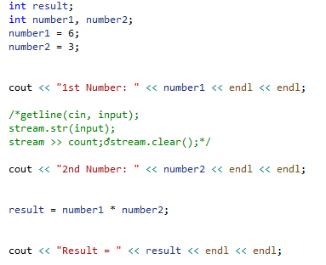

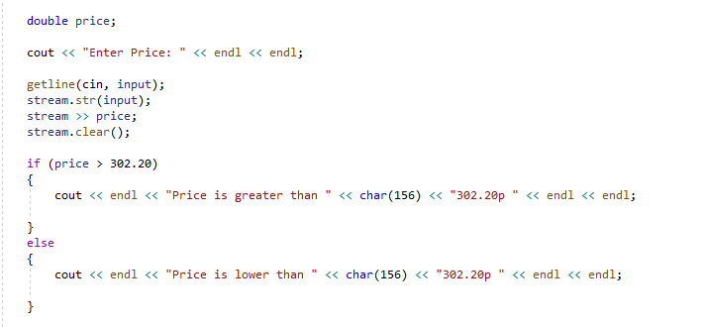

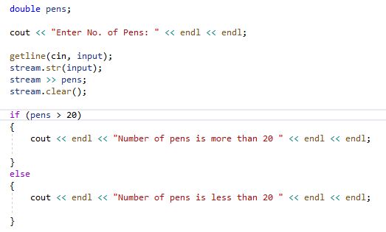

Images [8]

Exercise 3
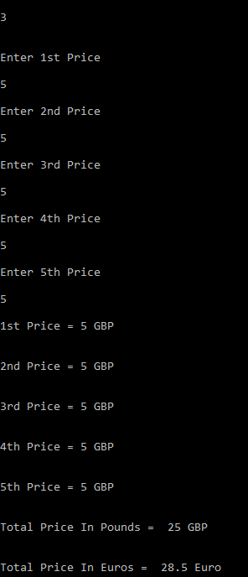

Image [4]

The third exercise will be to show what the user can type to answer the specific question and the program will show what the user has typed in a list. Then the program would add the numbers the user has typed and give the total result in GBP. Lastly, the program will convert the total result from GBP to Euros.
This exercise was little bit difficult to complete as the technique was from the class work and the lecturer PowerPoint presentations during this exercise.

The image below is evidence from class work and the lecturer PowerPoint presentation that has been adapted to create the Exercise 3 for this program.
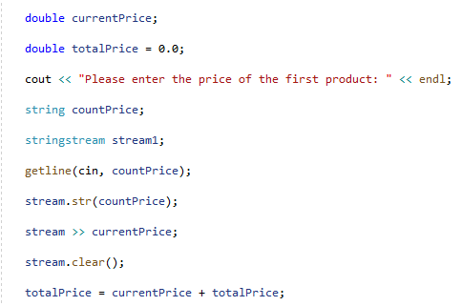

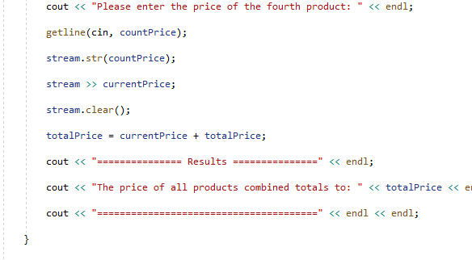

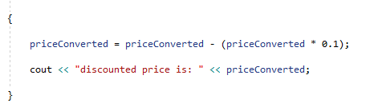

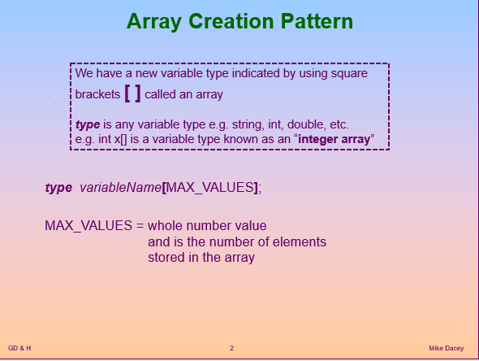

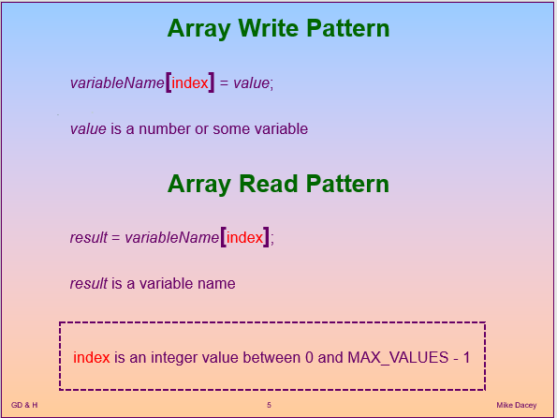

Images [6] & [9]

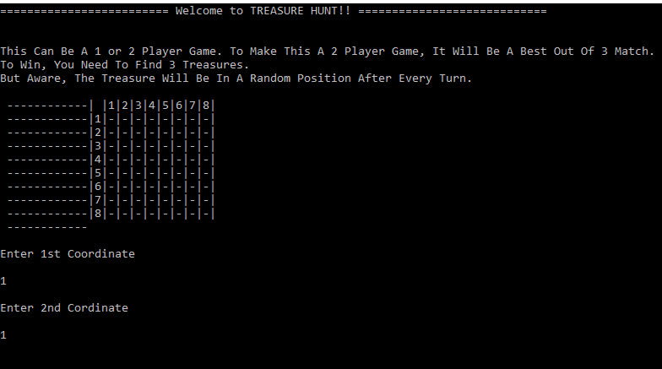
Exercise 4

Image [5]
The fourth exercise will be to show that the user can play a two-player game on this program called Treasure Hunt. The main concept for this exercise was to have the first player to place the treasure using the coordinates that the program gives and the second player has to guess where the first player has placed the treasure using the 8x8 grid. Also, the second player has three lives to guess or the player will lose the game. However, the program that was created did not meet the main concept as a two player Treasure Hunt game was created but the first player does not place where the treasure goes on which coordinates and the second player does not have three lives. Instead, the program places the treasure in a random position after every turn and it will be best out of three match between the two players.
This exercise was difficult to complete but the technique was from the class work, the lecturer PowerPoint presentations and some online research during this exercise.

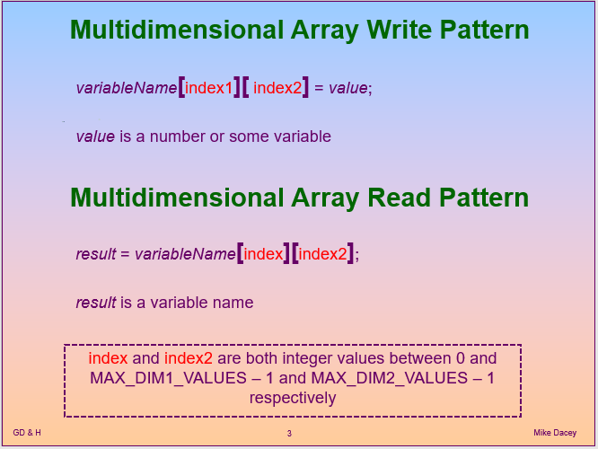
The image below is evidence from class work and the lecturer PowerPoint presentation that has been adapted to create the Exercise 4 for this program.

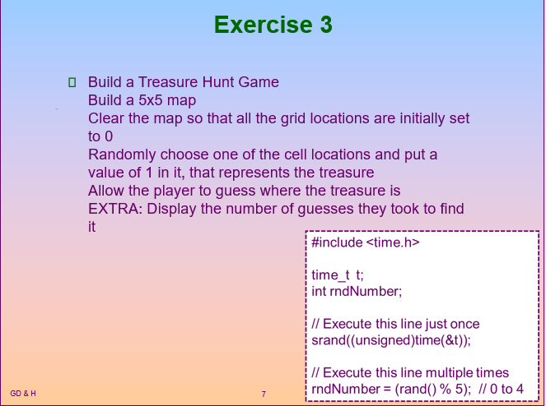

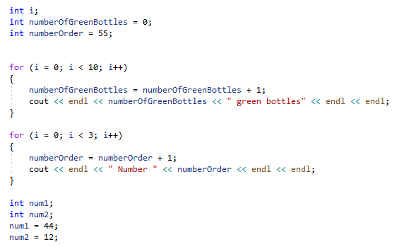

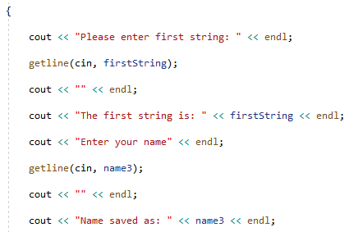

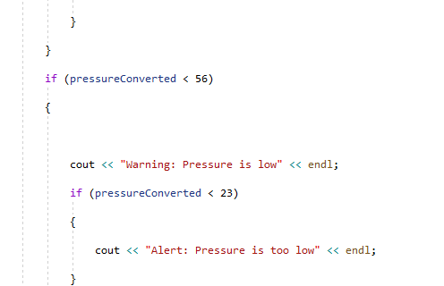

Images [10] & [6]
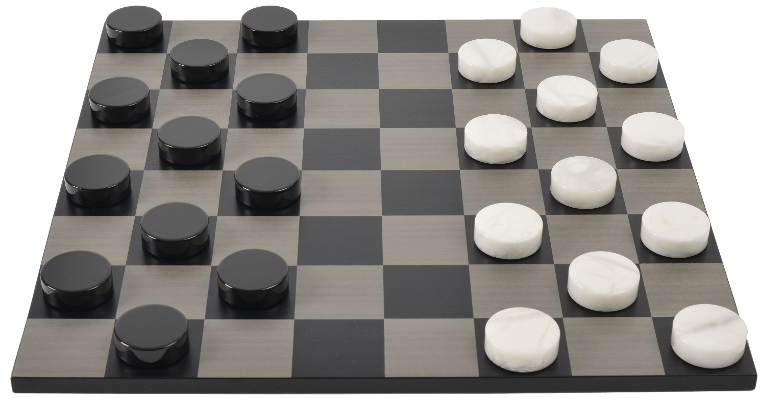
Exercise 5

Image [11]

The fifth exercise will be to show that the user can play a two-player game on this program called Checkers. The main concept for this exercise was to have the first player to move their represent checker piece and the second player to move their represent checker piece as well just like the classic version of the Checkers game. However, the program for this exercise was not created due to the fact that this exercise was very difficult to complete.

Appendix
This is the printed code that was used on ‘My Code’ file on Microsoft Visual Studio.

#include <string>
#include <iostream>
#include <sstream>
#include <iomanip>
#include <time.h>
#include <stdlib.h>
#include <stdio.h>
using namespace std;

int main(int argc, char* argv[])

{
/*cout << setprecision(2) << fixed;*/

// Main Menu

cout << "Welcome to The Main Menu" << endl << endl;

cout << "1. Exercise 1" << endl << endl;

cout << "2. Exercise 2" << endl << endl;

cout << "3. Exercise 3" << endl << endl;

cout << "4. Exercise 4" << endl << endl;

cout << "5. Exercise 5" << endl << endl;

//Variable
string pageNumber;

getline(cin, pageNumber);

cout << "" << endl;

//**************Exercise 1*****************************
if (pageNumber == "1")
{

//Variable
string bookname;
string lengthCM;
string shopcart;

// Display Book Title

cout << "Enter Book Name" << endl << endl;

getline(cin, bookname);

cout << "" << endl << endl;

cout << "The Name of the Book is Called " << bookname << endl << endl;

// Display Length Measurement in CM

cout << endl << "Enter The Length (cm)" << endl << endl;

getline(cin, lengthCM);

cout << "" << endl << endl;

cout << "The Length Will Be " << lengthCM << "cm" << endl << endl;

// Display The No. Of Products in Shopping Cart

cout << endl << "How Many Products Are There in the Shopping Cart?" << endl << endl;

getline(cin, shopcart);

cout << "" << endl << endl;

cout << "There are " << shopcart << " Products in the Shopping Cart" << endl << endl;

}

//**************Exercise 2*****************************
if (pageNumber == "2")
{

//Variable
double width1;
double height1;
double radius1;
double answer1;
double SRwidth;
double SRheight;
double SRanswer;
double overall;

string input1;
stringstream stream;

// Display Dimensions Of Shape

cout << endl << "Enter Rectangle 1 Width" << endl << endl;
getline(cin, input1);
stream.str(input1);
stream >> width1;
stream.clear();

cout << endl << "Enter Rectangle 1 Height" << endl << endl;
getline(cin, input1);
stream.str(input1);
stream >> height1;
stream.clear();

cout << endl << "Enter Circle Radius" << endl << endl;
getline(cin, input1);
stream.str(input1);
stream >> radius1;
stream.clear();

cout << endl << "Enter Small Rectangle Width" << endl << endl;
getline(cin, input1);
stream.str(input1);
stream >> SRwidth;
stream.clear();

cout << endl << "Enter Small Rectangle Height" << endl << endl;
getline(cin, input1);
stream.str(input1);
stream >> SRheight;
stream.clear();

SRanswer = SRheight * SRwidth;
radius1 = radius1 * radius1 * 3.14;
answer1 = height1 * width1;
overall = answer1 - radius1 - SRanswer;

// Calculate & Display Area Of Shape

cout << endl << "Rectangle Area = " << answer1 << " cm" << endl << endl;

if (answer1 > radius1)
{
cout << endl << "Circle Area = " << radius1 << " cm" << endl << endl;
cout << endl << "Small Rectangle Area = " << SRanswer << " cm" << endl << endl;
cout << endl << "Shape Area (Small Rectangle & Circle Removed) = " << overall << " cm" << endl << endl;

}

else
{
cout << endl << "Radius Is Larger Than Shape Area. Please Recorrect The Radius To Show Correct Data. " << endl << endl;
}

}

//**************Exercise 3*****************************
if (pageNumber == "3")
{

//Variable

stringstream stream;
/*double currentPrice;*/

double totalPrice = 0.0;

string countinput;

double theprice[5];

double array[5];

double euro1;

// Allows The User To Enter 5 Same or Different Prices & Add Them Up

cout << endl << "Enter 1st Price" << endl << endl;
getline(cin, countinput);
stream.str(countinput);
stream >> theprice[0];
/*stream >> currentPrice;*/
stream.clear();

totalPrice = theprice[0] + totalPrice;

cout << endl << "Enter 2nd Price" << endl << endl;
getline(cin, countinput);
stream.str(countinput);
stream >> theprice[1];
/*stream >> currentPrice;*/
stream.clear();

totalPrice = theprice[1] + totalPrice;

cout << endl << "Enter 3rd Price" << endl << endl;
getline(cin, countinput);
stream.str(countinput);
stream >> theprice[2];
/*stream >> currentPrice;*/
stream.clear();

totalPrice = theprice[2] + totalPrice;

cout << endl << "Enter 4th Price" << endl << endl;
getline(cin, countinput);
stream.str(countinput);
stream >> theprice[3];
/*stream >> currentPrice;*/
stream.clear();

totalPrice = theprice[3] + totalPrice;

cout << endl << "Enter 5th Price" << endl << endl;
getline(cin, countinput);
stream.str(countinput);
stream >> theprice[4];
/*stream >> currentPrice;*/
stream.clear();

totalPrice = theprice[4] + totalPrice;

// Shows The List Of Prices

cout << endl << "1st Price = " << theprice[0] << " GBP" << endl << endl;
cout << endl << "2nd Price = " << theprice[1] << " GBP" << endl << endl;
cout << endl << "3rd Price = " << theprice[2] << " GBP" << endl << endl;
cout << endl << "4th Price = " << theprice[3] << " GBP" << endl << endl;
cout << endl << "5th Price = " << theprice[4] << " GBP" << endl << endl;

//Shows The Total Price In Pounds

cout << endl << "Total Price In Pounds = " << totalPrice << " GBP" << endl << endl;

//Convert The Pounds To Euros

euro1 = totalPrice * 1.14;

cout << endl << "Total Price In Euros = " << euro1 << " Euro" << endl << endl;

}

//*********Exercise 4*******************

if (pageNumber == "4")
{

cout << endl << "Please View The 'My Exercise 4 V1' File. Sorry For The Trouble." << endl << endl;

//int result1, result2;
//int a = 0;
//int s = 0;
//int d = 0;
//int x;
//int y;
//int z1, z2;

////This Will Output The Treasure Board

//void board1(char board[8][8]) {
// cout << " ------------";
// cout << "| |1|2|3|4|5|6|7|8|";

// int numberline = 0;

// //This Will Loop The Output On The First Board

// for (int y = 0; y < 8; y++) {
// cout << endl;
// cout << " ------------";
// numberline++;
// cout << "|";
// cout << numberline;
// cout << "|";
// for (int x = 0; x < 8; x++) {
// cout << board[x][y];
// cout << "|";

// }
// }
// cout << endl;
// cout << " ------------" << endl;
//}

////This Will Place The Treasure In A Random Position

//void random(char zboard[8][8]) {
// int treasure = 0;
// int z1, z2;

// //This end of the randomizer loop/beggining of the mboarsd loop
// while (treasure < 3) {
// int z1 = rand() % 8;
// int z2 = rand() % 8;
// if (zboard[z1][z2] != 'X') {
// zboard[z1][z2] = 'X';
// treasure++;
// }
// }
//}
//void guess(char board[8][8], char zboard[8][8]) {
// int win = 0;
// do {
// cout << endl << "Enter 1st Coordinate" << endl << endl;
// cin >> result1;
// cout << endl << "Enter 2nd Cordinate" << endl << endl;
// cin >> result2;
// if (zboard[result1 - 1][result2 - 1] == 'X') {
// board[result1 - 1][result2 - 1] = 'X';
// cout << endl << "You Got One Treasure, Look For The Next One!" << endl << endl;
// win++;
// }
// else {
// board[result1 - 1][result2 - 1] = ' ';
// cout << endl << "Unlucky, Try Again" << endl << endl;
// }
// board1(board);
// } while (win != 3);
//}

//// This Will Show The Text At The Top Of The Screen
//int main() {
// srand(time(NULL));
// char board[8][8] = { '-','-','-','-','-','-','-','-','-','-','-','-','-','-','-','-','-','-','-','-','-','-','-','-','-', '-','-','-','-','-','-','-','-','-','-','-','-','-','-','-','-','-','-','-','-','-','-','-','-','-','-','-','-','-','-','-','-','-','-','-','-','-','-','-' };
// char zboard[8][8];

// cout << "========================= Welcome to TREASURE HUNT!! ============================" << endl << endl;

// cout << endl << "This Can Be A 1 or 2 Player Game. To Make This A 2 Player Game, It Will Be A Best Out Of 3 Match." << endl;

// cout << "To Win, You Need To Find 3 Treasures." << endl;

// cout << "But Aware, The Treasure Will Be In A Random Position After Every Turn." << endl << endl;

// board1(board);
// random(zboard);
// guess(board, zboard);

// cout << endl << "============================ Well Done, You Win! ===================================" << endl << endl;

}

//*********Exercise 5*******************

if (pageNumber == "5")
{

cout << endl << "Exercise 5 Was Not Attempted Due To The Fact It Was Very Difficult. Sorry For The Trouble." << endl << endl;

}

//Pause
cin.get();

return 0;
}

Code [4]

This is the printed code that was used on ‘My Exercise 4 V1’ file on Microsoft Visual Studio.

#include <iostream>
#include <iomanip>
#include <time.h>
#include <stdlib.h>
#include <stdio.h>
using namespace std;

int result1, result2;
int a = 0;
int s = 0;
int d = 0;
int x;
int y;
int z1, z2;

//This Will Output The Treasure Board

void board1(char board[8][8]) {
cout << " ------------";
cout << "| |1|2|3|4|5|6|7|8|";

int numberline = 0;

//This Will Loop The Output On The First Board

for (int y = 0; y < 8; y++) {
cout << endl;
cout << " ------------";
numberline++;
cout << "|";
cout << numberline;
cout << "|";
for (int x = 0; x < 8; x++) {
cout << board[x][y];
cout << "|";

}
}
cout << endl;
cout << " ------------" << endl;
}

//This Will Place The Treasure In A Random Position

void random(char zboard[8][8]) {
int treasure = 0;
int z1, z2;

//This Will Stop The Random Loop
while (treasure < 3) {
int z1 = rand() % 8;
int z2 = rand() % 8;
if (zboard[z1][z2] != 'X') {
zboard[z1][z2] = 'X';
treasure++;
}
}
}
void guess(char board[8][8], char zboard[8][8]) {
int win = 0;
do {
cout << endl << "Enter 1st Coordinate" << endl << endl;
cin >> result1;
cout << endl << "Enter 2nd Cordinate" << endl << endl;
cin >> result2;
if (zboard[result1 - 1][result2 - 1] == 'X') {
board[result1 - 1][result2 - 1] = 'X';
cout << endl << "You Got One Treasure, Look For The Next One!" << endl << endl;
win++;
}
else {
board[result1 - 1][result2 - 1] = ' ';
cout << endl << "Unlucky, Try Again" << endl << endl;
}
board1(board);
} while (win != 3);
}

// This Will Show The Text At The Top Of The Screen
int main() {
srand(time(NULL));
char board[8][8] = { '-','-','-','-','-','-','-','-','-','-','-','-','-','-','-','-','-','-','-','-','-','-','-','-','-', '-','-','-','-','-','-','-','-','-','-','-','-','-','-','-','-','-','-','-','-','-','-','-','-','-','-','-','-','-','-','-','-','-','-','-','-','-','-','-' };
char zboard[8][8];

cout << "========================= Welcome to TREASURE HUNT!! ============================" << endl << endl;

cout << endl << "This Can Be A 1 or 2 Player Game. To Make This A 2 Player Game, It Will Be A Best Out Of 3 Match." << endl;

cout << "To Win, You Need To Find 3 Treasures."<< endl;

cout << "But Aware, The Treasure Will Be In A Random Position After Every Turn." << endl << endl;

board1(board);
random(zboard);
guess(board, zboard);

cout << endl << "============================ Well Done, You Win! ===================================" << endl << endl;

return 0;
}

Code [5]

References

References

[1] | R. Harris, "The bright future of software development," 28 March 2018. [Online]. Available: https://appdevelopermagazine.com/the-bright-future-of-software-development/. [Accessed 1 April 2020].
[2] | G. Staff, "Learn Java, C#, Python, C++, and JavaScript Coding Skills with These Bundles," 10 November 2018. [Online]. Available: https://www.geek.com/deals-2/learn-java-c-python-c-and-javascript-coding-skills-with-these-bundles-1760201/. [Accessed 3 April 2020].
[3] | N/A, "Visual Studio 2019," N/A N/A N/A. [Online]. Available: https://visualstudio.microsoft.com/vs/. [Accessed 3 March 2020].
[4] | Zaeem, "My Code," Swansea, 2020.
[5] | Zaeem, "My Exercise 4 V1," Swansea, 2020.
[6] | Zaeem, "Missed Lecture 1," Swansea, 2020.
[7] | Zaeem, "1st Lecture," Swansea, 2020.
[8] | Zaeem, "2nd Lecture," Swansea, 2020.
[9] | M. Dacey, "Week8," Swansea, 2020.
[10] | M. Dacey, "Week10," Swansea, 2020.
[11] | N/A, "‘ Stone Checkers Black v White (Grey Board) ‘," N/A N/A N/A. [Online]. Available: https://purlinglondon.com/shop/stone-checkers-white-v-black-grey-board/. [Accessed 6 April 2020].

