Student name:Antonina Vasileva Danchova
Student number:2211877
Module name:Financial Management for the Hotel Industry
Module code:BMIH 5007
Lecture name:Tristan Hawkins
Business Report
Comparison of Two Hospitality Organisations

Table of Contents
Introduction 3
Recognised details about both the business 3
Determination of business revenue structure and growth 4
Concept of market position for both businesses 5
Identify the potential growth with Ansoff matrix 7
CSR engagement with financial relation 9
Conclusions 10
References 11

Introduction
In a competitive market every management used to evaluate the competitive analysis with some strategic tool to identify the level of trending position. In this report mainly the potential hospitality sector has been evaluated to identify the competitive positioning level of both businesses on an equivalent basis. For initiating such analysis along with the revenue position the market growth is also evaluated in relation to the correlation of CSR engagement.

Recognised details about both the business
According to the market presence, Shangri-La Hotel is a Chinese hospitality business which is operated in the United Kingdom. The overall performance of this particular business represents the involvement of an immense volume of customer presence considering the business branding position. At the present situation, the overall strategic approach of this business mainly indicates the incremental level of satisfaction for every individual customer and also provides a proper signifies development related to the 24-hour Customer services. In the present situation, the overall strategic position of the business provides a focus on the customer-centric approach including some accountability initiatives mainly so that a proper amount of revenue positioning approach can be initiated. The overall estimations related to the current Occupancy rate of this particular business in the UK indicate a level of 62% that expanded from the level of 37%. The overall generated value of RevPAR of the business indicates a level of USD483 which indicates a positive marketing development positioning level (Shangri-La Group, 2020).
The comparative business, Travelodge also identified as a hospitality business that is mainly incorporated in the United Kingdom and it was established in the year of 1985. The general operating area of the business includes the United Kingdom, Spain and Ireland. With proper affordability support the reasonable pricing approach is one of the main initiatives of this business that provides structural support for the business. In the present situation to provide a positive formulated development initiative the management of the business mainly focused on the promotional attribute including the brand reformation processing so that a proper volume of revenue formulation initiative can be established. In the present situation with the support of 600 hotels and over 45000 bedrooms the business mainly formulates a strong portfolio processing approach. The present level of RevPAR of this business indicates a level of USD 52.59 with market compatibility support (Travelodge Corporate Website, 2023).

Determination of business revenue structure and growth
The primary engagement and the presence of current customer volume initiate a proper volume of revenue development opportunity for both the business which ultimately structure the compatibility gains. The basic identified approach including the strategic growth initiative at the present situation indicates a competitive opportunity support for every individual business which ultimately represents the revenue development opportunity.
According to the basic identification, the overall market position for the business Shangri-La represents the contemporary significance of branding development that formulates a progressive volume of revenue positioning support for the business. Application of proper operating development with respect to individual businesses is used to provide a proper opportunity for the business revenue development and competitive positioning purpose which is accountable for the maintenance of business financial stability (Drury, 2021).
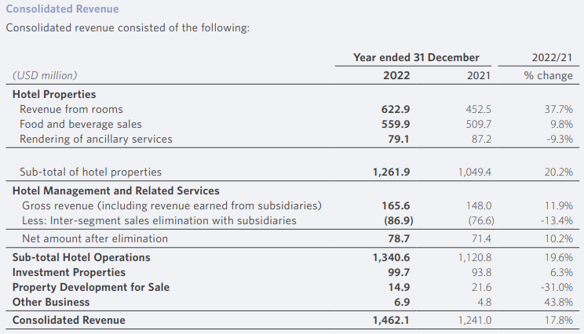
The primary recognitions related to the above-consolidated revenue structure indicate the overall generated volume of business revenue associated with the hotel property mainly indicates a progressive growth positioning structure from the level of 1049.4 million to 1261.9 million in 2022 indicating a positive growth of 20.2% (shangri-la.com, 2022). Compared to the earlier period the present volume of demand after the pre-covid phase mainly expanded in a rapid order that formulates a positive response for this business considering the level of promotional attributes. Even the overall investment properties income for the business also represents a progressive growth of 6.3% in the current year which ultimately represents the consolidated revenue expansions of 17.8% support basis.
The primary identified measurements of revenue for Travelodge also indicate an optimised formulated development structure including a contemporary positioning approach that indicates a positive and value-based earning support.
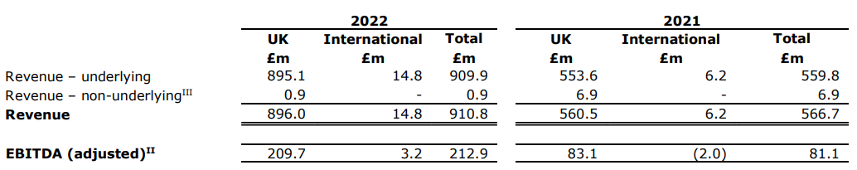
As per the identifications the revenue related to the underlying approach for the business associated with the both UK and international aspects represents a revenue positioning approach of 910.8 million financial positioning support compared to the previous position of 566.7 million. The overall adjusted EBITDA of the business also represents a progressive volume of growth from the level of 81.1 million to the level of 212.9 million in the year 212.9 which indicates a progressive market statutory opportunities and compatibility initiative support (Travelodge.co.uk, 2022). The present commitment to a value-based position and a proper affordable pricing structure of this particular business initiate a progressive opportunity for revenue expansion and stability support that ultimately provides an accountable revenue growth approach. In the present position, the engagement of branding initiatives including the strategy of next-generation room approach in this particular business mainly expands the revenue positioning level in a systematic order (The Caterer, 2023).

Concept of market position for both businesses
With the positioning support of a strong brand initiative, the current operating position of Shangri-La mainly provides significant importance to their elite-class hotel support that initiates a progressive marketing development structure for the business. The primary involvement of the 24-hour customer service initiative formulates the quality positioning structure of this particular business service on a differentiated basis that ultimately provides a proper Goodwill formulation approach for the business. The employee's stability apart from the branding is one of the plus-one approaches for the business that ultimately provides a proper volume of market potential. As per the operating engagement, the major volume of market operation related to this particular business belongs to China while around 79% of the Occupancy rate belongs to the UK economy (Lun, 2023). However, the present volume of fluctuations related to the foreign exchange position and the equity security pricing approach generally initiate a certain volume of challenging approaches related to the market value for this business which is insufficient for maintaining the compatibility growth.
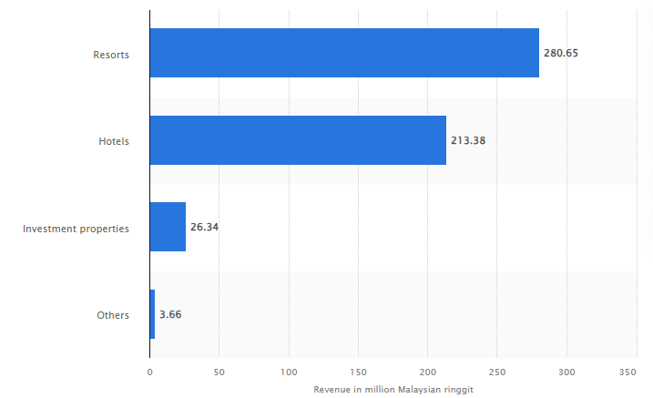
Under the general performance approach, the current operating value and the market approach for the organisation Travelodge indicate a proper competitive positioning approach associated with the potential number of competitors. With the flat Occupancy support of 81.8% approaching the current year, the overall average room rate level is expanded to 22.5% which represents comparative positioning support for the business market value.
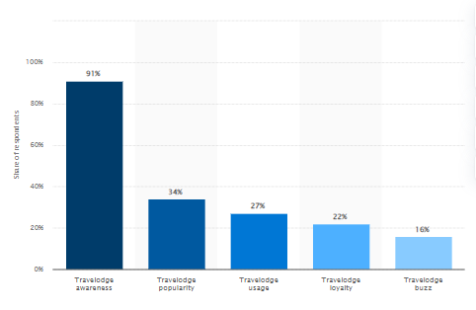
In relation to the above statistical analysis of the present situation, the majority level of business revenue position for Travelodge indicates 91% goodwill and branding initiative support which is accountable for the business values. In 2020 the primary identification of “offering 1 million rooms for £25 or less a night” formulates a positive branding support for the business that expanded the operating growth and market potentiality approach (uk.finance.yahoo.com, 2022).
After the pandemic for the purpose of expanding the business opportunity in a specified order this particular organisation officially opened its sixth Spanish hotel in Madrid with the contribution of €1 million in refurbishing that ultimately formulates the business positioning approach including the market value development in a sustainable basis (Hospitality Net, 2023). Additionally, the current market initiative structure of the business also initiates a progressive volume of market capitalisation position in support that ultimately formulates the business branding in an optimised order.

Identify the potential growth with Ansoff matrix
The applicability and maintenance of proper growth measurement are influential in identifying the business operating opportunities on a competitive basis. Under the present situation to evaluate a proper comparative evaluation support between hospitality businesses the application of Ansoff’s matrix is initiated which indicates operating opportunities and the new service engagement support for the business.
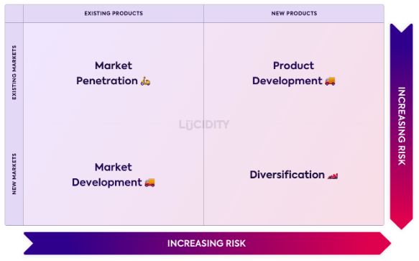
According to the primary initiative for the business of Shangri-La Hotel Group, the applied commitment related to the present branding initiative provides a proper volume of market penetration support that mainly formulates the business positioning growth including the operating accountability approach. In the present situation, the basic commitment towards the Pioneers of Asian Hospitality mainly formulates the branding structure including the operating value of the business on a formulated basis. Additionally, the applied Iconic Global Projects of the business also initiate formulated market development opportunities with the diversification support that mainly formulates the business value positioning support including the operation growth positioning approach. In the present situation, the applied commitment towards the Innovative Dining Concepts of the business mainly initiates a proper product development and diversification approach which indicates a quality uniqueness approach of this particular business compared to the others (Shangri-la.com, 2020). Apart from the above factors to provide a proper quality value initiative support to individual customers including the development of a lifestyle approach the management of the business provides a significant volume of contribution over the new strategy of Holistic Programmes for the Modern Urbanite with the formulation of which a new service development is associated with the existing market processing has been committed by the business that structures the operating value in a formulated manner.
At the present position, the operating structure and performance engagement related to the business of Travelodge Hotel provide a significant level of importance to the engagement of the Unique market proposition while providing importance to the value positioning approach for both the customer and stakeholders. Prioritising the best locations and operations along with customer satisfaction is one of the Primary market development initiative approaches for this business with a managing and well-priced quality positioning approach that ultimately formulates a proper volume of market potential at support and portfolio development (Travelodge Corporate Website, 2022).
To initiate a progressive volume of revenue development and as the diversification approach at the present situation, the management of this particular business selected “Medallia to power its new voice of the Customer Programme” with the initiative of which the overall branding including the technical-based operating engagement has been initiated (businesswire.com, 2022).

CSR engagement with financial relation
In relation to the business of Shangri-La Hotel Group, the present sustainability structure represents a proper volume of operating support with the engagement of four pillars related to people, environment, business and community. At the present situation, the ESG structure of the business provides a significant volume of focus on the implementation of green building standards along with constructing some of the new properties belonging to the renovation project approach with the initiative of which a proper volume of environmental footprint declining approach can be initiated.
Additionally, for the general purpose of initiating some positive development related to the sustainability program in this business, the management has initiated a particular commitment of 39 green building certifications and also 44 properties along with an environment and managerial approach system support structure which formulate a proper volume of environment-friendly approach. For the maintenance of proper environmental progress currently, the business is also committed to 100% elimination of plastic takeaway containers from the business so that a proper Social reformulation approach can be initiated. To provide a proper volume of accountability commitment the business also provides significance to the 74% diversion rate for the food waste that ultimately structures the operating position of this business on an effective basis.
Considering the same approach, the overall initiated engagement related to the CSR processing for the business of Travelodge represents a positive level of wellbeing approach that mainly formulates progressive support for the customers and employees. In the present situation, the management of the business also initiates a significant volume of contributions through charity partnership support which ultimately provides a significant volume of importance to the processing of human trafficking and child abuse prevention commitment (Better Future, 2022).
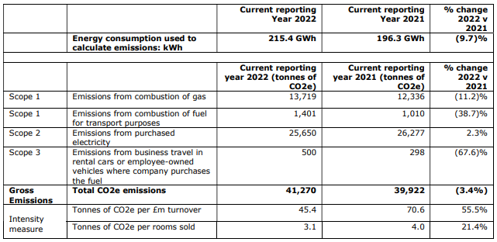
At the present situation, the overall analysis and initiative related to this particular base day indicate a positive volume of development approach related to the controlling of carbon emissions volume which expanded around 11.2% in the present year. Additionally, a proper amount of contribution related to the environmental approach is also initiated by this business which ultimately formulates a progressive volume of corporate sustainability approach by this organisation.

Conclusions
Overall, the present comparative analysis indicates both businesses are sustainable and also represent a contemporary revenue positioning approach that ultimately expands the marketing growth and stability position of the business. The primary engagement and the operating structural approach of both businesses also indicate and optimised valuable development support that ultimately enhances the contemporary positioning growth and operating value initiative approach for both businesses.

References
Better Future. (2022). Available at: https://www.travelodgesustainability.co.uk/wp-content/uploads/sites/2/2023/05/Better-Future-Report-2023.pdf [Accessed 30 Apr. 2024].
businesswire.com. (2022). Travelodge (UK) Selects Medallia to Power its New Voice of the Customer Programme. [online] Available at: https://www.businesswire.com/news/home/20220616005140/en/Travelodge-UK-Selects-Medallia-to-Power-its-New-Voice-of-the-Customer-Programme [Accessed 30 Apr. 2024].
Drury C (2021) (11th Ed) Management and Cost Accounting, London, Prentice Hall
Hospitality Net. (2023). Travelodge officially opens its sixth Spanish hotel in Madrid. [online] Available at: https://www.hospitalitynet.org/announcement/41010183.html [Accessed 29 Apr. 2024].
Lun, T.N. (2023). Shangri-La Asia posts H1 net profit of $177m on recovery of hotel business. The Straits Times. [online] 30 Aug. Available at: https://www.straitstimes.com/business/companies-markets/shangri-la-asia-posts-h1-net-profit-of-us1314-million-on-recovery-of-hotel-business [Accessed 29 Apr. 2024].
Shangri-La Group (2020). About Shangri-La. [online] Shangri-la.com. Available at: https://www.shangri-la.com/group/our-story/about-shangri-la [Accessed 29 Apr. 2024].
shangri-la.com (2022). Cover Photos: 1. JEN Shenzhen Qianhai by Shangri-La 2. Kerry Hotel. [online] Available at: https://sitecore-cd.shangri-la.com/-/media/Project/Shangri-La-Group/Investor/Files/Public-Disclosures/Latest-Top-Publications/e0069_230418_AR.pdf [Accessed 29 Apr. 2024].
Shangri-la.com. (2020). business operating strategies. [online] Available at: https://www.shangri-la.com/group/our-businesses/ [Accessed 29 Apr. 2024].
The Caterer. (2023). Travelodge reports ‘record’ results for... [online] Available at: https://www.thecaterer.com/news/travelodge-record-2022-financial-results-encouraging-start-2023 [Accessed 29 Apr. 2024].
Travelodge Corporate Website. (2022). Business Model & Strategy. [online] Available at: https://travelodge.co.uk/our-business/about-us/business-model-and-strategy/ [Accessed 30 Apr. 2024].
Travelodge Corporate Website. (2023). About Us. [online] Available at: https://travelodge.co.uk/our-business/about-us/#:~:text=visitors%20each%20year.- [Accessed 29 Apr. 2024].
Travelodge.co.uk (2022). Travelodge Investor Site. [online] www.travelodge.co.uk. Available at: https://www.travelodge.co.uk/investors/home [Accessed 29 Apr. 2024].
uk.finance.yahoo.com. (2022). Travelodge responds to coronavirus by offering 1 million rooms for £25 or less a night. [online] Available at: https://uk.finance.yahoo.com/news/travelodge-coronavirus-million-rooms-night-134153116.html [Accessed 29 Apr. 2024].

