Student name: chahir bentrad
Student ID :2223851
Module: Computer Architecture and
Operating systems
Module code: ACCA 4022
Lecturer: james Williams
Assignment title: Operating Systems
Resit Assignment

Contents
1. Introduction 3
2. Key Functions of General Operating Systems 3
2.1 Process and Processor Management 3
2.2 Memory Management 5
2.3 File, Storage and Device Management 5
2.4 Security, User and Network Management 7
3. Use of Windows OS CLI Commands 9
3.1 Process Management 9
3.2 File and Directory Management 11
3.3 Network Testing and Monitoring 12
3.4 User Management and Task Scheduling 15
4. Use of Linux OS CLI Commands 16
4.1 Process Management 16
4.2 File and Directory Management 17
4.3 Network Testing and Monitoring 19
4.4 User Management and Task Scheduling 20
5. Use of Windows OS Scripts 22
6. Use of Linux OS Scripts 25
7. Conclusion 29
8. Reference 31
9. Appendices 34
Appendix A: Tutorial Activity 1 – Operating-System Types 34
A.1 Batch Operating Systems 34
A.2 Time-Sharing Operating Systems 34
A.3 Distributed Operating Systems 34
A.4 Network Operating Systems 34
A.5 Real-Time Operating Systems 34
A.6 Mobile and Embedded Operating Systems 35
Appendix B: Lecture Activity Log 35
Appendix D: Practical Completion Procedure 35

1. Introduction
An operating system is the software that interfaces between applications and hardware. It controls the use of processor, memory, storage, devices, security, networking and interaction of users with the system and tries to keep the system stable and responsive. This report examines these functions through both research and practical work. Windows management interfaces were used to monitor system resources, while Windows PowerShell and Ubuntu Bash were used to perform process, file, network, user and scheduling operations. A PowerShell script and a Bash script were also implemented to automate the backup and reporting of sandwich-bar order files [1]. The practical results demonstrate how operating-system concepts are applied through graphical management utilities, command-line tools and reusable scripts.

2. Key Functions of General Operating Systems
General-purpose operating systems perform two closely related roles. First, they provide abstractions that make hardware easier for applications and users to access. Second, they act as resource managers by controlling the processor, memory, files, storage devices and input/output hardware. Modern systems must distribute these resources efficiently while maintaining isolation, reliability and security [2].

2.1 Process and Processor Management
Process management controls how programs are created, scheduled, executed and terminated. The operating system allocates processor time among running applications, allowing multiple tasks to operate concurrently. Windows Task Manager demonstrates this by displaying active processes and their CPU, memory, disk and network usage [3].
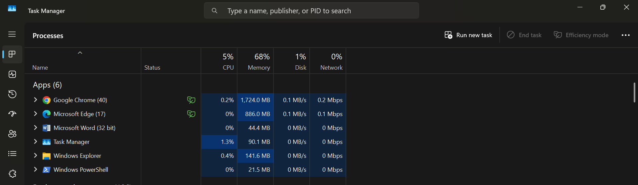
Figure 1: Task Manager Processes
As this figure 1 depicts, Chrome and Edge, Word, Windows Explorer, PowerShell and Task Manager were all open. Chrome used about 1,724 MB of memory and Edge used about 886 MB of memory. This demonstrates that the operating system tracks resource use separately for each process and allows users to identify demanding applications.
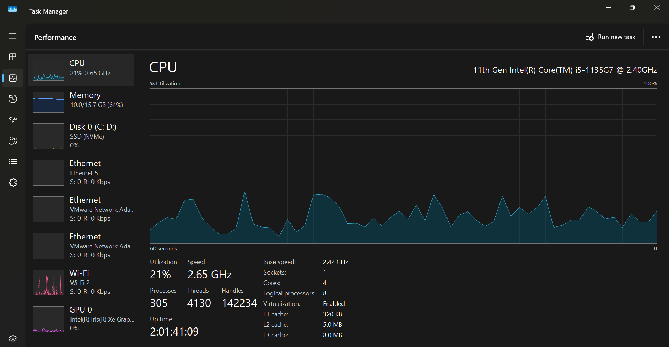
Figure 2: Task Manager CPU
Figure 2 shows 21% CPU utilisation at 2.65 GHz, with four physical cores and eight logical processors. The graph helps identify whether performance issues are caused by sustained processor demand.

2.2 Memory Management
Memory management allocates physical and virtual memory to processes, protects one process from interfering with another and releases memory when it is no longer required. Windows also supports memory mapping, copy-on-write operations and virtual-memory services [4].
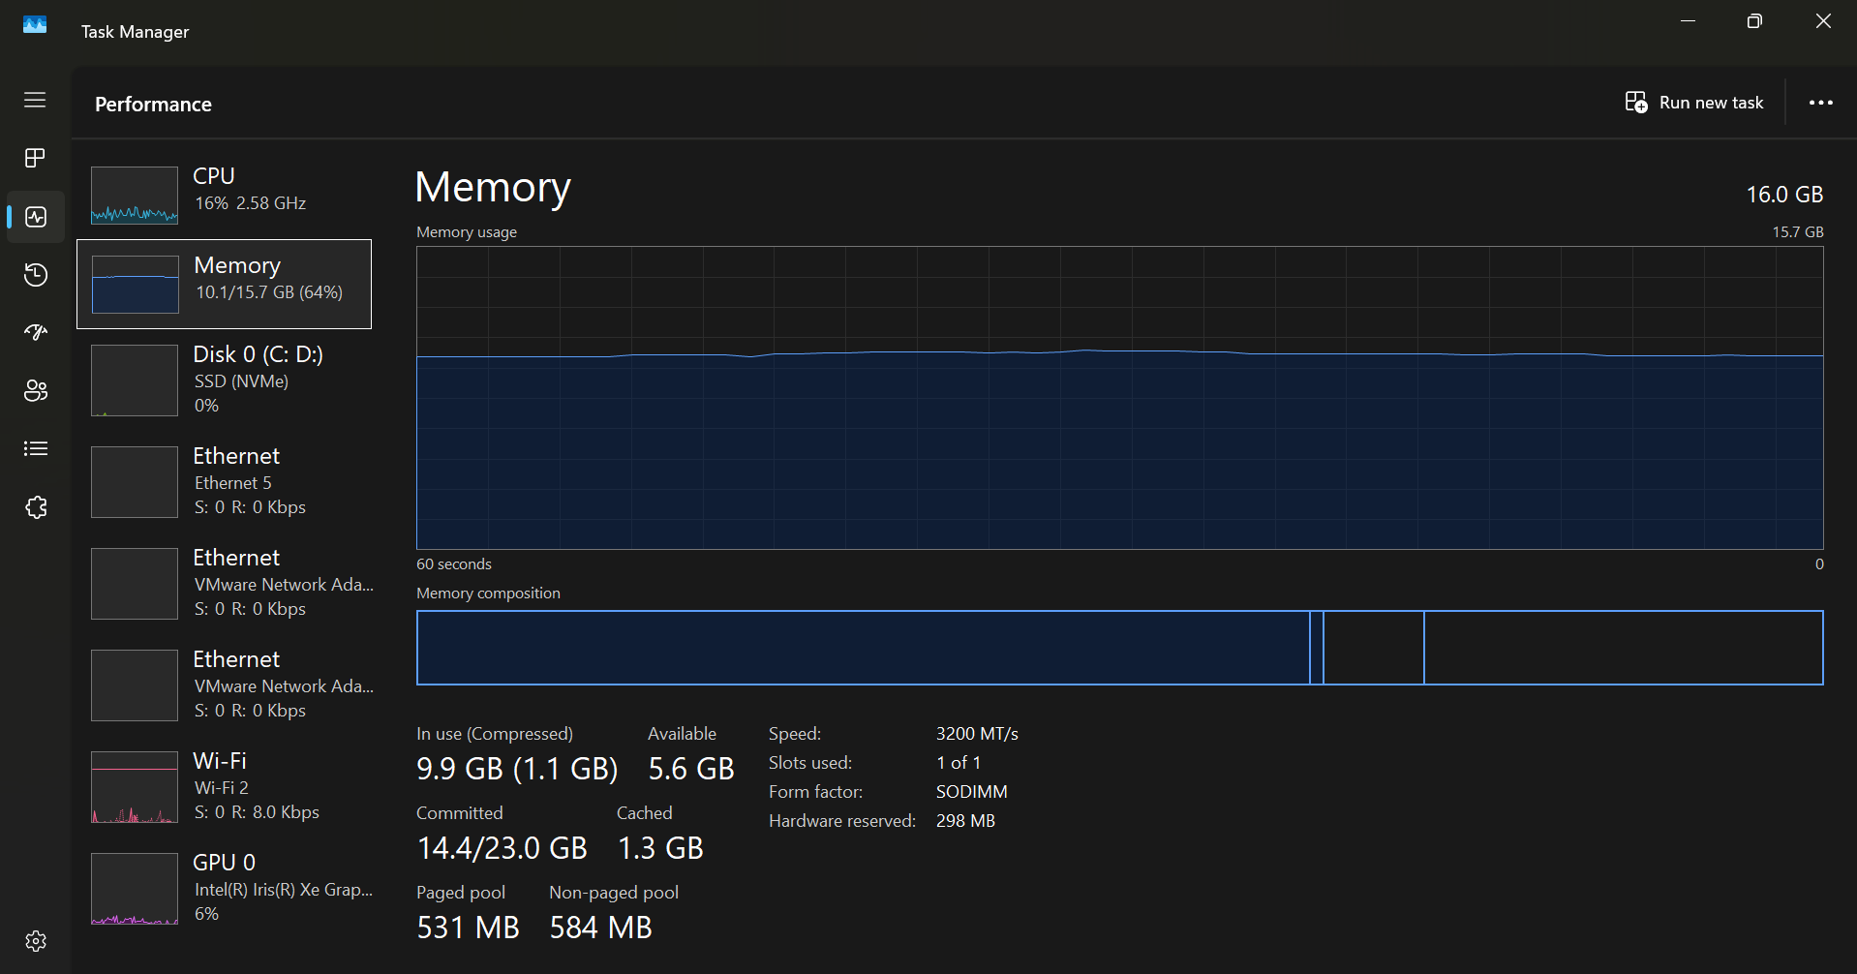
Figure 3: Task Manager Memory view showing physical-memory allocation and availability
Figure 3 shows 16 GB of installed memory, with 9.9 GB in use and 5.6 GB available. This indicates moderate memory use without immediate resource exhaustion.

2.3 File, Storage and Device Management
Figure 4 shows a 1 TB disk divided into EFI, Windows, recovery and data partitions. Disk Management also displays volume organisation, file systems and available storage space.
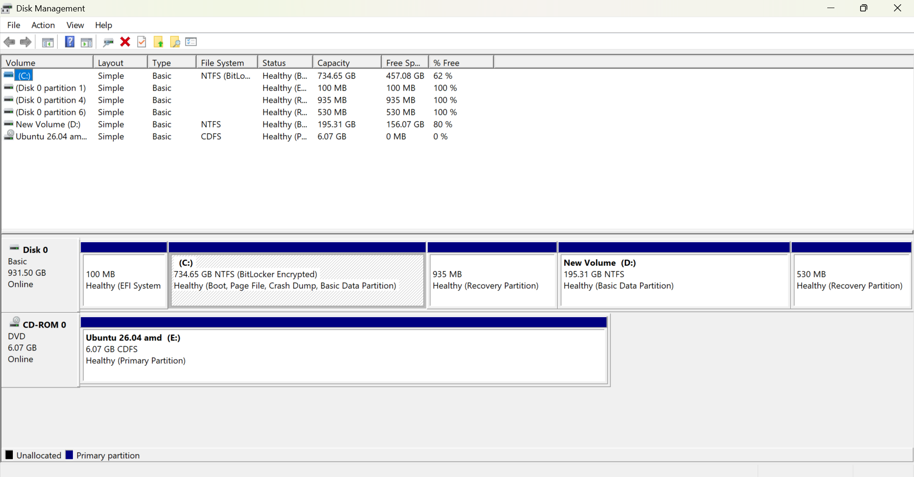
Figure 4: Windows Disk Management displaying system, recovery and data partitions
Figure 4 shows the Windows C: partition, BitLocker protection, D: data volume, and EFI and recovery partitions. Figure 5 shows the NVMe drive, Intel graphics adapter, and physical and virtual network adapters managed through device drivers.
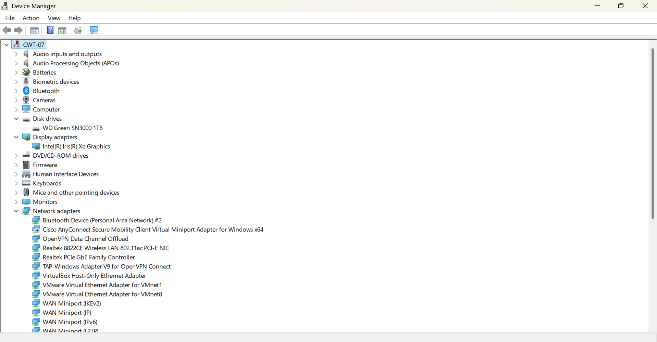
Figure 5: Device Manager showing storage, display and network hardware managed through device drivers

2.4 Security, User and Network Management
Operating systems authenticate users, apply permissions and protect resources through controls such as account privileges, encryption, firewalls and antimalware protection. Windows security documentation emphasises integrated protection of identity, hardware, applications and data [5].
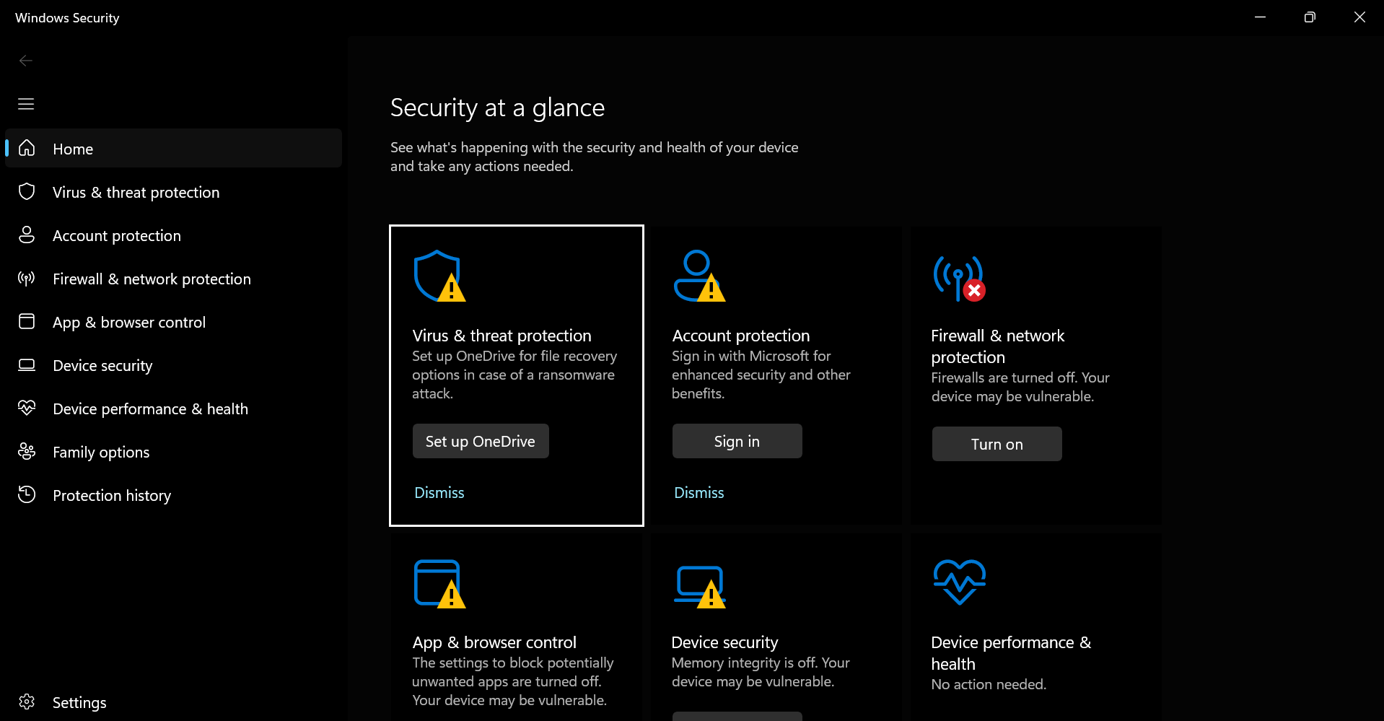
Figure 6: Windows Security dashboard showing the status of system-protection components
Figure 6 shows warnings for firewall protection, application control and memory integrity, indicating that key security defences were disabled and required review.
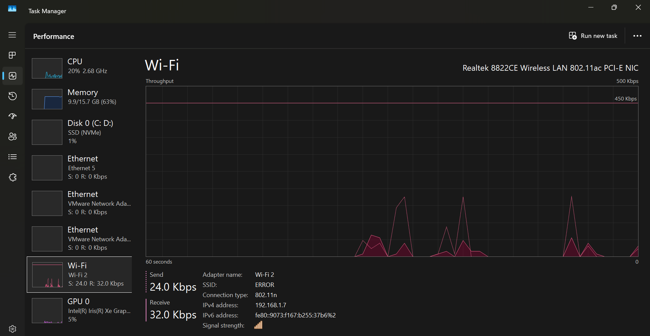
Figure 7: Wi-Fi performance monitoring showing adapter details, IP address and current throughput.
The Wi-Fi view identified the Realtek adapter, IPv4 address and live send and receive rates. When taken together, the screenshots 7 illustrate that operating-system functions do not exist in abstraction, but can be measured and controlled by using built-in tools.

3. Use of Windows OS CLI Commands
Windows offers Command Prompt tools and PowerShell Commands to administer and automate. Unlike a normal, non-structured command line shell, PowerShell uses a pipeline of objects. The practical commands covered every area required by the assessment: processes, files, networking, users and task scheduling.

3.1 Process Management
The tasklist /v command in figure 8 displayed running processes with verbose information, including process identifiers, sessions, memory use, and usernames and CPU time. Microsoft confirms that tasklist is designed to list locally or remotely running processes [6].
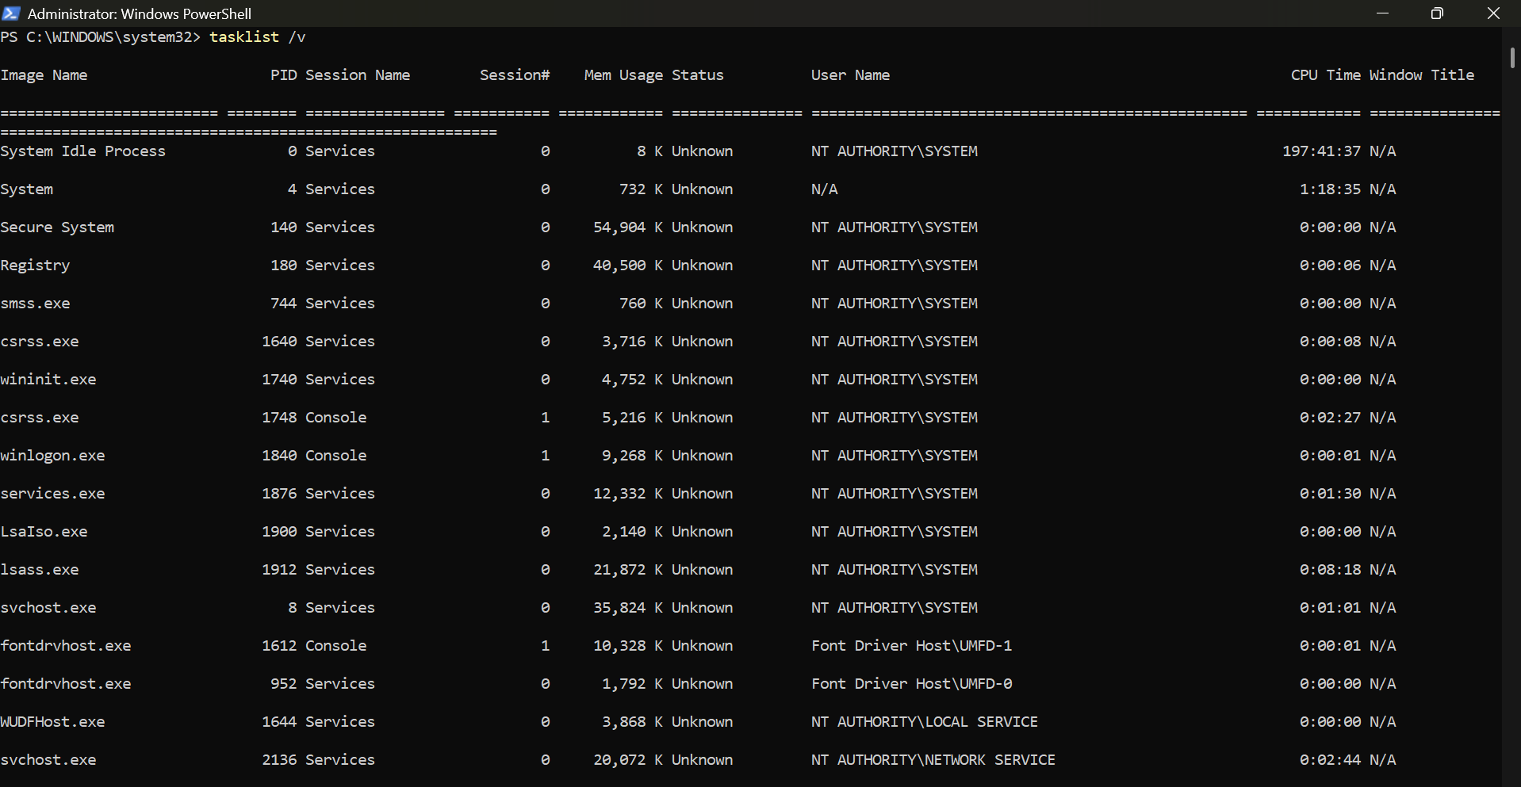
Figure 8: The tasklist /v command displaying detailed information about running Windows processes.
The PowerShell pipeline:
Get-Process | Sort-Object WorkingSet -Descending |
Select-Object -First 10. In figure 9 retrieved active processes, sorted them by working-set memory and returned the ten largest consumers. Get-Process returns local process objects, allowing properties to be filtered or sorted [7].
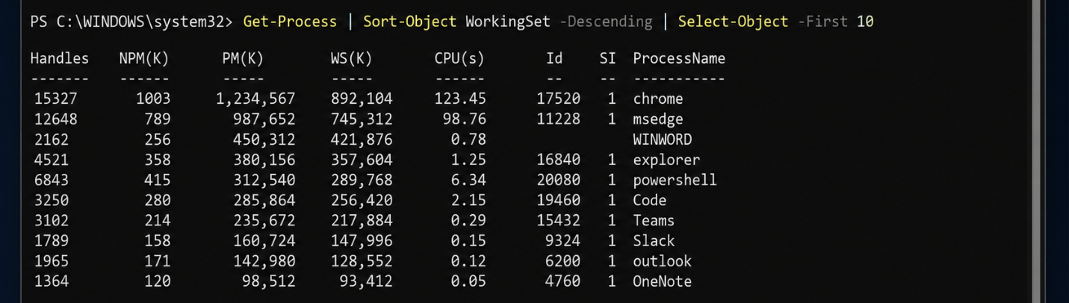
Figure 9: PowerShell identifying the ten processes using the most working-set memory

3.2 File and Directory Management
In figure 10, New-Item created TestFolder, while -ItemType Directory specified that the new item was a folder and -Force allowed creation without interruption if the path already existed.
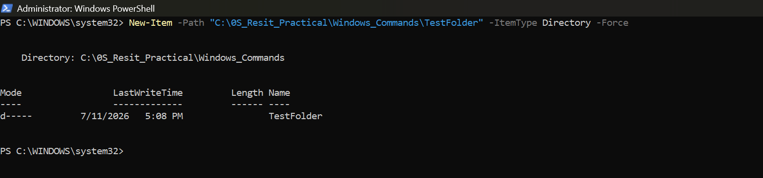
Figure 10: Creating a test directory with New-Item
Figure 11 shows Set-Content creating two order files, while Figure 12 shows Copy-Item transferring them to the Backup directory. The -Verbose option displayed each operation, and -Force allowed existing files to be overwritten [8].
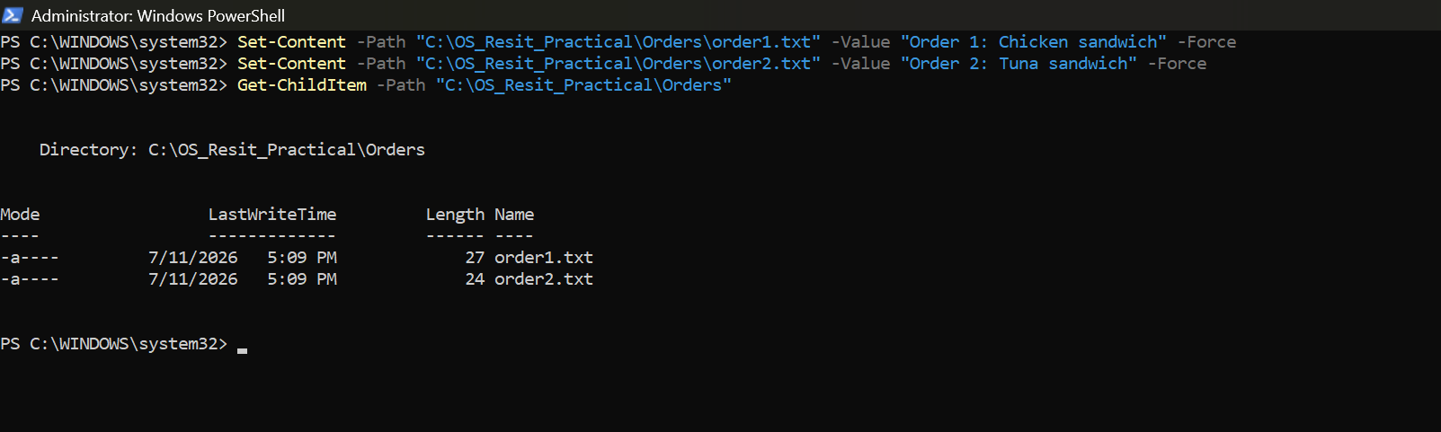
Figure 11: Creating and verifying two text-based order files
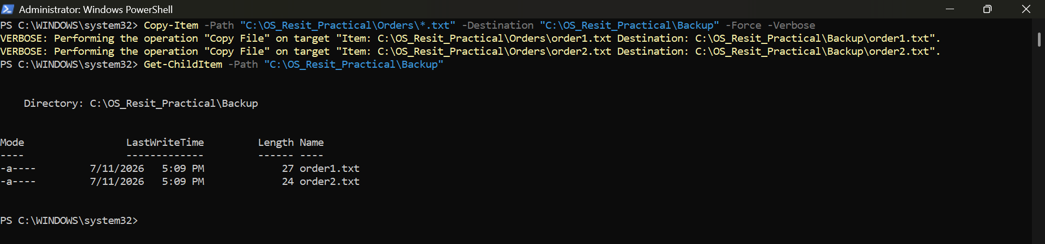
Figure 12: Copying the order files into the Windows Backup directory

3.3 Network Testing and Monitoring
With figure 13, ipconfig /all shows the full TCP/IP configuration with the IPv4 Addresses for the active Wi-Fi connection, DHCP, and default gateway and DNS. This switch, /all, is used to provide all information about all network adapters [9].
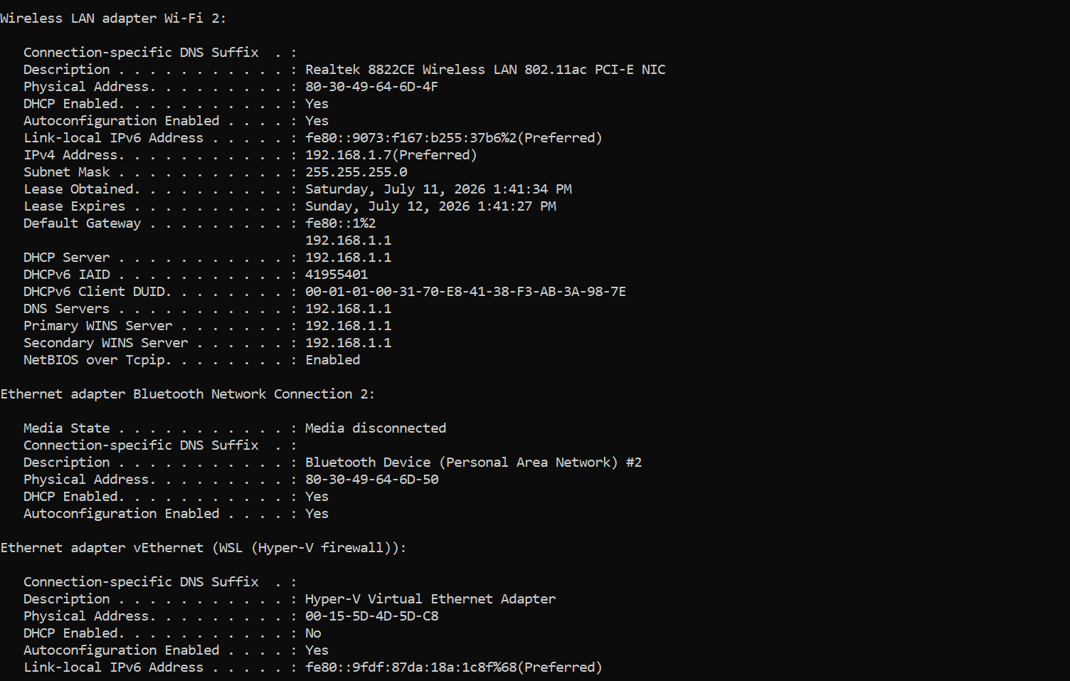
Figure 13: Full TCP/IP details for the active Wi-Fi adapter
In figure 14, ping -n 4 8.8.8.8 sent four ICMP requests. Successful external connectivity was established as all four replies were received with zero packet loss and with an average to get in answer of about 20ms. The /n switch controls the number of requests [10].
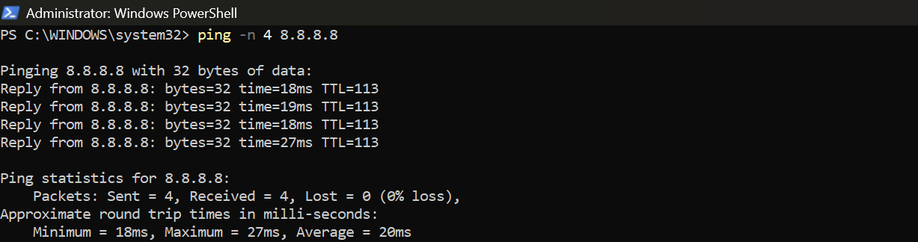
Figure 14: Successful Windows connectivity test with four replies and no packet loss
In figure 15, netstat -ano displayed listening and established connections. -a included listening ports, -n kept addresses numerical and -o showed the PID associated with each connection [11].
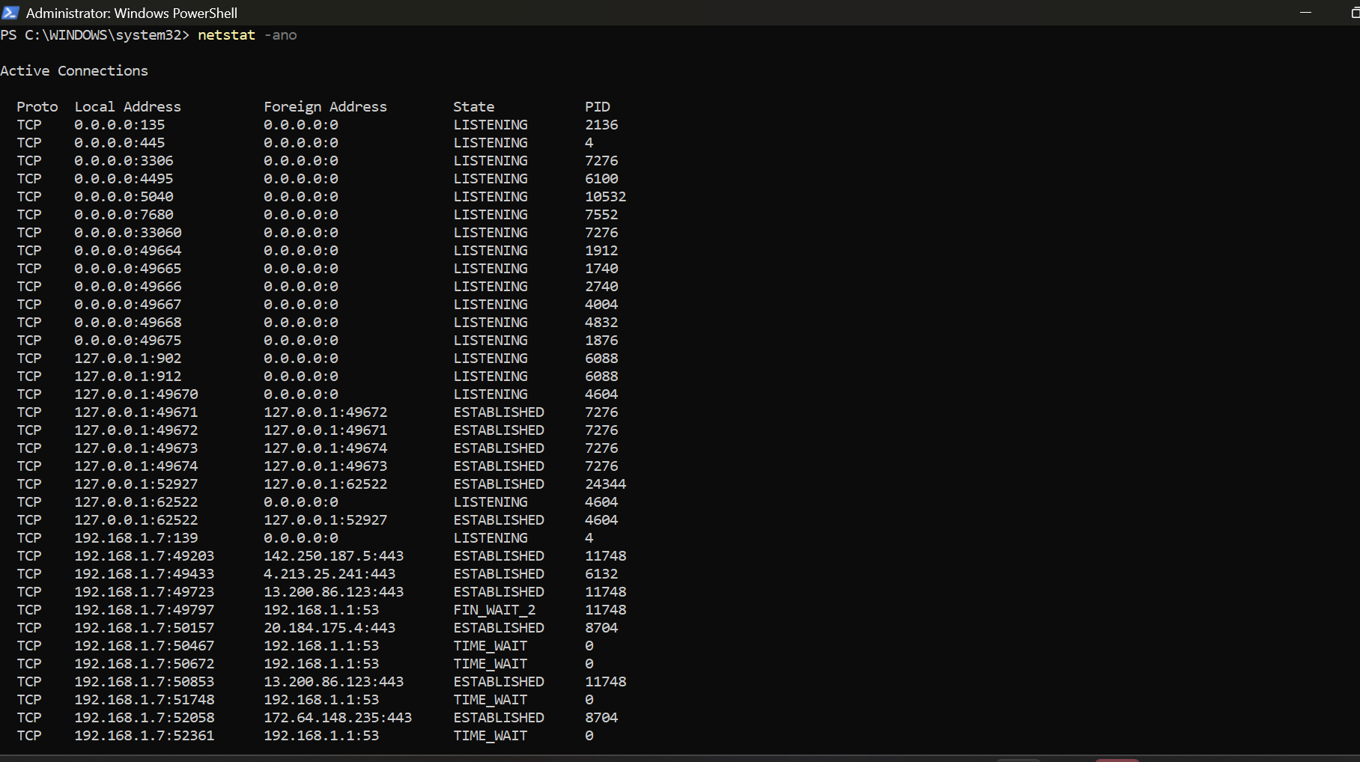
Figure 15: Active connections, listening ports and associated process identifiers

3.4 User Management and Task Scheduling
whoami /groups showed the security groups and integrity level associated with the current account in figure 16. Get-LocalUser then listed enabled and disabled local accounts in figure 17.
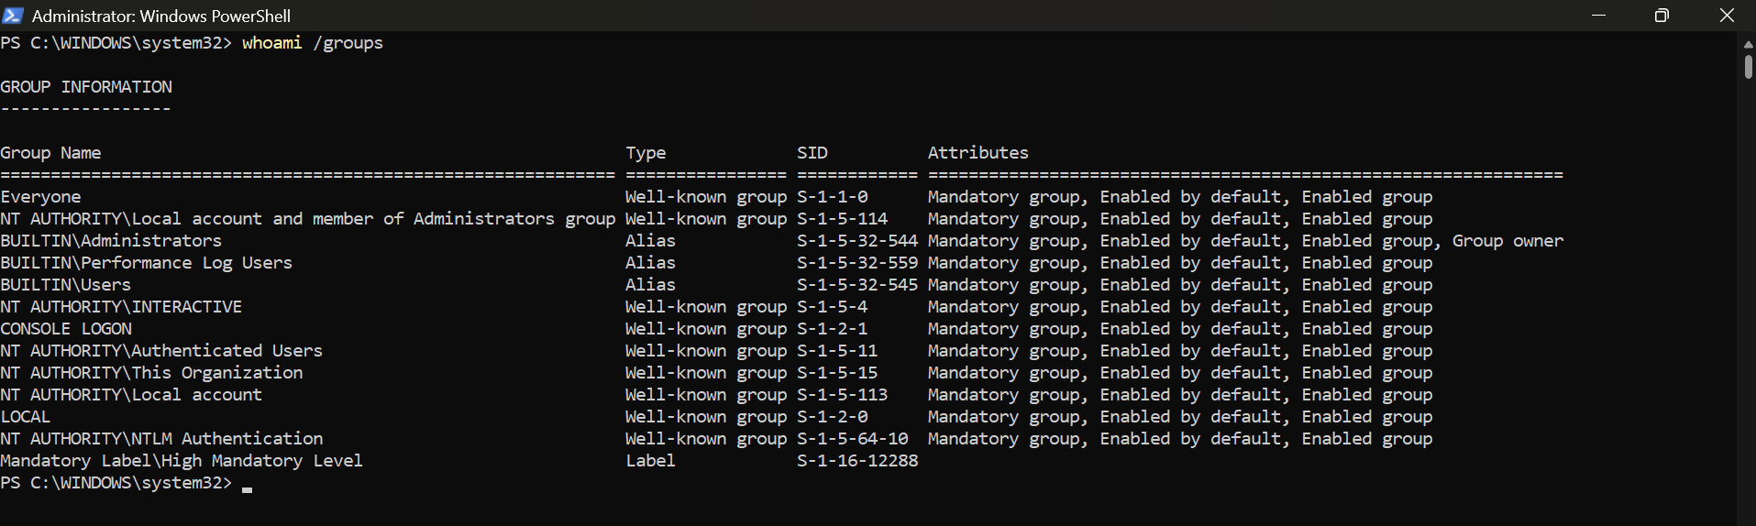
Figure 16: Security-group membership of the current Windows account
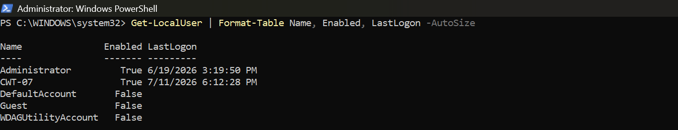
Figure 17: Enabled and disabled local user accounts
Get-ScheduledTask displayed registered task names, states and paths. schtasks /create then created OS_Resit_Test, /run started it immediately and Notepad opened as evidence in figure 18 and 19. Microsoft documents schtasks as a utility for creating, querying, starting and removing scheduled programs [12].
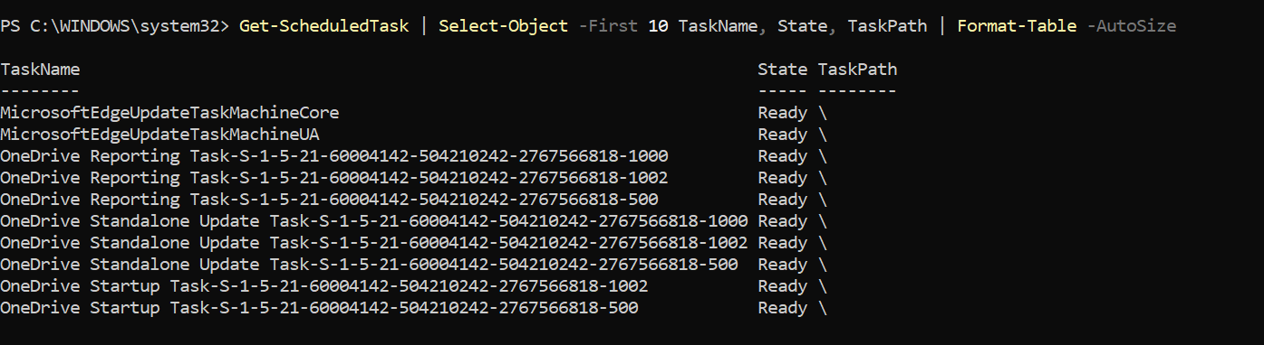
Figure 18: Existing scheduled tasks displayed through PowerShell
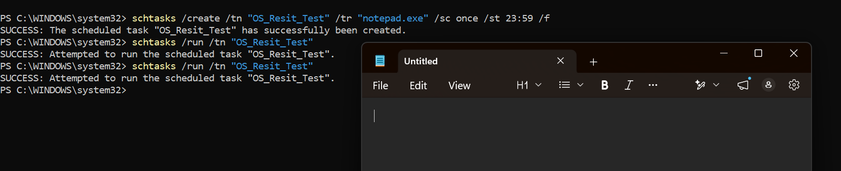
Figure 19: Successful creation and immediate execution of a Windows scheduled task

4. Use of Linux OS CLI Commands
Ubuntu was operated through WSL 2. The Bash commands demonstrated the same management categories as the Windows section while using Linux syntax, pipelines and permissions [13].

4.1 Process Management
Figure 20 shows ps aux --sort=-%mem | head, which lists processes by descending memory use. The options include processes from all users and those without a terminal, while head limits the displayed output [14].
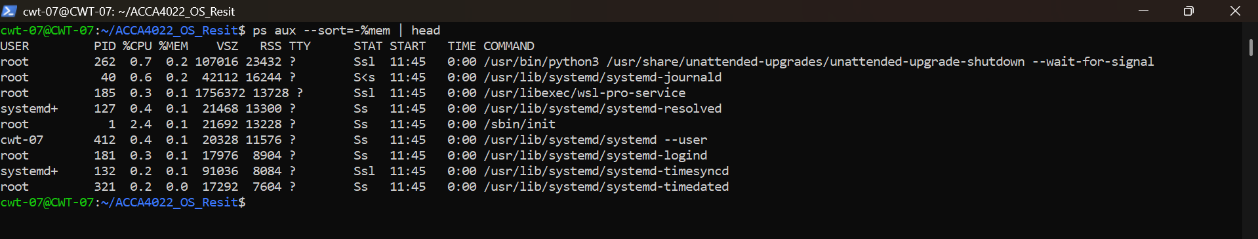
Figure 20: Linux processes ordered by memory utilisation
top -b -n 1 | head -20 used batch mode and performed one non-interactive update in figure 21. The output showed task counts, load averages, CPU states, memory and individual processes.
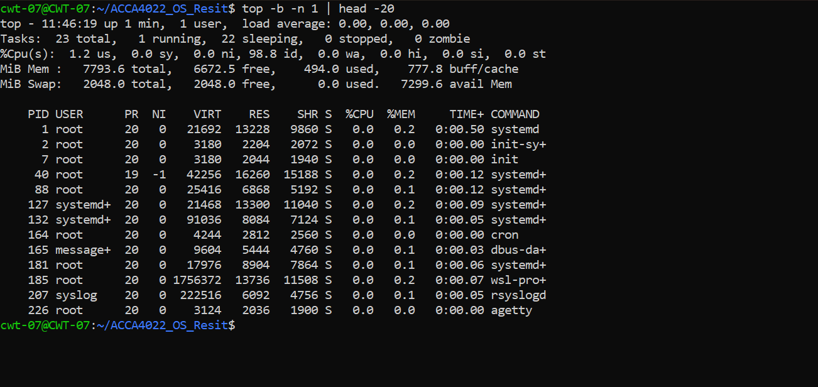
Figure 21: One-time Linux CPU, memory and process summary generated by top

4.2 File and Directory Management
ls -la listed all files, including hidden entries, in long format. mkdir -pv created nested Daily directories and described each created path in figure 22 and 23. GNU Coreutils documents ls, mkdir, cp, printf, id and related file and user utilities [15].
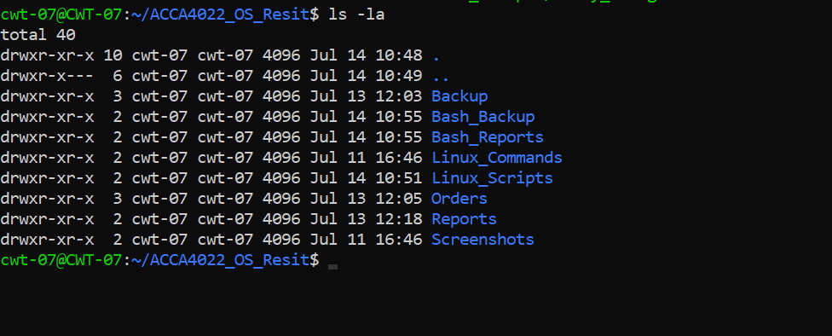
Figure 22: Detailed listing of the Linux practical directories
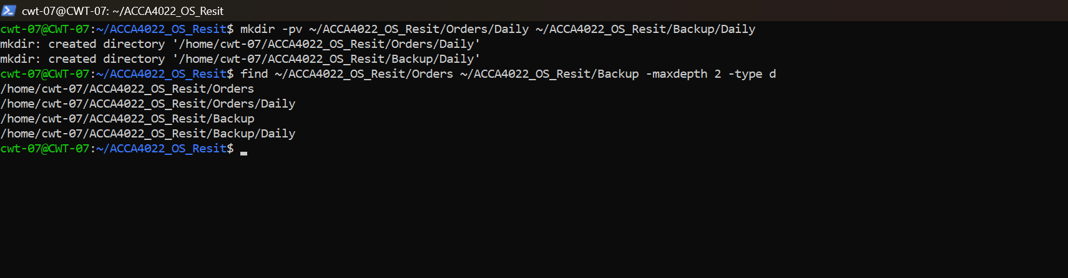
Figure 23: Creation and verification of nested Orders and Backup directories
In figure 24, printf created two order files, and cp -v copied them to the backup directory. -v printed each source and destination, giving direct evidence of the operation.
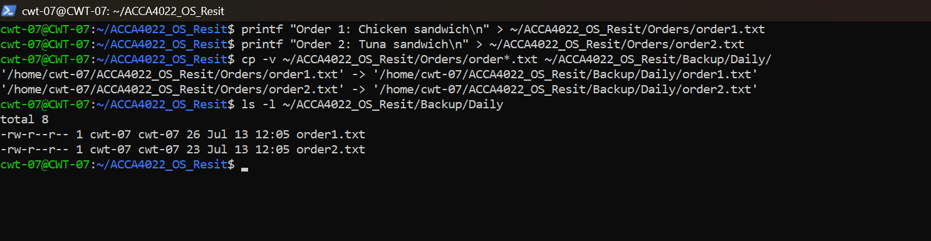
Figure 24: Creation and verbose backup of the Linux order files

4.3 Network Testing and Monitoring
In figure 25, ip -br addr displayed a brief summary of interface states and addresses. The eth0 interface was active and had an assigned IPv4 address.
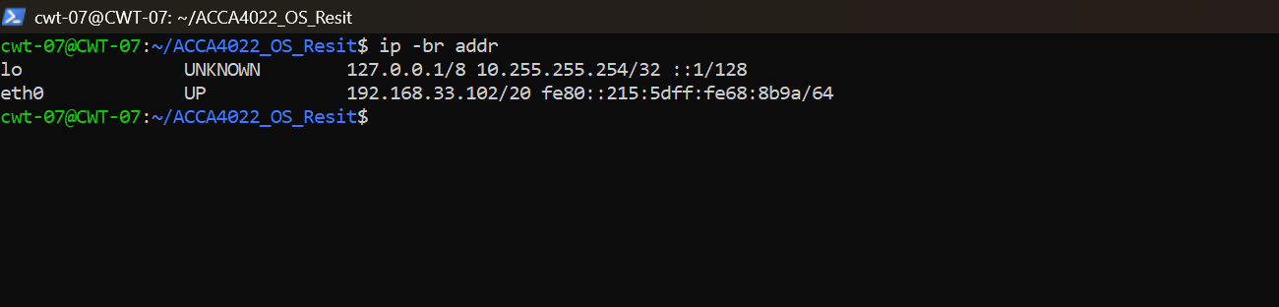
Figure 25: Brief Linux network-interface and IP-address summary
In figure 26, ping -c 4 8.8.8.8 sent four requests and reported four replies, zero packet loss and an average round-trip time of approximately 23.8 ms.
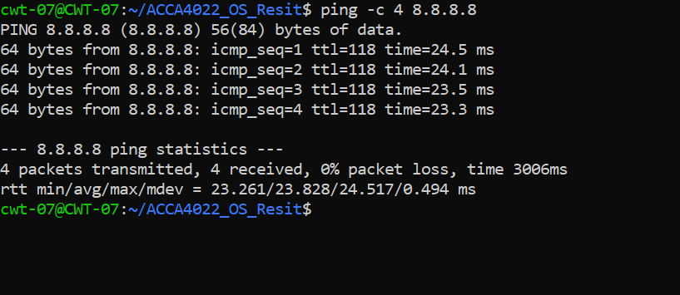
Figure 26: Linux connectivity test showing four successful replies
ss -tuln displayed TCP and UDP sockets. -t selected TCP, -u selected UDP, -l limited the display to listening sockets and -n kept addresses numerical in figure 27. The ss utility is designed to display socket statistics and network states [16].
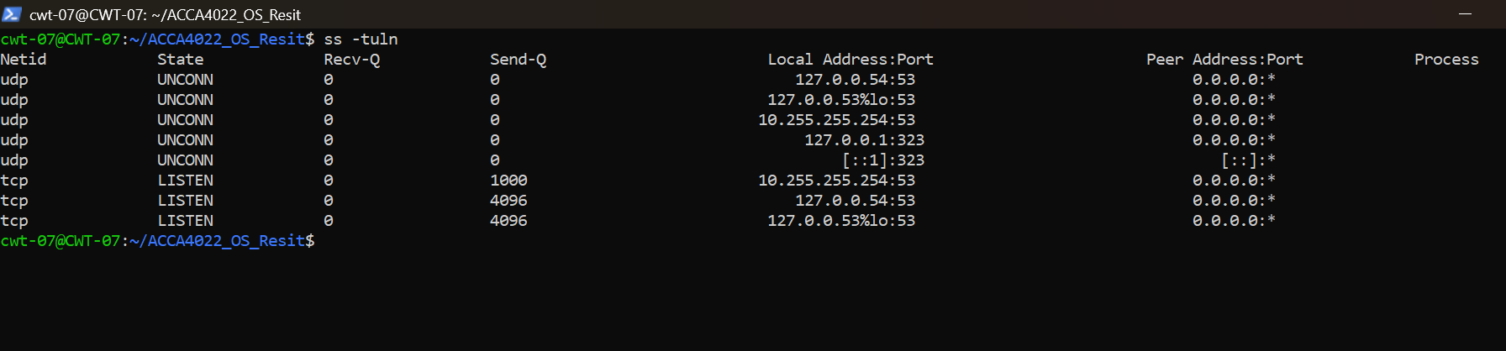
Figure 27: Listening TCP and UDP sockets displayed using ss

4.4 User Management and Task Scheduling
In figure 28 and 29, id -u -n && id -G -n printed the current username and named group memberships. getent passwd | cut -d: -f1,3,4,7 | head -n 10 then retrieved account records and selected usernames, user IDs, group IDs and login shells. Linux password records contain colon-separated account fields, although encrypted password data is held separately [17].
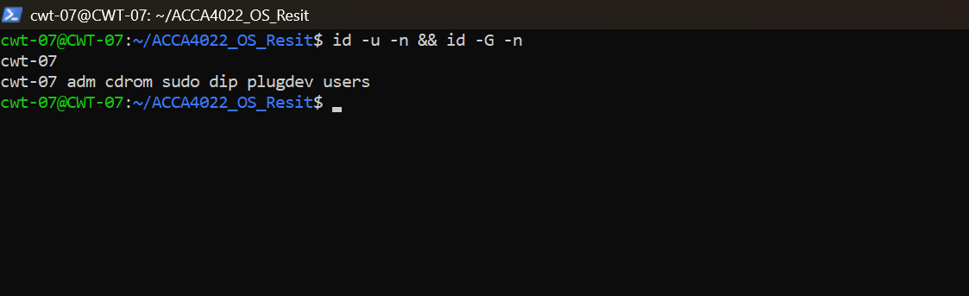
Figure 28: Current Linux username and supplementary groups
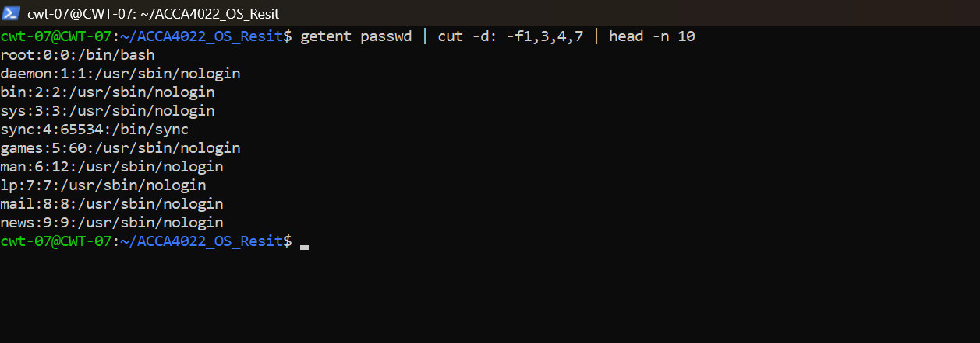
Figure 29: Selected Linux account fields retrieved from the user database
Finally, a cron entry wrote the date to cron_test.log every minute in figure 30. The repeated timestamps proved that scheduling worked. A crontab defines the time fields followed by the command to execute [18].
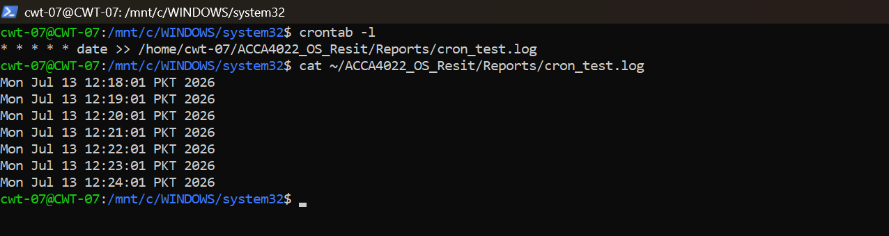
Figure 30: Linux cron schedule and repeated timestamp output

5. Use of Windows OS Scripts
Figure 31 shows the DailyManager.ps1 script defining folder paths, creating timestamped report names and using the reusable Ensure-Folder function. The function checks each directory with Test-Path and creates missing folders using New-Item [20].
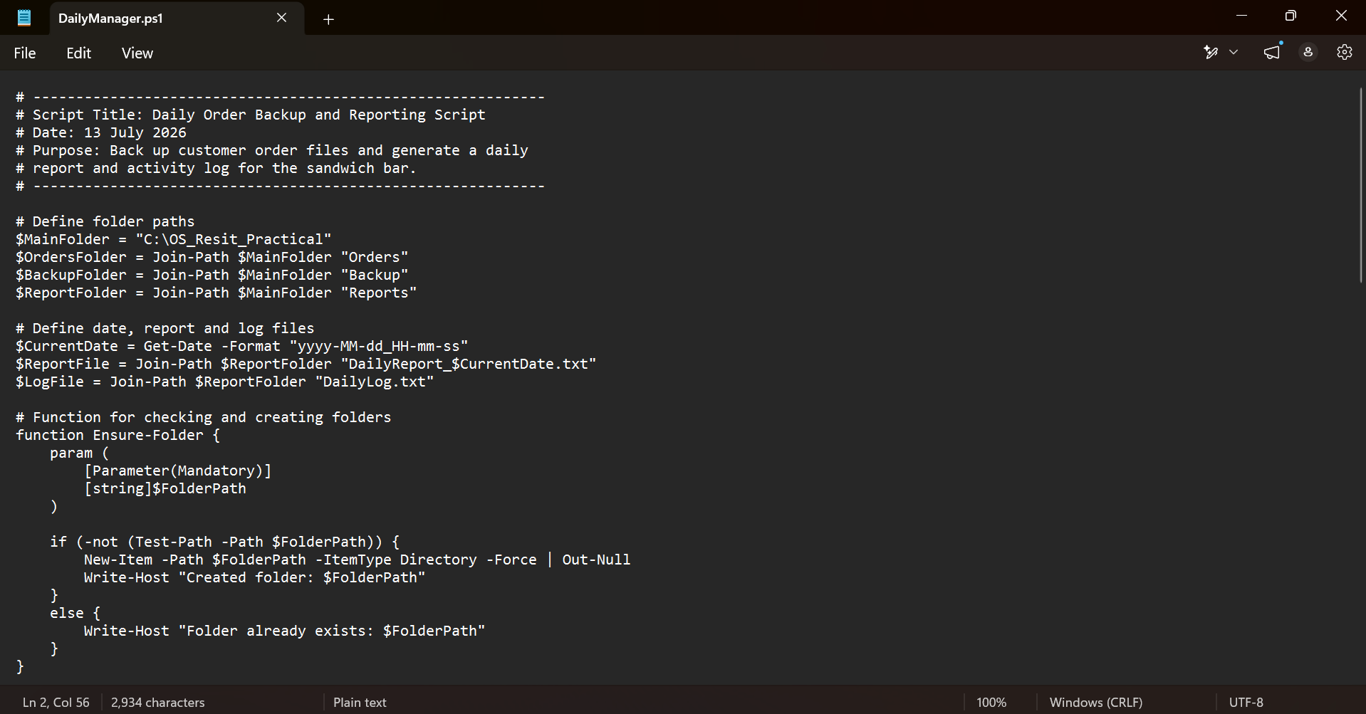
Figure 31: PowerShell comments, variables, timestamp handling and reusable folder function
Figure 32 shows the script retrieving .txt order files and checking that files exist before processing them. A foreach loop copies each file, updates the processed count, records the action in the log and writes a timestamped report [21].
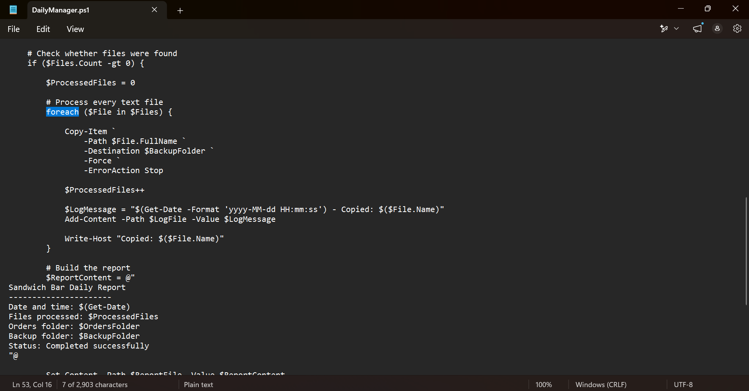
Figure 32: PowerShell conditional processing, file loop, backup operation and report generation
The catch block recorded terminating errors in figure 33. -ErrorAction Stop was used with operations that needed to transfer control to catch. Microsoft explains that try and catch provide a controlled response to statement-terminating and script-terminating errors [22].
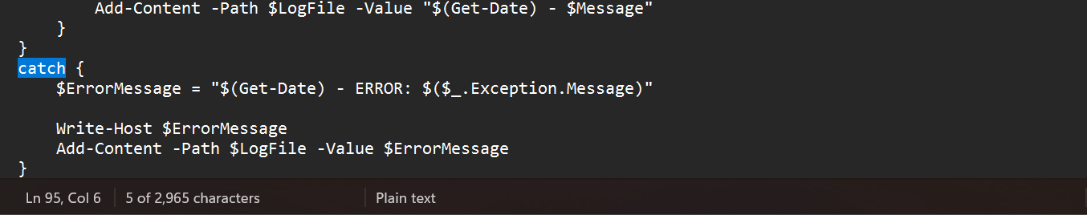
Figure 33: PowerShell exception handling and error-log creation
The script executed successfully and copied both order files in figure 34.
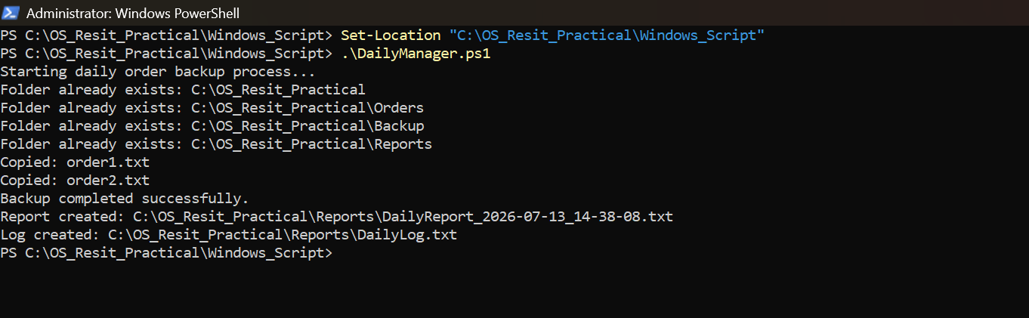
Figure 34: Successful execution of the Windows daily order-backup script
The generated report confirmed that two files were processed and that the operation completed successfully as shown in figure 35.
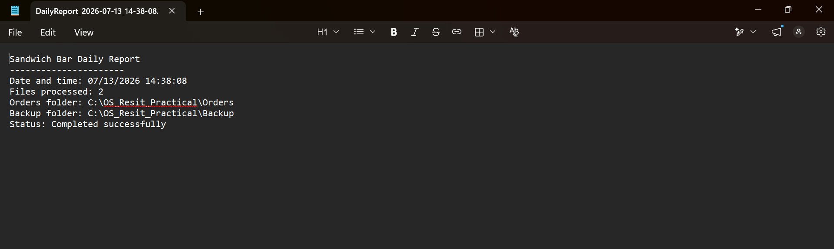
Figure 35: Timestamped Sandwich Bar Daily Report generated by PowerShell

6. Use of Linux OS Scripts
Figure 36 shows daily_manager.sh using #!/bin/bash, directory variables and timestamp generation. The ensure_folder() function receives a path through $1, checks whether it exists and creates it when necessary [23].
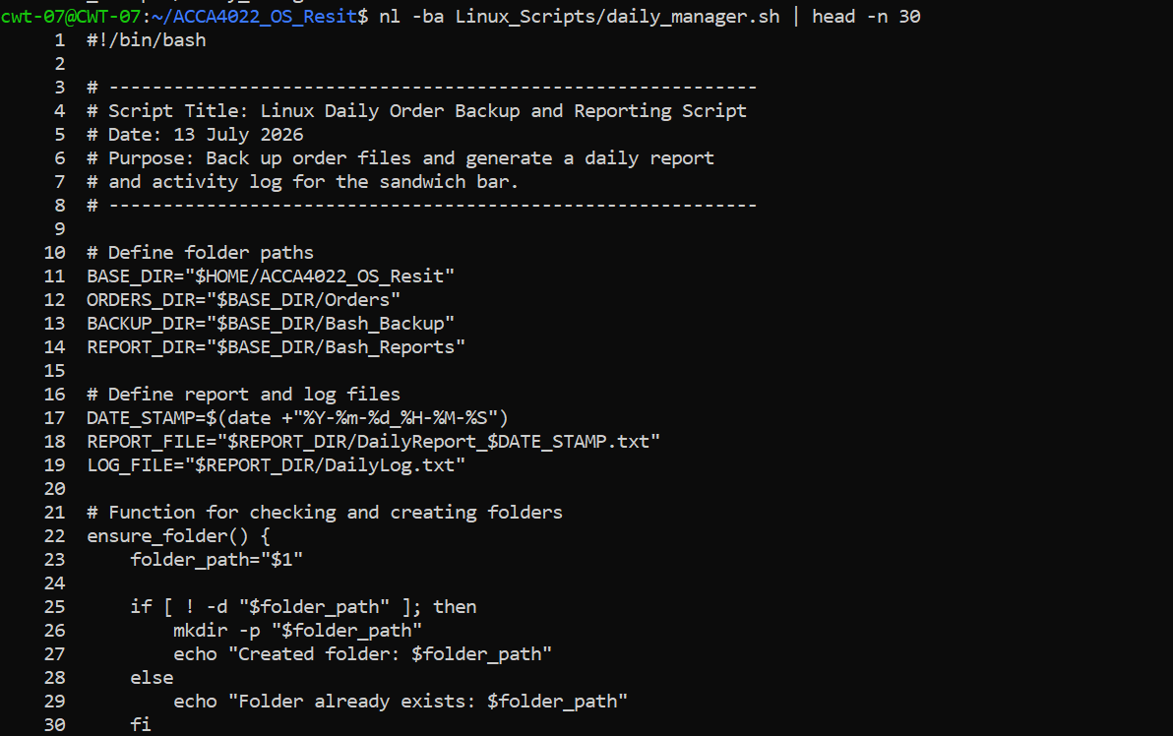
Figure 36: Bash shebang, comments, directory variables and folder-checking function
Figure 37 shows nullglob preventing unmatched wildcards, an array storing available order files and an if condition checking that files exist. A for loop then copies each file, updates success or failure counters and records successful backups in the log [23].
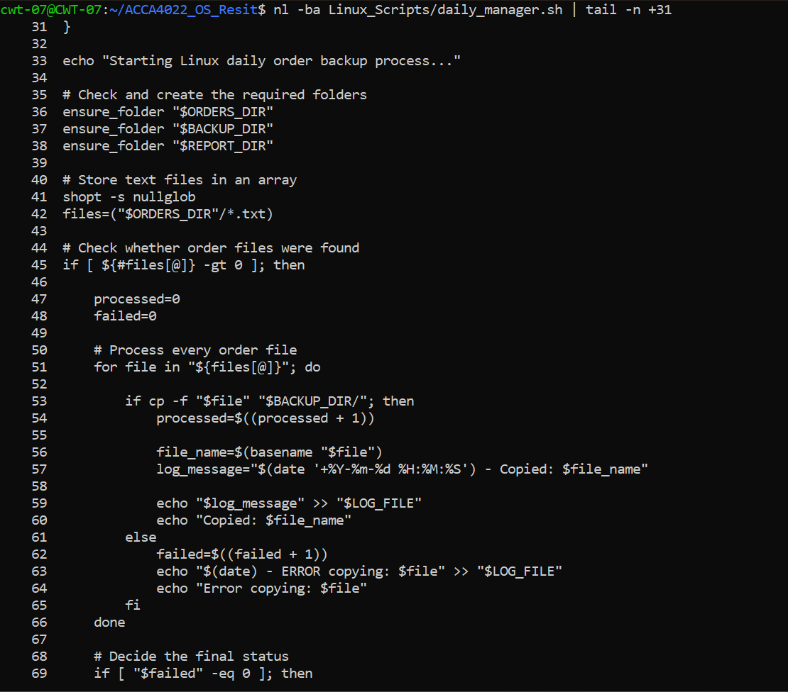
Figure 37: Bash file-processing loop with success and failure handling
In figure 38, second condition set the final status according to the failure count. The report was produced through a here-document beginning with << EOF. The outer else handled the case where no orders were present and wrote that result to the log.
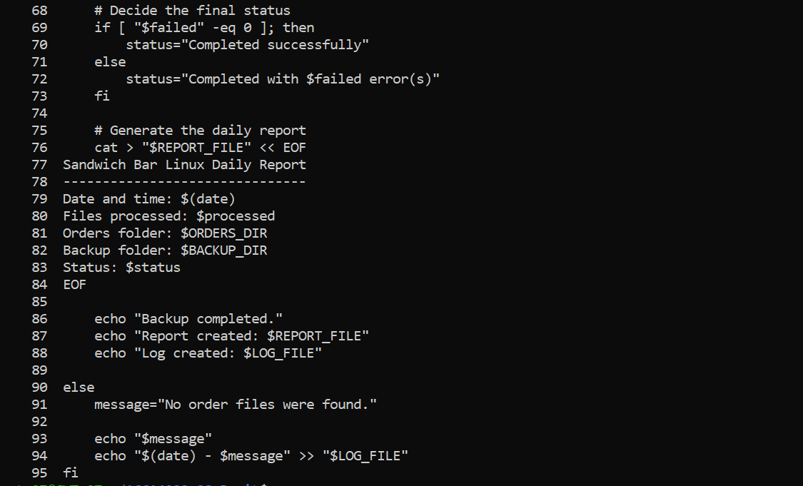
Figure 38: Bash completion-status decision and report generation
Linux requires execute permission before a script can be started directly as shown in figure 39. chmod +x added that permission, and ls -l confirmed the mode -rwxr-xr-x. GNU Coreutils documents chmod as the utility for changing file-access permissions [15].
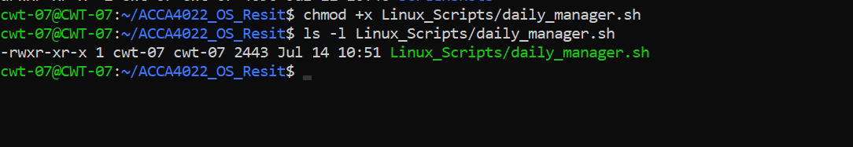
Figure 39: Execution permission granted to the Bash script
The script then copied order1.txt and order2.txt, created DailyLog.txt and produced a timestamped report as shown in figure 40.
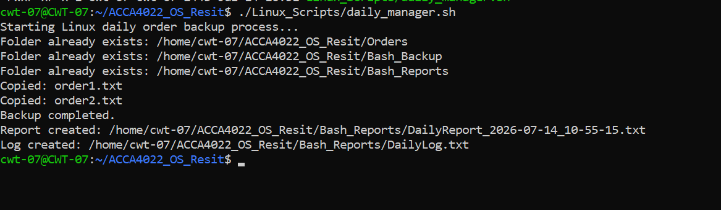
Figure 40: Successful execution of the Linux daily order-backup script
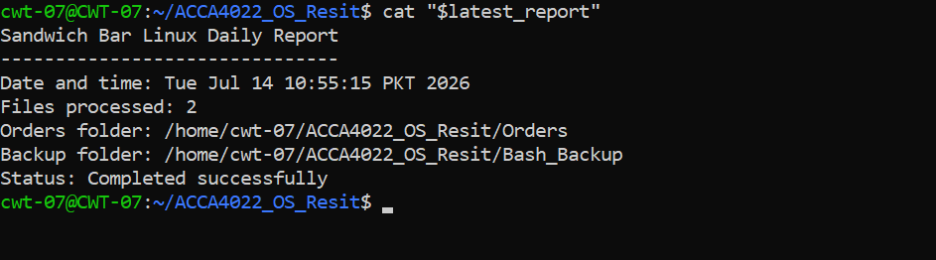
Figure 41: Sandwich Bar Linux Daily Report confirming two successful backups
In figure 41, the Bash implementation achieved the same outcome as the PowerShell version but used Linux-specific permission, array, test and redirection syntax.

7. Conclusion
The investigation showed that operating systems manage processes, memory, storage, hardware, security and networking. Windows and Linux provided comparable administrative capabilities through different command structures, while PowerShell and Bash successfully managed files, users, networks and scheduled tasks. Both scripts automated directory checks, file backups, logging and report generation. Functions, conditions and error handling improved reliability, while the practical evidence addressed the main weakness of the previous submission by demonstrating successful use of Windows commands, Linux commands and scripting.

8. Reference
[1] A. S. Tanenbaum and H. Bos, Modern Operating Systems. Pearson, 2022. Available: https://www.pearson.com/en-us/subject-catalog/p/modern-operating-systems/P200000003295/9780137618880?srsltid=AfmBOopmA9EAZqB-fsn2oj1RIVjKshBVVhjKTI6QIm3ZbvTnnnn6uNoU. [Accessed: July 15, 2026]
‌[2] A. S. Thyagaturu, P. Shantharama, A. Nasrallah, and M. Reisslein, “Operating Systems and Hypervisors for Network Functions: A Survey of Enabling Technologies and Research Studies,” IEEE Access, vol. 10, pp. 79825–79873, 2022, doi: 10.1109/access.2022.3194913. Available: https://ieeexplore.ieee.org/abstract/document/9844719. [Accessed: July 15, 2026]
‌[3] kaushika-msft, “Troubleshoot processes by using Task Manager - Windows Server,” MicrosoftLearn, Feb. 12, 2026. Available: https://learn.microsoft.com/en-us/troubleshoot/windows-server/support-tools/support-tools-task-manager. [Accessed: July 15, 2026]
‌[4] GrantMeStrength, “Memory Management (Memory Management) - Win32 apps,” MicrosoftLearn, Jan. 07, 2021. Available: https://learn.microsoft.com/en-us/windows/win32/memory/memory-management. [Accessed: July 15, 2026]
‌[5] officedocspr5, “Windows security documentation,” MicrosoftLearn, 2026. Available: https://learn.microsoft.com/en-us/windows/security/. [Accessed: July 15, 2026]
‌[6] robinharwood, “tasklist,” MicrosoftLearn, Feb. 03, 2023. Available: https://learn.microsoft.com/en-us/windows-server/administration/windows-commands/tasklist. [Accessed: July 15, 2026]
‌[7] sdwheeler, “Get-Process (Microsoft.PowerShell.Management) - PowerShell,” MicrosoftLearn, 2025. Available: https://learn.microsoft.com/en-us/powershell/module/microsoft.powershell.management/get-process?view=powershell-7.6. [Accessed: July 15, 2026]
‌[8] sdwheeler, “Copy-Item (Microsoft.PowerShell.Management) - PowerShell,” MicrosoftLearn, 2026. Available: https://learn.microsoft.com/en-us/powershell/module/microsoft.powershell.management/copy-item?view=powershell-7.6. [Accessed: July 15, 2026]
‌[9] robinharwood, “ipconfig,” MicrosoftLearn, Feb. 03, 2023. Available: https://learn.microsoft.com/en-us/windows-server/administration/windows-commands/ipconfig. [Accessed: July 15, 2026]
[10] robinharwood, “ping,” MicrosoftLearn, Nov. 2024. Available: https://learn.microsoft.com/en-us/windows-server/administration/windows-commands/ping. [Accessed: July 15, 2026]
‌[11] robinharwood, “netstat,” MicrosoftLearn, Nov. 2024. Available: https://learn.microsoft.com/en-us/windows-server/administration/windows-commands/netstat. [Accessed: July 15, 2026]
‌[12] robinharwood, “Get-ScheduledTask (ScheduledTasks),” MicrosoftLearn, 2026. Available: https://learn.microsoft.com/en-us/powershell/module/scheduledtasks/get-scheduledtask?view=windowsserver2025-ps. [Accessed: July 15, 2026]
‌[13] R. Wünschiers, “The World of Linux,” Computational Biology, pp. 21–50, 2025, doi: 10.1007/978-3-031-70314-0_3. Available: https://link.springer.com/chapter/10.1007/978-3-031-70314-0_3. [Accessed: July 15, 2026]
‌[14] “procps(1) - Linux manual page,” Man7.org, 2021. Available: https://man7.org/linux/man-pages/man1/procps.1.html. [Accessed: July 15, 2026]
‌[15] “GNU Coreutils 9.11,” Gnu.org, 2026. Available: https://www.gnu.org/software/coreutils/manual/coreutils.html. [Accessed: July 15, 2026]
[16] “ss(8) — iproute2 — Debian bookworm — Debian Manpages,” Debian.org, 2023. Available: https://manpages.debian.org/bookworm/iproute2/ss.8.en.html. [Accessed: July 15, 2026]
[17] “passwd(5) — passwd — Debian bookworm — Debian Manpages,” Debian.org, 2023. Available: https://manpages.debian.org/bookworm/passwd/passwd.5.en.html. [Accessed: July 15, 2026]
‌[18] “crontab(5) — cron — Debian bookworm — Debian Manpages,” Debian.org, 2023. Available: https://manpages.debian.org/bookworm/cron/crontab.5.en.html. [Accessed: July 15, 2026]
[19] H. S. Al-Sinani and C. J. Mitchell, “AI-Augmented Ethical Hacking: A Practical Examination of Manual Exploitation and Privilege Escalation in Linux Environments,” arXiv.org, 2024. Available: https://arxiv.org/abs/2411.17539. [Accessed: July 15, 2026]
‌[20] sdwheeler, “about_Functions - PowerShell,” MicrosoftLearn, Jan. 18, 2026. Available: https://learn.microsoft.com/en-us/powershell/module/microsoft.powershell.core/about/about_functions?view=powershell-7.6. [Accessed: July 15, 2026]
[21] sdwheeler, “Everything you wanted to know about the if statement - PowerShell,” MicrosoftLearn, Jan. 19, 2026. Available: https://learn.microsoft.com/en-us/powershell/scripting/learn/deep-dives/everything-about-if?view=powershell-7.6. [Accessed: July 15, 2026]
[22] sdwheeler, “about_Try_Catch_Finally - PowerShell,” MicrosoftLearn, Apr. 02, 2026. Available: https://learn.microsoft.com/en-us/powershell/module/microsoft.powershell.core/about/about_try_catch_finally?view=powershell-7.6. [Accessed: July 15, 2026]
‌[23] “GNU Bash manual - GNU Project - Free Software Foundation,” Gnu.org, 2025. Available: https://www.gnu.org/software/bash/manual/?ref=dargslan.de. [Accessed: July 15, 2026]

9. Appendices

Appendix A: Tutorial Activity 1 – Operating-System Types

A.1 Batch Operating Systems
A batch operating system groups similar jobs and executes them without continuous user interaction. This approach is appropriate for repetitive, high-volume work such as payroll processing, billing or scheduled report generation. Its main advantage is efficient processing of predictable jobs, although users may wait a long time before receiving results.

A.2 Time-Sharing Operating Systems
Time-sharing systems divide processor time among multiple users or processes. Each task receives a short time slice, creating the impression that programs run simultaneously. This model supports interactive use but depends on effective scheduling and protection between users.

A.3 Distributed Operating Systems
A distributed operating system coordinates several networked computers and attempts to present their resources as a unified system. Processing and storage can be shared across different machines. Advantages include scalability and fault tolerance, although communication and coordination are more complex.

A.4 Network Operating Systems
A network operating system provides services such as centralised authentication, file sharing, printer sharing and remote administration. Unlike a fully distributed system, users are usually aware that resources are located on separate servers.

A.5 Real-Time Operating Systems
A real-time operating system is designed to respond within defined timing constraints. Hard real-time systems cannot tolerate missed deadlines, while soft real-time systems can tolerate occasional delay. Typical applications include industrial control, medical equipment and embedded vehicle systems.

A.6 Mobile and Embedded Operating Systems
Mobile operating systems manage smartphones and tablets while considering touch interfaces, battery consumption, wireless communication and application isolation. Embedded operating systems are designed for specialised devices with limited memory and processing capability.

Appendix B: Lecture Activity Log
Date | Activity completed | Evidence and learning achieved
11 July 2026 | Windows resource monitoring | Used Task Manager, Disk Management, Device Manager and Windows Security to identify OS-management functions.
11 July 2026 | Windows CLI practice | Performed process, file, network, user and scheduled-task commands with options and switches.
13 July 2026 | PowerShell scripting | Created and tested DailyManager.ps1, including variables, a function, conditions, a loop and error handling.
13 July 2026 | Linux CLI practice | Used Ubuntu WSL to practise process, file, network, user and cron commands.
14 July 2026 | Bash scripting | Created and executed daily_manager.sh, added execution permission and verified the generated outputs.

Appendix D: Practical Completion Procedure
The following process records how the practical work was completed and can be used by the student when explaining the assignment to the professor.
- The previous lecturer feedback was reviewed, and the absence of practical command and scripting evidence was identified as the main cause of failure.
- Windows 11 was used for graphical operating-system monitoring and Windows command-line tasks.
- Ubuntu 24.04 was accessed through WSL 2 to provide a functioning Linux Bash environment.
- Separate folders were created to organise Windows commands, Linux commands, scripts, order files, backups, reports and screenshots.
- Task Manager, Disk Management, Device Manager and Windows Security were opened and captured to demonstrate process, CPU, memory, storage, device, security and network management.
- Approximately 12 Windows commands were executed. Each command included an appropriate option or switch and covered process, file, network, user or scheduling management.
- Approximately 11 Linux commands were executed with relevant options. Their output was interpreted rather than merely displayed.
- A PowerShell script was created to check folders, copy order files, count processed files, write an activity log and generate a timestamped report.
- The PowerShell script was tested, and the copied files, log and report were checked to verify success.
- A Bash script was created with equivalent functionality using Linux variables, a function, tests, an array, a loop and output redirection.
- chmod +x was used to add executable permission before running the Bash script.
- The Bash backup directory, report file and activity log were inspected to confirm that the script operated correctly.
- Only clear screenshots showing the final successful commands, code and outputs were selected for the main report. Early errors, empty files, practice scripts and duplicate screenshots were excluded.
- Research was obtained from recent textbooks and official Microsoft, GNU and Debian documentation. IEEE citations were inserted throughout the discussion.

