Module: Managing Organisations

Module Code: SHNS4008

Motivation in Leadership and Management Report

Contents Page

Abstract page 3

Introduction page 3

Aims and Objectives page 3

Main Body and Key Findings page 4

Conclusion and Recommendations page 7

Reference List page 9

Appendix page 10

Abstract
This report is evaluating: The role of leadership & management within the NHS. The aims and objectives of this report is to evaluate the role of leadership & management within the NHS. For this report research has been done into the different theories of management and leadership, several have been identified and explored as being used within the NHS. The King’s Fund Commission’s report (2011) has been examined within the report and its findings evaluated. The report evaluates the impact of organisational structure and culture in supporting or hindering leadership and management within the NHS. The report also evaluates the structure with particular reference to the motivation of employees. The report concludes with recommendations.

Introduction
This report is evaluating: The role of leadership & management within the NHS. The aims and objectives of this report is to evaluate the role of leadership & management within the NHS. Research will be done into the different theories of management and leadership, several will be identified and explored to see if they are being used within the NHS, with reference to weather the management structure motivates the NHS employees.

Aims and Objectives
The aims and objectives of this report is to evaluate the role of leadership & management within the NHS. The report also aims to look at the impact of organisational structure and culture in supporting or hindering leadership and management within the NHS. The report also aims to look at the structure of leadership and management with particular reference to the motivation of employees.

Main Body and Key Findings
The evidence shows that within the NHS there is at least one management/leadership theory in practice (Rowling, 2011). John Kotter’s Management Theory (1996) is the theory most in use in the NHS. Kotter (1996) outlines the management tools that are needed to create good management practice, they are;’ planning, budgeting, organising, staffing, controlling and problem-solving and leadership processes that involve establishing direction, aligning people, motivating and inspiring’ (Kotter, 1996 cited in Rowling, 2011, p.12).
According to the Corporate Finance Institute (CFI) (2015-2019) ‘management theories are concepts surrounding recommended management strategies, which may include tools such as frameworks and guidelines that can be implemented in modern organizations’ (CFI, 2015-2019, p.1). Usually individuals do not rely exclusively on one management theory, but use several different management theories that best suit their workforce and company (CFI, 2015-2019, p.1).
There are several popular management theories these include; the Scientific Management Theory, created by Fredrick Taylor in 1911, the Systems Management Theory, the Contingency Management Theory, created by Fred Fiedler in the 1960’s and the Theory X and Theory Y, created by Douglas McGregor in 1960 (CFI, 2015-2019, p.1). (See Fig.1)
Firstly the Scientific Management Theory (1911) Taylor’s philosophy highlighted the fact that forcing people to work hard wasn’t the best way to get results. Taylor recommended making things simpler to increase productivity, he developed the “fair day’s wages for a fair day’s work” concept (CFI, 2015-2019, p.1). Secondly the Systems Management Theory, this theory believes that the success of an organisation depends on quite a few main elements; ‘synergy, interdependence, and interrelations between various subsystems’ (CFI, 2015-2019, p.1). Thirdly the Contingency Management Theory (1960) Fiedler’s theory suggests that there is a set of leadership qualities for every situation, which means that a manager must be flexible enough to adjust to any changes in the work place (CFI, 2015-2019, p.1). Lastly the Theory X and Theory Y (1960) McGregor’s theory looks at two concepts of work place practice, those people who work for just the money and those who work as they find the job rewarding bringing much more to the work place, they are not motivated by the money. McGregor developed these two contrasting concepts these ‘theories refer to two management styles: the authoritarian (theory X) and participative, (theory Y)’ (CFI, 2015-2019, p.1).
There are three basic types of management skills that are needed to be a good manager and an asset to the NHS, Robert Katz explains them as Technical skills, Conceptual skills and Human or Interpersonal skills (CFI, 2015-2019, p.1). (See Fig.2)
According to the King’s Fund Commission’s report, Rowling (2011) ‘the health service has a long history of attempting to improve both management and leadership’ (Rowling, 2011, p.9). There have been many reports on the management and leadership in the NHS since the 1960’s. The Griffith’s report of 1983 stated that, ‘if Florence Nightingale were carrying her lamp through the NHS today, she would be searching for the people in charge’ (Griffith, 1983 cited in Rowling, 2011, p.9). The King’s Fund Commission’s report goes on to say in its recommendations that, ‘over recent years there has been considerable investment in both management and leadership development. These gains must not be lost in the transition to a redesigned health system’ (Rowling, 2011, p. viii).
Rowling (2011) goes on to say that ‘leadership development needs to extend ‘from the board to the ward’. The biggest weaknesses in the NHS is its failure to involve clinicians in a continuous way in management and leadership. Individuals within the NHS need to have the ability and the confidence to challenge poor practice (Rowling, 2011, p. ix).
In order to evaluate the importance of leadership and management within the NHS, health care depends on interaction between all areas of the NHS, the organisation and management of its delivery does not always reflect this understanding. In the UK, the NHS has
‘separate budgets and performance targets for primary care, secondary care, and social services promotes an internal focus on the operation of each of these parts, but not necessarily the good functioning of the system as a whole’ (Plsek and Wilson, 2001, p.746).
The evaluation of the impact of organisational structure and culture in supporting or hindering leadership and management within the NHS, with particular reference to the motivation of employees. The NHS in England has had a number of initiatives that have had a complex impact on the management and administration costs, more widespread is the contracting out the support services much more than in either Scotland or Wales. This has directly increased the numbers of contract managers in the NHS (Rowling, 2011, p. 8).
Not all NHS management is effective, in many reports from the National Audit Office prove that far better value for money could be achieved by improving the management of purchasing, behind the scenes functions and estates, the skills needed to manage these essentials of the NHS are in short supply across the public sector (Rowling, 2011, p. 8).
According to Dorgan et al. (2010) cited in Rowling, (2011, p.15) in Europe and the USA well-managed hospitals giving higher quality patient care and improved productivity, were those who had clinically qualified managers, so producing much better results. The uses of these health care professional in decision-making and accountability should be entrusted as closely as possible to the clinical front line. Successful performance in the NHS needs continuous leadership and that sustains a focus on improving performance line (Dorgan et al. (2010) cited in Rowling, 2011, p.15).
‘Leadership must be exercised across shifts 24/7 and reach to every individual: good practice can be destroyed by one person who fails to see themselves as able to exercise leadership, as required to promote organisational change, or who leaves something undone or unsaid because someone else is supposed to be in charge’ (Turnbull and James 2011, cited in Rowling, 2011, p.19).
The evaluation of the possible impact upon service users if NHS employees are lacking in motivation.’ Line managers need training and support to manage employees’ (Weyman, Meadows and Buckingham, 2013, p.33).
‘For staff to remain productively employed there needs to be a fit between the demands of their job, their working environment, their personal circumstances and their capability’. (Weyman, Meadows and Buckingham, 2013, p.32).
According to Weyman, Meadows and Buckingham (2013, p.32) there are extensive claims of disruption between the way that jobs have traditionally been configured in the NHS and the preferences and needs of the workforce for example; older workers, young parents and disabled people. Weyman, Meadows and Buckingham (2013) go on to say that opportunities for flexible or reduced hour working in the NHS are limited. The possibilities for flexible and part-time options varies by job role and grade.

Conclusion and Recommendations
This report has evaluated: The role of leadership & management within the NHS. The aims and objectives of this report were to evaluate the role of leadership & management within the NHS. Research has been done into the different theories of management and leadership, several were identified and explored as being used within the NHS, with reference to the management structure and how it motivates employees in the NHS. According to Storey and Holti (2013)
‘studies of health service innovations reveal a need for an effective alliance between clinicians and administrative managers in thinking through a range of administrative and information technology related aspects of the new service, as well as new clinical protocols and divisions of labour, and new criteria for judging service performance’ (Storey and Holti, 2013, p.20).
Storey and Holti’s (2013) findings explain the new leadership model being used in the NHS, it also agrees with the recommendations of Rowling, (2011) in the King’s Fund Commission’s report on leadership and management.
According to findings in the King’s Fund report there has not been a vital review of the strains placed on the service and its providers for many years. It goes on to say ‘A review leading to a rationalisation of those demands is essential’ (Rowling, 2011, p. viii).
Rowling (2011) concludes her recommendations with a quote from the Commons Health Select Committee report which said,
‘The Committee is mindful that this unprecedented requirement to manage a process of change … will require effort and commitment from NHS managers whose work we believe should be valued, alongside the work of the clinical staff of the NHS. The Committee regrets the fact that the work of NHS management is sometimes the subject of unjustified populist criticism’. (Rowling, 2011, p. x).
The King’s Fund report closes with a statement that is still very relevant today in the NHS and health sector in general,
‘High-quality leadership and management at all levels is a prerequisite for a National Health Service that delivers both the highest possible quality of care to patients and the best possible deal for the taxpayer’ (Rowling, 2011, p. x).

Reference List
Corporate Finance Institute (2015-2019) Management Theories. Available at: https://corporatefinanceinstitute.com/resources/careers/soft-skills/management-theories/ (Accessed: 28 March 2019).

Corporate Finance Institute (2015-2019) Management Skills. Available at: https://corporatefinanceinstitute.com/resources/careers/soft-skills/management-skills/ (Accessed: 28 March 2019).

Plsek, P. E. and Wilson, T. (2001) ‘Complexity science Complexity, leadership, and management in healthcare organisations’, British Medical Journal, 323(September), pp.746-749.

Rowling, E. (ed.) (2011) The future of Leadership and Management in the NHS: No More Heroes: Report from The King’s Fund Commission on Leadership and Management in the NHS. London: The King’s Fund Commission.

Storey, J. and Holti, R. (2013) Towards a New Model of Leadership for the NHS. UK: NHS Leadership Academy.

Weyman, A. and Meadows, P. and Buckingham, A. (2013) Extending Working Life: Audit of research relating to impacts on NHS Employees. London: NHS.

Appendix
Fig. 1
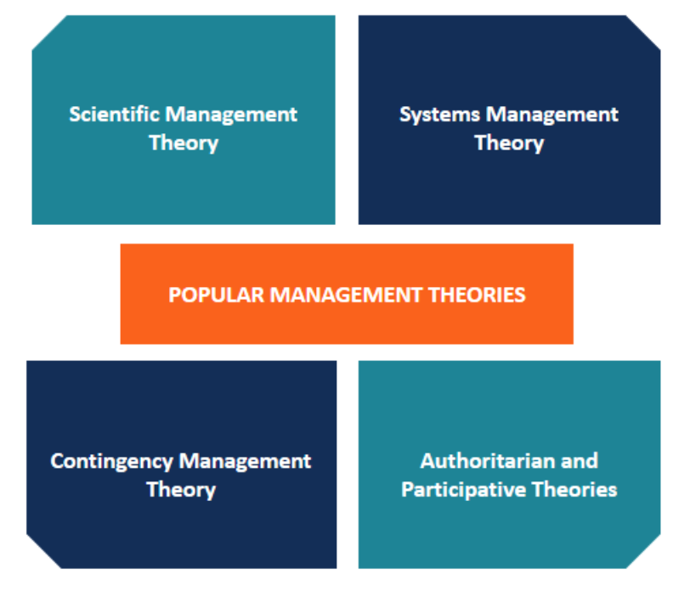
Corporate Finance Institute (2015-2019) Management Theories. Available at: https://corporatefinanceinstitute.com/resources/careers/soft-skills/management-theories/ (Accessed: 28 March 2019).

Fig.2
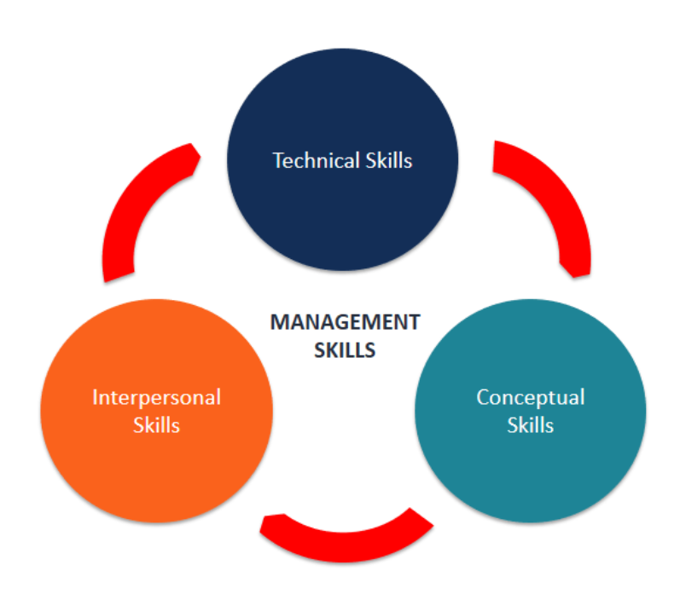
Corporate Finance Institute (2015-2019) Management Skills. Available at: https://corporatefinanceinstitute.com/resources/careers/soft-skills/management-skills/ (Accessed: 28 March 2019).

