

MBA

Embedding Sustainability within Organisations

Assessment 3 (9 of March)

Student name: | Ghanim Kashwani | Student ID number: | 1804502

Your role:
As a recent MBA graduate in Sustainability and Leadership you have joined the management team of the above organisation. Given your passion for and academic background in sustainability, you are
expected to bring an analytical, critical and innovative perspective to the existing management team.

The Task:
Following on from your initial report and the sustainability plan, you have earned a lot of respect as sustainability pioneer in your organisation and the senior management team values your ideas and approaches to sustainability. Now it is time for you to reflect on what you have achieved so far:

Be creative in your reflection and you can choose the format (essay (3,500 words), essay plus virtual presentation (equivalent to 3,500 words) or essay plus video (equivalent to 3,500 words).

For instance, you can address the following issues:

  - Does your plan (assignment 2) go far enough, i.e. are you satisfied in terms of the initiatives’ wider impact on the business, environment and society?
  - The senior management team is behind your plan. But what about staff at the front end and / or within specific departments of the organisation and how can you get them on board?
  - Does the success of your sustainability initiatives depend on a change in the organisational culture? Would it be possible to change the organisational culture?
  - The traditional stakeholder analysis does not include nature as a stakeholder. How can you convince industry leaders / other organisations in the supply chain etc. to acknowledge nature as part of their business?
  - Could your organisation become a sustainability leader within the industry?

These are only examples for reflective ideas and you can base your critical reflection on aspects relevant to your organisation and the previous assignments.

As in assignment 1 and 2, implement and apply appropriate theory, academic concepts and relevant data in your critical reflection.

Please note the following when completing your written assignment:

- Writing: Written in English in an appropriate business/academic style
- Focus: Focus only on the tasks set in the assignment.
- Length: 3,500 words (maximum)
- Formatting: Typed on A4 paper in Times New Roman or Arial font 12 with at least 2.5 centimetre space at each edge, double spaced and pages numbered.
- Document format: Depending on your choice: either essay, essay plus presentation or essay plus video
- Ensure a clear title, course, and name or ID number is on a cover sheet and a bibliography using Harvard referencing throughout is also provided.
- Research: Research should use reliable and relevant sources of information e.g. academic books and journals that have been peer reviewed. The research should be extensive.

The use of a range of information sources is expected – academic books, peer reviewed journal articles, professional articles, press releases and newspaper articles, reliable statistics, company annual reports and other company information.

The Sustainable Park Initiative

Detailed Proposal to City Municipality

“Reflection report/ life costing and social impact of the project”

- Introduction

EXECUTIVE SUMMARY

A Life Cycle Cost (LCC) Analysis has been carried out using the updated final construction costs for the Masdar Central Park Project. The site for the central park forms part of the Masdar City plan conforming to the requirements of design guidelines and sustainability objectives of Masdar. The LCC studies have been shaped at all the critical stages of the design process till the construction phase. Two materials/ options have been identified such as concrete stamps and paving interlock blocks, which are intended to be used for the walkway in the Masdar central park.

STATEMENT OF OBJECTIVE
Life cycle costing is done in order to compare the costs and design of two project alternatives, which in this case are concrete stamps and paving interlock blocks aimed for the purpose of walkway in the central park. All the capital and maintenance costs are compared over a defined period in order to evaluate the most feasible option. Moreover, environmental aspect is also considered i.e. the one which is more sustainable and environment friendly. So, after a detailed analysis and taking into consideration all specifics, paving blocks were selected for the purpose.

PURPOSE AND SCOPE
The purpose of Life cycle costing study between design stage identified options are to estimate the overall costs of project alternatives between paving interlock blocks and concrete stamp that ensures the facility will provide the lowest overall cost with its quality and function, while there is still a chance to refine the design in order to ensure a reduction in life-cycle costs (LCC). During the concept stage, LCC options analysis was undertaken on number of hardscape solutions including:
  - Paving interlock Blocks
  - Concrete Stamps
The initial costs, life cycle replacement costs, maintenance costs, connection costs were assessed over a 25 year analysis period. Costs were discounted using a 5% discount rate.
The results of this exercise are provided below.
The costs represent concept construction information and cost calculation based on installation overheads

Table 1 - Updated Construction Cost:

Element | Paving Interlock Blocks |  | Concrete Stamps
Element | AED/m2 |  | AED/m2
Element | Capex | Opex | Capex | Opex
Initial Installation Costs | 135 |  | 300
Replacement Costs |  | 68 |  | 94
Maintenance costs |  | 12 |  | 21
Total | 135 | 80 | 300 | 115

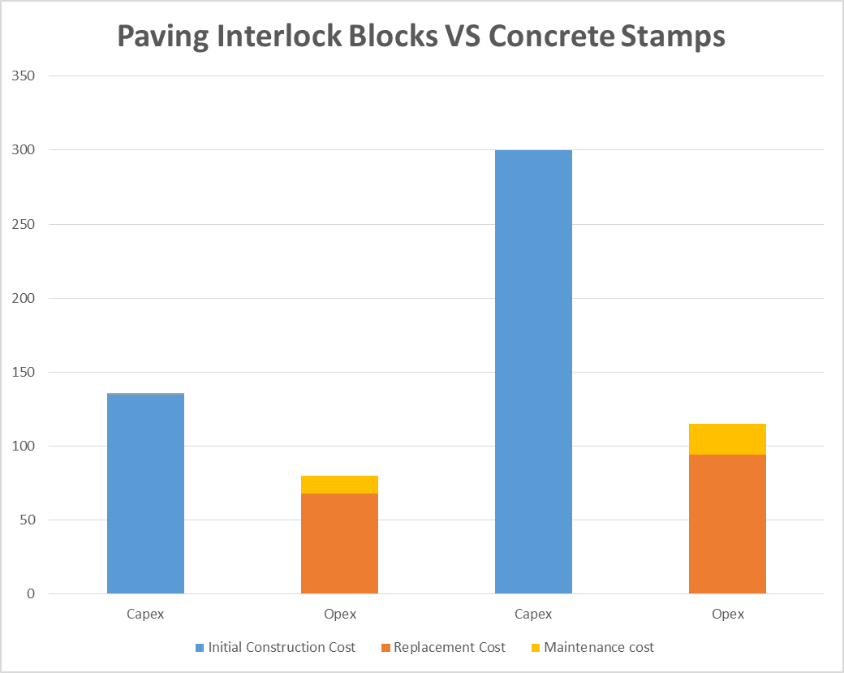
The graphs represent the updated construction information, the Capex and Opex amounts are represented individually of the net internal area of 8465 m2. Based on the construction costs between concrete stamps and paving interlock tiles.
The material viewed over a 25-year period, initial costs account for approximately 62% of the total, while operations and maintenance costs equal 18%, and personnel costs equal 20%.

MATERIALS CONSIDERED AND JUSTIFICATION FOR THEIR SELECTION

When compared to the equivalent life cycle costing of other traditional paving practice like concrete stamps, the results for paver systems are better because of the following points:
  - Higher performance life of pavers as compared to concrete stamp
  - Lower capital cost of pavers compared to cast-in place concrete stamp
  - Lower maintenance costs
  - Easier installation, maintenance and replacement with lesser workforce
  - Reduced vulnerability to utility cuts.

ANY ASSUMPTIONS MADE

The Following assumptions have been used in the life cycle costing exercise.

Parameter | Value
Appraisal Period: | 25 Years
Start Year | 0 (i.e. including initial Construction Costs)
Concept Design – Academic Exercise | Q2 2018
Schematic Design | Q1 2019
Detailed Design | Q2 2019
Final Construction Costs: | Q3 2019
Annual Inflation Rate: | 2.5%
Discount Rate (LCC options analysis): | 5.0%
The following assumptions have been made in the development of this life cycle cost analysis;
  - The cost of all replacement works includes: 5% risk contingency and 5% preliminaries allowance.
  - The life cycle cost model sets out major planned (capital) works such as replacements, plus major cyclical work such as revamping.
  - The model does not include for minor planned maintenance works.
  - The model does not include for damage due to malicious behaviour, grounds maintenance, cleaning and waste management, provision of security staff or caretaking staff, general Soft Facilities Management or utilities.
  - Replacement periods have been adjusted to account for the UAE environment.
  - Unimpeded access to areas to be refurbished.
  - Economically sized replacement contracts priced on a competitive basis.
  - All workmanships / installations are in accordance with manufacturer’s recommendations.
  - Replacement periods assume that the appropriate planned maintenance is carried out, in accordance with good industry practice and manufacturer’s recommendations.

ANY CONSTRAINTS AND RISKS IDENTIFIED

The LCC is prepared for 25 years, during that period it is not possible the same design and colour will be available in market due to redundancy of similar material, as material design and features may vary and change at once. In addition to the pavement interaction, the other primary factors affecting pavement durability are pavement design, material quality, subgrade conditions, weather conditions and importantly, construction quality.

ALTERNATIVES CONSIDERED IN THE ANALYSIS
Concrete stamps walkway is an alternative if paving interlock block does not appear to be beneficial in terms as stated. Due to higher cost associated as envisioned in the LCC study, concrete stamp was not a mere feasible option but it can be considered as a replacement.

LCC RESULTS INCLUDING RISK ASSUMPTIONS

The installation of concrete paving tiles at the Masdar Central Park were of the following nature of tiles. The total internal area covered within the Masdar Central Park is 8465 square meters.
  - Pre-cast concrete triangular paver - Main access (PV01A), 290mm side; 80mm
  - Pre-cast concrete triangular paver - Main access (PV01B), 290mm side; 60mm
  - Pre-cast concrete square paver - FAVO consent Pedestrian access (PV02); 400mmx400mmx60mm
  - Pre-cast concrete paver: CONRAD Consent Wadi (PV04); 350mmx250mmx80mm thickness
  - Concrete paving (PV07) 300mmx300mmx60mm

The careful study of LLC for Masdar central park was carried out and it has been identified that the overall results indicate the selection of paving interlock blocks not in terms of costing but also due to its durability, easy to install, non-skilled workmanship and environmental aspects that were accounted in terms of low GHG emission and the usage of sustainable material.

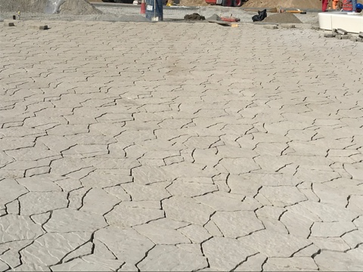
PICTURES – INSTALLED TILES AT MASDAR CENTRAL PARK
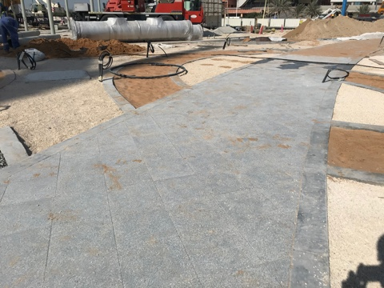
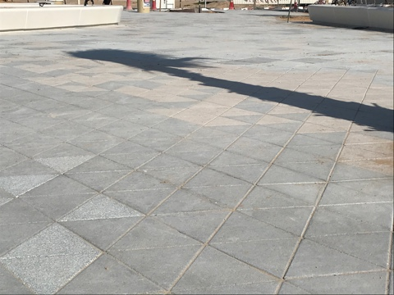
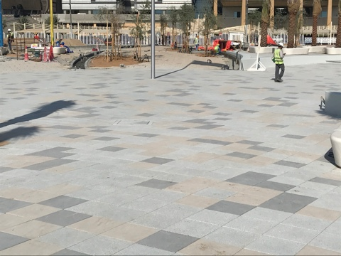

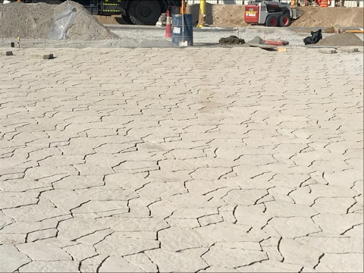
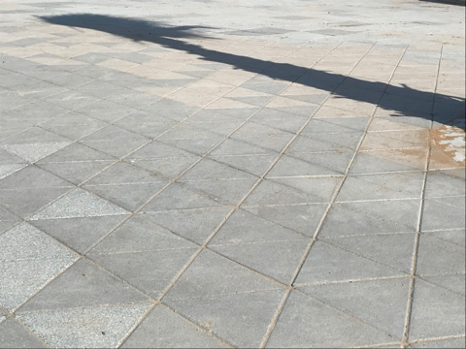

SPECIFIC AREA RELATED TO INSTALLED TILES AT MASDAR CENTRAL PARK
The below table specifies the actual area where the paver tiles were laid
Sl. No | Nature of Paving Tile | Area in m2
1. | Pre-cast concrete triangular paver - Main access (PV01A), 290mm side; 80mm | 1376.33
2. | Pre-cast concrete triangular paver - Main access (PV01B), 290mm side; 60mm | 1726.28
3. | Pre-cast concrete paver: CONRAD Consent Wadi (PV04); 350mmx250mmx80mm thickness | 500.58
4. | Concrete paving (PV07) 300mmx300mmx60mm | 898.16
5. | Pre-cast concrete square paver - FAVO consent Pedestrian access (PV02); 400mmx400mmx60mm | 3965.65

GRAPHICAL REPRESENTATION
The detail costing of paving interlock blocks and concrete stamps have been assessed for over 25 years by using the logarithmic calculations.
The best option identified in terms of all the associated costs were paving interlock blocks that came to around AED 1,142,775 for an area of 8465m2 at the final construction stage. A minimal cost is required as usual for the functional aspects of Masdar central park that is for the construction of walkway.
The assessment of concrete stamps was quite higher and not suitable to choose which would have certain other parameters to identify and application for each stage. The calculation of concrete stamps for the construction of road walkway would have been much higher in cost that is AED 2,031,600 which surrounds the same area of 8465m2.
By considering the paving interlock blocks placement option it will not only save the net amount but all reduce the other aspect of material and have increased durability. The paving interlock blocks will present a decent aesthetic look inside the park with sustainable features included of the material.

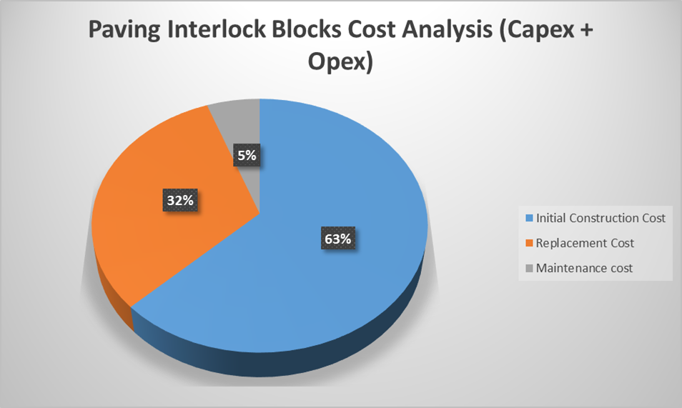

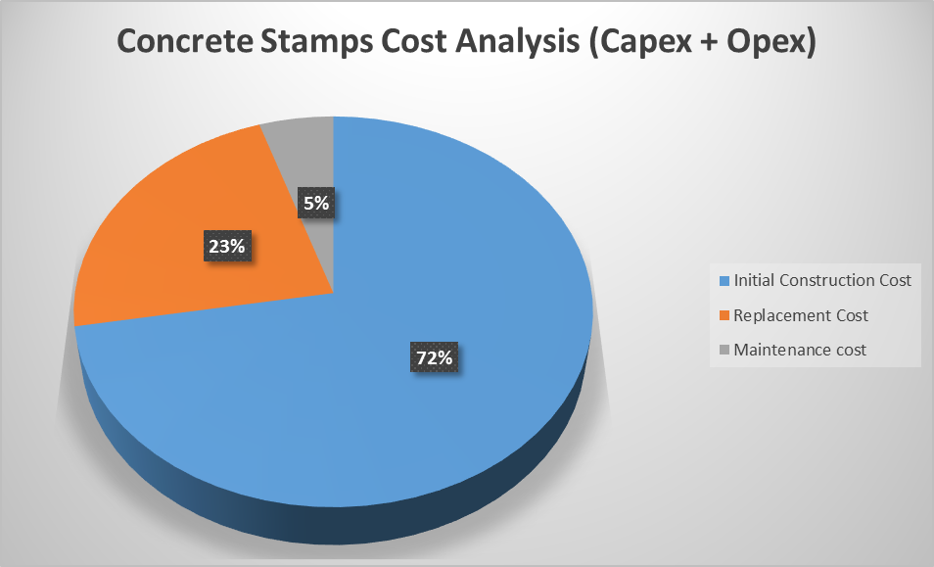

Element | Paving Interlock Blocks (AED/m2) |  | Concrete Stamps (AED/m2)
 | Capex | Opex | Capex | Opex
Initial Construction Cost | 135 |  | 300
Replacement Cost |  | 68 |  | 94
Maintenance cost |  | 12 |  | 21
Total | 135 | 80 | 300 | 115

Replacement and maintenance plan
Soon after installation of the paving tiles in the park, normal day to day visual inspection by the management team will be done to check any vulnerability. Daily sweeping also forms a part of maintenance plan. Similarly, if required, third party audit will also be commenced to examine any uncertainties. If any tile is damaged due to flooding, ground instability, damp and/or excessive load and usage, it will be replaced instantly with the tile of same design. Moreover, the left over paving blocks will also be warehoused for a minimum of 5 years period in case of any instant replacement.

Environmental Considerations
Considering the selection of convenient tiles colours, the central park is expected to contribute positively to the surrounding environment with the least possible heat Island effect. All the selected paving tiles are with light colours and very SRI values to minimize the heat gain of the park outdoor spaces.
In addition, as Masdar has always been keen on minimizing the embodied carbon emission s during the park operations, the team has developed a detailed embodied carbon calculations associated with the Central park open landscape areas.
The calculations result of total embodied carbon associated with the paving tiles = 17.5 kgCO2/m2 emission only, 40% less than what would emit from concrete stamp of the same area.

- Social Impact

Development in Masdar has sustainability and innovation at its core. Therefore, the central park project has been selected to delve into the exploratory options rather than the conventional approach. As such, the integration of the outdoor interactive play equipment is inherently available. Since the project is Design and Build, the Design and Development team along with the Client/developer was able to incorporate the discussion and findings more coherently.
The Cost/ Benefit analysis of the proposed play equipment can’t be quantified in monetary terms as the benefits go beyond economic feasibility. However, it is anticipated that the user will yield significant indirect benefits which will touch on the overall health and Well-being aspects of the users.
The below table indicates the costs of the proposed smart innovative equipment vs conventional equipment, which will give guidance to developers of future parks of similar or more innovation level on the budget required to be allocated for this item;

Item Description | Unit Price (As per Contract) | Conventional Item
Swing Frame | 68,000.00 | 48,500.00
Seesaw | 59,000.00 | 38,800.00
Some of the benefits that have been realized upon fruition and operation of the park is to set the roadmap for the following
- A future outlook on the public environment with respect to playgrounds and its play sets.
- A range of products that can be installed in any public across the region.
- Paving the road for further development and creation of new cutting edge technological play sets.
In other words, according to our detailed benefit analysis for this proposed Innovative Practice, the below performance targets are anticipated to be attained:
- Interactive play sets would be fun at all times and for different age groups.
- The interactive play sets will stimulate children playing together to aid children’s social development.
- Allow the children to interact with play sets in different ways which supports all four categories of development; physical, cognitive, emotional and social.

The playgrounds are all safe and they are designed with ergonomics in mind.
The below Risk Assessment gives detailed analysis of all potential risks associated with the use of the proposed play equipment from users perspective.
It can be noted from the below risk Assessment that overall risk score of each and every identified risk is lower enough to trigger any threat on the functionality of the play equipment.
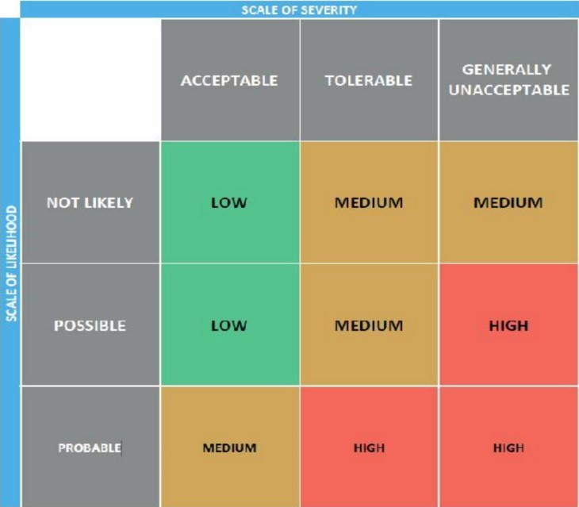

Risk Assessment (SEESAW)
Risk |  | Likelihood | Severity | Risk Impact
Fall of the seesaw seat |  | Possible | Acceptable | Low
Fall from height |  | Possible | Acceptable | Low
Impact by one player on seesaw to the other player |  | Not likely | Acceptable | Low
Structure Failure: Safety of the seesaw structure |  | Not likely | Unacceptable | Medium
fingers or feet under stopping block |  | Possible | Acceptable | Low
Risk Assessment (SHOT SPOT)
Risk | Likelihood |  | Severity | Risk Impact
Safety : fingers or feet trapped | Not likely |  | Acceptable | Low
Fall from height | Not likely |  | Acceptable | Low
Impact by one player on seesaw to the other player | Probable |  | Acceptable | Medium
Structure Failure: Safety of the shot spot structure | Not likely |  | Unacceptable | Medium

Risk Assessment (GAMENETIC)
Risk | Likelihood | Severity | Risk Impact
Fall Over foot pedal | Possible | Tolerable | Medium
Fall from height | Not likely | Acceptable | Low
Safety: fingers or feet in speaker cut out | Not likely | Acceptable | Low
Structure Failure: Safety of the GameNetic structure | Not likely | Unacceptable | Medium

Risk Assessment (AUDIONETIC)
Risk | Likelihood | Severity | Risk Impact
Fall Over foot pedal | Possible | Tolerable | Medium
Fall from height | Not likely | Acceptable | Low
Structure Failure : Safety of the AudioNetic structure | Not likely | Unacceptable | Medium

The purpose of selecting such interactive play sets is to set a role model for new parks between now and ten years’ time. The range of these new play equipment aims to push Masdar series of central parks to the next level of interactivity.
This goal has been achieved based on analyzing the past, present and future of playgrounds and play sets by observing children playing outside, analyzing child development, analyzing the market developments and using these to create an outlook on the future for public parks.
Recent advancement in the technology has infiltrated the playgrounds. However, this doesn’t imply that children will be less active during their outdoor play, but instead will encourage them to interact with the playground equipment and each other on a new and enhanced level.
The fact that children grasp technology with ease meant that it was inevitable to incorporate the technology into playgrounds. While there will always be a place for classic playground equipment like slides and swings, adding technology to playgrounds can add another dimension to children’s outdoor play.
Incorporating technology into playgrounds mean devices that are designed specifically for engaging the user and enabling them to develop their social skills and be more active during their free time.
One of the prime benefits of introducing technology is that it can encourage children to play games that require them to be active. Technology-based games can adapt to the level of the child’s ability, speeding up to make it harder, or slowing down encouraging children of all abilities to play the game, not just those who are naturally agile and fast.
Another benefit is the fact that children are so used to technology being part of their everyday lives, they easily engage with technology but it doesn’t distract from traditional playground equipment. Instead of making children less sociable and active, technology engages children to get more from their playtime. Over time, more and more playgrounds will start embracing technology and soon it will become as common as the traditional slides and swings

Conclusions
It can be seen that the discounted cost approach results in a greater difference between initial construction cost and whole life cost for paving tiles in comparison to concrete stamp which requires more maintenance over their service lives.
For the low maintenance costs assumed for the concrete block pavement, whole-life costs were not appreciably greater than initial construction costs and were insensitive to the discount rate in the range five to fifteen per cent. At a discount rate of five percent, discounted maintenance and rehabilitation costs for the concrete stamps were of the same order and magnitude as initial construction costs, but were significantly reduced as the discount rate increased to fifteen per cent. Clearly, whole life cost analysis can only be useful if costs can be accurately estimated. LCC analysis showed that interlock block pavements are having low maintenance over a long life become increasingly attractive at owner discount rates.
Hence, the results can be summarized as:
- Life cycle cost analysis takes into account all the costs (capital and maintenance) over a given period of 25 years analysis.
- Lifecycle cost analysis also considers the design involved for the two alternatives selected i.e. concrete stamp and paving interlock blocks.
- In the analysis, alternative pavement structures are assessed on the basis of discounted total costs.
- Particularly for low values of the discount rate, the ranking of pavement structures on the basis of whole-life costs can differ from that based on initial construction costs.
- The benefits attained from low maintenance of well-constructed interlocking paving blocks can be taken into account through the use of whole-life cost comparisons with alternative surfacing such as concrete stamps.
- There is a need for data concerning the actual maintenance requirements and associated costs of in-service concrete block pavements.
- Paving interlock blocks are selected on the basis of lower capital, maintenance and installation cost, higher durability and less vulnerability to external constraints.

References

Clift, M., (2003). Life-cycle costing in the construction sector. Industry and environment, 26(2), pp.37-40.

Dwaikat, L.N. and Ali, K.N., (2018). Green buildings life cycle cost analysis and life cycle budget development: Practical applications. Journal of Building Engineering, 18, pp.303-311.

Goh, B.H. and Sun, Y., (2016). The development of life-cycle costing for buildings. Building Research & Information, 44(3), pp.319-333.
Haapio, A. and Viitaniemi, P., 2008. Environmental effect of structural solutions and building materials to a building. Environmental impact assessment review, 28(8), pp.587-600.

Hossaini, N., Hewage, K. and Sadiq, R., (2015). Spatial life cycle sustainability assessment: a conceptual framework for net-zero buildings. Clean Technologies and Environmental Policy, 17(8), pp.2243-2253.

Hossaini, N., Reza, B., Akhtar, S., Sadiq, R. and Hewage, K., (2015). AHP based life cycle sustainability assessment (LCSA) framework: a case study of six storey wood frame and concrete frame buildings in Vancouver. Journal of Environmental Planning and Management, 58(7), pp.1217-1241.

Kishk, M., Al-Hajj, A., Pollock, R., Aouad, G., Bakis, N. and Sun, M., (2003). Whole life costing in construction: a state of the art review.

Loiseau, E., Saikku, L., Antikainen, R., Droste, N., Hansjürgens, B., Pitkänen, K., Leskinen, P., Kuikman, P. and Thomsen, M., (2016). Green economy and related concepts: An overview. Journal of cleaner production, 139, pp.361-371.

Olubodun, F., Kangwa, J., Oladapo, A. and Thompson, J., (2010). An appraisal of the level of application of life cycle costing within the construction industry in the UK. Structural Survey.
Pinder, J., III, R.S. and Saker, J., (2013). Stakeholder perspectives on developing more adaptable buildings. Construction Management and Economics, 31(5), pp.440-459.

