Step 1: Go to https://ilabs.eccouncil.org/store/
Step 2: Scroll down to the 6th product on the list as shown below
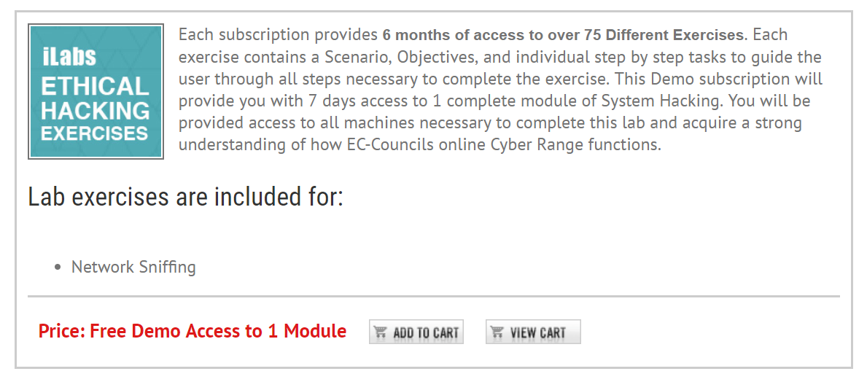
Step 3: Click “Add to Cart”
Step 4: Enter the Country and Zipcode and click “CHECKOUT” as shown below
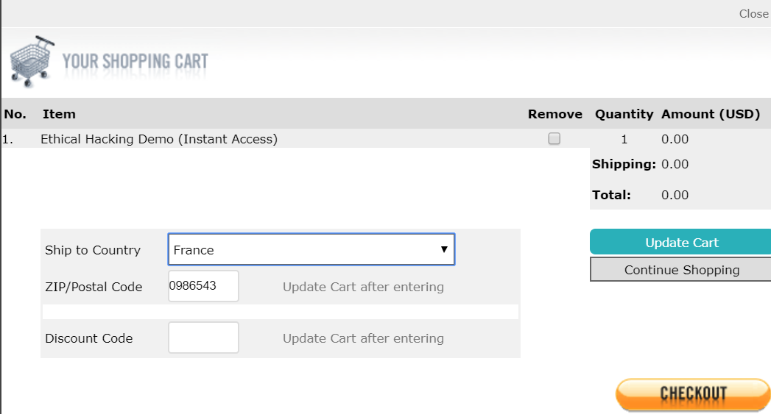
Step 5: Register by filling in the required fields as shown below and complete the checkout process as shown below
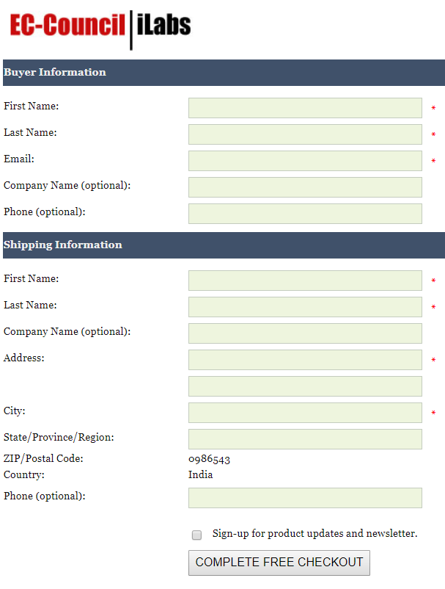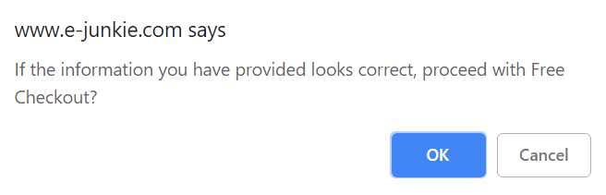
You will receive a confirmation message as below, and a key at the email id provided during purchase
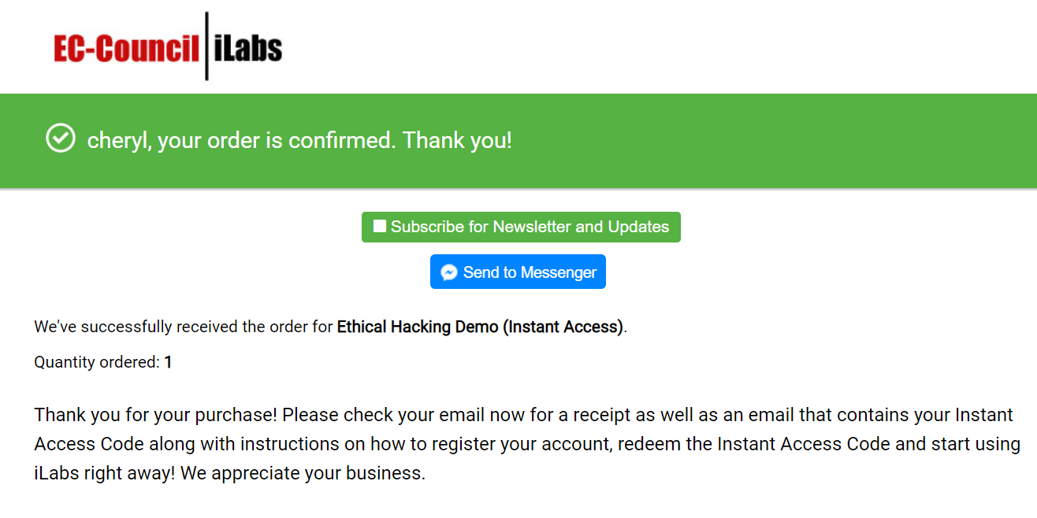
Step 6: Register at https://eccouncil.learnondemand.net/User/Register?OrganizationId=1060
Step 7: Login to your account and click on “Redeem Training Key”
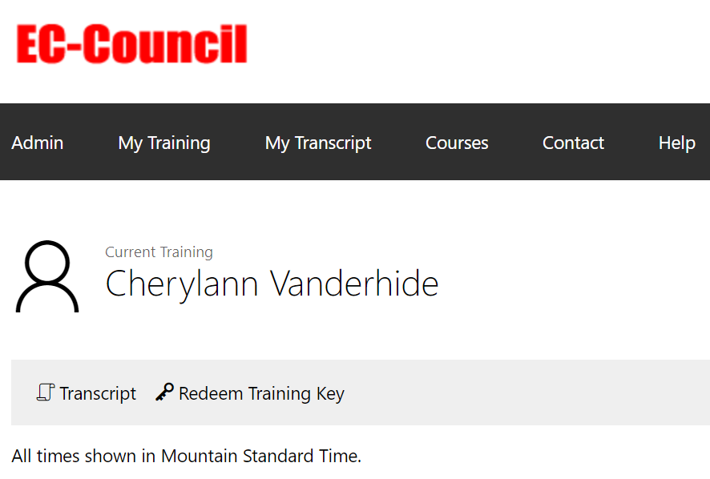

Step 8: Activate the key received at your registered email id
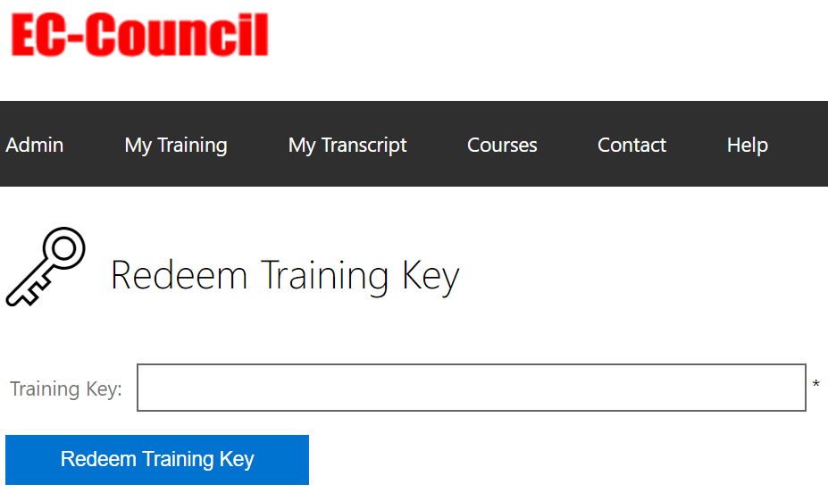
Step 8: Launch your labs


