

LCBB 4002- COMMUNITY ENGAGEMENT

DAY CENTRE PROVIDING CHILDCARE FOR STAYING HOME PARENTS WANTING TO RETURN TO WORK


Source: Getty Images

Student name: Vali-Daniela Pantazi
Student number: 2212835

Lecturer: Efua Adams
Table of contents

Introduction 3
The purpose of the day centre 4
Principles used to engage the community 4
Gibbs reflective cycle 6
Feelings 6
Evaluation 7
Analysis 7
Conclusion 7
Action plan 8
References 8
Appendix 10

Introduction

Community engagement represents a democratic process, and it is important because it empowers citizens to exercise their powers and become responsible for the well-being of their community; they can organize in groups in pursuit of the same goal by ensuring the state institutions are performing their public duties (www.londoncouncils.gov.uk, 2008). Engagement happens when the public is involved in policies or service decisions which may affect their community (www.londoncouncils.gov.uk, 2008).
The community engagement module gave me insight into studying the communities, finding out about their needs and how to successfully implement projects to meet these needs, and how important is for a business to give something back to the community. To write this essay and present this project I will use Gibbs’s reflective cycle as it represents a framework for analysing experiences and allowing one to learn and plan according to how things worked: well or not so well (The University of Edinburgh, 2020).
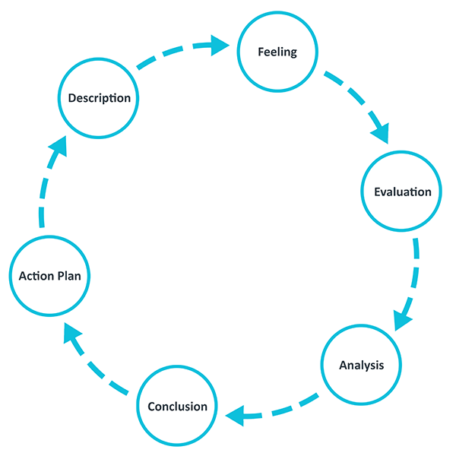
Gibbs Reflection Cycle
Source: www.ed.ac.uk

This essay aims to present the process of involving the Sandwell community in a project referring to the opening of a Day Centre for stay-home moms, which will enable them to find a part-time job, while their children will be cared for at this centre. The need for opening such a facility appeared when moms looking after their young children complained about the impossibility of having a job, due to a lack of governmental support for funded hours for children from 9 months to 3 years. A petition has been made to the government in 2019 and another in 2021 to request free childcare for children from 9 months to 3 years, a petition that gathered 106,000 signatures (Petitions - UK Government and Parliament, 2021).
The Council live project related to the hub was meant to boost the economy in the area and create learning opportunities, but my project focuses on a stringent problem, which is represented by staying-home parents, with no perspective to have a job due to high childcare costs.

The purpose of the day centre

According to BBC News (2023), free childcare for working parents will be extended to all children under five years by September 2025. This will allow around 60,000 parents to go back to work as in December 2021, 1.3 million people in the UK were unemployed (Wells, et al., 2023). Until then, a solution must be found to help parents reintegrate into the workforce. For the area of Sandwell, the community will be consulted regarding the opening of the Day Centre providing free or low-cost childcare for parents wanting to return to work.
According to www.sandwelltrends.com (2021), 31.3% of Sandwell’s working population is economically inactive due to looking after family or home. This percentage needs to be reduced to boost the borough’s economy.
The day centre will be providing free or low (depending on the family’s income) childcare for children between 9 months and 3 years, from 9 am and 3 pm, Monday to Friday, to allow moms to go back into employment and develop their careers. The facility will also support parents wanting to enrol on universities or to continue their studies. Enabling moms to go back to work will boost the economy of the area, will give them economic stability, and eventually ease the benefits system, also will reduce depression and anxiety, as according to mentalhealth.org.uk ( 2021), 68%of women and 57% of men with mental health problems are parents.

Principles used to engage the community

The project strives for a positive outcome and for this to happen, the community’s awareness about this project must be increased. Citizens have been encouraged to develop new knowledge about the situation of stay-home parents, use the opportunities to improve the project and use effective communication on a regular basis for the success of the project (artscapediy.com, 2019). Strategies and methods of effective community engagement have been used and will be detailed further.
For this project, the ground-up engagement strategy was used as it has proven to be the most effective in partnering with communities and building long-term trust. Sandwell Council, in consulting the community about the Education Hub, used the same model and the response and engagement from the community were positive.
This project requires 5 weeks of consultations as the community considered to be consulted is very diverse in terms of culture, age, social status, and economic situation and time is needed to approach and involve all these segments.
To achieve effective engagement from the community, Open Days were organized at three local Playground centres between 16.15 pm and 17.15 pm, four local Libraries from 12 pm to 15.30 pm and at West Smethwick Park Pavilion, every day between 14.00 pm and 16.30 pm, for three weeks. To organize these days, 15 moms volunteered to be there and inform the visitors about the project, and its benefits and collect feedback through feedback forms. Out of 458 community members visiting during the three weeks, 402 gave positive feedback, 35 were worried about the funding and council spending money that can be allocated to more important projects and the rest did not see the need for it.
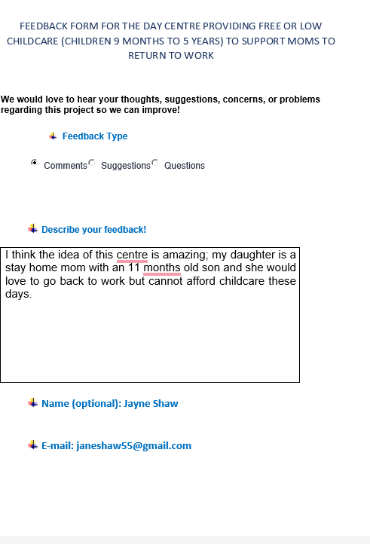

Also, social media platforms were used to make the community aware about the project. The Facebook page had the most visitors, and important feedback and ideas could be collected from 980 respondents. On Twitter, the page was tweeted 280 times and shared. The Local Radio Stations announced the project. Moms volunteered to organize four days of activities in West Smethwick Park to raise the community’s awareness about the project, its benefits and challenges. Flayers were given to the participants and when possible, feedback was collected.
Regarding the funding concerns outlined by several members of the community, this project will be fully funded from sponsorships and monthly donations made by wealthy local businesses in the area which have found the project very interesting, thinking even of employing some of the moms using the childcare services of the day centre. Also, fundraising events will be organised in the parks, local pubs and playgrounds, every three months to raise money to furnish the day centre appropriately. The qualified personnel looking after the children will be voluntary apprentices that have completed Childcare and Early Years Courses and need to build their experience.
The Day Centre will be opened in a building that used to be a mosque belonging to the Islamic community of Sandwell, comprising three rooms, a kitchen and 2 bathrooms, the perfect location for the proposed facility. The Chief of the Islamic community was more than happy to donate the building, with the condition that Islamic women to be involved and supported to progress in their careers. This building will need a lot of improvements and adaptations. For this purpose, AMC BUILDERS AND DECORATORS LTD offered to donate the construction materials and made available a decorator to help with setting up the building for the purpose. As a difficulty in planning for this project, a “Change of Use” authorization needs to be obtained by Sandwell Council and the response will be given in 4 weeks, but hopefully, it will be a positive one, as redecorating this building will have a positive environmental impact on the area implying a beautiful view, more activity and constant cleanliness of the surroundings.

Gibbs reflective cycle

Feelings

Seeing all those moms unhappy and anxious about not having a career perspective due to the lack of affordable childcare facilities made me feel helpless and pushed me on finding a solution to help them.
When involving the community in this project and seeking opinions and approval I felt very supported in the way that most of the community understood the importance of this project, the positive impact that it will have on the well-being and mental health of staying-home moms, and, on the economic situation of the families. The community was very apprehensive, and the level of volunteers impressed me.
About finding sponsorship and donations for the project, in the beginning, I felt rejected by several companies I approached due to the present economic situation of the country and the hardships they found in running their businesses. After many attempts, I managed to secure funding and regular sponsorship, but I will be continuously searching as things may change with the actual sponsors.

Evaluation

To evaluate my project, I will compare it to the Council Live Project in terms of communication and standards of inclusion.
Sandwell Council failed in communicating updates and outcome of the project to the community. I plan to inform the community of the progression of each step of the project, by using social media, and local Council meetings, as the community showed great interest. This way I will gain the community’s trust and future support in other projects.
My project uses all the inclusion standards as I know it will make it successful, compared to Sandwell Council which failed to use, for example, Support Standards in approaching the community. In my project I used Punjabi interpreters as a major part of the community is formed by Punjabi-speaking members; I also managed to find sponsorship from several local Taxi Companies to enable people with special mobility needs to take part in the events organized to promote the project. This increased the community’s sense of belonging and support for my project.
The Gantt Chart below, shows the development of the project, the objectives and the time allocated for these to be completed.
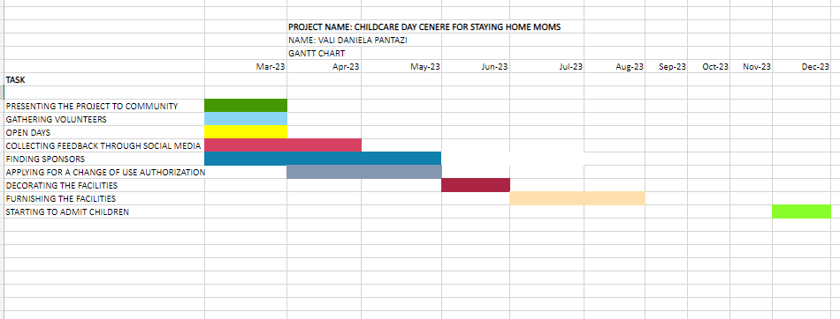

Analysis

By conducting this project, I understood that community engagement represents the very important process of involving community members in the decision-making, planning, assessing and evaluating solutions to problems that may affect their daily lives (planh.ca, n.d.). Using effective engagement processes in engaging the community in my project helped me build trust and ensured the efficient implementation of decisions and the successful outcome of the project. The neighbourhood planning was fully inclusive, and everyone in the community was given equal opportunities to have their views and opinions heard and respected, including those whose first language is not English (Neighbourhood Planning Guidance Note 12, 2013). To ensure the success of my project, I tried to use all the means of consultation by sharing consultation responses and different views with the community, tried to find out if there were any sections in the community that did not engage and why, as consulting the community should not be a singular event (Neighbourhood Planning Guidance Note 12, 2013).

Conclusion

This project had a positive outcome as it was approved by the majority of the community members. The success of it was achieved by using correctly the strategies and techniques of community engagement. The communication with the community was made on different plans, so every member of the community had access, the purpose was clearly explained; for consulting with the community enough time was allocated considering mainly everyone’s lifestyles and work schedule. Planning developed after positive feedback was gained and the eventual issues or concerns were resolved.
For future projects, I would try to use a community engagement platform, e.g. The Stakeholder Engagement System, which helps with mapping and organising the stakeholders of the project, selecting stakeholders demographically by using Google Maps and unlocking important communication and feedback channels in order to build better relationships (www.tractivity.co.uk, 2022). This kind of technology will help me organize better and have all the data in one place.
Engaging the community can have a positive or negative outcome, for example, the Berkley Project was at first unsuccessful as the community was inappropriately engaged and their opinions were not valued. After reviewing the strategies for community engagement, the project became a real success.

Action plan

AREAS TO IMPROVE | HOW WILL I IMPROVE | TIMESCALE
Understanding the laws regarding the “Change of Use” that refers to buildings | I will improve in this area by studying the regulations. | I will achieve a full understanding of this area within 2 months
Learning how to use an online community engagement platform | I will improve this area by finding funds to purchase such a platform | I will achieve full knowledge in 5 months

References

artscapediy.com. (2019). A Guide to Engaging the Community in Your Project – ArtscapeDIY. [online] Available at: https://www.artscapediy.org/guide/a-guide-to-engaging-the-community-in-your-project/ [Accessed 15 Mar. 2023].
Neighbourhood Planning Guidance Note 12 Best practice community engagement techniques. (2013). Available at: https://www.herefordshire.gov.uk/downloads/file/3703/guidance_note_12_best_practice_community_engagement_techniques [Accessed 26 Mar. 2023].
Petitions - UK Government and Parliament. (2021). Petition: Fund free childcare for working parents with children over 9 months. [online] Available at: https://petition.parliament.uk/petitions/602132 [Accessed 15 Mar. 2023].
planh.ca. (n.d.). Community Engagement | PlanH. [online] Available at: https://planh.ca/take-action/healthy-society/public-involvement/page/community-engagement [Accessed 26 Mar. 2023].
SANDWELL TRENDS. (2021). Economic Activity. [online] Available at: https://www.sandwelltrends.info/economic-activity/#:~:text=71%25%20are%20in%20employment%20(GB [Accessed 15 Mar. 2023]
The University of Edinburgh (2020). Gibbs’ reflective cycle. [online] The University of Edinburgh. Available at: https://www.ed.ac.uk/reflection/reflectors-toolkit/reflecting-on-experience/gibbs-reflective-cycle#:~:text=One%20of%20the%20most%20famous [Accessed 23 Mar. 2023].
Wells, I., Islam, F. and Morton, B. (2023). Budget: Government expands free childcare once maternity leave ends. BBC News. [online] 14 Mar. Available at: https://www.bbc.co.uk/news/uk-politics-64959611 [Accessed 15 Mar. 2023].
www.londoncouncils.gov.uk. (2008). Community Engagement - What is it and why is it important? | London Councils. [online] Available at: https://www.londoncouncils.gov.uk/node/5871#:~:text=Community%20engagement%20is%20the%20democratic [Accessed 15 Mar. 2023].
www.mentalhealth.org.uk. (2021). Family and parenting: statistics. [online] Available at: https://www.mentalhealth.org.uk/explore-mental-health/statistics/family-parenting-statistics [Accessed 23 Mar. 2023].
www.tractivity.co.uk. (2022). Tractivity: The UK’s Leading Stakeholder Management Software. [online] Available at: https://www.tractivity.co.uk/ [Accessed 26 Mar. 2023].

Appendix




