Module Name: Networks and Cyber Security Essentials
Module Code: ACCA4024

Student Name: AHMED REMACHE
Student ID: 2334747
Group 2

Lecturer’s Name: Amit Naik
30/04/2026

A COMPREHENSIVE CYBERSECURITY GOVERNANCE FRAMEWORK FOR HEALTHPLUS ANALYTICS: THREAT MITIGATION, COMPLIANCE, AND SECURITY AWARENESS IN HEALTHCARE DATA ENVIRONMENTS

Abstract
HealthPlus Analytics (HPA) is a healthcare organization working under a very sensitive environment in which confidentiality of patient information, system integrity and availability of services are critical missions. The recent events of cloud data exposure, ransomware attacks on analytics server are indicators that there is poor governance, monitoring, and staff awareness. This report develops a cybersecurity governance framework, which identifies both internal and external risks, aligns the policies with UK GDPR, NHS security standards, ISO 27001, and NIST principles, and proposes workable technical and administrative controls. Multi-factor authentication, role-based access, SIEM monitoring, immutable backups, endpoint protection, and organized incident escalation are some of the main measures. The other feature that is introduced in the framework is a cycle employee awareness that focuses on resilience to phishing and compliance with policies. These controls, combined, would improve operational resiliency, improve compliance preparedness, and reduce reputational and financial risk.

1. Introduction

1.1 Company and Context
HealthPlus Analytics is a healthcare technology company that handles patient records of hospitals and clinics through storing the data on clouds, analytics engines, and central databases that contain patient information. As such, violations of cybersecurity security may have severe legal, financial and ethical consequences since such datasets contain personal identifiable as well as medical data. The recent ransomware and unauthorised cases show the weaknesses in identity management, cloud control, and recovery planning. This is why there is a pressing need to have a proper governance system that would protect sensitive healthcare information among internal consumers, external interfaces, and hybrid infrastructure facilities.
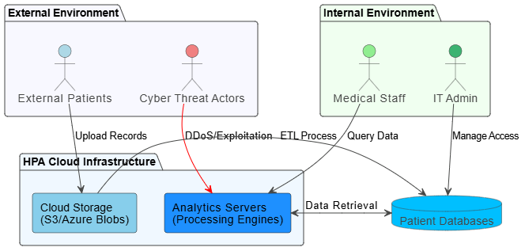
Diagram 1: Healthcare Cyber Risk Context Overview
(Source: Draw.io)

1.2 Aim and Scope
The report is meant to develop a realistic and standards-based cybersecurity governance model at HPA. The scope will entail identifying the key internal and external cyber threats, mapping the threats to business using CIA triad and setting security policies that will address access control, data governance, BYOD and data resiliency using backup. The report also recommends phased implementation priority of the technical, administrative and physical mitigation measures. In addition to that, it generates a lifecycle of monitoring and incident response aided by detection and escalation which are SIEM-based. Lastly, it instils a staff awareness programme, which reinforces human-layer security, regulatory compliance, and organisational cyber maturity in the long term.

2. Threat Identification and Risk Analysis

2.1 Internal Threats
The most severe internal risks are privileged misuse, lack of identity controls, and lack of operations negligence. Sharing data, using the same password or connecting untested personal devices in the BYOD policy is something that the health care personnel can share unknowingly and reveal the data of the patients. The IT administrators are the high-impact insider risk due to the unauthorised access to the database, configuration errors, or accidental service failure with unwarranted permissions [1]. This is because it is unable to control privileges, there is inefficient session time out and limited access to audit and this increases the chances of unauthorised access to data. Routine breaches of GDPR provisions are accidental leakage through unsecured endpoints, removable storage, or stolen email. The greatest effect of these risks is the breach of confidentiality and integrity and the access control is performed in an inappropriate manner that may cause the issue of availability because of an accidental deletion or misconfiguration of the system.

2.2 External Threats
On the external front, HPA is prone to ransomware, phishing, malware injection, DDoS disruption, exploiting the cloud, and abusing APIs. Cyber threat actors can attack analytics servers with malware that is delivered by phishing or use vulnerable cloud interfaces to obtain a persistent access. The DDoS attacks can affect analytics services used by hospitals to facilitate continuity of services and patient care workflow. The configuration of cloud storage can endanger high amounts of patient records, whereas insecure APIs can endanger sensitive information to unauthorised third parties [2]. The attackers also can use ETL processes, inter-system data transfers that are represented in the infrastructure context diagram. Healthcare is one of the areas where such threats are especially prone to occur because any disruption, manipulation of data, or slow analytics may directly affect clinical decision-making, regulatory adherence, and credibility among people.

2.3 CIA Triad Risk Impact
Risks of confidentiality are in the form of insider abuse, phishing abuse, exposure to the cloud, and API abuse exposing patients’ records. It can compromise the integrity through the presence of malware, misuse of privileges or unauthenticated manipulation of ETL that creates alterations on the outputs of analytics that could affect clinical insights. The most susceptible to ransomware, DDoS, and exploiting servers, and failing to recover data in a manner that disrupted hospital and clinic access to data [3]. Priorities in investment may be done using CIA triad: confidentiality: must be encrypted and access regulated; integrity: must have an audit trail, change monitoring and segmentation; availability: must have immutable backups, tested disaster recovery and robust network architecture; resiliency. This triad prioritisation ensures that there is alignment of the operations of the control to the operational risk profile of HPA.

3. Security Policies and Governance Framework

3.1 Access Control and Authentication Policy
HPA will need to implement multi-factor authentication on all access point of privilege and remote access. Role-based access control should be least privilege in order that the medical personnel, analysts and administrators should be able to receive permissions only in tasks. The session timeouts need to be programmed to close the idle sessions, especially on clinical device(s) shared [4]. The reviews of privileged accounts will be done monthly to identify orphaned accounts or overused accounts. These steps reduce abuse by insiders, utilisation of stolen credentials and unauthorised access to patient database.

3.2 Data Protection and Cloud Governance Policy
The encryption needs of the enterprise levels must be enabled to encrypt all patient information at rest or in transit. Buckets and analytics data lakes on clouds need to secure themselves using private access, geo-restricted copies, retention policies and ongoing audit logs. The retention schedules must be developed to comply with the GDPR requirements on data minimisation, legal storage duration, and safe deletion [5]. Evidence trails in compliance and incident investigations should be preserved by the fact that the logs are kept in a centralised location. To ensure reduced exposure because of misconfiguration, cloud configuration baselines should be aligned to ISO 27001 and NHS digital security requirements.

3.3 BYOD and Remote Working Policy
Any personal devices accessed by HPA systems must meet the minimum-security standards, and these may include endpoint protection, OS patching, full disk encryption, and MDM registration. VPN must be used with device posture validation by remote users. The non-compliant devices will automatically quarantine [6]. It is a policy that ensures a reduction in risk of insecure home network, uncontrolled laptops, and mobile devices by medical or administrative personnel.

3.4 Backup and Incident Response Policy
HPA must possess non-mutable daily analytics workloads as well as patient database backups that have recovery point and recovery time objectives. The incident roles should define escalation ownership between the SOC analysts, IT administrators, legal teams, and the executive leadership [7]. The backup restoration testing should be performed every quarter to be ransomware resilient. These processes help to improve continuity of services and accountability of governance.

4. Threat Mitigation Measures and Implementation

4.1 Technical Controls
To identify malware, ransomware behaviour and abuse of credentials, HPA ought to implement EDR/XDR on servers, user endpoints, and administrator devices. Authentication logs, network events, cloud events, and endpoint telemetry centralisation should be part of SIEM integration to be correlated to raise alerting [8]. The IDS/IPS controls must analyze both the north-south and east-west traffic particularly between the analytics servers and the patient databases. The analytics workloads, storage environment as well as the network administration should be segregated in network segments to decrease the lateral movement. Advanced email filtering that also involves sandboxing reduces the chances of phishing, whereas key management is encrypted, guaranteeing the privacy of patient information [9]. The API gateways should implement rate limiting and anomaly detection as well as token-based authentication. These controls address individually the threat pathways of the external threats that were enumerated in Section 2.

4.2 Administrative Controls
Access reviews should be done quarterly to ensure role appropriateness, especially of privileged IT and analytics personnel. The policy audits should set password policy and BYOD policy and cloud governance standards. The compliance reviews should be adjusted to HPA to the GDPR, NHS standards, ISO 27001 controls, and the NIST incident response maturity [10]. The third-party vendor risk should not be ignored either since cloud and integration vendors are usually utilized by healthcare analytics platforms. The security provisions should be able to reach suppliers in good time and record and control suppliers as a contract.
4.3 Physical and Backup Controls
The servers need to be critical and situated in access-controlled rooms with CCTV, environmental monitoring and restricted badge entry. USB storage should be disabled, and sharing of medical terminals should be controlled through a kiosk [16]. The offsite and the cloud-isolated backups are not to be logically connected with the production credentials to resist the ransomware encrypted.
4.4 Implementation Roadmap
Phase 1 should be dedicated to MFA, immutable backups, SIEM onboarding and phishing filtering. Phase 2 is expected to bring segmentation, vendor assurance, API security as well as quarterly compliance reviews. Phase 3 will be based on sustainable optimisation in which red-team testing, behaviour analytics, and policy refinement will be engaged.

5. Monitoring and Incident Response Framework

5.1 Continuous Monitoring
The constant surveillance should be grounded on the SIEM dashboards that obtain the logs of the cloud storage, authentication tools, analytics servers, endpoints, and network controls. Ransomware indicators, privilege escalation, suspicious ETL changes, and suspicious database queries should be placed as priorities of real-time alerts [11]. The detection of abnormal staff behaviour, record retrieval, or out of hours administrative activities can be detected using anomaly detection using UEBA. Daily log overview and weekly threat trend reporting are also useful in proactive governance.

5.2 Incident Response Lifecycle
The incident response life cycle has been founded on detection, verification, containment, eradication, recovery, and lessons learned. Once SIEM alerts or user reports have proven the existence of an event, the affected systems should be isolated and removed accounts. Root cause removal entails erasing malware, resetting of credentials, and approval of patches [12]. The immutable backup restorability and service integrity validation and subsequent restoration of patient systems should be the focus of recovery. The incident review should be followed by updating policies and training.
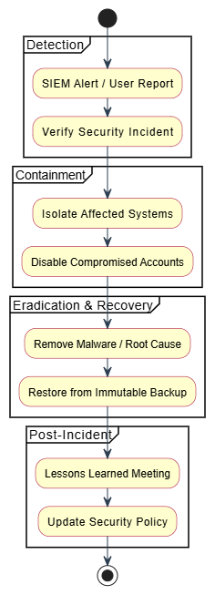
Diagram 2: Incident Response Flowchart
(Source: Draw.io)

6. Staff Training and Security Awareness Programme

6.1 Training Structure
The new employees at HealthPlus Analytics should be provided with a mandatory induction security training programme as a form of onboarding to ground on cyber awareness. This training should also cover UK GDPR, use of secure passwords and their management, phishing and social engineering awareness, patient record management, incident reporting, and reasonable use of cloud-based systems [13]. The programme should be role-based such that the medical staff, analysts and IT administrators understand what exact risks are associated with their access points and duties. In addition to the induction, quarterly refresher courses will be offered to refresh the changing threat awareness and in particular phishing exercises, ransomware recovery training, and policy adherence training [15]. They should include short assessment quizzes and activities based on scenarios to measure the level of knowledge and identify the weak areas and ensure the continuation of the change in the culture of behaviour and compliance with the culture of cybersecurity among the personnel in the field.

6.2 Compliance Reinforcement
There must be an increase in behavioural accountability, as this can be achieved by quarterly evaluations, obligatory policy acknowledgment, and anonymous reports of suspicious behaviour [14]. The results of training should be the sources of retraining of high-risk users.
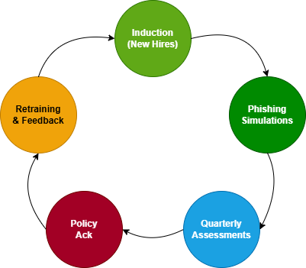
Diagram 3: Security Awareness Training Cycle
(Source: Draw.io)

7. Conclusion
HPA is vulnerable to the strongest threats of ransomware, insider abuse, cloud misconfiguration, and unsecured BYOD. MFA, RBAC, surveillance under the watch of SIEM, irreversible backup, division and continuous awareness reinforcement of the staff are the best controls. Together with GDPR-congruent governance policies and validated incident processes, these interventions would help ensure confidentiality, integrity, and availability of healthcare analytics processes to a considerable extent. The suggested framework will make the organization more compliant, less vulnerable to breach, more likely to recover ransomware, and more likely to have executive confidence. The framework will also provide business value to the board that can be measured as a reduction in the operational risk, enhanced regulatory defensibility, increased stakeholder trust and resilient healthcare data services.

References
[1] A. S. Rafika, S. Baltasar, Adiwijaya, A. R. M. H. Chakim, and Z. S. Rizky, “Cybersecurity strategies for preventing ransomware attacks in cloud-based applications,” J. Comput. Sci. Technol. Appl., vol. 2, no. 2, pp. 1–11, 2025, doi: 10.33050/corisinta.v2i2.77.
[2] B. Alamri, K. Crowley, and I. Richardson, “Cybersecurity risk management framework for blockchain identity management systems in health IoT,” Sensors, vol. 23, no. 1, p. 218, 2023, doi: 10.3390/s23010218. [Online]. Available: https://www.mdpi.com/1424-8220/23/1/218
[3] A. Alharbi and A. Alkhalifah, “Cybersecurity governance in the healthcare sector during digital transformation: An integrated model and hybrid analytical approach,” Front. Public Health, vol. 13, p. 1703689, 2025, doi: 10.3389/fpubh.2025.1703689. [Online]. Available: https://www.frontiersin.org/journals/public-health/articles/10.3389/fpubh.2025.1703689/pdf
[4] P.-C. Allen, “Surviving the storm: The key to cyber resilience and incident response in healthcare,” Healthcare Manage. Forum, vol. 37, no. 1, pp. 26–29, 2024, doi: 10.1177/08404704231187103.
[5] S. H. Almotiri, “AI driven IOMT security framework for advanced malware and ransomware detection in SDN,” J. Cloud Comput., vol. 14, no. 1, p. 19, 2025, doi: 10.1186/s13677-025-00745-w. [Online]. Available: https://link.springer.com/content/pdf/10.1186/s13677-025-00745-w.pdf
[6] T. Ban, T. Takahashi, S. Ndichu, and D. Inoue, “Breaking alert fatigue: AI-assisted SIEM framework for effective incident response,” Appl. Sci., vol. 13, no. 11, p. 6610, 2023, doi: 10.3390/app13116610.
[7] M. Dart and M. Ahmed, “CYBER-AIDD: A novel approach to implementing improved cyber security resilience for large Australian healthcare providers using a unified modelling language ontology,” Digit. Health, vol. 9, 2023, Art. no. 20552076231191095, doi: 10.1177/20552076231191095. [Online]. Available: https://journals.sagepub.com/doi/pdf/10.1177/20552076231191095
[8] J. Ferdous, R. Islam, A. Mahboubi, and M. Z. Islam, “A survey on ML techniques for multi-platform malware detection: Securing PC, mobile devices, IoT, and cloud environments,” Sensors, vol. 25, no. 4, p. 1153, 2025, doi: 10.3390/s25041153. [Online]. Available: https://www.mdpi.com/1424-8220/25/4/1153
[9] P. Ganoje, “Implementing GDPR compliance in medical device data management,” Int. J. Sci. Res. (IJSR), vol. 12, no. 6, pp. 3002–3004, 2023, doi: 10.21275/sr24810081716.
[10] S. Jarugula, “Regulatory compliance and secure data protection mechanisms: A framework for GDPR adherence and data security in the digital age,” Eur. Mod. Stud. J., vol. 9, no. 5, pp. 410–418, 2025, doi: 10.59573/emsj.9(5).2025.38.
[11] G. Kotte, “AI-powered automated incident response in healthcare cybersecurity operations,” Int. J. All Res. Educ. Sci. Methods, vol. 13, no. 5, pp. 3369–3375, 2025, doi: 10.56025/ijaresm.2025.1210243369.
[12] A. Kumar Mittapelly, “Salesforce and GDPR compliance: Ensuring data privacy and security,” Int. J. Sci. Res. (IJSR), vol. 11, no. 5, pp. 2147–2153, 2022, doi: 10.21275/sr220511110820.
[13] A. Lakhan, O. Thinnukool, T. M. Groenli, and P. Khuwuthyakorn, “RBEF: Ransomware efficient public blockchain framework for digital healthcare application,” Sensors, vol. 23, no. 11, p. 5256, 2023, doi: 10.3390/s23115256. [Online]. Available: https://www.mdpi.com/1424-8220/23/11/5256
[14] H. M. Melaku, “A dynamic and adaptive cybersecurity governance framework,” J. Cybersecurity Privacy, vol. 3, no. 3, pp. 327–350, 2023, doi: 10.3390/jcp3030017. [Online]. Available: https://www.mdpi.com/2624-800X/3/3/17
[15] D. Morice, “Trust framework on exploitation of humans as the weakest link in cybersecurity,” Appl. Cybersecurity Internet Governance, vol. 2, no. 1, pp. 1–26, 2023, doi: 10.60097/acig/162867.
[16] O. A. Omar, H. M. Ahmed, T. A. Nofal, A. Darwish, and A. S. Ahmed, “Analysis and optimal control of propagation model for malware in multi-cloud environments with impact of Brownian motion process,” Math. Comput. Appl., vol. 30, no. 1, p. 8, 2025, doi: 10.3390/mca30010008. [Online]. Available: https://www.mdpi.com/2297-8747/30/1/8
[17] R. Palanisamy, A. A. Norman, and L. Mat Kiah, “BYOD security risks and mitigation strategies: Insights from IT security experts,” J. Organizational Comput. Electron. Commerce, vol. 31, no. 4, pp. 1–23, 2022, doi: 10.1080/10919392.2022.2028530.
[18] V. Papakonstantinou, “The cybersecurity obligations of states perceived as platforms: Are current European national cybersecurity strategies enough?,” Appl. Cybersecurity Internet Governance, vol. 1, no. 1, pp. 44–55, 2022, doi: 10.5604/01.3001.0016.1237.
[19] W. Triplett, “Ransomware attacks on the healthcare industry,” J. Bus., Technol. Leadership, vol. 4, no. 1, pp. 1–13, 2022, doi: 10.54845/btljournal.v4i1.31.

Appendix

Slide 1
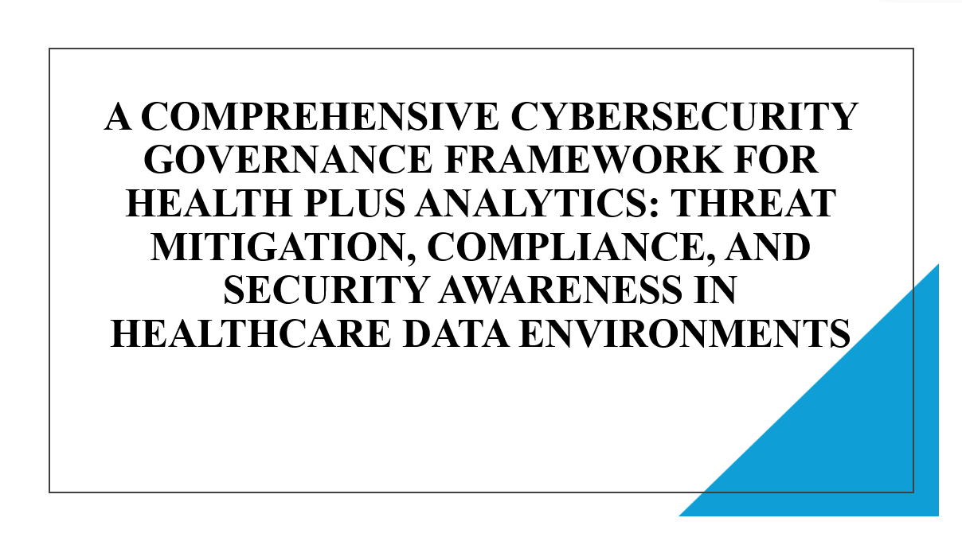

Slide 2
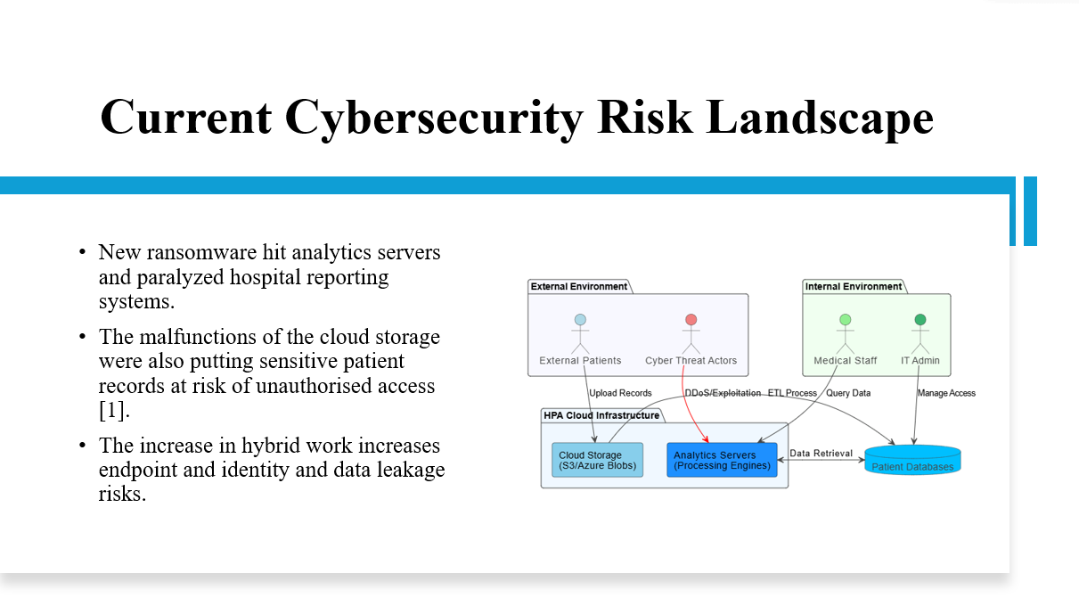

The following slide provides the board with the cyber risk posture at HPA in the short term. Educate on the effects of ransomware and cloud breach on patient trust, legal compliance, and continuity of operations. Indicate that access hybridization and rising data volumes have made the attack surface in clinical analytics services explode

Slide 3
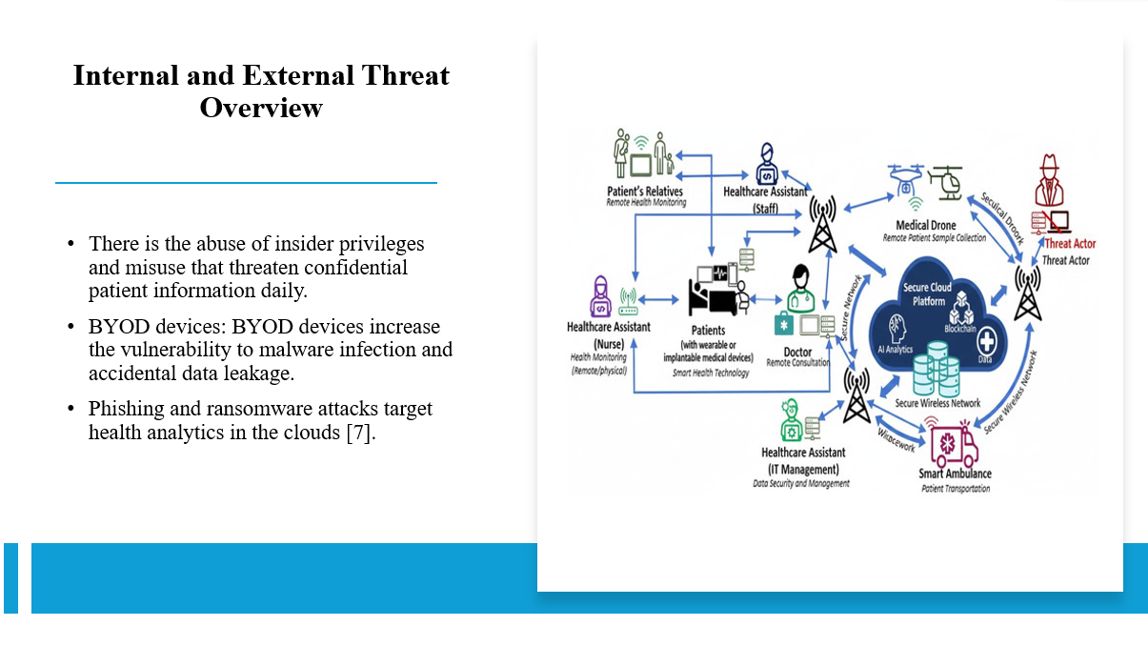

Talk about the threats posed by internal or insiders and external threats. It is important to stress that employees do not do everything right, devices are easy to hack, and phishing messages are convenient. Correlate such threats with the healthcare environment where information privacy and availability of services are the most critical to hospital decision support systems.

Slide 4
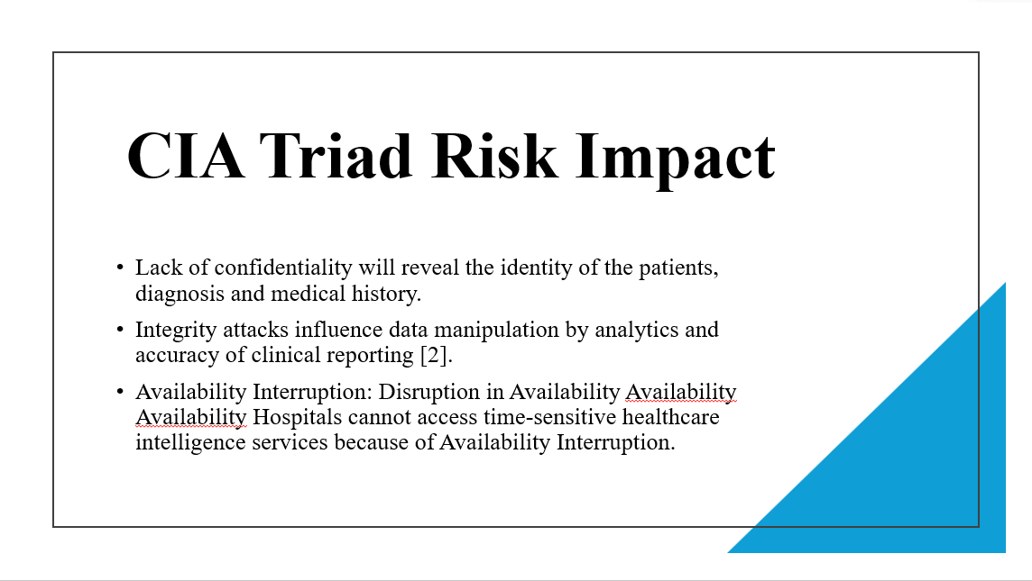

Not only technical risks but business impact should be demonstrated with the help of this slide. Explain how confidentiality breaches negatively affect coordination of care through compliance, integrity violations and availability breaches. The CIA model will help understand why the priorities in investment should be balanced between privacy, trust, and offering continuous services.

Slide 5
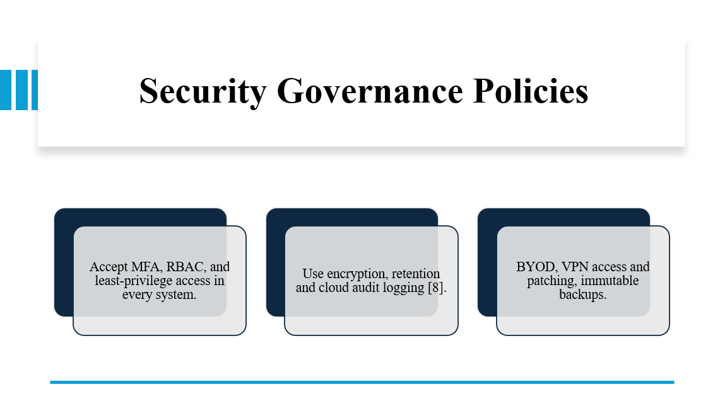

Existing policies as executive and not technical regulations. Explain the role of access, cloud governance, BYOD and backup standards in ensuring accountability and regulatory defensibility. Board confidence in compliance preparedness and policy maturity Compliance with GDPR, NHS standards and ISO 27001 to ensure board confidence in compliance preparedness.

Slide 6
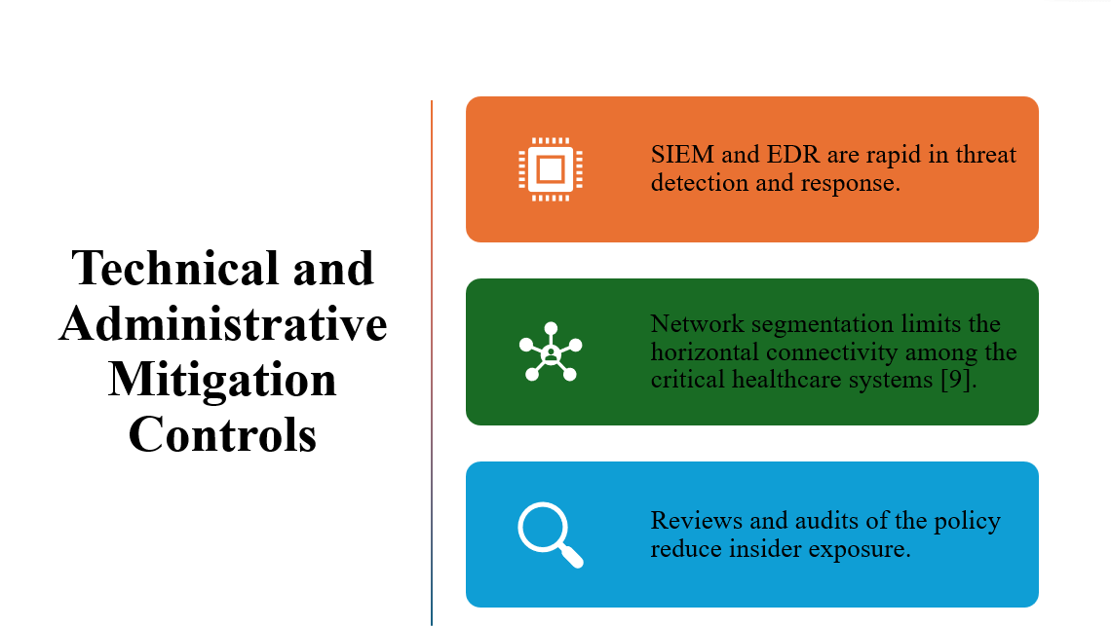

Pay attention to the way these controls minimize the probability and consequences of attacks. Technical tools facilitate visibility and speed of containment, audits and access reviews reduce human and governance vulnerabilities. Emphasize that vertical integration of technical and administrative protective controls will offer superior layered defence to healthcare analytics.

Slide 7
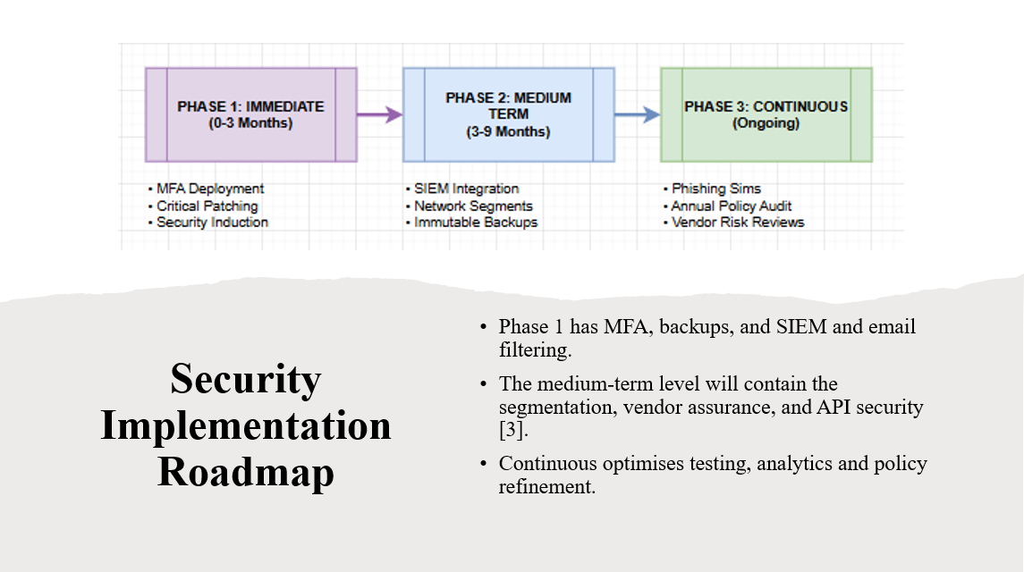

Demonstrate to the board that it is a realistic and staged implementation. Short-term measures are aimed at resolving ransomware and credential threats, short-term measures are aimed at making the architecture more robust, and ongoing measures are aimed at reaching maturity. This roadmap enables the decision making of budgets and demonstrates realistic development of governance instead of a single control implementation.

Slide 8
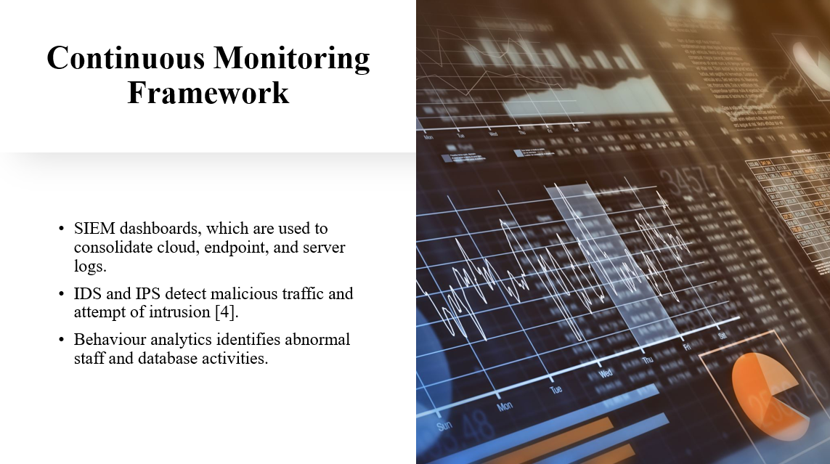

Define proactive defence as one founded on monitoring. Dashboards provide visibility, intrusion systems identify malicious traffic and behaviour analytics identify insider threats in latent forms. Focus on the fact that real-time monitoring saves time attackers spend in the system and helps to develop evidence-based reporting on governance to management and auditors.

Slide 9
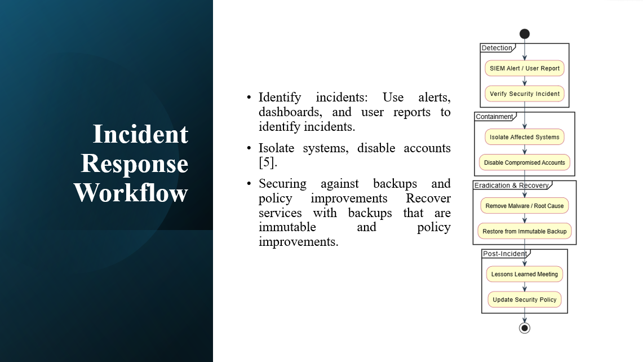

This is the incident response flowchart that is uploaded. Follow the lessons learned / detection to lessons learned lifecycle. Highlight that speed of recovery is the most important in the healthcare sector, where downtimes affect operations in hospitals. The after-incident assessment ensures that all events build the governance, training, and resilience capacity in future.

Slide 10
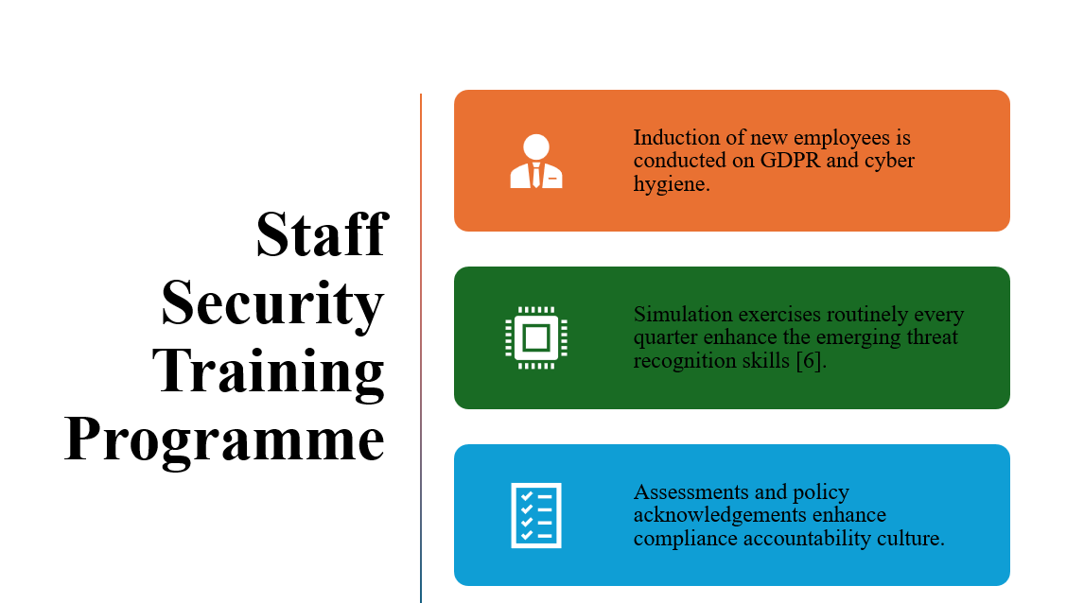

Apply the circular training cycle image on this slide. Demand the significance of the first risk and first defence tier, which is personnel. On-the-job training, simulation, testing, and retraining help to improve behaviour, phishing suicides, and inculcate a sense of long-term responsibility in medical, analytics and IT units.

Slide 11
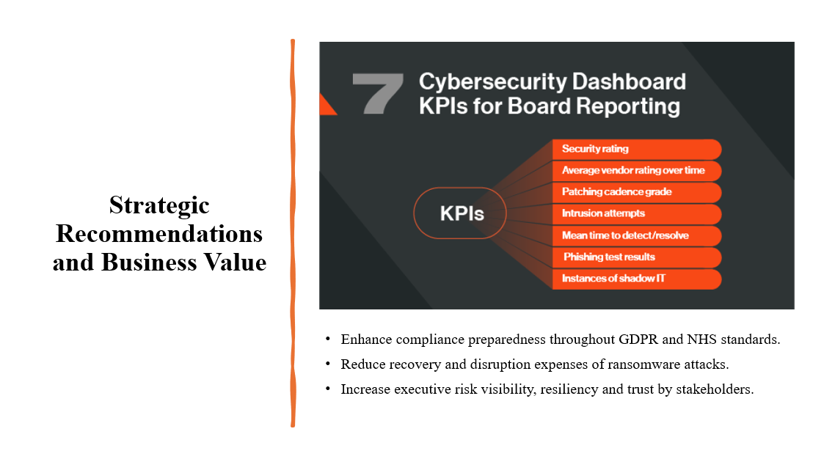

In close relation to business results rather than technical controls. Concentrate on measurable value: lower breach risk, less recovery time, and improved compliance defensibility and increased patient confidence. Cybersecurity as a board-level resiliency investment to defend reputation, health care partners, and sustainable digital growth.

Slide 12
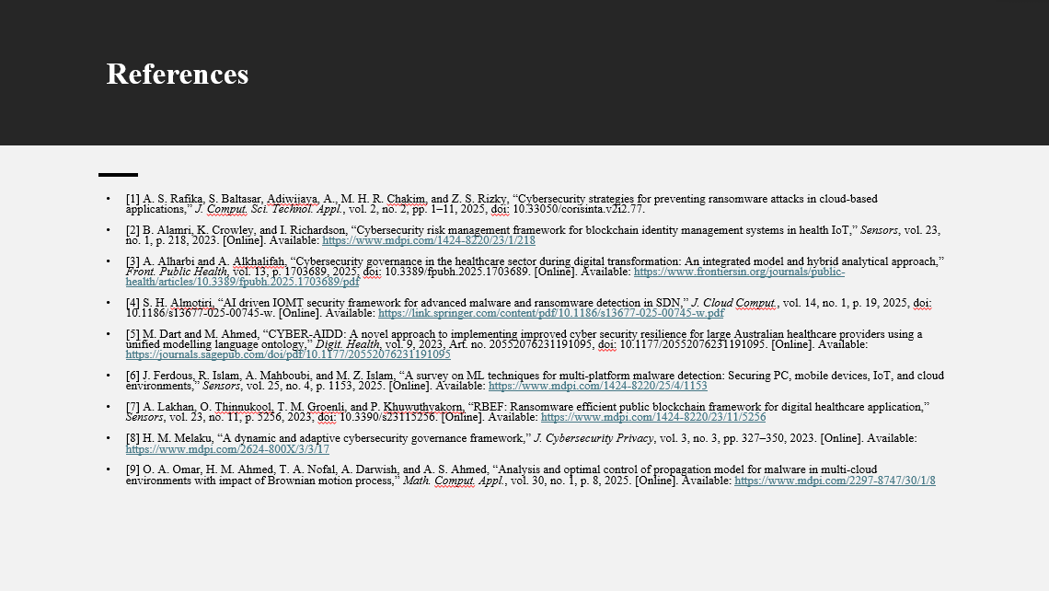

Slide 13


