Coursework 2
Project Planning for Construction

Student Number: 1808474

Submitted in part fulfilment for the requirements of the module ‘Project Planning’ (ACBA 5001) for the completion of a HND In Civil Engineering at UWTSD.

Introduction
A university has been built in Swansea and student accommodation needs to be built in the nearby. Due to concerns from a previous project and complaints from students over the quality of the building, our aim is to help re-assure the client over the management of the project by highlighting the management and quality management procedure.
The management procedure will outline how a site manager will lead and manage the various parties that are involved within the project. A flow chart will be produced to outline the communication required within a traditional procurement approach. The quality management procedure will describe a system that will focus in on how to improve overall satisfaction of the client and to alleviate any problems that may have arisen if not for these procedures. This essay will highlight the documents generated from the quality management system, the people involved, a process map, the procedure for quality assurance for suitable quality standards and a chart showing the after-sales procedure.
Management Procedure
It is suggested that a traditional procurement approach should be used, it is the most common procurement method used within the construction industry (FutureLearn, 2021). This method will provide the client with the most control over the project. This traditional procurement route means that the design and construction phases are separate it should be noted that through this method the client takes on most of the risk (Oyegoke et al., 2009). The main reason for this method is to have control of the design and contract is to ensure a high level of quality at all times. The design will be finalised before contractors even see a tender for the build and it essentially means the client knows what they are getting (Pro, 2021). Typically cost will also be known at the start of the project which means the client to have certainty of the project in its entirety. Figure 1 below shows a flow chart of a traditional procurement method.

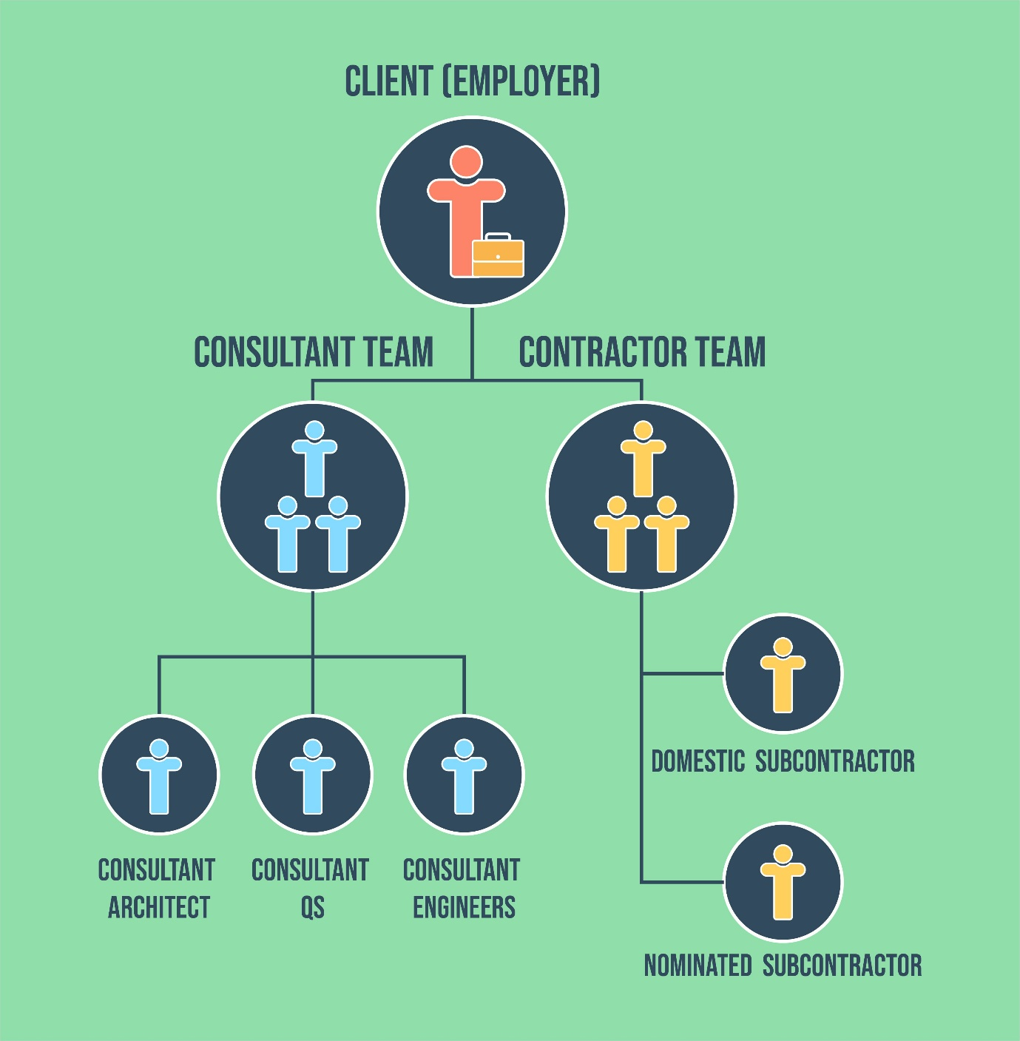
Figure 1
Figure 1 – Traditional procurement route (FutureLearn, 2021)

The client will engage with separate parties for the key project activities, they will have control of the consultant team made up of the architect, quantity surveyor and engineers who’s job it is to design, cost and advise on the project before construction even begins. The client will go to the architect and they will design as per the clients brief, during this stage the QS will provide advice to the architect regarding costs and generate a Bill of Quantities (BoQ), engineers will also advise on the build.

Upon completion of the design element of the traditional procurement method the client can then prepare the project for tender and formally invite contractors to ‘let the tender’ (Designingbuildings.co.uk, 2021) The contractor team will only be in-charge of the construction works, if required the contractor will also hire a sub-contractor to undertake or assist in specialist work.
Traditionally, the tender is based upon cost so in theory lowest price wins, however, this is where the PQQ becomes very important it is a starting point for making the contractor aware of the quality requirements that a client has outlined within their design. Within a tender you typically have a quality section that needs to be completed it will help the client to decide what is most important to them either cost, time or quality/scope with health and safety being a primary factor to maintain at all times this is commonly referred to as the ‘iron triangle’ seen in figure 2 below. An advantage to this traditional method is that all tenderers will produce a tender based on the same information (FutureLearn, 2021).
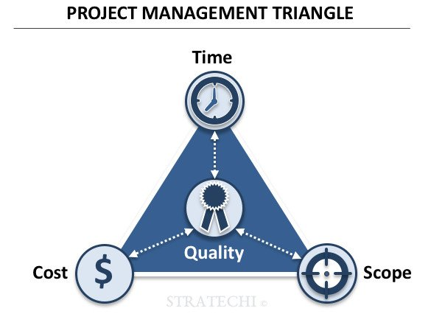
Figure 2 – Shows the iron/project management triangle (stratechi, 2021).
Figure 2

The client will need to decide with the project manager which is most important of the 3 elements. A collaboration of all 3 is the desired route however this balanced is not always assured (Prince2.com. 2021). Typically, with the traditional procurement route the time is longer as you have to go to an architect first then the contractor, there is also generally a higher quality element due to the higher number of steps to achieve the end result. The client however does take on the most risk and if changes occur the contractor can claim for this. Good communication between clients, contractors and the consultant team are therefore very important.
There are various lines of communication that are key for the client Figure 3 highlights a communication flowchart relevant for this project

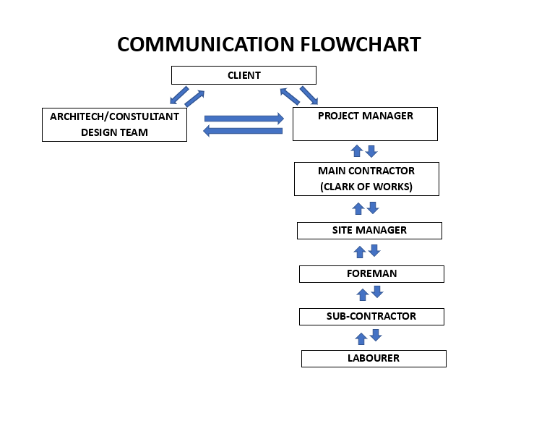Communication is essential to achieve the desired result of the build from start to finish, as a site/project manager there are various parties to manage to have positive collaboration and result for the client. This is achieved by having clear lines of communication i.e. the chain of command. Initially the lines of communication are between the client and the architect and vice versa until a contractor is put in place and lines of communication become more apparent. As a project manager all lines of communication ultimately lead to them and the then the client. The contractor is responsible for any sub-contractors and communicates to them what they must do.
Figure 3 – Communication flow chart highlighting the forms of communication between parties.
Figure 3
Appropriate methods of communication will be used depending on the role and their requirements. This may be via written correspondence i.e. emails, drawings, texting etc typically architects will communicate via drawings and/or emails and the client will provide a brief initially then subsequently communicate back either via email. The client will then communicate with the project manager by email, phone, text, or video and vice versa. Written communication may come in the form of reports, circulars, notices, diaries, and records. The contractor will have a clerk of works that will provide weekly reports to the project manager. The main contractor and sub-contractor(s) and can communicate on site via signals, signs, drawings, photos, and verbal meetings. It is essential that all parties use BIM (Building Information Modelling) to create and manage digital information about the built asset to keep all shared information uniform (Desiginingbuildings.co.uk, 2021). It is essential to be clear and concise and avoid jargon or vague terms that may be unclear. These clear methods of communication will help manage the build effectively to ensure the overall project is delivered on time. Records that need to be kept are as follows site diaries, site reports, material requisitions, allocation sheets, daywork sheets, site instructions (task orders), drawing registers, accident reports, health and safety files, drawing register and quality assurance inspection sheets that will aid in communication.
Quality Management Procedure
The quality management system (QMS) will focus on client satisfaction and continuous improvement that is progressive in nature to resolve issues on an ad-hoc basis. This QMS will be based on ISO 9001; 2015 (ISO, 2015). It will use ISO 9001 to help maintain and develop processes that are needed to produce a build/construction of high quality at a competitive cost.
The QMS mandatory documents outlined in ISO 9001:2015 are a Quality Manual, Quality Objectives, Quality Policies and Quality Records. Having a quality manual will describe our QMS it will include our scope and how we will manage the project to ensure that all works are reviewed and tracked and that records are kept and implemented.
The quality manual will include our brief of our expectations for the client highlighting the need for clear management over the project especially with the QM and QA to ensure maximum satisfaction for the client. We will demonstrate our ability to conform to ISO 9001:2016, it will also include our organisational responsibilities, roles and authorities will be assigned communicate and understood and also a starting point for auditors, this will provide the client everything they need to know about the company (isoconsultantkuwait.com, 2018)
Our quality procedures will include a ‘say what you do, do what you say’ principle. The procedures will show and explain exactly what is required to be done and how it will be done to reach a required output. This means that we will have a quality manual, a procedure for a control of any documents, control of how we record these documents, procedure for auditing and any non-conformities and how to prevent and correct in the future (Abuhav, 2014).
Another document that will be maintained, recorded, and updated will be our work instructions any activity within a process will have detailed descriptions on how to perform and subsequently record said task. We will also have a procedure to ensure quality records so that equipment maintenance/testing, any work that is carried out, and implement these records as part of a BIM system to the client’s standards. This system will be accessible, and all documents will readily available for ease of service. This procedure will be controlled and followed for all documents, thus being a crucial factor for audit to limit compliance issues and reduce costly resources if problems occur. Each of these elements help the QMS to achieve certain goals and should meet the clients requirements, the client will advise on any unique needs not highlighted above.
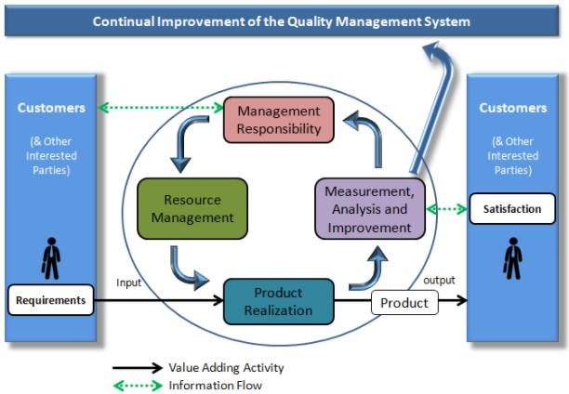
We will use a plan-do-check-act (PDCA) cycle (asq.org, 2021), this can be seen in figure 4 to consistently improve throughout the project. It is a process map that allows us to plan what we are going to do, how we are going to carry it out, how we will monitor the work and has it worked/successful and is the client happy and how we may improve going forward, as it is cyclic and has a feedback loop which will be utilised.
Figure 4

Figure 4 – Continual improvement of QMS for our project to help achieve client satisfaction. (Greycampus, 2021).

To improve quality standards within construction we need to identify our quality assurance (QA) for quality control in the project, this will be to British standard 5750 ensuring that there is a prevention of non-conformities (ISO, 2015). The most important QA will be to have a quality checklist it will help track what is happening, when it is happening and any observations, these checklists will help assure and clarify what the client is getting. One of the systems that will be implemented for quality management procedure is a clerk of works on site (monitoring work) and he can be responsible for a feedback loop to the client.
There is an essential need for quality through the supply chain, a definition of materials and work units such as CE markings, agrement certificates, responsible sourcing of materials and records of delivery, labelling and storage. Certain standards will be met when constructing for example using concretes testing will be done i.e. slump test, cube test etc. for the ground a CBR test will be done to ensure the load bearing is suitable. These tests combined with inspections will help to dictate responses.
To plan for production quality control records will be maintained such as checking-lists and as-built records. Partial and final acceptance reports will help to carryout production control, areas of inspection any changes that are made and finally the acceptance of work. Site inspections and visits will be recorded and any meetings regarding the project will also be recorded, site diaries and photo reports will be kept. Instructions given by the client and architect will also be kept with plans and schemes updated regularly in BIM to the most up to date records for plans and schemes as well as as-built records, this will ensure an easy handover for the client to the facilities management.
Figure 5 shows a flow chart that will describe the after-sales procedure for the client. The handover stage will consist of the below. The defect period is 12 months after handover however if there are any latent defects the contractor will ‘make right’ any issues relating to these matters.
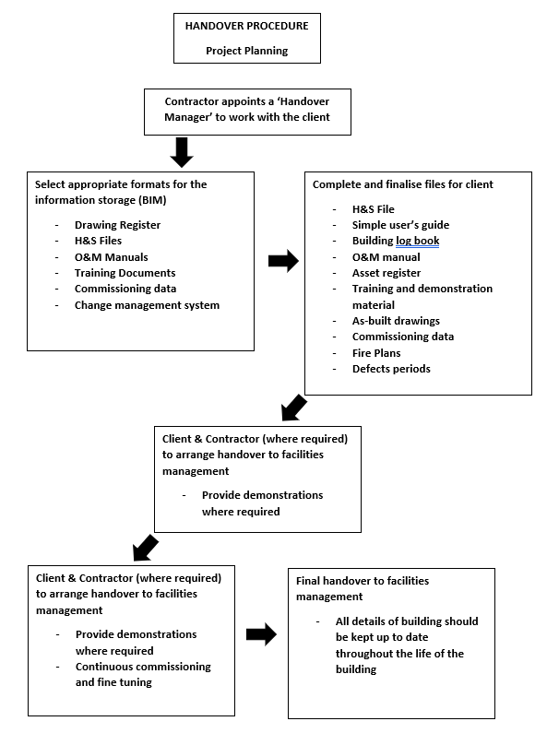
Figure 5

Conclusion
Overall, it is suggested that a traditional procurement method would be the most advantageous and suitable method of procurement. As the client has already designed the project and there is cost assurance already, through methods outlined above specifically for quality management and assurance it should help alleviate any outstanding concerns for students and staff regarding the quality of the building when in use.
Through strong lines of communication the site manager can lead various parties on site to ensure a consistent and high quality build, combining this with the quality management procedures such as the PDCA cycle will help to reduce and solve problems progressively throughout the project. Quality assurance can also be achieved through quality records, work instructions, quality procedures and a quality manual to allow a smooth transition for the client to the facilities management and the end users (staff and students).
It is also important to ultimately improve the quality of flow of information within the aftersales via BIM models, Cloud systems, soft landing concepts that are being derived by the government to improve the handover experience for the client. This information should have helped the client to develop the pre-quality questionnaire for whichever contractor they ultimately choose.

Word Count : 2170

References

Abuhav, I., 2014. Quality Procedures According To The ISO 9001 Standard Requirements. [online] ISO 9001 – Quality management knowledge center. Available at: <http://9001quality.com/quality-procedures-iso-9001-standard/#:~:text=Quality%20procedures%20include%3A%20quality%20manual,corrective%20action%20and%20preventive%20action> [Accessed 11 January 2021].

Designingbuildings.co.uk. 2021. Building Information Modelling BIM. [online] Available at: <https://www.designingbuildings.co.uk/wiki/Building_information_modelling_BIM> [Accessed 13 January 2021].

Designingbuildings.co.uk. 2021. Tender Documentation For Construction Projects. [online] Available at: <https://www.designingbuildings.co.uk/wiki/Tender_documentation_for_construction_projects#:~:text=A%20tender%20is%20a%20submission,to%20an%20invitation%20to%20tender.&text=Tender%20documents%20are%20prepared%20to,demolition%2C%20enabling%20works%2C%20etc.> [Accessed 9 January 2021].

Greycampus.com. 2021. Greycampus. [online] Available at: <https://www.greycampus.com/blog/quality-management/steps-for-implementing-a-quality-management-system-the-successful-way> [Accessed 7 January 2021].

ISO Consultant in Kuwait. 2021. ISO 9001:2015 Quality Manual. [online] Available at: <https://isoconsultantkuwait.com/2018/11/15/iso-90012015-quality-manual/#:~:text=A%20quality%20manual%20is%20a,your%20customers'%20and%20ISO's%20requirements> [Accessed 11 January 2021].

International Organization for Standardization. (2015). ISO 9001:2015 Quality Management Systems

Oyegoke, A., Dickinson, M., Khalfan, M., McDermott, P. and Rowlinson, S., 2009. Construction project procurement routes: an in‐depth critique. International Journal of Managing Projects in Business, 2(3), pp.338-354.

Asq.org. 2021. PDCA Cycle - What Is The Plan-Do-Check-Act Cycle? | ASQ. [online] Available at: <https://asq.org/quality-resources/pdca-cycle> [Accessed 9 January 2021].

Pro, M., 2021. The 3 Procurement Methods: Advantages And Disadvantages. [online] Property Like a Pro. Available at: <https://propertylikeapro.com/procurement-methods/> [Accessed 10 January 2021].

Prince2.com. 2021. Project Management Triangle: A Triple Constraints Overview | UK. [online] Available at: <https://www.prince2.com/uk/blog/project-triangle-constraints> [Accessed 12 January 2021].

stratechi, 2021. Project Management Triangle. [image] Available at: <https://www.stratechi.com/wp-content/uploads/2018/03/Stratechi-Project-Management-Triangle-Quality-Time-Cost-Scope.jpg> [Accessed 10 January 2021].

FutureLearn.2021. Traditional Procurement. [online] Available at: <https://www.futurelearn.com/info/courses/contract-management-and-procurement/0/steps/75144> [Accessed 15 January 2021].

