
Operating System
Module Name: Computer Architecture and Operating
Module Code: ACCA4022
Student Name: Farzana Khan
Student ID: 2508956
Lecturer Name: Dr. Md Shantanu Islam

Submission date: 20 Mar. 26

Contents
Introduction 4
Key functions of general Operating Systems 4
Task Management: 4
Application/Program Management: 5
File/Directory Management: 6
Device Management: 6
Security Management: 7
Example 1: 8
Example 3: 9
Example 4: 9
Example 5: 9
Example 6: 10
Example 7: 10
Example 8: 11
Example 9: 11
Example 10: 12
Example 1: 12
Example 2: 13
Example 3: 13
Example 4: 14
Example 5: 14
Example 6: 15
Example 7: 15
Example 8: 16
Example 9: 16
Example 10: 17
Use of Windows OS scripts 17
Example 1: 18
Example 2: 19
Use of Linux OS scripts 20
Example 1: 20
Example 2: 21
Conclusion 23
References 24

Introduction
An Operating system (OS) is an important software that manages the computer’s hardware and software. It works as a bridge between the user and the computer system. The operating system controls tasks such as running programs, managing files, handling memory, and controlling devices like printers and keyboards. Two popular operating systems are Microsoft Windows and Linux. Both Windows and Linux also support scripting, which helps automate tasks. Windows uses scripting tools such as batch files. Linux commonly uses shell scripts like Bash. These scripts help users perform repeated tasks quickly and efficiently. Therefore, operating systems and scripting tools are essential for managing and improving computer system performance.

Key functions of general Operating Systems
Microsoft Windows is a graphical user interface (GUI)-based operating system developed by Microsoft Corporation. It was first introduced in 1985 and has since become one of the most widely used operating systems globally [1], dominating both personal and enterprise computing environments. The operating system also performs file management, organises and sorts files so users can easily access them. The operating system also supports networking, allowing computers to connect and share data over networks or the internet. System performance monitoring tracks how well the computer is working and helps improve efficiency. The operating system manages software installation and updates, and makes sure programs run properly and securely [2].

Task Management:
The Task Manager shows you what programs are running on your Windows computer and offers some limited control over those running tasks. For an advanced tool that can perform an incredible number of tasks, the Windows Task Manager is often used for something very basic: checking what is currently running. Effective task management helps individuals and teams stay organised, reduce stress, and improve productivity. Common techniques include creating to do list, using a calendar, and applying methods such as prioritisation and time blocking. Digital tools and apps can also assist in managing tasks and collaboration. By breaking large projects into smaller, manageable steps, task management ensures work is completed on time and with better quality [3].

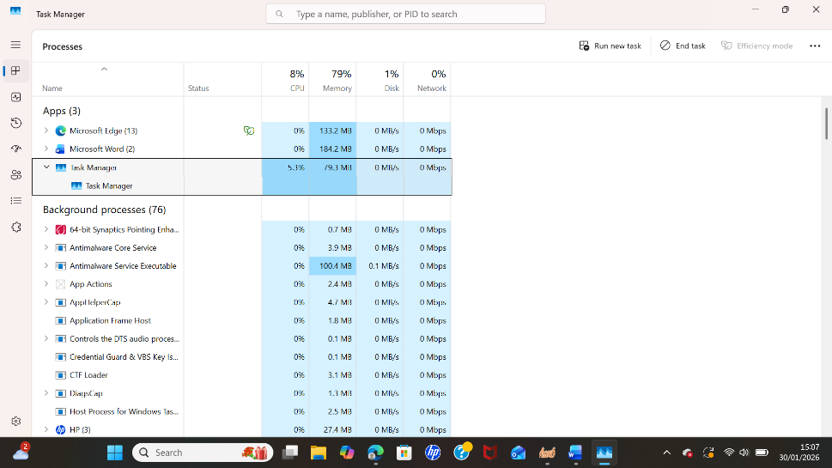
Figure 1: Task Manager

Application/Program Management:
Application management is the comprehensive process of managing, maintaining and supporting software applications throughout their lifecycle. This encompasses tasks such as installation, updating, patching, upgrading and overseeing both the software and hardware components necessary for application operation. Often referred to as AM, application management integrates various services, processes and methodologies to ensure the efficient management, maintenance and enhancement of custom, packaged or network-delivered business applications. The process often incorporates the use of specialised tools and methodologies to streamline and automate various aspects of application management. Application management teams collaborate closely with various stakeholders, including developers, testers and business units to ensure that the applications meet organisational objectives and user requirements. They monitor application performance, identify and resolve any bugs or issues, implement necessary updates and security measures and provide ongoing support to users [4].

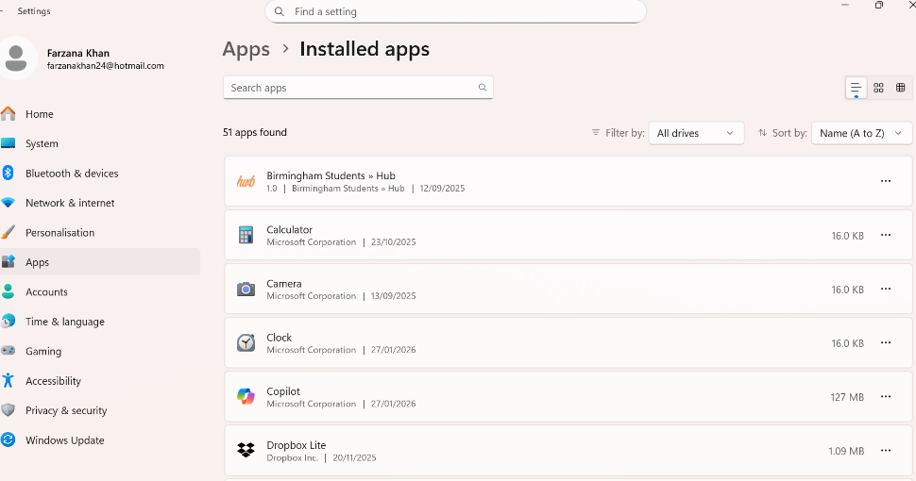
Figure 2: Description of Programmer Manger

File/Directory Management:
File Director Management refers to the systematic process of organising, storing, maintaining and controlling files and folders within a computer system or network so that information can be easily accessed, protected and managed efficiently [5]. It shows that file directory management is about structure and order. Computers store vast amounts of data, documents, images, software files, databases, and system resources. Without proper organisation, files become difficult to locate, are unnecessarily duplicated, or are even corrupted. File directory management provides a logical framework that keeps data usable and secure. One of the primary goals of file directory management is efficient access. Well-organised directories reduce the time needed to find files and improve productivity.

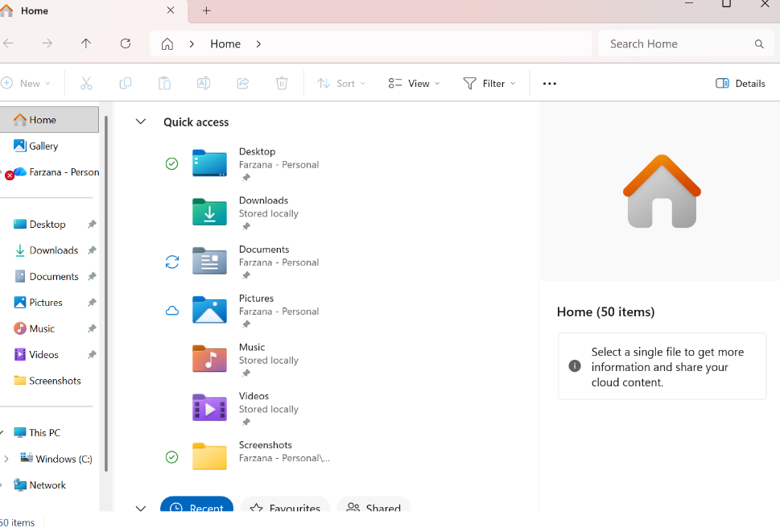
Figure 3: Description: Window Explorer

Device Management:
Device management enables organisations to administer and maintain devices, including virtual machines, physical computers, mobile devices, and IoT devices. Device management is a critical component of any organisation's security strategy. It helps admins ensure that devices are secure, up-to-date, and compliant with organisational policies, to protect the corporate network and data from unauthorised access. As organisations support remote and hybrid workforces, it's more important than ever to have a solid device management strategy. Organisations must protect and secure their resources and data on any device. Many organisations use on-premises Configuration Manager to manage devices, including desktops and servers [6].
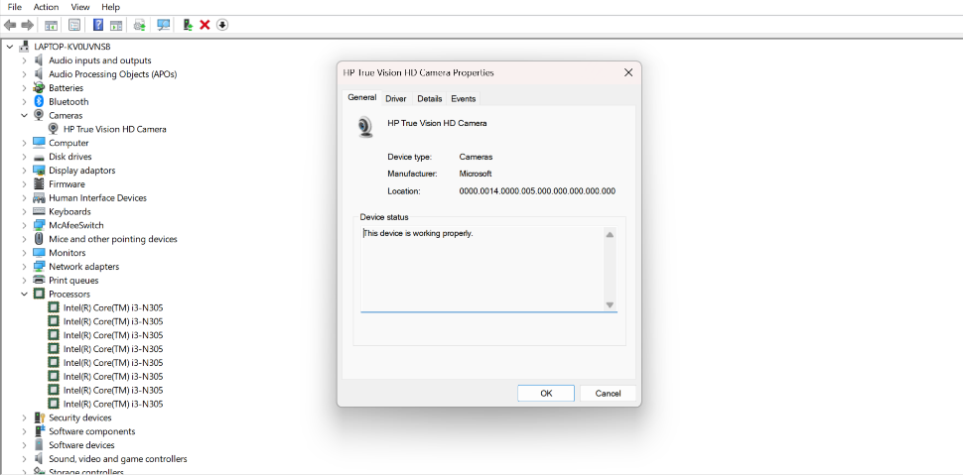
Figure 4: Description Management Device

Security Management:
Security management is the structured approach to protecting an organisation’s people, physical assets, and digital infrastructure. It includes developing policies, setting procedures, and using technology to identify and reduce risks. From managing physical access to safeguarding sensitive data, security management supports business continuity by reducing the impact of internal errors and external threats. Security management focuses on anticipating risks before they become serious issues. This includes implementing access controls, educating employees, monitoring systems, and preparing for emergencies [7]. Many organisations rely on security management systems that combine physical and digital protections. These systems define how to handle security incidents, outline policies for data access, and ensure compliance with industry standards. Security management helps build an organisation-wide awareness of potential threats while setting expectations for behaviour and response.

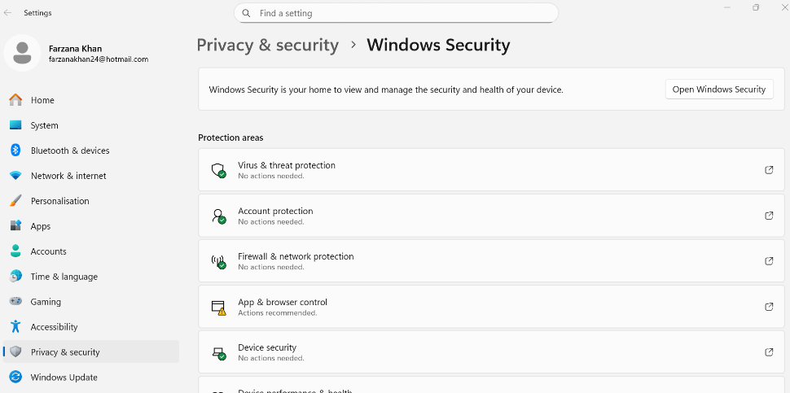
Figure 5: Description: window Security
Windows OS CLI (command line interface) commands are used to interact with the Windows operating system by typing text commands instead of using the mouse [8]. Window CLI commands are used to control, manage and troubleshoot the Windows operating system using text-based instructions [9].

Example 1:
Dir command is used in Windows to list all files and folders in the current directory. It shows the names, sizes and dates of files and folders.

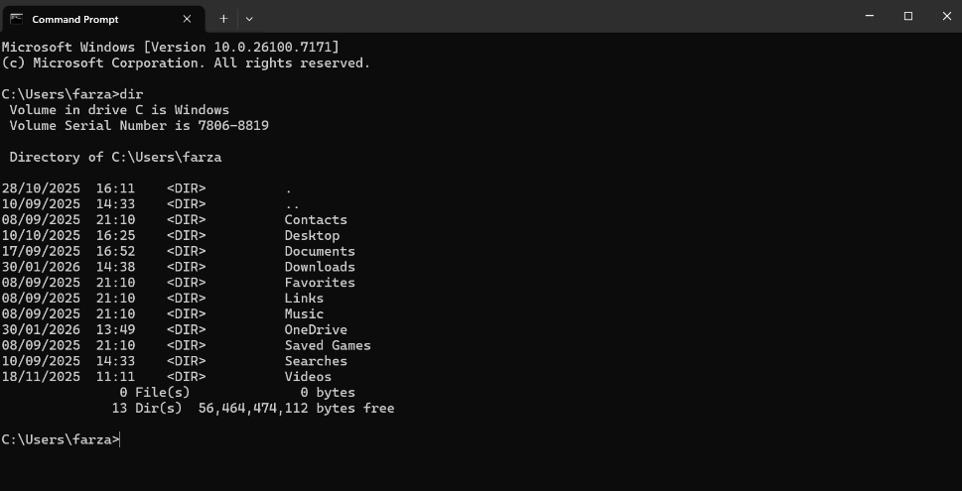

Figure 6: Description: dir
The Command Prompt in Windows is a program that lets you talk to your computer by typing commands instead of clicking the mouse. You can use this command to see open files and open folders.
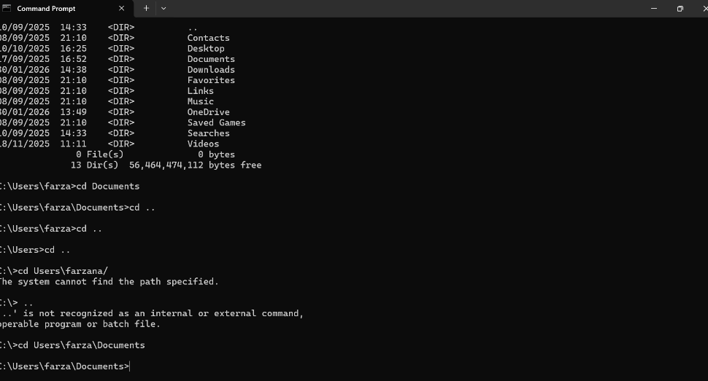
Figure 7: Description Command Prompt

Example 3:
This command is used in Windows to create a new folder. It stands for make director. You can also create folders inside another folder. It creates only empty folders.

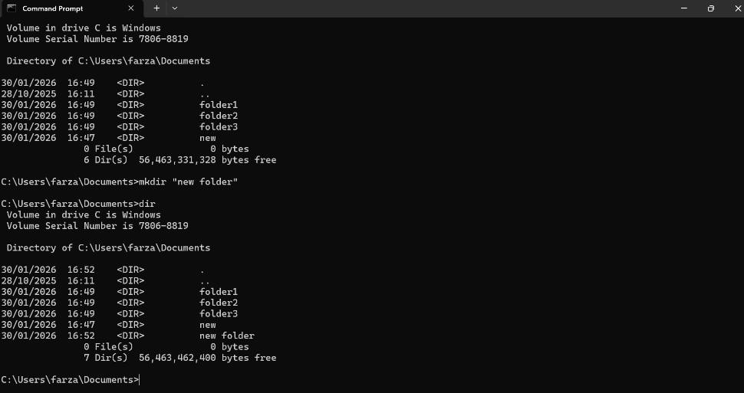
Figure 8: Description mkdir

Example 4:
The rmdir command stands for remove the directory. To use it, open the command and type rmdir followed by the folder name.
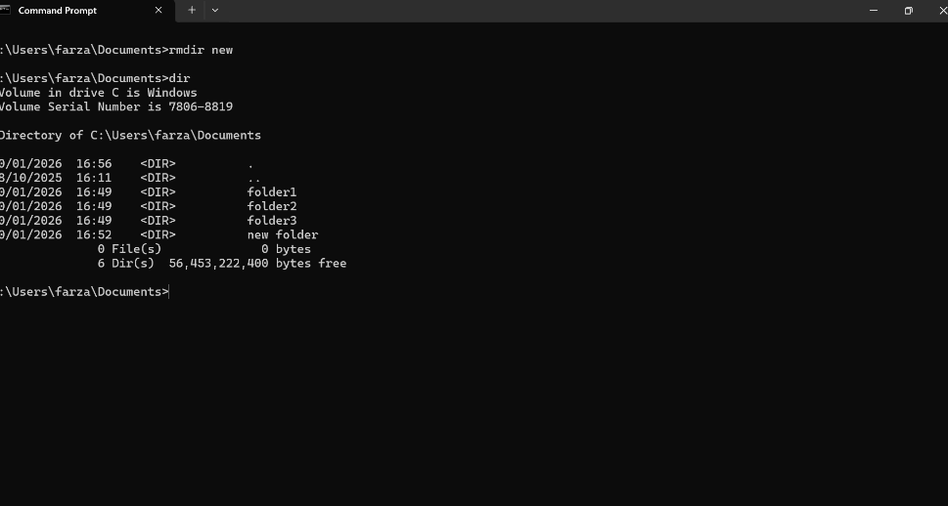
Figure 9: Description rmdir

Example 5:
Echo command in Windows is used to show/display text on the screen. Mostly, it is used to print a message. For example, if you type echo Hello, it will display Hello on the screen.
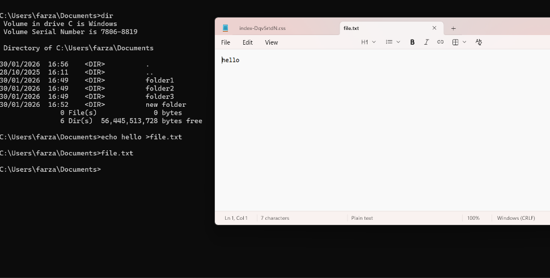
Figure 10: echo

Example 6:
In Windows, txt stands for text and represents a plain text file. You can open .txt files using programmes like Notepad or WordPad. They are very simple and easy to edit.
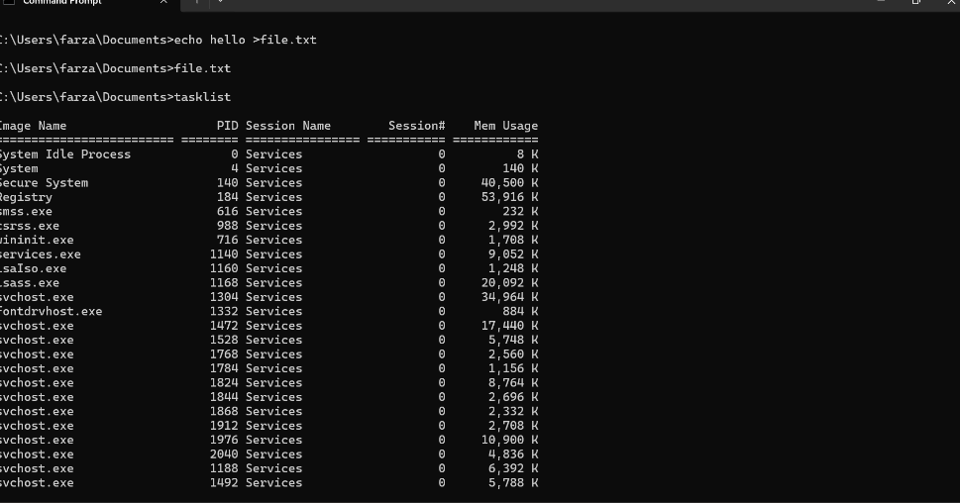
Figure 11: Description txt

Example 7:
System Info in Windows shows all important information about your computer. It tells you about the hardware, software and system settings.
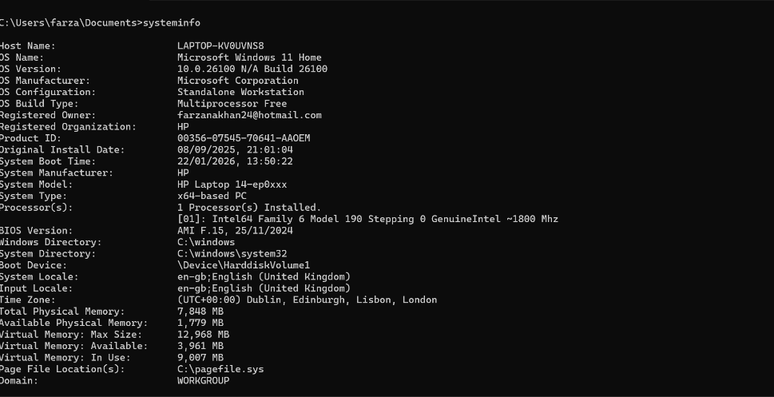
Figure 12: Description system info

Example 8:
The ipconfig command in Windows is used to show network information about your computer. To open the command and type ipconfig /all, then press enter. Windows will display all network information.
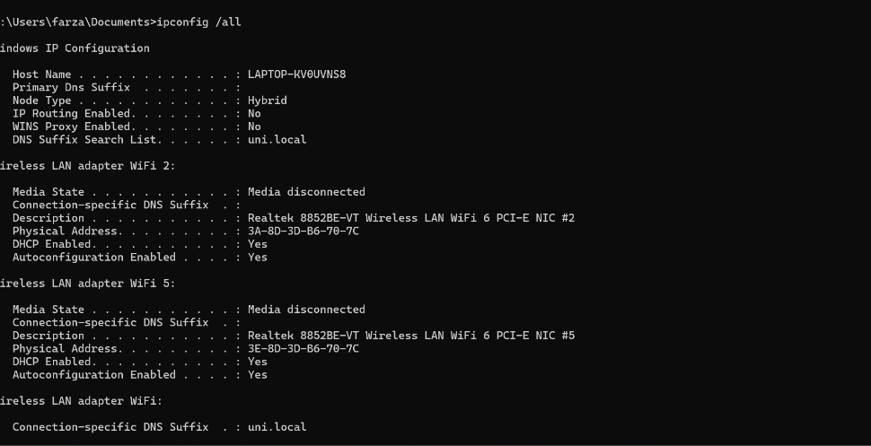
Figure 13: Description ipconfig

Example 9:
The Ping Command in Windows is used to check the internet on your computer by typing www.google.com, then press enter.
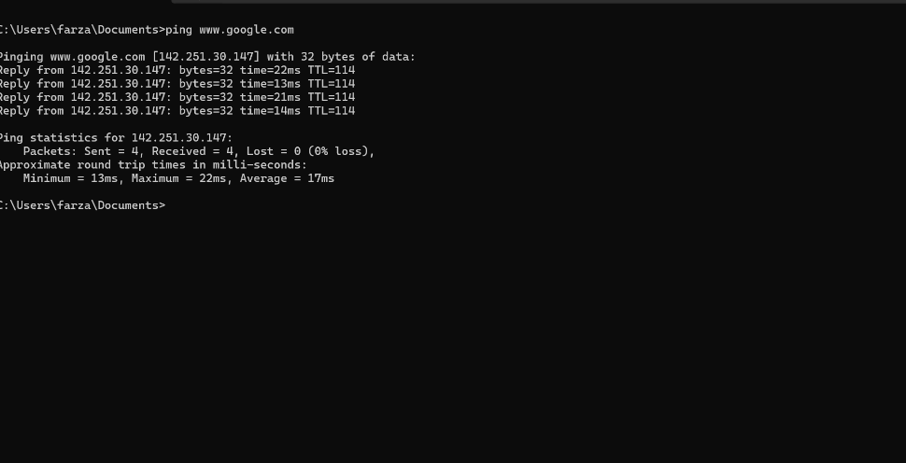
Figure 14: Description ping

Example 10:
This netstat command is a test for internet checking. This tells you every activity of internet, like how many people are working/connecting now. What type of connection do they use?
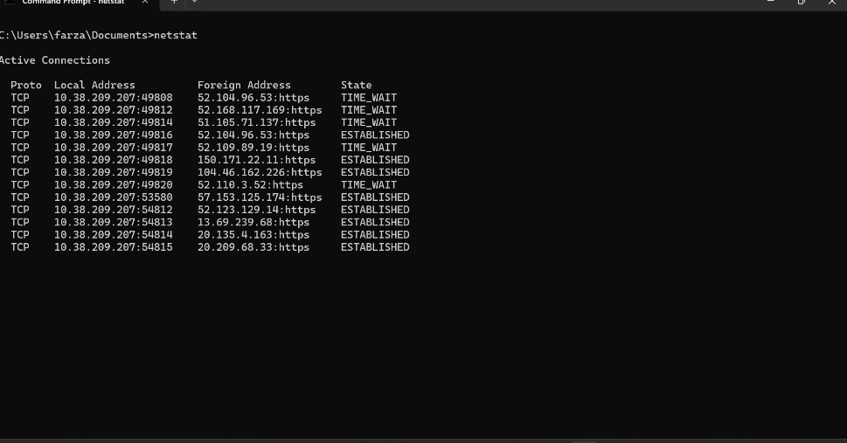
Figure 15: Description netstat

An OS CLI (Operating System Command Line Interface) command is a text-based instruction entered into a terminal or command prompt to interact directly with an operating system [10]. Instead of using a graphical interface with icons and a menu, users type commands to perform tasks [11].

Example 1:
Su Command stand for “substitute user” and is used by a computer user. In this command password is not shown on the screen; it hides the password, because of safety features. This account gives full control to the user. After that tried to log in to the user account as shown in the screenshot.
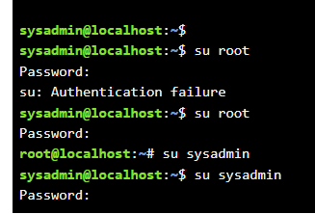
Figure 16: su

Example 2:
To another command, clear the screen by typing “clear”. This command is “pwd” stand for print working directory. Pwd command does not change anything on the computer. It only shows information.
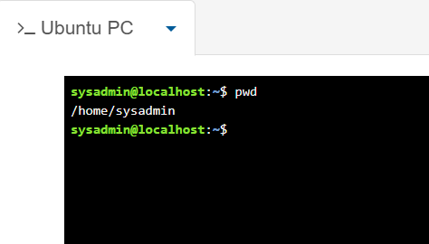
Figure 17: Description pwd

Example 3:
Ls command is used to list files. It is a colour-coded command. For example, folders are in sky blue colour, files will be in white colour, and if you have any application, it will be showing bright green colour. This command shows what you have (all files, even hidden files).
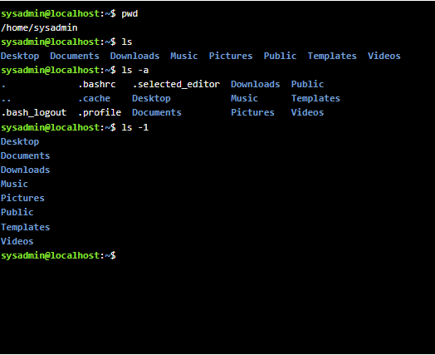
Figure 18: Description ls

Example 4:
The cd commands stand for change directory/location. Write cd Desktop. Desktop (D) should be capital otherwise; this command will not work.
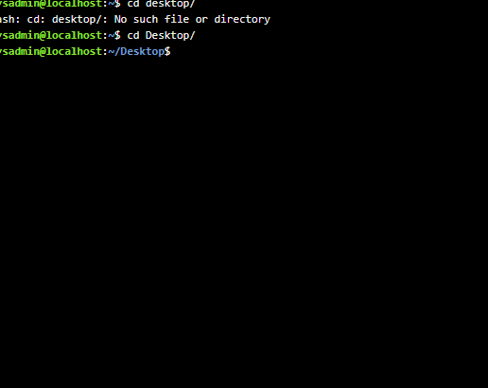
Figure 19: Description cd

Example 5:
The mkdir (make directory). It is used to create a new folder. You can create many folders at once by writing several names after the command.
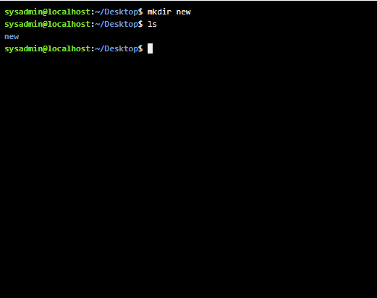
Figure 20: Description mkdir

Example 6:
Rmdir command is used for removing a directory. It is used to delete empty folders. The folder must be empty. If the directory still has files inside, this command shows an error.
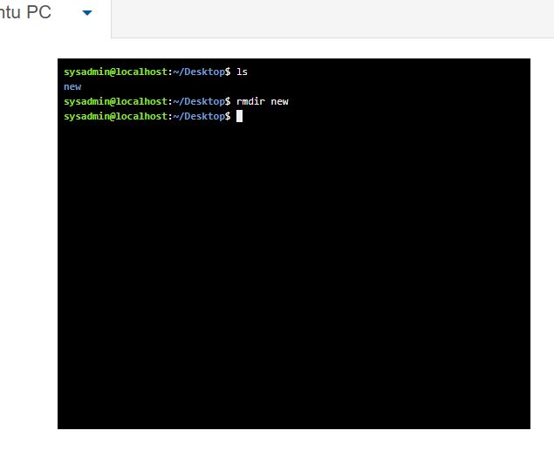
Figure 21: Description rmdir

Example 7:
The touch command is used to create a new empty folder. When you type touch files. Text, Linux creates a file named file. Text in the current folder is in white.
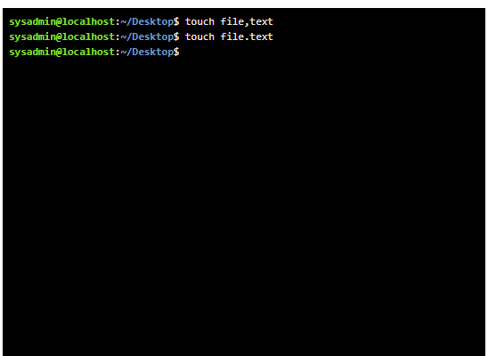
Figure 22: Description touch

Example 8:
The echo cat rm three commands. Echo is used to print text on the screen. The cat command is used to read the file and print the text. Rm command to remove the file. Whatever you write in the echo cat file text, it shows whatever you write.

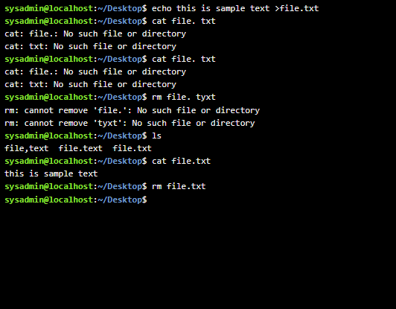
Figure 23: Description echo cat rm

Example 9:
The ifconfig command is used to view and manage networking settings. It shows the information about your network.
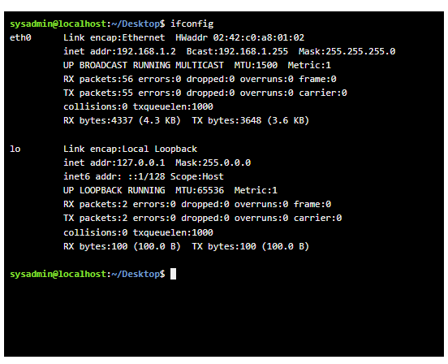
Figure 24: Description ifconfig

Example 10:
The whoami command if you want to know the username. If you want to know the date and time, type date and enter, it shows the date, time and user details.
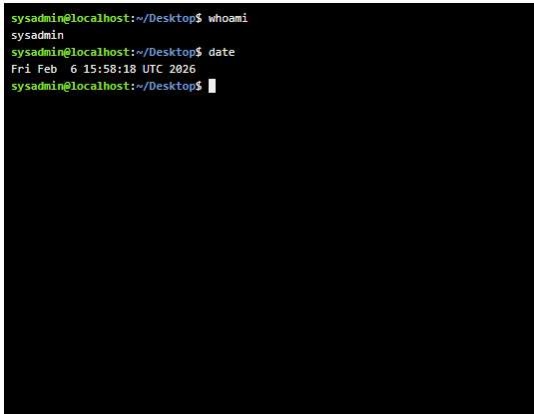
Figure 25: Description whoami date

Use of Windows OS scripts
Windows OS Scripts are plain text files containing a sequence of commands and instructions that the Windows operating system executes to automate tasks, manage system configuration and perform batch operation [12]. Instead of manually clicking through a Graphic user interface (GUI), scripts allow administrators to run complex workflows with a single click or command [13].

Example 1:
A script is a set of automated instructions. The output is the visible result of the response after those instructions are executed. Together, they allow Windows users to control and automate system tasks efficiently. In a Window, scripts can be written in different scripting languages. The most common types are Batch Script (.bat or .cmd), Powerful shell scripts run in the Command Prompt and use basic Command-line instructions. A script works by executing commands in a sequence. The operating system reads the script line by line and performs each instruction in the order it appears. For example, a script might create a folder, copy files into it, and then display a confirmation message. Each command contributes to completing the overall task defined in the script. When a script completes execution, its output appears in the following places: A message detailing the success or failure of each operation is sent to the Message tab in script windows. The time it takes to execute the script is also shown in the Messages tab.

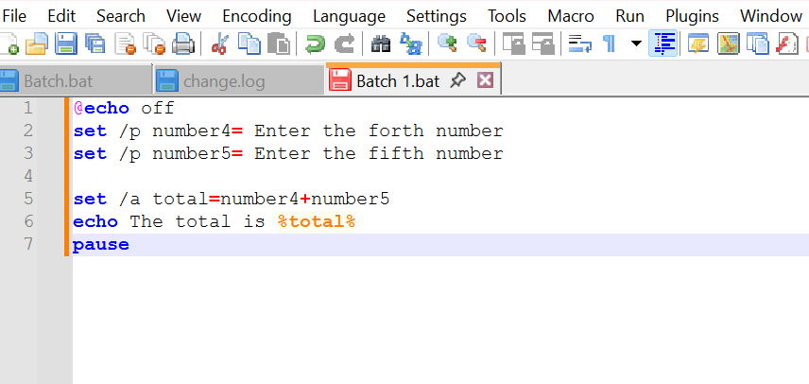
Figure 26: script
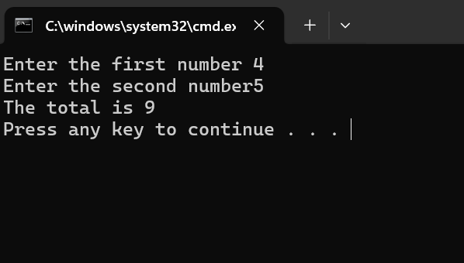
Figure 27: Description number

Example 2:
Another form of output is file output. Instead of displaying results on the screen, a script can redirect the output to a file. This is useful when generating reports or saving logs for later review. For example, a command can store system information or error logs in a text file. This allows administrators to analyse results without manually copying information from the screen. Error about output is also an important type of output. When a script encounters a problem, such as a missing file or insufficient permissions, the operating system generates an error message. These messages help users identify and fix issues in the script or system configuration. Proper error handling in the script ensures that problems are detected and reported clearly. In summary, a script is a collection of automated instructions that control system tasks, while output is the visible or recorded result of those instructions. Scripts improve productivity by automating operations, and output provides feedback about the success or failure of that operation.
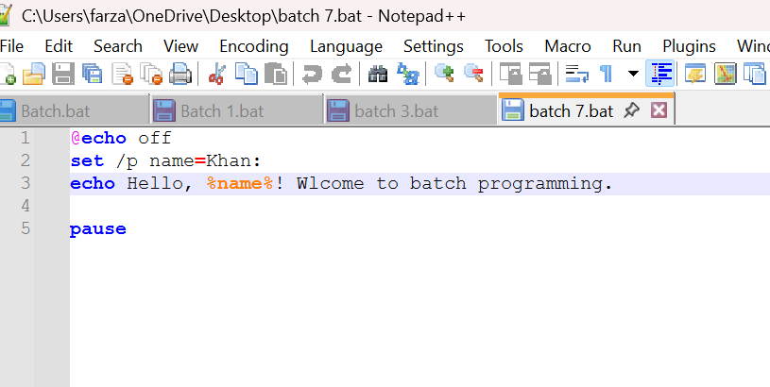
Figure 28: Description script name

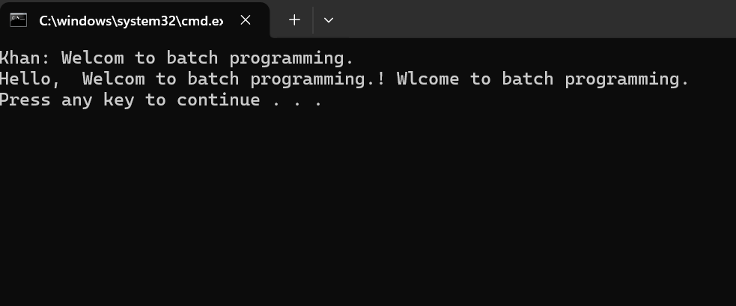

Figure 29: Description welcome

Use of Linux OS scripts
Abash script is a text file containing a sequence of Linux/Unix. Shell command executed automatically by the Bash Interpreter. It is widely used for task automations, system, admission, [14] file management, backup, and deployment workflows. Bash scripts save time, reduce human error, and enable repeatable processes [15].

Example 1:
This example is a script add two numbers. This is useful for beginners because it shows how to take input from the user, perform a calculation, and display the result. First, the script asks the user to enter two numbers. This is done using the read command in Bash. The read command stores the numbers in variables. Variables are names used to store values in a program. For example, the first number may be stored in a variable called num1, and the second number is num2. Next, the scripts perform the addition. Bash can do arithmetic using $ (()) expression. Inside this expression, the two variables are added together. The result is stored in another variable, often called sum. Finally, the script prints the result on the screen. In this example, the user enters 345 and 234 numbers. The script calculates the numbers and displays “The total is 579”
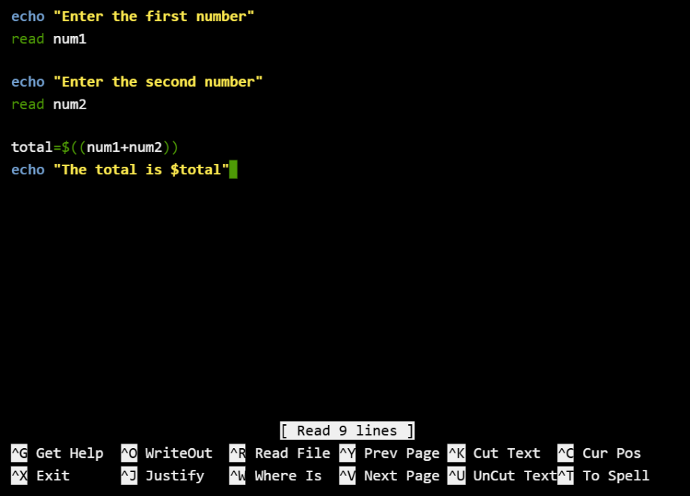
Figure 30: Description Bash script to add two numbers

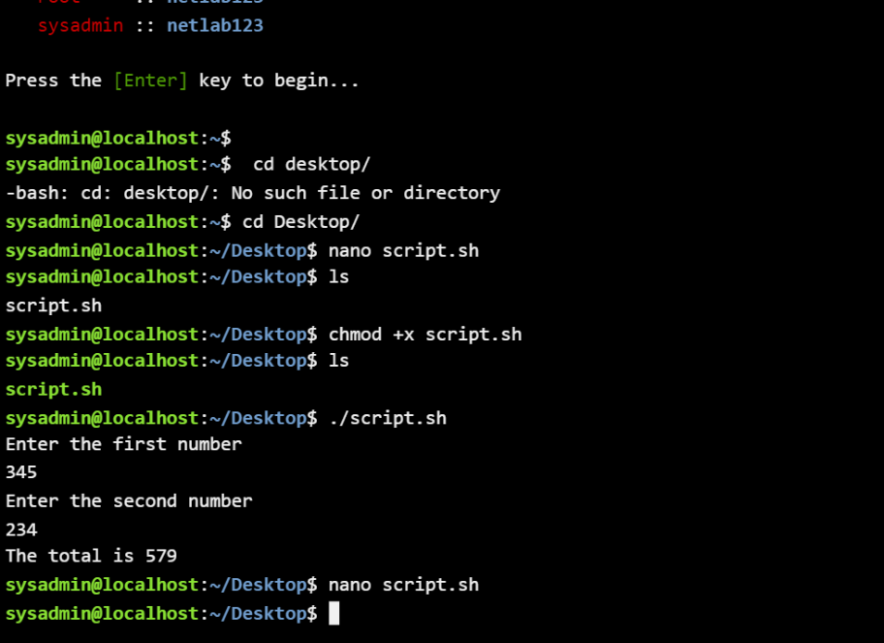
Figure 31: Output of script in fig 30

Example 2:
In Bash, a for loop is used to repeat a command or a group of commands many times. It is useful when you want to do the same task again with different values. Instead of writing the same command many times, a for loop does the work automatically. A for loop works with a list of items such as numbers, words, or file names. The loop takes one item from the list each time and runs the commands inside the loop. This continues until all items in this list are used. Variable stores the current value from the list. The list can be numbers or names, like file 1, file 2. The do keywords tell Bash that the loop commands are starting, and done shows where the loop ends. In this example, if the list is: for((i=1; i<=10; i=i+1)) enter do echo”si”

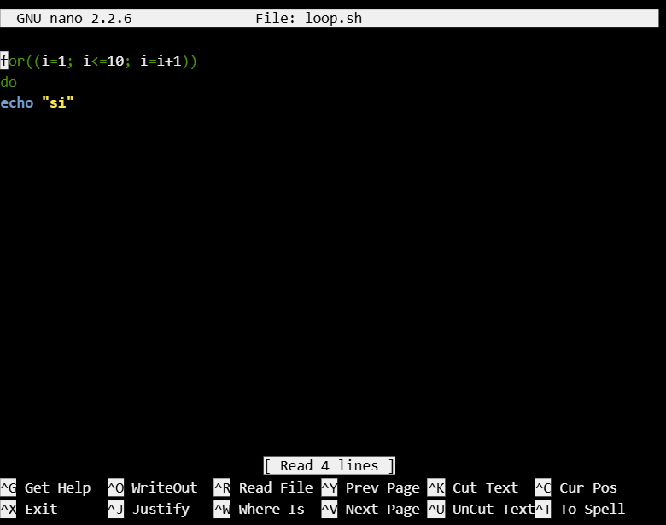
Figure 32: Description forloop

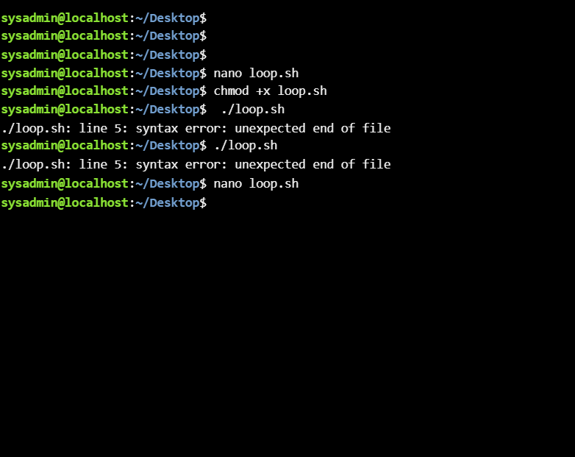
Figure 33: Description otput of loo

Conclusion
In this assignment, you learnt about the key functions of general Operating Systems MS Window Script and Linux software, which play an important role in managing computer hardware and software. They provide basic functions like file management, memory management, device control and running applications. These systems help users interact with computers easily through the command line.

References

[1] | Stuart E and Donovan, John Madnick, Operating systems.: McGraw-Hill New York, 1974, vol. 197.
[2] | Peter J and Brown, Robert L Denning, "Operating systems," vol. 251, pp. 94-129, 1984.
[3] | Craig Tashman, Windowscape: a task oriented window manager., 2006.
[4] | F Robert A and Duce, David A and Fielding, Elizabeth VC and Robinson, Ken and Williams, Antony S Hopgood, Methodology of Window Management: Proceedings of an Alvey Workshop at Cosener’s House, Abingdon, UK, April 1985.: Springer Science \& Business Media, 2012.
[5] | Nawab and Devulapalli, Ananth and Dalessandro, Dennis and Wyckoff, Pete and Sadayappan, P Ali, An OSD-based approach to managing directory operations in parallel file systems., 2008.
[6] | Open Mobile Alliance, Oma device management tree and description., 2006, vol. 1.
[7] | Charles A and Baillie, Curtis Sennewald, Effective security management.: Butterworth-Heinemann, 2015.
[8] | Matin Maleki, "Common CLI commands and file utilities," 2022.
[9] | Wesley and Naughton, Thomas and Vall, Design and implementation of a menu based oscar command line interface., 2007.
[10] | William Shotts, The Linux command line: a complete introduction., 2026.
[11] | Alan Mitchell and Gubitoso, Marco Dimas Durham, Using Linux.: National Center for Biotechnology Information (US), 2006.
[12] | Jesse M Torres, Windows Admin Scripting Little Black Book.: Paraglyph Press, 2004.
[13] | Rajkumar and Godishala, Aruna Kranthi Banoth, The Windows Operating System, Linux Overview.: Springer, 2026.
[14] | Dave Taylor, Wicked Cool Shell Scripts: 101 Scripts for Linux, Mac OS X, and Unix Systems., 2004.
[15] | Richard Blum, Linux command line and shell scripting bible., 2008, vol. 481.

Appendices
Online Course name:


Figure 34: Certificate of completion

