Managing Projects in the Organisation

Lecturer name:Alfred Mensah

Student id:2111891

Student name:Gabriela-Madalina Ciobanu

Module name:Managing Projects in the Organisation

Module Code:BMSW5014
Table of Content
Introduction 3
A basic project outline/description/scope based on your project 3
Stakeholder analysis 4
Work Breakdown Structure (WBS) 6
Decent draft of costs use 7
Consideration of resources 9
An outline Project Schedule / Gantt Chart 11
Risk Assessment 12
Conclusion 15
Reference List 16
Appendix: PPT slides 18

Introduction
One of the major aspects that define the success of any project is its proper management and planning (Lock, 2020). Especially in the organisation managing the activities within the project and regulating the overall requirements of the project ensures that the project is proceeding and being executed as per the plan. Another vital role of the project management plan is that it also ensures that the project that is being executed is properly aligned and operated based on the budget allocated. This report will serve the aim of analysing and evaluating the project management plan proposed for building the building canteen within the premises of Froster Cross Plc.

A basic project outline/description/scope based on your project
As mentioned in the Powerpoint presentation the basic project outline is to build up a canteen facility within the premises of the Foster Cross PLC company. Based on the overview as mentioned in the presentation, this plan serves the main aim of proposing the fundamental reason for addressing and building these facilities is to provide various services related to relaxation, and food and beverage services to the employees and staff of the company. Referring to Maslow’s Hierarchy of needs fulfilling the basic needs of the employees or the staff of the company can help motivate and increase the productivity of the employee (Pawsey et al., 2023). Therefore, based on the motivational theory, planning to build up the canteen within the Foster Cross PLC company in the UK will naturally enrich the motivation of the employees. Therefore, it can further justify the motive of building the canteen within the company’s premises. Furthermore, another major motive as per stated in the presentation is that as the employees face problems during their arrangements during lunch, this canteen can be served with that decent facility to the employees of the company. Also, the canteen will also offer a decent and specific and healthy environment with decent quality food and beverages to ensure better health and safety for the employees. The scope of the project of building the canteen within the premises refers to the way to make boundaries for the project of making the canteen and also to address and determine the exact goal of the project aligned with its deadlines and aspects with the proposed project.
The project life cycle model will provide a detailed analysis of how any project needs to be executed in order to make it successful (Gao et al., 2023). Based on the first stage stated by the project life cycle model “Starting the project” the project of building up the canteen is being acknowledged by the stakeholders and employees of the Foster Cross PLC as they were continuously facing the issue of the absence of a decent lunch environment. In the next step, called “Preparing and organizing” the canteen for the Foster Cross PLC based on the process of allocation of the funds the project has identified various investors and stakeholders as per the presentation. The next stage, called “Carrying out the task” in this stage proposes the execution of the preparation of the canteen within the Foster Cross PLC, and also to utilise the available resources available and collected from the mentioned stakeholders. Lastly, the stage involves, “Closing the project” This stage involves the closure of the canteen construction project. This stage involves addressing any kind of risks involved within the structure or identifying any needs that are left unsatisfied.

Stakeholder analysis
Stakeholder | Impact | Interest | Power | Contribution | Blocking of project | Strategy
Project Manager | High | High | High | Project managers are responsible for guiding the overall team and supervising the overall project | While terminating the project deadline and stopping the overall operation | Team meeting
Workers and project team | High | High | High | Workers are relevant while building the canteen and making the project successful | Going on strikes | Incorporating the announcements
Suppliers | Moderate | Low | High | Suppliers will provide the required raw materials for the project. | While preventing the supply of raw materials | Online or offline meetings
Staffs | High | High | Low | The need of staff depends on the type of the organisation. | Not contributing to the project operation | Information meetings and collecting feedbacks
Investors | Moderate | Low | High | Investors will provide the necessary initial funding’s | Not providing the initial funding’s | Annual meeting about the annual estimated budget
Table 1: Stakeholder analysis
(Source: Created by the learner)

Work Breakdown Structure (WBS)
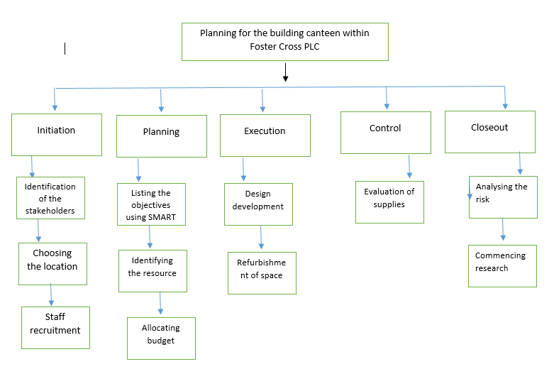
Figure 1: Work Breakdown Structure
(Source: Created by the learner)
Based on figure 1, mentioned above the work breakdown structure for the proposed project of constructing the canteen facility within the Foster Cross PLC company. Referring to this Figure 1, various activities were mentioned that needed to be performed systematically in order to complete the canteen project as per the proposed planning. In the opinion of Venkataraman et al. (2023), a work breakdown structure can be defined as the hierarchical outline of all the tasks required to complete a particular project. Similarly, through the use of this work breakdown structure, the PLC company can systematically allocate their priorities and attention to building the canteen. Considering Figure 1, there were various stages which to be addressed, the first stage is the initiation stage, where the company will identify the sources of resources and also address their stakeholders for the project. On the other hand, the later the company news to locate the ideal space for the canteen and lastly the company needed to recruit staff. Furthermore, in the next stage called the Planning stage, the company needs to list their objectives using the SMART objectives, then the company needs to identify the resources and then to allocate their budget. In the third stage called execution, the company needs to execute the planned activities based on the resources and planning in the previous stage. The next stage is control, where the company needs to evaluate the supplies of the resources in order to ensure that the project is properly being executed and no such flaws can be made (Cerezo-Narváez et al., 2020). Lastly, the stage called the closure, where the evaluation of the overall project is conducted, based on the risks of the project of the canteen construction and this stage also signifies how the risks are being mitigated. Therefore, based on this above-mentioned evaluation of the breakdown structure from the perspective of the canteen construction project management plan as proposed by the Foster Cross PLC company, it can be addressed the importance of the work breakdown Structure for the planning of the project.

Decent draft of costs use
Expense Category | Estimated Cost (£)
Initial Setup expenses | 8000
Renovation Cost | 3000
Licence | 1500
Inventory | 3500
Marketing | 3200
Contingency | 2000
Utilities | 700
Supplies | 1100
Staff Wages | 6100
Miscellaneous expenses | 300
Total Cost | 29400
Table 2: Cost table
(Source: Created by the learner)
As identified from the cost table, it can be identified that there are basically 10 types of expenses that have been outlined throughout the canteen formation project of Froster Cross PLC. Now each of the expenses has a different cost number based on the project type. The first expense has been recorded as Initial Setup expenses which have the cost of £8000. That could be the accommodations for the employees, required machinery and other components. The other expense has been recorded as renovation cost where the respective cost has been measured as £3000. The next expense has been recorded as a Licence where the respective amount has been estimated as £1500. Besides that, another expense can be identified as Inventory where the respective number can be estimated as £3500. The proper example of this inventory could be food resources, money resources and others. The next expense can be identified as Marketing which may include aspects like online marketing, offline marketing, social media marketing and others. The respective amount which has been measured is £3200. The next expense is contingency and it is also important for the process of project execution. The respective amount which has been recorded is £2000. Another resource can be identified as utilities where approximately £700 has been invested. The next expense has been recorded as Supplies which can include any type of raw materials. The respective amount has been recorded as near about £1100. Afterwards, the staff wages can be recorded where the respective cost can be £6100. Lastly, there is another expense Miscellaneous expenses where the amount has been measured as £300 which is the least expense among the list of expenses. While adding up all those expenses, the total calculated cost has been £29400 regarding the canteen formation project in Froster Cross PLC company.

Consideration of resources
Resources | Importance | Impacts
Funds | It is important as initial funding can be gathered for the overall project execution. | High
Equipment’s and Tools | Those are needed for constructing a genuine staff base. | High
Workers | Workers are also very important as determined efforts progress the overall project | High
Safety Measures | It is also important as employee safety is also necessary during the execution of the projects | High
Technical Assessments | The technical assessments are important for advancing the project execution time. | Moderate
Table 3: Resources table
(Source: Created by the learner)
For the project of constructing a canteen within the workplace of Froster Cross Plc regarding employee well-being, there are several resources that are being used for the overall successful execution of the project in an efficient and transparent way. Each resource has a different impact starting from the initiation of the project and ending in the project termination phase (Araújo et al., 2022). Those impacts can be measured as high, moderate and low and each of those has its own significance in the overall projects of Froster Cross PLC. Now, coming to the resources there are basically five types of resources that are being used in this particular project. The first resource can be identified as Funds which have a higher impact on this specific project. Funds basically refer to the initial funding that is provided to the projects. It can be defined as the process of getting financial resources or financial support for the motive of implementing a particular project or initiative (Chan et al., 2020). Those types of funds can be collected from various sources or resources that may include grants by the respective governments, private investors, monthly or annual loans and other resources.
The second resource is necessary equipment or tools which also have a high impact on the project of Froster Cross PLC. Equipment and tools are also necessary for the efficient and effective execution of projects which will be time savings (Kockmann, 2019). In the case of the canteen project two of the resources are being used which are the critical path method and also the work breakdown structure.
Another used resource is workers or enough labour forces which is also having a higher impact on the canteen project of Froster Cross PLC. Employees or workers are also important to implement the project as a project progression solely depends on the determination of the employees or workers (Haralayya, 2021).
Another resource is safety measurements which also have a high impact on the overall project (Stoessel, 2021). Safety measurements are considered to be one of the essential elements in a project's construction time. The safety of workers and labourers is necessary during the formation of the canteen.
The last resource can be identified as Technical assessments which have a moderate impact on the project. It is considered to be a significant component of the project as it makes the process easier to understand and faster to execute.

An outline Project Schedule / Gantt Chart
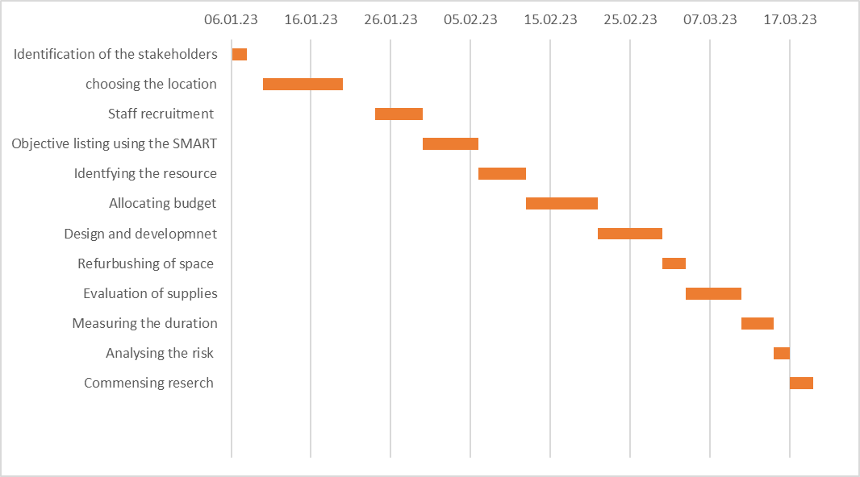
Figure 2: Gantt chart
(Source: Created by the learner)
Gantt chart is beneficial to maintain the time and budget limitations while performing a project management (Li et al., 2022). Based on Figure 2, the Gantt chart is mentioned identifying the various activities that need to be addressed while commencing the project for building the canteen structure. The activities such as stakeholder identification. Designing and development, measuring the duration of the project, budget allocation and vicarious other activities that drive any particular project towards success.

Risk Assessment
Risk assessment programmes are beneficial in identifying the potential risks engaged with the business environment to mitigate them on a prior basis to enhance project outcomes (Nicholas and Steyn, 2020).
Risks | Impact | Likelihood | Influence | Mitigation strategy
Critical Legal Risk | High | Low | If the canteen fails to meet the health and safety standards, it can create critical legal risks. Apart from that, the safety standard issues can cause critical legal risks for Froster Cross Plc. | Continuous legal documentation and sharing the documentation with the stakeholders'
Environmental issues | High | Medium | The waste generation during the manufacturing process of the canteen can cause environmental issues while running the business operations. Apart from that, it can further affect the environment of the local communities. | The organisation is required to focus on the Environment Protection Act 2021 of the UK to enhance environmental protection during construction protection.
Employees’ Injuries | High | Low | Injuries in the construction site for the canteen development can cause postponement of the entire project that can affect stakeholders’ satisfaction. Apart from that, it can also negatively impact the brand image of Froster Cross Plc. | Safety management plan
Financial risks | High | High | The budget limitation can close the entire project which can hurt the stakeholders' satisfaction. In addition, financial risks can also cause delays in project deliveries. | Continuous budget planning and communication with the stakeholders
Technological risks | High | Low | Inappropriate implementation of advanced technologies can affect the efficiency and dependency of the canteen. It can further cause financial threats to the organisation. | Training and skill development of the human resources.
Equipment management risks | Moderate | Low | If the equipment is not maintained in a proper manner, it can cause errors in task completion. Further, it can increase the budget for making the canteen for Froster Cross Plc. | Risk management plan
Time management risks | High | High | If any of the scheduled activities are delayed, it can cause time management risks. It has the potential to exceed the budget and further, it can cause client dissatisfaction. | Following the Gantt Chart completely
Availability of the human resources | High | High | Brexit, covid and the Russia-Ukraine war have made it difficult to find skilled and talented human resources. It can further affect the entire project's performance. | In this regard, the organisation can focus on contacting a hiring agency to enhance the performance while manufacturing the canteen for the human resources present in Froster Cross Plc.
Inefficient performance | High | Low | If the performance of the human resources gets decreased, it can affect the entire performance that can affect the quality of the project delivery that can affect client satisfaction. | The organisation in this context can implement training and development programmes for the human resources to attract greater performance in constructing the canteen.
Table 4: Risk Assessment
(Source: Created by the learner)

Conclusion
In conclusion, Foster Cross PLC is aiming to develop a canteen facility within the office premises. It is to encourage human resources by fulfilling the initial needs of human resources. Different stages of the project life cycle have been discussed in this context. Apart from that, in terms of stakeholder analysis, the strategies to ensure greater stakeholder satisfaction have been mentioned in the study to increase the project outcomes. Further, the WBS structure for the project accomplishment has been emphasised in this study. In addition, the cost and resource requirements for the project have been discussed through a tabular representation. Employees’ Injuries have been observed to attract high risks in the context of the risk assessment programme.

Reference List
Araújo, L.L.F., Saldanha, M.C.W., Gohr, C.F. and Nascimento, G.H.P., 2022. Improvement factors of constructability and occupational safety on project life cycle phases. Automation in Construction, 138, p.104227.
Cerezo-Narváez, A., Pastor-Fernández, A., Otero-Mateo, M. and Ballesteros-Pérez, P., 2020. Integration of cost and work breakdown structures in the management of construction projects. Applied sciences, 10(4), p.1386.
Chan, C.R., Parhankangas, A., Sahaym, A. and Oo, P., 2020. Bellwether and the herd? Unpacking the u-shaped relationship between prior funding and subsequent contributions in reward-based crowdfunding. Journal of Business Venturing, 35(2), p.105934.
Gao, W. and Lu, W., 2023, July. A 6D BIM integrated data management system in controlling construction quality throughout project life cycle. In EC3 Conference 2023 (Vol. 4, pp. 0-0). European Council on Computing in Construction.
Haralayya, B., 2021. Employee Job Satisfaction at Big Bazaar. Iconic Research And Engineering Journals, 4(12), pp.197-206.
Kockmann, N., 2019. Digital methods and tools for chemical equipment and plants. Reaction Chemistry & Engineering, 4(9), pp.1522-1529.
Li, D., Han, D., Xia, B., Weng, T.H., Castiglione, A. and Li, K.C., 2022. Fabric-GC: a blockchain-based Gantt chart system for cross-organizational project management. arXiv preprint arXiv:2207.09249.
Lock, D., 2020. Project management. Routledge.
Nicholas, J.M. and Steyn, H., 2020. Project management for engineering, business and technology. Routledge.
Pawsey, H., Cramer, K.M. and DeBlock, D., 2023. Life satisfaction and Maslow's hierarchy of needs: an international analysis of the world values survey. International Journal of Happiness and Development, 8(1), pp.66-79.
Stoessel, F., 2021. Thermal safety of chemical processes: risk assessment and process design. John Wiley & Sons.
Venkataraman, R.R. and Pinto, J.K., 2023. Cost and value management in projects. John Wiley & Sons.

Appendix: PPT slides


