Module No: | BMSK4002
Module Title: | Effective team working and communication.
Student Number: | 1911020
Student Name: | Lucy Jayne Morgan

Skills for the Workplace
Module Assignment Submission

Statement of Confirmation of Authenticity
By the act of making this submission, the student declares that this is the work of the student named above. The work has not, in whole or in part, been knowingly presented elsewhere for assessment, or where assessment has been built on a previous assessment, this has been identified. Where materials have been used from other sources it has been properly acknowledged. If this statement is untrue, the student acknowledges that an assessment offence has been committed. Attention is drawn to the plagiarism and unfair practice policies of both the University and of ILM.

Introduction
In this assignment the author will be writing about communication in the workplace and the communication cycle. Furthermore, the author will be assessing her own communication skills with questionnaires, quizzes, and a SWOT analysis. In addition, the author will write a personal development plan, to plan accordingly on how she can improve on her communication. In addition, she will write a gap analysis and back up her writing with credible, reliable, and academic references. Lastly, she will be writing a report on her feedback from her presentation and using a gap analysis and personal development plan, to plan accordingly how she can improve for future presentations. She will be applying the C.R.A.A.P test to evaluate her sources, before applying it to her writing and produce a bibliography for the sources she did not use in her text.
Management synopsis
In this assignment the author will be explaining effective communication in the workplace, examples of her communication in the workplace and the communication cycle. From research she will be writing about all elements of communication and how Lucy communicates in her workplace. The author has undertaken several communication questionnaires and has produced a communication questionnaire for her clients. She used the data from her results to produce a bar chart and analysed the data accordingly. Furthermore, Lucy undertook a SWOT analysis, gap analysis and personal development plan regarding her communication. In addition, the author has written a report on her feedback from her presentation and has undertaken a personal development plan and gap analysis, on how she can improve accordingly for future presentations.

Effective communication in the workplace is vital for employers and employees because it is an essential tool in achieving productivity, maintaining strong working relationships and helps build trust among employees (Page, No Date). It is also an essential part of everyday life; therefore, we must be able to communicate properly and sufficiently (Essays UK, 2018). By communicating effectively in your workplace, it can increase productivity, morale and increases employee job satisfaction. The communication cycle is a vital element to be able to communicate effectively and correctly within the workplace. The communication cycle plays an important role in the workplace and by implementing these theories, it can help you communicate more efficiently. In addition to this, the communication cycle is important because it develops the communication between the sender and the receiver (Communication Theory, No Date). Moreover, there can be noise while communicating for example encoded signals or crowd noise. This can disrupt the transmission process, resulting in the receiver may not receive the correct message. Shannon and Weaver recommend that all communication must include six elements source, encoder, channel, message, decoder, and receiver. Implementing the communication cycle into your workplace is important for the author, because if she does not get the correct message across to the receiver, it could cause a financial loss for her business or cause conflict. It is vital for Lucy to understand the steps in the communication cycle because it can build and maintain relationships with her clients if she communicates correctly. The author has experienced miscommunication in her workplace when she spoke quickly to an elderly client and communicated with too much information. Her client was unable to understand what the author was saying and what information the author was trying to say. The author realised the client was confused, so she repeated the information at a slower pace and went over the information step by step until the client fully understood. The author must take into consideration communication barriers in her workplace and learn from her mistakes.
There are many ways to communicate successfully, by recognizing your own communication style, learning others communication styles, and exercise precision and care, according to Farmer (2019). It is important to understand your personal communication style because it will help you communicate effectively, build strong relationships, and avoid unnecessary conflict. The author has taken a communication style questionnaire (Appendix A) from her results, her
communication style is assertive. From the authors results, she had an exceptionally high score for an assertive communicator, but most of us do not use a single communication style. The positive attributes of being an assertive communicator are, honest communication of thoughts and feelings, respecting the feelings, ideas and needs of others. One of the negative attributes are, misinterpreting assertive behaviour as aggressive (Princeton University, No Date). The author fully agrees that she is honest while communicating and respects the feelings, ideas and needs of others. The author disagrees that assertive behaviour can be misinterpreted as aggressive, because if you use a courteous tone of voice and positive body language, you can communicate assertively without being mistaken as aggressive. Furthermore, the author has undertaken a communication effectiveness questionnaire (Appendix C). From her results, the author was able to determine what areas she can improve on and areas she does well inn. Lucy often interrupts individuals while they are talking, and she communicates verbally at a fast pace, when talking with enthusiasm. The author understands this is a barrier when communicating and it could be portrayed as rude, by the recipient. In addition, the author listens well, she is helpful and genuine when in conversation. Moreover, the author has undertaken a communication quiz to find out how good her communication skills are (Appendix G). The authors total score was 58 and from her results it states that she is an excellent communicator. Although, the author somewhat agrees with her results, she feels that certain areas of communication she could improve on.
According to Willkomm (2018) there are five main types of communication, verbal communication, non-verbal communication, written communication, listening and visual communication. Although Field (2017) argues that there are ten types of communication to match everyone facial expressions, gestures, hobo signs, emoticons, sign language, music, the five big languages, English, math, and programming languages. The author agrees with Willkomn because he states the main five types of communication most people use. Nonverbal communication is important in the workplace because it is how we communicate without words (Quintanilla and Wahl, 2017). Our nonverbal behaviours are the gestures you make, posture, tone of voice and eye contact (Segal et al. 2019). By using nonverbal communication correctly in the workplace, it can put people at ease, build trust, helps
build relationships and draws others towards you. In the authors workplace, using correct nonverbal communication is vital. She provides a service to the public daily and attends client’s homes regularly to provide quotes. The author is aware of her posture, facial expressions, body language and tone of voice when communicating with her clients. The author recognises that nonverbal communication is key for her to be able to build rapport with client’s and maintain a good reputation for her business. Furthermore, the author has produced a communication questionnaire for her clients to take part inn. (Appendix M). From her results the author was able to assess what areas off communication she is good at and what areas she needs to improve on. Lucy had 21 responses from her clients and was pleased with her results. From her results, Lucy conducted a bar chart to calculate the mean, mode, median and range to analyse her data. The range was 20, mean 21, median 21, and mode 21. Lucy recognises that if more clients participated in the questionnaire, the data would have been more accurate. According to Mehrabian (1972), his communication model has a 7-38-55 rule. His rule states that only 7% of what we communicate consists of the literal content of the message, opposed to 38% through tone of voice and 55% through body language. Gurteen (No Date) argues that non-verbal signals play a role in communication, but they are not more important than the words. The author agrees with Mehrabian because our nonverbal communication is more important than literal content. By understanding how everyone communicates, you can adapt your communication type to everyone’s needs. What is the result of poor communication in the workplace? When there is poor communication within a workplace or business it can affect morale, efficiency and workload resulting in a potential financial loss to a business.
There are several barriers regarding communication, active listening, lack of transparency and trust, communication styles (when they differ), conflicts in the workplace, cultural differences, and language (Willkomm, 2018). Active listening is a vital communication skill, that is poorly understood and performed by most people. The six active listening skills are paying attention, withholding judgement, reflecting, clarifying, summarizing, and sharing (Centre for creative leadership, No Date). To overcome this barrier, you can limit your distractions and pay full attention to the individual talking, avoid interrupting when the individual is speaking, practise self-control and decreasing outside noise.
From research, the author has discovered that there are four different types of listeners detached, passive, active and involved (Slideshare, No Date). A detached listener avoids making eye contact, appears withdrawn and lacks enthusiasm, whereas an active listener makes direct eye contact, participates fully, and gives full attention. After researching the four different types of listeners, the author has determined she is an active listener majority of the time. The author feels it is important to listen to others, to learn and progress as manager in her business. The authors colleague Sarah is an involved listener, she provides some direct eye contact and reflects on the message to some degree. When communicating to her colleague, Lucy must repeat instructions to Sarah. If Lucy does not repeat instructions to her colleague, or if her colleague is not listening this could cause miscommunication, resulting in Sarah not doing the job correctly. This could cause conflict or loss of business for Lucy’s company, because each job requires different instructions. Another element in being able to communicate effectively in the workplace, is to understand the communication cycle. Efficient communication is vital in a business because it creates a common understanding environment, between a manager and employees. Nonverbal, written, and verbal communication are essential in the authors business it helps her achieve her goals and build relationships with her clients. Communication is the exchange of thoughts, information, or ideas that results in mutual understanding between two or more people according to Griffiths and Dunham (2015). Consequently, communication skills are a key element to communicating correctly in the workplace, therefore it is important we understand these skills. In the authors workplace, it is vital she communicates effectively and correctly. She has two small businesses which requires her to communicate using all five main types of communication. The author has undertaken a SWOT analysis on her communication in her workplace to establish her strengths, weaknesses, threats, and opportunities (Appendix B). From her results, one of the authors weaknesses were her lack of communication by email. This could be overcome by the author emailing customers on a weekly basis with offers and checking her emails daily. In addition, another weakness the author possesses is nonverbal communication. Although the author can maintain good eye contact and uses facial expressions, she often does not possess the correct posture or body language. Lucy recognises that correct posture and body language is critical in making a strong impression, and when lacking in these areas of nonverbal communication, it can give the wrong impression to her customers. She could overcome this by practising and implementing the correct posture and body language within her workplace. Moreover, one of the authors strengths are communicating via social media, this can provide several opportunities for the author. The author can utilize her social media communication skills to gain potential custom, build stronger customer relationships and gain potential contracts. Lastly one of the authors threats was miscommunication, which could result in a potential financial loss for her business if the author does not communicate correctly with her customers. The author could conquer this by active listening, giving accurate information and avoid interrupting. The author has written a gap analysis to set goals and to see what she can improve on across all fields of communication in her workplace. She will then evaluate her skills against the criteria, for the skills required for her to communicate efficiently (Appendix E). From her GAP analysis results the author was able to identify her objectives and act on them accordingly. The author has undertaken a personal development plan on her communication, to reflect and plan on her communication for short-term and long-term goals (Appendix D).
The author presented a slideshow based on the difference between groups and teams to her students. Due to the pandemic in the UK, the author was unable to present her slideshow in a classroom setting, instead she presented her slideshow online via Microsoft Teams. The author was feeling nervous and felt she was lacking in confidence because this was her first slideshow, however her students put her at ease by encouraging her to do well. The author faced many barriers prior and during her slideshow. Firstly, her tutor Bob had technical problems, so he was unable to watch the presentation live. Secondly, Lucy experienced a technical hitch herself, when her computer froze when delivering her presentation to the group. The author felt that she delivered her presentation to a high standard, kept her slides simple but informative and referenced correctly from reliable sources. In addition, the author gave her students feedback forms to complete so she can evaluate what she did well inn and what she needs to improve on (Appendix N). From her feedback, Lucy did well in presenting clear slides, remained calm and composed, used her communication skills throughout and showed good body language. In addition, she showed an interest in her students, was well prepared, spoke confidently and spoke in depth about the topic. Furthermore, from her feedback Lucy could improve on her timing, size of the text on her slides, change the colour of her background and not refer to her notes as often. The author agrees with most of the feedback she received from her students but disagrees that she should change the colour of her background. Background colour is cosmetic and personal preference, this does not affect the students learning from her presentation. Lucy has undertaken a personal development plan, to plan accordingly on how she is going to improve for her next presentation (Appendix X). From her results the author will improve on her timing by using a stopwatch when practising, to be aware of her timing for each slide. Lucy will use a larger font size for future presentations by using less words on each slide. Furthermore, Lucy will improve her confidence for future presentations by practising with family and friends via Skype and Microsoft Teams.

Appendix A
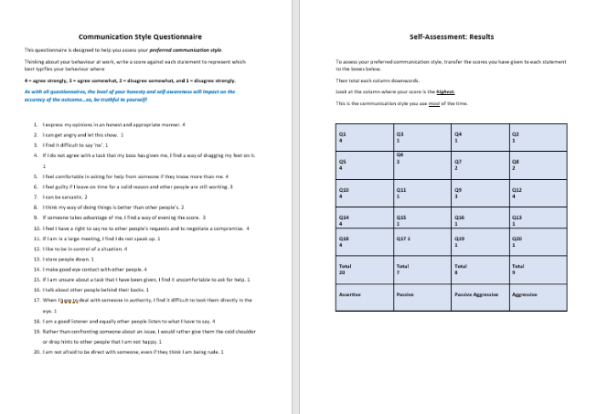

Appendix B
Strengths  - Communicates well in a team setting.  - Interpersonal skills.  - Listening skills  - Decision making, vision and strategy.  - Verbal communication.  - Communication via social media.  - Punctuation.  - Speaks clearly when presenting a slideshow. | Weaknesses  - Lack of written communication between the author and her suppliers sometimes lead to a delay in products being delivered.  - Nonverbal communication.  - Company policies.  - Communication via email.  - Interrupts when others are speaking.

Opportunities  - Networking for business ideas.  - Gain potential customers.  - Gain potential contracts.  - Progress in marketing.  - Stronger customer relationships.  - Improve efficiency and morale. | Threats  - Miscommunication would potentially cause financial loss for the author.  - Cost.  - Distrust.  - Lack of resources which causes a lack of communication.  - Fear.

Appendix C
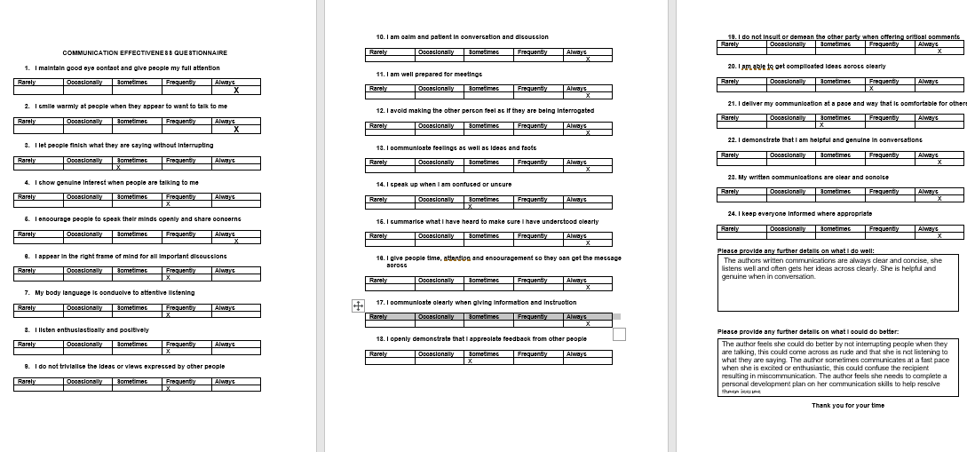
Appendix E
Objective | Current Position | Deficiency | Action
What do I want to do? | What can I already do? | What am I lacking? | How do I fix this?
Improve on written communication skills in her workplace. | The author has excellent verbal communication skills. | The author is lacking on written communication in the workplace. | The author will practise her written communication, not use buzzwords or jargon and keeping her written work concise. She will do this by the 20th of July 2020.
Gain potential customers. | Network effectively via social media to gain custom. She gains custom mainly through reputation and word and mouth. | The author is lacking in financial funds, to be able to spend money to advertise her business to gain potential custom. | The author can set aside a percentage of her profits, to use for advertising purposes, resulting in gaining potential customers, by 20th of December 2020.
Improve on communication via email. | The author emails customers with offers but not frequently enough. She also checks emails daily. | The author is lacking in time management, she needs to set time aside for communication via email. | The author will buy a diary to help manage her time more effectively. She will also set reminders on her laptop to check her emails several times a day. The author will do this by 27th of May 2020.

Appendix D
Objectives | Tasks | Success Criteria | Time Frame | Resources
List your Goals | What do you need to do to achieve these goals? | How will you identify your success? | When do they need to be done by? | Who or what do you need to help you?
Improve on written communication in the workplace. | Be clear and concise when writing to customers. Write short sentences. | The author will practise her writing and will pay attention to structure. | 18th of June 2020. | Researching online to structure sentences concisely.
Improve on communication via email. | Use appropriate tone, keep the text simple and organised and respond to emails within an appropriate time frame. | The author will check emails several times a day and respond in a timely manner. She will set a reminder on her mobile phone, to remind herself to check emails. | 18th of May 2020. | Use her phone to set reminders, to remind her to check and respond to emails. Buy a daily planner to help set time aside for emails.
Build stronger relationships with customers. | The author will show appreciation to customers and communicate with her customers regularly, to build rapport. | The author will send out thank you messages to all customers after ordering, ask for feedback and set up a loyalty scheme. | 20th of May 2020. | The author will order loyalty cards and put them in her orders. She will use her laptop to send thank you messages to customers.
Improve Non-verbal communication. | The author needs to pay attention to her body language, facial expressions, always make direct eye contact and her posture. | The author will always make eye contact and sit correctly. She will be aware of her facial expression and body language. | 12th of July 2020. | She will practise her eye contact, posture, and body language, when speaking with her family and friends.
Interrupts when others are speaking. | The author needs to stop interrupting when people are talking. | The author will listen when people are talking and will not interrupt. | 11th of June 2020. | The author will be more aware when others are speaking.

Appendix G
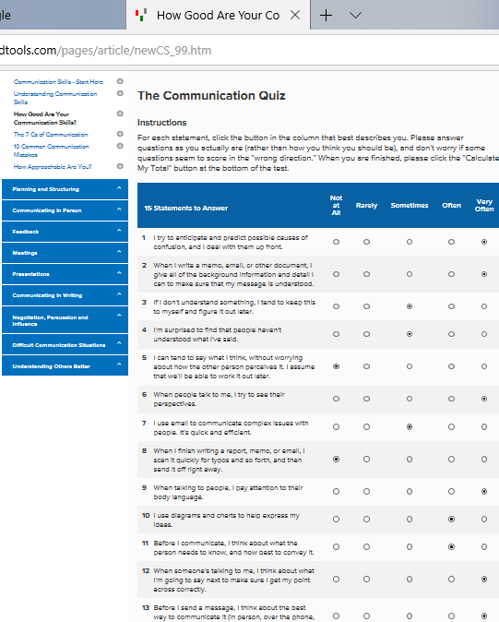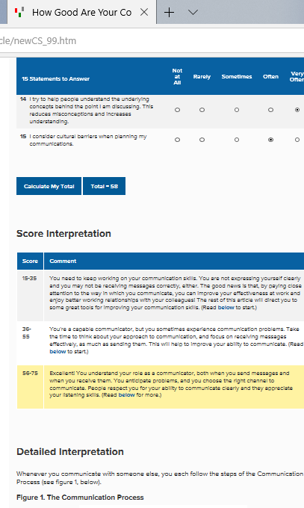

Appendix M

Appendix N

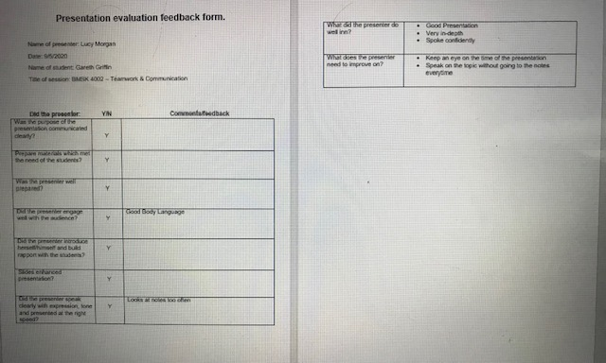

Appendix N
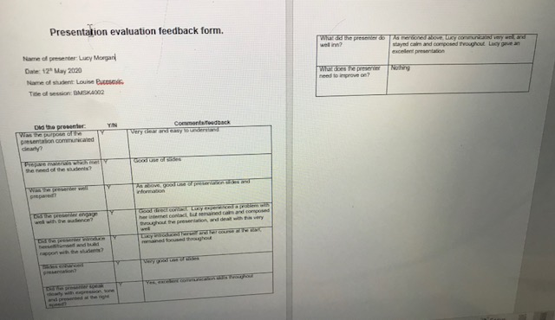
Appendix N
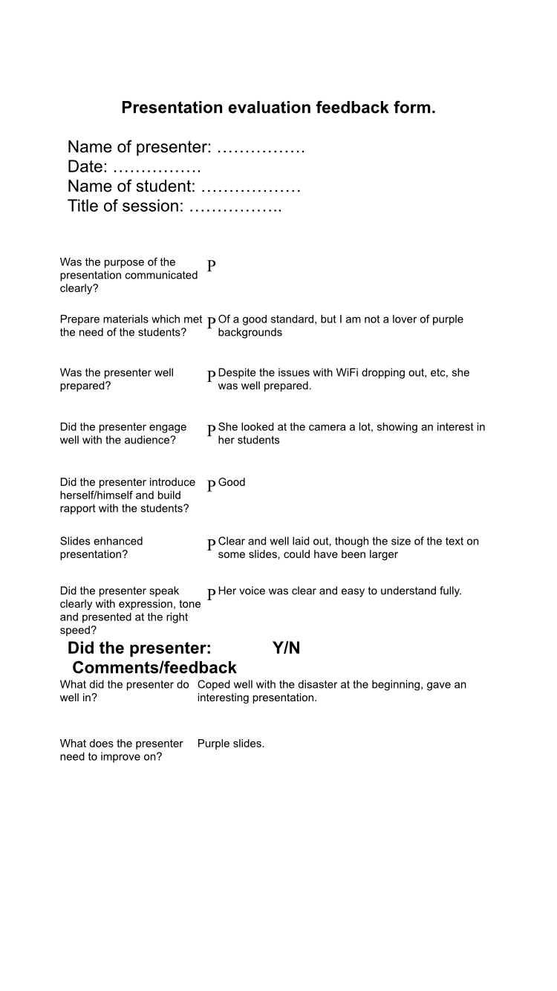

Appendix W
Objective | Current Position | Deficiency | Action
What do I want to do? | What can I already do? | What am I lacking? | How do I fix this?
Gain confidence in presenting a presentation. | The author speaks clearly, concise and at a steady pace when presenting her presentation. | The author is lacking in self-confidence and belief. | The author will practise delivering presentations with her friends and family by 1st of July 2020.
Use larger font on her slides. | The author can use PowerPoint to a high standard, layout her work clearly and her information is informative for her students to learn. | The author is lacking in the ability to use the correct size font without loosing vital information on the slide. | The author will add more slides into future presentations and use a larger size font by 1st of June 2020.
Use images in her slides for future presentations, to make her slideshow more appealing for her audience. | The author can evaluate her sources using the C.R.A.A.P test. She can reference an image correctly using the Harvard style referencing. | The author is lacking in creativity when planning her slides. | The author will add suitable images to future presentations by 1st of February 2021, when she next has a presentation to complete for her degree.

Appendix X
Objectives | Tasks | Success Criteria | Time Frame | Resources
List your Goals | What do you need to do to achieve these goals? | How will you identify your success? | When do they need to be done by? | Who or what do you need to help you?
Use bigger front on the slideshow. | Use less texts on slides to enable to increase font size. | The author will plan her slides accordingly and use less words on each slide. | 1st of June 2020. | Microsoft PowerPoint.
Improve confidence when presenting a presentation. | Practise presenting to gain confidence. | The author will practise presenting to family and friends to gain confidence. | 1st of July 2020. | Skype, facetime, and Microsoft Teams. The authors father, sister and stepmother.
Use appropriate colours on slides to suit everyone. | Research appropriate colours for a presentation. | The author will research appropriate colours for a slideshow. | 2nd of July 2020. | Internet, computer.
Learn notes. | The author needs to stop referring to her notes as frequently. She needs to revise notes continuously, until she can speak without any notes. | The author will practise until she does not need her notes to refer to. | 12th of July 2020. | Pen, paper, and computer.
Timing | The author needs to be aware of timing when presenting. | The author will practise her slides and be aware of her timing. | 11th of June 2020. | Stopwatch, Computer.

Reference list
All Answers. (2018) ‘Assertiveness’
https://nursinganswers.net/essays/assertiveness.php?vref=1
[Accessed 19th of April 2020].

Centre for creative leadership. (No Date) ‘Use active listening to coach others’
https://www.ccl.org/articles/leading-effectively-articles/coaching-others-use-active-listening-skills/
[Accessed 19th of April 2020].

Communication theory. (No Date) ‘Shannon and Weaver model of communication’
https://www.communicationtheory.org/shannon-and-weaver-model-of-communication/
[Accessed 26th of April 2020].

Farmer, J. (2019) ‘How to communicate effectively in any relationship’
https://www.lifehack.org/arcticles/communication/effective-communication-how-communicate-your-daily-life.html
[Accessed 15th of April 2020].

Field, D. (2017) ‘10 types of communication closest to a universal language’.
https://www.toptenz.net/10-types-communication-closest-universal-language.php
[Accessed 19th of April 2020].

Griffiths, B. A. and Dunham, E. B. (2015)
In working teams
Thousand Oaks: SAGE. Ch. 5, pp. 91-112.
[Accessed 19th of April 2020].

Gurteen, D. (No Date) ‘The Mehrabian myth’
https://conversational-leadership.net/mehrabian-myth/
[Accessed 1st of May 2020].

Mehrabian, A. (1972) ‘Nonverbal communication’
[Available on-line] at https://books.google.co.uk/books?id=Xt-YaLu9CGwC&dg=mehrabian+communication+model+1972&lr=&source=gbs_navlinks_s
[Accessed 1st of May 2020].

Page, M. (No Date) ‘The importance of good communication in the workplace’
https://www.michealpage.co.uk/advice/management-advice/development-and-retention/importance-good-communication-workplace
[Accessed 15th of April 2020].

Quintanilla, K. M. and Wahl, S. T. (2017)
In business and professional communication. Third edition.
Thousand Oaks: SAGE. Ch. 2, pp. 22-46.
[Accessed 28th of April 2020].

Segal, et al. (2019) ‘Nonverbal communication’
https://www.helpguide.org/articles/relationships-communication/nonverbal-communication.htm
[Accessed 26th of April 2020].

Slideshare. (No Date) ‘Active listening presentation’
https://www.slideshare.net/mobile/kdbourque/active-listening-presentation-36893005
[Accessed 5th of May 2020].

Willkomm, A. (2018) ‘Five types of communication’
https://drexel.edu/goodwin/professional-studies-blog/overview/2018/July/Five-types-of-communication
[Accessed 19th of April 2020].

Bibliography
Bailey, B. (2018) ‘The importance of nonverbal communication in business and how professors at the University of North George train students on the subject’
https://digitalcommons.northgeorgia.edu/cgi/viewcontent.cgi?article=1031&context=honors_theses
[Accessed 28th of April 2020].

Douglas, E. (No Date) ‘It all starts with communication styles’
https://communicationstyles.org/it-all-starts-with-communication-styles/
[Accessed 16th of April 2020].

Knight, R. (2017) ‘How to work with a bad listener’
https://google.co.uk/amp/s/hbr.org/amp/2017/08/how-to-work-with-a-bad-listener
[Accessed 6th of May 2020].

