INTRODUCTION

The aim of this report is to demonstrate how to identify problems at the work place by applying several problem-solving tools. Understanding organization analysis, working with others and understanding employees behavior and the influence of technology within the health care sector.

Skills for tackling the problem successfully within the health care sector

According to the first approach of F. E. Emery and E. L. Trist (1965), there are 4 types of problems that can occur within an organization and differs along the dimension of simplicity and complexity.
The first type is a docile, isolated problem; this means that quite often the simplest type of problem is isolated, an organized and orderly environment contains the problem therefore the organization is free to locate it, find the way to resolve it and move towards it in order to eliminate it. The best tactic that can be used in order to eliminate this type of problems is to basically just by trial and error.
The second type is docile problem groups; unlike the first type, this usually happens when the problems are grouped together is when the situation becomes more complex. In order to find a solution for this problem, an strategy is needed.
The third type is a dynamic interactive problem, which is basically a situation that changes in one problem are give rise to changes in another problem area. This is a very complex problem, as it just not depends on the organization to try and find a solution, but to include other organizations as several organizations might be concerned with the same group of interacting problems.
The last type is called the aggressive interactive problem where the interactive problems do not merely respond unpredictably to the actions of the organizations tackling them, but appears to have a momentum and aggressive initiative of their own (F. E. Emery and E. L. Trist, 1965).

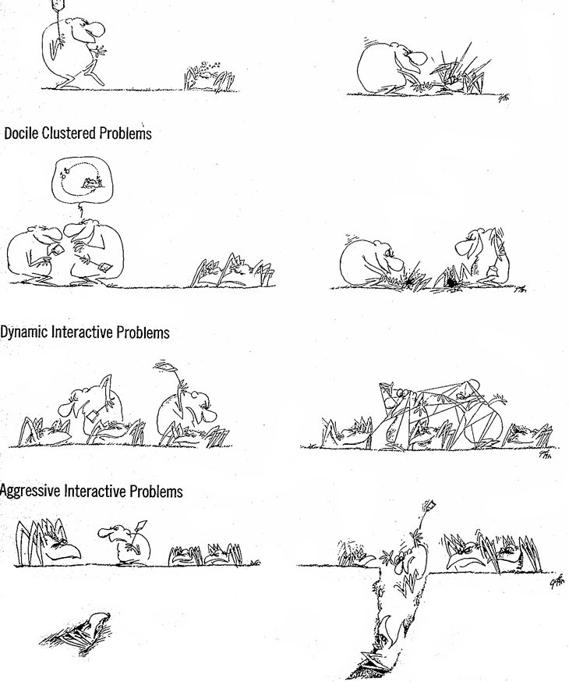
*This image illustrates the different type of problems just mentioned above.
F. E. Emery and E. L. Trist. The Causal Texture of Organizational Environments. Human Relations, 18, 1965, pp. 21-32

Another type of problems are based on the degree to which the difficulty of perceiving certain problems in inherent in the organization, cultural, or psychological assumptions of the people attempting to detect such problems.
Some of these problems can be direct consequence of lack of adequate economic resources such as the rich-poor gap, others could be from social consequences such as crime, third level problems could be population explosion, mental health, discrimination etc. Other problems such as credibility and value-related problems could came as consequence of a poor organization coordination. Psychological, conceptual and cultural problems could prevent decision-makers and their support from being able to justify solutions.

In conclusion, a problem is something that needs attention in different levels and needs to be solved such as a specific situation, thing or a person.
A quite often problem that occurs within the health care sector is that the needs of the service users are not met either by short staffing, unqualified personnel, poor communication and no team work or by specific requirements such as diet.

The stages of a problem are the followings:
- Identify the issue, which in this case could be the economy of the organization.
- Understand everyone’s interest: The interest of everyone is to meet or even exceed the expectation of the service users.
- List the possible solutions: There could be so many solutions but the most important in this case is to improve the financial situation or on the other hand, in order to be able to meet the needs to every service user is to reduce the number of people admitted in every hospital, care home, hospice.
- Evaluate the options: In general every organization have a specific budget to spend and is extremely difficult to increase it, moreover, this depends on the governance and in the financial crisis of the country. The organization will also lose a lot of money if the reduce the number of service users. In a care home for example, is not a very good solution to increment the prices that the service users needs to pay as if this happens, lots of them will move to a cheaper place, and number of people applying for expensive care home will decrease.
- Select an option: The best option in the balance could be the one of reducing the number of service users as is true that lots of money will be lose but the level of service on that specific care home will increment a lot and both the staff and the service users will be satisfied.

An study has confirm that men with relatively low income have the poorest health outcomes such as coronary hearth disease (Marmot 2003).
Stress has also been associated with exacerbations of autoimmune disease (Harbuz et al. 2003) and other conditions in which excessive inflammation is a central feature (Appels et al. 2000).
Having problems at the work place, affect in many ways the mental health and as a consequence, life outside the workplace such as private or social is often destroyed.

According to Barry K. Beyer (1995) critical thinking mean ‘making clear, reasoned judgments’.
In order to be a successful critical thinker, anecdotes and non-specific evidence needs to be rejected and only needs to count the information based on evidences. A personal with critical thing is open-minded and well informed, able to judge the quality of an argument and draw cautious yet evidence-based conclusions.

Critical thinking is very useful at the workplace as it can be applied by researching the competition and their practice, assessing what is successful in order to for the company to be able to expand and develop.
An example of this is when you compare different care homes, the family of a service user will be researching for the best option so it will be a good idea to think what they would like and include it in your company.

UNDERSTANDING ORGANISATIONAL ANALYSIS & COMMUNICATION SKILLS

PLEST analysis which stands for political, economical, social and technological is a strategic framework for understanding external influences in an organization, which in this case is the health care sector (nursing homes), and by understanding this factors, organizations have the opportunity to increase their development and decrease any threats that can put at risk the organization.
A political factor relates to the pressures and opportunities brought by political institutions and to what degree the government policies impact the business.
Economic factors relates to economic policies, economic structures and to what degree the economy impacts the business.
Social factors relates to the cultural aspects, attitudes, beliefs, that will affect the demand for a company's products and how the business operates.

Technological factors relate to the technological aspects, innovations, barriers and incentives, and to what degree these impact the business.
Legal factors relates to the laws, regulation and legislation that will affect the way the business operates.
Environmental factors relate to the ecological and environmental aspects that will affect the demand for a company's products and how that business operates (Processpolicy.com, 2018).

The key influences factors to the organization is the economical and the political as institutions such as nursing homes depends very much in the funding or grand that they can received from the government and currently the NHS is experiencing lots of cuts and this puts lots of pressure in this types of organization as if they do not have the enough resources to meet the service users needs they will need to close.

Flor Maria Durazno Cochancela
London
SW25 4XB
01ST of January 2018
Mr Jones
Line Manager
Sunrise nursing Home
London
SW25 4XB

Dear Mr Jones,

I would like to raise a concern about the short staff that we are experiencing and that the number of incidents and complains from the residents have risen.

External factors such as the political, economical, technological and social have had a negative impact in the organization.
British elderlies prefer to be care at home, however the rapid aging of the population means that the demand for nursing homes will increase.
This is a very big problem as my co-workers and I feel that we are unable to cope anymore with the demands: we are often covering other co-workers because of sickness or maternity leave and new employees are unable to handle all the pressure and they leave. Residents require more attention and more time and we are unable to do that, we do as much as possible to at least offer them the basics.
Some residents required specific care as they have good religious believes or specific conditions. Also, factors such as kinetic disability, emotional and cognitive disorders, fallings, widowhood and a poor subjective perception required more attention and time and specific treatments and therapies (Stoddart et al., 2002).

I am very much aware of the financial pressure of the company but I am afraid you should do something in order to improve our and the resident situation otherwise we would not be able to cope any longer with all the pressure.

Yours sincerely,

Flor Durazno

WORKING WITH OTHERS AND UNDERSTANDING EMPLOYEES BEHAVIOUR

The behaviour of an employee refers to the way in which they respond to specific circumstances or situations in the workplace. There are many factors that influence in an individual’s behaviour, however an employee’s behaviour is shaped by the organization's culture.
Personal and corporate culture affect the way employees communicate and interact with one another and with management. Additionally, an employee's beliefs affect his or her ethics and sense of ethical responsibility.
Employee behaviour is very much impacted by internal and external forces as an attempt to perform their job duties. Employers who are aware of these forces, and who are prepared to leverage or counteract them, can have a positive impact on the employee's behaviour.
Some of these forces are positive environments, which is an internal force and is very much the action of the colleagues. Companies that can effectively build an internal culture that is based on mutual respect, teamwork, and support will attract and retain employees with good behaviour.
Technology is very helpful as it make the work easier for the workers; however learning how to use new technology can be very complicated and stressful.
Companies often need to send their employees to courses, training, new documentation and new procedures of performing new tasks including technology.
Customer often exerts pressure on organizations in order to stay ahead the competitive organizations. Employees must adapt to the changing needs of customers, the growing shrewdness of customers, and the heightened expectations that customers put on employee behaviour (Study.com, 2018).

The key influencing techniques of the management of managing the behavior of employees are the followings:
- Positive reinforcement: It is a very good technique to reward employees whenever they demonstrate desired behaviors because this will motivate them to continue doing so.
- Discipline: In the other hand, discipline is very useful whenever a continue misbehavior is occurring, for instance, docking the paycheck of an employee who is often late will make him avoid being late again.
- Extinction: This strategy refers to the elimination of procedures and policies that inhibit the ability to communicate effectively or perform work efficiently. Generally, extinction is most relevant in situations involving organizational change (Notredameonline.com, 2018).

DATA ANALYSIS SKILLS AND INFORMATION COMMUNICATION TECHNOLOGY

The use of supportive technologies for providing better care for the elderly in their own place is an issue that has been promoted for several years (elliott, 1991).
Nowadays, the vast proliferation of information and communication technologies, and the widespread diffusion of the Internet, the integration of new technologies in the health sector is at the forefront of health policies. The adoption of e-health initiatives offers new approaches in many areas of care. The advanced technological environment could be exploited in order to provide up to date and sophisticated health care services.

Some of the advantages the technology has supported nursing homes in general by providing the ability to communicate 24/7 with residents, employees, employers, third parties, etc. It is a much quicker, cheaper, easier and efficient way to communicate.
Is more efficient at the time to do the financial part of the organization, such producing the payments to the employers, external organizations or even getting payments.
It is also very beneficial in recruiting staff as the post is all the time on the Internet and can be accessed at any time.
Technology also promotes more efficient operation of the company and also improves the supply of information to decision-makers.
Lastly it is very beneficial for language and cultural barriers or boundaries, with the access to the technology people from other countries are able to communicate and in this way the care provided by nursing home is improved.

Even though technology could offer us all of the benefits mentioned above, in most nursing homes there is not the immediate possibility even of a simple computer. It is therefore an urgent necessity to bridge this gap between the technological reality that is now readily available on the one side, and the nonexistent technological capabilities of the program’s structures on the other side.

Also, lots of mistakes can happen such as for example when the connection is down, payments, emails, information etc cannot be received or given.
Technology is open for everyone, thus everybody can assess it and there are a lot of security issues, organizations need to implement secure boundaries in order to protect their resident’s information.

REFERENCES

Anon, (2018). [online] Available at: https://www.ncbi.nlm.nih.gov/pmc/articles/PMC2568977/ [Accessed 2 Jan. 2018].

Appels A, Bar FW, Bar J, Bruggeman C, de Bates M. Inflammation, depressive symptomatology, and coronary artery disease. Psychosom. Med. 2000;62:601–605.

F. E. Emery and E. L. Trist. The Causal Texture of Organizational Environments. Human Relations, 18, 1965, pp. 21-32

Harbuz MS, Chover-Gonzalez AJ, Jessop DS
Ann N Y Acad Sci. 2003 May; 992():99-106.

Notredameonline.com. (2018). Cite a Website - Cite This For Me. [online] Available at: https://www.notredameonline.com/resources/leadership-and-management/strategies-for-managing-employee-behavior/#.WlTYFFTvDys [Accessed 9 Jan. 2018].

Marmot M. Social resources and health. In: Kessel F, Rosenfield PL, Anderson NB, editors. Expanding the Boundaries of Health and Social Science. New York: Oxford Univ. Press; 2003. pp. 259–285

Processpolicy.com. (2018). What is PESTLE Analysis?. [online] Available at: https://processpolicy.com/pestle-analysis.htm [Accessed 9 Jan. 2018].

Study.com. (2018). Employee Behavior: Definition, Issues & Expectations - Video & Lesson Transcript | Study.com. [online] Available at: https://study.com/academy/lesson/employee-behavior-definition-issues-expectations.html [Accessed 9 Jan. 2018].

