Developing and Managing Individuals and Teams
Module Code: LCLM5002
Assignment Title: Component 2 – Individual Report

Report Title: A Critical Evaluation of Contemporary HR Challenges and Practices at J Sainsbury plc

Student Name:

Table of Contents
Introduction 2
Company Context: Sainsbury’s 3
Factors Affecting HR at Sainsbury’s 4
Technological Advancement 4
Talent Acquisition and Retention 4
Diversity, Equity and Inclusion 6
Evaluation of Contemporary HR Practices 7
Practices for Technological Advancement 7
Practises of Retention and Talent Acquisition 7
Diversity, Equity and Inclusion Practises 7
Critical Evaluation of How Departmental Managers Can Ensure Urgent Implementation 9
Translating Policy into Daily Practice 9
Creating Urgency Through Capability and Visible Leadership 9
Monitoring, Accountability and Follow-Through 9
Barriers and Limitations 10
Conclusion and Recommendation 11
References 12

Introduction
The capacity to match people's capabilities with business change at high speed has become more of a human resource management strategy in large retail organisations rather than a matter of routine administration. This issue is particularly important in the case of Sainsbury's since the business needs to provide the level of consistency of service in the stores, depots, digital channels and support functions, as well as address the pressure of costs, the rivalry in the labour market, and the increasing demands of stakeholders. This report is thus an analysis of three aspects that have a material impact on HR at Sainsbury: technological improvement, talent acquisition and retention and diversity, equity and inclusion. It subsequently applies them as a foundation on which it tries to assess the way people management should react (Armstrong and Taylor, 2023).

Company Context: Sainsbury’s

Figure 1: Sainsbury’s (Weber, 2024)
Sainsbury is a relevant option since it is a combination of scale, operational complexity and visibility to the populace. The company defines itself as the second largest employer in the UK within the private sector and adds that they recruit over 141,000 colleagues, the fact that implies that HR challenges are strategically placed and no longer strictly administrative. Its Next Level strategy, too, relies on efficiency in logistics, digital capability, service quality to customers and involvement with colleagues; therefore, a vulnerability in people management would soon manifest itself throughout the business execution (J Sainsbury plc, 2025a).

Factors Affecting HR at Sainsbury’s

Technological Advancement
One of the key HR problems at Sainsbury is technological development since at the same time, the labour distribution, requirements and level of skills demanded, and the expectations of managers are affected by the innovation in the retail sector. Practically, this implies that HR is not just concerned with recruitment or training anymore; it needs to foresee where jobs are being redesigned, what capabilities are becoming unnecessary, and how co-workers can be shifted into more efficient forms of work. This is what renders workforce planning significant, since organisations must have a clear understanding of the future capability requirements prior to the technology programmes being implemented at speed (CIPD, 2025b).
The reason why this is important can be seen in the present profile of investments at Sainsbury. In its 2024/25 preliminary results announcement, the company cited that its three-year future front-end programme had taken self-service involvement to more than 70 per cent of transactions, a significant enhancement from a 40 per cent five years prior, but also added to a nine per cent year-on-year rise in front-end productivity. The identical update reports that Sainsbury is streamlining its logistics network, implementing video analytics in retail outlets and to aid in-store operations, and forecasting, it is applying AI and machine learning in its partnership with Microsoft. These trend-setters make workers more efficient, yet put more strain on HR to reskill workmates, minimise uncertainty and assist managers by operational redesign (J Sainsbury plc, 2025b).

Talent Acquisition and Retention
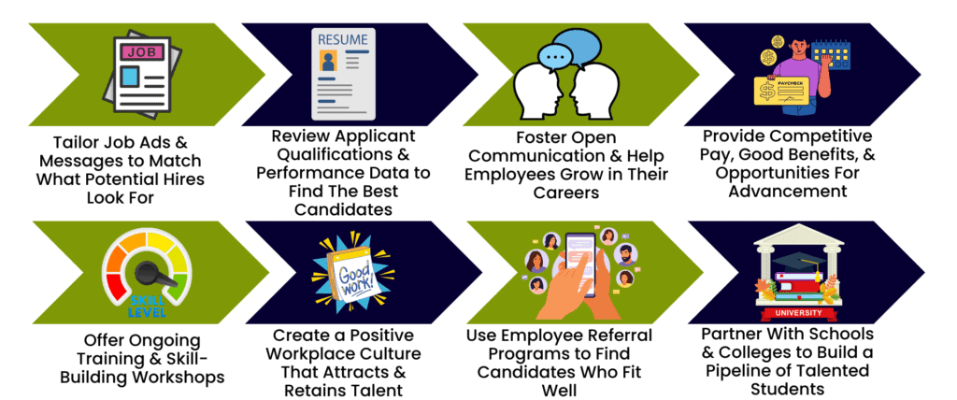
Figure 2: Talent Acquisition Strategies (Anon, 2024)
A second critical HR pressure is talent acquisition and retention, as big retailers are the competitors in the labour market where the employees compare employers based on their compensation, but also in terms of development, wellbeing, stability, and everyday treatment. It means that talent management needs to be perceived as an entire cycle consisting of attraction, development, engagement and retention of people, instead of a recruitment process that is concerned solely with filling vacancies (CIPD, 2025c). In the case of Sainsbury, it is a commercially necessary way of understanding that the quality of customer experience is strongly determined by experienced frontline staff that were experienced, the quality of supervisors and the motivation of store and depot staff. There are more than just costs to be incurred when it comes to hiring new employees due to high turnover in this environment, but it could diminish consistency, cause a rise in the supervisory pressure and lack of confidence in service delivery during extremely busy trading times.
The Sainsbury sustainability reporting reveals that the company has realised this challenge. According to the company, its Next Level Employee Value Proposition is being built on the moments that matter to its colleagues to enable it to develop a better employee experience and retain and attract the best employees. In the same report, it is also stated that 92 per cent of the apprentices completed their programme and that their colleagues have a platform where they can learn and grow, and receive training that is compulsory. This implies that retention in Sainsbury is being regarded as an experience and development concern as opposed to merely a pay concern, which is a more viable reaction to present labour market circumstances (J Sainsbury plc, 2025c).

Diversity, Equity and Inclusion
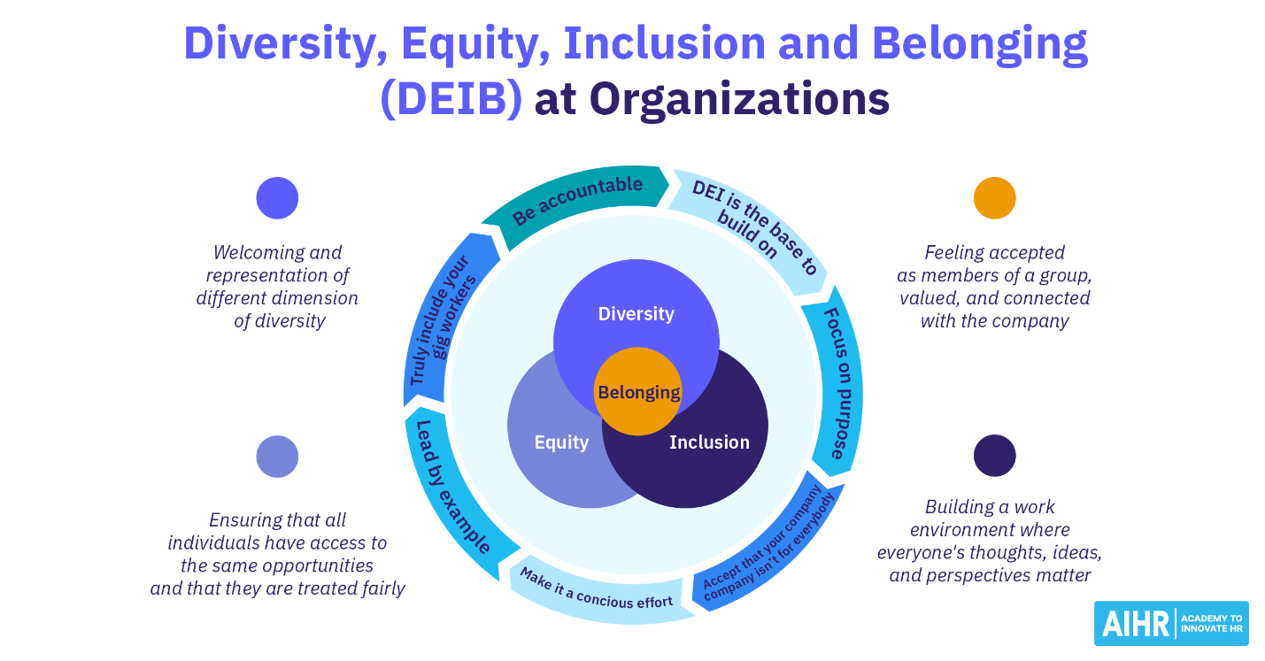
Figure 3: Diversity, Equitey and Inclusion (Verlinden, 2022)
Diversity, equity and inclusiveness are also significant HR issues since in such a large and customer-facing organisation as Sainsbury, inclusion influences organisational trust, progression, engagement and reputation at once. A good EDI approach is not merely a question of compliance or principles; it is related to business aims since it affects how the organisation may employ competent individuals, keep them justly and provide environments where various groups can perform to their fullest (CIPD, 2026a). This is because, to HR, inclusion has to be embedded in recruitment, line management, progression and workplace support and not a separate theme of communication.
At Sainsbury's, the problem is operationally topical since the outcomes in terms of equality still require proactive supervision. According to the most recent Gender and Ethnicity Pay Report of the company, its mean ethnicity pay gap grew by 0.5 percentage points to -3.4 per cent, as well as the median ethnicity pay gap by 0.4 percentage points to -5.8 per cent. In any direction, the presence of the detailed voluntary reporting itself represents that the workforce fairness is not being controlled as a live structural matter, but assumed that has been addressed. To HR, it is obvious: inclusion at Sainsbury is not only conditioned by extensive policy commitments but also by whether everyday management decisions yield plausible and trusted results in the workforce (J Sainsbury plc, 2024).

Evaluation of Contemporary HR Practices

Practices for Technological Advancement
The HR response to the changing face of technology at Sainsbury should not be seen as a lone training exercise, but as strategic workforce planning. As store operations change due to digital systems, during checkout, forecasting and logistics, HR should find out which jobs are impacted, what new tasks they need, and where the reskilling strain is emerging before performance declines. This is more effective than reactive training since it connects the use of technology to capability planning and role redesign. It would also suit the Sainsbury context, as the firm explains that innovation of data and technology is the core of how it enhances its efficiency and customer experience. Practically, thus, the combination of skills forecasting, targeted digital learning, and manager-led support becomes the strongest HR practise so that colleagues would be able to adjust to the redesigned processes with less ambiguity and less service quality reduction (CIPD, 2025b; J Sainsbury plc, 2025a).

Practises of Retention and Talent Acquisition
One of the most plausible retention and talent acquisition strategies utilised at Sainsbury is the consistent employee value proposition as opposed to its excessive dependence on pay competition. This is important since retention in retail is not only about wages, but also about development, support, and regular treatment. According to the 2024 evidence provided by CIPD, 69% of employers acknowledged that well-qualified talent is more competitive, and 56% said that talent was more difficult to keep. At the same time, 56 per cent were cultivating additional talent within the company. In the case of Sainsbury, this is very applicable since the company has more than 141,000 colleagues, and frontline customer-facing pay has increased by 58% since 2018, and it is leveraging its Next Level Employee Value Proposition to enhance the colleague experience. Most importantly, this is more powerful than a perfunctory recruitment approach since it adjoins a reward with development as well as retention planning, but it will never function unless the colleagues undergo it on a regular basis within different departments and managers.

Diversity, Equity and Inclusion Practises
A system-based practise where inclusion is incorporated in progress, accountability and leadership behaviour is the strongest DEI practise. This is more plausible than symbolic messaging since it attributes culture to quantifiable results. At Sainsbury, senior leadership and management positions are to be 50% women and 15% ethnically diverse; in 2024/25, 42.4% and 11.3% was achieved respectively. The company also says that 78% of colleagues feel free to be themselves at work, and its five colleague networks have over 13,000 members. These statistics indicate that the inclusion structures of Sainsbury are apparent; however, the process of representation is not finished.

Critical Evaluation of How Departmental Managers Can Ensure Urgent Implementation

Translating Policy into Daily Practice
Departmental managers are crucial as they translate HR policy into the real experience of employees. Colleagues working in a company such as Sainsbury are exposed to organisational priorities such as schedules, feedback, support, work allocations and managers' tone instead of the corporate policy books. That is to say that even well-developed HR design may fail when local managers use it unevenly or see it as secondary to instant operational effect. The CIPD advice to line managers can help in this case since it places line managers between people policy and day-to-day delivery. Urgent implementation thus relies on how managers are able to justify change succinctly, address concerns promptly and reaffirm predicted behaviours uniformly in their respective teams (CIPD, 2024a).

Creating Urgency Through Capability and Visible Leadership
Managers who can guide people through changes instead of issuing orders are also needed urgently. This is particularly vital to well-being, inclusion and novel ways of working, as staff measure seriousness by managerial behaviour. Management development advice given by CIPD emphasises the fact that organisations must determine the development requirements of managers and develop the skills necessary to lead people effectively. This is proven even by the self-reporting of Sainsbury, which reports that 11,600 line managers did Mental Health Awareness Training last year and that 71 per cent of its colleagues were confident that their line manager cared about them. These facts are important as they reveal that urgency is achieved once managers are ready to take action, rather than being told what to say (CIPD, 2024b; J Sainsbury plc, 2025b).

Monitoring, Accountability and Follow-Through
Managers will not be able to implement urgently unless they monitor and put progress into action. This is the area where most HR strategies fail, where plans are proclaimed, yet scrutiny is not conducted locally. The people manager guide by CIPD introduces performance management as an ongoing process of expectation, feedback, support and accountability; not a yearly activity. To departmental managers at Sainsbury, that translates to monitoring under such practical indicators as training completion, premature disengagement, common capability lapses and individual performance patterns on a team basis. The worth of such an approach is that it maintains the management of people active and quantifiable. The drawback is that it is only effective when managers possess sufficient authority and time to act on the evidence collected (CIPD, 2024c).

Barriers and Limitations
Although this is the case, the departmental managers cannot provide prompt implementation unless organisational barriers are solved. Confidence is one of the barriers: when managers feel unprepared, they might not act in case of inclusion, conflict or well-being issues. The other one is workload, since fast-paced retail settings tend to move people's priorities aside in favour of urgent trading needs. In a new EDI report, CIPD reports that managers are reluctant to admit to saying the wrong thing, and its 2025 wellbeing evidence indicates that line-manager ability is a major barrier to helping employees well. In the case of Sainsbury, the critical implication is quite obvious: without the appropriate support, managers must not be viewed as the ultimate channel of HR strategy delivery. It is only through training, support and sufficient operational space that managers can prioritise people issues and commercial performance, leading to urgent implementation becoming realistic (CIPD, 2025a; CIPD and Simplyhealth, 2025).

Conclusion and Recommendation
This report has demonstrated that three interrelated pressures of technological change, acquisition and retention of talent, and diversity, equity and inclusion are reshaping the HR function of Sainsbury. These are not singular problems, since both of them affect the workforce's ability, employee experience and operational consistency simultaneously. It is also revealed during the analysis that modern HR practise is most effective when it is integrated, practical and backed by solid managerial execution. On the whole, the effectiveness of Sainsbury in people and team management will not just hinge on the design of policies, but whether people's plans are operationalised into valid, resourceful action throughout the business.
Sainsbury should begin enhancing the workforce preparedness to technological change by connecting digital investment to systematic reskilling, role-specific learning and manager-led backing. Second, it ought to operationalise its employee value proposition so that development, wellbeing and career opportunities are practised continuously and interdepartmentally instead of interdepartmentally via local practise. Third, it ought to enhance managerial responsibility to encompass and retain through more precise people-centric goals, frequent review indicators and greater assistance to line managers in such a way that HR priorities do not get wedded to the operational immediate pressure.

References
ANON (2024). 16 Talent Acquisition & Retention Strategies For 2025. [online] Genius. Available at: https://joingenius.com/recruiting/talent-acquisition-and-retention/ [Accessed 8 Mar. 2026].
Armstrong, M. and Taylor, S. (2023) Armstrong’s Handbook of Human Resource Management Practice: A Guide to the Theory and Practice of People Management. 16th edn. London: Kogan Page.
Bratton, J., Gold, J., Bratton, A. and Steele, L. (2022). Human Resource Management: A Critical Approach. 7th edn. London: Bloomsbury Publishing.
CIPD (2025a) Equality, diversity and inclusion in the workplace. Available at: https://www.cipd.org/en/knowledge/factsheets/diversity-factsheet/ (Accessed: 8 March 2026).
CIPD (2025b) Resetting EDI and reaffirming inclusion. Available at: https://www.cipd.org/globalassets/media/knowledge/knowledge-hub/reports/2025-pdfs/8841-resetting-edi-and-reaffirming-inclusion.pdf (Accessed: 8 March 2026).
CIPD (2025c) Strategic workforce planning: Guide for people professionals. Available at: https://www.cipd.org/en/knowledge/guides/strategic-workforce-planning/ (Accessed: 8 March 2026).
CIPD (2025d) Talent management. Available at: https://www.cipd.org/en/knowledge/factsheets/talent-factsheet/ (Accessed: 8 March 2026).
CIPD (2026) Employee turnover and retention. Available at: https://www.cipd.org/en/knowledge/factsheets/turnover-retention-factsheet/ (Accessed: 8 March 2026).
CIPD and Omni RMS (2024) Resourcing and talent planning report 2024. Available at: https://www.cipd.org/globalassets/media/knowledge/knowledge-hub/reports/2024-pdfs/8662-resource-and-talent-planning-2024-report-web.pdf (Accessed: 8 March 2026).
CIPD and Simplyhealth (2025). Health and wellbeing at work 2025. Available at: https://www.cipd.org/globalassets/media/knowledge/knowledge-hub/reports/2025-pdfs/8920-Health-and-wellbeing-report-2025-/ (Accessed: 8 March 2026).
Ciuk, S., Śliwa, M. and Harzing, A.-W. (2023) ‘Implementing the equality, diversity, and inclusion agenda in multinational companies: A framework for the management of (linguistic) diversity’, Human Resource Management Journal, 33(4), pp. 868–888. doi: 10.1111/1748-8583.12487.
Dawson, N.E.A., Parker, S.L. and Okimoto, T.G. (2024) ‘Profiles of diversity and inclusion motivation: Toward an employee-centred understanding of why employees put effort into inclusion and exclusion’, Human Resource Management, 63(1), pp. 45–66. doi: 10.1002/hrm.22186.
J Sainsbury plc (2024) Gender and Ethnicity Pay Report 2024. Available at: https://corporate.sainsburys.co.uk/media/ps5pdsax/gender-ethnicity-pay-gap-report-24.pdf (Accessed: 8 March 2026).
J Sainsbury plc (2025a) Annual Report and Financial Statements 2025. Available at: https://corporate.sainsburys.co.uk/media/e1lfnybd/sainsbury-annual-report-and-financial-statements-2025.pdf (Accessed: 8 March 2026).
J Sainsbury plc (2025b) Plan for Better Report 2024/25. Available at: https://corporate.sainsburys.co.uk/media/dfkfh1jr/sainsburys-plan-for-better-report-2024-25.pdf (Accessed: 8 March 2026).
Priyashantha, K.G., De Alwis, A.C. and Welmilla, I. (2024) ‘Disruptive human resource management technologies: a systematic literature review’, European Journal of Management and Business Economics, 33(1), pp. 116–136. doi: 10.1108/EJMBE-01-2022-0018.
Umeh, C., Cornelius, N. and Wallace, J. (2023) ‘Exploring equality, diversity, and inclusion in multiethnic settings: A context-sensitive approach’, Human Resource Management Journal, 33(1), pp. 148–169. doi: 10.1111/1748-8583.12441.
Verlinden, N. (2022). Diversity, Equity, Inclusion and Belonging (DEIB): A 2022 Overview. [online] AIHR. Available at: https://www.aihr.com/blog/diversity-equity-inclusion-belonging-deib/ [Accessed 8 Mar. 2026].
Weber, B. (2024). Sainsbury’s is replacing Oracle with SAP Retail. [online] Retail Optimiser. Available at: https://retail-optimiser.de/en/sainsburys-is-replacing-oracle-with-sap-retail/ [Accessed 8 Mar. 2026].

