ANDREEA LOREDANA MIRICA
(2028692)
Kathryn Flynn
Word count:2718

Planning and Delivering an International Event
International Meetings Management BMIH6007
Table of Contents
Executive Summery 2
Introduction 3
Main Body 5
The Event Cycle 5
Event Concept 6
Aim and Objectives of the Event 7
Event Management 7
Operational planning 8
Market strategy 8
Marketing Initiatives: 9
Event Budget 9
Industry trends 11
Situational and Cultural Considerations 12
SWOT 12
Conclusion 14
References 15

Executive Summery

This report provides a strategy for Sophia's Garden Winter Magic Event a welcoming to family’s and adults as well winter event organised in Cardiff between November 15 and January 5. The event aims to deliver a lifetime memories getaway for an array of attendees, including families, couples, and travellers, while also increasing community interaction while promoting small-scale enterprises. The primary attractions include Santa's Grotto, a big Ferris wheel, an icy bar along with live music. The paper focusses on the event cycle's planning, execution, and assessment phases, as well as the financial, marketing, and administrative challenges that are critical to success. The entire event aligns to social expectations and principles because it uses the SWOT model to identify external factors influencing it.
In conclusion, Sophia's Garden Winter Magic Event is a feasible and well-planned event that has the potential to become a major winter event in Cardiff, encouraging happiness and togetherness during the holiday season.

Introduction

As defined by Silvers and O'Toole (2020), an event is a planned gathering for objectives such as festivities, education, or organisation, which involves customised risk management depending on its type, aims, consumers, and specific needs.
According to Getz and Page (2016), tourism events that are planned by employees and business owners can be divided into four primary groups, such as MICE (meetings, incentives, conventions, and exhibitions), requiring specialised facilities, sports and entertainment events, and festivals that blend public and private areas.
According to The Business of the Event (2024) in the UK Events Report 2024, the UK events industry produced £61.65 billion in 2023, which benefitted travel, trade, and cultural exchange. Leisure events produced £28.05 billion, while corporate events generated £33.6 billion, with £16.3 billion from meetings and £10.9 billion from exhibitions (Colston, 2024). In addition, 1.5 million inbound business travellers spent £1.7 billion, up 84% from 2019 and 38% per trip (Visit Britain, 2024). Furthermore, in figure1.the United Kingdom placed sixth for organised association events (Neves, 2024), but London remained the top conference destination in Europe, show in Figure2 (Cvent, 2024).

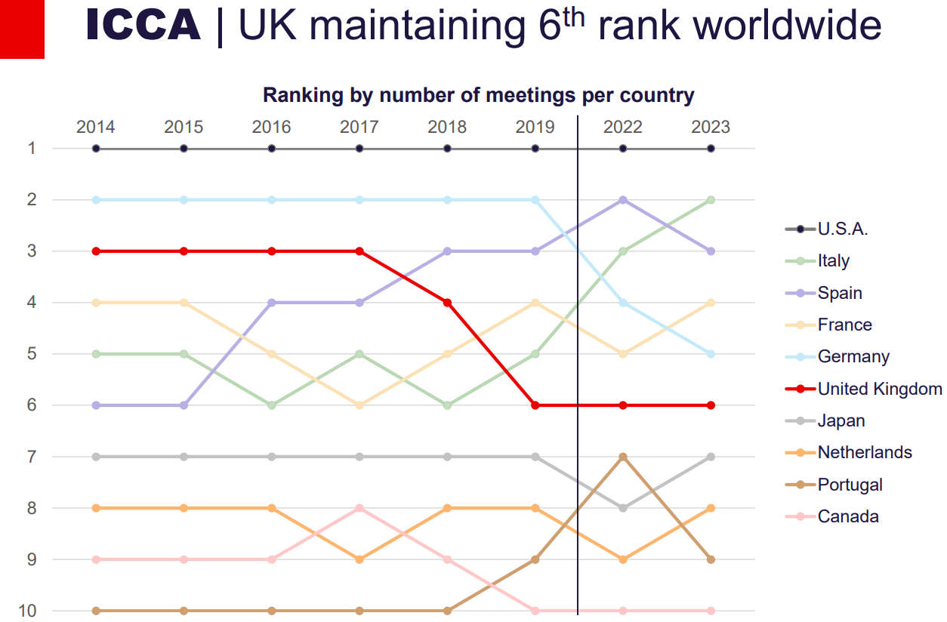
Figure1. ICCA Business Analytics Statistics Report 2023.

Top 10 Meeting Destinations
1. London, UK
2. Barcelona, Spain
3. Madrid, Spain
4. Berlin, Germany
5. Lisbon, Portugal
6. Amsterdam, Netherlands
7. Paris, France
8. Rome, Italy
9. Frankfurt, Germany
10. Munich, Germany
Figure2. Top 10 Meeting Destinations
Sophia's Garden Winter Magic Event is a wintertime event that seeks to involve people in a seasonal, suitable for families setting with a range of activities in the day. The event is designed to appeal to visitors of all age groups in the night as well, which includes attractions such as the Big Wheel and Santa's Grotto, as well as an ice bar, light shows, and live music.
The celebration was made because of its potential to meet the growing demand for focusing on communities and on engagement seasonal festivities. The festival celebrates Cardiff's vibrant cultural scene while adhering to seasonal customs and encouraging family bonding and local travel. The easily accessible, vast location in Sophia's Garden, near Cardiff's city centre, is suitable for large-scale gatherings outdoors. The celebration takes place throughout the peak holiday season, from November 15 to January 5, ensuring maximum visitor participation.
Sophia's Garden Winter Magic Event takes advantage of Cardiff's thriving hospitality sector, particularly during the winter months, by catering to locals, families, and tourists alike. Its strategic location, central concept, and distinctive features all point to its potential as a seasonal event.

Main Body

The Event Cycle

As indicated by TeamGantt (2024), the project life cycle is an organised plan that encompasses five essential stages that constitute project management—initiation, planning, execution, monitoring and control, and closure—and acts as a basis for executing projects smoothly from beginning to end.
The Event Cycle model covers every phase of managing an event, from idea to post-event evaluation, enabling full planning and execution (Bowdin et al., 2011). Every phase of "Sophia's Garden Winter Magic" will be thoroughly analysed to ensure effective and successful results.
An event concept gives an organised structure to planning in accordance with objectives, resulting in a unified, lasting memory that boosts branding and customer satisfaction (Piratex, 2023).
Sophia's Garden Winter Magic" attempts to create a family-friendly, joyous atmosphere by featuring attractions such as Santa's Grotto, a Ferris wheel, live music, and a lighting show. Creating SMART goals is an essential action for increasing clarity, motivation, and focus for event success (Bell, 2023). Also, another important step is identifying the target audience, such as families, couples, and travellers, while also assessing early feasibility for the premises, timing, and possible consumer demand.
An event planning covers every aspect of an event, including essential details like times, finances, location, marketing, and visitors, with the scope varied based on occasion scale but encountering similar core issues (Bridges, 2023).The following event planning phases will lead to the event's success: Firstly, it is essential to establish a precise budget that includes sources of income and major costs, such as entertainment and décor. Secondly, obtaining all required approvals, including health certifications and supplier licenses (Production Hire, 2024), is important to ensure compliance with regulations. Thirdly, setting up a marketing strategy using the four Ps (product, pricing, place, and promotion) is crucial to reaching a diverse market (Twin, 2024). Lastly, managing logistics, such as transport, easy access, and managing crowds, will enhance visitor satisfaction and health.
As noted by Good, (2024), during the stage of implementation (or execution), a planner organises and supervises all scheduled activities, handles logistics, interacts with stakeholders, checks progress, and solves any challenges to guarantee that everything works perfectly and effectively. For Sophia's Garden Winter Magic Event this entails preparing tourist attractions, staffing requirements for the event, and effectively monitoring visitor interactions. During this phase, important tasks include setting up equipment like the ice bar, light displays, and musical performance areas, coordinating employees and volunteers in charge of purchasing tickets, crowd flow, safety and security rules, and conducting immediate evaluations for tackling technical difficulties throughout the event, all of which are essential for the event to run smoothly.

The Monitoring and Control Phase involves monitoring the development of the project, evaluating finances, identifying concerns at an early stage, optimising effectiveness, and keeping open dialogue to guarantee the event attains targets and maintains within costs (Carroll, 2024).The Monitoring and Control phase of Sophia's Garden Winter Magic Event includes receiving spectator feedback, analysing revenue from ticket sales, and tracking the financial results to evaluate success while gaining insights for upcoming events. Furthermore, participation in the gathering of information, guest surveys, and budget assessment for efficient future strategy are all important operations.
In addition, the last part of the event includes closing outcomes, paperwork handover, contractual dismissals, and formalised closure notices. A post-project assessment evaluates achievements and opportunities for improvement to help guide future event success (Johansson, 2023). Sophia's Garden Winter Magic Event ensures that financial stability, logistical, and strategic elements have been settled during the closing phase, establishing a foundation for the events continued achievement and expansion in the following years.

Event Concept
Unique events became popular towards the end of the 20th century because of their strong influence on society, according to Fox et al. (2014), and they had to be effectively planned to achieve their goals.
Sophia’s Garden Winter Magic Event offers a festive experience in Cardiff with entertainment for all ages. Visitors will be introduced to a wintertime wonderland with outstanding daytime activities that includes Santa's Grotto with stories and gifts, a magical illumination tunnel, and a Ferris Wheel with stunning views of the park. At night, adults and couples can enjoy seasonal cocktails at the ice bar, live jazz, and piano performances. The event features light shows for photo opportunities, Christmas treats like mulled wine and cocoa, and special events such as a Christmas play and community carol singing.

Aim and Objectives of the Event

Sophia's Garden Winter Magic Event aims to create an enjoyable and welcoming winter event that caters to families, couples, and singles, improves relationships within the community, draws travellers, and markets Cardiff as a cheerful seasonal destination by engaging festive activities and partnerships with the community.
SMART event goals ensure positive results and advantages for everyone involved (Visit Monmouthshire, 2024).
Specific: Draw in around 700 people each day with different activities for every target audience. Measurable: The outcome will be determined by the sale of tickets and supplier attendance figures.
Achievable: Use Cardiff's joyful vibe and strategic location to attract visitors and residents alike.
Relevant: Provide entertainment appropriate for kids as well as adults.
Time bond: The event occurs from November 15 to January 5, including post-event evaluations following immediately after.

Event Management

To succeed in its goals, provide outstanding guest service, and maintain its competitiveness in the market, the event needs a wide range of planning, marketing, and operations resources and skills.
In the words of Getz and Page (2019), the EMBOK model covers five essential event management skills: administration, design, marketing, operations, and risk, emphasising practical, career-orientated education.
The event requires organisational skills for personnel and logistics cooperation, the ability to have good communication skills for managing teams and suppliers, and accounting skills for managing costs. Among the resources required are a group of volunteers, employees, and event organisers to manage different parts of the event, funding for location rental, equipment, and marketing.

Operational planning
An important part of event planning that has an enormous effect on an event's success is location choice (Location Direct, 2023). The conveniently located and expansive Sophia Gardens in Cardiff is perfect for this winter event because it is near the city centre and easily reached by public transportation for visitors and locals alike.
Important resources are needed for the event, including lights, snow machines, outside heaters, Ferris wheel equipment, and food stands providing seasonal meals. Also, to supervise events and help visitors, event leaders, general personnel, grotto actors, and vendors are needed.
Event planners need to control safety risks, analyse the viability of the location, and make emergency plans, especially when dealing with areas with significant dangers (HSE, 2024). Safety evaluations, emergency planning, on-site medical care, and crowd management by security at busy locations such the Ferris wheel and Santa's Grotto all prioritise security for guests at the event.
To guarantee a smooth, welcoming visit for every single guest, Sophia's Garden Winter Magic Event will provide easy reach of transportation and parking spaces, plenty of seating, a range of beverage options, and accessible amenities.

Market strategy
To successfully market Sophia’s Garden Winter Magic Event a strong marketing plan seeks to reach a wide range of people to ensure high participation and engagement.
Target Audience: Families looking for entertaining activities to enjoy with their young children; couples and singles in their 20s and 40s for pleasure in the evenings; locals of all ages for local gatherings; tourists interested in Cardiff's winter celebrations; and teens looking for exciting attractions.
Demand and Competition in the Market: 57% of Cardiff people join events involving a Christmas concept, indicating substantial demand for wintertime events (Solopress, 2019). Santa sightings, an ice bar, illumination displays, and live jazz music are some of the features that make ‘Sophia’s Garden Winter Magic’ unique.

Marketing Initiatives:
To achieve a profitable marketing strategy, the four Ps of marketing—product, pricing, place, and promotion—form a complex framework (Forbes, 2024).
Product: A spectacular wintertime event that includes live performances, crafts, Santa's Grotto, and the Big Wheel. ice bar, illuminated tunnel
Price: Reasonable price tickets with group and family discounts (e.g., £3 for Santa's Grotto, £5 for Big Wheel).
Place: Easily accessible, in the heart of Sophia Gardens.
Promotion: To attract an extensive audience, use influencer relationships, social media, email marketing, flyers and posters.

Event Budget

The event industry performs well; according to Bizzabo (2024), 60% of events currently take place in person, 35% online, and 5% in a mix of both.
As reported by Allied Market Research (2024), the international events industry is projected to rise at a 6.4% annual rate (CAGR) through 2023 and 2032, from a value of $1,135.4 billion in 2019 to $2,046.7 billion.
An event budget is an economic strategy aimed to monitor costs, set spending priorities, and analyse profits while trying to improve upcoming ways of budgeting (Bauer, 2023).
As shown in Figure 3, Knowland's (2024) stated that event planners are most worried about growing costs, with 46.3% experiencing this as their main problem and 21% referring to decreasing customer finances.
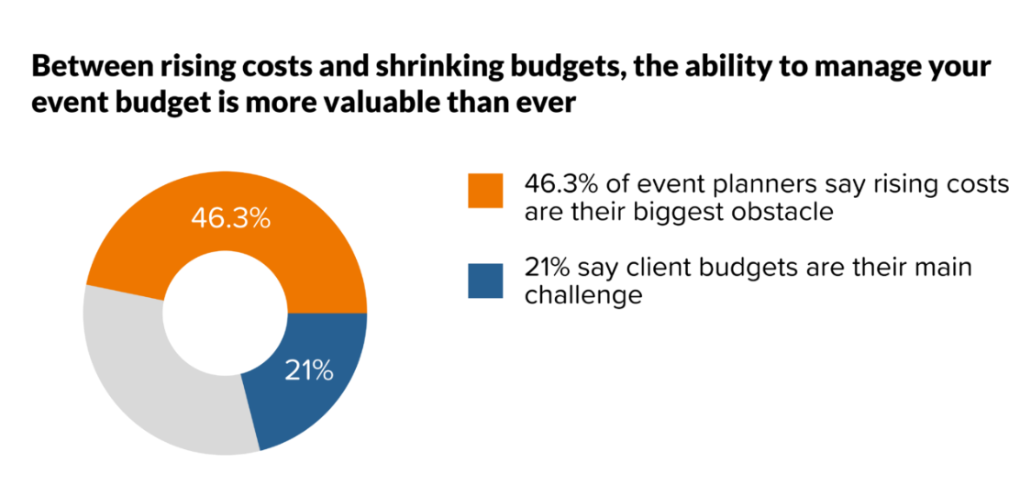
Figure 3.( Knowland, 2024)
As indicated in the table below Sophia Garden Winter Magic Event budgeting shows a total of £29.000 in expenses, which includes £4.000 for decorations, lights and entertainment, £5.000 for staff, £3.000 for advertising, and £3.000 for the set-up of the ice bar. A total of £36.000 is anticipated to be made, with rides (£12.000), merchant fees (£8.000), partnerships (£10.000), and food sales (£6.000) representing the main sources of revenue. By generating a profit of £7.000 with a profit margin of 19.44%, this guarantees financial stability. Using meticulous planning to ensure both success and profitability, the revenue generated can be invested in upcoming events.
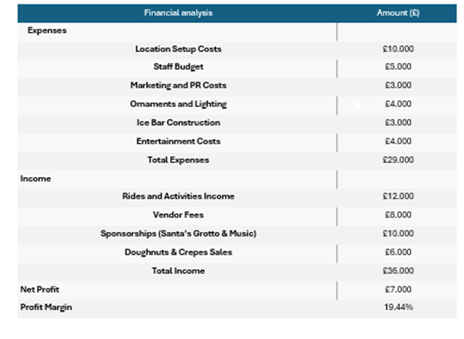
Figure 4. Financial analysis (Author’s work)

Industry trends

The event sector continues to evolve significantly because of new difficulties, trends, and their implications.
Sustainability represents one of the most recent trends in the event sector, including a priority on minimising waste, efficient illumination, and the adoption of recyclable products. Due to research from the Events Industry Council, these techniques can minimise waste by up to 80% and expenses about 20–30% (Rehman, 2024). Sophia's Garden will help to reduce its effect on the environment by reducing disposable plastics while offering facilities for recycling.

An important trend in the industry of events because of the COVID-19 is the use of hybrid models, which combine digital and physical elements, as seen in Figure 5, providing easy access and flexibility to new limitations. For generating fully immersive sensations, as in Figure 6, hybrid events take advantage of digital tools such as augmented reality (AR) wireless check-ins and real-time streaming (Mahadewi, 2022).

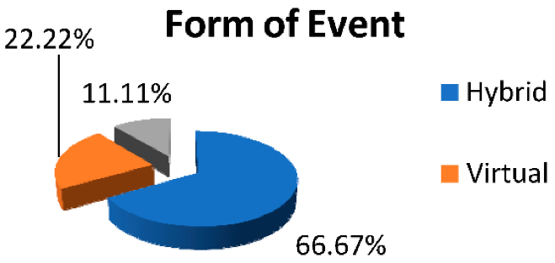
Figure 5. The Impact of the COVID-19 Pandemic on Organizing Events

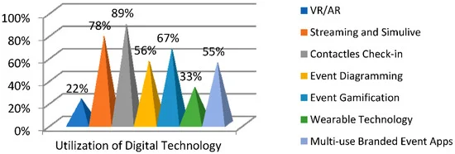
Figure 6. Utilization of Digital Technology

By engaging with worldwide viewers online, this trend allows Sophia's Garden Winter Magic Event to expand beyond Cardiff.
Diversity, inclusion, and accessibility are becoming more important in event planning as guests look for experiences that represent a variety of viewpoints, encouraging innovation, boosting decision-making, and promoting brand recognition (Speaker Agency, 2024).
Supplying a range of activities that accommodate every preference and accessibility requirement, such as family-friendly gatherings, an ice bar, and evening jazz, Sophia's Garden Winter Magic will undoubtedly cater to individuals of every generation.
By integrating significant industry trends like diversity through offering diverse events and sustainability via environmentally friendly methods, Sophia's Garden Winter Magic Event ensures the event stays accessible and engaging to people of all ages.

Situational and Cultural Considerations
The success of Sophia's Garden Winter Magic Event depends on several situational and cultural factors. Providing offers and family packages may increase affordability as economic conditions have significant effects on customer purchases (ONQOR, 2022). Because Sophia's Garden is an outdoor wintry event, it needs to account for unpredictable weather. Regardless of weather conditions, preventive measures like forecasting, sheltered places, warming areas, and essentials (hot drinks, blankets) will all help keep people experiencing safe and enjoyable moments (Graham, 2024).
By celebrating Welsh customs, like Christmas carols, local crafters, local cuisine, Welsh music, and language, Sophia's Garden Winter Magic Event in Cardiff embraces diversity in culture (Business Wales, 2024).

SWOT
Strengths
Santa's Grotto, an ice bar, and a Ferris wheel are just a few of the unique features that differentiate Sophia's Garden Winter Magic.
Collaboration with local businesses and the government creates links across communities and promotes the local economy (IOOE, 2024).
The event's heart of town Cardiff location guarantees accessibility for all attendees with advantages like no barriers, paths, and accessible areas that can fit participants of all abilities (Events, 2024).
Weaknesses
Uncertain wintertime weather might have an influence on the budget and activities that reduce participation (OUTCO, 2023).
The financial resources might be severely restricted by necessities like staffing, permits, attractions, and site rents (Hamilton, 2023).
Opportunities
Seasonal events' increasing popularity provides an advantage that boosts revenue, customer interaction, and opportunity for growth (Anthill, 2023).
Employing sustainable methods enhances reputation and brings in collaborators, sponsors, and visitors who embrace green ideals (Knupp, 2024).
Threat
Because competition is intense, comparable events, like Winter Wonderland, could turn back visitors.

Conclusion

The Sophia’s Garden Winter Magic Event reaches a broad demographic in Cardiff and abroad through effective planning and marketing. It increases its popularity and credibility through implementing trends in sustainability, digitalisation, and diversity. The event could evolve into a significant attraction, highlighting Cardiff's winter attractiveness while promoting travellers and community engagement with an established budget and goals.

References

Allied Market Research (2024) Events Industry Market Size, Share, Competitive Landscape and Trend Analysis Report, by Type, Revenue Source, Organizer and Age Group : Global Opportunity Analysis and Industry Forecast, 2022-2032 Available at: https://www.alliedmarketresearch.com/events-industry-market (Accessed: 5 November 2024).
Anthill (2023) Take Advantage of Seasonality in Our Industry Available at: https://anthill.co.uk/insights/take-advantage-of-seasonality-in-our-industry/ (Accessed: 7 November 2024).
Bauer, E, (2023) The Ultimate Guide to Event Budgets (Examples + Templates Provided). Eventmobi Available at: https://www.eventmobi.com/blog/event-budget-basics/ (Accessed: 5 November 2024).
Bell, S. (2024) SMART Goals Available at: https://www.mindtools.com/a4wo118/smart-goals (Accessed: 02 November 2024).
Bizzabo (2024) The Events Industry’s Top Marketing Statistics, Trends, and Data Available at:https://www.bizzabo.com/blog/event-marketing-statistics#:~:text=Here%20are%20some%20insights%20into,%25%20were%20in%2Dperson%20attendees. (Accessed: 5 November 2024).
Bowdin, G., Allen, J., O’Toole, W., Harris, R., McDonnell, I. (2011). Events management. (2nd ed.). Routledge
Bridges, S. (2023) How to Plan an Event: Event Planning Steps, Tips & Checklist Available at:https://www.projectmanager.com/training/how-to-plan-an-event#:~:text=An%20event%20plan%20defines%20how,fundamental%20challenges%20remain%20the%20same. (Accessed: 03 November 2024).
Business Wales, 2024) Promote the Welsh language and culture Available at: https://businesswales.gov.wales/tourism/promote-welsh-language-and-culture (Accessed: 7 November 2024).
Carroll, A. (2024) Project Management Monitoring & Control Phase Guide Available at: https://project-management.com/project-management-phases-exploring-phase-4-monitoring-control/ (Accessed: 02 November 2024).
Colston, P. (2024) OUTDOOR EVENTS ARE INDUSTRY’S BIGGEST CONTRIBUTOR TO UK ECONOMY Available at:https://accessaa.co.uk/outdoor-events-are-industrys-biggest-contributor-to-uk-economy/#:~:text=Events%20industry%20umbrella%20organisation%20UKEVENTS%20has%20announced,found%20to%20be%20the%20biggest%20financial%20contributor (Accessed: 01 November 2024).
Cvent (2024) Cvent Announces Top Meeting Destinations and Top Meeting Hotels in Europe for 2024 Available at:https://www.cvent.com/en/press-release/cvent-announces-top-meeting-destinations-and-top-meeting-hotels-europe-2024 (Accessed: 01 November 2024).
Donald Getz, Stephen J. Page, (2016) Progress and prospects for event tourism research, Tourism Management, Volume 52. Available at: https://www.sciencedirect.com/science/article/pii/S0261517715000679?pes=vor#sec1(Accessed: 31 October 2024).
Events (2024) Important Tips for Planning an Outdoor Event Available at: https://events.org/events101/Outdoor-Event-Planning-Tips- (Accessed: 7 November 2024).
Forbes (2024) The 4 Ps Of Marketing Available at: https://www.forbes.com/advisor/business/4-ps-marketing/(Accessed: 8 October 2024).
Fox, D. et al. (2014) Doing events research: from theory to practice. Routledge: Oxford
Getz, D. and Page, S. (2019) Event studies: theory, research and policy for planned events. 4rd Edition. Routledge: Oxford Available at:https://www.taylorfrancis.com/books/mono/10.4324/9780429023002/event-studies-stephen-page-donald-getz (Accessed: 02 November 2024).
Good, L. (2024) 5 Phases of Project Management Life Cycle | Complete Guide Available at: https://project-management.com/project-management-phases/ (Accessed: 02 November 2024).
Graham, J. (2024) Risk Mitigation at Outdoor Events: Key Tips for Safety & Security Available at: https://blog.ehab.co/risk-mitigation-at-outdoor-events-key-tips-for-safety-security (Accessed: 7 November 2024).
Hamilton, (2023) 10 BUDGET CONSIDERATIONS FOR OUTDOOR EVENTS Available at: https://blog.hamilton-ex.com/blog/budget-considerations-for-outdoor-events (Accessed: 7 November 2024).
HSE (2024) Large-scale temporary outdoor events near to major accident hazards Available at:https://www.hse.gov.uk/event-safety/large-scale-temporary.htm(Accessed: 4 November 2024).
IOOE( 2024) The Power of Community in Business and Enterprise Available at: https://ioee.org.uk/2024/04/04/the-power-of-community-in-business-and-enterprise/ (Accessed: 7 November 2024).
Johansson, J. (2023) Mastering the project life cycle: Your complete guide (+ examples) Available at: https://resourceguruapp.com/blog/project-management/project-life-cycle#:~:text=Phase%203:%20Execution%20(or%20implementation,team%20meetings%20to%20share%20progress (Accessed: 02 November 2024).
Knowland's (2024) Meeting Planner Survey: 2024 State of The Meetings Industry Available at:https://get.knowland.com/2024-state-of-the-meetings-industry(Accessed: 5 November 2024).
Knupp, D. (2024) Sustainability in Events: Strategies for Reducing Waste and Promoting Eco-Friendly Practices Available at: https://personifycorp.com/blog/sustainability-in-events/#:~:text=Incorporating%20eco%2Dfriendly%20strategies%20into%20events%20helps%20build,and%20attendees%20who%20align%20with%20their%20values.( Accessed: 7 November 2024).

Location Direct (2023) Importance of Venue Selection in Events Available at:https://www.locationsdirect.co/news/importance-of-venue-selection-in-event/ (Accessed: 4 November 2024).
Mahadewi (2022) "Hybrid Event: Utilization of Digital Technology in Organizing Events during the COVID-19 Pandemic in Indonesia" Proceedings 83, no. 1: 53 Available at: https://www.mdpi.com/2504-3900/83/1/53 (Accessed: 6 November 2024).
Neves, M. (2024) The State of Association Meetings Available at:https://meetings.skift.com/2024/05/31/the-state-of-association-meetings/#:~:text=Destinations%20Losing%20Out%20on%20Association%20Meetings&text=The%20country%20hosted%20170%20meetings,more%20of%20their%20market%20share. (Accessed: 01 November 2024).
ONQOR (2022) What are the Economic Factors Affecting Consumer Behaviour? Available at: https://onqor.com/blog/digital-marketing/economic-factors-affecting-consumer-behaviour/ (Accessed: 7 November 2024).
OUTCO( 2023) How Unusually Warm Weather Patterns Impact Commercial Winter Gritting Available at: https://www.outco.co.uk/weather-patterns-impact-commercial-winter-gritting/(Accessed: 7 November 2024).
Piratex (2023) Event Concept: What Is It and Why Is It Essential to Have One? Available at: https://piratex.com/blog/event-concept-important/(Accessed: 02 November 2024).
Production Hire (2023) A 2023 guide to understanding your outdoor event requirements Available at: https://productionhire.com/news/outdoor-event-requirements/ (Accessed: 03 November 2024).
Rehman, A. (2024) Sustainable events a priority for African exhibition organisers Available at:https://www.exhibitionworld.co.uk/node/324759#:~:text=Research%20conducted%20by%20the%20Events%20Industry%20Council,Exhibition%20Organisers%20(AAXO)%2C%20Devi%20Paulsen%2D%20Abbott%20said: (Accessed: 6 November 2024).
Silvers, J.R., & O'Toole, W. (2020). Risk Management for Events (2nd ed.). Routledge Available at: https://www.taylorfrancis.com/books/mono/10.4324/9780429291296/risk-management-events-julia-rutherford-silvers-william-toole (Accessed: 01 November 2024).
Solopress (2019) Holding a Christmas event. Available at: https://www.solopress.com/blog/special-occasions/holding-a-christmas-event/ (Accessed: 7 October 2024).
Speaker Agency( 2024) The Importance of Diversity and Inclusion in Event Planning Available at: https://www.speakeragency.co.uk/blog/the-importance-of-diversity-and-inclusion-in-event-planning (Accessed: 7 November 2024).
TeamGantt (2024) The Project Life Cycle Explained: 5 Phases of Project Management Available at: https://www.teamgantt.com/blog/5-crucial-project-management-phases (Accessed: 01 November 2024).
The Business of Events (2024) Unlocking Growth in the Global Events Economy Available at:https://the-business-of-events.com/2024/10/30/uk-events-report-published-industry-valued-at-61-7-billion/ (Accessed: 01 November 2024).
Twin, A.(2024) They Are & How to Use Them Successfully Available at:https://www.investopedia.com/terms/f/four-ps.asp#:~:text=The%20four%20Ps%20or%20marketing,or%20service%20to%20the%20public. (Accessed: 03 November 2024).
Visit Britain (2024) Business events research Available at:https://www.visitbritain.org/research-insights/business-events-research(Accessed: 30 October 2024).
Visit Monmouthshire (2024) Event aims and objectives. Available at: https://www.visitmonmouthshire.com/information/events-management/aims(Accessed: 4 November 2024).

I confirm that I have not used any AI tools in the research and creation of this
assignment. I confirm that I have not presented any AI generated materials as my own
work. I confirm I have copies of my drafts, notes, and other resources I used, which I
may be asked to provide in evidence.

