STUDENT: MONDAY EROMOSELE {1916732}

MODULE: ACADEMIC AND EMPLOYABILITY SKILLS

TERM: JUNE {WEEKEND 2ND TERM}

SCHOOL: UNIVERSITY OF WALES, LONDON CAMPUS.

LECTURER: NADEEM MIRZA

TABLE OF CONTENTS
- Introduction …………………………………………………………………….1
- SWOT Analysis ………………………………………………………………… 2
- SWOT Analysis table …………………………………………………………3
- Time Management using SMART Goal……………………………….4
- Covering letter ………………………………………………………………….5
- Summarising and Paraphrasing ………………………………………..6
- Conclusion…………………………………………………………………………7
- Appendix …………………………………………………………………………..8

INTRODUCTION
As a way of measuring my academic progress, I am writing an academic reflective report on my module to demonstrate my understanding, experience and its application to my academic and personal life since I gained admission into the University of Wales, London Campus. This will enable me to demonstrate, how well they have improved my skills in Personal/Professional Development Plan (PPDP), applying SWOT analysis, time management/SMART goal setting, covering letters, summarising and paraphrasing to avoid plagiarism in my academic writing and a lot more.
I was struggling with my Personal/Professional Development plan (PPDP) in life, prior to my admission into the University of Wales, London Campus in February 17th 2020. At a point, I realised the need to upgrade my knowledge, sharpen my skills, develop my personal life and career so as to be relevant in this modern society of today. A friend who recently graduated from the University of Plymouth with Bachelor degree in Business and Management encouraged me to take this course that I am still very brilliant, that he is very sure I will come out in flying colour. Initially, I was getting scared generally, if I could still coup with learning, after so many years I stopped schooling, especially combining studies and work but at point I choose to give it a trial by seeking for admission to this University of Wales.
SWOT ANALYSIS (STRENGHTS, WEAKENESSES, OPPORTUNITIES & THREATS)
One of the most beneficial topics to me that was taught during first term was SWOT analysis (Strengths against Weaknesses, Opportunities against Threats). At the beginning of the class, I was not comfortable or confident if I would catch up, what the module was all about and how it would help improve my life and career but I was determined to listened to the lecture attentively with full concentration and asking question at interval of which the lecturer was happy with me because my questions were very sensible and interesting. The lecturer was more than happy providing answers to all my questions. This also motivate my co-students to be asking questions too in the areas they were not cleared.
As a matter of fact, at end the of the lecture the knowledge I acquired was massive and as a result, I was able to apply what I am learning towards Personal/Professional Development Plan (PPDP), using SWOT analysis to analysed and recognised my strengths against my weaknesses and opportunities against threats. It has helped me to know where I am, the strengths I have acquired and where I want to be and those skills, knowledge and qualification preventing me as my weaknesses. It has further helped me to recognise the opportunities awaiting me out there, when I eventually acquire these skills, knowledge and qualification. Threats are also part of the things my eyes were open to, which help me to prepared and plan for them ahead of time.
SWOT Analysis may be a vital arranging system utilized in assessment of an organization, an individual, an arrangement, a project or a trade movement. SWOT Analysis is subsequently a noteworthy instrument for circumstance investigation that helps the supervisors to recognize organizational and natural variables. SWOT Analysis has two dimensions: Internal and outside. Inner measurement incorporates organizational variables, too qualities and weaknesses, external measurement incorporates natural components, also opportunity and threats. BRAD, S. & BRAD, E. (2015).
SWOT Analysis consist of internal factors (Strengths and Weaknesses) and external factors (Opportunities and Threats), as shown on the below table:
STRENGTHS | WEAKNESSES
- Qualifications  - Experience  - Knowledge  - Good personal attitude  - Motivation/skills | - Gap in my qualifications  - Gap in my experience  - Gap in my knowledge  - Having poor finance  - Other personal weakness
OPPORTUNITIES | THREATS
- Business opportunities  - Scholarships/student loan  - Academy opportunities  - Elimination of International trade barriers | - Government austerity plan  - Competition from rivals  - Unfavourable economic condition due to COVID-19  - Increase trade barriers

TIME MANAGEMENT USING SMART GOALS
Time management using SMART goal setting was another beneficial topic to me which I initially know nothing about. At the beginning of the lecture, mere hearing the name of the topic, my interest was seriously aroused and I was so keen to know all about it. In time management, we were taught how to manage our time towards achieving any task we have set as goal. I came to realise that time management is very paramount in achieving any task. After gaining this knowledge, I have been applying it, using “to do list” setting my “to do list” according to their urgency or important, not urgent or less important and all other needs that did not require immediate action while setting urgent needs as top priority.
I now have a clear understanding of time management and goal setting using SMART goal. After our lecturer have taught and analyse the topic to us with so many questions and answering section from me and my co-students, the topic was now very clear to me. I have now learnt how to manage my time and setting goals using:
SMART GOAL S – Specific
M – Measurable
A – Achievable
R – Relevant
T – Time
During this lecture, I have learnt to specify my goal, knowing what exactly I am setting my goal on and set a clear goal, measuring the space, from what date to what date this can be achieved. I have also learnt to analyse and evaluate the goal to ascertain it is achievable. How relevant is the goal that I have set to me in line with my growth at that point in time. Managing my time towards my goal by setting time on my daily tasks that will eventually lead to weekly or monthly or yearly result toward achieving the goal I have set.
Smart goals are composed utilizing the following guidelines being: 1) Particular – characterize precisely what is being pursued? 2) Quantifiable – is there a number to track completion?, 3) Feasible - can the objective be accomplished?, 4) Realistic – doable from a commerce point of view, and 5) Timely – can it be completed in sensible sum of time? (Williams, 2012). https://absel-ojs-ttu.tdl.org/absel/index.php/absel/article/view/90/86.
COVERING LETTER
Prior to this lecture on covering letter, I thought I know it all and there was nothing new to learn about covering letter. In the past I have written so many covering letter with my CV to various companies when I was jobless and I never knew or realise why most of them never short list me among candidates to be interview but I was surprise to find out most things I do not know about covering letter such as the opportunity it provide for me to selling myself to the prospective employers, find out to whom I am writing to and address it as such “Dear Mr Wilson” instead of “To Whom It May Concern”.
During this lecture, I clearly understood how I should structure my covering letter to a prospective employer to catch the employer’s attention, interest and probably short list me for an interview. Now I have fully realised, after my introduction paragraph, the need and important of selling myself to the prospective employer by describing how my previous experience, skills, extra mile efforts and abilities will allow me to meet the company’s goals, will pave way for an opportunity for me to be shortlisted for an interview or attract prospective employer’s attention, as it gives an impression of the kind of person I am. It will also give me the opportunity to describe how my skills and experience can help the company, elevate their progress to the next level. I now clearly understood why final paragraph should be call to action and thanking them for spending time to read my covering letter as it is my final opportunity to request for an interview to speak further on my abilities and how I will be a great asset to the company’s progress. During this lecture, I also know five things I should avoid while writing a covering letter.
In other to demonstrate how well this lecture has changed my writing covering letter skill, I submitted my CV and a covering letter to Digitex Technologies Company recently and the email feedback I got was amazing. A screen shot of the email is attached in the appendix below. I got the job even before I was interviewed. I would proudly say without missing words that, our lecturer Nadeem Mirza for the module in 2nd term is one of best Lecturer University of Wales, London Campus has employed and I thank him for using his skills, experience and abilities without reserve to make sure we all make progress in the module in flying colours.
Covering letters are utilized for clarification of sending encased reports, for underlining that there exist those papers conjointly for reminding imperative data or fair keeping in touch with a recipient. Covering letters are proofs of better than average conduct what implies that in case a individual does not compose a covering letter when he or she needs to send some documents it may be respected as a sign of being impolite. Missing of a covering letter seem moreover causing other issues like putting absent gotten reports and conceivable misfortune. Fundamental reason of covering letter joined with CV is to attract the reader to be willing to examine accompanied curriculum vitae. As covering letter is exceptionally frequently studied at to begin with, it may be a way how to offer oneself by indicating out his or her qualities there. It may be a useful tool for highlighting interface within the post and extending or emphasizing important focuses from educational modules vitae, particularly these which may well be vague for the primary time or which could help to get the job. An applicant has also expedient opportunity to indicate his or her ambition to participate at the interview. Source: http://candocareer.com/images/cover-letter-samples/thank-youletter-sample.gif (accessed on 29/08/2020).
SUMMARISING AND PARAPHRASING
Finally, summarising and paraphrasing was another important part of this module that has improved my academic writing greatly. Prior to my admission into the University of Wales, I do not really know much about paraphrasing and a little about summarising. When I saw it as part of the topic that will be treated during last term and this term, I knew it is a topic that will greatly improve my academic writing especially when writing my assessment and making references to various recognised authors. I pay special attention to the lecturer and asked several question in the areas I am not too clear. During the lecture, I now clearly understood that paraphrasing the work written by someone else is very essential while writing my assignment to avoid plagiarism and get penalised for it by the examiner. During the lecture, I was able to understand that while making citation or reference to someone’s work I have to read and understand the text and rewrite them in my own words without changing the meaning but demonstrate my understanding of the text and my ability to convey this same information. I was able to understand the danger and consequents behind copying someone else’s work as your own without any changes or acknowledging the author. I was also able to understand clearly how to summarise my academic text/writing by expressing most important facts or idea about someone or something in clear and short form.
University students are anticipated to maintain a strategic distance from plagiarism by citing sources and paraphrasing suitably. Their composed work, in any case, regularly contains “patch writing”, a formative organize of composing that includes deleting/replacing words and/or changing structures in replicated writings (Howard, 1995). Nine university instructors and 66 of their understudies reacted to studies tending to recognitions of summarizing and quotation and suggestions for creating these abilities. Reactions uncovered varieties in discernments of worthy rewording, especially for fix composing. Members prescribed rewording workshops or online courses to supply more unequivocal instruction and direction for both lecturers and students. Source: https://journalhosting.ucalgary.ca/index.php/ajer/article/view/55730 (accessed on 29/08/2020).
CONCLUSION
The knowledge I have acquired so far in the above mention topics and a lot more since the beginning of my course (certificate in higher education for the workplace) in University of Wales, London campus has transformed me tremendously within these two terms. I am so much grateful to our dedicated and experienced team of lecturers who have put in extra mile efforts to make sure we all come out in flying colours at the end of this course and of course also to the school management for all their support towards our studies.

Reference
BRAD, S. & BRAD, E. (2015).
Source: https://absel-ojs-ttu.tdl.org/absel/index.php/absel/article/view/90/86 (accessed on 28/08/2020)
Source: http://candocareer.com/images/cover-letter-samples/thank-youletter-sample.gif (accessed on 29/08/2020)
Source: https://journalhosting.ucalgary.ca/index.php/ajer/article/view/55730 (accessed on 29/08/2020)

APPENDIX
Attached below is a response from my covering letter sent to Digitex Technologies Company.
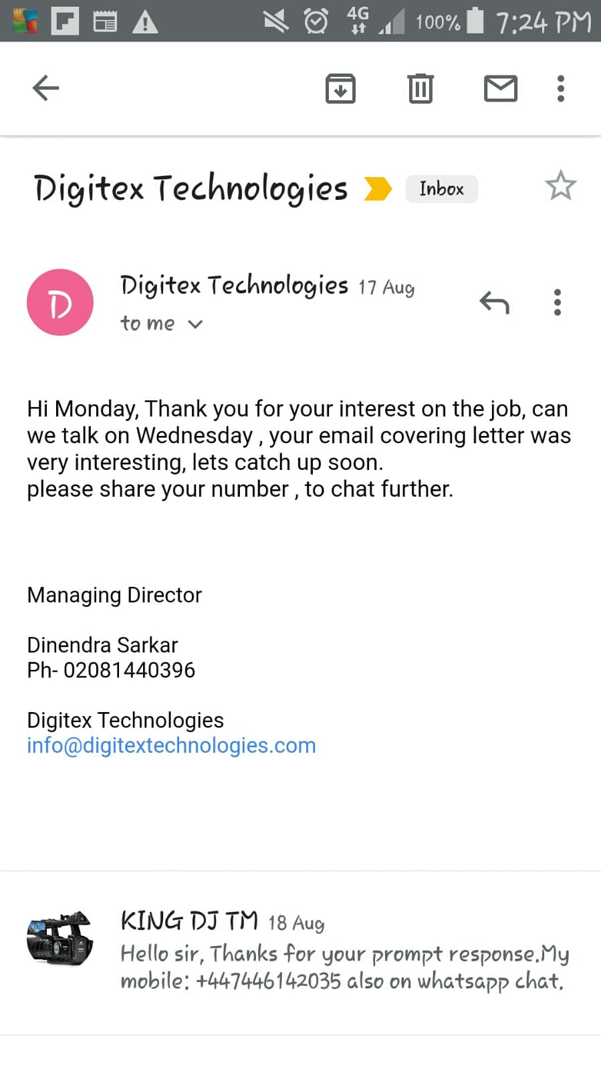
Some in class activities are: In this section below, each student were told to do presentation exercise which I participated on and our lecturer was impressed with my presentation skills.

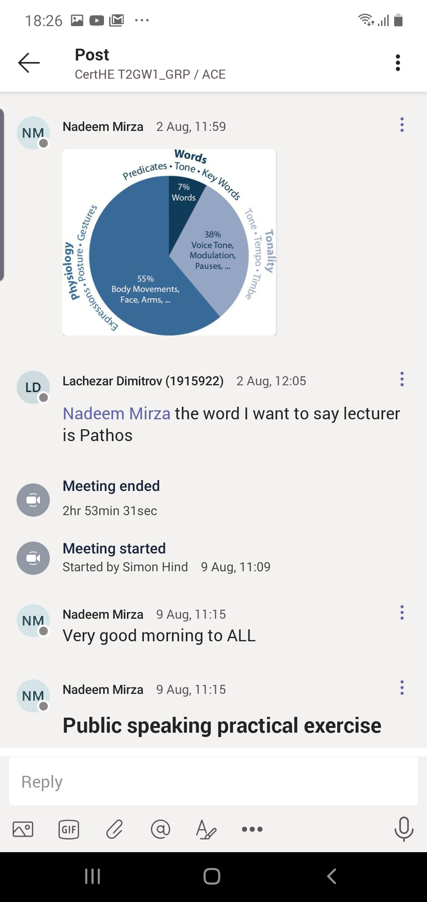
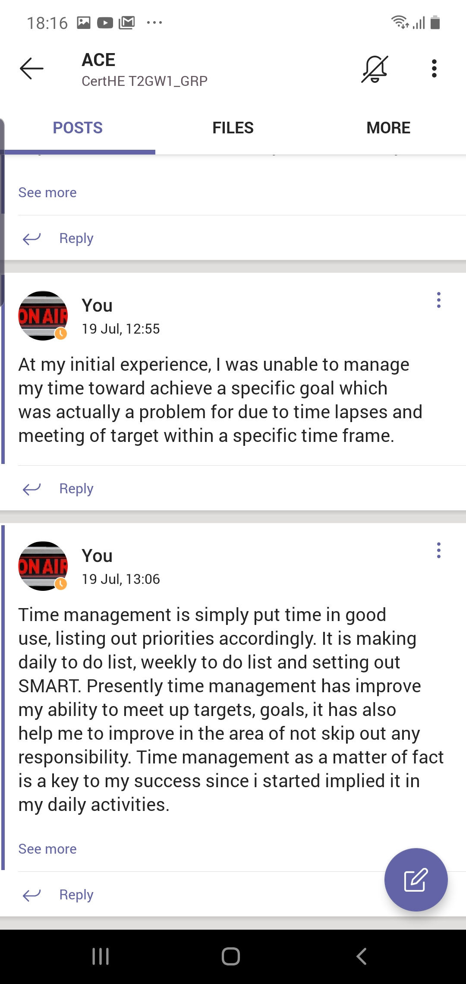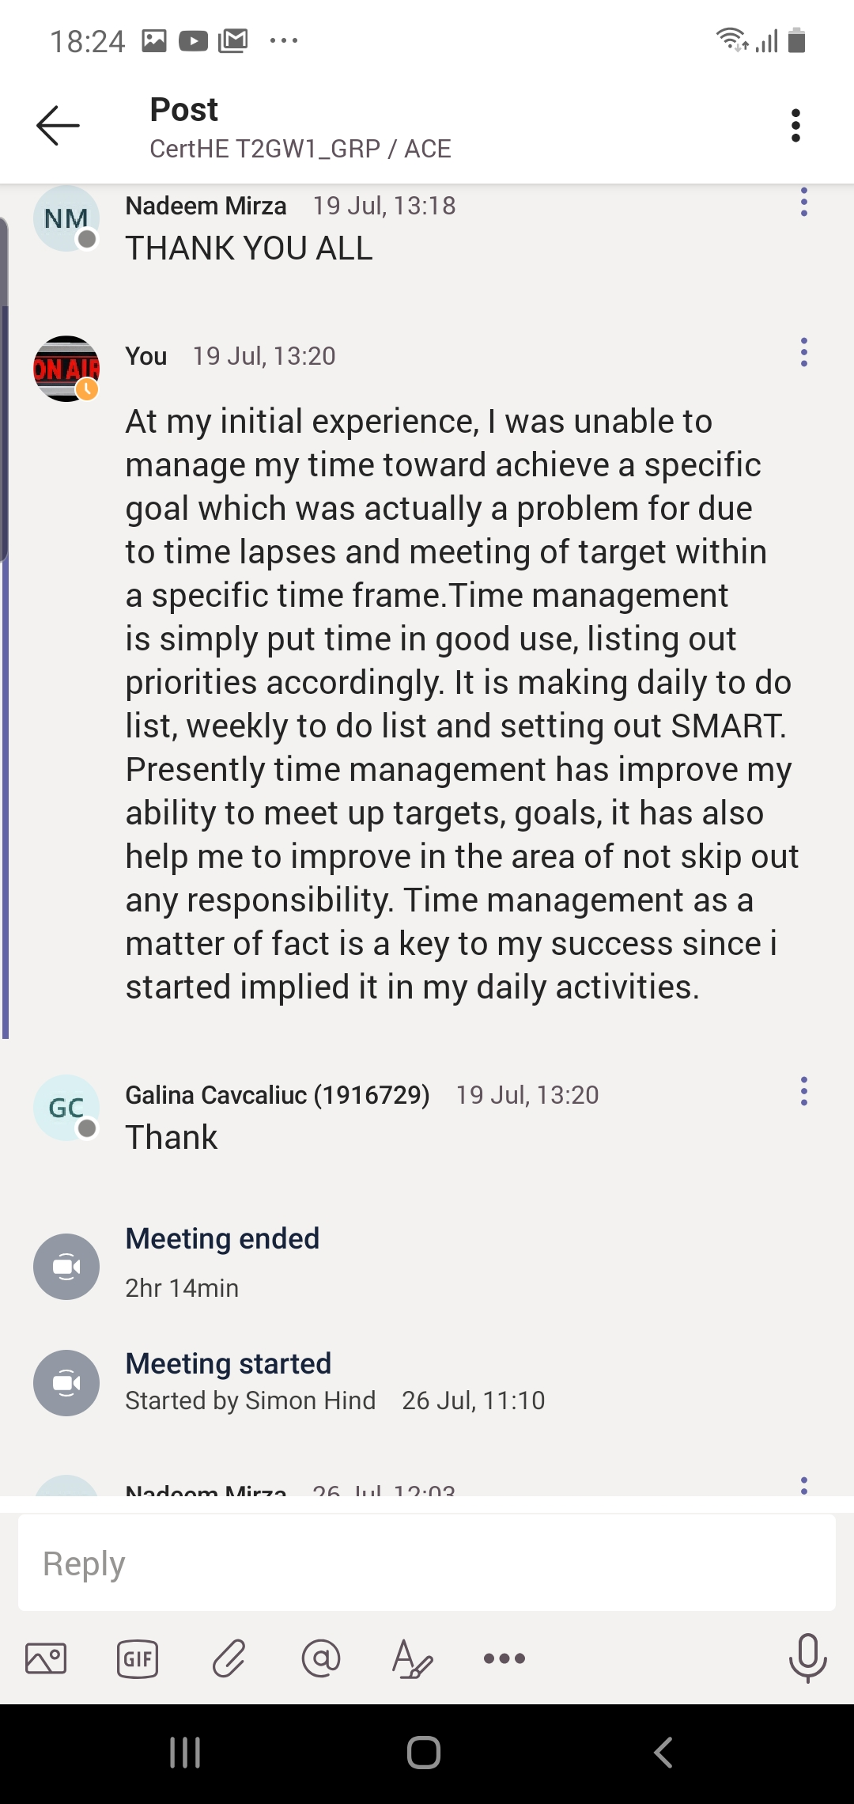

The above are the reflective exercise we carried out during the class section.

