Application Development Assignment

Christine Woods 1704446

Application Development ACCA5012

Development and creation of applications

Christine Woods 1704446

Kemi Ademoye

School of Applied Computing

University of Wales Trinity Saint David

^{4th May} 2020

Declaration by Christine Woods

The work of this report completed under the supervision of Kemi Ademoye. I declare that this report is the product of my own work and is not being submitted for any other degree etc.



Acknowledgments
- Kemi Ademoye – UWTSD Lecturer

1. Introduction

This assignment will demonstrate understanding when using concepts, principles and technologies for the implementation of applications.
The application will show a database for the Medicines Management Team to be able to view a list of patients with their details, a list of Clinics with the dates of the clinics and the patients that are in those clinics and a list of the procedures that will be carried out and by which drug companies. CRUD functionality will be used along with search options.
Visual Studio – the database used for this assignment is v2

Contents
1. Introduction 5
1. Requirements 7
Brief introductory of the application software implemented 7
Main functional requirements/features of this application 7
Brief introduction to the web application, its purpose and subject matter, who would use it and how it would be beneficial 7
2. Design and Implementation 8
The main design features 8
The main classes used 8
The main controllers used 8
3. Screenshots of Web Application 9
Home Page 9
Clinics Page 10
Procedures page 10
Privacy page 10
Attributions page 11
4. Evaluation 12
Expectation 12
Testing and Evaluation 12
Validation testing 13
5. References 14

Requirements

Brief introductory of the application software implemented

The software requirements for this application will be the use of CRUD (Create, Read, Update and Delete) functionality to allow the user to update the application by making changes, editing the existing information or creating a new or deleting a record.
For implementation of the application three tables normalized to 3NF [1] however, if this application were to be implemented for use within Medicines Management it would require sufficient tables to allow for better interaction of the database. Data used for this has been taken from a random generator site [2]

Main functional requirements/features of this application

1. The ability to create new records
2. The ability to update existing records
3. The ability to view existing records

4. The ability to delete existing records

Brief introduction to the web application, its purpose and subject matter, who would use it and how it would be beneficial

Currently the Medicines Management team do not require access to find out who is having which operation or the code that is used but long term this application could be rolled out to be used by numerous departments. It would need updating with many more tables to capture the amount of information required. For example coding would have access to the daily operations and be able to see the codes used in costings for procedures. Medicines Management Pharmacists would be able to view the daily procedures, reviewing the intended medications that may be used and finding cheaper alternatives. This would entail a much wider data base for each department but the structure/idea would be the same. With future development it would assist with costings for the Health Board.

Design and Implementation

The main design features
- Secure login
- Ability to use CRUD operations
- MVC Controllers [3]

The main classes used
- Start up where all of the services required by the application are configured

- Entity class Patients – using CRUD functionality the user can see the details of each patient and which procedure they are having by the NHS number

- Entity class Clinics – each clinic that is running shows a list of which patient is having that procedures and which patient is in that clinic

- Entity class Proceedures- each procedure gives the codes and patient that is having the procedure

The main controllers used
- ClinicsController

- HomeController

- PatientsController

- PreoceeduresController

3. Screenshots of Web Application

Home Page
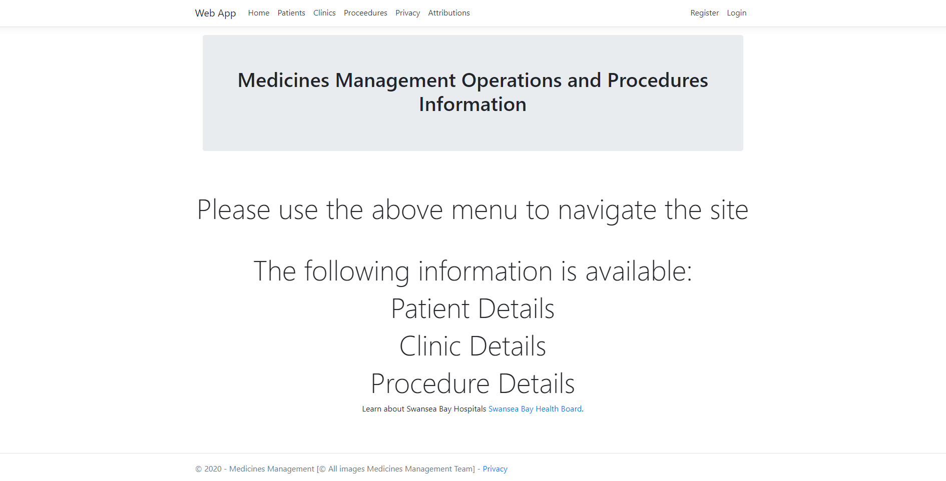
Patients Page
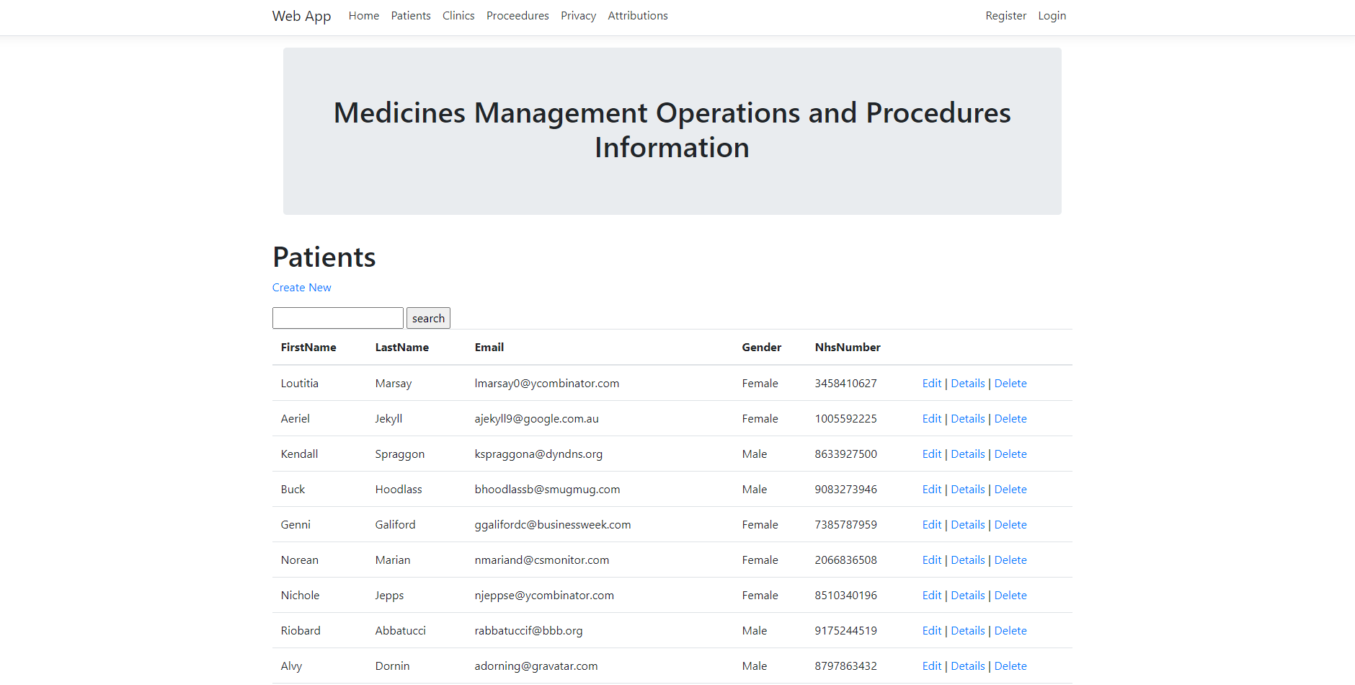

Clinics Page
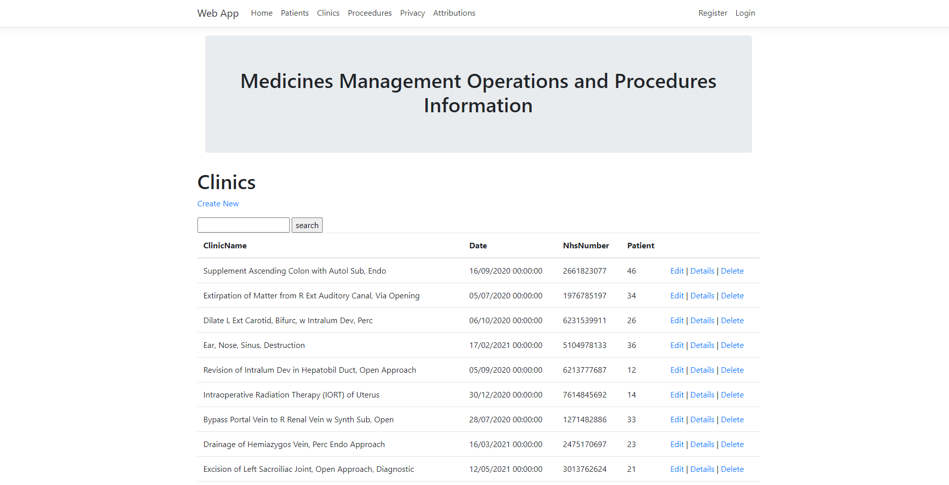

Procedures page
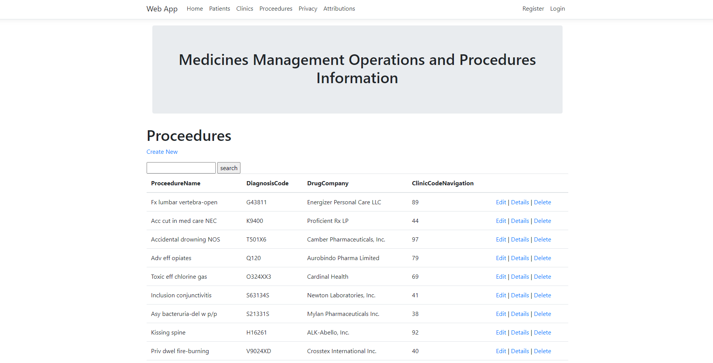

Privacy page
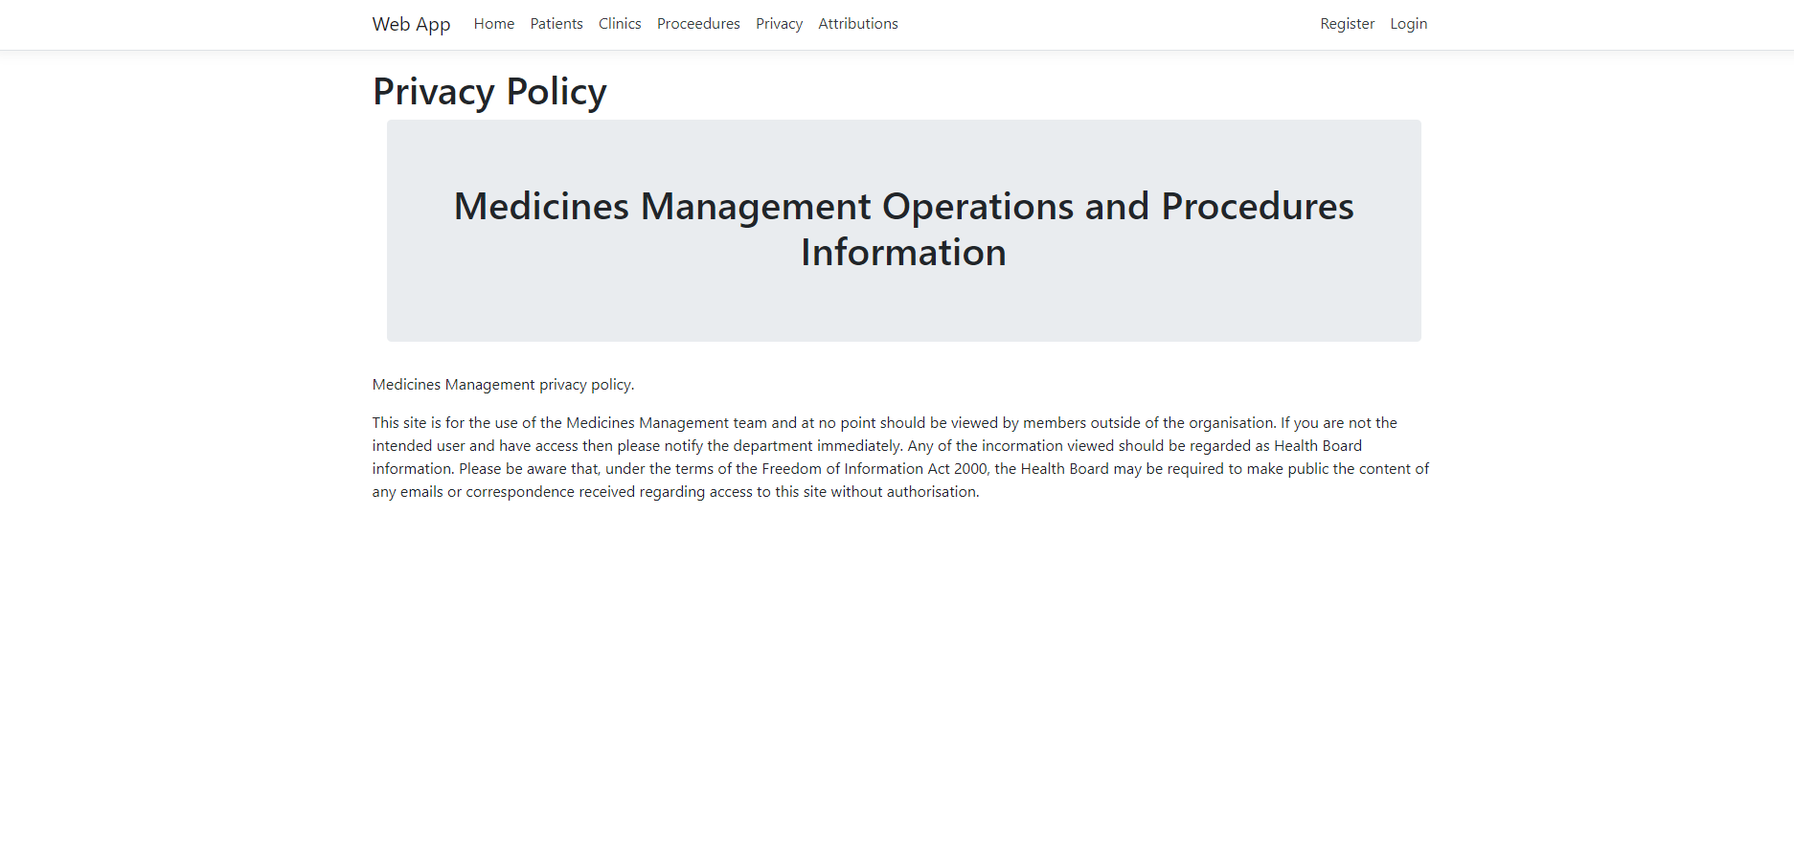

Attributions page
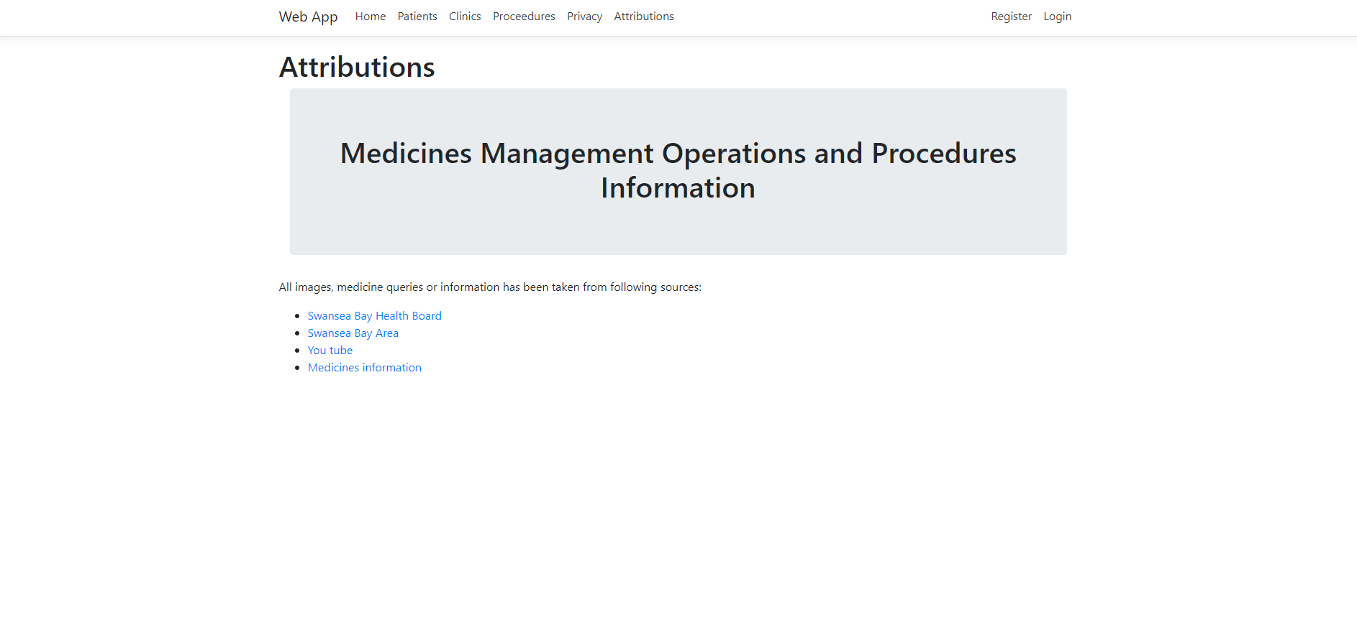

4. Evaluation

The following test case was performed on the application showing the results, identifying areas for future improvements.

Expectation

On opening the database there should be a log in feature to maintain constant security against threats from malicious behavior. It would benefit from two log in features, one for admin to make changes and the other as a view only screen to ensure that unnecessary changes could not take place.
Each page should allow CRUD operations of each data entry and data view options which also allows for interaction with other pages. [3]
When the application is opened there is a log in option allowing for application security, testing of the app allows users to view the information without logging in, this is not secure and requires update.

Testing and Evaluation

On review of the Patients page it shows the required information regarding a patient with good CRUD features. It does not give an option to search for a patient which is a fundamental requirement for a web application and would need to be implemented.
On design of the data base insufficient foreign key relationships were implemented therefore not allowing anything other than the patient information to be seen. Update to the tables and the relationships would allow the user to see if the patient had any clinics or procedures.
Again on the Clinics page it does not show the patient details but only the NHS number, a better search facility or relationship would allow the information to be more meaningful. The date field gives a date without any order, there should be a filter option to show the dates in order.
The Proceedures page lists the procedures but not who is having them. It shows the clinic that the procedure will be held in by number but not by clinic name.

Overall the functionality would require update to allow the user to search and also the database relations would require updating to join the tables giving a better view of which patients were having which procedure in which clinic. For example a table showing the drug companies, the drugs they supply, the cost and the alternatives would enable the Pharmacist to evaluate the costs and implementations in order to make the changes.

Unfortunately when using Visual Studio if the database implemented is not set up correctly to start with then later update is a near impossibility without deleting or creating a new data base.

Validation testing

On testing each of the pages the “Create New” button allows insertion of records.
The validation will not allow for duplication of records however it will allow for records to be updated with incorrect information.
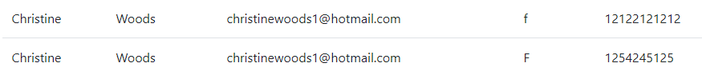
For example the above insertion has allowed for duplicate name and email address and has also allowed F or f for the gender input which should have be “Female”. It has also allowed an incorrect NHS to be implemented.
These could have been stopped if originally added into the database create tables SQL statements.

The below image shows the database working correctly by not allowing the creation of a new patient as the data has not been inputted correctly
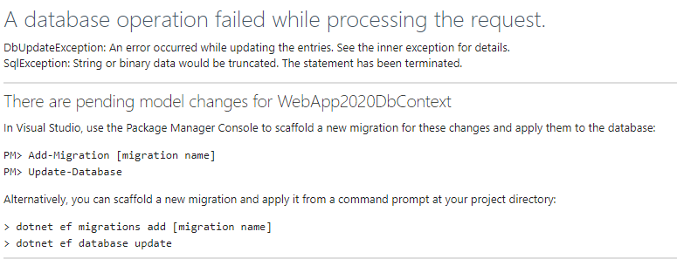

5. References

[1] | https://www.guru99.com/database-normalization.html#3, "What is Normalisation?," Guru99, 2020. [Online]. [Accessed 14 April 2020].
[2] | Mockaroo, "Mockaroo," Mockaroo, 2020. [Online]. Available: https://www.mockaroo.com/. [Accessed 17 May 2020].
[3] | W. Schools, "SQL Tutorial," Refsnes Data, 1999-2020. [Online]. Available: https://www.w3schools.com/about/default.asp.
[4] | Microsoft, "Clusteres and Nonclustered Indexes Described," [Online]. Available: https://docs.microsoft.com/en-us/sql/relational-databases/indexes/clustered-and-nonclustered-indexes-described?view=sql-server-ver15.
[5] | "GeeksforGeeks," [Online]. Available: https://www.geeksforgeeks.org/distributed-database-system/.
[6] | A. G. Taylor, SQL for Dummies, London, 2006.

marking criteria and Student FEEDBACK

This section details the extent to which the assessment criteria are demonstrated by you, which in turn determines your mark. The marks available for each category of skill are shown. Lecturers will use the space provided to comment on the achievement of the task(s), including those areas in which you have performed well and areas that would benefit from development/improvement.

Common Assessment Criteria Applied (Assignment 2) | Marks available | Marks  awarded
1. Engagement with Literature Skills

2. Knowledge and Understanding Skills

3. Cognitive and Intellectual Skills

Overall, a good evaluation has been provided, but the scope of the test cases needs to be expanded upon. The limitations of the application has limited what test cases you can perform. However, you have correctly identified functionality that does not work and the limitations of the application. (Grade mark: 56.67%) | 30 | 17
4. Practical Application Skills

A satisfactory attempt. There is, however, room for improvement. Good, simple database design but it requires at least one more table to be efficient and normalised. Although, you have customised some of the static views for the Home Controller, for the views connected to the database have generally relied on the scaffolding functionality provided by VS and I would have liked to see you extend some of the functionality of the application. As you have left the default views created by VS, it means members of the public can view, edit, and delete data records. For the nature of the application created, authentication and authorisation is needed. (Grade mark: 46.67%) | 60 | 28
5. Transferable Skills for Life and Professional Practice

The report is well written and presented. (Grade mark: 70.00%) | 10 | 7

Assignment Mark (Assessment marks are subject to ratification at the Exam Board. These comments and marks are to give feedback on module work and are for guidance only until they are confirmed. ) | Late Submission Penalties (tick if appropriate) |  | 52%
 | Up to 1 week late (40% Max) |  | 52%
 | Over 1 week late (0%) |  | 52%

