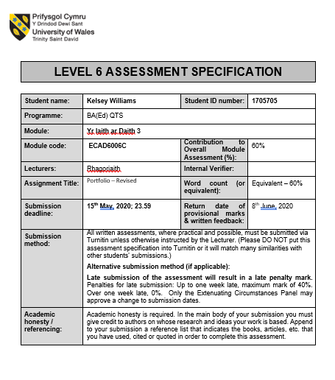

Task 1- You will need to submit a written piece of reflection based on the filmed/audio activity submitted last year in 'Yr Iaith ar Daith 2'.
Teaching Welsh as a second language in the English-medium sector certainly comes with its own challenges in trying to achieve the best outcomes possible for students. Welsh Government (2017) identify the advantages that are produced for learners whose Welsh language skill competence is increased. Furthermore, being bilingual has well established benefits for enrichment of experiences in both Wales and the world around us. Reflection upon my own linguistic skills in terms of Welsh play a key role in providing the most beneficial learning experiences for pupils. Having reflected on these skills as part of my filmed Welsh lesson last year, I recognise the need to address the ways in which I have improved and developed these skills over the course of the year.
In last year’s reflection, I recognised that the children should have been allowed more time to respond to statements and questions that I ask them. Additionally, I was also able to consider the need to collaborate appropriate wait time with the need for scaffolding learning, which I have been using to some extent already. Hindman and Wasik (2018) support the benefits of ‘wait time’ in the learning of a language. Their research identified that pupils are effectively encouraged to extend their vocabulary and language when the teacher or practitioner waits after the pupil initially responds. Additionally, waiting for the pupil to respond or extend their response can provide feelings of value or worth to them which encourages them to confidently test their language skills beyond the realms of their comfortability or normality in relation to their language skills. Limiting the wait time to an average of 3 seconds as been recognised as an effective amount of time by Hindman and Wasik (2018) for this strategy. Activities that will be benefitted by the use of ‘wait time’ will be activities that promote reading and oral language skills such as reading of books in a group setting which promote the asking of open ended questions where the wait time of 3 seconds can be used for learners’ to respond.
In the previous reflection I made, I was able to recognise the need for more subject and/or subject specific Welsh rather than reliance of building incidental Welsh. While incidental Welsh has shown very beneficial in my practice in building fluency of learners’ language skills. It is important to note that incidental Welsh generally only focuses on development of learners’ oracy skills. In order to support and achieve bilingualism in learners, it is important to consider all aspects of the Welsh language, which also includes, writing, reading and listening and understanding. Recommendations by Estyn (2013) identify the need for increased specific time to directly teaching Welsh. Breen and Smith (2002, cited in Baker, 2011) support the building of prior knowledge in the teaching of Welsh and recognise that prior knowledge acts as scaffolding for the learning. Collaborative activities that involve learners’ peers are beneficial as the support through peers can be crucial for linguistic improvements. Scaffolding pupils learning of language and vocabulary can be assisted by the use of adult feedback to pupils’ responses and questions, (Barnes, Dickinson & Grifenhagen,2017). Furthermore, Hindman, Wasik & Erhart (2012) recognised that asking for further extension of children’s conversations in relation to books and reading skills has been identified as being a key and effective strategy which has a direct effect on the development of their language and vocabulary. Research by Justice et al (2013) suggested that when learners are provided with opportunities to explore the language in a comfortable setting and get feedback on such language, their early language development is supported efficiently. Research by Harris, Golinkoff, & Hirsh-Pasek (2011) and Justice et al (2018) has highlighted that learners benefit from being provided with opportunities that allow them to engage with conversations with adults who are linguistically competent. This aids with development of language skills, which are able to flourish in a structured setting that allows such conversations to take place.
During previous reflections, I identified that I need to make a conscious effort to include more technology within my teaching of the Welsh language, as per guidance made by Donaldson (2015). Recommendations made by Donaldson (2015) signified the need for better and more creative use of technology in collaboration with teaching of the Welsh language. During reflections made on my previous Welsh lessons I recognised the need to include further technologies to coincide with the teaching of welsh which would benefit the learner’s language acquisition. Additionally, One language for all (2013) recommended that there was a great need for more interactive resources which would engage and stimulate learners in learning and teaching of Welsh as a second language. Further support from Estyn (2017) identified the use Welsh second language resources which are motivating and the use of technology aids as good practice in language acquisition as it promotes children in becoming enthusiastic learners. Baker (2011) recognised that innovation of language is a beneficial for learners acquiring a second language and the use of technology in doing so is a great support to acquisition.
The Welsh language competency framework (2019) is a concise framework for education practitioners that enables teachers to assess their Welsh language skills. These skills can be assessed according to the criteria set out within each stage of skills competence displayed within the framework. These skill stages include: ‘No Welsh language skills’, entry, foundation, intermediate, higher and proficiency. The specific Welsh language skills being assessed are ‘listening, speaking, reading and writing’. In order to reflect on my competence of the Welsh language as a practitioner I have assessed myself against this framework. Using the framework, I have concluded that my welsh language ‘listening’ skills are currently at ‘foundation’ level. It is important to note that last year, my skills were ‘entry’ level. This meant that I was able to confidently understand and respond to simple conversations and sentences relevant to the school context, in a quiet setting where I had opportunity to take my time in regard to response. I have now progressed my skills further and feel that at foundation level I am able to further understand and respond to a range of simple sentences, still within the school context but possibly within everyday themes and including different verb tenses. The fluidity in my responses has improved greatly over the course of the year. I have taken much opportunities to improve my listening skills over the course of the year, which with have a positive effect on the teaching of welsh second language skills. In order to improve these skills, I have been utilising Welsh audio stories to gain further understanding of common themes and model correct pronunciation of the language.
My oral Welsh language skills have improved significantly over the course of the year, last year I was at entry level within the framework, at the present time I feel that I have progressed onto foundation level. I have made a conscious effort to attempt to expand my language variety beyond simple sentence structures to include everyday themes within the school. On reflection of last year’s assignment, I recognised that there was a need to use more theme/subject specific welsh language with learners, I have extended this requirement to my own language skills and have been utilising ‘Duolingo’, which is a language learning app and website. Duolingo’s credibility has been tested and research frequently to establish the benefits of its use in second language acquisition. McDowell and Goodman (2019) recognise that that Duolingo effectively fosters ‘pragmatic reasoning’ in language acquisition. Pragmatic reasoning enables learners to use their language skills to go beyond literal meanings of words and sentences when interpreting language in various contexts. Pragmatic reasoning enables children learning a second language to learn the meanings of words at a quicker pace, (Frank and Goodman, 2014). Duolingo enabled me to direct my own language learning to include language patterns, subjects or themes that I recognised I needed to further or revise. This was an effective method in improving my skills. Boekaerts (1997) and Bruner (1961) believed that people are able to learn in more effective and beneficial ways when they can direct their own learning experiences. In preparation for planning of lessons in the school context this coming year, I appropriately revised common theme and subject specific Welsh language patterns, which has helped me progress my skills according to the competency framework.I have further assessed my Welsh language skills according to the competency framework and have concluded that I am now at a foundation level for my reading skills. Utilising the practical course resource by Jones (2013) I have revised my written and reading skills, focusing on the correct punctuation, tense and grammar of my written welsh. At foundation level it is expected to be able to begin to read emails and letters in the school context. To do so I have used this resource and the use of the welsh dictionary to refine and check texts that I have been reading or responding to in Welsh. Furthermore, my writing skills are currently at entry level however I am still actively working towards foundation level. While I feel confident in providing some basic written feedback to learners, I am not giving this extensively. Therefore, I am utilising the use of this grammar resource as I have been over the course of the year to expand and refine my written language skills.

Reference List:
Baker, C. (2011) Foundations of Bilingual Education and Bilingualism, 5th Edition. Clevedon: Multilingual Matters.
Barnes, E.M., Dickinson, D.K. and Grifenhagen, J.F.,(2017). The role of teachers’ comments during book reading in children's vocabulary growth. The Journal of Educational Research.
Boekaerts, M., (1997). Self-regulated learning: Where we are today. International journal of educational research.
Brown, H.D. (2006) Principles of Language and Teaching, NY: Pearson Brown.
Bruner, J.S, (2006) In Search of Pedagogy Volume I: The Selected Works of Jerome Bruner, 1957-1978. Routledge.
Cook, V.J. (2008) Second Language Learning and Language Teaching, 4th Edition. London: Hodder Education.
Donaldson, G. (2015) Successful Futures. Crown copyright. Available at: http://gov.wales/docs/dcells/publications/150317-successful-futures-en.pdf
Estyn (2013) Supplementary Guidance: Welsh. Cardiff: Crown.
Estyn (2013) Welsh Language development in the Foundation Phase. Cardiff: Crown.
Estyn (2015) Guidance for the inspection of primary schools. Cardiff: Crown.
Estyn (2017) Supplementary guidance: Welsh. Cardiff: Crown.
Estyn (2018) Welsh in Key Stage 2 and Key Stage 3 in Welsh-medium or bilingual schools. Cardiff: Crown.
Harris, J., Golinkoff, R.M. and Hirsh-Pasek, K., (2011) Lessons from the crib for the classroom: How children really learn vocabulary. Handbook of early literacy research.
Hindman, A.H., Wasik, B.A. and Erhart, A.C.,(2012). Shared book reading and Head Start preschoolers' vocabulary learning: The role of book-related discussion and curricular connections. Early Education & Development.
Jones, C. (2013) Welsh Grammar You Really Need to Know. London: Hodder & Stoughton.
Justice, L.M., McGinty, A.S., Zucker, T., Cabell, S.Q. and Piasta, S.B., (2013) Bi-directional dynamics underlie the complexity of talk in teacher–child play-based conversations in classrooms serving at-risk pupils. Early Childhood Research Quarterly.
McDowell, B. and Goodman, N. (2019). Learning from omission. In Proceedings of the 57th Annual Meeting of the Association for Computational Linguistics.
Wasik, B.A. and Hindman, A.H. (2018) Why wait? The importance of wait time in developing young students’ language and vocabulary skills. The Reading Teacher.
Welsh Assembly Government (2008) Welsh Language Development in the Foundation Phase, Cardiff: WG.
Welsh Government (2013) One language for all - Review of Welsh second language at Key Stages 3 and 4. Cardiff: WG.
Welsh Government (2014) Evaluating the Foundation Phase: Key Findings on Welsh Language (WISERD). Cardiff: Crown.
Welsh Government (2015) Programme of Study – Welsh Second Language, Key Stages 2-3.
Welsh Government (2015) Programme of Study – Welsh, Key Stages 2-3.
Welsh Government (2017) Review of a project to encourage Welsh-medium teaching in English-medium primary schools. Cardiff: Crown.
Welsh Government (2019) Welsh language competency framework for educational practitioners. Cardiff: WG.

Task 2: Please submit 2 lesson plans for future development using the new curriculum as a focus, e.g appropriately theme based plans (equivalent to 1500 words). The lessons should be suitable for a year group of your choice.

Name of Trainee: | Kelsey Williams |  |  | Session ref: |  | 2/5 |  | Date: |  | 15/05/2020 |  |  | Class: | Reception |  |  | Cynllun Ffocws y Cyfnod Sylfaen  2d
Targed(au) Hyfforddi Personol |  |  | Welsh language skills- QTS descriptor: ‘There is a commitment to incremental development of personal skills in the use of the Welsh language’. |  |  |  |  | Number of learners: |  |  |  | Whole class- Rotation of groups- 4 x groups of 7 pupils | Age: | 4-5 years |  |  | Cynllun Ffocws y Cyfnod Sylfaen  2d
Learning objectives/intentions: |  | - WALT- Model information from a text.  - WALT- Respond to information from a text. |  |  |  |  | Success Criteria |  | - I can model information presented in a text  - I can respond verbally and in written form to information from a text |  |  |  |  | Meeting learners’ needs: |  | Lesson will be on a rotation of small groups to ensure a structured environment for language acquisition.
Introduction/plenary tasks |  |  |  |  | Main activities |  |  |  |  |  | Resources/  Key Vocabulary |  |  |  | Assessment for Learning (strategies and opportunities)
Introduction:  Carpet area as a whole class.  Introduction of Tedi Twt ar y fferm book with take place.  Teacher to read book aloud at a slow pace making a conscious effort to add expression to your reading.  Puppets of the animals can be used to engage learner’s attention to the story. |  |  |  |  | During the theme ‘on the farm’ we will be learning about different animals, their products (Cheese/milk), their homes and their feelings. Over this period of time we will be reading various stories about the farm and preparing for the end of theme visit to the local farm.  Trainee focused task:  Theme for Term: Ar Y Fferm/ On the Farm  Activation of Prior knowledge - lesson prior to this was focused around the learning and revision of the farm animals which will be revised again this lesson.  Circle Time- following reading of the book learners will move into a circle formation where the puppets of the character animals from the book will be will be passed around. Learners to recite the sentence patterns of introducing the animals- For example... ‘Dyma..... mr Dafad/ here is Mr Sheep. This will familiarise the learners with the different animals which they have previously learn.  Teacher to model correct pronunciation- Oracy Skills.  Wait time- ensure a 3 second wait time is given for learners to respond.  Tedi Twt book talks about the feelings of the animals.  Writing activity to encourage independent writing skills centred around the question “Sut wyt ti?”  Writing and illistartion activity- Learners to ask their peers this question and paint feelings on paper plates and label. Labels will be given but learners should be encouraged to write the label on their plate.  Encourage reading of paper plates. |  |  |  |  |  | - Ar y fferm- axel scheffler (See appendix 3)  - Hwb resources about the farm  - Cyw farm song  - Tedi Twt ar y fferm book (See appendix 5)  hwyaden - duck  dafad - sheep  buwch - cow  mochyn - pig  hwyaid - ducks  defaid - sheep  gwartheg - cows  moch - pigs  Hapus - Happy  Wedi Blino - Tired  Da iawn - Very Good  Bendigedig - Wonderful  Sut wyt ti? |  |  |  | “Thumbs up and down”. Children will do this individually to assess how difficult they found it.  Writing/ illistration activity to form Feelings board- continuous provision to be used daily.  Encouraging independent language skills- post paper plates with faces/feelings into appropriate feelings box.  Following this session- Feelings drop in at start of day and after session/activity. Learners put their face onto the correct feelings in Welsh. Pictures and Images to assist associations/understanding.

Plenary
Session to end with whole class plenary to Sing song- ‘Sut wyt ti?’
Curriculum coverage

Language, Literacy and Communication- Welsh in English-medium settings:

Understanding language helps us make sense of the world around us:
Progression Step 1:
- I can listen to others with growing attention

Expression through language is key to communication:
Progression Step 1:
- I am beginning to ask and answer questions.
- I am beginning to express my feelings.

Literature fires imagination and inspires creativity:
Progression Step 1:
- I am beginning to respond to literature I hear and view.
- I can join in with familiar songs, rhymes, stories and poems

Literacy (LNF) |  |  |  |  |  |  |  |  |  |  | Numeracy (LNF)
DCF  Sut wyt ti song to be played on the interactive whiteboard. |  |  |  |  | Thinking |  |  |  |  |  | ESDGC |  |  |  | YCC  .  Cross curricular – Expressive Arts

Name of Trainee: |  |  |  | Kelsey Williams |  |  | Session ref: | 3/5 | Date: |  | 5/05/2020 |  |  | Class: | Reception | Cynllun Ffocws y Cyfnod Sylfaen  2d
Targed(au) Hyfforddi Personol |  |  |  |  |  | Welsh language skills- QTS descriptor: ‘There is a commitment to incremental development of personal skills in the use of the Welsh language’. |  |  | Number of learners: |  |  | Whole class- Rotation of groups- 4 x groups of 7 pupils |  | Age: | 4-5 years | Cynllun Ffocws y Cyfnod Sylfaen  2d
Learning objectives/intentions: | - WALT- Respond to questions from a text.  - WALT- Participate in group song. | Success Criteria |  |  | - I can respond to prompts in Welsh.  - I can distinguish different animals in Welsh. |  |  |  |  |  |  |  | Meeting learners’ needs: |  |  | Lesson will be on a rotation of small groups to ensure a structured environment for language acquisition.
Introduction/plenary tasks |  |  | Main activities |  |  |  |  |  |  | Resources/  Key Vocabulary |  |  |  |  |  | Assessment for Learning (strategies and opportunities)
Introduction:  Carpet area as a whole class.  Teacher to read aloud to class-  Ar y Fferm by Axel Scheffler.  This book will link in with previous book read in lesson prior.  Pronunciation of Language linked to this theme will be revised.  Children’s listening and  understanding skills are promoted.  Teacher to choose at random learners on the carpet to repeat sentences from the book. Teacher will model the sentence for learner to repeat- attention should be paid to checking the learner’s pronunciation and understanding. |  |  | During the theme ‘on the farm’ we will be learning about different animals, their products (Cheese/milk) and their homes. Over this period of time we will be reading various stories about the farm and prepare for the end of theme visit to the local farm.  Trainee focused task:  Theme for Term: Ar Y Fferm/ On the Farm  Previous knowledge of learners- lesson prior focused on animals and feelings.  This lesson is centred around the use of the interactive whiteboard. The use of technology will engage the learners further.  Please follow link for the interactive resource. (examples in appendix below)  https://resources.hwb.wales.gov.uk/VTC/2008-09/wsl/fph_welsh_190209/y_fferm/activity/index.html |  |  |  |  |  |  | Ar y fferm- axel scheffler  Hwb resources about the farm  Cyw farm song  Tedi Twt ar y fferm book  hwyaden - duck  dafad - sheep  buwch - cow  mochyn - pig  hwyaid - ducks  defaid - sheep  gwartheg - cows  moch - pigs  Use the following language patterns:  Clicia yma. -Click here.  Pa liw? -Which colour?  melyn / gwyn / pinc / du -Yellow / white / pink / black  Da iawn. -Very good.  Hen dro. Tria eto.  -What a pity. Try again. |  |  |  |  |  | “Thumbs up and down”. Children will do this individually to assess how difficult they found it.  Feelings board- continuous provision to be used daily.  Encouraging independent language skills- post paper plates with faces/feelings into appropriate feelings box.  Feelings drop in at start of day and after session/activity. Learners put their face onto the correct feelings in Welsh. Pictures and Images to assist associations/understanding.
Sawl hwyaden sydd yn y cae?
-How many ducks are in the field?
Sawl buwch sydd yn y cae?
-How many cows are in the field?
Sawl dafad sydd yn y cae?
-How many sheep are in the field?
Sawl mochyn sydd yn y cae?
-How many pigs are in the field?

Learners should be encouraged to count with the teacher and within the small group, take in turns to find the number symbol on the screen. (See appendix 1)

If learners are correct they will continue to the next screen. If incorrect the number symbol will turn grey.
Plenary  Hwb interactive farm song to be played on the interactive white board and sang by the learners.  https://resources.hwb.wales.gov.uk/VTC/2008-09/wsl/fph_welsh_190209/y_fferm/song/Ar%20Fferm%20y%20Foel.mp3  (See Appendix 4) |  |  | Peintia’r mochyn yn binc. -Paint the pig pink.  Peintia’r hwyaden yn felyn. -Paint the duck yellow.  Peintia’r fuwch yn ddu. -Paint the cow black  Peintia’r ddafad yn wyn. -Paint the sheep white.  (See appendix 2)  When learners choose the correct colour, an animation of the animal will appear.  Encourage all children to participate in the activity
Curriculum coverage:

Language, Literacy and Communication- Welsh in English-medium settings:

Understanding language helps us make sense of the world around us:
Progression Step 1:
• I can use context and pictures to help me understand words.

Expression through language is key to communication:
Progression Step 1:
• I can contribute to shared writing for different audiences and purposes
• I can choose to talk to my peers in Welsh.

Literature fires imagination and inspires creativity:
Progression Step 1:
• I can join in with familiar songs, rhymes, stories and poems.
• I can use familiar words and phrases and begin to experiment with newly-learned vocabulary.

Literacy (LNF) |  |  |  |  |  |  |  |  |  | Numeracy (LNF)
DCF  Interactive Whiteboard resources:  Clicia yma. -Click here.  Eto -again  Gwranda. -Listen.  Wedi gorffen. -Finished. |  |  | Thinking |  |  |  |  |  |  | ESDGC |  |  |  |  |  | YCC  Language, literacy and communication curriculum links.

Appendix 1:

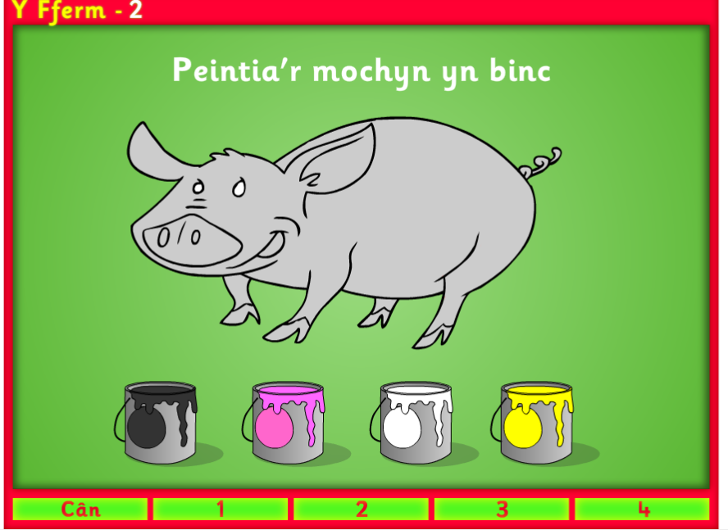

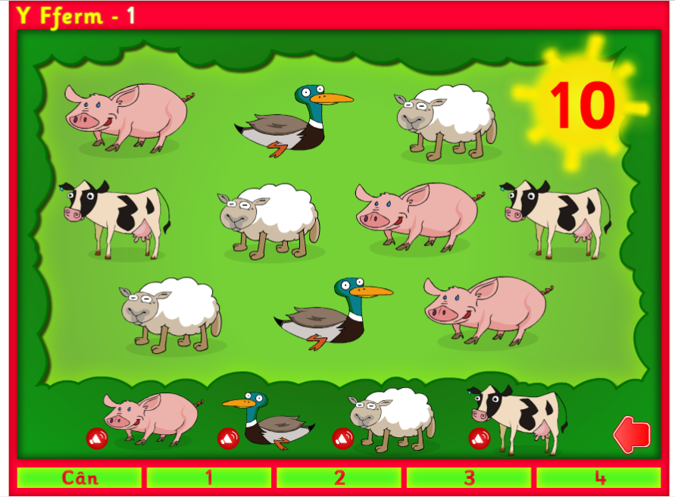Appendix 2

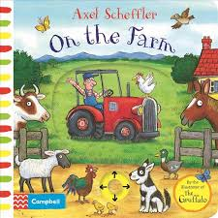
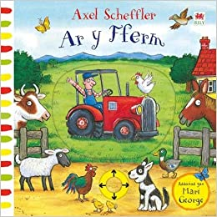 Appendix 3:

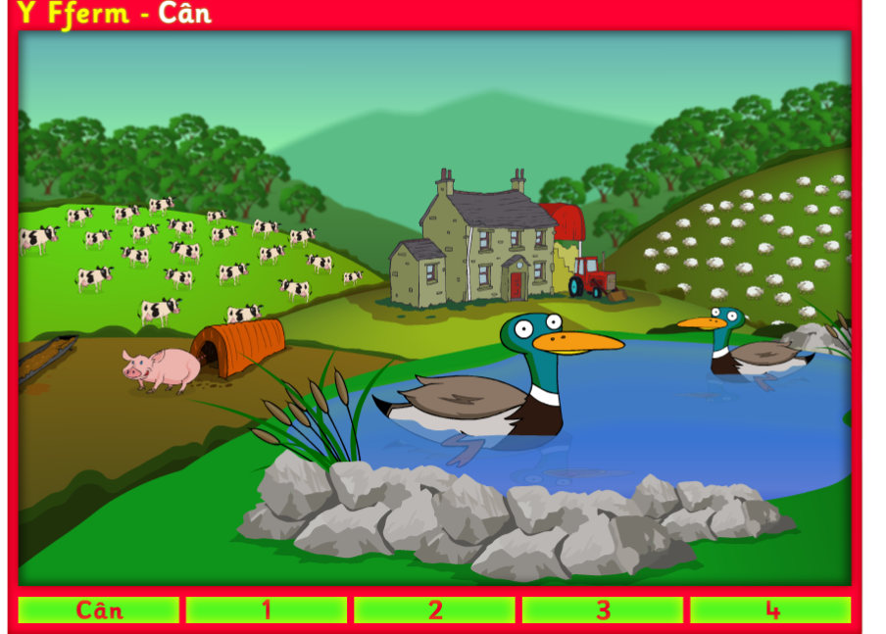
Appendix 4:

Appendix 5:



