

BSc (Hons) Health and Social Care

Changemakers: Building your Personal Brand for Sustainable Employment

Module code – BMHP5015 - BIRM

Component 2 - Report
Lecturer – Parese Ahmed

Student: Claudia Gomes
Student No - 2326791
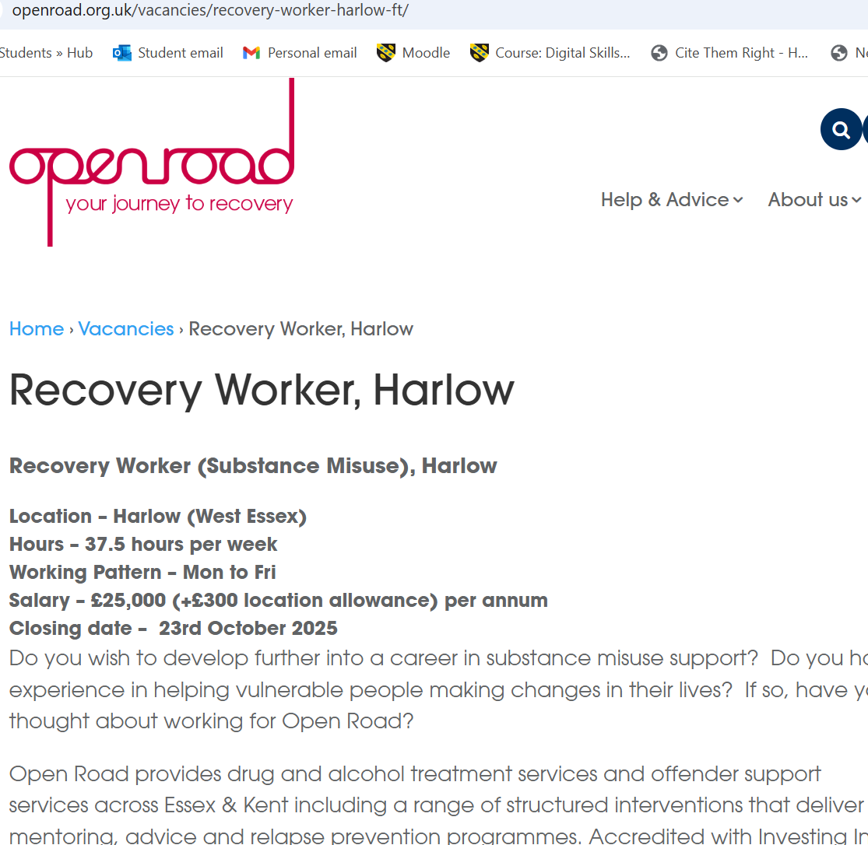
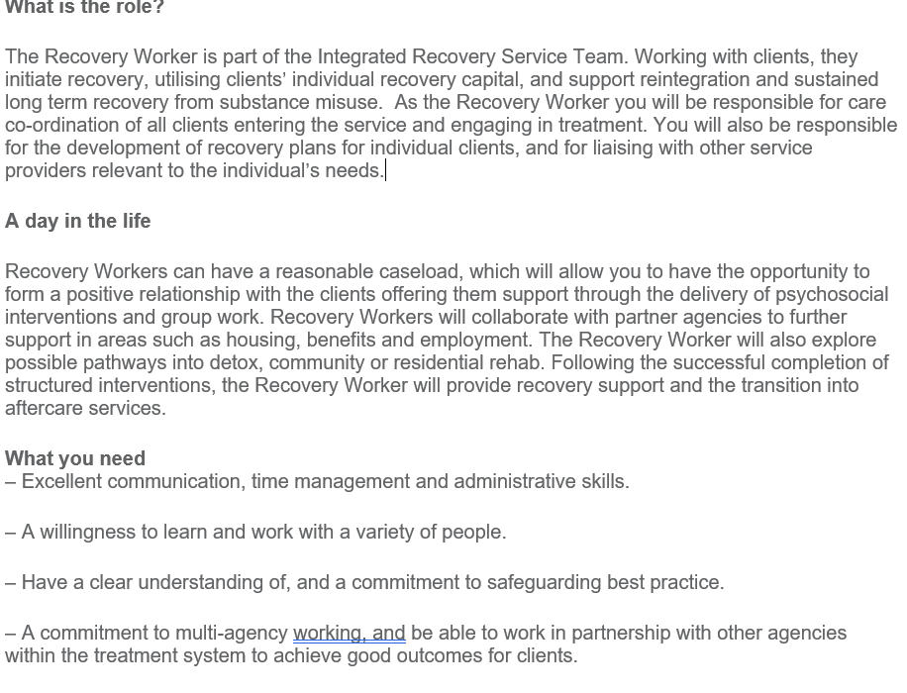

(Recovery Worker, Harlow - Open Road Visions, 2025)

Employability Skills and Professional Development Plan for a Substance Misuse Worker Role.
This report assesses the competencies required for a role as a Substance Misuse worker and evaluates my relevant skills against these criteria. As a second-year BSc (Hons), Health and Social Care student at the University of Wales Trinity St David, with five years of practical experience in complex care, I am well-positioned to transition into this field. My ambition to specialize in substance misuse is driven by both my professional background and a personal commitment to the issue.
The report will cover:
- The employability skills required for a Substance Misuse Worker.
- My own skills, experience, and areas for development.
- An action plan and timeline to gain the necessary skills.
It will also discuss how I can build my personal brand, develop a professional identity, and build networks to support my career.
Employability Skills for a Substance Misuse Worker Role
According to Skills for Health (2023), and the NHS Employability Framework (2022) a Substance Misuse Worker requires a range of professional, personal, and social skills to effectively support individuals recovering from drug and alcohol misuse.
Strong communication and interpersonal skills are essential for building trust with clients and maintaining good relationships with colleagues and partner agencies. Active listening demonstrates empathy and helps practitioners understand each client’s needs. Clear and accurate communication also supports record-keeping, safeguarding, and effective information sharing (What skills should a substance abuse counsellor possess? 2019).
Effective assessment and care planning are vital for tailoring support to individual circumstances. These skills ensure interventions are person-centred, progress is monitored, and recovery outcomes are improved.
The role also relies strongly on teamwork and multi-agency collaboration. Professionals in substance misuse services often work closely with other sectors, such as healthcare, housing, social services, and employment support. Effective teamwork ensures that everyone involved shares information and coordinates their efforts. This joined-up approach helps clients receive holistic, consistent, and well-organized care, addressing not only their substance misuse but also the wider factors that affect their recovery and wellbeing.
Working with individuals affected by addiction can be emotionally challenging. Therefore, emotional intelligence and resilience are crucial (Humankind – For fair chances, 2024). These qualities allow workers to remain professional under pressure, respond sensitively to distress, and encourage clients to stay motivated throughout recovery.
A strong understanding of safeguarding and ethical practice is equally important. Workers must protect vulnerable people, follow safeguarding procedures, and act with fairness and respect to maintain trust and professional integrity (Care Act, 2014).
Finally, organisation and time management are key to handling complex caseloads and maintaining accurate records . Prioritising tasks effectively ensures timely, high-quality support
In conclusion, successful Substance Misuse Workers combine compassion, professionalism, and collaboration (Pycroft, 2010). These employability skills ensure safe, ethical, and effective care, supporting individuals to achieve lasting recovery.
Evaluation of My Own Skills
As a Health and Social Care student at the University of Wales and a full-time Complex Needs Carer, I have developed a strong foundation of employability skills that align with the role of a Substance Misuse Worker. This evaluation will use elements of Gibbs’ Reflective Cycle (1988), to assess my strengths, areas for development, and strategies for improvement.
Strengths
According to Hargie (2011), effective communication and interpersonal skills are essential in care settings, and I consider these among my strongest attributes. Working in complex care has helped me develop active listening, empathy, and clarity when supporting clients with diverse needs. These abilities allow me to build trust, de-escalate challenging behaviours, and maintain professional relationships, essential qualities in substance misuse support.
I also demonstrate resilience and emotional intelligence, developed through managing clients with physical disabilities, mental health conditions, and behavioural difficulties. Remaining calm under pressure and showing compassion without losing professional boundaries has improved my emotional awareness and self-regulation (Cherniss, 2010).
Another key strength is teamwork. My role requires constant multi agency collaboration with nurses, social workers, and occupational therapists. This has strengthened my confidence in multidisciplinary working and taught me the value of shared decision-making in client care.
Areas for Improvement
Although I have developed a solid foundation through my experience in complex care, I recognise specific areas that require further development to meet the demands of a Substance Misuse Worker role. My practical understanding of interventions such as Motivational Interviewing (MI) and Cognitive Behavioural Therapy (CBT) is limited, and I would benefit from gaining hands-on experience with these approaches. I also aim to deepen my knowledge of harm reduction methods to better support individuals at different stages of recovery. In addition, improving my digital documentation and record-keeping skills will help ensure compliance with professional and organisational standards (Public Health England, 2017). To strengthen these areas, I plan to seek guidance from academic tutors, workplace mentors, and supervisors, as well as participate in professional training and reflective practice sessions to enhance my competence and confidence.
Action Plan for Improvement

To address the identified skill gaps, I intend to pursue accredited training in Motivational Interviewing and harm reduction through the NHS or a reputable organization such as The Association for Psychological Therapies (APT). Alongside this, I will seek a practical placement or voluntary position within a substance misuse service to apply theoretical learning in real-world settings. To support my ongoing development, I will participate in regular professional supervision and maintain a reflective journal (Johns, 2017), to critically analyse my learning experiences, assess progress, and refine my practice.
Through self-reflection, I have identified that my existing strengths in communication, empathy, and teamwork provide a solid foundation for a transition into substance misuse work. However, to progress further, I must enhance my specialist knowledge and intervention skills. My professional development plan is designed to systematically build the theoretical understanding and practical competence essential for effective practice in this field. Initially, I will strengthen my core knowledge by completing certified online courses on substance misuse, recovery models, and addiction frameworks within the next three to six months. Simultaneously, I will expand my practical skills through accredited workshops in Motivational Interviewing and Cognitive Behavioural Therapy (CBT) techniques, applying these methods in voluntary or supervised environments throughout the following year (Miller and Rollnick, 2002).
To ensure my practice remains safe, ethical, and effective, I will complete a safeguarding refresher course with an emphasis on addiction-related risks and enhance my documentation and record-keeping abilities through targeted e-learning modules and supervisor feedback. Within six to twelve months, I aim to secure a placement or volunteer role in a local recovery or rehabilitation service, allowing me to gain hands-on experience in client engagement, relapse prevention, and multi-agency collaboration (Volunteer with us, 2025). Additionally, I will expand my professional network by joining relevant professional bodies such as the Federation of Drug and Alcohol Professionals (FDAP) and maintaining an active LinkedIn presence to connect with practitioners and stay informed about best practices and sector developments.
This structured action plan integrates formal education, reflective practice, practical experience, and professional networking to foster comprehensive professional growth. By completing these steps, I will enhance my therapeutic competence, consolidate my professional identity, and strengthen my employability within the health and social care sector. Continuous reflection, supervision, and commitment to lifelong learning will ensure my development remains aligned with professional standards and the evolving needs of clients within substance misuse services.
Building My Personal Brand in Healthcare
Building a personal brand in healthcare enables me to communicate who I am as a professional and what I value in practice. As I progress towards becoming a Substance Misuse Worker, I aim for my personal brand to reflect compassion, professionalism, and a strong commitment to supporting individuals in recovery (Walter, 2024). My background in complex care and current university studies provide a solid foundation for this professional identity.
To develop and promote my brand, I will use LinkedIn to connect with practitioners, share insights, and engage with current discussions in health and social care. By posting information from credible sources such as the National Institute for Health and Care Excellence (NICE, 2016), Public Health England (2020), and Skills for Care (2023), I can demonstrate my awareness of evidence-based practice and commitment to continuous professional development.
Additionally, I plan to create a digital portfolio showcasing my training certificates, reflective writing, and supervisor feedback to evidence my growth and competence. Attending relevant conferences, workshops, and webinars will help me stay informed about emerging trends and expand my professional network. Together, these strategies will enhance my visibility, credibility, and employability within the substance misuse sector.
Promoting My Professional Identity
Promoting my professional identity is an important part of developing my career in health and social care. My identity is based on being compassionate, reliable, and committed to helping people overcome challenges such as substance misuse. To present this identity effectively, I will use both traditional and digital tools (Linder, 2018).
My CV will highlight my education at the University of Wales, five years of experience as a Complex Needs Carer, and the transferable skills I have gained, such as communication, teamwork, and safeguarding. It will also include examples of training, achievements, and volunteering to show my dedication to continuous professional development.
I will maintain a professional online presence through LinkedIn, where I can connect with others in health and social care, share learning experiences, and engage with discussions on recovery and wellbeing. Posting reflections, achievements, and relevant articles will help demonstrate my knowledge and enthusiasm for the field.
By combining a strong CV, active online networking, and a professional attitude in all communications, I can promote my identity as a caring, ethical, and skilled practitioner, someone who is ready to contribute positively to the health and social care sector, especially within substance misuse support.
Building a Network for Successful Employment
In health and social care developing a strong professional network is essential for career growth and resilience within health and social care. Networking helps identify new job opportunities through referrals and word-of-mouth, provides access to mentors who can offer valuable guidance, and keeps you informed about best practices and industry developments. It also fosters vital peer support, which can help reduce stress and prevent burnout in demanding roles (Gibson, H. Hardy III and Ronald Buckley, 2014).

How to Build Network:
- Find Mentors: Seek advice from experienced colleagues, supervisors, or senior managers.
- Join Associations: Become a member of organisations such as the Royal College of Nursing (RCN) or the British Association of Social Workers (BASW) and attend their local or national meetings.
- Attend Events: Participate in conferences , webinars and local authority workshops (HF Online and Morgan, 2025).
- Use LinkedIn: Engage with professionals and join relevant online forums.
By engaging actively in these communities, I enhance your reputation and become a trusted, desirable professional.
Conclusion
Completing this report has provided valuable insight into the professional, personal, and ethical competencies required to become an effective Substance Misuse Worker. It has highlighted the importance of empathy, communication, teamwork, and resilience in supporting individuals through recovery while maintaining professional boundaries and safeguarding responsibilities. Reflecting on my current experience as a Complex Needs Carer, I recognise that I have already developed many transferable skills such as active listening, multi-agency collaboration, and emotional intelligence. However, I also acknowledge the need to expand my specialist knowledge through further training in Motivational Interviewing, Cognitive Behavioural Therapy and harm reduction strategies to enhance my practice.
My professional development plan outlines realistic steps to achieve these goals, including undertaking accredited courses, securing a placement within a substance misuse service, and engaging in reflective supervision. In addition, building a strong personal brand and professional network will be central to establishing credibility and creating opportunities for progression. By connecting with professional bodies, attending sector events, and maintaining an active online presence, I can demonstrate my commitment to continuous improvement and ethical practice. Ultimately, my aspiration is to combine compassion, lived experience, and evidence-based knowledge to empower individuals in recovery, promoting hope, dignity, and sustainable positive change within the community.

References
- Care Act (2014) Care Act 2014, Legislation.gov.uk. Available at: https://www.legislation.gov.uk/ukpga/2014/23/contents.

- Cherniss, C. (2010) Emotional Intelligence: Toward Clarification of a Concept. Industrial and Organizational Psychology, 3(2), pp.110–126.

- Gibbs, G. (1988) Learning by Doing: A Guide to Teaching and Learning Methods. Oxford: Oxford Polytechnic.

- Gibson, C., H. Hardy III, J. and Ronald Buckley, M. (2014) ‘Understanding the role of networking in organizations’, Career Development International, 19(2), pp. 146–161. Available at: https://doi.org/10.1108/cdi-09-2013-0111.

- Hargie, O. (2011) Skilled Interpersonal Communication: Research, Theory and Practice. 5th ed. London: Routledge.
- HF Online and Morgan, M. (2025) How to Build a Strong Professional Network in the Health and Social Care Sector, Academy for Health & Fitness. Available at: https://uk.hfonline.org/how-to-build-a-strong-professional-networ (Accessed: 11 October 2025).
- Humankind – For fair chances (no date) humankindcharity.org.uk. Available at: https://humankindcharity.org.uk (Accessed 9 October 2025).

- Johns, C. (2017) Becoming a Reflective Practitioner. 5th ed. Chichester: Wiley Blackwell.

- Linder, K.E. (2018) Managing your professional identity online : a guide for faculty, staff, and administrators. Stylus Publishing, Llc.

- Miller, W.R. and Rollnick, S. (2002) Motivational interviewing: Preparing people for change. 2nd edn. Guilford Press. Available at: https://bluepeteraustralia.wordpress.com/wp-content/uploads/2012/12/motivational-interviewing.pdf.

- NHS (2022) Employability Framework for Health and Social Care. London: NHS.

- Public Health England (2017) Developing Effective Substance Misuse Services. London: PHE.

- Pycroft, A. (2010) Understanding and Working with Substance Misusers. SAGE.

- Recovery Worker, Harlow - Open Road Visions (2025) Open Road Visions. Available at: https://www.openroad.org.uk/vacancies/recovery-worker-harlow-ft/ (Accessed: 11 October 2025).

- Service Care Solutions hiring Substance Misuse Recovery Worker in Nottingham, England, United Kingdom | LinkedIn (2025) Linkedin.com. Available at: https://www.linkedin.com/jobs/view/4302949756/ (Accessed: 11 October 2025).

- Skills for Health (2023) Employability Skills Matrix for Health. [Online] Available at: https://www.skillsforhealth.org.uk [Accessed 9 Oct 2025].

- What skills should a substance abuse counselor possess? (2019) Quora. Available at: https://www.quora.com/What-skills-should-a-substance-abuse-counselor-possess (Accessed: 11 October 2025).

- Volunteer with us (2025) Changegrowlive.org. Available at: https://www.changegrowlive.org/careers-volunteering/volunteering.

- Walter, Y. (2024) ‘Council Post: Brand Yourself, Build Your Future: The Importance Of Personal Branding For Professional Success’, Forbes, 12 August. Available at: https://www.forbes.com/councils/forbesbusinesscouncil/2023/03/30/brand-yourself-build-your-future-the-importance-of-personal-branding-for-professional-success/.

