The future of hospitality and is it profitable to be green?

Student name: Sayeda Laila Yeasmine

Module Title: Sustainable Hospitality & Tourism
Management

Module Number: BMIH5006

Lecturer: Ruth Taylor Davies

Executive Summary
The hospitality industry is one of the largest and most significant industries and the cruciality of business ethics is also applicable for the hospitality businesses. While the hospitality industry is highly profitable and contributes significantly to global economic development, it is criticised for its impact on the environment. The hospitality businesses are required to be more environmentally sustainable along with being profitable. Achieving environmental sustainability is a crucial necessity for businesses. With an understanding of the attitude of people, the necessary approaches required for sustainability can be identified at the right time. Along with sustainability practices, regenerative practices can also assist in counteracting the remaining impacts.
Table of Contents
Executive Summary ii
Introduction 1
Main Findings 2
Relevance of Friedman’s Doctrine 2
Primacy of Finance 3
Driver of Environmental Soundness 4
Future Recommendations 5
Viability of Sustainability in the Hospitality Industry 6
Significance of Financial Resilience for Sustainability 7
Conclusion 9
References 10
Table of Figures
Figure 1: Triple Bottom line model 3
Figure 2: Waste materials generated in the Hospitality industry 5
Figure 3: Doxey’s Irritation Index 6
Figure 4: Butler’s life cycle model 8

Introduction
The hospitality and tourism industry is one of the largest industries in the world and a considerably large percentage of the global economic development can be attributed to the industry. Despite such a significant contribution to the global economy, the tourism industry is often criticised for unsustainable practices as the industry is often associated with dramatic environmental impacts through high energy consumption, water pollution and wastage of consumable goods. Due to the nature of business, these environmental impacts often seem inevitable for the industry, while environmental sustainability has become a major concern in the modern business environment. In the contemporary world, environmental sustainability is considered just as important as maintaining the profitability of business. While prior theories argued that the only concern for business is generating profit, the views of the modern world have shifted towards more sustainable practices and societal concerns. However, the question regarding the viability of greener practices in the industry is another major concern.

Main Findings

Relevance of Friedman’s Doctrine
Business organisations are the pillar of economic development and a major purpose of business organisations is to generate financial profit. Considering this dynamic, it is undeniable that organisations in the hospitality and tourism industries are highly successful as they contribute significantly to the development of the global economy (Uyar, Karaman and Kilic, 2019). But business ethics is another crucial dynamic that cannot be disregarded in the modern business environment. In the prior times, the concept of business ethics was not fully developed, while the modern concept of business ethics has come a long way.
A business organisation is considered a separate entity existing within the society. Thus, as other social entities in society, business organisations should also have some social responsibilities. However, a doctrine developed by American economist, Milton Friedman, states that the only responsibility of a business organisation towards society is to generate profit. According to the doctrine, any business organisation is only liable to satisfy the interests of the shareholders (Cuervo-Cazurra, 2018). As the stakeholders generally have an interest in increasing profitability, the main purpose of a business organisation should be to maximise profit (Martínez, Pérez and del Bosque, 2013).
With the adoption of system theory in business, new dynamics in business ethics have been added. As a part of society, the organisations also have some responsibilities toward the society (Marens, 2016). With this view, the concept of CSR has been developed, stating that business organisations are liable to have societal concerns as they obtain all their inputs from society. Any impact on society due to the actions of the business organisations would influence the organisations (Miska, Witt and Stahl, 2016). Thus, for the sake of their own survival, business organisations are required to fulfill their responsibilities towards all the stakeholders and society. Thus, with the added dynamics in business ethics, Friedman’s doctrine can be considered irrelevant in the modern world.

Primacy of Finance
Finance is undoubtedly an indispensable part of business in all industries. Any general business model involves the investment of financial resources with the expectation of generating financial returns (Salehi and Arianpoor, 2021). Maximising profit is considered one of the primary objectives of any business. Due to the involvement of large financial investments, gaining profit is also in the interest of the shareholders. Considering these aspects, financial gains are often considered as the metric for measuring business success.
Despite the pivotal role of finance in business, there has been a paradigm shift in the business environment due to the evolution of business ethics. As mentioned in the previous section, business organisations are dependent on society and they must consider the interest of all its stakeholders.
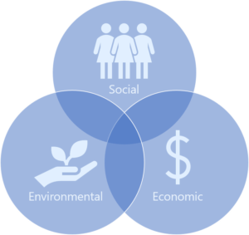
Figure 1: Triple Bottom line model
Source: (Siltaloppi, Rajala and Hietala, 2020)
With the introduction of the triple bottom line theory, new dynamics have been added to business ethics and metrics for measuring business success (Siltaloppi, Rajala and Hietala, 2020). While financial gain is crucial for business success, responsibility towards the community and the environment is also essential.
According to the triple bottom line theory proposed by John Elkington, the success of modern business is measured using three metrics: people, planet and profit. For a business to be successful it must meet the criteria of ensuring the well-being of the community and any other individuals involved with the organisation. Thus, the well-being of people is essential for the efficiency of the business organisation. Along with the people, the business organisation must also be responsible for environmental sustainability (Cornelisse, 2019). Business organisations obtain all their resources from the environment. Thus, ensuring the well-being of the planet is essential for ensuring the long-term survival of the business. Upon fulfilling their responsibilities towards people and the planet, businesses must be able to maintain profitability to become successful. Thus, in the modern business environment, finance is considered the last metric for measuring business success.

Driver of Environmental Soundness
As discussed in the prior section, environmental sustainability is considered one of the metrics for measuring business success according to the triple bottom line theory. Due to the reliance of business organisations on the environment, it is essential for business organisations to fulfil their responsibilities towards the environment.
Considering the necessity of the environment for the survival of humans along with the contemporary deteriorating condition of the environment, various government regulations have been established and business organisations are required to comply with these regulations. Thus, government regulations for environmental sustainability are considered to drive businesses towards sustainability practices (Rhou and Singal, 2020). With concern for the environment, modern-day consumers are growing preferences for environmentally sustainable organisations (Lőrincz, Banász and Csapó, 2020). Thus, various organisations are adopting sustainability practices as strategies to attract customers and develop unique brand images in the market.
While these factors are driving business organisations towards sustainability practices, in actuality environmental soundness is a general business responsibility. According to the most conventional model of business, organisations extract resources from the environment, convert the resources and exchange them for generating profit. If the resources of the environment are abused beyond necessity, the exhaustion of resources would result in a shortage of supply (Lund-Thomsen and Lindgreen, 2014). With the deteriorating condition of the environment, the cost of maintaining product quality can also increase (Karabag, 2019). The impact on the environment can also increase transportation costs for the business organisation. Considering all these factors, it is evident that business organisations are reliant on the environment to ensure their long-term continuation. Thus, the soundness of the environment is the responsibility of business.

Future Recommendations
From the discussion in the previous sections, it has been well-founded that environmental sustainability is a significant concern in the contemporary period and business organisations have significant responsibilities in adopting sustainability practices. Due to the nature of business, businesses in the hospitality and tourism industry are responsible for a considerable percentage of environmental degradation. The consumption of energy and water along with the generation of waste materials is significant in the industry.

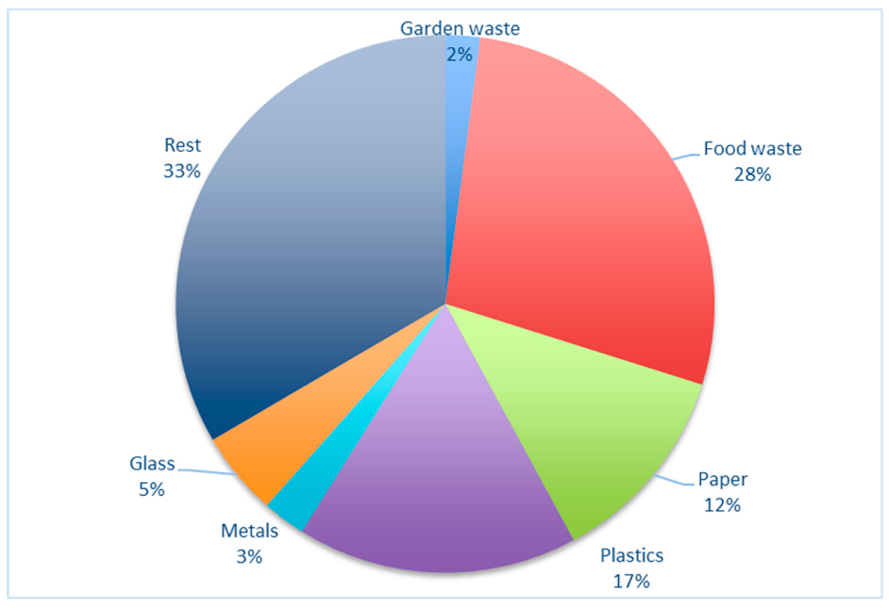
Figure 2: Waste materials generated in the Hospitality industry
Source: (Cerchione and Bansal, 2019)

Some recommendations for the industry to become more sustainable are as follows:
- Businesses in the hospitality and tourism industry should establish appropriate mechanisms for waste management and recycling. Around 17% of the waste generated by the industry consists of single-use plastics (Cerchione and Bansal, 2019). Aside from that, a considerable amount of glass and paper waste is also generated from the industry and all these materials are recyclable. The businesses in the industry should reduce the use of plastic and recycle all the recyclable materials. The organic waste should also be safely discarded.
- Organisations in the hospitality and tourism industry should also focus on the conservation of water and energy. The supply of these resources should be personalised based on the needs and uses of the consumers. Grey water should be recycled and reused.
- The hospitality industry should source its supplies from local vendors to reduce emissions caused by the transportation of materials (Prud’homme and Raymond, 2016). By purchasing locally grown supplies, the business can help the local businesses to grow while ensuring the quality and sustainability of the supplies.

Viability of Sustainability in the Hospitality Industry
The hospitality industry is resource-intensive in nature which makes it highly challenging for the industry to become more environmentally sustainable. Due to the nature of the business model in the industry, the activities often cause irritation to the local residents and environment making the business unsustainable.
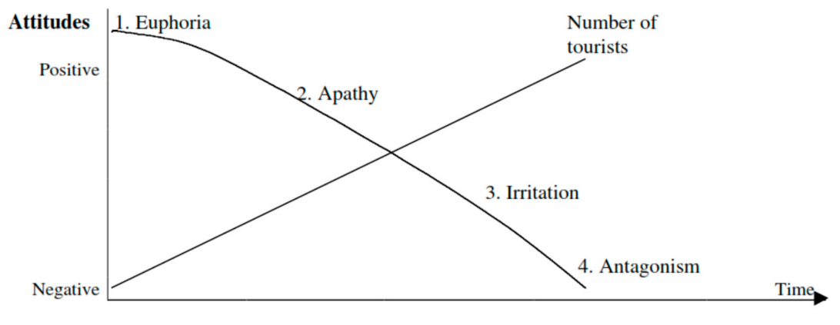
Figure 3: Doxey’s Irritation Index
Source: (Ruggieri, 2015)
According to Doxey’s Irritation Index, the attitude of the local residents towards tourists changes in four stages. The euphoria and apathy stages are where the local residents generally have a positive attitude towards tourism (Ruggieri, 2015). The model can be used as a metric for the sustainability practices of the hospitality and tourism industry. To become greener, the hospitality industry should monitor the attitudes of the local residents on a scale of these four stages to identify when additional actions are necessary.
Due to the nature of the industry, the environmental impact cannot be entirely eliminated but by monitoring the attitudes of the locals, additional approaches such as regenerative tourism can be implemented (Peters, Chan and Legerer, 2018). By implementing recommended approaches in the prior section, the hospitality industry can reduce the environmental impact on the environment. Additionally, through regenerative tourism practices, the industry can counteract the remaining impact on the environment.
Large organisations such as Hilton Hotel and Marriot Hotel have been implementing sustainability practices to become greener. Through the use of LED lights, personalised supply of water and environmentally sustainable design, the hotels are moving towards net zero (Hilton, 2023). Marriot Hotel has been investing significantly in the development of renewable energy to reduce environmental impacts (Marriott, 2016). As evident from the actions of these renowned hotel chains, the tourism and hospitality industry can be greener with the implementation of sustainable practices and regenerative tourism.

Significance of Financial Resilience for Sustainability
Attaining sustainability in the hospitality industry is not impossible, yet the criticism of the hospitality industry relating to sustainability practices is caused by the lack of financial resilience. Operating in the hospitality industry requires large investments and the shareholders often intend to achieve short-term financial gains by overlooking sustainability issues in the development stage.
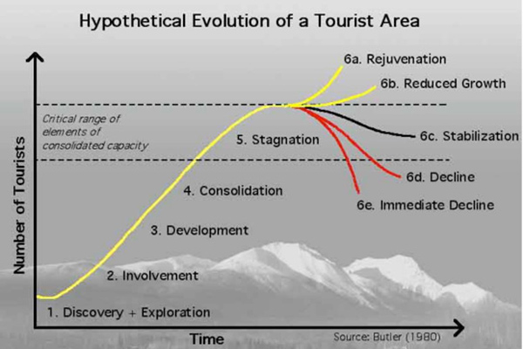
Figure 4: Butler’s life cycle model
Source: (Kalyar, Ali and Shafique, 2021)
According to the life-cycle model developed by Richard Butler, the development and evolution of tourism in a particular region occurs in six stages. The first stage starts with the exploration of the tourist attraction and followed by it, in the involvement stage, the infrastructure is built. The following stage is the development stage when the development of infrastructure and tourism organisations boost significantly (Kalyar, Ali and Shafique, 2021). Thus, it is essential to plan the infrastructure and development appropriately to maintain sustainability in the long term.
However, due to a lack of financial resilience, shareholders often show reluctance to invest in sustainable development causing the unintentional decline in growth in the consolidation stage caused by the negative impacts of unplanned tourism development (Chalip and Costa, 2015). As the condition worsens, the decline in tourism begins in the stagnation stage due to surpassing tourist capacity and environmental consequences which leads to a total decline in tourism (Kozak and Martin, 2016). Through financial resilience, these issues can be addressed which is the key to achieving sustainability in the hospitality industry.

Conclusion
The contribution of the Hospitality and tourism industry to the development of the global economy cannot be disregarded. On the other hand, the deteriorating condition of the environment in the contemporary period is becoming more concerning. While government policies and consumer preferences are driving businesses towards sustainability, fulfilling responsibilities towards the environment is essential for businesses. The resource-intensive hospitality industry needs to adopt more sustainable practices by focusing on reducing wastage and unnecessary consumption of resources. Aside from that, the industry should also develop more financial resilience by focusing more on long-term gains rather than short-term gains and investing in regenerative tourism.

References
Cerchione, R. and Bansal, H. (2019). Measuring the impact of sustainability policy and practices in tourism and hospitality industry. Business Strategy and the Environment, 29(3). doi:https://doi.org/10.1002/bse.2420.
Chalip, L. and Costa, C.A. (2015). Clashing worldviews: Sources of Disappointment in Rural Hospitality and Tourism Development. Hospitality & Society, 2(1), pp.25–47. doi:https://doi.org/10.1386/hosp.2.1.25_1.
Cornelisse, M. (2019). Moral Claims in Sustainable Tourism Development. Tourism Planning & Development, 2(1), pp.1–19. doi:https://doi.org/10.1080/21568316.2019.1622591.
Cuervo-Cazurra, A. (2018). The Evolution of Business Groups’ Corporate Social Responsibility. Journal of Business Ethics, 153(4), pp.997–1016. doi:https://doi.org/10.1007/s10551-018-3912-4.
Hilton (2023). 2030 Goals. [online] Travel With Purpose | Hilton ESG. Available at: https://esg.hilton.com/2030-goals/.
Kalyar, M.N., Ali, F. and Shafique, I. (2021). Green Mindfulness and Green Creativity Nexus in Hospitality industry: Examining the Effects of Green Process Engagement and CSR. International Journal of Contemporary Hospitality Management, 33(8), pp.2653–2675. doi:https://doi.org/10.1108/ijchm-09-2020-1079.
Karabag, S.F. (2019). Factors Impacting Firm Failure and Technological development: a Study of Three emerging-economy Firms. Journal of Business Research, 98(31), pp.462–474. doi:https://doi.org/10.1016/j.jbusres.2018.03.008.
Kozak, M. and Martin, D. (2016). Tourism Life Cycle and Sustainability analysis: Profit-focused Strategies for Mature Destinations. Tourism Management, 33(1), pp.188–194. doi:https://doi.org/10.1016/j.tourman.2011.03.001.
Lőrincz, K., Banász, Z. and Csapó, J. (2020). Customer Involvement in Sustainable : Analysis of the Consumer Preferences of the Active Cycling Tourists. Sustainability, 12(12), p.5174. doi:https://doi.org/10.3390/su12125174.
Lund-Thomsen, P. and Lindgreen, A. (2014). Corporate Social Responsibility in Global Value Chains: Where Are We Now and Where Are We Going? Journal of Business Ethics, 123(1), pp.11–22. doi:https://doi.org/10.1007/s10551-013-1796-x.
Marens, R. (2016). Laying the Foundation: Preparing the Field of Business and Society for Investigating the Relationship between Business and Inequality. Business & Society, 57(6), pp.1252–1285. doi:https://doi.org/10.1177/0007650316679990.
Marriott (2016). Sustain - csr-marriott. [online] csr-marriott. Available at: https://serve360.marriott.com/sustain/.
Martínez, P., Pérez, A. and del Bosque, I.R. (2013). Measuring Corporate Social Responsibility in tourism: Development and Validation of an Efficient Measurement Scale in the Hospitality Industry. Journal of Travel & Tourism Marketing, 30(4), pp.365–385. doi:https://doi.org/10.1080/10548408.2013.784154.
Miska, C., Witt, M.A. and Stahl, G.K. (2016). Drivers of Global CSR Integration and Local CSR Responsiveness. Business Ethics Quarterly, 26(3), pp.317–345. doi:https://doi.org/10.1017/beq.2016.13.
Peters, M., Chan, C.-S. and Legerer, A. (2018). Local Perception of Impact-Attitudes-Actions towards Tourism Development in the Urlaubsregion Murtal in Austria. Sustainability, 10(7), p.2360. doi:https://doi.org/10.3390/su10072360.
Prud’homme, B. and Raymond, L. (2016). Implementation of Sustainable Development Practices in the Hospitality Industry. International Journal of Contemporary Hospitality Management, 28(3), pp.609–639. doi:https://doi.org/10.1108/ijchm-12-2014-0629.
Rhou, Y. and Singal, M. (2020). A Review of the Business Case for CSR in the Hospitality Industry. International Journal of Hospitality Management, 84(31), p.102330.
Ruggieri, G. (2015). Tourism Development: Concepts and Issues. Tourism Planning & Development, 13(2), pp.250–251. doi:https://doi.org/10.1080/21568316.2015.1106776.
Salehi, M. and Arianpoor, A. (2021). The Relationship among Financial and non-financial Aspects of Business Sustainability Performance. The TQM Journal, 1(1). doi:https://doi.org/10.1108/tqm-08-2020-0175.
Siltaloppi, J., Rajala, R. and Hietala, H. (2020). Integrating CSR with Business Strategy: a Tension Management Perspective. Journal of Business Ethics, 174(3), pp.507–527. doi:https://doi.org/10.1007/s10551-020-04569-3.
Uyar, A., Karaman, A.S. and Kilic, M. (2019). Institutional Drivers of Sustainability Reporting in the Global Tourism Industry. Tourism Economics, 1(1), p.135481661988625. doi:https://doi.org/10.1177/1354816619886250.

