‘Sculpture and Society: The Effect of Social Changes on the Development of Greek Free-Standing Sculpture from the 6th to the 5th Centuries BCE.’
To understand and draw meaning from sculpture in ancient Greece, we must look at the state of society in tandem with our observations. The values and ideologies of Greece are reflected within their sculpture [Boardman. 2016. Pg.267]. As such, when looking at the artwork of the periods which will be discussed, the 6th and 5th century BC, one must also look at societies’ development to see the bigger picture of what is being displayed before an onlooker. There is little use in only appreciating art for the aesthetics if one cannot also gauge what the artist is also conveying about the world around them.
6th Century art exists in the realm of what is known as the Archaic period and is the last century which is involved in such before the move to the Classical period in the 5th century. The Archaic period comes a little after a period which modern historians, such as John Boardman or Robert Waterfield, would consider the Greek ‘Dark Age’ [Waterfield. 2018. Pg.16]. This is a period in which we have little evidence from [Langdon. 1997. Pg.2] and a lot of older evidence that has been collected remains ambiguous due to the lack of written work to accompany art [Coldstream. 1977. Pg.44]. However, it is obvious that people did exist in this period [Snodgrass. 2000. Pg.363], there just appears to be a loss of identity due to internal struggles and an apparent loss of physical work, especially written pieces [Desborough. 1972. Pg.21]. Those, such as Waterfield, consider dubbing this period as a ‘Dark Age’ to be a “failure,” especially because we have begun to uncover more solid evidence of civilisation in recent years with an increase of archaeological finds [Waterfield. 2018. Pg.17]. Dan Stanislawski dedicates an entire paper to how the Greeks were moving forward and making advancements in the Mediterranean area, but we dubbed it the Dark Ages because we lack Greek literary sources from the period, literacy seemingly declining during this time [Stanislawski. 2010. Pg.397-398]. Moving past this dark period in Greek history from roughly 1200-750 BCE, by the time we get to the Archaic period (750-479 BCE) the Greek poleis have already been trying to redefine themselves and solidify their culture and history [Waterfield. 2018. Pg.17]. This is why we can see such an interesting style in art in Greece, during the Archaic period, due to the need to find order from chaos in this time [Woodford. 1986. Pg.1]. Some scholars, like Waterfield, have suggested the beginning of this to have started in what he calls the Formative Period, which spans the last 150 years of the ‘Dark Ages’ [Waterfield. 2018. Pg.16]. This is because in this point we get to see what is often referred to as the Geometric Period in which we have a large amount of pottery covered in geometric art [Burn. 1966. Pg.22]. This then links to the mathematical and geometric style of the adopted Egyptian style which was employed to create the kourai of the Archaic period [Woodford. 1986. Pg.39]. Free-standing sculpture from the 6th century was mostly kourai which were funerary monuments to commemorate the death of a loved one [Boardman. 1995. Pg.114]. Usually, these pieces were given to young men who had died heroically in battle or as decorative pieces in temples [Osborne. 1998. Pg. 128]. Having statues dedicated to someone in the family was a way of flaunting one’s status for it cost a large amount to have such a piece made [Sparkes. 2010. Pg.25], even though these pieces would not resemble the deceased [Rodgers. 2012. Pg.80]. The Egyptians had a very measured, mathematical and ordered style which was adopted by the Greeks in Egypt [Hilloowala. 2000. Pg.51]. As such, the Greeks imitated the poses the Egyptians used in their sculpture and also the 4-way grid pattern in which the marble would be drawn on to create these four different but either nearly or completely symmetrical views [Woodford. 1986. Pg.39:Fig.40]. The constrictive nature of this style will be illustrated later to aid the analysis of the statues.
Firstly, looking at the New York Kouros, carved approximately 590 BCE, one can gather how the Egyptian style has influenced the composition of this male’s form. The symmetrical design is evident throughout; the face and hair follow a symmetrical style and the lines carved upon the body to indicate the muscular and bone structure of the male work in a symmetrical formation [Woodford. 1986. Pg.42:Fig.45]. The idea of order from chaos that was previously observed in Susan Woodford’s analysis of the Greeks emerging from the dark ages can be observed in this symmetrical fashion of sculpting [Woodford. 1986. Pg.1]. It is also something which lends to the rigidity of the sculpture, especially in the long hair which clings to the back of the male in long, straight lines [Fig.2]. The Kouros’ rigidity in its structure can also be leant to the pose that kouros is in, something which was adopted from the Egyptian style [Boardman. 2016. Pg.89]. Whilst the rigidity of the form is not life-like in its projection, lacking contrapposto, the Greeks used sculptures such as this and the Anavyossos Kouros (another kouros of the 6th century, crafted after the New York Kouros at approximately 530 BCE) was to present the ideal male form [Osborne. 1998. Pg.81]. This display of the idealistic male does not just pertain to the need to have an impressive muscular formation but also the fact that it was important to remain calm in the face of adversity [Rodgers. 2012. Pg.79]. This is one of the reasons for the Archaic smile, a serene and relaxed expression which could also be attributed to not being afraid of dying heroically in battle and passing to the afterlife [Boardman. 2016. Pg.89-92]. Contrasting to this, Archilochus, a lyric poet from the Archaic period, would contest that the act of dying in war was unfortunate and valour is not everything [Tritle. 2000. Pg. 41; Archilochus, Frag,16.184]. As such, we could attribute the Archaic smile to grim acceptance. Aesthetically speaking, having the male form presented naked does not just serve the function of displaying an idealistic male form but also worked so that the artist did not have to work around the limitations that adding drapery would pose [Woodford.1986. Pg.40]. This was something which can be seen as a hindrance to creating an aesthetically pleasing form when regarding kore but is overcome in the 5th century, which can be seen in such pieces as the Charioteer of Delphi by Pythagoras of Samos and Calamis. However, this does not mean that the kouros were completely realistic or natural, it takes until the fifth century to gain the ability to accurately show the human form, though as the Greeks gained confidence in their skills, we can see the beginnings of naturalism [Boardman. 2016. Pg.89]. Whilst, to a modern onlooker, the lack of proper anatomical knowledge, odd facial carvings or rigidity in pose would seem low quality, the Greeks viewed this as innovative for the time and were gaining confidence due to their style [Hilloowala. 2000. Pg.54]. A lot of the shortcomings of this era’s free-standing sculpture came from the limited techniques and tools which sculptors were using, as time progressed, the Greeks adopted better systems for sculpting [Woodford. 1986. Pg.40]. The material – marble – was one of the main limitations. Needing optimal support to ensure that parts did not fall off meant that they needed to keep limbs very close together, needing what is referred to as bridges to connect limbs to an anchoring point [Hilloowala. 2000. Pg.53]. It was also incredibly expensive to buy [Hall. 2007. Pg.275], which is why it was only the social elite who could commission great marble pieces such as this [Fox. 2006. Pg.47]. This meant that they lost out on being able to carve interesting scenes, as would have been seen on relief sculpture, such as grave stelai or in later works which used bronze casting [Osborne. 1998. Pg.79]. Through the New York Kouros, we can see the beginnings of cultural revival, the Greeks have come out of the Dark Ages, wanting to make a more solid mark and they have started doing this by refining their free-standing sculpture [Waterfield. 2018. Pg.17]
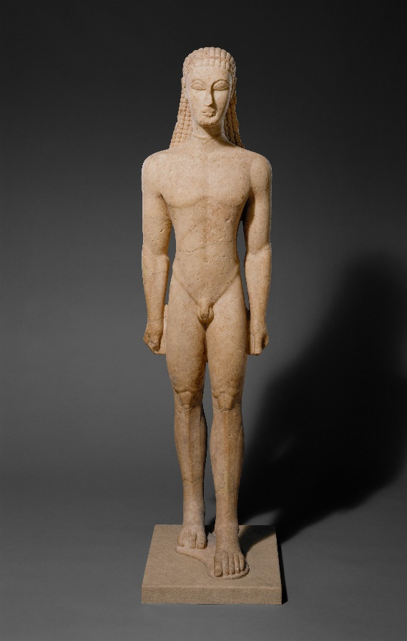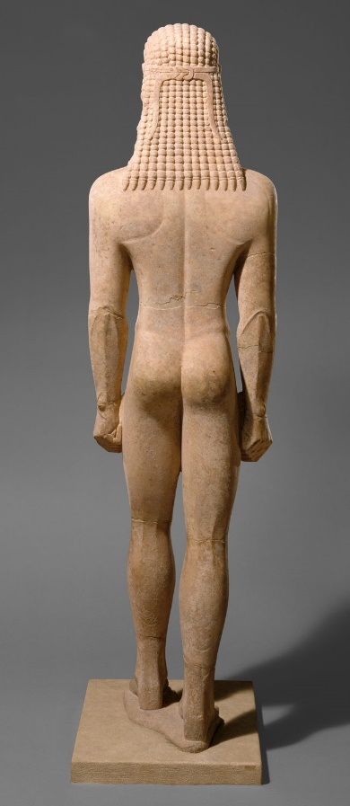
Left:Fig.1: New York Kouros 590-580 BCE, Naxian Marble, 194.6cm, Front View, The Met Collection, Accessed:25/07/2019, https://www.metmuseum.org/art/collection/search/253370
Right:Fig.2: New York Kouros 590-580 BCE, Naxian Marble, 194.6cm, Back View, The Met Collection, Accessed:25/07/2019, https://www.metmuseum.org/art/collection/search/253370

Approximately half a decade after the creation of the New York Kouros sees the birth of the Peplos Kore [Fig.3]. The figure is believed to be that of Artemis, goddess of the hunt, or Athena (which would link her more firmly to the acropolis), her missing arm believed to have held a bow or other offering [Ridgeway. 1977. Pg.58]. Despite her namesake, historians, such as Brunilde Ridgeway, have speculated that she is, in fact, wearing a chiton and a belted peplos instead [Ridgeway. 1977. Pg.50]. However, in a different approach, R.M Cook argues against Ridgeway directly saying that it is merely an overfold and that trying to argue that the dress of the Peplos Kore is still a peplos [Cook. 1978. Pg.85] The reasons that historians often have this debate over whether the Peplos Kore truly wears a peplos is due to the style and limited sculpting ability of the time leaves the fabric looking heavy or discontinued in form [Osborne. 1998. Pg.82]. Ridgeway herself admits that historian’s struggle with identifying the garment could come from the artistic representation of the old-fashioned garment [Ridgeway. 1977. Pg.55], and then goes on to explain that it is likely that a stylised peplos was used [Ridgeway. 1977. Pg.60]. The goddess’ dress, also plays a large part in reflecting society’s view on women during that era [Hall. 2007. Pg.222]. Women of that period were expected to remain modest and chaste in their appearance, covering up their bodies [Waterfield. 1986. Pg.48]. This is another reason we can infer that this is Artemis, the drapery creating this chaste and innocent nature, barely belying the form of the woman underneath [Osborne. 1998. Pg.83], it is also respectful to clothe a goddess in such a manner. However, the form is much more easily grasped than that of the Berlin Kore, who, due to the use of bridges and heavy drapery, has a form which is nearly completely concealed. We can see the distinct difference in what it meant to be a man as opposed to what it meant to be a woman, being confined to the domestic sphere and only to be appreciated by the husband, seeing as they were not to go into public [Waterfield. 1986. Pg.223-227]. This is something which changes slightly in the 5th century; for example, the eroticised Aphrodite of Knidian but is then revisited in the 4th century as we look at figures such as Eirene and Plautus which portrays a maternal air. However, the drapery of the Peplos Kore retains the same sort of rigidity that the Berlin Kore has. Having been carved in the grid fashion from a block of marble in the same symmetrical way as the rest of the kourai, there is limited movement in all of the archaic statues [Rodgers. 2012. Pg.80]. Both kore have heavy drapery which falls much like a block around them, only basic pleating breaking up the solidity, creating a static and undynamic look to the figures, emphasised by their full-frontal pose [Cook. 1978. Pg.85] The fact that this statue is of a goddess is also interesting for many different reasons. Firstly, the height of this statue is merely 118cm, making it above statuette size but below a normal life-sized sculpture and smaller than how gods were often portrayed [Osborne.1998. Pg.181]. In comparison, the New York Kouros, without its plinth, stands at 194.6cm, making it above life-sized. This may pertain to the fact that women are being treated as lesser than men [Fox. 2006. Pg.208], but it also could be the beginnings of the Greeks humanising the gods, something which is more prevalent in the 5th century onwards [Kitto. 1971. Pg.60]. Furthermore, she reflects an average appearance for a woman of the period, adorned in jewellery, some of which has since been lost but we can see holes on the statue which show the positioning [Fox. 2006. Pg.81]. Reflecting appearance has also become much more distinct with the refinement of naturalism in sculpture [Woodford. 1986. Pg.55]. This can be seen with the rounding of the flesh, creating a more distinct view of cheekbones, the planes of the face becoming more natural and realistic [Hilloowala. 2000. Pg.53]. Furthermore, we can see this rounding of the flesh in the arms too and, if we had more view of the figure, it would likely conform to the same roundness as the Anavyssos Kouros, carved roughly the same time. This evolution towards naturalism would lead the Greeks to the watershed moment between the Archaic and Classical with the Kritios Boy in 480 BCE, which retains a similar stance but the beginnings of contrapposto are evident [Hilloowala. 2000. Pg.55]. In figure 4, it can be observed that Greek statues were often adorned with colour, this was common with both marble and bronze sculptures, it is only through time and whitewashing that we have lost this colouring, emphasising garments and jewellery [Claridge. 2011. Pg.1]. The white marble view of Classical and Archaic art is only because preservation of originals has not allowed for paint to survive and reproductions have not been able to make use of some of the rare or expensive materials [Beard and Henderson. 2001. Pg.84-86]. Whilst less important now, when all the statues are displayed close to the viewer, when created, the use of colour was extremely useful in being able to tell different parts of a statue apart from far away and example of this would be on temples [Claridge. 2011. Pg.3]. Thus, whilst the colours may seem garish and not aesthetically pleasing, they were useful when placed in their context, working in tandem with the shadows created by the creases of the sculpture [Claridge. 2011. Pg.2]. Overall, whilst the Peplos Kore has its drawbacks, it does show the development of skill by the Greeks and also how they are gaining confidence in their sculpting ability. The reflections of real-world ideals upon the sculpture are seen through how even a goddess is not exempt from the scrutiny of a woman.
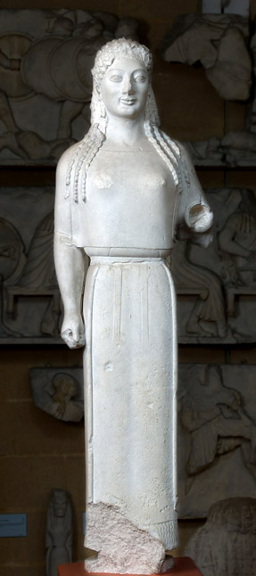
Fig 3:Peplos Kore 530 BCE, Parian Marble, 1.18m, Discovered at the Acropolis in Athens in 1886, Museum of Classical Archaeology: Cambridge, Accessed:26/07/2019, https://museum.classics.cam.ac.uk/collections/casts/peplos-kore

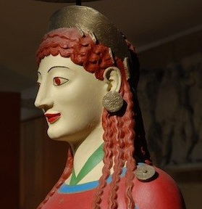
Right:Fig.4:Peplos Kore 530 BCE, Marble, Colour Copy created using colour imprints which have since faded, Museum of Classical Archaeology: Cambridge, Accessed:26/07/2019, https://www.classics.cam.ac.uk/museum/collections/peplos-kore

The fifth-century brings about a lot of change for the Greeks, both in an artistic medium and with their society and confidence. They saw the birth of a functioning Athenian democracy, aided by the triumphs of the Tyrannicides, Harmodius and Aristogeiton, or the tyrant slayers [Stuttard. 2014. Pg.49]. Scholars, including Waterfield, herald the feats of Harmodius and Aristogeiton as the catalyst to Greece’s functioning democratic state [Waterfield. 1986. Pg.100] We see a distinct formation of Greek identity as they begin to become more defined and distance themselves from barbarism as much as possible [Kitto. 1971. Pg.9]. This meant a surge in the creation of art and literature which portrayed the Greeks as far above other races and nationalities, such as the Persians [Fox. 2006. Pg.137]. Subsequently, the severe style came into being, giving a lordly and superior air to their art [Boardman. 1964. Pg.151]. Sculpture sees big improvements due to the use of bronze casting. This involves creating a clay mould of what is to be created, coating it in a wax layer and then having a mould made over it, removing the wax and then pouring bronze into the now empty cast and allowing it to set [Woodford. 1986. Pg.76]. Sometimes this would only be done in parts and then the different sections were fused [Sparkes. 2010. Pg.35]. On occasion, artists would use other metals to add contours or highlights [Rodgers. 2012. Pg.82]. This meant that sculptors were able to create more dynamic and realistic poses with their sculptures, without having to use bridges or supports [Osborne. 1998. Pg.228]. However, there was a big problem with the Greeks using bronze since the bronze from the sculptures would oft be melted down to produce other wears [Stewart. 2015. Pg.48]. Fortunately, evidence sometimes remained for where the statues were, not only in literal copies but also in pedestals would often remain too [Spivey. 2005. Pg.956]. Sometimes this destruction would come about from their own needs to repurpose and recycle the bronze for coins and the like but it could also come about from other countries sacking cities and using the bronze for their own means [Beard and Henderson. 2001. Pg.84]. The use of large-scale bronze freestanding sculpture was in high demand after the Persian wars [Sparkes. 2010. Pg.34]. Whilst not many of these sculptures survive now, they are written in literary sources by those such as Pliny [Sparkes. 2010. Pg.35]. Athens was sacked by Persian armies frequently throughout the years and it took a while for the Greeks to finally win against the Persians, driving them out of their city [Rhodes. 2010. Pg.35]. There were also victories over the Spartans in the 1st Peloponnesian war which brought hope to the Athenians [Rodgers. 2012. Pg.90]. Their victories left the Greeks feeling confident in themselves, going forward to make more impressive victory monuments to celebrate wins like this [Castriota. 1992. Pg.134]. The fifth century was a time of renewal and strength for the Greeks, they grew and progressed as a society and we can see how this is reflected in their artistic endeavours.
The Diskobolos is a further step into achieving realism in sculpture. The statue in figure 5, shows an athletic and idealistic form for a young man of the era, which is carved in the severe style, by Myron, around 460-450 BCE [Thliveri. 2013. Pg.8]. This figure does not have such extreme musculature patterns, as in the Riace Warriors [Stewart. 2015. Pg.51], yet it does still serve as a demonstration that the Greeks were adamant about portraying the ideal in artistic renditions of the human form [Osborne. 1998. Pg.21]. However, the problem with trying to exhibit what they classed as the ideal form, usually means that their sculptures end up with an aspect which isn’t feasible, in the Diskobolos’ case, this is the pose and muscle tightness, showing no response to limb movement [Woodford. 1986. Pg.90]. In the Riace warriors, we can see that the two figures, made from the same bronze cast [Rodgers. 2012. Pg.77], had a musculature which was not feasible for a human, alluding to the fact that one should aim to be like the gods [Woodford. 1986. Pg.85]. You can disregard or rationalise the inaccuracies with the Riace warriors, but placing the figure in a form which was unnatural for the sport means that Myron was focused more on aesthetics than a faultless athlete [Von Mach. 1903. Pg.448]. The reason that Myron was even able to get the sculpture to stand alone, without the use of the tree trunk bridge in marble copies, is due to the versatility of working in bronze [Osborne. 1998. Pg.162]. It is interesting that Myron would fall short of creating a true rendition of the human form when he was born and working in about the same time-frame as Polykleitus, who created the Doryphoros [Stuttard. 2014. Pg.120]. On the aesthetics of the Diskobolos, we can see how the Greeks were trying to define their refinement. We are solidly within the realms of the Severe Style [Boardman. 1964. Pg.151]. With this in mind, the fact that Myron has chosen to omit the usual facial expression that comes with physical exertion conveys that he is trying to follow the fact that Greeks were attempting to define themselves as refined and above barbarism and the uncouth [Kitto. 1971. Pg.9]. Despite these shortcomings, the Diskobolos remains one of the more popular sculptures of the ancient world [Boardman. 1995. Pg.228]. Nigel Rodgers comments that it is Myron’s obsession with creating such extreme realism in contrapposto and dynamism that was his own downfall [Rodgers. 2012. Pg.89]. Hara Thliveri’s paper on the Diskobolos goes in-depth in how whilst Myron created this beautiful dichotomy of angles when carving this dynamic pose, the sculpture falls short of being perfect when viewed from any other angle than the front view because you can no longer see this [Thliveri. 2013. Pg.7-12]. Many scholars, such as Beard and Henderson theorise that not all of these faults may have been present in Myron’s original work; since all we have are Roman and modern copies there is no way to gauge that these replications will have ever truly replicated what Myron produced [Beard and Henderson. 2001. Pg.88]. However, the general consensus of critics is that the copies are accurate enough to judge the faults as realistic. Through this analysis of Myron’s Diskobolos, we can gather that, the social expectancy for the idealistic male figure is being reflected in art. Furthermore, we can see that sculptors were able to vastly improve on contrapposto and losing that rigidity that was seen in 6th-century work and the early 5th century works.
Left:Fig.5:Myron, 450-460 BCE, Diskobolos, Townley rendition believed to have the head facing the wrong direction (Roman copy), The British Museum, Accessed:21/08/2019, https://www.britishmuseum.org/research/collection_online/collection_object_details.aspx?objectId=8760&partId=1
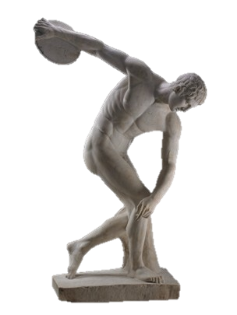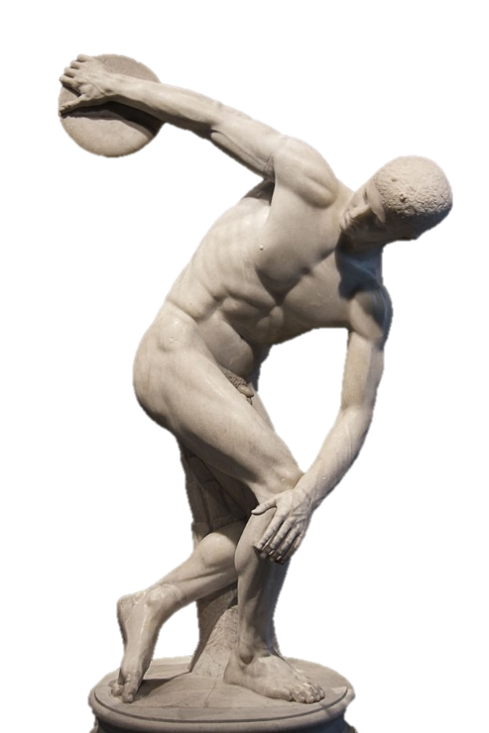
Right:Fig.6:
Myron, 450-460 BCE, Diskobolos, Lancellotti rendition with restored head that is believed to be most accurate rendition (Roman copy), Italian Ways, Accessed:21/08/2019, http://www.italianways.com/the-discobolus-lancellotti-beautiful-from-any-angle/

Later in the fifth century, 420 BCE, sees the creation of Paionios’ statue of Nike, winged victory [Rodgers. 2012. Pg.90]. Nike Paionios was a towering statue which was larger than mortal standards but also sat upon a ten-meter pillar, not to mention the wingspan of the statue which commanded power [Woodford. 1986. Pg.150]. The birth of this statue comes at the same time which the Greeks, not aligned with the Persians, had regained a lot of confidence in their fighting prowess – for this particular statue, victory over the Spartans in the Peloponnesian War [Byvanck-Quarles Van Ufford. 1972. Pg.111]. There is also a significant development in the sculpting of drapery [Woodford. 1986. Pg.150-152]. This statue [Fig.7] is the original marble work, so Paionios was able to create this large piece, with impressive dimensions, using the large areas of fabric as bridges to help the statue hold structure over time [Rodgers. 2012. Pg.90]. The long flowing drapery, pushed back by the wind as she glides forward, frames the statue providing structural integrity from the back [Fig.7]. One of her arms is extended upwards, possibly holding a piece of fabric, as recreations depict, creating a further mass of flowing fabric [Fig.8]. Her straight-backed pose and upright position exudes confidence as she steps forwards on the battlefield; the use of this step perhaps representing the Athenians moving forward into a more confident era [Fig.7]. The drapery, blown back against her body, hugs her form, belying the figure underneath, one of her breasts is exposed for the onlooker [Boardman. 1964. Pg.161]. This is a considerable step forwards in sculpting history for whilst we have seen many a male nude, women are always modestly dressed [Osborne. 1998. Pg.183]. This shows development in what society viewed the ideal woman to be, no longer are they just confined to the chaste viewpoint, but they are not also being eroticised in art [Boardman. 1964. Pg.168]. This becomes more apparent in the early fourth-century sculpture by Praxiteles, the Knidian Aphrodite which has been framed in an erotic light since its inception [Haynes. 2013. Pg.73]. For this is not an equalisation of the sexes, as a modern viewer may interpret it, but the blatant sexualisation of the female form. Paionios seems to merely be experimenting with the sexual nature of the female form whereas Praxiteles, using contrapposto to create a sensual ‘S’ curve and hand placement which seeks to add a hint of modesty, only serving to draw the viewer’s eye to her breasts and genitalia, refines it [Lee. 2015. Pg.103]. Beard heralds the Knidian Aphrodite as the epitome of a statue tailored for the male gaze – when a statue is crafted for the enjoyment of a male through a heterosexual mindset – she is used, even today for her sexualised image [Beard and Henderson. 2001. Pg.123]. From this, one can gather that not much has shifted from the sixth century, in the sense that goddesses are still subject to the same social issues that mortal women faced even despite their godly status. This likely stems from the fact that, generally, women were viewed to be secondary citizens or less than human in Athenian society [Waterfield. 2018. Pg.100]. Aristotle saw women as merely defective males, on par with the nature of barbarians [Fox. 2006. Pg.208-209]. Thus, it is not entirely surprising that some of these viewpoints may have passed on to the female sculptures of the Ancient Greek world. However, this could also be the humanisation of the gods, something which was becoming more common place as people questioned their presence [Kitto. 1971. Pg.60]. Despite this, Nike of Paionios stands as an important victory monument for the Athenians, showing their newfound confidence. It also shows an impressive improvement in the way that sculptors were carving marble, overcoming aspects which once caused limitations upon the sculptor.
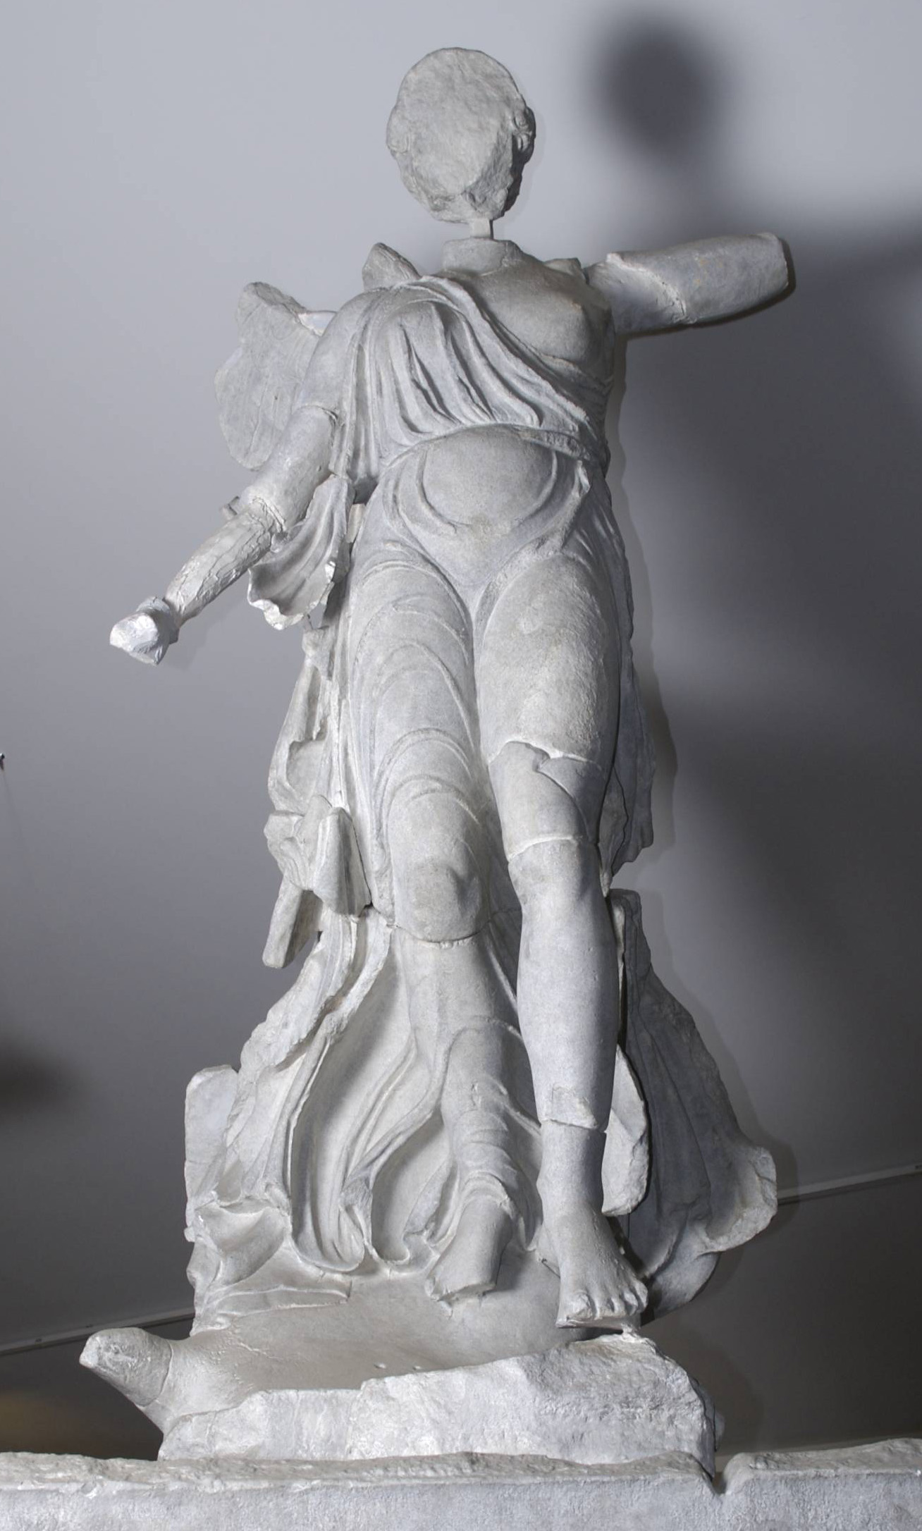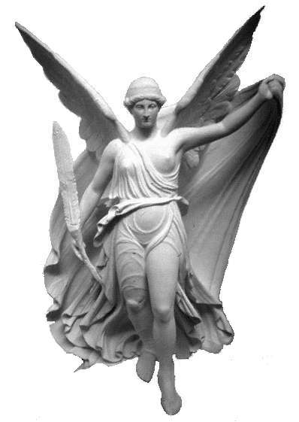
Paionios on Mende, 420 BCE, Nike -Winged Victory, Reconstruction of original marble statue which is 3 meters tall including the wings, Hellenica World, Accessed:23/08/2019, http://www.hellenicaworld.com/Greece/Art/Ancient/en/NikePaionios.html
Paionios on Mende, 420 BCE, Nike -Winged Victory, Original marble piece with several missing segments it was discovered in 1875 at Olympia, Museum of Classical Archeology Databases, Accessed:23/08/2019, https://museum.classics.cam.ac.uk/collections/casts/nike-paionios

To conclude, from the evidence presented, one can gather that the forms of free-standing sculpture from the sixth and fifth centuries are intrinsically linked to the views and state of society during their periods of creation. Most notably we have the pressing matter of idealism, for both men and women. This idealism pertains not just to the physical form but also how they behave. It is the imagery and messages which these sculptures convey that create links the societies of their time. All art must be viewed in its context, without such it does not allow a viewer to gain the whole picture [Boardman. 1964. Pg.267].

Word Count: 4379

Bibliography
Beard, M., & Henderson, J., 2001. Classical art from Greece to Rome. Oxford: Oxford University Press.
Boardman, J., 1955. Greek Sculpture: The Late Classical Period. London: Thames and Hudson.
Boardman, J., 1964. Greek Art. London: Thames and Hudson.
Burn, A.R., 1966. The world of Hesiod : a study of the Greek Middle Ages, c 900-700 B.C 2nd ed. New York: B. Blom.

Byvanck-Quarles Van Ufford, L., 1972. W. DEONNA, La Niké de Paionios de Mendé et le triangle sacré des monuments figurés (Coll. Latomus, vol. 62). Bruxelles, Latomus, 1968. 320 p. Pr. frs. belges 350. Mnemosyne, 25(1), pp.110–112.

Castriota, D., 1992. Myth, Ethos and Actuality: Official Art in Fifth-Century B.C Athens. Madison, Wis: University of Wisconsin Press.
Claridge, A., 2011. Looking for Colour on Greek and Roman Sculpture. Journal of Art Historiography, 5, pp.5-AC/1.
Coldstream, J.N., 1977. Geometric Greece. London: E. Benn.
Cook, R., 1978. The Peplos Kore and Its Dress. The Journal of the Walters Art Gallery. 37, 84-87.
Desborough, V.R.d'A., 1972. The Greek dark ages. London: Benn.
Fox, R.L., 2006. The Classical World: AN Epic History of Greece and Rome. London: Penguin Group.
Hall, J.M., 2013. A History of the Archaic Greek World: 1200-479 BCE. West Sussex: Blackwell Publishing.
Haynes, M., 2013. Framing a View of the Unviewable: Architecture, Aphrodite, and Erotic Looking in the Lucianic Erôtes. Helios, 40(1/2). Pp.71–96.

Hilloowala, R., 2000. Anatomy and the Art of Archaic Greece. THE ANATOMICAL RECORD (NEW ANAT.) 261:50 –56.
Kitto, H.D.F, 1971. The Greeks. Middlesex, England: Penguin Books Ltd.
Langdon & Langdon, Susan H., 1997. New light on a dark age: exploring the culture of geometric Greece. Columbia, Mo: University of Missouri Press.
Lee, M.M., 2015. Other "Ways of Seeing": Female Viewers of the Knidian Aphrodite. Helios, 42(1), pp.103–123.

Osborne, R., 1998. Archaic and Classical Greek Art (Oxford History of Art). Oxford: Oxford University Press.
Rhodes, P.J., 2010. A History of the Classical Greek World: 478-323 BC. West Sussex: Blackwell Publishing.
Ridgway, B. (1977). The Peplos Kore, Akropolis 679. The Journal of the Walters Art Gallery. 36, 49-61.
Rodgers, N., 2012. The Art and Architecture of Ancient Greece. Leicestershire: Anness Publishing Ltd.
Snodgrass, A.M., 2000. The dark age of Greece: an archaeological survey of the eleventh to the eighth centuries BC. Edinburgh: Edinburgh University Press.
Sparkes, B.A., 2010. “II Freestanding Sculpture,” New Surveys in the Classics. Cambridge University Press, 40, pp. 24–50.
Spivey, N., 2005. Olympia, Olympiads and Olympic bronze. Antiquity, 79(306), pp.956–958.

Stanislawski, D., 1973. DARK AGE CONTRIBUTIONS TO THE MEDITERRANEAN WAY OF LIFE. Annals of the Association of American Geographers, 63(4), pp.397–411.

Stewart, P., 2015. Legacies of Loss. Apollo, 181(628), pp.48–53.

Stuttard, D., 2014. A History of Ancient Greece in Fifty Lives. London: Thames and Hudson.

Thliveri, H., 2013. 2 -- THE DISCOBOLOS OF MYRON: NARRATIVE APPEAL & THREE-DIMENSIONALITY. Bulletin of the Institute of Classical Studies of the University of London, 56(S104), pp.7–70.
Tritle, L.A., 2000. From Melos to My Lai: War and Survival. London: Routledge.
Von Mach, E., 1903. Hermes Diskobolos. American Journal of Archaeology, 7(4), pp.445–449.
Waterfield, R., 2018. Creators, Conquerors, and Citizens: A History of Ancient Greece. Oxford: Oxford University Press.
Woodford, S., 1986. An Introduction to Greek Art. New York: Cornell University Press.
Ancient Sources
Anon, The Anavyssos Kouros, c. 530 BCE (marble)
Anon, The Berlin Kore, c. 570-560 (marble)
Anon, The New York Kouros, c. 590-580 BCE (naxian marble)
Anon, The Peplos Kore, c. 530 BCE (parian marble)
Anon, The Riace Warriors, c. 450 BCE (bronze)
Antenor, Harmodius and Arisogeiton: The Tyrannicides, c. 477 BCE
Kritios, The Kritios Boy, c. 480 BCE
Paionios, Nike of Paionios, c. 420 BCE
Polykleitos, Doryphoros, c. 450 BCE
Praxiteles, Statue Knidian Aphrodite, c. 350BCE
Pythagoras of Samos et Calamis, The Charioteer of Delphi, c. 478-474 BCE (Bronze)
Myron, The Diskobolos, c. 460-450BC (Bronze)

